Artificial intelligence imbedded Gamification to Promote the Emergency Health Care

Dr. Pratika Mishra, Ph. D.
pratikamishra@presidencyuniversity.in: 9643103117
Professor -Marketing, School of Management, Presidency University, Bangalore 560064

Dr. Shiv Shanker Tripathi, M.D.

shiv_shanker2@rediffmail.com; 8808073004

Professor, Department of Emergency Medicine Dr Ram Manohar Lohia Institute of Medical Sciences, Lucknow, India 226010

Dr. S. P. Mishra,Ph D.

mishrasp05@gmail.com; 09415365781

Department of Radiation Oncology, Dr Ram Manohar Lohia Institute of Medical Sciences, Lucknow, India 226010

Dr Anoop Kr Srivatava, Ph D

anoopsrivastava78@gmail.com; 8176007237

Professor, Department of Radiation Oncology, Dr Ram Manohar Lohia Institute of Medical Sciences, Lucknow, India 226010

Dr. Madhup Rastogi, MD,

drmadhup1@gmail.com; 8176007010

Professor, Department of Radiation Oncology, Dr Ram Manohar Lohia Institute of Medical Sciences, Lucknow, India 226010
Introduction: Artificial Intelligence (AI) is a broad subset of computer science that attempts to mimic human cognitive ability. AI can include speech recognition, predictions, and problem-solving. A popular subset of AI is machine learning, which includes the ability to improve itself autonomously, without human input. Deep learning is a subset of machine learning which is based on artificial neural networks. Natural language processing, which involves the analysis and manipulation of human language, can include all three levels of artificial intelligence, machine learning, and deep learning (Figure 1). Broad categories of AI can include supervised learning, unsupervised learning, reinforcement learning, and natural language processing. AI has received considerable progress for its applications in medicine given its ability to outperform human expertise in clinical predictions, diagnosis, and monitoring. The emergency department (ED) may be uniquely situated to benefit from AI, due to the diversity of patient information, the necessity of balancing probabilities for risk stratification, and the rapid decision-making. AI can read a series of x-rays and CT images in quick succession and predict the diagnosis more accurately. A new diagnostic stream has evolved using AI for helping the accurate diagnosis and solve the diagnostic dilemma faced in many emergency situations. Artificial intelligence (AI) has long been thought to be the next major technological breakthrough in healthcare. While proposed applications of AI touch on nearly all aspects of medicine and healthcare, applications within emergency medicine (EM) appear particularly promising. With increasing emergency department (ED) wait times, a reliance on high acuity diagnostic decisions, and an environment that constantly pushes the cognitive bandwidth of its providers, AI interventions in EM pose substantial benefits to both EM physicians and the EDs and health systems they work within. AI has shown promise in numerous applications within EM, including in the interpretation of diagnostic imaging, predicting patient outcomes, optimal utility of resources and monitoring of patient vitals.
Type of AI | Definition
Supervised Machine Learning | Machine learning that learns a function based on examples and previous input
Unsupervised Machine Learning | Machine learning that does not require human input or labelled response to generate inferences
Reinforcement Machine Learning | Machine learning that trains models to make decisions based on incentives
Natural Language Processing | AI regarding human language (including language recognition, understanding, and generation)

Artificial intelligence (AI) aims to enable computers to emulate human cognitive functioning. While the potential applications of AI are therefore seemingly endless, there is considerable excitement about what AI could mean to healthcare. Emergency medicine (EM) has been at the forefront of discussions surrounding applications of AI in healthcare due to the uniqueness of EM practice. With increasing departmental flow challenges and wait times, a reliance on high acuity diagnostic decisions, and an environment that constantly pushes the cognitive bandwidth of its providers, the benefit of an AI intervention that could increase the speed and accuracy of clinical decisions poises EM to substantially benefit from this technology. The most established applications of AI in EM are rooted within the emergency department (ED)itself ie. triage monitoring.
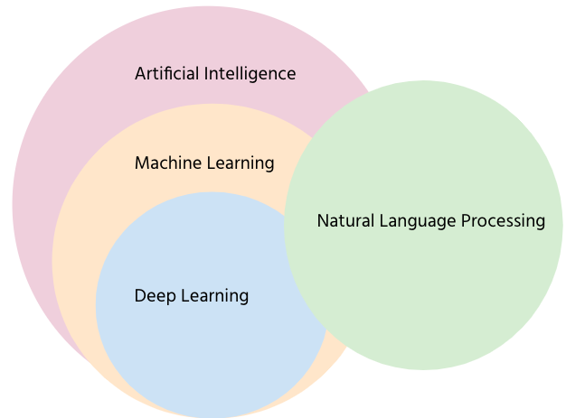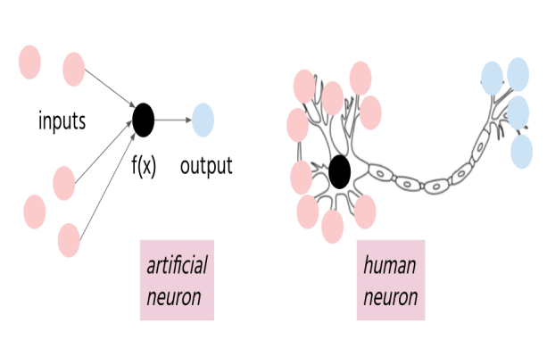
Fig.-1: Artificial intelligence Process.
In recent review of literature it was reported that ED has benefited mostly in establishing accurate radiological diagnosis using AI applications. It was also found that AI interventions were better able to diagnose acute cardiac events, identify hyperkalemia, risk-stratify patients in triage, identify participants, predict wound infection, predict mortality, predict patients for clinical trials, and read types of imaging. Beyond clinical care, AI was also found to be useful in predicting hospital wait-times and optimizing staffing hours.
Considerations for AI Implementation
There are a few reasons why AI might be able to outperform human clinicians. For one, AI has the ability to process multiple variables simultaneously across large data sets. Humans often struggle when balancing numerous data points to predict outcomes, and our decision-making is often subject to biases and various other limitations. In addition, AIs can take advantage of large data sets for stronger pattern recognition, which is particularly relevant in fields such as radiology. For example, an AI can process databases made of hundreds of thousands of radiographs and their reports, resulting in an algorithm that can accurately diagnose new radiographs based on pattern recognition such as the detection of fractures.​However, AI needs to be tested in pragmatic real world settings that mimic the rapid, unpredictable environment of an ED – there isn’t much use for an AI that only works in a tightly controlled, study setting. Human errors and lack of familiarity can contribute to a lack of uptake or poor implementation.
Another concern for AI is its “black box” nature (i.e., its lack of transparency), in which it is difficult for an observer to determine what goes “into” an AI. It has been observed that the opacity of technology has inadvertently discriminated against certain patients, or coded for incorrect outcomes. For example, a widely used American hospital algorithm was noted to have unintentional racial bias when allocating healthcare resources for African origin patients.​​ Transparency and audits of AI should be recommended, not only to ensure the correctness of the algorithm, but also to build public and provider trust. Ultimately, AI may indeed change the practice of emergency medicine through its simulation of human cognitive ability. However, it is important to cut through the “hype” of AI and read research with a critical eye.
Emergency Room Triage with Assistance of AI
Today, triage is the front line emergency medical care, providing both the medical practitioner and patient with the coordinates they need to ensure that care is provided to the right person, on time. Backdrop artificial intelligence (AI) has become an increasingly powerful tool for emergency room triage. The algorithms and intelligence of AI have evolved significantly over the past few years to become more reliable and are designed to support physicians as they juggle increasingly challenging workloads. The science that sits behind the algorithm is deep and highly complex. This is not just technology and data, it’s deep learning, neural networks and machine learning. It’s using data sets and insights to create algorithms that are capable of identifying the different layers of patient triage so that physicians can ensure that patients are accurately categorized and cared for.
This requires significant volumes of clean data that can be used to ensure that AI is not just capable, but also of value in an emergency room setting. This means that AI in triage has to follow rigorous process, testing and modeling to get the best results. AI in emergency room triage is designed to support the medical sector in all types of emergencies. As it evolves it may become increasingly capable of providing a solid foundation for triage in EM, one that has the potential to minimize risk, improve accuracy, and reduce the burden on the ICU. AI possesses significant promise in the emergency setting and has already begun to improve the efficacy and quality of care delivered in select interventions. One of the primary applications of AI within the ED is in triage. The triaging of patients within the ED fundamentally impacts patient flow, wait times, resource utilization and allocation, and risk-stratification. While most EDs currently rely on clinical decision making in triage, there is evidence that AI systems could improve this process. The Emergency Severity Index (ESI) is the most commonly used triage scale in the United States. Several AI models have shown to be effective in delineating patients at this mid-acuity level Fig.2.
Necessary steps to delivering an AI-powered future
- INVEST IN DIGITAL COMPETENCIES,
- INTEROPERABILITY AND INFRASTRUCTURE
- PROVIDE AN INCREASINGLY PERSONALISED EXPERIENCE
- BUILD COLLABORATIVE RELATIONSHIPS WITH REGULATORS
- IMPROVE TRANSPARANCY AND TRUST IN TECHNOLOGY AND DATA

Fig: 2: AI improves patient support by an interphase optimized Personalize communication and steps to comply , engage and connect module.

Evolution and Reach of Artificial Intelligence in Emergency Medicine
Artificial intelligence (AI) may be one of the major technological breakthrough in healthcare in recent decades. Potential of proposed applications of AI touch on nearly all aspects of medicine and healthcare. Its Applications within emergency medicine (EM) appear particularly promising. Increasing emergency department(ED) wait times need efficient management. Reliance on high acuity diagnostic decisions, in ED environment is utmost critical. Interventions of AI in EM poised to enhance substantial benefits to both EM physicians and health systems. AI has shown promise in numerous applications within EM ,including in the interpretation of diagnostic imaging, predicting patient outcomes, and monitoring of patient vitals. However, barriers to widespread adoption and integration of AI remain due to technological absorption and availability of reliable AI tools. The evolution of user friendly technology , attitudes and regulations towards it is going to be critical for its integration in EM. Newer interventions have targeted the use of AI outside the hospital or ED, such as home monitoring programs and continued connectivity with treating physician. Hence it is important to understand the AI in EDs in the context of current practices, limitations, and the direction that this new innovation is heading in the future.

AI systems were also effective in predicting the risk of severe complications such as sepsis, the likelihood of cardiac arrest within 72 hours, and earlier assessment of trauma patients who were likely to have a positive computed tomography (CT) head result. Each AI application outperformed the comparative clinical decision making tool (mortality in ED sepsis score, thrombolysis in myocardial infarction Global Registry of Acute Coronary Events, and Canadian CT head algorithm, respectively). While these prediction tools are less focused on the initial acuity of the patient, they still impact triage by informing the amount of investigations needed, how quickly said investigations need to be completed, and how closely the patient needs to be followed in the ED. Similar AI interventions have been applied in the context of clinical monitoring. While the aforementioned tools can predict the likelihood of cardiac complications or sepsis based on a patient’s initial presentation and basic work-up, other tools have been developed to monitor heart rate and rhythm and blood pressure dynamics over time to predict clinical complications. These Interventions have been primarily focused on predicting sepsis and cardiac instability, and have been shown to perform equally or better than current clinical tools. Other AI tools have used natural language processing (NLP), which involves computers interpreting text, to predict the likelihood of patients having appendicitis or influenza based on information in the clinical notes from the ED.
AI interventions in diagnosis have been shown to have up to 94% sensitivity and 99% negative predictive value in detecting life-threatening pathology on head CT, such as subarachnoid hemorrhage, epidural hematoma, midline shift, hydrocephalus, and acute ischemic stroke. Quick and accurate identification of these diagnoses is extremely valuable both in high-volume tertiary centers with potentially lengthy waiting periods for radiology consultations and in smaller centers with limited access to radiology specialists. AI has also shown to be very effective in fracture diagnosis, both in common orthopedic injuries to the extremities, such as wrist and ankle fractures, and in more serious vertebral pathologies. AI also shows promise in assisting in diagnosis from ultrasound investigations, such as detecting fluid on focused assessment with sonography for trauma and providing an automated calculation of ejection fraction on echocardiogram. Again, AI proves useful in determining if there is an obvious pathology present, thereby providing an additional safety net for EM providers, particularly in lieu of a specialist consult. Moreover, it helps in informing the allocation of ED resources and patient disposition planning. AI monitoring discussed above, has been shown to be effective in detecting acute exacerbations of chronic obstructive pulmonary disease, identifying 75.8% of exacerbations an average of 5 days before the patient sought treatment. Similarly, AI interventions have been able to predict asthma exacerbations in children 1 week before symptom onset by using patterns in asthma symptoms, patient attributes, and environmental factors collected in a self-reported asthma symptom tracker database. Wrist-worn accelerometers have been able to detect seizures with a high degree of accuracy, and specialized smart phone audio applications have been used to detect falls in the elderly. By analyzing the caller’s speech and description and providing advice on what questions to ask next, indicating when a patient may have a particular presentation, such as a myocardial infarction or stroke. It also helps in data extraction, where the system can pull information on the caller’s address and/or location to reduce time needed to complete the call and dispatch EMS. While each of these AI applications occurs in a pre-hospital environment, they may substantially reduce the burden on EDs and serve as early detection and warning systems for acute care events outside healthcare environments. By predicting which chronic diseases patients are in need of emergency care and when and where an infectious disease outbreak may occur, EDs would be better able to prepare for the patient type and volumes they may encounter. Further, by assisting emergency dispatchers, emergency medical and paramedic services could be dispatched more quickly and with more detailed clinical information.
The Limitations of AI in ED and Current Legislations.
The limitations are that in EDs there is minimal standardization between electronic medical record systems used between healthcare organizations. This presents challenges in broadly applying any one AI program across many EDs. Another limitation involves the nature of the internally evolving algorithm by which neural networks and machine learning develop prognostic algorithms. We are faced with a turning point in technology where trust is placed in the hands of not just the human developer of the algorithm, but the computer to generate appropriate codes internally. This makes the replication and interpretation of AI algorithms somewhat opaque for both clinicians and patients. This presents numerous unforeseen ethical and potentially medico-legal challenges. Furthermore, the healthcare data being collected is often confidential in nature, a common rate-determining step in large data mining projects that require constant updating and real time feedback for optimal performance. It will be important to classify available data with patient consent moving forward to avoid large breaches in confidential information, as has been seen in many non-healthcare large-scale AI projects to date. Arguably one of the greatest sources of mistrust associated with widespread adoption of AI revolves around the idea that, as with the application of any AI technology, the program will always lack of a sense of the clinical acumen. Although the vast majority of proposed AI interventions will be able to assist physicians as opposed to operating independently, it remains important to be aware of when and where these algorithms are at play, and how they may inadvertently influence clinical decision making. Many times the delivery of acute care in medicine lends to increased risk of human error. AI possesses significant promise in the emergency setting and has already begun to improve the efficacy and quality of care delivered in select interventions.
Artificial Intelligence and Gamification: The results of the gaming and its ramifications has been profound and it may have large potential to evolve further with integration of AI to support the pharmacological treatment in serious ailments such as neurological treatment, cancer and trauma patients. The gaming through smart apps in health care sector has come long away and it is posed to grow further in more systematic and definite way. More clinical research is required in AI supported gaming that how it influences the neurochemicals which work as healing agents. It will soon be possible for induction of artificial intelligence to make its inroads in gaming. The robtonic technology in combinations of artificial intelligence are poised to make large contribution to hitherto unconventional method of healings. Such platform in neurological, trauma, cancer care , cardiology and HIV , diabetes and physiotherapy with new intelligent platform will shape the future researches. Signs and symptoms of mental illness can vary, depending on the disorder, circumstances and other factors. Mental illness symptoms can affect emotions, thoughts and behaviors. Sometimes symptoms of a mental health disorder appear as physical problems, such as stomach pain, back pain, headache, or other unexplained aches and pains. It is a challenge for the gaming industry to develop gaming to address these important issues in mental health areas. Innovators , researchers , clinicians and businesses have to pool the resources to augment the subject further in future

