Social Media and Communication during COVID- 19
Mansi Kapil
Amity University, Jaipur
Rajasthan
Kapil.mansi95@gmail.com

Introduction
Communication is a simple act of transferring information from one place to another. The transmission of message from sender to receiver to recipient. These include our emotions, cultural situation, the medium used to communicate and even our location. Communication can be done through various medium such as television, newspaper, and social media.
In today's modern society, media has become a really big part of our life. Its duty is to tell, educate and entertain.TV acts as a bridge between the government and the public. Whereas if we see radio, it remains accessible when other modes of communication go down in emergencies. Millions of people have evacuated homes and offices during the shocking earthquake or crises like COVID, we fruitlessly attempted to use our smartphones to reach out to loved ones and find out exactly what had happened, or whether they are fine or not. Social media is a web platform that individuals use to build a social network with people who share similar personal or career interests, activities, backgrounds, or real-world connections. The impact of social networks on children is extremely significant. It is becoming clear that social networks have become part of laptops, tablet, tablet computers and smartphones to check tweets and status updates from their friends and family. Social media basically allows people to share information, to have conversations and create web content. Moreover, billions of people are using it throughout the world. Media has two folds i.e. positive and negative. However, these days positive side is affecting more and more people like sharing self-experiences during the crisis, rendering emotional help, providing counseling etc. There is a dramatic shift in every aspect of life for example increase in the use of e-commerce, increased use of digital media, and Information and communication technology. Today, in a huge pandemic situation (Coronavirus) media is playing huge role in molding the situation. In fact, usage of mobile phones and the internet has increased during the pandemic. Media’s update on coronavirus or on the ground situation and how to cure oneself from the virus is a boon for people but Recently, in many states of India, huge numbers of FIRs are made for spreading fake news and communal hate on the internet during covid whereas on to other hand, we can see people are seeking for peer support and health care support on the platform. In this paper, we are presenting how communication mediums like social media are playing their respective role in caring information or helping by providing peer support or health care support during pandemic situation and at which rate it is affecting people’s mind in positive manner.
Epidemics affect regions, whereas pandemics affect the entire world and have negative repercussions in terms of disease spread. The novel corona virus infectious illness is an ongoing specific strain of COVID-19 infection that has produced severe acute respiratory syndrome corona virus around the world. This virus first appeared in Wuhan, China, and then spread to more than 200 countries. In January 2019, the World Health Organization (WHO) designated the Coronavirus to be a "public health emergency" of "international concern."
According to the survey, people with high anxiety levels in the twenty-first century have a tendency to utilize social media excessively. They can use social media to temporarily escape their unfavorable emotions. This incites a strong urge to be online indefinitely. Furthermore, health information shared on social media platforms assists individuals in obtaining accurate information about the COVID-19 epidemic.
Literature Review
A.K.M. Chan et al(2020),in their study "Social Media for Rapid Knowledge Dissemination," looked into whether social media has potential if handled correctly. It has the ability to give people timely and accurate critical information. They also noted that the success of knowledge distribution is determined by the quality of infographics, content, and the speed with which information is disseminated via social media. As a result, many institutions can save time by not having to create fresh content. Free and rapid circulation of information is a valuable input during the health crisis of coronavirus.
Daniel A Gonzalez – Padilla(2020), in their study “Social media influence in COVID-19 pandemic,” examined that the social media has both advantages and disadvantages depending on its usage. Responsible use of these help in the circulation new information quickly, and new scientific finding, and can share diagnostic and treatment digitally.

Research Methodology
This research study is based on review and analysis of existing literature during the pandemic period. General observation and news information are taken into studies. Many databases information is taken from Journals.

Role of Social Media During COVID-19
People used social media in a more regular pattern at the start of COVID-19 because they relied on it for new information, news, and so on. In reality, in times of health crisis or disaster, social media has become a lifeline. WHO, along with a slew of other brands and social media platforms, has banded together to combat the corona virus. Coca-Cola and Google have both run campaigns promoting the fight against covid and the precautions that should be done. Furthermore, Instagram prioritized the WHO account handle in their search engine so that accurate information could be provided to all audiences. When the global crisis hit, the WHO reported that the number of persons suffering from depression and anxiety had increased compared to the previous year. In April 2020, Assam police conducted a study of 239 calls and discovered that 46 percent experienced anxiety, 22 percent had depression symptoms, and about 5% had suicidal thoughts. Indeed, social media made health information more accessible, assisting people in assessing their health risks and managing global health crises. In response to the global health issue, social media users create and share information gathered from local and worldwide sources. Meanwhile, the government tried to figure out how social media could aid in a disaster and began using social media tools and apps to do so. People can use apps like Arogyasetu to find out how many cases of the Coronavirus are present, book vaccinations, and so on. However, the app had several flaws in the beginning, but the government gradually improved it.

Social Media, Social Support & Health Information
The general population seeking health information can find social support content on social media. Many people are concerned about their health and have medical problems. In essence, social media provides them with accurate information. The term "social media" refers to how social networks embed people into social obligations and communication networks. It also implies that the supportive nature of one's social network, as well as the localization of health through sports activities, are beneficial. Emotional care and sustenance, physical assistance, financial assistance, a sense of belonging, and personal advice are all examples of supportive assistance. In a nutshell, any and all forms of concrete and intangible assistance. The term "social support" relates to the provision of physical assistance, assistance, or the degree to which an individual participates in a social obligation or network. Social support can come from coworkers, friends, and family members. In fact, numerous Facebook and Instagram pages engage in fund-raising and counseling initiatives in order to provide social assistance in any way.
Social Media, Health Related News & Peer Support
Social Media has played a remarkably positive role in providing health information from peer group to the public. The concept of the peer group is basically about those people who are keen to help by sharing information and experiences that they had during the crisis of covid-19. Most importantly they use social media and users are seeking information and try to stay connected with people who are going through this situation and feel a sense of belongingness with them. Such peer support on social media increases the self-efficacy and self-esteem and decreases the risk of uncertainty among people. Seeking health information from social media is vital in the life of people who wants to seek health care information, treatment, and counseling. Most importantly, these online resources and health care information caters as a complement to communication and decrease the fear of social isolation which is necessary to manage depression, anxiety, or health disaster etc. Therefore, peer support aspect on social media is essential.

Social Media Use and Health Behavior
Social Media platforms have provided significantly updated information to those who wish to seek information about covid crisis. People have faced pressure and received false information sometime, but the government bodies tried to correct such information. This shows dependency of people on social media for information as people seek it and tries to connect with their loved ones such as friends, family, Coworkers, colleagues etc. Social media has promoted the health behavior changes such as social distancing, sanitizing hands, wearing mask etc. Many brands on social media have carried campaign on getting vaccinated and following the safety measures. This led to positive behavioral change in society as it keeps going in mind of people. Also, emotional advertising related covid has also played a significant role in it as getting scared is the most fearful emotion of people which in turn can make them follow the rules. This is how communication and interaction has gone beyond the personal message delivery. The media platform is just not used for seeking heath care information but also for seeking virtual learning and teaching. No doubt, that it has given rise to virtual education which in turn can be beneficial for many communities.

Role Of Social Media And Technological Tools In Education
Information technology has significantly changed many aspects of human lives. However, IT sector has played remarkable role in providing the virtual education to primary, secondary, and higher education provision. During the time of pandemic, the use of education technology has gained popularity in education industry. Since pandemic affected many countries and so their education system. The government bodies have suspended the face-to-face education until the situation come in control. The overnight change in education to online teaching has given rise to importance of media literacy among parents and students. Apps like Google meet, zoom Microsoft has come into more light. However, virtual learning process is not new to anyone. The overnight change of education mode was difficult for students who cannot afford a laptop or mobile phones. This creates the digital divide and feeling of being left out. Due to non availability of technologies, many students have faced anxiety and somewhere the lack of government can also be responsible. No matter countries have opted everything online but many regions in the country is still lacking behind in owning a computer, laptop or the availability or access to internet facility.

Behavioral changes in communication (Study)
According to the Datareportal analysis, approximately 4.57 billion have started using the internet since last year. And social media users have grown even faster than last year.
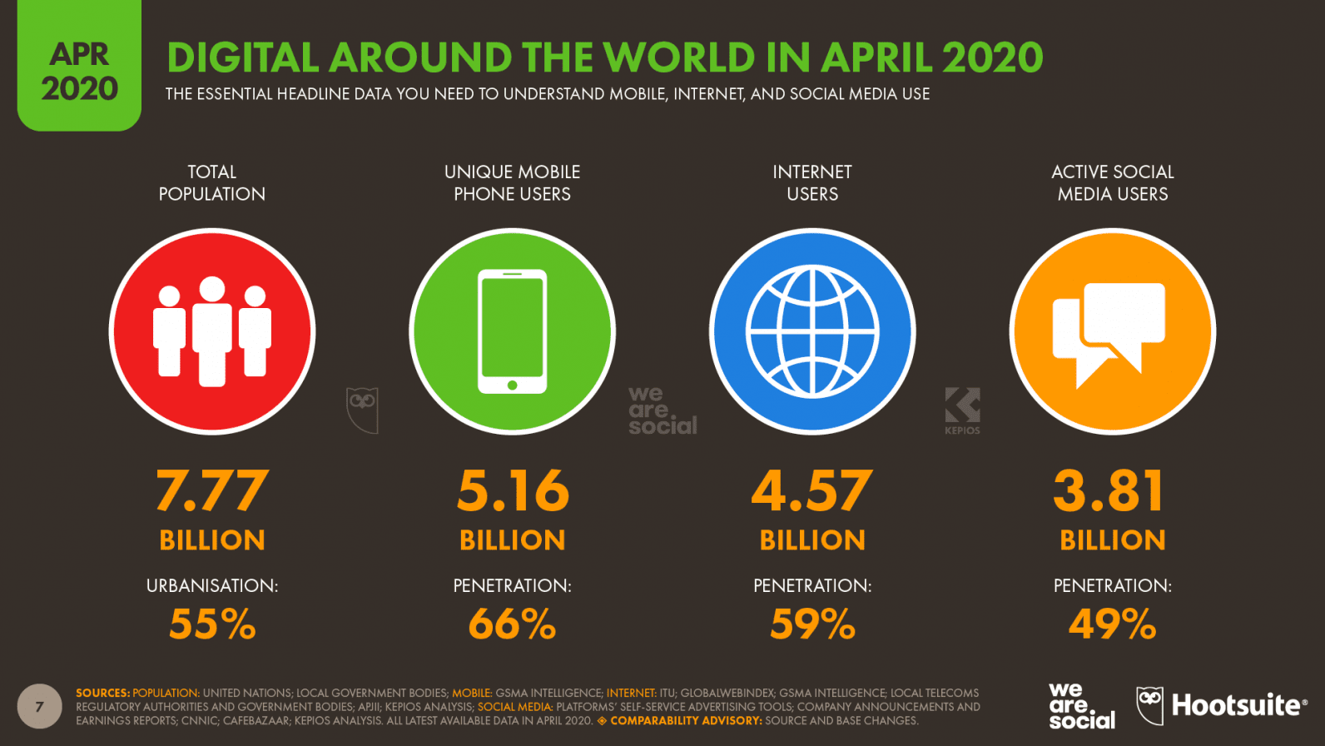
In fact, it was expected that global social media will touch its key milestone by the end of 2020 and this eventually happened!
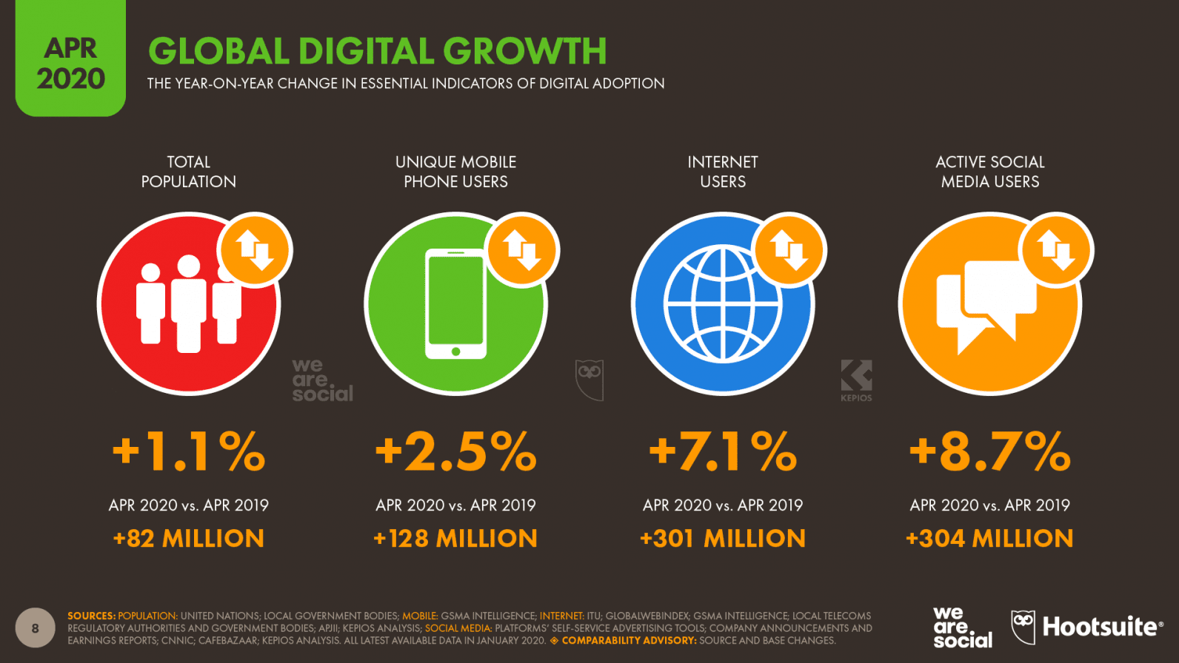
The number of individuals using mobile phones has increased, with a 128 million increase in global users over the previous year. Here in above image, we can see number of mobile phone users, internet users and active social media users have increased from last year April to this April 2021.
During the pandemic, digital media was used tremendously as people spent most of their time in lockdown. There was increase in messaging, voice calls but video calls apps like Google duo, skype. Google meets were used most often. In turn, it leads to wide spread of ICT (Information and communication Technology) globally. According to the study of Minh Hau Nguyen, 43% of people used text messaging more often. 36% used video calls and 35% used social media and video calls were used by 30% people. On other hand, quarter of people used to email i.e.24% & 22% spent time playing video games. This shows that there is increase in using digital media; approximately 46% of respondents are using digital media more. However, there were people who reduced their digital communication during pandemic, but they were less in percentage. In total there were only 9% of people who decreased the use of digital media

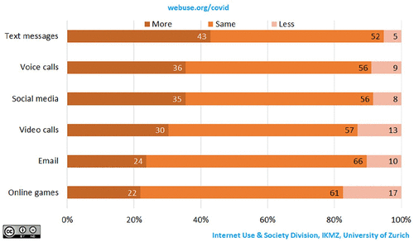
Image: Change in people’s digital communication during pandemic

Digital Divide and Inequalities
Social inequalities are the indifferent distribution of sacred goods and services in society. For example, different distribution of knowledge i.e., highly educated, less educated or not educated. Today valuable subjects can be capital, education, or digital access. And this type of capital defines the person’s position in society. A lack of resources leads to societal differences. Crucially, as we see in long terms, diffusion use of internet can decrease the difference of social inequalities in the society. If the lower section of society uses it in a beneficial way, the social disparities in terms of resources will also decrease. When it comes to Asian specific countries, social inequalities is more seen in villages areas. According to community study, more than 30% of students cannot continue their studies because of non availability of internet.

Conclusion
The research identifies that availability of internet and social media is rewarding in the time of health crisis situation as it provides all necessary health care information, seeking social support, peer support. However, it also increases the mental anxiety by its non availability, Since many people are more dependent on social media and digital platform during pandemic, there is no way out to save people from its experience. We can say that taking break from social media from time to time can give some hope of improvement in the mental well being of people during the advent of coronavirus.
Since the deadly virus has not come to an end but it is important to stay at home specially in the countries where the population is high, and resources are bit low like Pakistan and Africa. These countries have minimum resources and less developed health care equipments. Health staffs, psychiatrist can help in treating people by communicating with them online whether it is counseling, attending, or prescribing them medicine. And this how they can prevent the mitigation of deadly virus in the atmosphere as it promotes distancing and people will obtain what they need.
The public need medical care and protection from the deadly virus and paramedical staff and psychologist can do it digitally. For example: many doctors in India have been imparting the knowledge through social media accounts be it post or long video. However, many people fall under false information given by random people, and this is why peer support and social support plays an important role. They can share their experiences which they had during the time of crisis. Social support can be taken from any coworker, friend, or family etc. In fact, many apps have come in light during the crisis period where people can seek information, emotional support. Finally, social media has helped people in following the safety measures like washing hands, wearing mask, and maintaining the social distance.

References
1. Social media technology during COVID-19 | RMHP
[Online] Available through:
<https://www.dovepress.com/the-role-of-social-media-in-the-advent-of-covid-19-pandemic-crisis-man-peer-reviewed-fulltext-article-RMHP>

2. Changes in Digital Communication During the COVID-19 Global Pandemic: Implications for Digital Inequality and Future Research
[Online] Available through:<https://journals.sagepub.com/doi/full/10.1177/2056305120948255>
3. Digital inequalities: differentiated internet use and social implications
[Online] Available through:
<https://www.zora.uzh.ch/id/eprint/148989/1/Buchi_2017_DigitalInequalities.pdf>
4. Report: Most important data on digital audiences during coronavirus
[Online] Available through:
<https://thenextweb.com/news/report-most-important-data-on-digital-audiences-during-coronavirus>
5. Social media influence in the COVID-19 Pandemic
[Online] Available through:
https://pubmed.ncbi.nlm.nih.gov/32550706/

