Role of online education in the current scenario
Dr. Meenu Yadav
Assistant Professor IGU Meerpur
Abstract
It is not negative to say that the past scenario was of corona and omicron. The disease had taken vast troll of people in every field. From lower group to high class people even ministers had got crapped under it. The work in offices, labours, education, management, engineering etc had all stopped to comparable extent. Online computer Information technology which has been a developing field has helped us a lot in continuing the work and economy has been reached up to normal since Covid-19 till now. However Omicron was creating havoc and is considered to be more disastrous. Government runs the vaccination programs to sort out the problem of corona disease. Due to the lots of efforts of Government, a stage came when it seems that situation under the control and economy of India will be growing. But sudden entry of Omicron (a variant/mutant) of the virus had caused disaster not only in India but also other countries. Its vaccine is also on the verge. Booster doses are applied and children are kept safe. During the disaster period of corona Various Organization set up the online education system and online education of children and youth had been continued. Video classes, lectures and online examinations on mobile were very helpful for children and youth and they stepped the ladder.
Introduction
Even in the rural areas the mobile system and online laptop systems were encouraged to understand and teach them by ICT (Information Communication Technology). Schools were kept closed along with colleges to bare from infection, hence online mobile systems delivered all the messages of syllabus, midterm examinations and online examinations at home under the visibility of the examiner in the camera.
The sessions were adjusted so that the classes of children may not get wasted and they may step up the ladder to the next. Masks were made compulsory is reports were collected.
The online system due to corona has been spread to rural areas and people have learnt much more. Each and every notice about curfew, vaccination, no-parties outside, etc has been transferred through online system of mobiles and laptops.
As a result, education has changed noticeably, with the distinguishing rise of e-learning, whereby teaching is undertaken vaguely and on digital platforms. There has been a sudden shift away from the classroom to home education by online contents, which has impacted the worldwide education market.
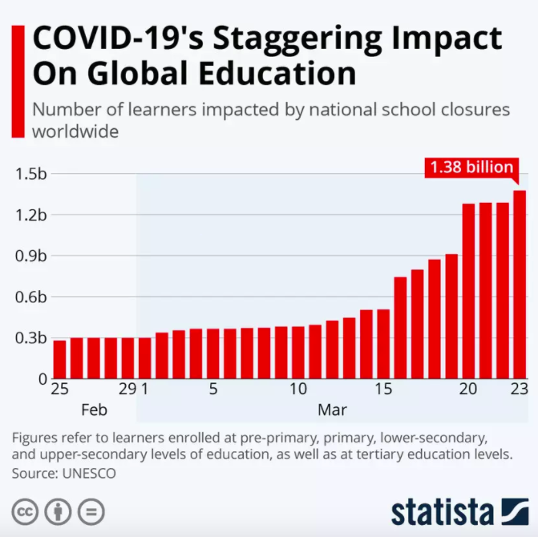

Online meet groups had been created, like Google meet, Google teams etc for students to be in connection with each other. Also parent teachers meeting had done online to maintain student record and information. However is most places as per need are continuing.
Discussion
Many tutorials have been opened online for children and youth like Byjus, Meritnation, etc. which gave the coaching classes along with daily routine of the student. These are supportive and their questionnaires are in internet for youth to understand the type of examination which might have possibilities.
These basic knowledge and lessons have been expressed in the form of a discussion in online class focusing on the major aspects of :
1. All topics related to subjects
2. Method of online teaching at home
3. Comfort ability
4. Discussion in online class from student to student
5. More attainment of methods by improvement of ICT
Parent’s participation has increased due to online classes of children from home. Home comfort had relaxed schedule with break after every class as they may not get strained by computer sickness. Digital education guidelines and mental health tips for children are also given side by side to let them be aware of their health against computer sickness. Many students have found online exams to be more comfortable as compared to offline. The student teacher relationship has become more evident and understandable as compared to offline classes where students made fun of teachers. But online students are aware and rather make a good relationship with the mentor.
Everything was known online. Daily attendance online means the scholar is attending the class and can answer the required questions.
Results
Live classes are maintained through various apps like Google meet, Microsoft Teams, and Zoom etc. These apps are very helpful and accessible by all the sections of society because these apps provide free service. Rural students found it adventurous and wanted to study more by online ways. Online campaigns, online chapter making, online workshops and online conferences have been a wonderful experience for all. Various digital courses through the web such as SWAYAM (Study Webs of Active-Learning for Young Aspiring Minds), digital courses through TV such as SWAYAM-PRABHA, e-books, etc. had launched which provide better lectures and study notes compared to others. Lecture notes are provided in virtual classes.
Online or Virtual classes were also helpful to provide positive interaction with students. It requires them to build up self-determining and critical thoughts, problem-solving, decision making, and time quality understanding. Quality of communication in online classes have increased to the better and there is no fun time in between class hours Online parties , gatherings in apps have created low tension and stress and more communication.
Government has understood the importance and value of online education and promotes their growth by significant key areas and regulates strict guidelines that will ensure all students gain profit from these methods. The new laws and guidelines could make online education more useful by providing better online platforms and due to these efforts of Government problems faced by teachers and learners has minimized. Higher education institutions need to stop minimizing opportunities and hence strengthen data device, programming, and evidence-based practices online for the students. This is also a good opportunity to increase the insufficient literature which is uploaded online in Google regarding the learning systems in India.
Conclusion
The basic dilemma has raised presently due to covid-19 and omicron. Scholars have been more attentive in online classes, as they were comfortable in the favorable situations at home. The home is the favorite place of everyone hence we can say that learning environments can influence the quality of online learning and teaching. Students and teachers who are facing many physical and mental discomforts during these tough times are made comfortable due to Google meets, zoom and other online apps. The aspect of mutual communication and clearing doubts should be made more elaborated which will ensure natural and unrestricted access to online classes for students and teachers belonging to all rural and urban classes of society.
Future scope
The prospectus is widened online with more syllabuses and more knowledge for students. Students favored well-structured substance with recorded videos uploaded in university websites. They also indicated the need for interactive sessions with questionnaires and assignments at the end of each class to optimize the wisdom experience. However, most students also reported that online classes at home comfort could be more demanding than traditional classroom because of the scientific constraints, delayed feedback and inability of the coach to handle effectively the Information and Communication Technologies. Therefore, all these factors should be considered while developing an online course to make it more effective and industrious for the scholar.
It’s possible that after the COVID-19 pandemic settles down, we might see a sustained increase in education systems using online platforms for study aids, albeit in a hybrid mode in combination with regular classes. Hence this study will prove useful for reimagining and redesigning the higher education with components involving online mode with some limitations.
References
- Alanezi & AlAzwani (2020). Future of Mobile Learning During and After Global (Covid-19) Pandemic: College of Basic Education as Case. Journal of Education and Practice,11,.17, 2020
- Ali, J. K. M. (2017). Blackboard as a motivator for Saudi EFL students: A psycholinguistic study. International Journal of English Linguistics, 7(5), 144- 151DOI:10.5539/ijel.v7n5p144
- Alturise, F. (2020). Evaluation of the Blackboard Learn Learning Management System for Full Online Courses in Western Branch Colleges of Qassim University. International Journal of Emerging Technologies in Learning, 15(15), 33-50.
- Bataineh, K. B., Atoum, M. S., Alsmadi, L. A., & Shikhali, M. (2020). A Silver Lining of Coronavirus: Jordanian Universities Turn to Distance Education. International Journal of Information and Communication Technology Education (IJICTE), 17(2), 1-11.
- Byun, S. & Slavin, R. E. (2020). Educational Responses to the COVID-19 Outbreak in South Korea. Best Evid Chin Edu, 5(2), 665-680.
- Coffield, F. (2008). Just suppose teaching and learning became the first priority. Learning and Skills Network
- Coiro, J., Knobel, M., Lankshear & Leu, D. (2008). Handbook of research on new literacies. New York: Laurence Erlbaum.
- Cole, M., & Werstch, J. (1996). Beyond the Individual-Social Antimony in Discussions of Piaget and Vygotsky. University of California San Diego USA.
- Dhawan, S. (2020). Online Learning: A Panacea in the Time of COVID-19 Crisis. Journal of Educational Technology Systems, 49(1), 5-22. https://doi.org/10.1177/0047239520934018
- Eccles, J. S. et al., (1993). Development during adolescence: The impact of stage- environment fit on young adolescents’ experiences in schools and in families. American Psychologist, 48(2), 90–101. https://doi.org/10.1037/0003-066X.48.2.90
- Engeström, Y. (1987). Learning by Expanding. An activity theoretical approach to developmental research. Orienta konsultit.
- Harter, S., Whitesell, N. R., & Kowalski, P. (1992). Individual differences in the effects of educational transitions on young adolescent’s perceptions of competence and motivational orientation. American Educational Research Journal, 29(4), 777–807. https://doi.org/10.3102/00028312029004777
- Kaid Mohammed Ali, Jamal and Rashad Ali Bin-Hady, Wagdi, (2019). A Study of EFL Students’ Attitudes, Motivation and Anxiety towards WhatsApp as a Language Learning Tool Arab World English Journal (AWEJ) Special Issue on CALL Number 5. July 2019. ,Available at: SSRN: https://ssrn.com/abstract=3431782 or http://dx.doi.org/10.2139/ssrn.3431782
- Ko, S., & Rossen, S. (2017). Teaching online: A practical guide.
- Taylor & Francis Liguori, E., & Winkler, C. (2020). From Offline to Online: Challenges and Opportunities for Entrepreneurship Education Following the COVID-19 Pandemic. Entrepreneurship Education and Pedagogy, 3(4), 346-351. https://doi.org/10.1177/2515127420916738
- Louwrens, N., & Hartnett, M. (2015). Student and teacher perceptions of online student engagement in an online middle sch ool. Journal of Open, Flexible and Distance Learning, 19(1), 27–44.
- Lynch , M. M. (2004). Learning Online: A Guide to Success in the Virtual Classroom. Routledge.
- Marinoni, G., Van’t Land, H., & Jensen, T. (2020). The impact of Covid-19 on higher education around the world. IAU Global Survey Report.
- Midgley, C., Anderman, E., & Hicks, L. (1995). Differences between elementary and middle school teachers and students: A goal theory approach. The Journal of Early Adolescence, 15(1), 90– 113. https://doi.org/10.1177/0272431695015001006
- Mohalik, R., & Sahoo, S. (2020). E-Readiness and Perception of Student Teachers’ towards Online Learning in the Midst of COVID-19. Available at SSRN: https://ssrn.com/abstract=3666914
- Mwanza, Daisy, & Engeström, Y. (2005). "Managing Content in e-Learning Environments. British Journal of Educational Technology, 36(3), 453-463.
- Pellegrini, M., Uskov, V., & Casalino, N. (2020). Reimagining and Re-Designing the PostCOVID-19 Higher Education Organizations to Address New Challenges and Responses for Safenand Effective Teaching Activities. Law and Economics Yearly Review Journal, 219-248. Available at: https://papers.ssrn.com/sol3/papers.cfm?abstract_id=3659062
- Prensky, M. (2001). Digital natives, digital immigrants. From On the Horizon. MCB University Press, 9(5), 1-6.
- Rajab, M. H., Gazal, A. M., & Alkattan, K. (2020). Challenges to Online Medical Education During the COVID-19 Pandemic. Cureus, 12(7), e8966. DOI:10.7759/cureus.8966
- Reuman, D., Flanagan, C., & MacIver, D. (1993). Development during adolescence: The impact of stage environment fit on young adolescents’ experiences in schools and in families. American Psychologist, 48(2), 90–101. https://doi.org/10.1037/0003-066X.48.2.90

