Reporting of Potholes on Roads to Aid Drivers
Pragati Jain
Assistant Professor, Dept. of Mathematics, Govt. College Manawar
Ishita Jain
Computer Science Engineer & Analytics Consultant
Diksha Mulchandani
Information Technology Engineer & Data Analyst

Abstract: Finding and repairing potholes in a timely and accurate manner is crucial to avoid road accidents. Currently, road distresses are identified manually that requires a lot of time and effort. The proposed system is an algorithm-based system which detects potholes in real time using a smartphone. The user will provide the source and destination location as inputs. Using the android application, the user can view all the potholes present on the route.
Keywords: Pothole detection, Object Detection, Single Shot Multi box Detector, Road Accidents, Safe Driving, Android
Introduction:
India's traffic congestion has been worsening because of economic expansion, urbanization, and a significant increase in the number of cars. Because of terrible road conditions, the number of reported accidents is growing dramatically. The roads are degrading as more people use them and less is done to maintain them. Because to the bad road conditions, drivers have a tough time identifying manholes, bumps, and other hazards, which leads to catastrophic mishaps. Recently, researchers have looked on automatic pothole detecting systems that use a variety of sensors. Existing suggestions are divided into three categories: vibration-based approaches, laser-scanning methods, and vision-based methods.

Camera-based techniques are suitable for precisely identifying potholes across a large region at a low cost. Many techniques based on 2D pictures and video data have been investigated. Koch and Brilakis pioneered the use of 2D pictures to identify potholes. Their method involved spotting specific pothole traits and pinpointing pothole locations. They used a prototype remote-controlled robot vehicle with a webcam set up 60 cm above the ground. A brand-new unsupervised vision-based strategy without costly tools, additional filtering techniques, or a training stage was proposed by Buza et al. Using a monocular camera mounted on the back of a car, Jog et al. created a novel approach for identifying and measuring the breadth, quantity, and depth of potholes.
Object detection is a technique used in visual data to discover a candidate region for a detection target in order to recognise a specific target and forecast the kind and position of the object (bounding box) proposed by Boukhriss RR, Fendri E, Hammami M. R-CNN by Ma C, Chen L, Yong J, and YOLO by Jamtsho Y, Riyamongkol P, Waranusast R. are some of the algorithms used for this. To enhance object detection, T. Gong et al. presented a multi-label classification approach. Accuracy of Single Shot Multiple Box Detector has higher accuracy than RCNN, Fast RCNN and YOLO hence, we will be using SSD in our project.
When compared to other approaches, laser scanning provides superior detection performance. This method proposed by Li Q, Yao M, Yao X, Xu B collects very detailed road-surface information by employing a technology that uses reflected laser pulses to generate exact digital models.
Here, we present a pothole detecting system that makes use of a smartphone camera. We also present a pothole detection method in which camera and sensors run in background for real time detection of potholes. Our pothole-detection technology may be utilised as an effective and low-cost pothole-maintenance method.

2. Methodology

A pothole detection and warning system is built into an android application for traffic information. Each car has a different speed restriction. Therefore, we are unable to determine the traffic density of that road based primarily on one car. We employ the Global Positioning System, also known as GPS, which is a satellite-based navigational tool that records the location and time in any climate, everywhere on Earth. By using GPS, we can determine whether traffic is congested and determine whether the road has a high volume of traffic if cars are moving slowly.

2.1 Camera Based Pothole Detection

The rear camera records a continuous movement and sends individual frames to a trained custom object detection model; the Single Shot Multi-Box Detector or SSD which are designed to assist units with low computational capabilities like the Smartphone, however, performs better than YOLO and CNN. Pothole pictures are recorded and labelled for the dataset and the TensorFlow object detection API is employed.

Data Acquisition
On the Android phone, the camera will operate in the background. There are numerous frames of images in the video stream captured by the camera. Single shot multi-box detector algorithm is used in this model.

Detection using SSD algorithm
SSD is an algorithm that is used to identify objects. It generates bounding boxes around identified objects, along with confidence scores for each one. Convolutional filter is used to forecast object categories and feature maps are multiplied by this filter for detection at different scales. Even low-resolution pictures may be detected with great accuracy because of this technique. SSD is faster and more accurate than R-CNN and YOLO. Devices with minimal computing capabilities such as mobile phones can benefit from the use of SSD-Mobile nets.

Detection using TensorFlow API
Tensor Flow object identification API includes pre-trained deep learning models and transfer learning capabilities. TensorFlow is used to train this model on the custom dataset that will be gathered. It will also be converted into a lightweight model using TensorFlow Lite, which can be incorporated into Android applications for real-time detection.

Dataset and Labelling
Over 300 photos of potholes will be taken for training. For each picture, LabelImg tool will create an XML file with the annotations. As a final step, all pictures and XML files have been transformed to TensorFlow RECORD format.

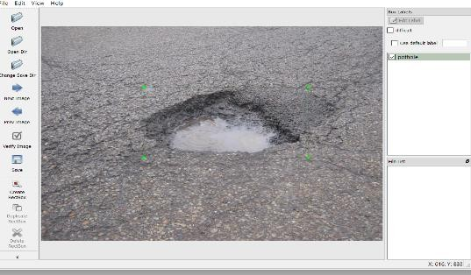
Figure 1. Label Img tool for labelling potholes
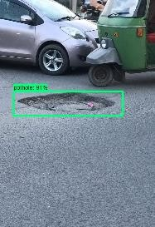
Figure 2. Pothole detection through SSD

2.2 Sensor Based Pothole Detection

When a car travels over a pothole, the spikes in the accelerometer and gyroscope data are recorded. Prior to specifying the source and destination, the user chooses the method of transportation. The user has the opportunity to choose the radius for which he wants to get traffic statistics. Following that, GPS provides a route, and the app shows the segments with the traffic density of various modes of transportation along the route. It also shows the average speed of the moving vehicles in that path. This aids the user in choosing the best, least-traveled route. The information on the traffic is frequently updated. Potholes and other messes of disorganization affect traffic density. The latitude and longitude of the pothole are recorded into the database whenever a vehicle travels over a pothole because the accelerometer detects the vibration and compares it to the value given in the code. All pothole detection values are stored in the database. If a user notices a pothole three times, the system will immediately send a message to corporate with the location of the pothole and update the public webpage. Once the issue has been fixed, the database's pothole values are deleted. For the purposes of this experiment, we'll assume that commuters on.
Dataset Acquisition

The model's accuracy is mostly determined by the parameters that are supplied into it as input. When the car travels over a pothole, the gyroscope sensor, which monitors rotational velocity, captures the vibrations and uneven motions of the vehicle. As the name implies, an accelerometer detects acceleration in three dimensions (x, y, z). Measurements per second will be recorded by the application running on the smartphone Whenever any car passes over a pothole, the data will be manually tagged.

Real time detection

On smartphone, the machine-learned model will be transferred to TensorFlow Lite and used for real-time pothole identification. As soon as the model determines that the reading is due to a pothole, the location coordinates are uploaded to the database. On the map, these co-ordinates can be seen by other users of the system.

Results: For each experiment, we randomly divided the dataset into training set and testing sets at a ratio of 80:20. We used a dataset that includes 350 pothole images that were in different daylight conditions, different road conditions, and with different shapes and sizes. The pothole dataset was trained with SSD algorithm. After the training is completed, we have converted the weights into TensorFlow version. Once the model is converted into TensorFlow version, we can now test the model on a route in Indore. The user has to first register in the Pothole Detection Application and provide input of source and destination location based on which a route will be marked on the map and a notification will be sent to the user whenever a pothole is detected. The user interface and camera-based pothole detection are shown below –
Figure 3. Sign Up Page

Figure 4. Sign in Page

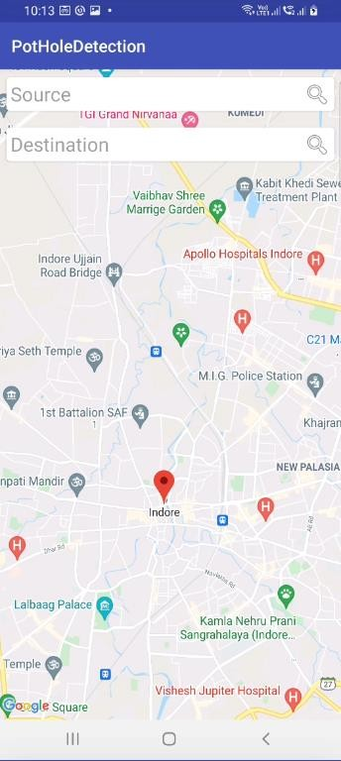

Figure 5. User Interface for Source and Destination location

User enters the source and destination location according to which a route will be marked on the map. After clicking on the Camera based pothole detection button, the application runs camera and detects pothole. Rectangular box with confidence interval will appear whenever a pothole will be detected.

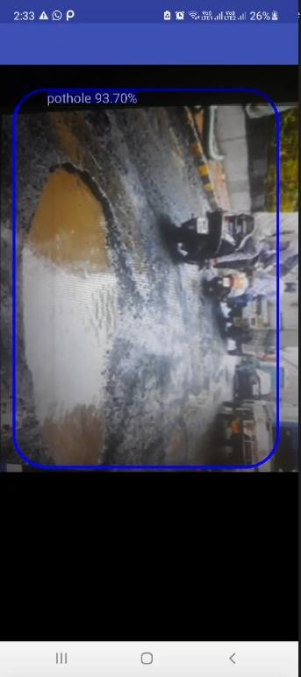

Figure 6. Camera based Pothole detection on a route in Indore with Confidence Interval

References

      - Chang, K. T., Chang, J. R., & Liu, J. K. (2005). Detection of pavement distresses using 3D laser scanning technology. In Computing in civil engineering (2005) (pp. 1-11).
      - De Zoysa, K., Keppitiyagama, C., Seneviratne, G. P., & Shihan, W. W. A. T. (2007, August). A public transport system-based sensor network for road surface condition monitoring. In Proceedings of the 2007 workshop on Networked systems for developing regions (pp. 1-6).
      - Eriksson, J., Girod, L., Hull, B., Newton, R., Madden, S., & Balakrishnan, H. (2008, June). The pothole patrol: using a mobile sensor network for road surface monitoring. In Proceedings of the 6th international conference on Mobile systems, applications, and services (pp. 29-39).
      - Ghose, A., Biswas, P., Bhaumik, C., Sharma, M., Pal, A., & Jha, A. (2012, March). Road condition monitoring and alert application: Using in-vehicle smartphone as internet-connected sensor. In 2012 IEEE international conference on pervasive computing and communications workshops (pp. 489-491). IEEE.
      - Howard, A. G., Zhu, M., & Chen, B. (2017). Dmitry, Kalenichenko, Weijun Wang, Tobias Weyand, Marco, Andreetto, and Hartwig Adam. Mobilenets: Efficient, convolutional neural networks for mobile vision applications., CoRR,,, abs/1704, 4861, 1.
      - Li, Q., Yao, M., Yao, X., & Xu, B. (2009). A real-time 3D scanning system for pavement distortion inspection. Measurement Science and Technology, 21(1), 015702.
      - Liu, W., Anguelov, D., Erhan, D., Szegedy, C., Reed, S., Fu, C. Y., & Berg, A. C. (2016, October). Ssd: Single shot multi-box detector. In European conference on computer vision (pp. 21-37). Springer, Cham.
      - Mednis, A., Strazdins, G., Zviedris, R., Kanonirs, G., & Selavo, L. (2011, June). Real time pothole detection using android smartphones with accelerometers. In 2011 International conference on distributed computing in sensor systems and workshops (DCOSS) (pp. 1-6). IEEE.
      - Raj, S., Jain, A., & Misra, R. (2013, June). Smartphone sensing for large data set collection of potholes. In Proceeding of the 11th annual international conference on Mobile systems, applications, and services (pp. 517-518).
      - Vigneshwar, K., & Kumar, B. H. (2016, December). Detection and counting of pothole using image processing techniques. In 2016 IEEE International Conference on Computational Intelligence and Computing Research (ICCIC) (pp. 1-4). IEEE.Research,2016
      - Yadav, N., Binay, U. (2017, November) Comparative Study of Object Detection Algorithms. IRJET vol.4 (pp-586-590)
      - Yu, B. X., & Yu, X. (2006). Vibration-based system for pavement condition evaluation. In Applications of Advanced Technology in Transportation (pp. 183-189).

