“A review on Endophytes and its role in the development of plant growth”
¹Dr Pooja R*
¹Assistant Professor, Department of Biotechnology, Surana College (Autonomous), South end road, Bangalore-560004
*Corresponding Author: Dr Pooja R
Email Id: poojaravi2015@gmail.com
Abstract:
Endophytes are microorganisms (mainly bacteria and fungus) that live in plants asymptomatically. Endophytic microorganisms are frequently functional in that they can transport nutrients from the soil into plants, modify plant development, boost plant stress tolerance, lower pathogen virulence, increase disease resistance in plants, and inhibit the development of rival plant species. Endophytic microbes have been shown to: (i) obtain nutrients in soils and transfer nutrients to plants through the rhizophagy cycle and other nutrienttransfer symbioses; (ii) increase plant growth and development; (iii) reduce oxidative stress in hosts; (iv) protect plants from disease; (v) deter herbivore feeding; and (vi) suppress the growth of competitor plant species. While plant sources for new chemical entities for therapeutic reasons are being extensively researched, endophytic microorganisms are also a significant source for drug discovery. The purpose of this review is to comprehend the contribution and usage of endophytes as a potential source of medications against various diseases and other potential medical uses.
Introduction:
Plants have served as a source of medicinal bioactive compounds against numerous forms of ailments for centuries. Ironically, in recent years, microorganisms associated with plants rather than plants themselves have proven to offer material and products with high therapeutic potential. Biological diversity the variety of living things has been of interest for centuries. In recent years, it has become apparent that human activities are causing the loss of biological diversity at an increasing rate: the current rate of extinction appears to be among the highest in the fossil record. Although nonhuman organisms can cause extinctions of other species to a small degree, no other organisms produce such large effects over such wide areas as humans do and have done at least locally for thousands of years. Habitat alteration and degradation are probably the most severe effects humans have on other species today.
Origin of endophytic fungi:
The word “endophyte” was at first used broadly to refer to any organism found within the tissues of living autotrophs (Arnold and Lewis, 2005). However, this term has undergone several redefinitions. In the year 1991, Petrini offered a working definition for endophytes and has since been widely accepted by the scientific commonly which states, “organisms inhabiting plant organs that at some time in their life can colonize internal plant tissues without causing apparent harm to their host”. This definition holds well for those endophytic organisms that have a lengthy epiphytic phase and also for latent that live an asymptomatic life within their hosts (Petrini, 1991). Endophytes are diverse microorganisms which include bacteria, fungi and cyanobacteria which inhabit the vascular tissues and the reproductive structures of living plants. Predominantly, endophytes are plant mutualists as they receive nutrition and protection from host plants; while the host plant enjoys enhanced resistance to herbivores, pathogens, increased competitive abilities and resistance to various abiotic stresses due to endophytes residing within them. Endophytes are found in every plant species including bacteria and fungi that live inside plant tissues without causing any negative effects. They are rich sources of bioactive natural compounds, and different variety of agents are isolated from these endophytic microorganisms with promising applications in development of natural drugs and other industrial products.
The relationship that the endophytes which establish along with the plant varies from symbiotic to bordering on pathogenic. In the majority of the plants only a grass species had proved complete complement of endophytic studies.
Endophytic fungi were studied in the plants in temperate regions, but recently these studies were extended to tropical plants as well. All plants are having fungal endophytes and epibionts. These sources between fungi and plants are generally a cryptic phenomenon in nature. Endophytic fungi inhibit tissues of stems, bark, branches, roots, petioles, flowers, seeds, and fruits which includes xylem of all plant organs. Quality and quantity of crude drugs were originated from the medicinal plants which are very much affected by the factors such as genetic background of the concerned plants as well as ecological habitats where the plants live and soil nutrients intake (Dai et al., 2003; Sherameti et al., 2005). Nowadays endophytes play a very important role by affecting quantity and quality of crude drugs which are present in the fungal extract of medicinal plants. Hence the relationships between the medicinal plants and endophytic fungi are very much essential for the development as well as for the production of crude drugs (Faeth and Fagan, 2002). Endophytic fungi play a major role in plant micro-ecosystems that should have significant influences on the growth and development of host plants, relationships between endophytic fungi and their host plants are still incomplete. Some of the methods were used for the development of medicinal plants such as by adding a particular group of endophytic fungi to the plants which improves drug quality and quantity (Firáková et al., 2007). Some of the methods were used as an alternative for the production of desired drugs under certain conditions through bioengineering of the selected medicinal plants and endophytic fungi (Kumaran et al., 2008, 2009). Such an industry style of manufacture may replace the traditional way to produce drugs, which essentially depends on natural medicinal plants.
The biological diversity of endophytic fungi which occurs naturally in the temperate regions as well as tropical rainforests around 3,00,000 terrestrial host plant species were distributed. These endophytic fungi belong to the meiosporic and mitosporic ascomycetes (Bacon and White, 2000), “asymptomatically reside in the internal tissues of plants beneath the epidermal cell layer, where they colonize healthy and living tissue via quiescent infections”. Each and every plant species of hosts has more than one endophytic fungal species. Usually, endophytes occur in different healthy tissues of living plants under the ground, including leaves, stems or roots. More than one million endophytic fungal species occur in nature (Faeth and Fagan, 2002). According to the scientist Schultz, 2006; fungal endophytes are divided into three main ecological groups: (1) mycorrizal; (2) balansicaeous or pasture endophytic fungi; and (3) non pasture endophytic fungi (Faeth and Fagan, 2002). Endophytic fungi produce many bioactive compounds which are very exclusive to their host plants, which increases the adaptability of both endophytic fungi and their host plants, such as tolerances to abiotic and biotic stresses. Hence, these compounds can induce the production of novel biologically active secondary metabolites that can be exploited and applied by human as important medicinal resources (Zhang et al., 2006; Firáková et al., 2007; Rodriguez et al., 2009). At the same time, different kinds of secondary metabolites, like saponin and essential oils from medicinal plants, are produced through long-term co-evolution as a resistance mechanism to the pathogens, most possibly including endophytic fungi. Hence secondary metabolites became very difficult for the colonization of endophytic fungi. To overwhelmed this, endophytic fungi should secrete the matching detoxification enzymes, such as lactase, cellulases, protease, and xylanase, and to decompose these secondary metabolites before they penetrate through the defense systems of the resided host-plants. Once inside the tissues of a host-plant, the endophytic fungi assumed a quiescent (latent) state, either for the whole lifetime of the host plant (neutralism) or for an extended period of time (mutualism or antagonism) until environmental conditions are favorable for endophytic fungi or the ontogenetic state of the host changes to the advantage of the fungi (Sieber, 2007).
(A)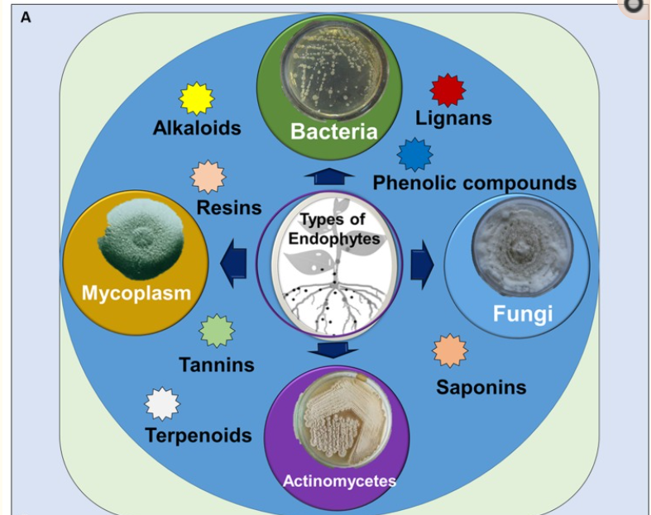 (B) 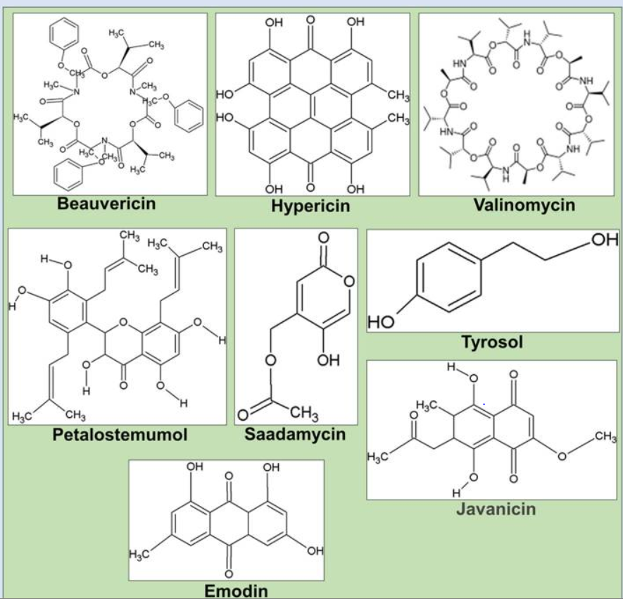
Fig. 1.1: Structure of various secondary metabolites
During the long co-evolution of endophytes and their host plants, endophytes have adapted themselves to their special micro environments by genetic variation, including uptake of some plant DNA into their own genomes. Apart from fungi, bacteria belonging to various genera have also been shown to exist inside plants without causing apparent disease symptoms (Hallmann et al., 1997). Other beneficial effects of endophytes to plants include helping plants acquire nutrients, nitrogen fixation, phosphate solubilization or iron chelation, increased drought resistance, thermal protection, survival under osmotic stress, suppressing, phytopathogens by competition in the invasion sites and by secreting antibiotic compounds (Ryan et al., 2008).
Although limited, the results of research on endophytic bacteria and their role in host trees so far are very encouraging and will hopefully draw more attention to this developing area of study. Diverse array of endophytic bacteria which forms a nonpathogenic relationship with their hosts also confer benefit to plants (Nunes and Melo, 2006). Plant or fungal extraction of metabolites from endophytes is affected by various factors, such as climatic condition, seasonal variation of sample collection, and geographical location (Shukla et al., 2014). From past few years, extraction of plants and also other natural sources has now become more efficient, convenient and feasible (Hussain et al., 2012). The production of bioactive compounds by endophytes, has been directly associated with the evolution of the host of microorganisms, which may have incorporated genetic information from higher plants, allowing them for better adapt to the host plant and perform some functions, such as protection from various types of pathogens, grazing animals and insects, (Strobel, 2003).
Endophytes are present within plant tissues and grows within stems, leaves and/or roots, emerging to sporulate at plant or host‐tissue senescence (Sherwood and Carroll, 1974; Carroll, 1988; Stone et al., 2004). Earlier endophytes are divided into two major groups, reflecting differences in taxonomy, ecological functions, plant hosts and evolutionary relatedness (table 1): the endophytes which infect some grasses are clavicipitaceous endophytes (C‐endophytes); nonclavicipitaceous endophytes (NC‐endophytes), which can be recovered from asymptomatic tissues of nonvascular plants, ferns and allies, conifers, and angiosperms.
Table 1. Classification of Endophytic fungi
Groups | Clavicipitaceous | Non Clavicipitaceous
Criteria | Class I | Class 2 | Class 3 | Class 4
Host range | Narrow | Broad | Broad | Broad
Host plants | Grasses such as perennial ryegrass, tall and meadow fescue | Vascular and nonvascular plants such as Bryophytes, Ferns, Gymnosperms and Angiosperms
Distribution | Temperate grasslands, Alpine grasslands | Deciduous and evergreen perennials | In tropical forest and Antarctic regions | Antarctic, arctic, alpine, sub-alpine, temperate and tropical ecosystems.
Tissue(s) colonized | Shoot and rhizome | Shoot, root and rhizome | Shoot | Root
Transmission | Vertical and horizontal | Vertical and horizontal | Horizontal | Horizontal
In planta biodiversity | Low | Low | High | Unknown
In planta colonization | Extensive | Extensive | Limited/ Localized | Extensive in roots
Fitness benefits* | NHA | NHA and HA | NHA | NHA
* Nonhabitat‐adapted (NHA) benefits such as drought tolerance and growth enhancement are common among endophytes regardless of the habitat of origin.
*Habitat‐adapted (HA) benefits result from habitat‐specific selective pressures such as pH, temperature and salinity.
Endophytes of Class 1 are all phylogenetically related and proliferate within warm and cool season grasses. They naturally colonize shoots where they form a systemic intercellular infection. They are transmitted from host to host by vertical transmission, in which maternal plants pass fungi on to their offspring through seeds. They are further divided into Type I, II and III. Among these 3 types of clavicipitaceous endophytes are different interactions with their plant hosts. These interactions range from pathogenic to symbiotic and symptomatic to asymptomatic. Endophytes of type III clavicipitaceous which grows within their plant host without manifesting symptoms of any diseases or harming their host. Class 1 endophytes typically confer benefits on their plant host such as increasing drought tolerance, improving plant biomass, and increasing the production of chemicals that are toxic. These benefits can vary depending on the host and environmental conditions (Rodriguez et al., 2009).
Non-clavicipitaceous endophytes represent a polyphyletic group of organisms. Non-clavicipitaceous endophytes are typically ascomycota fungi. The ecological roles of these fungi are diverse and still poorly understood. These endophyte plant interactions are widespread and have been found in nearly all land plants and ecosystems (Rodriguez et al., 2009). Many non-clavicipitaceous endophytes have the ability to switch between endophytic behavior and free-living lifestyles. Non-clavicipitaceous endophytes are divided into class 2, 3 and 4. Class 2 endophytes can grow in plant tissues both above and below ground. This class of non-clavicipitaceous endophytes has been the most extensively researched and has been shown to enhance fitness benefits of their plant host as a result of habitat-specific stresses such as pH, temperature and salinity (Rodriguez et al., 2009). Class 3 endophytes are restricted to growth in below ground plant tissues and form in localized areas of plant tissue. Class 4 endophytes are also restricted to plant tissues below ground but can colonize much more of the plant tissue. These classes of non-clavicipitaceous endophytes have not been as extensively studied to date (Rodriguez et al., 2009).
Endophytes can be studied via three methods:
- Histological method revealing the internal location of the endophytes, whether infection is intercellular or intracellular.
- Genetic method by direct amplification of microbial genomic DNA from colonized plant tissue.
- Microbiological method by isolation from surface disinfected tissue and plating onto appropriate growth media (Schulz and Boyle, 2005).
Plant collection is one of the most important steps during surveying endophytes. The exact position of the vegetation should be recorded using; for example, a General Positioning System (GPS) to allow for repeated resampling. Healthy plant tissues without lesions or spots should be prioritized. In addition, conducting samplings on different parts of the plants, different ages, growing in different location and at different season allows gathering useful information on the distribution of the endophytes, community analysis, ecological diversity, and influence of abiotic factors on endophyte infections. As far as possible, fresh plant material should be transported in good condition to the laboratory and surface sterilization should be done within 24 hours after moving from the collecting areas. During the transport, plant tissues should be maintained in proper aeration in order to prevent desiccation, tissue senescence and contamination by epiphytic fungi and bacteria. Processing plant materials at the collection site remains the most adequate to avoid hyper-contamination with epiphytes.
In order to recover the broadest range of internal endophytic communities, the use of selective media and media which favor the growth of slow-growing endophytes is needed to avoid that plate to be overgrown by rapid-growing ones. For example, if the goal is to isolate endophytic fungi, antibacterial antibiotics such as chloramphenicol, streptomycin sulphate, oxytetracycline are incorporated into the agar media either singly or combined along with low concentration of cyclosporin A, dichloran or rose bengal that restrict rapid radial growth of fungi. In contrast, for selective isolation of endophytic bacteria, fungitoxic agents such as cycloheximide and/or nystatin are added to the growth media.
References:
- Arnold, A. E. and Lewis, L. C. 2005. Ecology and evolution of fungal endophytes, and their roles against insects. Insect- Fungal Association: Ecology and Evolution. Oxford University Press, New York, 74-96.
- Petrini, O. 1991. Fungal endophytes of tree leave In: Andrews, J. H, S. S. Hirano, editors. Microbial ecology of leaves. New York: Springer. p. 179–197.
- Dai, C. C., B. Y. Yu, Z. L. Xu, and S. Yuan. 2003. Effect of environmental factors on growth and fatty acid composition of five endophytic fungi from Sapium sebiferum. J. Appl. Ecol. 14, 1525–1528. h.
- Sherameti, I., B. Shahollari, Y. Venus, L. Altschmied, A. Varma, and R. Oelmüller. 2005. The endophytic fungus Piriformospora indica stimulates the expression of nitrate reductase and the starch-degrading enzyme glucan-water dikinase in tobacco and Arabidopsis roots through a homeodomain transcription factor that binds to a conserved motif in their promoters. J. Biol. Chem. 280, 26241–26247. doi: 10.1074/jbc.M500447200.
- Faeth, S. H., and Fagan, W. F. 2002. Fungal endophytes: common host plant symbionts but uncommon mutualists. Integr Comp Biol, 42(2), 360-368. doi: 10.1093/icb/42.2.360.
- Firáková, S., M. Šturdíková, and M. Múčková. 2007. Bioactive secondary metabolites produced by microorganisms associated with plants. Biologia 62:251–257. doi: 10.2478/s11756-007-0044-1.
- Kumaran, R. S., J. Muthumary, and B. K. Hur. 2008. Taxol from Phyllosticta citricarpa, a Leaf Spot Fungus of the Angiosperm citrus medica. J. Biosci. Bioeng. 106, 103–106. doi: 10.1263/jbb.106.103.
- Kumaran R. S., J. Muthumary, E. K. Kim, and B. K. Hur. 2009. Production of taxol from Phyllosticta dioscoreae, a leaf spot fungus isolated from Hibiscus rosa-sinensis. Biotechnol. Bioprocess. Eng. 14, 76–83. 10.1007/s12257-008-0041-4.
- Bacon, C. W., and J. F.J. White. 2000. Physiological adaptations in the evolution of endophytism in the Clavicipitaceae. Microbial endophytes. New York, NY, USA: Marcel Dekker Inc., 237–263.
- Schulz, B., and C. Boyle. 2006. What are endophytes? Microbial Root Endophytes (Schulz, B. J. E., C. J. C. Boyle and T. N. Sieber, eds), pp. 1–13. Springer-Verlag, Berlin.
- Zhang, H. W., Y. C. Song, and R. X. Tan, 2006. Biology and chemistry of endophytes. Nat. Prod. Rep. 23, 753–771. doi: 10.1039/b609472b.
- Rodriguez, R. J., J. F. White, A. E. Arnold, and R. S. Redman. 2009-04-01. "Fungal endophytes: diversity and functional roles". The New Phytologist. 182 (2): 314–30. doi:10.1111/j.1469-8137.2009.02773. x. PMID 19236579.
- Sieber, T. N. (2007). Endophytic fungi in forest trees: are they mutualists?. Fungal biology reviews, 21(2-3), 75-89.
- Hallmann, J., A. Quadt-Hallmann, W. F. Mahaffee, and J. W. Kloepper. 1997. Bacterial endophytes in agricultural crops. Can. J. Microbiol. 43 895–914. 10.1139/m97-131.
- Ryan, R. P., K. Germaine, A. Franks, D.J. Ryan, D.N. Dowling. 2008. Bacterial endophytes: recent developments and applications. FEMS Microbiol. Lett., 278, pp. 1-9. Nunes, F. V., and L. S. de Melo. 2006. Isolation and characterization of endophytic bacteria of coffee plants and their potential in caffeine degradation. Environmental Toxicology 1, 293–297. https://doi.org/10.2495/ETOX060291.
- Shukla, S. T., P. V. Habbu, V. H. Kulkarni, K. S. Jagadish, A. R. Pandey, and V. N. Sutariya. 2014. Endophytic microbes: a novel source for biologically/pharmacologically active secondary metabolites. Asian J. Pharmacol. Toxicol. 2 1–16.
- Hussain, M. S., S. Fareed, S. Ansari, M. A. Rahman, I. Z. Ahmad, and M. Saeed. 2012. Current approaches toward production of secondary plant metabolites. J. Pharm. Bioallied Sci. 4 10–20. 10.4103/0975-7406.92725.
- Strobel, G. A. 2003. Endophytes as sources of bioactive products. Microbes Infect.5, 535–544. doi: 10.1016/S1286-4579(03)00073-X.
- Sherwood, M., and G. Carroll. 1974. Fungal succession on needles and young twigs of old-growth Douglas fir. Mycologia 66: 499–506.
- Carroll, G. 1988. Fungal endophytes in stems and leaves – from latent pathogen to mutualistic symbiont. Ecology 69: 2–9.
- Stone, J. K., J. D. Polishook, and J. R. J. White. 2004. Endophytic fungi. In: Mueller, G., G. F. Bills, and M. S. Foster, eds. Biodiversity of fungi: inventory and monitoring methods. Burlington, MA, USA: Elsevier, 241–270.

