Crop Quality Prediction using Convolutional Neural Networks (CNNs)

Dr.I.Hemalatha
Professor
Department of IT
S.R.K.R. Engineering College
Bhimavaram
A.P, India
drihl@srkrec.ac.in

Bh. Hema Sai Harshini
B.Tech (ECE)
Department of ECE
S.R.K.R. Engineering College
Bhimavaram
A.P, India
harshinibhupathiraju2002@gmail.com

I.ABSTRACT
Deep learning is an important decision support tool for crop quality prediction, including supporting decisions on what crops to grow and what to do during the growing season of the crops. Determining the quality of the plant as well as the type of plant based on the leaf of a plant is the goal. Dataset used is Plant Village dataset, which contains images of the leaves of plants like potato, tomato etc. In order to detect the quality and the type of plant we can use Deep Learning, more specifically it can be done by building a convolution neural network. Crop diseases have grown significantly in recent years due to drastic climate changes and a lack of immunity in crops. This results in large-scale crop destruction, reduced cultivation, and eventually financial loss for farmers. Identification and treatment of diseases has become a major challenge due to rapid growth in a variety of diseases and insufficient farmer knowledge. The texture and visual similarities of the leaves aid in disease identification. As a result, computer vision combined with deep learning offers a solution to this problem. This paper proposes a deep learning-based model that is trained using images of healthy and diseased crop leaves from a public dataset. The model achieves its goal by categorising images of leaves as diseased or healthy.

Key Words- Deep Learning; Convolutional Neural Networks; Plant Disease Detection.

II.INTRODUCTION
Agriculture is an important part of India's economy and at present it is among the top two farm producers in the world. This sector provides approximately 52 percent of the total number of jobs available in India and contributes around 18.1 percent to the GDP. The early prognosis of crop disease can aid in making decisions on changes in usage of fertilizers, pesticides and in turn reduce the complications, which can be great in the field of agriculture[5]. This prompts for its early detection. The utilization of suitable technology support in this regard can prove to be highly beneficial to the field agriculture and farmers [1]. Crop quality prediction is an essential task for the decision-makers at national and regional levels for rapid decision-making [2]. An accurate crop quality prediction model can help farmers to decide on what to grow, when to grow and the measures that are needed to be taken to ensure the health of the plants [3]. Appropriate estimation of the quality of the crops allows the farmers to know about the disease and then he/she will be able to take certain further prevention measures. Using Deep learning and Convolutional Neural Network preparing a tool or a model is taken into consideration to bring the work of physical or manual detection of crop quality to simple and easy prediction system [6].

III. METHOD
A) Crop Quality Prediction Model

Input Image
(Plant Village Data set)
Image Preprocessing
Preprocessed Image Data
Build a Model using Deep Learning Algorithm (CNN)
Output Image Prediction
Model Accuracy

Fig.1: System Architecture of Crop Quality Prediction Model
To predict whether the leaf is diseased or healthy the steps to be fallowed are shown in the Fig.1. To come up with a system that indicates the use of deep learning in crop quality detection systems which would help the farmers to know the quality of their crops which in turn helps them to take appropriate measures to protect the crops and increase their crop yield [4].
A Convolutional Neural Network (ConvNet/CNN) is a Deep Learning algorithm model is developed which can take in an input image, assign importance (learnable weight sand biases) to various aspects/objects in the image and be able to differentiate one from the other. The pre-processing required in a ConvNet is much lower as compared to other classification algorithms. While in primitive methods filters are hand-engineered, with enough training, ConvNets have the ability to learn these filters/characteristics [9].

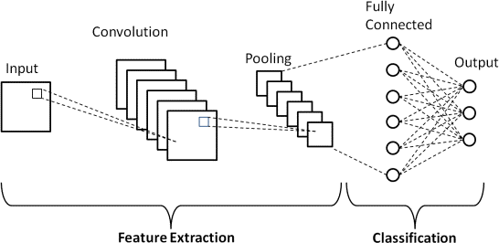
The Fig.2 shows the architecture of a ConvNet is analogous to that of the connectivity pattern of Neurons in the Human Brain and was inspired by the organization of the Visual Cortex. Individual neurons respond to stimuli only in a restricted region of the visual field known as the Receptive Field. A collection of such fields overlap to cover the entire visual area.
Fig. 2: CNN Architecture

B) Dataset Description: The Dataset of diseased plant leaf images and corresponding labels is used from the Plant Village Dataset available with different types of crops Tomato, Potato, Bell Pepper leaf images a total number of images 20,620 in 15 number of directories.
https://www.kaggle.com/datasets/emmarex/plantdisease

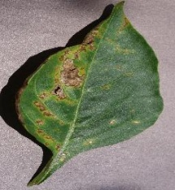  Pepper__bell___Bacterial_spot | 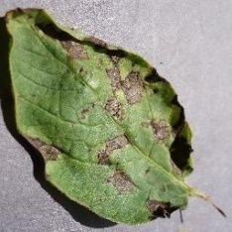  Potato___Early_blight
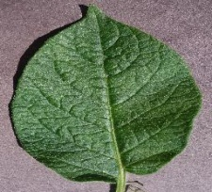  Potato___healthy | 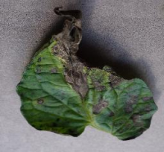  Tomato_Early_blight
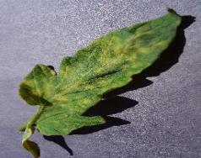  Tomato_Leaf_Mold | 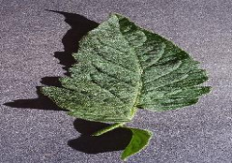  Tomato_healthy
Fig. 3: Dataset of diseased plant leaf images with corresponding labels
In this proposed system the dataset is divided into training, testing, validation datasets. As shown in the Fig.3 the data set consists of diseased plant leaf images with corresponding labels. The data set is taken as Training dataset: 60% of the data, Testing dataset: 20% of the data, Validation dataset: 20% of the data.

C) Pre-process the data :
Data pre-processing is used to transform the raw data in a useful and efficient format. The image data cannot be fed directly into the model so we need to perform some operations and process the data to make it ready for our neural network.
In this step we perform data normalization of the data. The pixel values can range from 0 to 256. Each number represents a color code. When using the image as it is and passing through a Deep Neural Network, the computation of high numeric values may become more complex.
To reduce this we can normalize the values to range from 0 to 1.In this way, the numbers will be small and the computation becomes easier and faster. As the pixel values range from 0 to 256, apart from 0 the range is 255. So dividing all the values by 255 will convert it to range from 0 to 1. The following Fig. 4 shows the output of pre-processed images found from the 15 classes image dataset.
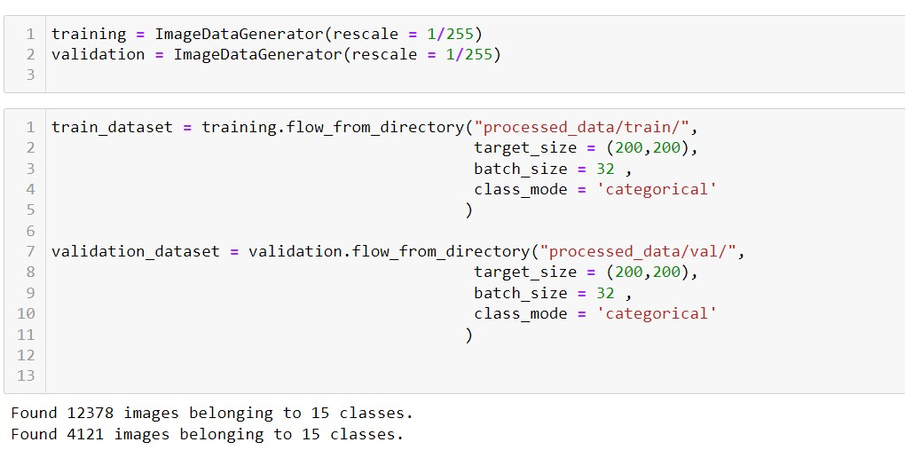
Fig. 4: Pre-processing the data

D) Pseudo code for Training and Testing Images
Pseudo code for training images:
1. Labelled images of leaves
2. for Every image in training image in dataset do
a. I ← image
3. Pre-processing
a. I resized ← Image Resizing (I)
b. I feature extraction ← feature extraction(I resized)
4. Pass this instance to the pre-trained model Get the output
5. Calculate the loss
6. Update weights based on loss for n number of epochs end for save the model trained
Pseudo code for testing images:
1. Labelled images of Leaves
2. Input image I Pre-processing
a. I resized ← Image Resizing(I)
b. I feature extraction ← feature extraction(I resized)
3. The testing image will be classified based on the trained model
4. The output will be displayed

E) Build a Model using Deep Learning Algorithm (CNN)
Convolution and pooling layers are typically found in CNN models. CNN performs effectively for challenges involving picture classification because it performs better for data that are represented as grid structures. Convolutional layers are the layers where filters are applied to the original image, or to other feature maps in a deep CNN. Pooling layers are used to reduce the dimensions of the feature maps. Thus, it reduces the number of parameters to learn and the amount of computation performed in the network. The pooling layer summarizes the features present in a region of the feature map generated by a convolution layer.
The following Fig. 5 shows the building model will then compile by applying the RMSprop optimizer. Optimizers are algorithms or techniques that alter the weights and learning rates of your neural network in order to decrease losses. There are a myriad of hyper parameters that you could tune to improve the performance of your neural network. But, not all of them significantly affect the performance of the network. One parameter that could make the difference between your algorithm converging or exploding is the optimizer you choose. The RMSprop optimizer restricts the oscillations in the vertical direction. Therefore, we can increase our learning rate and our algorithm could take larger steps in the horizontal direction converging faster.
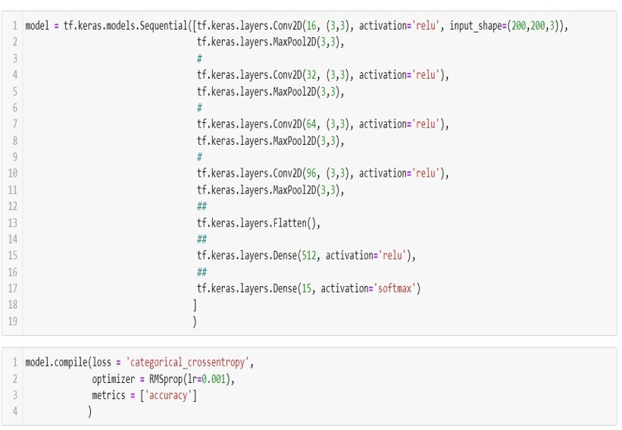
Fig. 5: Building the model and applying the optimizer
Train the model: The process of teaching a DNN to perform a desired AI task (such as image classification) by feeding it data, resulting in a trained deep learning model, is known as training. Known data is fed into the DNN during the training process, and the DNN makes a prediction about what the data represents. The model.fit() function of Keras will start the training of the model. It takes the training data, validation data, epochs, and batch size.
Epochs:
Epoch 84/90
10/10 [==============================] - 15s 2s/step - loss: 0.7722 - accuracy: 0.7226 - val_loss: 0.7444 - val_accuracy: 0.7547
Epoch 85/90
10/10 [==============================] - 14s 2s/step - loss: 0.7726 - accuracy: 0.7269 - val_loss: 0.6626 - val_accuracy: 0.7814
Epoch 86/90
10/10 [==============================] - 15s 2s/step - loss: 0.6705 - accuracy: 0.7942 - val_loss: 0.7539 - val_accuracy: 0.7513
Epoch 87/90
10/10 [==============================] - 14s 2s/step - loss: 0.8114 - accuracy: 0.7060 - val_loss: 0.6943 - val_accuracy: 0.7610
Epoch 88/90
10/10 [==============================] - 14s 2s/step - loss: 0.8336 - accuracy: 0.7053 - val_loss: 0.9076 - val_accuracy: 0.6967
Epoch 89/90
10/10 [==============================] - 14s 2s/step - loss: 0.8748 - accuracy: 0.7343 - val_loss: 0.7445 - val_accuracy: 0.7394
Epoch 90/90
10/10 [==============================] - 14s 2s/step - loss: 0.6278 - accuracy: 0.7675 - val_loss: 0.6857 - val_accuracy: 0.7726

F) Evaluate the model:
A 20,620-image input data set is utilised to assess how well our model performs. As a result, the testing data is new data for our model since it was not used to train the data. Finally the main aim of our model is to detect the quality of the crop whether it is diseased or healthy using CNN model which is as depicted in the Fig. 6.

Fig. 6: Evaluation of the model

G) Experiments and Results: Accuracy is a metric that describes how the model performs in general across all classes[10]. It is helpful when all classes are equally important. It is determined by dividing the number of correct predictions by the total number of predictions. We use RMSprop Optimizer is what we utilise for our model. Wherever we dial, our network begins, model_fit = model.fit (train_dataset, steps_per_epoch = 10, epochs = 90, validation_data = validation_dataset). Our objective is to add data, test and training data, and the number of training epochs. The number of epochs we used for this model was 90. Different tests were performed in order to check the performance of newly created model as shown in the Fig. 7.

(a) Model Accuracy (b) Model Loss

(c) AccuracyVsVal_Accuracy (d) Loss VsVal_Loss

Fig. 7: Shows the (a) Model Accuracy (b) Model Loss (c) AccuracyVsVal_Accuracy (d) Loss VsVal_Loss

IV. CONCLUSION
Crop cultivation was previously undertaken on the basis of the farmer's hands-on expertise. However, change in climate and new types of diseases have impact to affect crop yields. Consequently, farmers are unable to know the quality of their crops based on the process of manual prediction. The quality of the crops of land has, more often than not, resulted in failure. Accurate crop quality prediction results in increased crop production because when the quality of the crop is known appropriate measures can be taken. This is where Deep Learning plays a major role in prediction of crop quality. Deep Learning algorithms work well when the data is huge. Hence, using CNN for crop quality prediction using PlantVillage dataset gives good results. Convolutional neural network trained for identifying and recognising plant leaf disease could correctly classify and predict the diseases for almost all images with few anomalies, achieving 80% model accuracy as shown in Fig. 7.

V. REFERENCES
[1]Van Klompenburg, Thomas, AyalewKassahun, and CagatayCatal. "Crop yield prediction using machine learning: A systematic literature review." Computers and Electronics in Agriculture177(2020):105709.
[2] Nischitha, K., Mahendra N. DhanushVishwakarma, and Manjuraju MR Ashwini. "Crop prediction using machine learning approaches." Int. J. Eng. Res. Technol.(IJERT) (2020): 23-26.
[3] Medar, Ramesh, Vijay S. Rajpurohit, and ShwetaShweta. "Crop yield prediction using machine learning techniques."2019 IEEE 5th International Conference for Convergence in Technology (I2CT).IEEE, 2019.
[4] Khaki, Saeed, and Lizhi Wang. "Crop yield prediction using deep neural networks." Frontiers in plant science 10 (2019): 621.
[5] Sharma, Bhawana, Jay Kant Pratap Singh Yadav, and SunitaYadav. "Predict crop production in India using machine learning technique: a survey." 2020 8th International Conference on Reliability, Infocom Technologies and Optimization (Trends and Future Directions)(ICRITO). IEEE, 2020.
[6]. GarimaTripathi, Jagruti Save, “AN IMAGE PROCESSING AND NEURAL NETWORK BASED APPROACH FOR DETECTION AND CLASSIFICATION OF PLANT LEAF DISEASES,” Int. J. Comput. Eng. Technol. IJCET, vol. 6, no. 4, pp. 14–20, Apr. 2015.
[7]. S. Arivazhagan, R. NewlinShebiah, S. Ananthi, S. Vishnu Varthini, “Detection of unhealthy region of plant leaves and classification of plant leaf diseases using texture features,” AgricEngInt CIGR J., vol. 15, no. 1, pp. 211–217, Mar. 2013.
[8]. Prof. Sanjay B. Dhaygude, Mr.NitinP.Kumbhar, “Agricultural plant Leaf Disease Detection Using Image Processing”IJAREEIE, vol. 2(1),pp. 599-602, January 2013.
[9]. K. Muthukannan, P. Latha, R. PonSelvi and P. Nisha, “CLASSIFICATION OF DISEASED PLANT LEAVES USING NEURAL NETWORK ALGORITHMS,” ARPN J. Eng. Appl. Sci., vol. 10, no. 4, pp. 1913–1918, Mar. 2015.
[10]. Md. Nazrul Islam, M.A. Kashem, MahmudaAkter and Md. JamilurRahman, “An Approach to Evaluate Classifiers for Automatic Disease Detection and Classification of Plant Leaf,” presented at the International Conference on Electrical, Computer and Telecommunication Engineering, RUET, Rajshahi-6204, Bangladesh, 2012, pp. 626–629.
[11]. HrishikeshKanjalkar P. and Prof. Lokhande S. 2013. Detection and Classification of Plant Leaf Diseases using ANN. International Journal of Scientific & Engineering Research. ISSN: 2229 5518.
[12]. SuhailiBeerankutty. and Noor ezan Abdullah. 2013. ‘Classification of Watermelon Leaf Diseases Using Neural Network Analysis’, IEEE Business Engineering and Industrial Applications Colloquium (BEIAC). International Journal of Engineering Science and Computing, March 2017 5328 http://ijesc.org/.

