Exploring bio-signalling pathways under cold stress in forest trees: A critical review

Ayushman Malakar
Genetics and Tree Improvement Division
Institute of Forest Productivity (ICFRE)
Ranchi, Jharkhand, India
ORCID: 0000-0002-4330-697X
Mail: ayushmanmalakar@gmail.com

Santan Barthwal
Genetics and Tree Improvement Division
Forest Research Institute
Dehradun, Uttarakhand, India
Mail: santan@icfre.org

Sudhan Singh Kaintura
Genetics and Tree Improvement Division
Forest Research Institute
Dehradun, Uttarakhand, India
Mail: kainturasudhan20@gmail.com

Sandip Debnath
Department of Genetics and Plant Breeding,
Palli Siksha Bhavana (Institute of Agriculture),
Visva-Bharati University, Sriniketan-731236, West Bengal, India
ORCID: 0000-0002-0234-6633
Mail: sandip.debnath@visva-bharati.ac.in

ABSTRACT
The objective of breeding and development programmes for cold-hardy forest trees is to provide non-destructive laboratory procedures for evaluating the trees' cold tolerance. Through the expression of stress-responsive genes, forest plants are able to tolerate the cold. In cells, the Cold regulated genes (CORs) are implicated in cold and frost defense. CBFs (C-repeat Binding Factors) regulate a variety of genes involved in osmolyte synthesis and other protective processes as mediators during cold stress and its acclimation in higher plants. Several biochemical techniques, including the detection of catalase activity, proline, etc. in exposed cells, may be used to assess cold stress. The cold sensitivity and cold stress tolerance of exposed cells may be assessed by measuring the levels of these chemicals. Electrolyte leakage or Ion leakage is the most often used screening test for assessing cold or frost damage and hardiness in woody tree species. Both genetic and hybrid adaptations may provide cold resistance to a species. Forest cold stress responses demand genetic understanding of tree stress physiology. Due to the complexity of forest tree genetics, our understanding of the genetic regulators that govern this response in woody perennials is limited. An interdisciplinary approach, combining genetics, genomics, and phenomics are required to comprehend cold stress processes in forest trees and how tree growth efforts may increase resilience. Genomes, sequencing of the next generation, and computational biology have made the study of cold stress in forest trees possible. Therefore, using a thorough technique and understanding the regulatory pathways that play role in response to cold stress, we may select for cold- or frost-tolerant tree phenotypes among the many forest-tree species discussed in detail in this chapter.

Keywords—cold stress; cold responsive genes; signal transduction; transcription factors; tree improvement

INTRODUCTION

Cold stress is one of the severest stresses that any forest tree faces in the environment. Direct effects on plants exposed to frost or sub-zero temperature are extracellular ice formation, efflux of water, dehydration and cell deformation which eventually cause in the death of the plant. Plant tissues contain large amount of water and hence more susceptible to sub-zero temperature depending on the behaviour of cell water under freezing conditions [1]. Mechanical damage to the cells and denaturation of proteins along with disruption of macro-molecular complexes can also be seen as an effect of growing ice crystals under cold stress. As dehydration of cells is a major effect of cold stress, freezing tolerance along with protective mechanisms and related gene activity is reported to be strongly correlated with drought tolerance in plants. Moreover, sub-zero temperature, in combination with high light flux, can cause excessive production of reactive oxygen species (ROS) and hence tolerance to frost also correlates with effective scavenging systems for ROS to cope with oxidative stress [2].
Cold acclimation process in forest trees is associated with complex mechanisms of gene expression. The cold-regulated genes (CORs) directly encode the proteins involved in the protection of cells during cold and frost stress. A large pool of genes for osmolyte synthesis and other protective functions in higher plants are regulated by the CBFs (C-repeat Binding Factors), which proved to be key mediators during the cold acclimation process [3]. The level of cold stress can be measured through several biochemical tests like measuring the catalase activity, proline, hydrogen peroxide (H₂O₂) content in exposed cells [4]. Higher content of these metabolites in exposed cells indicate cold susceptibility and low tolerance to cold stress of the species. Although several methods have been developed to evaluate cold or frost stress in plant species so far, the electrolyte leakage or Ion leakage method is the most practiced screening technique to assess cold or frost damage and hardiness in several higher tree species [2]. Cold acclimatised or tolerant species are able to withstand with lower temperature and incur no or very less damage under cold stress. The cold hardiness in species may be present naturally or can be achieved through hybridization techniques.
Excellent works have already been completed on the other abiotic stresses like drought, salinity, water stress etc. in several forest tree species. Significant improvements have been achieved increasing the tolerance level against these stresses. These stress studies may serve major assist in the genetic improvement of the forest species. However, availability of limited literatures suggests that studies related to cold stress in woody perennial forest tree species are still at its nascent stage. These are very selective and possess complex mechanisms in adaptive response to cold stress exposure. This opens up the opportunities to explore the signalling pathways under cold stress and the mechanisms for cold tolerance in forest tree species.

GENERAL EFFECTS OF COLD STRESS ON FOREST TREES

Throughout its lifetime, plants are subjected to several biotic and abiotic stresses. Prolonged low temperature conditions or sudden temperature fluctuations to sub-zero temperature induce cold stress in plants. Cold stress often causes chilling and freezing or frost injury. Many authors define chilling injury and freezing or frost injury differently. Prolonged low or sub-zero temperature conditions causes frost injury whereas extreme fluctuations in temperature induces chilling injuries in plant [5]. Slow and gradual decrease in temperature may help the plants to be acclimatised to the cold temperature to a certain extent. However, if plants are suddenly exposed to extremely low temperature, they become highly susceptible to cold stress induced injuries. Plants can tolerate a certain degree of cold temperature which varies species to species. But below that tolerance limit, plants become prone to severe damage due to freezing. The plants already exposed to any other stress previously may have a very low tolerance level and will be more prone to cold stress [6].
Chilling injuries incur to plants in the temperature above the freezing point, i.e. 0°C or 32°F. Whereas frost or freezing injuries in plants occur at sub-temperature, i.e. below 0°C. Continuous low temperature causes chilling injury into cold susceptible species. Chilling stress induces solidification of lipids in membranes disturbing the normal regulation of permeability in membranes leading to ionic imbalance and leakage of ions from the tissues and cells. Frost injury is way more serious problem, especially for the plants and trees acclimatised for tropical and sub-tropical regions. Physiological functions of the plants are disrupted due to frost injury as frost induces damage to membranes of the cells through osmotic shock, lead to dehydration stress and forms intracellular or extracellular ice crystals [7]. Freezing in plant cells and tissues can be manifested through two ways. Sudden and extreme drop in temperature induces rapid freezing of cells and as a result the cellular contents get solidified into non-crystalline state which is generally known as vitrification. On the other hand, gradual drop in temperature forms up intracellular or extracellular ice crystals known as crystallization. Frost susceptible plants are more prone to intracellular crystallization. Freezing happens when plant or plant cells are unable to prevent nucleation [7]. Nucleation is defined as formation of ice nucleus when water molecules come together and freeze. During homogenous nucleation formation of ice nucleus happens spontaneously and in case of heterogenous nucleation the formation is catalysed by other substances, mainly sugar molecules. It affects the plant to lose its membrane integrity, finally leading to leakage of metabolites and in severe cases deplasmolysis [5]. Both chilling and freezing injury due to cold stress affect the plant physiology and metabolic processes to severe extent under extreme conditions. Virtually all aspects of cellular functions in plants are affected when exposed to cold stress. Phenotypic expressions of cold and frost damage can be manifested generally in root, shoot and cambium (Figure 1).
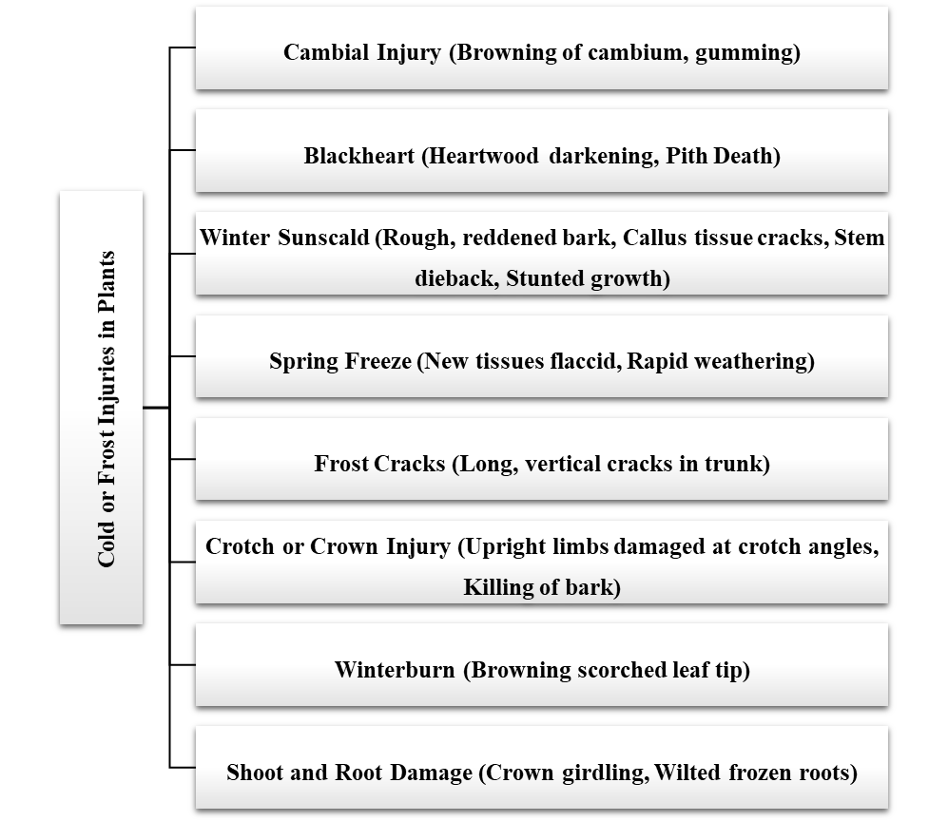
Figure 1: General manifestations of phenotypic expressions under cold and frost stress in plants
Sensitivity and tolerance to cold stress as well as the phenotypic symptoms expressed due to cold stress varies from different species to species. Cold stress on plants may lead to reduced leaf area, chlorosis, necrosis, wilting, stunted growth, sterility and finally death of the plant. Reproductive stage is the most vulnerable stage to cold stress. Delay heading and pollen sterility is caused due to cold stress, which is responsible for reduced yield [8]. The adverse effect of cold stress is analysed in terms of damage on plasma membrane of the exposed plants [9]. Lipids in plasma membrane consists both saturated and unsaturated fatty acids. Lipid which contains more saturated fatty acid is more prone to cold susceptibility. It has higher transition temperature and solidifies faster than lipid containing higher unsaturated fatty acid in low temperature and form crystals. Cold sensitivity in plants is shown due to the presence of high amount of saturated fatty acid in lipid membrane. On the other hand, cold stress tolerant plants contain higher proportion of unsaturated fatty acid [9]. The disintegration in membrane lipid directly affects water permeability in plant cells and induces dehydration like symptoms due to cold stress. Water potential of ice remains lower than liquid water and hence ice crystals formed due to cold stress draw water from the plant cells. This causes dehydration in cell as ice crystals draw water until water potential of cells and ice become equal [7]. With the lowering of temperature, water potential of ice falls and thus dehydration in plant cells becomes higher as temperature goes down [10].
Alterations in cell membrane under cold stress is considered to be a prominent marker for cold stress damages and injuries. Under cold or frost stress, galactolipids and phospholipids present in membrane are degraded affecting the membrane integrity leading to an increse in free fatty acids. Increased free fatty acids alter the standard ratio of sterols:phospholipids, as a result membrane fluidity is decreased due to cold stress [11]. Loss in membrane fluidity is associated with reduced permeability of membranes, for which membrane transport is severly affected. As a result, sugar translocation and water uptake pathways are hampered in response to lowering of temperature. Lowered ATP level and increased permeability changes the molecular ordering of membrane lipids under cold stress, imperilling the overall physiology and metabolism of the exposed plant.
To develop cold or frost hardiness in plants, detailed study on how the stress induces the damage and injuries is very crucial [9]. Ice crystals during cold or frost stress is formed in the apoplasts of the tissues. As ice has a much lower vapour pressure than liquid water, formation of ice crystals leads to vapour pressure gradient between the apoplastic space and the cells surrounding it. Consequently, the cytoplasmic water rapidly migrates from cytosol to the apoplast following the vapour pressure gradient. This rapid movement of water creates sheer mechanical stress on the cell wall of the tissue and as a result ruptures the cell [12]. Besides altering the lipid compositions of bio-membranes and leading to solute leakage from cells, several additional factors also contribute to the damages induced by cold stress. Integrity of intracellular organelles is disrupted leading to loss of compartmentalization, photosynthetic capacity is hindered, protein assembly and general metabolic processes are also reduced due to cold stress on plants [13]. Effects of cold stress on plants can be understood more prominently through analyzing whole-plant metabolome [14]. Recently metabolic profiling has been done by Cook et al. (2004) on cold acclimatised Arabidopsis and they found that cold acclimation increases 75% of 434 metabolites analyzed [15]. These metabolites are considered to play their role as osmoprotectants and key signals for reconfiguration of gene expressions under cold or frost stress [9].

SIGNAL TRANSDUCTIONS AND GENETIC REGULATIONS DURING COLD STRESS ON FOREST TREES

Higher plants possess an ability to react to different stresses under adverse environmental conditions and adapt to the changing scenario for their survival. These responses are shown in terms of metabolism, growth and development and potentially help the plant to overcome or tolerate the damages done. Primary site for cold stress sense in every plant are documented to be associated with reduction of cell membrane fluidity, increase in membrane rigidity, alteration in metabolite concentration and cellular redox status [16]. Plasma membrane rigidification under cold stress is reported to induce the cold responsive genes helping in cold acclimation process [17]. Cytosolic calcium levels are also found to be increased under cold stress which is mediated through membrane rigidification-activated mechano-sensitive or ligand-activated calcium channels [9]. Higher level of cytosolic calcium is thought to help in signal amplification for sensing the cold stress through phospholipid channels [18].
Specific receptors and signalling pathways for cold stress in forest trees are very complex and still to be explored in details. Preliminary studies have shown that the signalling is transduced downstream and a number of signalling pathways are involved which are activated in concert. The signal transduction pathways vary from genus to genus, species to species through combinations in the timing of activation of different signalling cascades. The signal transduction pathways and genetic regulation systems in response to cold stress in forest trees constitutes several components and the signal is transduced through a very complex mechanism. The definitive receptor(s) for sensing cold stress is still unknown in major forest tress and the all the abiotic stress response pathways cross-talk with each other. Initial cold stress exposures trigger downstream signal transduction through various signalling cascades and transcriptional controls, activating stress responsive mechanisms in trees. Adequate responses in the signalling and stress-gene-activation process result in cold acclimation and tolerance in tress, whereas, inadequate response at one or more processes leads to susceptibility [19]. The cold response signalling pathway finally result in the change of expression of cold-regulated genes (CORs) and the expressivity level of these genes determines the susceptibility or tolerance of the tree under cold stress (Figure 2).
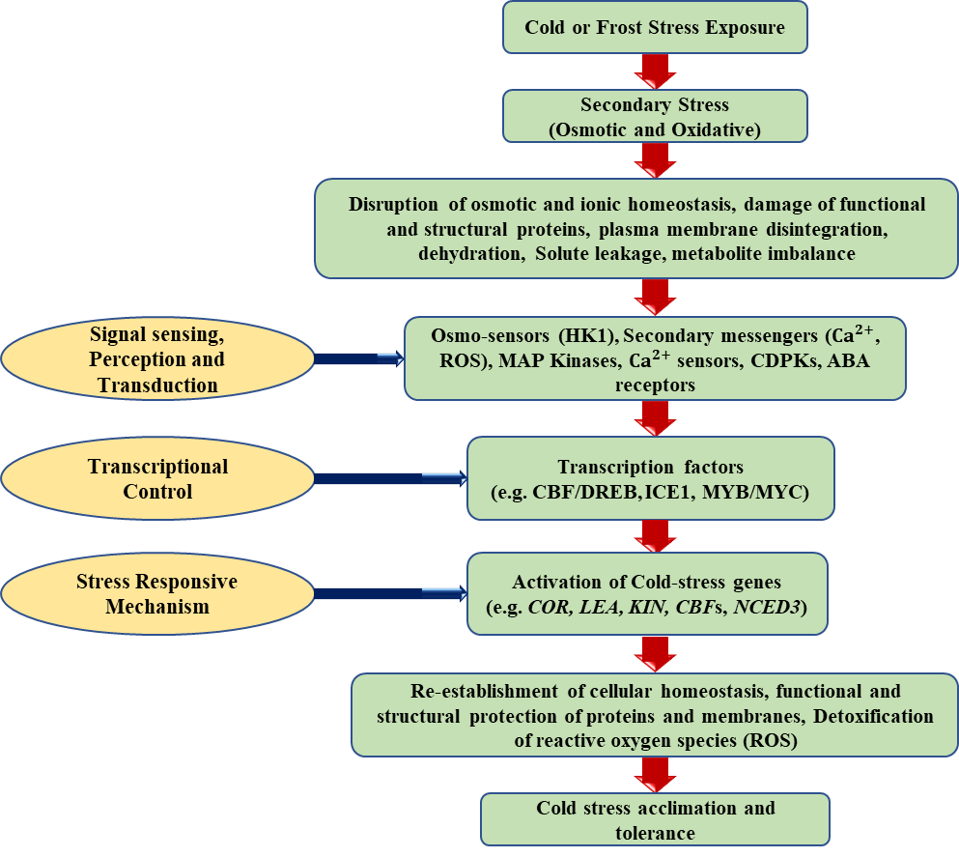
Figure 2: A general model for cold and frost stress response in forest trees
These signalling cascades are believed to comprise several components like reactive oxygen species (ROS), calcium, protein phosphatase, protein kinase etc. Calcium binding proteins primarily sense the change of cytosolic calcium level and initiate a phosphorylation cascade after undergoing conformation changes [9]. The cascades induce the expressions of major stress responsive genes regulated through several transcription factors [20]. Plant hormones like abscisic acid, ethylene, salicylic acid are believed to amplify the cascade, or they may initiate new signalling pathway in the stress signal transduction mechanism [21]. Apart from cytosolic calcium mediated signal transduction, lipid molecules in cell membranes are believed to play a crucial role in cold stress signalling pathway. Membrane lipids constitute a minor portion of phosphatidic acid, which increases significantly under exposure of cold stress [22]. The rapid and transient generation of phosphatidic acid is proposed to act as a secondary messenger in plants exposed to cold stress [23]. This secondary messenger influences the enzymatic activities of other membrane proteins and regulate their levels which can be sensed by the plants through different signalling cascades [24]. Additionally, cold stress along with other abiotic stresses regulate expression and activity of several mitogen-activated protein kinase (MAPK) pathways. Several MAPK cascades converges in cold stress signalling. Kovtun et al. (2000) has suggested that the AtMEKK1/ANP1(MAPKKK)-AtMKK2(MAPKK)-AtMPK4/6(MAPK) cascade is activated by reactive oxygen species (ROS) under cold stress which is crucial for cold acclimation in plants [25].

Role of transcriptional factors
A large number of genes are over-expressed in tree species under cold stress conditions. All these genes contain cis-elements in their promotor regions that is subjected to regulation by a number of transcription factors induced in response to cold stress. Trans-acting factors bind to the promoter regions of CBF gene and induces the CBF-transcription factor which plays the master regulatory role in cold stress sensing pathways in plants [26]. Chinnusamy et al. (2003) reported that inducer of CBF3 Expression 1 (ICE1) binds to the CBF promoter region, recognized with a consensus sequence CAXXTG and initiates the ICE1-CBF pathway in response to cold stress in many plant species [27]. CBF transcription factors are generally involved in the regulation of Cold-regulated genes (CORs) through CBF-COR regulon [28]. These COR genes are divided into separate groups according to their process of induction or response pathways, i.e., cold-induced (KIN), low temperature inducible (LTI), responsive to dehydration (RD) etc. [16]. Promoter regions of COR genes constitute highly conserved 5′-CCGAC-3′ core sequence with one or multiple copies of C-repeat/DRE. Besides cold stress response, CBFs are also believed to be associated with salinity and drought stress response pathways in plants which suggests that there is close interconnection among these abiotic stresses responsive system in plants. It has been found that CBF-DREB1 transcriptional pathway is involved in several stress responses like cold, salinity or osmotic stress conditions, whereas CBF-DREB2 is induced exclusively for cold stress response controlled by ICE1 transcription factor in plants [21]. This also justifies the fact that there surely is interconnection of abiotic-stress response signalling pathways. Detailed studies revealed that two principal transcriptional pathways are involved in response of exposure of plants to cold stress [29]. The transcriptional pathways can be dependent or independent of C-repeat (CRT)/dehydration responsive element (DRE)-binding factor (CBF/DREB) [5]. CBF-DREB dependent pathway controls the expression of COR genes which is fundamentally Abscisic Acid (ABA)-independent. On the other hand, in CBF-DREB independent cold-responsive pathway is dependent on ABA. Upon exposure of cold stress, a homeodomain protein, HOS9 and a R2R3 type MYB (Myc-like basic helix-loop-helix), HOS10 is over-expressed, which activate NCED3 gene responsible for biosynthesis of ABA causing accumulation of ABA as a response if cold stress [30]. The ABA dependent (or CBF/DREB independent) cold responsive pathway is common in Arabidopsis, but not very prominently found in woody plants or forest trees. Surprisingly, HOS1 (High Expression of Osmotically Responsive Gene 1) gene found in Arabidopsis is found to be a negative regulator of CBF genes [31]. HOS1 encodes for a 915 Amino acid protein containing a short motif ring finger like domain near the N-terminus which cause negative regulation of CBF genes inhibiting the expression of downstream genes.
Another important group of possible transcription factors that are activated in response to cold stress include MYB, WRKY and NAC. Members of MYB family of genes are widely distributed in plants [32, 32]. They act as transcriptional factors in regulating the expression of several downstream genes involved in conferring cold resistance. NAC forms a large group of transcriptional factors responsive under cold stress. Each member of this family possesses a N-terminal DNA binding domain. It is known to be regulated by other CORs. Its transcriptome profiling has shown presence of a cis-regulatory element that binds with DREB regulating the synthesis of this gene [34]. Hu et al. (2008) reported that NAC is a plant specific transcriptional factor found in plant nuclei and transgenic plants tolerant to severe cold stress can be designed by overexpressing NAC [35]. WRKY transcriptional factors consist of a 60 amino acid DNA binding domain having WRKYGQK sequence at its N-terminal side, along with a zinc finger motif which primarily recognizes the W-box sequence, (C/T)TGAC(T/C) [36]. WRKY knock down showed increased expression of important cold regulated gene such as LEA, DREB in several plant species like Arabidopsis, Pinus and Oryza.
The physiological and biochemical changes in forest trees due to the exposure of cold stress which underlie the process of cold hardiness and acclimation is the result of the induced expression of a large number of genes, sometimes around 25% of the entire genome [37] which makes it very difficult to study the definitive pathways and identify the involved gene(s). C-repeat-binding factor/dehydration-responsive element binding (CBF/DREB) pathway is the most accepted cold response pathway model for the forest trees [38]. It is suggested that CBF genes have crucial roles in both perennial and annual trees. Orthologs and homologs for cold responsive genes in major forest trees are yet to be explored. Recently, CBF orthologs have been described in two major forest species – Poplar and Eucalyptus [39, 40]. Ko et al. (2011) confirmed that poplar homologs of A. thaliana CBF regulon genes like CBF1, CBF3, ICE1 is activated and over expressed up to 391 folds under winter stress [41]. During overwintering of forest trees, dehydrins play a crucial role in cold stress tolerance mechanism. Promoters of cold inducible dehydrin genes in forest trees constitute CRT elements [42]. This suggests that the expression of dehydrin genes is controlled by CBF genes under low temperature [19]. Under cold stress, high accumulation of CBF transcript is an observed phenomenon which helps evergreen broad leaved forest trees to survive in winter under low temperature conditions [43]. Expression analysis in forest trees have revealed several CBF genes and transcription factors related to cold stress and its tolerance. Welling and Palva (2008) identified four CBF transcription factors designated as BpCBF1, BpCBF2, BpCBF3 and BpCBF4 in birch (Betula pendula) during its cold acclimation process under winter conditions [44]; whereas in Eucalyptus gunnii three CBF genes namely CBF1a, CBF1b and CBF1d are found to be induced under cold stress [43]. These findings support that CBFs effectively contributes to the cold stress response pathway in forest tress while helping them in cold acclimation and winter hardiness process.

Role of osmolytes
Cold stress, more precisely frost stress leads to ice crystals formation in the apo-plastic region in the plant cells. As ice formation is initiated in the intercellular spaces, cellular water moves down the water potential gradient towards the extracellular ice. Therefore, a water deficit condition occurs in response to freezing within the plant cells. In order to maintain the homeostasis of the cell several osmolytes are accumulated in the cell sap [45]. Accumulation of osmolytes in the cytoplasm or vacuole decreases the water potential of the cell which alters the water potential gradient established due to ice formation and the helps in forming an equilibrium between the intracellular and extracellular water potential. As a result, the water deficit condition is bypassed with reduced efflux of water from the plant cells under such stress conditions [46].
Proline is a major amino acid synthesized in plants under cold stress conditions and plays a major role in osmo-protection preventing dehydration in plant cells [47]. Increased accumulation of proteins has been reported in response to cold temperature and proline forms a major constituent of the free amino acid pool generated due to cold stress induced by dehydration. Proline catabolic pathway involves P5C dehydrogenase (P5CDH) enzyme which releases glutamate from P5C and accumulates under cold stress condition [48]. Increased accumulation of proline has been reported in cold tolerant Zoysia japonica along with the overexpression of ZjICE1 which belongs to the CBF gene family [49]. Apart from proline, sugars are another major osmolytes in plants under cold stress [50]. Major sugars that act as osmolytes in response to stress include soluble sugars such as sucrose, raffinose, fructose, trehalose etc. and sugar alcohol (Polyols) sorbitol, mannitol, inositol, galactisol etc. [51]. Among these, glucose acts as the precursors of all the sugars and their derivatives involving in multiple reactions with key enzymes [52]. Starch degradation into soluble sugars is also an important pathway for enhance cold tolerance during early stages of cold acclimation [53]. The pathway involves several hydrolytic enzymes like β-amylase (mainly BAM3), debranching enzymes (Isoamylase ISA3), Glucan Water Dikinase (GWD), Phosphoglucan Water Dikinase (PWD), and Phosphoglucan Phosphatase Starch Excess 4 (SEX4) etc. [51].

Role of Desaturase enzymes
Membrane phase transition is considered as one of the primary events during cold stress in which the plasma membrane accumulates more unsaturated and cis-configured lipids and fatty acids. These fatty acids provide structural barriers against stress through the remodeling of membrane fluidity [54]. It is observed that cold sensitive plants possess more percentage of saturated fatty acid. This modification lowers the temperature at which the membrane lipids begin a gradual phase change from fluid to semi crystalline and allow membrane to remain fluid at lower temperature. Cold sensitivity has been correlated with degree of unsaturation of fatty acids in phosphatidyl glycerol of chloroplast membrane [55]. The ability to adjust membrane lipid fluidity by changing the levels of unsaturated fatty acids is a primary feature of cold resistant plants [56].
Several studies have been conducted in order to identify the role of desaturase activities in during cold storage of seeds. Over-expression an ω-3 fatty acid desaturase from Glycine max (GmFAD3A) showed increased lipid and total Poly Unsaturated Fatty Acids (PUFA) contents in transgenic line of rice [57]. Number of studies are being conducted in order to relate the PUFA content with cold tolerance in higher plants. Zhou et al. (2010) studied the relationship between PUFA level and alternation in cold tolerance in Poplar by up and down regulating the Populus tomentosa D-12 fatty acid desaturase gene (PtFAD2) in a hybrid poplar (P. alba X P. glandulosa) clone. The transcriptional level of PtFAD2 was found to be increased by 90% in over-expressing Poplar lines, whereas, decreased in down regulated lines by 64% [58]. Martz et al. (2006) investigated the role of microsomal and chloroplast enzymes along with its molecular regulation in maintaining the membrane fluidity during cold acclimation in Birch leaves (Betula pendula) [59]. Four genes involved in fatty acid biosynthesis were isolated, viz., a 3-ketoacyl-ACP synthase II gene (BpKASII) involved in the elongation of palmitoyl-ACP to stearoyl-ACP, and three fatty acid desaturase genes (BpFAD3, BpFAD7, and BpFAD8) involved in the desaturation of linoleic acid (18:2) to a linolenic acid (18:3). Chen et al. (2014) reported several candidate genes potentially involved in cold tolerance in Corylus heterophylla, providing a material basis for future molecular mechanism analysis of cold stress in woody plants [60]. Recently, Liu et al. (2020) analysed 24 members of the JrFAD gene family regulating fatty acid desaturase pathways under cold stress in walnut (Juglans regia) [61].

Role of Anti-freeze proteins (AFPs)
Several specialized proteins have been identified that limit the formation of ice crystal in plant cells under cold or frost stress. These are called anti-freeze proteins (AFPs) which are induced by near sub-zero temperatures and bind to the surface of ice crystals to prevent or slow further crystal growth in plant cells. Intra-cellular ice formation primarily affects the equilibrium of cellular water potentials. During sub-zero conditions, ice formation is initiated in the subcellular location due to which cellular water moves down the potential gradient across the plasma membrane and towards the extracellular ice resulting in water deficit condition in plant cells. Ice formation starts with intercellular spaces and later in the xylem vessels, along which the ice can propagate quickly. The ice formation generally begins from the apo-plastic region. However, in case of rapid freezing symplastic ice accumulation can occur, which may be lethal and cause instant death of the cells in frost sensitive plants.
On the other hand, frost tolerant plants tend to accumulate AFPs in the apo-plastic region to slow down the formation of ice and cellular dehydration [45]. AFPs play major role both in tolerance as well as resistance mechanism in plants under freezing conditions. The AFPs are associated with the cell wall, other cell organelles, and the intercellular spaces. and act by modifying the crystallization of ice propagators throughout the plant [62]. AFPs also inhibit recrystallization of ice and keep a check on the size of ice crystals in order to prevent physical damages to plant cells [63]. Different AFPs function by different mechanisms and pathways which makes them very complex to be studied in perennial woody plants. Most of the AFPs have been isolated from the annual or biennial plant species but proper studies are still lacking in forest trees. However, presence of such kind of proteins have been proposed in tree like Poplar suaveolens, Pinus monticola and Pseudotsuga menziesii [64]. Potential roles and regulatory pathways of the suggested AFPs needs to be further explored in forest tree species in details.

METHODS FOR SCREENING PHENOTYPIC RESPONSES TO COLD STRESS IN FOREST TREES

Several methods have been devised to screen impacts of cold stress in trees. Cold injuries in the entire plant can be evaluated through whole-plant freezing tests. This gives benefits to approximate the final extent of cold damage and evaluate the rate of recovery. Moreover, the results obtained through this have usually been in good agreement with field observations of natural cold injuries. Sometimes, instead of whole plant, sample plant materials are used to evaluate the cold damage by exposing them to cold or frost stress employing freeze chambers, temperature gradient bars or controlled temperature liquid baths. Mobile freezing units can be used for testing intact trees or branches in-situ. The sample data is then can be related to the whole-plant survival through relative importance of different plant part or tissues in the survival of the whole-plant. To simulate the damage, exposure of low-temperature must be long enough for establishing a thermodynamic equilibrium [65]. In common sense, longer cold exposure will bring increased cold damage on the plant; but they are also to be protected from desiccation. Generally, a cold exposure time of 4 to 6 hours is considered to be minimum for evaluating cold injuries on any hard wood plant and prior to the exposure samples are equilibrated at a constant temperature. Practically a series of low-temperature exposure is preferred against a long duration single cold exposure.
The major goal for the breeding and improvement programmes targeting the trait of cold tolerance in forest trees was to develop reliable non-destructive laboratory methods to screen the cold stress and tolerance level. Hardwood developed the main procedure to measure leaf damage in Eucalyptus under cold or frost stress. The procedure is called ‘Ion leakage method’ or ‘Electrolyte Leakage method’ where leaf damage in measured in terms of electrical conductivity of the leaf discs damaged due to the exposure to freezing temperature. In this method correlation between the conductivity of the leachates and damage to cell membranes is measured efficiently. The electrolyte leakage test proved to be a preferred measure of cold or frost induced damages as it is based on alterations in the locus of initial cold injury i.e., cell membranes. Furthermore, the procedure of the test is easy to conduct, rapidly yields quantitative data that can be used in statistical interpretations and only small amounts of plant material is sufficient for the method. This method was first adapted to successfully screen cold stress on E. pauciflora seedlings by Hardwoord [66]. This method is applied successfully to other forest tree species later by several researchers as the methodology is quite simple and fast and provides reliable results with agreement to visual classification. Data acquired from this method is fairly amenable to statistical treatments and interpretation [2]. The method is still used extensively to screen cold stress tolerance in several woody plant species with some improvisation for better reliability [67]. Moreover, the electrolyte leakage method allows an alternative measure of cold injury through simultaneous spectrophotometric measurement of leached phenolic compounds [68]. Azar (2016) recently modified method of electrolytic leakage method and successfully standardized a laboratory protocol to evaluate cold tolerance mechanisms in E. gunnii [69].

CONCLUSION

Responses to cold stress and cold tolerance mechanisms in woody perennials include accumulation of osmolytes and changes in lipid composition of cell membrane which fairly resembles the responses to drought or salt stress and mechanism of tolerance. However, till date, the overall understanding of response to cold and frost stress and its tolerance mechanisms in forest trees remains far from complete. In order to fully understand the cold stress responses in forest trees at the whole-plant level, a detailed insight into the tree stress physiology at genetic level is needed. However, the complete understanding of genetic regulations during cold stress in the woody perennials is always hampered due to the complexity of the genetic analysis of forest trees. An interdisciplinary approach combining genetics, genomics and phenomics is required to understand the yet-unexplored mechanisms of cold stress pathways in forest trees and how the tolerance can be imposed through tree improvement approaches. With recent advances in the areas of genomics, next-generation sequencing and computational biology, it is now being possible to elucidate the complex molecular mechanisms and pathways of cold stress in forest trees. As a result of this holistic approach, the doors will be opened for exploiting the natural variation present is forest-tree species and developing desired tree phenotypes tolerant to cold or frost stress.

REFERENCES

- Ishikawa, M., Ide, H., Price, W. S., Arata, Y., Nakamura, T., & Kishimoto, T. (2009). Freezing behaviours in plant tissues: visualization using NMR micro-imaging and biochemical regulatory factors involved. Plant Cold Hardiness: from the Laboratory to the Field’. (Eds. LV Gusta, KK Tanino, ME Wisniewski) pp, 19-28.
- Teulières, C., Bossinger, G., Moran, G., & Marque, C. (2007). Stress studies in Eucalyptus. Plant Stress 1(2), 197-215.
- Grattapaglia, D., & Kirst, M. (2008). Eucalyptus applied genomics: From gene sequences to breeding tools. The New phytologist, 179(4), 911–929. https://doi.org/10.1111/j.1469-8137.2008.02503.x
- Lin, Y., Zheng, H., Zhang, Q., Liu, C., & Zhang, Z. (2014). Functional profiling of EcaICE1 transcription factor gene from Eucalyptus camaldulensis involved in cold response in tobacco plants. Journal of plant biochemistry and biotechnology, 23(2), 141-150. DOI: 10.1007/s13562-013-0192-z.
- Mukhopadhyay, J., & Roychoudhury, A. (2018). Cold-induced injuries and signalling responses in plants. In Wani, S. H., & Herath, V. (Eds.). Cold tolerance in plants: Physiological, molecular and genetic perspectives (pp. 1-35). Springer, Cham.
- Arora, R., & Rowland, L. J. (2011). Physiological research on winter-hardiness: deacclimation resistance, reacclimation ability, photoprotection strategies, and a cold acclimation protocol design. HortScience, 46(8), 1070-1078.
- Pearce, R. S. (2001). Plant freezing and damage. Annals of botany, 87(4), 417-424.
- Suzuki, K., Nagasuga, K., & Okada, M. (2008). The chilling injury induced by high root temperature in the leaves of rice seedlings. Plant and Cell Physiology, 49(3), 433-442.
- Yadav, S. K. (2010). Cold stress tolerance mechanisms in plants. A review. Agron Sustain Dev, 30, 515–527.
- Gusta, L. V., Burke, M. J., & Kapoor, A. C. (1975). Determination of unfrozen water in winter cereals at subfreezing temperatures. Plant Physiology, 56(5), 707-709.
- Whitaker, B. D. (1993). Lipid changes in bell pepper fruit during chilling and rewarming. Hortscience, 28, 519.
- McKersie, B. D., & Bowley, S. R. (1997). Active oxygen and freezing tolerance in transgenic plants. In Plant cold hardiness (pp. 203-214). Springer, Boston, MA.
- Baek, K. H., & Skinner, D. Z. (2003). Alteration of antioxidant enzyme gene expression during cold acclimation of near-isogenic wheat lines. Plant science, 165(6), 1221-1227.
- Kaplan, F., Kopka, J., Haskell, D. W., Zhao, W., Schiller, K. C., Gatzke, N., ... & Guy, C. L. (2004). Exploring the temperature-stress metabolome of Arabidopsis. Plant physiology, 136(4), 4159-4168.
- Cook, D., Fowler, S., Fiehn, O., & Thomashow, M. F. (2004). A prominent role for the CBF cold response pathway in configuring the low-temperature metabolome of Arabidopsis. Proceedings of the National Academy of Sciences, 101(42), 15243-15248.
- Wisniewski, M., Bassett, C., & Gusta, L. V. (2003). An overview of cold hardiness in woody plants: seeing the forest through the trees. HortScience, 38(5), 952-959.
- Vaultier, M. N., Cantrel, C., Vergnolle, C., Justin, A. M., Demandre, C., Benhassaine-Kesri, G., ... & Ruelland, E. (2006). Desaturase mutants reveal that membrane rigidification acts as a cold perception mechanism upstream of the diacylglycerol kinase pathway in Arabidopsis cells. FEBS letters, 580(17), 4218-4223.
- Komatsu, S., Yang, G., Khan, M., Onodera, H., Toki, S., & Yamaguchi, M. (2007). Over-expression of calcium-dependent protein kinase 13 and calreticulin interacting protein 1 confers cold tolerance on rice plants. Molecular Genetics and Genomics, 277(6), 713-723.
- Harfouche, A., Meilan, R., & Altman, A. (2014). Molecular and physiological responses to abiotic stress in forest trees and their relevance to tree improvement. Tree physiology, 34(11), 1181-1198.
- Mahajan, S., & Tuteja, N. (2005). Cold, salinity and drought stresses: an overview. Archives of biochemistry and biophysics, 444(2), 139-158.
- Yamaguchi-Shinozaki, K., & Shinozaki, K. (2006). Transcriptional regulatory networks in cellular responses and tolerance to dehydration and cold stresses. Annu. Rev. Plant Biol., 57, 781-803.
- Munnik, T. (2001). Phosphatidic acid: an emerging plant lipid second messenger. Trends in plant science, 6(5), 227-233.
- Meijer, H. J., & Munnik, T. (2003). Phospholipid-based signaling in plants. Annual review of plant biology, 54(1), 265-306.
- Testerink, C., & Munnik, T. (2005). Phosphatidic acid: a multifunctional stress signaling lipid in plants. Trends in plant science, 10(8), 368-375.
- Kovtun, Y., Chiu, W. L., Tena, G., & Sheen, J. (2000). Functional analysis of oxidative stress-activated mitogen-activated protein kinase cascade in plants. Proceedings of the National Academy of Sciences, 97(6), 2940-2945.
- Fowler, S., & Thomashow, M. F. (2002). Arabidopsis transcriptome profiling indicates that multiple regulatory pathways are activated during cold acclimation in addition to the CBF cold response pathway. The Plant Cell, 14(8), 1675-1690.
- Chinnusamy, V., Ohta, M., Kanrar, S., Lee, B. H., Hong, X., Agarwal, M., & Zhu, J. K. (2003). ICE1: a regulator of cold-induced transcriptome and freezing tolerance in Arabidopsis. Genes & development, 17(8), 1043-1054.
- Thomashow, M. F. (1999). Plant cold acclimation: freezing tolerance genes and regulatory mechanisms. Annual review of plant biology, 50(1), 571-599.
- Lincoln Taiz, P. E. (2018). Fundamentals of Plant Physiology 7th Edition. Sunderland, MA: Sinauer Associates.
- Zhu, J., Shi, H., Lee, B. H., Damsz, B., Cheng, S., Stirm, V., ... & Bressan, R. A. (2004). An Arabidopsis homeodomain transcription factor gene, HOS9, mediates cold tolerance through a CBF-independent pathway. Proceedings of the National Academy of Sciences, 101(26), 9873-9878.
- Dong, C. H., Agarwal, M., Zhang, Y., Xie, Q., & Zhu, J. K. (2006). The negative regulator of plant cold responses, HOS1, is a RING E3 ligase that mediates the ubiquitination and degradation of ICE1. Proceedings of the National Academy of Sciences, 103(21), 8281-8286.
- Ambawat, S., Sharma, P., Yadav, N. R., & Yadav, R. C. (2013). MYB transcription factor genes as regulators for plant responses: an overview. Physiology and Molecular Biology of Plants, 19(3), 307-321.
- Baldoni, E., Genga, A., & Cominelli, E. (2015). Plant MYB transcription factors: their role in drought response mechanisms. International Journal of Molecular Sciences, 16(7), 15811-15851.
- Erpen, L., Devi, H. S., Grosser, J. W., & Dutt, M. (2018). Potential use of the DREB/ERF, MYB, NAC and WRKY transcription factors to improve abiotic and biotic stress in transgenic plants. Plant Cell, Tissue and Organ Culture (PCTOC), 132(1), 1-25.
- Hu, H., You, J., Fang, Y., Zhu, X., Qi, Z., & Xiong, L. (2008). Characterization of transcription factor gene SNAC2 conferring cold and salt tolerance in rice. Plant molecular biology, 67(1), 169-181.
- He, C., Teixeira da Silva, J. A., Tan, J., Zhang, J., Pan, X., Li, M., ... & Duan, J. (2017). A genome-wide identification of the WRKY family genes and a survey of potential WRKY target genes in Dendrobium officinale. Scientific reports, 7(1), 1-14.
- Kreps, J. A., Wu, Y., Chang, H. S., Zhu, T., Wang, X., & Harper, J. F. (2002). Transcriptome changes for Arabidopsis in response to salt, osmotic, and cold stress. Plant physiology, 130(4), 2129-2141.
- Puhakainen, T., Li, C., Boije-Malm, M., Kangasjärvi, J., Heino, P., & Palva, E. T. (2004). Short-day potentiation of low temperature-induced gene expression of a C-repeat-binding factor-controlled gene during cold acclimation in silver birch. Plant Physiology, 136(4), 4299-4307.
- Benedict, C., Skinner, J. S., Meng, R., Chang, Y., Bhalerao, R., Huner, N. P., ... & Hurry, V. (2006). The CBF1‐dependent low temperature signalling pathway, regulon and increase in freeze tolerance are conserved in Populus spp. Plant, Cell & Environment, 29(7), 1259-1272.
- El Kayal, W., Navarro, M., Marque, G., Keller, G., Marque, C., & Teulieres, C. (2006). Expression profile of CBF-like transcriptional factor genes from Eucalyptus in response to cold. Journal of Experimental Botany, 57(10), 2455-2469.
- Ko, J. H., Prassinos, C., Keathley, D., & Han, K. H. (2011). Novel aspects of transcriptional regulation in the winter survival and maintenance mechanism of poplar. Tree physiology, 31(2), 208-225.
- Wisniewski, M. E., Bassett, C. L., Renaut, J., Farrell Jr, R., Tworkoski, T., & Artlip, T. S. (2006). Differential regulation of two dehydrin genes from peach (Prunus persica) by photoperiod, low temperature and water deficit. Tree physiology, 26(5), 575-584.
- Navarro, M., Marque, G., Ayax, C., Keller, G., Borges, J. P., Marque, C., & Teulieres, C. (2009). Complementary regulation of four Eucalyptus CBF genes under various cold conditions. Journal of experimental botany, 60(9), 2713-2724.
- Welling, A., & Palva, E. T. (2008). Involvement of CBF transcription factors in winter hardiness in birch. Plant physiology, 147(3), 1199-1211.
- Buchanan, B. B., Gruissem, W., & Jones, R. L. (Eds.). (2015). Biochemistry and molecular biology of plants. John wiley & sons.
- Hare, P. D., Cress, W. A., & Van Staden, J. (1998). Dissecting the roles of osmolyte accumulation during stress. Plant, cell & environment, 21(6), 535-553.
- Yancey, P. H. (1994). Cellular and molecular physiology of cell volume regulation. Competable and counteracting solutes. CRC Press (Taylor & Francis Group), Boca Raton, 81-110.
- Hayat, S., Hayat, Q., Alyemeni, M. N., Wani, A. S., Pichtel, J., & Ahmad, A. (2012). Role of proline under changing environments: a review. Plant signaling & behavior, 7(11), 1456-1466.
- Zuo, Z. F., Kang, H. G., Park, M. Y., Jeong, H., Sun, H. J., Song, P. S., & Lee, H. Y. (2019). Zoysia japonica MYC type transcription factor ZjICE1 regulates cold tolerance in transgenic Arabidopsis. Plant Science, 289, 110254.
- Slama, I., Abdelly, C., Bouchereau, A., Flowers, T., & Savouré, A. (2015). Diversity, distribution and roles of osmoprotective compounds accumulated in halophytes under abiotic stress. Annals of botany, 115(3), 433-447.
- Dong, S., & Beckles, D. M. (2019). Dynamic changes in the starch-sugar interconversion within plant source and sink tissues promote a better abiotic stress response. Journal of plant physiology, 234, 80-93.
- Sakr, S., Wang, M., Dédaldéchamp, F., Perez-Garcia, M. D., Ogé, L., Hamama, L., & Atanassova, R. (2018). The sugar-signaling hub: overview of regulators and interaction with the hormonal and metabolic network. International Journal of Molecular Sciences, 19(9), 2506.
- Yano, R., Nakamura, M., Yoneyama, T., & Nishida, I. (2005). Starch-related α-glucan/water dikinase is involved in the cold-induced development of freezing tolerance in Arabidopsis. Plant Physiology, 138(2), 837-846.
- Iba, K. (2002). Acclimative response to temperature stress in higher plants: approaches of gene engineering for temperature tolerance. Annu. Rev. Plant Biol, 53, 225-45.
- Murata, N., Ishizaki-Nishizawa, O., Higashi, S., Hayashi, H., Tasaka, Y., & Nishida, I. (1992). Genetically engineered alteration in the chilling sensitivity of plants. Nature, 356(6371), 710-713.
- Upchurch, R. G. (2008). Fatty acid unsaturation, mobilization, and regulation in the response of plants to stress. Biotechnology letters, 30(6), 967-977.
- Wang, X., Yu, C., Liu, Y., Yang, L., Li, Y., Yao, W., ... & Peng, X. (2019). GmFAD3A, a ω-3 fatty acid desaturase gene, enhances cold tolerance and seed germination rate under low temperature in rice. International journal of molecular sciences, 20(15), 3796.
- Zhou, Z., Wang, M. J., Zhao, S. T., Hu, J. J., & Lu, M. Z. (2010). Changes in freezing tolerance in hybrid poplar caused by up-and down-regulation of PtFAD2 gene expression. Transgenic research, 19(4), 647-654.
- Martz, F., Kiviniemi, S., Palva, T. E., & Sutinen, M. L. (2006). Contribution of omega-3 fatty acid desaturase and 3-ketoacyl-ACP synthase II (KASII) genes in the modulation of glycerolipid fatty acid composition during cold acclimation in birch leaves. Journal of Experimental Botany, 57(4), 897-909.
- Chen, X., Zhang, J., Liu, Q., Guo, W., Zhao, T., Ma, Q., & Wang, G. (2014). Transcriptome sequencing and identification of cold tolerance genes in hardy Corylus species (C. heterophylla Fisch) floral buds. PLoS One, 9(9), e108604.
- Liu, K., Zhao, S., Wang, S., Wang, H., & Zhang, Z. (2020). Identification and analysis of the FAD gene family in walnuts (Juglans regia L.) based on transcriptome data. BMC genomics, 21(1), 1-12.
- Pihakaski‐Maunsbach, K., Moffatt, B., Testillano, P., Risueño, M., Yeh, S., Griffith, M., & Maunsbach, A. B. (2001). Genes encoding chitinase‐antifreeze proteins are regulated by cold and expressed by all cell types in winter rye shoots. Physiologia plantarum, 112(3), 359-371.
- Venketesh, S., & Dayananda, C. (2008). Properties, potentials, and prospects of antifreeze proteins. Critical reviews in biotechnology, 28(1), 57-82.
- Jarząbek, M., Pukacki, P. M., & Nuc, K. (2009). Cold-regulated proteins with potent antifreeze and cryoprotective activities in spruces (Picea spp.). Cryobiology, 58(3), 268-274.
- Lindén, L. (2002). Measuring cold hardiness in woody plants. Academic Dissertation. University of Helsinki, Department of Applied Biology, Publication no. 10. Helsinki. Available at: http://ethesis.helsinki.fi/
- Harwood, C. E. (1981). Frost resistance of subalpine Eucalyptus species. II. Experiments using the resistance index method of damage assessment. Australian Journal of Botany, 29(2), 209-218.
- Raymond, C. A., Owen, J. V., Eldridge, K. G., & Harwood, C. E. (1992). Screening eucalypts for frost tolerance in breeding programs. Canadian Journal of Forest Research, 22(9), 1271-1277.
- AniśAko, T., & Lindstrom, O. M. (1995). Applying the Richards function in freezing tolerance determination with electrolyte and phenolic leakage techniques. Physiologia Plantarum, 95(2), 281-287.
- Azar, S. (2016). Laboratory Assessment of Cold Tolerance in Eucalyptus gunnii. Imperial Journal of Interdisciplinary Research (IJIR), 2(6), 529-534.

