TABLE OF CONTENT

I.INTRODUCTION
- BACKGROUND OF THE COOLING TOWER
- HEAT PIPE
- PRINCIPLE OF HEAT PIPE

II. LITERATUREREVIEW

III.PROBLEM DEFINITION

IV.METHODOLOGY
- COOLING TOWER WITHOUT HEAT PIPE
- COOLING TOWER WITH HEAT PIPE

V. CALCULATIONS

VI. MANUFACTURING PLAN
- FABRICATION PLAN STEPS
- PURCHASED COMPONENTS
- FABRICATED COMPONENTS

VII. OBSERVATIONS
- Table 1 WITHOUT HEAT PIPE
- Table 2 WITH HEAT PIPE

VIII. RESULTS AND DISCUSSIONS

IX. FUTURE ENHANCEMENT

X. CONCLUSION

XI. REFERENCES

Study of Cooling Tower with the Application of Heat Pipe on the Environment

Garima Khare¹, Garima Sharma² ,Jaspreet Singh Chhabra³
¹ Research Scholar, Department of Mathematics, School of Liberal Arts and Sciences,
Mody University of Science and Technology, Lakshmangarh, Rajasthan, India
garimashish188@gmail.com
² Assistant Professor, Department of Mathematics, School of Liberal Arts and Sciences,
Mody University of Science and Technology, Lakshmangarh, Rajasthan, India
sharmagarima2802@gmail.com
³ MS Student of University of Maryland Baltimore County in Engineering management
Jaspreetsinghchhabra123@gmail.com

ABSTRACT

Nowadays, the requirements of people are increasing day by day for which industries are playing a vital role,but as per the high demands, industries require high energy to run. Which can be fulfilled by setting up a power plant but more the power plants, more the use of cooling towers, which can affect, the effectiveness and the efficiency of the power plant?As well as the environment as more the power plants more the carbon footprint which means more effect on ozone layer So, to enhance such influencing factors and to tackle the question of how to save the environment.We came up with an innovation: we are applying heat pipe in the system or cycle of a power plant.We use heat pipes between the condenser and the cooling tower to see the factors affected by innovation. A heat pipe is a device which works on a principle of thermal conductivity and shows a capillary action by which the hot water which is coming from the condenser can automatically cool down without any external source before entering the cooling tower, which can be very much helpful to enhance the efficiency of the cooling tower and the effectiveness of the entire power plant.The heat pipe is a phenomenal device with a working fluid where the phase change occurs. The working fluid that is most commonly used in heat pipes is water. From the hot end, the water takes the heat from the source, and the liquid water changes its phase to vapours and moves to the cold end by capillary action. Then at the stern end, the fog rejects heat from the atmosphere and changes its phase back to liquid water, and this liquid water then moves back to the hot end to take the further heat from the heated source, and the cycle continues. The material used for the heat pipe generally depends on the heated basis, fluid and other parameters. Generally, the alloy material used is copper-nickel alloy.

Keywords-Cooling Tower, Effectiveness, Efficiency, Heat Pipe

- INTRODUCTION

- BACKGROUND OF THE COOLING TOWER

A cooling tower is a heat rejection gadget which concentrates on squandering heat to the atmosphere by lowering the temperature of cooling water. This sort of heat removal in a cooling tower is termed "evaporative" in this. It permits a small portion of the water to be cooled to discard in moving air to give significant cooling to the rest stream of water. The heat from the water stream moves to the air stream and raises the temperature and its relative humidity to 100%; then,the air is discharged into the atmosphere. Heat removal devices like cooling towers are generally used to provide lower water temperatures than "air cooled" or "dry" heat rejection devices, like the radiator in a car, thereby achieving more cost-effective and energy-efficient operation of systems in need of cooling. Think about the times when you’ve seen something hot that is cooled rapidly by putting water on it, which dissipates, cooling quickly, for example, an overheated car radiator. A wet surface's cooling compatibility is superior to a dry one.
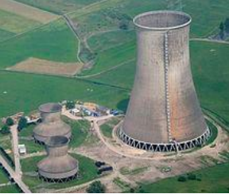

Figure 1 COOLING TOWER[1]

- HEAT PIPE

Heat pipe works based ona closed loop system. It is a phenomenal device that operates continuously and passively, creating a reliable component in our thermal management system. A small amount of working fluid is in the heat pipe, which is sealed under the vacuum. The fluid flows inside the wick structure that lines the inner diameter of the heat pipe. When the heat is supplied through the electric heater, the liquidvaporises due to heat generated in the evaporative section. The fluid vapour quickly spreads to the other end of the heat pipe due to pressure caused by the temperature difference. The fluid gives up its latent heat at the opposite end, known as the condenser. The juice gives up its latent heat, which is rejected by an external heat sink. The fluid returns to liquid form, and the wick structure passively pumps the fluid back to the evaporator using capillary force. By utilising liquid and vapour phases, heat transport is highly efficient.
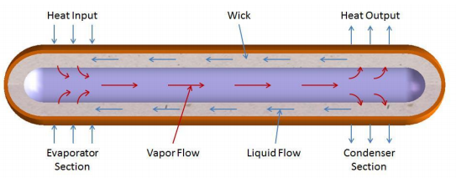
Figure 2 HEAT PIPE[2]

- PRINCIPLE OF HEAT PIPE

Thermal conductivity and phase transition theories underlie the operation of a heat pipe. It effectively moves heat across two solid contacts. When a liquid at a heated interface comes into touch with a solid thermally conductive surface, the liquid condenses into a vapour. When the smoke reaches the cold contact and condenses back into liquid, latent heat is released. It flows along the heat pipe. The cycle is repeated when the liquid returns to the heated interface. Due to the high heat transfer coefficient for boiling and condensation, this process uses capillary action, centrifugal force, or gravity to operate. Thermal conductors with excellent efficiency include heat pipes. Heat pipe’s thermal efficiency is determined by design factors such as size, composition, wick structure, and working fluid.
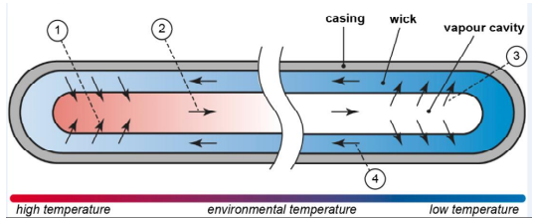
Figure 3 PRINCIPLE OF HEAT PIPE[3]

- LITERATUREREVIEW

He and Hoyano (2010) have studied the cooling effects of passive evaporative cooling walls constructed of porous ceramic materials. Experimental results showed that the cooling efficiency reached a maximum of 0.7 during sunny daytime. Higher cooling efficiency is obtainedunder windy conditions where wind continuously blows at a speed of 1-3 m/s. [4]
Gomez et al. (2005) have developed a ceramic evaporative cooling system which acts as a semi-indirect cooler. The water-cooled in a cooling tower is passed through the annulus passage of the ceramic tube. The outside air is passed through the central region. Chilled water evaporates by seeping through pores. Such a system permits indoor air recirculation, which is impossible in the conventional evaporative cooling system. Sucha 15 system is experimentally demonstrated, and 5-12 ºC drops in temperatures are obtained under various conditions. [5]
Khandelwal et al. (2010) have studied energy saving in a building using regenerative evaporative cooling. The result revealed that regenerative evaporative cooling systems indicated the significant potential for energy savings of up to 15.69 %, whereassimple evaporative cooling systems provided 12.05 %. The indoor temperatures obtained are between 22 °C and 26 °C. [6]
El-Awad (2010) has studied the feasibility of solar-assisted winter air conditioning systems using evaporative coolers. The evaporative air cooler obtains the heat from solar energy for preheating the water supply. A theoretical model is developed for a room of 3×3×3 m3 volume. Typical power consumption is found to be 0.1 kW. It is estimated that for air conditioning, a 500 cfm air flow rate for a minimum of four hours of operation, a 150 LPD solar heater is needed and that for eight hours 250 LPD solar heater is required. [7]

REVIEW CONCLUSION

- The cooling efficiency of the evaporative cooling system is found to be increased by imparting the following three methodologiesin the design:
- Introduction of suitable components for effective evaporation
- Combining direct and indirect cooling systems
- The utilisation of different pad materials with different thicknesses.
- The difference between the outside airdry bulb temperature and the wet bulb temperature is the critical factor which decides the use of evaporative coolers. The more significant the difference, the usefulness of evaporative coolers is more considerable.
- Various attempts have been made to study the effect of multiple parameters on the evaporative cooler performance. The pad material and thickness significantly affect a given air flow rate.
- Studies have shown that excessive water circulation does not improve performance. Considerable energy savings are possible by optimising the pump operations.

- PROBLEM DEFINITION

The application of cooling towers is significant in regions witha scarcity of electricity and other power sources, and we cannot afford to use our helpful electric power to cool the machines. A better way is to use a cooling tower in places with abundant water, which also helps us reduce the cost of the power plant. The significance of our project is to check the improvement in the power plant output by using the heat pipe in the cooling tower. We also check which fluid is to use in the heat pipe according to the temperature drop required in the cooling tower because various working fluid works in different temperature ranges, and we have to choose which working fluid to select according to our cooling tower’s operating temperature range[8]. Generally, water is used as a working fluid in the heat pipe as its working temperature is 30℃ to 150℃. Some other functionalfluids can also be used, like methanol with a temperature range of - 45℃ to 120℃. Also, the material of the heat pipe is selected according to the desired condition. In our project, we have copper-nickel alloy as the heat pipe material [10]. It is expected that the cooling tower's effectiveness and the power plant's efficiency are increased by using the heat pipe in the cooling tower.

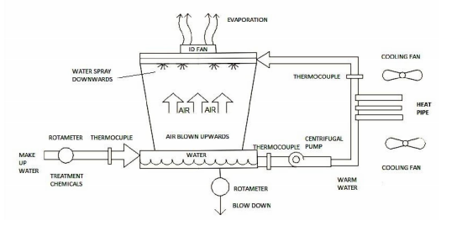
Figure 4 COOLING TOWER WITH APPLICATION OF HEAT PIPE

- METHODOLOGY

COOLING TOWER WITHOUT HEAT PIPE:-

- Firstly, we use a cooling tower without a heat pipe. In this, we cool the hot water from the power plant by evaporation of this hot water by flowing relatively calm air past through it.
- We also calculate air and water enthalpies at the inlet and outlet of the cooling tower.
- After this, we calculate the cooling tower's effectiveness and efficiency.

COOLING TOWER WITH HEAT PIPE:-

- Along with the cooling tower, we use a heat pipe to pre-cool hot water before it enters the cooling tower.
- Heat pipes of diameter 10mm and length 80mm and 2 in number are used.
- Also, we calculate the enthalpies of air and water at the inlet and outlet of the cooling tower.
- The cooling tower's effectiveness and efficiency are calculated.

CALCULATIONS
Given,
Pressure = 1.5 bar
The inner diameter of the cooker=22 cm
Initial height = 9.6cm
Final height = 9 cm
The heating time of the cooker = 1450 sec
Steam flow rate = 50.96 sec
Initial volume = (π/4) d² h
= π/4 * (22)² * 9.6
=3649.274 cm³
Final volume = (π/4) d² h
= (π/4) * (22)² *9
= 3420.549 cm³
Change in volume = final volume – initial volume
= 3649.274 – 3420.549
= 228.725 cm³
Volume flow rate = 228.725/50.96
=4.488 cm³ /sec
=4.488 *10⁻⁶ m³ / sec
@1.5 bar pressure
V_{f}= 0.001352 m³ / kg
V_{g} = 0.027378 m³ / kg
V_{fg} = 0.026026 m³ / kg
Density = 1/ϱ = V_{f}+ xV_{fg} = 0.001352+0.7(0.026026)
ϱ = 51.098 kg/m³
Mass flow rate (m_{s}) = ϱ * Q
= 51.098 * 4.488 * 10⁻⁶
= 229.3282 * 10⁻⁶ kg/sec
For MW
Volume =750 ml
Time = 102 sec
Volume flow rate = 7.352 * 10⁻⁶ m³ / sec
Mass flow rate = 7.352 * 10⁻³ kg/sec

The formulas used above is taken from heat and mass transfer by PK Naag [9]

- MANUFACTURING PLAN

FABRICATION PLAN STEPS

- Firstly, we would calculate all the unknown parameters related to the design of the condenser and the cooling tower.
- After calculating parameters, we must purchase some components while fabricating some remaining parts.
- The following list shows the purchase and fabricating of components

- PURCHASED COMPONENTS
- Fan
- Pump
- Copper tube
- Connecting pipe
- Pressure cooker (boiler)
- Heat pipe
- Thermocouple
- Fan – We are using it to circulate air in the cooling tower.
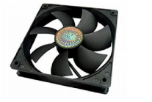
Figure 5 FAN [11]

- Pump – We use it to circulate the water in a dia -16mm copper pipe.
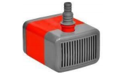
Figure 6 PUMP [12]

- Copper Pipe – We are using two different pipes of dia-16mm and dia-5mm lengths of 1.2m and 1m.
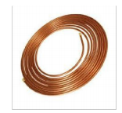
Figure 7 COPPER PIPES [13]

- Connecting Pipe – We are using these pipes to connect with copper pipes and a cooker for passing the steam.
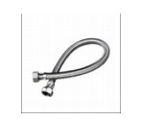
Figure 8 CONNECTING PIPE [14]

- Pressure cooker –We are using this to generate this steam as it works as a boiler.
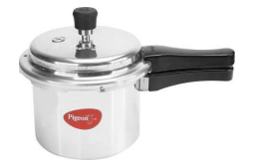
Figure 9 PRESSURE COOKER [15]

- Heat Pipe – We use this to extract heat from the water to increase the cooling tower's efficiency.
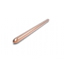
Figure 10 HEAT PIPE [16]

- Thermocouple – We are using this to measure the temperature of the steam and incoming water and outlet.
Figure 11 THERMOCOUPLE [17]

FABRICATED COMPONENTS

- Cooling tower –We are using this cooling tower to set the same condition used in the power plant.
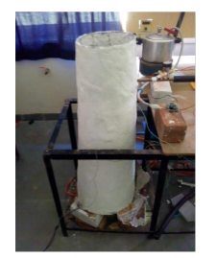
Figure 12 COOLING TOWER

- Condenser - We use this condenser to use the same condition present in the power plant condenser with the help of a pressure cooker (boiler) and copper pipes.
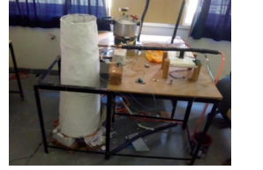
Figure 13 COOLING TOWER WITH CONDENSER

- We have manufactured a 1m height of the cooling tower of iron structure with an aluminium frame to support the system. We have kept the shape of the cooling tower as a frustum of a cone.
- Then, we coated the structure with the frame with a layer of plaster of Paris.
- We drilled a hole in the cooling tower diameter of 20mm to insert copper pipe from the condenser.
- We use counter flow concentric copper pipes with 19mm and 4.5mm diameters.
- Lengths of copper tubes are 1.4 and 1m for 16mm diameter and 4.7mm diameter pipes, respectively.

- OBSERVATIONS

Table 1 WITHOUT HEAT PIPE

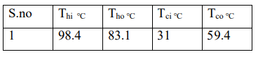
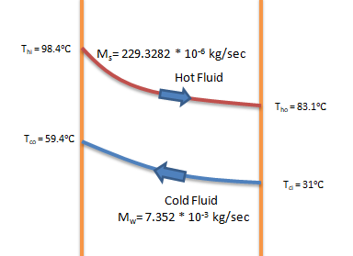
Figure 14 LMTD Curve -Without Heat Pipe

Table 2 WITH HEAT PIPE
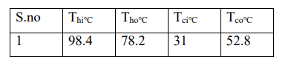
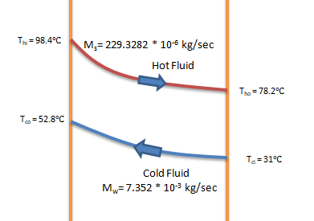
Figure 15 LMTD Curve -With Heat Pipe

CALCULATION:-
For counter flow heat exchanger
When cold fluid minimum
Effectiveness without heat pipe:-

€= (T_{hi}-T_{ho}) / (T_{hi}-T_{co})
€= (98.4-83.1) / (98.4-59.4)
€= 15.3 / 39
€= 0.3923

Effectiveness with heat pipe:-
€= (T_{hi}-T_{ho}) / (T_{hi}-T_{co})
€= (98.4-78.2) / (98.4-52.8)
€= 20.2 / 45.6
€= 0.4429

The formula used above is taken from the book of heat and mass transfer by PK Naag. [9]

- RESULTS AND DISCUSSIONS

The effectiveness of heat exchanger without heat pipe =0.3923. The point of heat exchanger with heat pipe = 0.4429. Based onthe above result,the effectiveness of the heat exchanger is increased significantly from a value of 39.23% when no heat pipe is used in arrangement to 44.29% when the heat pipes are used.
It can also be seen that using the heat pipe in an actual power plant, the efficiency of the heat exchanger is characteristically increased, thereby increasing the efficiency of the complete power plant.
So, this experiment provides essential data to indicate the use of the heat pipe in the power plant to increase the overall efficiency.

- FUTURE ENHANCEMENT

The weather around us changes rapidly, leading to air quality at different seasons, which means more load on the power plant. So, the effectiveness of the heat exchanger, which increased by 5% in our experiment, can help us think of future carbon footprint and methane gas output. The use of heat pipes in future can be helpful as they will cool the water before it enters the cooling tower on a large scale.

- CONCLUSION

The cooling tower design is closely related to tower characteristics and different types of losses generated in the cooling tower. Even though losses are caused in the cooling tower, the cooling is achieved due to heat transfer between air and water. In ideal conditions, the heat loss by water must equal the heat gained by the atmosphere. But in actual practice, it is not possible because of sun losses. Cooling tower performance increases with increased air flow rate, and characteristics decrease with increasedwater-to-air mass ratio.

- REFERENCES

- HTTPS://EN.WIKIPEDIA.ORG/WIKI/COOLING_TOWER#/MEDIA/FILE:POWER_STATION_WESTFALEN._COOLING_TOWERS.JPG
- HTTPS://MYHEATSINKS.COM/HEAT-PIPE-SOLUTIONS/STANDARD-HEAT-PIPES/
- HTTPS://EN.WIKIPEDIA.ORG/WIKI/HEAT_PIPE#/MEDIA/FILE:HEAT_PIPE_MECHANISM.SVG
- HTTPS://WWW.SCIENCEDIRECT.COM/SCIENCE/ARTICLE/PII/S03601323090017 0X
- HTTPS://WWW.RESEARCHGATE.NET/PUBLICATION/44024693_THE_PHENOM ENON_OF_EVAPORATIVE_COOLING_FROM_A_HUMID_SURFACE_AS_AN_A LTERNATIVE_METHOD_FOR_AIRCONDITIONING
- HTTPS://KUNDOC.COM/QUEUE/PDF-ENERGY-SAVINGS-IN-A-BUILDINGUSING-REGENERATIVEEVAPORATIVE-COOLING-.HTML
- HTTPS://WWW.SCIENCEDIRECT.COM/SCIENCE/ARTICLE/PII/S03787788100037 86
- HTTP://SHODHGANGA.INFLIBNET.AC.IN/BITSTREAM/10603/11543/7/07_CHAP TER%202.PDF.
- HTTPS://WWW.SAPNAONLINE.COM/BOOKS/HEAT-MASS-TRANSFER-PK-NAG-0070702535-9780070702530
- HTTPS://WWW.ENERTRON-INC.COM/PRODUCTS/SELECTING-HEAT-PIPE/
- HTTPS://SHOP.CLARIONCOMPUTERS.IN/PRODUCT/ASUS-ROG-STRIX-XF120-PWM-CABINET-FAN/
- HTTPS://WWW.TRADEINDIA.COM/PRODUCTS/COOLER-PUMP-333-C6006200.HTML
- HTTPS://WWW.BOBVILA.COM/ARTICLES/COPPER-PIPE-TYPES/
- HTTPS://WWW.PEPPERFRY.COM/STAINLESS-STEEL-CHROME-PLATED-CONNECTING-PIPE-LENGTH-39-5-INCHES-BY-R-N-1779986.HTML
- HTTPS://WWW.AMAZON.COM/HAWKINS-CLASSIC-ALUMINUM-PRESSURE-COOKER/DP/B000E7BX96
- HTTPS://IN.ELEMENT14.COM/CCI/00C93480101/HEAT-PIPE-300MM-8MM-DIA/DP/1373311
- HTTPS://PI-PLATES.COM/THERMOPLATE/

