Book Chapter/V-12

Drying strategies in tea (Camellia sinensis L.) preparation marks footprint from individual to environmental health
Ajay Singh¹, Kumar Abbhishek², Shiladitya Dey³, Priyanka Joshi^{4*}
¹Agricultural and Food Engineering Department, Indian Institute of Technology Kharagpur, Kharagpur–721302, India.
²School of Life Sciences, Indira Gandhi National Open University (IGNOU) New Delhi, New Delhi–110068, India.
³Department of Microbiology, University of Calcutta, Calcutta–700073, India.
⁴International Crops Research Institute for Semi-Arid Tropics (ICRISAT), Patancheru, Hyderabad–502324, India
*Corresponding author:
Dr. Priyanka Joshi
Project Scientist
Accelerated Crop Improvement, Global Research Program
International Crops Research Institute for Semi-Arid Tropics (ICRISAT)
Patancheru, Hyderabad–502324, India
Email: j.priyanka@cgiar.org
Phone: +91 9713695806

ACKNOWLEDGEMENTS
Ajay Singh thanks the Ministry of Education, GoI, for supporting through MHRD Fellowship.

KEYWORDS: Green tea, Oolong tea, Drying methods, Carbon footprint
RUNNING TITLE: Biochemical properties of Tea

HIGHLIGHTS
- Study shows significant variations in chemical properties of oolong and green tea
- Freeze drying is a better option than microwave drying
- Drying process is one of the major energy consuming processes during tea preparation
- Tea preparation processes should be modified to make them more carbon neutral and energy-efficient

Graphical abstract

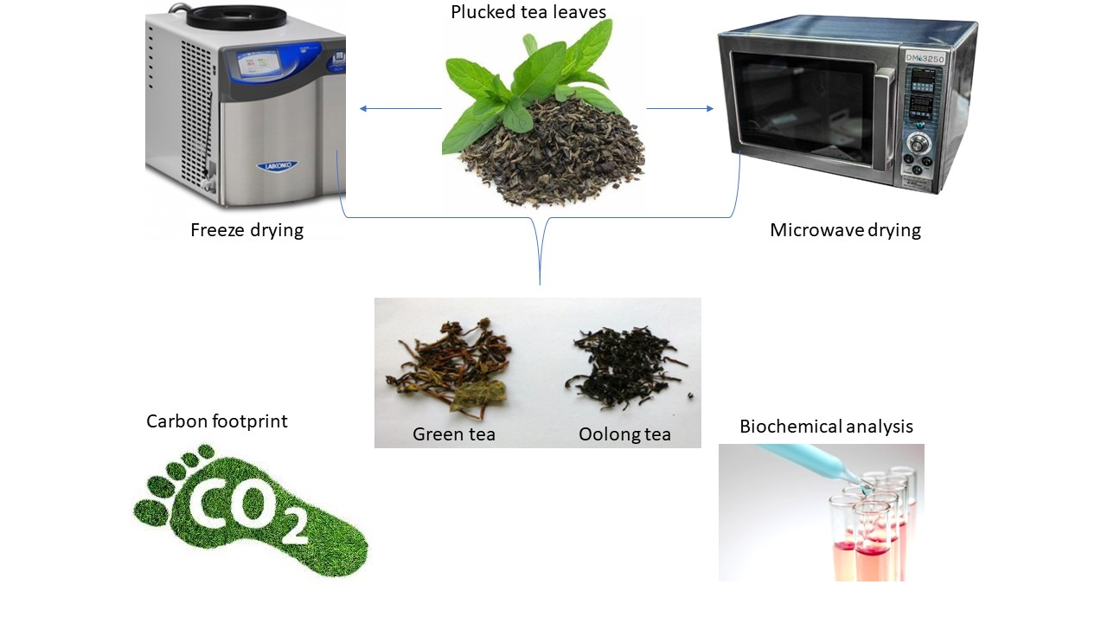

ABSTRACT
Tea (Camellia sinensis L.), an aromatic beverage with global reach needs sustainable interventions to improve its ameliorating medicinal properties. The health benefits relate to the biochemical properties of tea. The evidence from in vitro studies indicate the dependence of biochemical properties on the methods of tea processing and steps followed. We analyzed the variation in bio-chemical properties of oolong and green tea (Camellia sinensis) under two different drying methods, i.e., microwave and freeze drying. Oolong tea refers to a unique preparation process where leaves are first semi-fermented and then dried whereas green tea refers to freshly plucked leaves, directly dried without any fermentation. We compared the freeze-dried and microwave dried samples of both oolong and green tea and observed their performance in terms of rehydration ratio, chlorophyll content, TPC, TFC values and DPPH radical scavenging activity. Our results clearly indicate an improvement in pharmacological properties of tea with the strategic changes in drying process. Furthermore, we also report that despite the superior quality of tea under the freeze-drying method, the process consumes 57% higher energy than microwave drying. Our finding necessitates production technology to be more energy efficient and viable for both oolong and green tea.

INTRODUCTION

Tea (Camellia sinensis L.) is the second most consumed nonalcoholic beverage, next to water (Van Der Wal & Sanne, 2008). However, the current tea production process consumes nearly 0.67kWh of energy to produce one kg of tea (Kumar et al., 2021). The more energy demand has associated carbon footprints. Therefore, the process needs to be analyzed in terms of cost to the environment. The method of tea preparation involves different processes like withering, fermentation, drying, and sorting. According to the extent of fermentation, tea is divided into several types, namely green tea (non-fermented), oolong tea (semi-fermented) and black tea (fully fermented) (Chaturvedula et al., 2011). Among these types, green tea is the most important and favored tea due to antioxidants/polyphenols associated with beneficial health aspects (Lee et al., 2008; Armoskaite et al., 2011).
A typical tea shoot comprises an apical bud and two tender leaves containing about 10–30% polyphenolic compounds (Li et al., 2013). Polyphenols are naturally occurring secondary metabolites found in plants (El Gharras & Hasna, 2009). Tea has strong antioxidant properties due to these polyphenolic compounds (Gardner et al., 2007). The Major roles of antioxidants are to prevent detrimental oxidative damage caused to cells by the reactive oxygen species (ROS) (Winterbourn & Christine, 2008). However, they may also aid in the prevention of a wide range of diseases, including cardiovascular disease (Zaveri & Nurulain, 2006), cancers (Kris-Etherton et al., 2002), cerebral damage (Suzuki et al., 2004), diabetes (Vinson & Zhang, 2005). They are also reported to have an anti-carcinogenic effect (Cabrera et al., 2006).
Nevertheless, the acceptability of any preparation depends upon the quality of tea. Taste, astringency, aroma, and color are essential parameters that determine the quality of tea (Liang et al., 2003; Perumalla & Hettiarachchy, 2011). Additionally, these characteristics primarily depend upon the biochemical constituents of tea (Rossetti et al., 2009; Chaturvedula et al., 2011; Li et al., 2013). Polyphenolic constituents play important roles in determining the color of infused tea (Kumar et al., 2011). Characteristic aroma and taste can be attributed to several volatile and non-volatile compounds (Wang et al., 2010). Astringency of tea is primarily due to catechins (Rossetti et al., 2009).
Catechins are the groups consisting of hydroxylated flavanols and their gallic acid esters, namely, catechin, epicatechin, gallocatechin, epicatechingallate, epigallocatechin and epigallocatechin gallate (Zaveri & Nurulain, 2006). However, in green tea, the inactivation of enzymes like polyphenol oxidases prevents the oxidation of catechins (Babu et al., 2008). In black and oolong tea, phenolase-catalyzed oxidation of catechins results in the formation of dimeric theaflavin and polymeric thearubigins during fermentation (Łuczaj & Skrzydlewska, 2005). Nevertheless, the release of these compounds depends on different processing parameters and methods (Chen et al., 2010).
Multiple health benefits budding from associated differences in biochemical properties of green and oolong tea make this study a more apposite. Neuro-degenerative amelioration and antiproliferative properties in green tea have been shown in intra-cerebroventricular (I.C.V) colchicine induced memory impairment and hypolipidemic hepatoma treated rat models, respectively (Bagchi et al., 2020; Chacko et al., 2010). Furthermore, some studies report prevention of hepatoxicity through modulation of immune system and post-initiation antitumorigenic properties of green tea catechins (Park et al., 2003; Dorchies et al., 2003). Higher levels of polyphenols in green tea may lower the blood pressure, risk of coronary heart disease, blood glucose level and body weight (Chacko et al., 2010). Nevertheless, green tea (and to a lesser extent black and Oolong teas) has more pronounced health benefits for middle aged population due to age-mediated biochemical and behavioral modulation. However, the biochemical properties of tea types can be further modulated to a larger extent with the type of drying process involved in the tea preparation (Das and Ghosh, 2018). During microwave drying, leaves undergo a much higher temperature (Li et al., 2010) than freeze-drying process (Sagar & Kumar, 2010). So, there may be a chance of degradation of biochemical compounds during this drying process which may affect the quality of tea.
In the present study, we have further explored the hypothesis that drying methods in tea processing have significant effect on associated biochemical properties of oolong and green tea. Furthermore, prepared green tea using microwave and freeze-drying processes have significant variations in some health relevant qualitative biochemical properties. Also, we have determined the energy consumption of the two drying methods to determine the carbon footprint of the whole process.
MATERIAL AND METHODS
Plant material: Fresh tea leaves (two leaves and a bud) of Camellia sinensis L., grown in the tea garden, Department of Agricultural and Food Engineering, IIT Kharagpur were collected. The garden is located in the lateritic belt of the south-western region of West Bengal and is situated at 22ᵒ 19’ N latitude and 87ᵒ 19’ E longitude at an elevation of 44.0 m above MSL (mean sea level). The average precipitation ranges from 1300 to 1500 mm.
Sample preparation: The steps of tea processing for oolong tea include withering, rolling, semi-fermentation and drying, while in green tea withering and fermentation processes are not performed. During oolong tea preparation, the plucked leaves were withered for 14 hours followed by rolling and fermentation for 40 minutes under high humid conditions (92%). After semi-fermentation, the leaves were dried using the microwave at 720 watts for 10 minutes and freeze dryer for 24 hours. In green tea processing the freshly plucked leaves were fed in a microwave dryer at 720 watts and dried for 13 minutes, while during freeze-drying the leaves were allowed for pre-freezing at -20ᵒC for 6 hours, followed by drying at -40ᵒC for 16 hours. After the drying process, the moisture content of the prepared tea was determined by Halogen Moisture Meter. In either case, the moisture content was maintained in the range of 3-5% to mark the drying process's completion.
Determination of Biochemical properties:
Rehydration Ratio: We soaked Five grams (5g) of dried tea in 150 ml of boiled water for 30 minutes and calculated the rehydration ratio as explained in Lin et al. (2010).
$$R=\frac{Ma}{Mb}$$
where Ma = Tea weight after soaking in grams and Mb= Tea weight before soaking
Chlorophyll content: We measured the chlorophyll content of different preparations following the spectrophotometric method of Devmalkar et al. (2014) with some modifications. We took 100mg of tea sample and soaked it in 80% acetone for 10 minutes. The solution was filtered by whatman no.1 filter paper and absorbance were measured at 663nm and 645nm. The chlorophyll content is determined using the following formula:
$$Chlorophyll content \left(\frac{mg}{g}\right): \frac{\left(20.2*OD645+8.02*OD663\right)*Volume }{100*DW}$$
Total polyphenol content: We determined the total polyphenol content (TPC) by Folin–Ciocalteu’s reagent (FCR) method (Pinelo et al., 2004). We soaked the samples (400mg) in 20ml of 50% ethanol for 24 hours. The sample was then filtered with Whatman no.1 filter paper. The extracted sample (500µl) was mixed with 25ml of Folin-Ciocalteu solution and 7.5% sodium carbonate and heated at 45ᵒ C for 15 minutes. After that, OD values were taken at 765nm against 80% ethanol as blank. The result was expressed in gallic acid equivalent. The calibration equation for gallic acid is presented in Table 1.
Table 1 goes here
Total flavonoid content (TFC): TFC was measured spectrophotometrically (Roshanak et al., 2015). Tea extract was prepared following the same procedure as TPC and a 500 µl aliquot was mixed with 2ml distilled water, followed by the addition of a NaNO₂ solution (5%, 0.15ml). The mixture was left for 6 minutes. AlCl₃ (10%, 0.15 ml) was added to the mixture followed by NaOH solution (4%, 2ml). Distilled water was added to make the final volume of 5ml. The mixture was left for 15 minutes and OD value was taken at 510nm. The calibration equation for quercetin is provided in Table 1.
2, 2-diphenyl 1, 1-picrylhydrazyl (DPPH) radical scavenging activity: The ability of tea extracts to scavenge free radical was assessed using the DPPH method described by Stankovic et al. (2012). The stock solution was prepared in 50% ethanol to get different phenolic concentrations. 100 µl of solutions were mixed with 5ml DPPH solution and kept in the dark at room temperature for 30 minutes. After that, OD was measured at 517nm. The Calibration equation used in the process is presented in Table 1.
We have calculated the Radical scavenging activity according to the formula of Yen & Duh (1994).
$Percent inhibition: \frac{(Ab-Aa)}{Ab}*100$
where, Ab = absorption of blank sample (t=0), Aa = absorption of tested extract solution (t=T)
Energy calculation: Total energy consumed during each treatment was calculated by adding the amount of energy consumed in different operations such as withering, drying etc. Because the fermentation and rolling of all the samples were done in a natural environment, no energy was consumed during fermentation and rolling (human resource is not taken into consideration). Therefore, energy consumed in withering and drying was added to obtain the total energy consumption for all the treatments.
Carbon footprint: In our calculations for carbon footprint for various drying methods used in the preparation of green and oolong tea, we convert kWh to kg of carbon released based on Greenhouse conversion factors (GHG report, U.K., 2018). The factor includes carbon emissions generated by power stations, including greenhouse gasses such as methane and nitrous oxide, which are converted to their carbon dioxide equivalents so that the value is reported in kg CO₂ eq. per kWh.
Statistical Analysis: All data were analysed statistically following standard analysis of variance techniques, i.e., CRD with 4 replications described by Gomez and Gomez (1984). Treatment difference was tested at a 5% significance level by F test. The critical difference was calculated wherever “F” was significant. The correlation was performed using Microsoft Excel.
RESULTS AND DISCUSSION
Rehydration ratio: Test for rehydration ratio demonstrates the ability of dried materials to absorb water (Khaskheli et al., 2014). The rehydration capability of a dried food material is primarily a parameter of cellular damage (Bilbao-Sáinzet et al., 2005). Drying methods significantly impact the rehydration ratio (Lin et. al, 2010). Our study indicates that freeze-dried samples show a higher rehydration ratio than leaves dried in a microwave dryer (Fig.1).
Fig.1 goes here
During drying high temperature leads to water loss from cells, leading to irreversible cell damage in various ways that include loss of cellular integrity, causing gradual loosening of the hydrophilic property of cells (Giraldo et al., 2006). However, during freeze-drying, the least amount of cellular damage and the porous product is produced because of the low drying temperature (-40°C) (Marques et al., 2009). The microwave drying process employs an internal heating system with less shrinkage of cells, a more porous structure and less cellular damage (Lin et al., 2010), but the higher temperature during drying might cause a lower rehydration ratio.
Chlorophyll Content: It has been suggested by many authors that chlorophylls act as an important factor in determining tea soup color (Xu & Chen, 2002; Zhen & Yong-Su, 2003; Ostadalova et al., 2015). In tea leaves, the amount of chlorophyll a is much higher than chlorophyll b (Zhen & Yong-Su, 2003). During processing and stoarage maximum degradation of chlorophyll occurs (Xu et al., 2002). Drying temperature and duration of drying are the major factors (Roshanak et al., 2016) that determines the magnitude of chlorophyll degradation. The highest amount of chlorophyll content was obtained in freeze-dried (green tea: 4.79 mg/g; oolong tea: 2.81mg/g) samples in both oolong and green tea followed by microwave dried products in both tea types (Fig.1). The results are in agreement with the result found by Negi et al. (2000). During drying, magnesium in chlorophyll is replaced by hydrogen atoms forming pheophytin which occur in presence of organic acids like oxalic acid (Arslan & Ozcan 2010).
Polyphenol and Total flavonoid content: Flavonoids are a large family of secondary plant metabolites comprising about 4000 components such as anthocyanine, flavanol, flavones (Harborne, 2013). They are mostly found as O-glycosides with sugar bound at C-3 position. The idea of the test was to evaluate the changes in total polyphenol and flavonoid content in both oolong and green tea made by microwave and freeze-drying processes. The result shows higher total polyphenol (oolong tea: 73.75, Green tea: 83.39) and flavonoid content (oolong tea: 16.20, Green tea: 33.28) in the freeze-dried sample in both tea types (Fig.2). The probable reason for lower TPC and TFC values in microwave drying might be higher processing temperature due to the dielectric heating principle of microwave dryers (Khraisheh et al., 1997).
Fig.2 goes here
Furthermore, according to the microwave working principle, the waves are absorbed by water molecules that intensify the heating of the target molecule (Li et al., 2011). During freeze-drying, ice crystals are produced within the leaves that rupture plant cell structure and cause better access to extraction solvent (Asami et al., 2003; Chan et al., 2009). Low temperature also prevents the action of destructive enzymes that might lower cellular polyphenol content (Chan et al., 2009). Previous reports suggest that Polyphenol oxidase degrades some amount of TPC before the enzyme becomes completely inactivated (Ahmed et al., 2014; Lim and Murtijaya, 2007).
DPPH radical scavenging activity: Hydroxyl groups present on the aromatic rings of phenolic compounds contribute to the scavenging activity via hydrogen or electron transfer (Villano et al., 2007). In C. sinensis these phenolic compounds are present in the form of catechins and a few other forms that play a major role in scavenging free radicals (Frei et al., 2003). The samples showed a dose dependent scavenging activity. The graph was plotted using extract concentration against scavenging ability and specific concentration of the sample for 50% inhibition (IC50) was calculated (Fig.3).
Fig.3 goes here
Freeze dried samples showed higher radical scavenging activity in both oolong and green tea. This could be due to high total polyphenol content in freeze-dried samples owing to low-temperature treatment (Zheng et al., 2001). On the other hand, microwave drying employs higher temperature for drying than freeze drying (Larrauri et al., 1997). Some antioxidant degrading enzyme activity is also favored at high temperature (Lim and Murtijaya, 2007). It is well known that phenolics play a major role in protecting the plant from stress related damage. Reports suggest there is a correlation between phenolic compounds and antioxidant capacity (Rice et al., 1996; Frei, Balz, and Jane V. Higdon., 2003; Paśko, Paweł, et al., 2009). Our results also show a strong positive correlation between TPC, TFC and TPC, DPPH activity with Pearson's r equals to 0.90, 0.91, respectively. However, DPPH radical scavenging activity was not significantly (p<0.05) correlated with TFC observed in both oolong and green tea.
Energy Consumption and Carbon footprints: We present the variation in moisture content, energy consumption and carbon footprint for different types of tea preparation in Fig.4. the initial moisture content of fresh leaves was 78% and the final moisture content was reduced to 4%. Therefore, approximately 74% moisture was removed in both tea types. It is observed that the freeze-drying technique consumed 25.6 and 20.4 MJ/kg of thermal energy for oolong and green tea, respectively. Microwave drying consumes 13.96 and 8.76 MJ/kg for oolong and green tea, respectively. This indicates that energy consumption by microwave drying is approximately 57% less than freeze-drying leading to less production cost for production of the same amount of tea.
Fig.4 goes here
Carbon footprint calculation indicates that the freeze-drying process has more impacts on the environment than micro-wave drying methods. The 30% higher emissions in freeze-dried green tea than micro-wave dried green tea demands regulating the operations and making the process more energy efficient. Nevertheless, 60% higher emissions in preparation of micro-wave dried oolong tea compared to a similar type of green tea guides our preference considering the impacts on the ecosystem.
CONCLUSIONS
This study opens a new vista to the merits and demerits of freeze-drying and microwave drying during tea processing which will be preferred as per requirement. Irrespective of the type of tea (green tea or oolong tea) freeze-drying proved to be better in retaining the phytochemical properties than microwave drying. The health-promoting effects of green tea can be better preserved with microwave drying. The higher perseverance of catechins with freeze-drying of tea can potentiate them better as anti-tumorigenic agents and immune modulators in immune-dysfunction. Furthermore, more preserved polyphenols and flavonoid content in green tea with freeze drying can improve its effectiveness in treating diarrhea, typhoid, and H. pylori infection. Although, our study has shown improved biochemical constituents of tea types with modified drying process, it can be beneficial up to certain doses only. We agree with the findings of earlier studies that higher doses of tea constituents may cause some unknown adverse health effects. Therefore, a rigorous evaluation of such improvements in biochemical properties of tea on animal models are required. Nevertheless, our study shows for the first time that the freeze-drying process consumes 57% more energy than microwave drying. This might lead to a higher cost to the environment in the freeze-drying process despite better quality tea. However, our study paves the way to selectively improve certain beneficial and medicinal properties of tea through modulation in drying process.

Declaration of interest
The authors declare that they have no known competing financial interests or personal relationships that could have appeared to influence the work reported in this paper.

REFERENCES
Armoskaite, V., Ramanauskiene, K., Maruska, A., Razukas, A., Dagilyte, A., Baranauskas, A., & Briedis, V. (2011). The analysis of quality and antioxidant activity of green tea extracts. Journal of Medicinal Plants Research, 5(5), 811-816.
Arslan, D., & Özcan, M. M. (2010). Study the effect of sun, oven and microwave drying on quality of onion slices. LWT-Food Science and Technology, 43(7), 1121-1127.
Asami, D. K., Hong, Y. J., Barrett, D. M., & Mitchell, A. E. (2003). Comparison of the total phenolic and ascorbic acid content of freeze-dried and air-dried marionberry, strawberry, and corn grown using conventional, organic, and sustainable agricultural practices. Journal of agricultural and food chemistry, 51(5), 1237-1241.
Babu, A., Pon, V., & Liu, D. (2008). Green tea catechins and cardiovascular health: an update. Current medicinal chemistry, 15(18), 1840-1850.
Bilbao-Sáinz, C., Andrés, A., & Fito, P. (2005). Hydration kinetics of dried apple as affected by drying conditions. Journal of food Engineering, 68(3), 369-376.
Cabrera, C., Artacho, R., & Giménez, R. (2006). Beneficial effects of green tea—a review. Journal of the American College of Nutrition, 25(2), 79-99.
Chan, E. W. C., Lim, Y. Y., Wong, S. K., Lim, K. K., Tan, S. P., Lianto, F. S., & Yong, M. Y. (2009). Effects of different drying methods on the antioxidant properties of leaves and tea of ginger species. Food chemistry, 113(1), 166-172.
Chaturvedula, V. S. P., & Prakash, I. (2011). The aroma, taste, color and bioactive constituents of tea. Journal of Medicinal Plants Research, 5(11), 2110-2124.
Chen, Y. L., Duan, J., Jiang, Y. M., Shi, J., Peng, L., Xue, S., & Kakuda, Y. (2010). Production, quality, and biological effects of oolong tea (Camellia sinensis). Food Reviews International, 27(1), 1-15.
Devmalkar, V. S., Murumkar, C. V., Salunkhe, S. M., & Chavan, S. J. (2014). Studies on pigment chlorophyll isolation and estimation of different bryophytes for their biochemical properties. Journal of Natural Product and Plant Resources, 4(2), 56-61.
El Gharras, H. (2009). Polyphenols: food sources, properties and applications–a review. International journal of food science & technology, 44(12), 2512-2518.
Frei, B., & Higdon, J. V. (2003). Antioxidant activity of tea polyphenols in vivo: evidence from animal studies. The Journal of nutrition, 133(10), 3275S-3284S.
Gardner, E. J., Ruxton, C. H. S., & Leeds, A. R. (2007). Black tea–helpful or harmful? A review of the evidence. European journal of clinical nutrition, 61(1), 3.
Giraldo, G., Vázquez, R., Martín-Esparza, M. E., & Chiralt, A. (2006). Rehydration kinetics and soluble solids lixiviation of candied mango fruit as affected by sucrose concentration. Journal of food engineering, 77(4), 825-834.
Gomez, K. A., & Gomez, A. A. (1984). Statistical procedures for agricultural research. John Wiley & Sons.
Harbowy, M. E., Balentine, D. A., Davies, A. P., & Cai, Y. (1997). Tea chemistry. Critical reviews in plant sciences, 16(5), 415-480.
Kumar, P. S., Basheer, S., Ravi, R., & Thakur, M. S. (2011). Comparative assessment of tea quality by various analytical and sensory methods with emphasis on tea polyphenols. Journal of food science and technology, 48(4), 440-446.
K. Ravi Kumar, Kavya Dashora, Naveen Krishnan, S. Sanyal, Hukum Chandra, S. Dharmaraja, Vandita Kumari (2021). Feasibility assessment of renewable energy resources for tea plantation and industry in India - A review, Renewable and Sustainable Energy Reviews, Volume 145, 111083, ISSN 1364-0321, https://doi.org/10.1016/j.rser.2021.111083.
Kris-Etherton, P. M., Hecker, K. D., Bonanome, A., Coval, S. M., Binkoski, A. E., Hilpert, K. F., ... & Etherton, T. D. (2002). Bioactive compounds in foods: their role in the prevention of cardiovascular disease and cancer. The American journal of medicine, 113(9), 71-88.
Khraisheh, M. A. M., Cooper, T. J. R., & Magee, T. R. A. (1997). Microwave and air drying I. Fundamental considerations and assumptions for the simplified thermal calculations of volumetric power absorption. Journal of Food Engineering, 33(1-2), 207-219.
Larrauri, J. A., Rupérez, P., & Saura-Calixto, F. (1997). Effect of drying temperature on the stability of polyphenols and antioxidant activity of red grape pomace peels. Journal of agricultural and food chemistry, 45(4), 1390-1393.
Lee, S. M., CHUNG, S. J., LEE, O. H., LEE, H. S., KIM, Y. K., & KIM, K. O. (2008). Development of sample preparation, presentation procedure and sensory descriptive analysis of green tea. Journal of sensory studies, 23(4), 450-467.
Li, S., Lo, C. Y., Pan, M. H., Lai, C. S., & Ho, C. T. (2013). Black tea: chemical analysis and stability. Food & function, 4(1), 10-18.
Li, C., Yang, X., Hu, J., & Ni, D. (2013). Effect of fluoride on aroma of tea leaves. Fluoride, 46(1), 25-28.
Li, Z. Y., Wang, R. F., & Kudra, T. (2011). Uniformity issue in microwave drying. Drying Technology, 29(6), 652-660.
Li, Z., Raghavan, G. S. V., & Orsat, V. (2010). Temperature and power control in microwave drying. Journal of Food Engineering, 97(4), 478-483.
Li, Z., Raghavan, G. S. V., & Orsat, V. (2010). Temperature and power control in microwave drying. Journal of Food Engineering, 97(4), 478-483.
Lim, Y. Y., & Murtijaya, J. (2007). Antioxidant properties of Phyllanthus amarus extracts as affected by different drying methods. LWT-Food Science and Technology, 40(9), 1664-1669.
Łuczaj, W., & Skrzydlewska, E. (2005). Antioxidative properties of black tea. Preventive medicine, 40(6), 910-918.
Marques, L. G., Prado, M. M., & Freire, J. T. (2009). Rehydration characteristics of freeze-dried tropical fruits. LWT-Food Science and Technology, 42(7), 1232-1237.
Mediani, A., Abas, F., Tan, C. P., & Khatib, A. (2014). Effects of different drying methods and storage time on free radical scavenging activity and total phenolic content of Cosmos caudatus. Antioxidants, 3(2), 358-370.
Negi, P. S., & Roy, S. K. (2000). Effect of blanching and drying methods on β-carotene, ascorbic acid and chlorophyll retention of leafy vegetables. LWT-Food Science and Technology, 33(4), 295-298.
Ošťádalová, M., Tremlová, B., Pokorná, J., & Král, M. (2015). Chlorophyll as an indicator of green tea quality. Acta Veterinaria Brno, 83(10), 103-109.
Paśko, P., Bartoń, H., Zagrodzki, P., Gorinstein, S., Fołta, M., & Zachwieja, Z. (2009). Anthocyanins, total polyphenols and antioxidant activity in amaranth and quinoa seeds and sprouts during their growth. Food Chemistry, 115(3), 994-998.
Perumalla, A. V. S., & Hettiarachchy, N. S. (2011). Green tea and grape seed extracts—Potential applications in food safety and quality. Food Research International, 44(4), 827-839.
Pinelo, M., Rubilar, M., Sineiro, J., & Nunez, M. J. (2004). Extraction of antioxidant phenolics from almond hulls (Prunus amygdalus) and pine sawdust (Pinus pinaster). Food Chemistry, 85(2), 267-273.
Rahimmalek, M., & Goli, S. A. H. (2013). Evaluation of six drying treatments with respect to essential oil yield, composition and color characteristics of Thymys daenensis subsp daenensis. Celak leaves. Industrial Crops and Products, 42, 613-619.
Roshanak, S., Rahimmalek, M., & Goli, S. A. H. (2016). Evaluation of seven different drying treatments in respect to total flavonoid, phenolic, vitamin C content, chlorophyll, antioxidant activity and color of green tea (Camellia sinensis or C. assamica) leaves. Journal of food science and technology, 53(1), 721-729.
Rossetti, D., Bongaerts, J. H. H., Wantling, E., Stokes, J. R., & Williamson, A. M. (2009). Astringency of tea catechins: more than an oral lubrication tactile percept. Food Hydrocolloids, 23(7), 1984-1992.
Rice-Evans, C. A., Miller, N. J., & Paganga, G. (1996). Structure-antioxidant activity relationships of flavonoids and phenolic acids. Free radical biology and medicine, 20(7), 933-956.
Sagar, V. R., & Kumar, P. S. (2010). Recent advances in drying and dehydration of fruits and vegetables: a review. Journal of food science and technology, 47(1), 15-26.
Stankovic, M. S., Niciforovic, N., Mihailovic, V., Topuzovic, M., & Solujic, S. (2012). Antioxidant activity, total phenolic content and flavonoid concentrations of different plant parts of Teucrium polium L. subsp. polium. Acta Societatis Botanicorum Poloniae, 81(2), 117.
Suzuki, M., Tabuchi, M., Ikeda, M., Umegaki, K., & Tomita, T. (2004). Protective effects of green tea catechins on cerebral ischemic damage. Medical Science Monitor, 10(6), BR166-BR174.
Van Der Wal, S. (2008). Sustainability issues in the tea sector: A comparative analysis of six leading producing countries.
Villano, D., Fernández-Pachón, M.S., Moyá, M.L., Troncoso, A.M. and García-Parrilla, M.C., 2007. Radical scavenging ability of polyphenolic compounds towards DPPH free radical. Talanta, 71(1), pp.230-235.
Villano, D., Fernández-Pachón, M.S., Moyá, M.L., Troncoso, A.M. and García-Parrilla, M.C., 2007. Radical scavenging ability of polyphenolic compounds towards DPPH free radical. Talanta, 71(1), pp.230-235.
Vinson, Joe A., and Juan Zhang (2005) "Black and green teas equally inhibit diabetic cataracts in a streptozotocin-induced rat model of diabetes." Journal of agricultural and food chemistry 53.9: 3710-3713
Wang, K., Liu, F., Liu, Z., Huang, J., Xu, Z., Li, Y., Chen, J., Gong, Y. and Yang, X., 2010. Analysis of chemical components in oolong tea in relation to perceived quality. International journal of food science & technology, 45(5), pp.913-920.
Winterbourn, C.C., 2008. Reconciling the chemistry and biology of reactive oxygen species. Nature chemical biology, 4(5), p.278.
Xiangyang, L., Zhang, L., Lei, H., Zhang, H., Cheng, Y., Zhu, R., & Ruan, R. (2010) Effect of drying technologies on quality of green tea. International Agricultural Engineering Journal, 19(3), 30-37
Xu, N.I.N.G. and Chen, Z.M., 2002. Green tea, black tea, and semi-fermented tea. Tea: bioactivity and therapeutic potential. London: CRC Press UK, pp.35-54.
Zaveri, N.T., 2006. Green tea and its polyphenolic catechins: medicinal uses in cancer and noncancer applications. Life sciences, 78(18), pp.2073-2080.
Zhen, Y.S., 2003. The Chemistry of Tea Non-volatiles Zong-mao Chen, Hua-fu Wang, Xiao-qing You and Ning Xu. In Tea(pp. 69-100). CRC Press.
Zheng, W., & Wang, S. Y. (2001) Antioxidant activity and phenolic compounds in selected herbs. Journal of Agricultural and Food Chemistry, 49(11), 5165-5170

Figures:

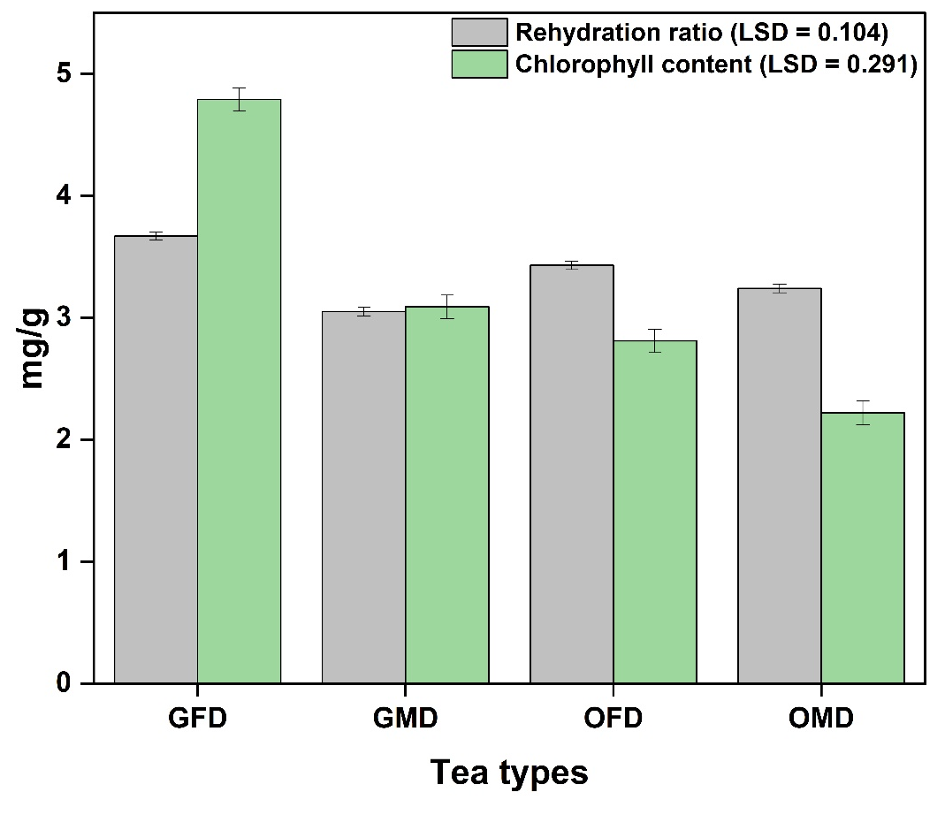
Fig.1: Variation in rehydration ratio and chlorophyll content in different tea preparations like green tea-freeze dried (GFD), green tea-microwave dried (GMD), Oolong tea–freeze-dried (OFD) and Oolong tea-microwave dried (OMD). Error bars represent the standard error of means across the treatments. LSD is the least significant difference (p<0.05).

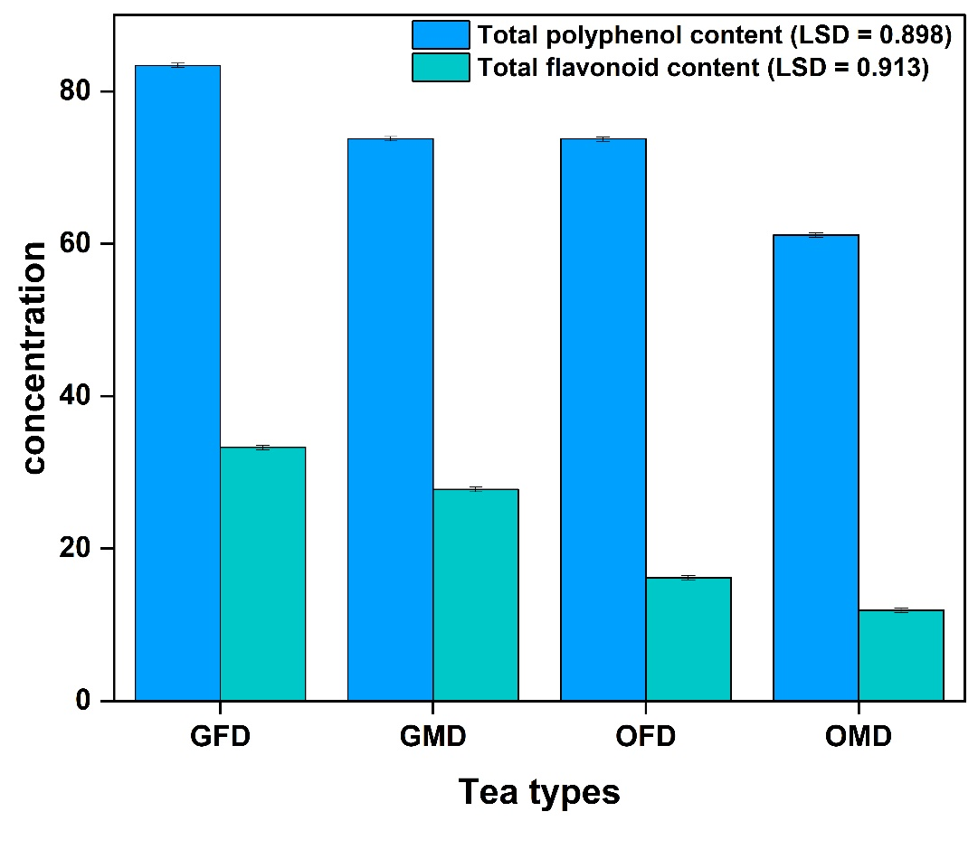
Fig.2: Variation in total polyphenol content and total flavonoid content in different tea preparations like green tea-freeze dried (GFD), green tea-microwave dried (GMD), Oolong tea–freeze-dried (OFD) and Oolong tea-microwave dried (OMD). Error bars represent the standard error of means across the treatments. LSD is the least significant difference (p<0.05).

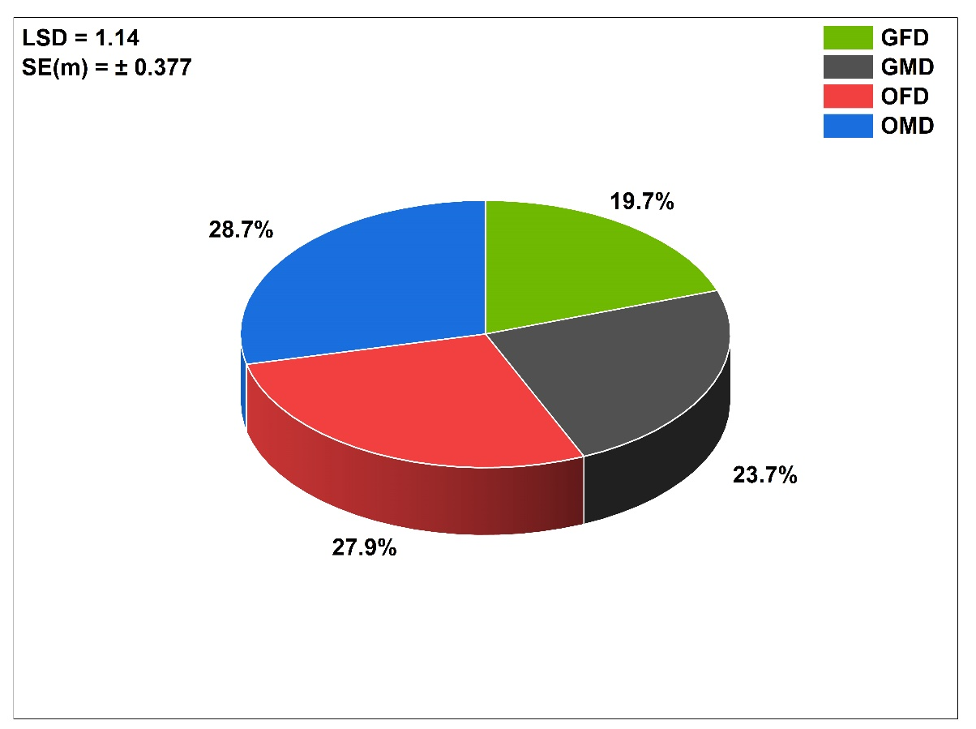
Fig.3: Variation in DPPH radical scavenging activity in different tea preparations like green tea-freeze dried (GFD), green tea-microwave dried (GMD), Oolong tea–freeze-dried (OFD) and Oolong tea-microwave dried (OMD). SE(m) represents the standard error of means across the treatments. LSD is the least significant difference (p<0.05).

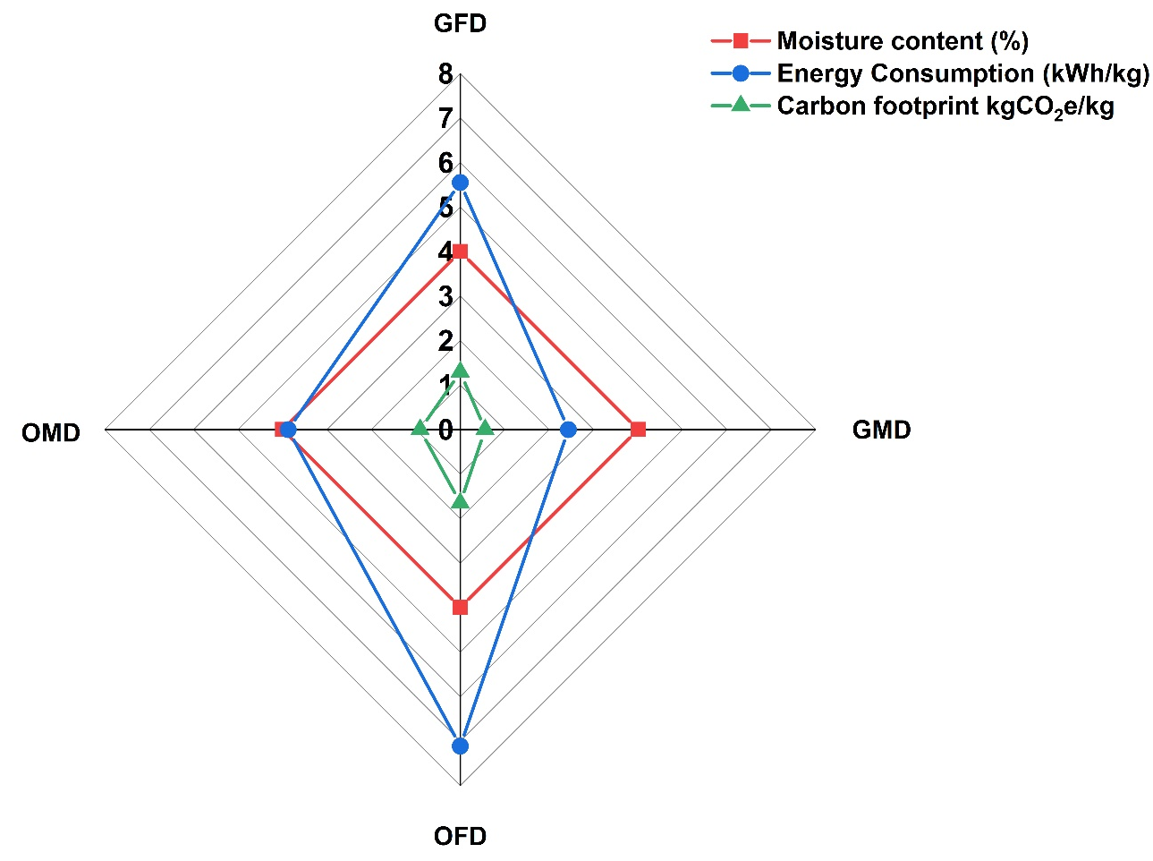
Fig.4: Variation in moisture content, energy consumption and carbon footprint of different tea preparations like green tea-freeze dried (GFD), green tea-microwave dried (GMD), Oolong tea–freeze-dried (OFD) and Oolong tea-microwave dried (OMD).

Tables
Table1: Calibration equations for polyphenol content, flavonoid content, and DPPH activity
Treatment | Calibration equation* | R²
Polyphenol Content | $$Y=0.013x+0.0368$$ | 0.978
Flavonoid Content | $$Y=0.0124x+0.011$$ | 0.985
DPPH radical scavenging activity | $$Y=0.01x+0.5042$$ | 73.75
*Equation represents the calibration curves where x: absorbance and Y: concentration (μg/ml)

