ARTIFICIAL INTELLIGENCE AND ITS ROLE IN HEALTH CARE
D. Gayathri¹ and V. Gokula²
1. Assistant Professor of Zoology, PG & Research Department of Zoology, National College, Tiruchirappalli, Tamil Nadu.
2. Associate Professor and Head, PG & Research Department of Zoology, National College, Tiruchirappalli, Tamil Nadu.
E – Mail ID: gayathridzoo@nct.ac.in
ABSTRACT
Artificial intelligence (AI) technologies have made enormous strides recently and are already pervasive in many aspects of our everyday life. Numerous attempts are being undertaken in the healthcare industry for application of technology of AI for efficient disease diagnosis. Technology of AI processes large number of medical and health care reports effortlessly by application of machine and deep learning algorithms. However, compared to current medical technology, AI technology offers a number of distinctive qualities. There are vast areas to be explored in the present health system in order to impart technology of AI in it for future betterment. Apart from the truth that not many doctors and members of the general public accept AI in healthcare, there are several worries about the security and dependability of AI technology applications. The present chapter would describe the current research and application state of AI technology in healthcare and its future perspectives.
KEYWORDS: Machine learning, Artificial Intelligence, Healthcare system and Future application.
- INTRODUCTION
The majority of facets of contemporary life, including entertainment, business, and health care, are being impacted by big data and machine learning. Google is aware of the ailments and symptoms people are searching for, just as Google, Netflix is aware of the movies and television shows people choose to watch and Amazon categorises people according to their choice of purchase of things. All of this information may be utilised to create incredibly thorough personal profiles, which have the potential not only for incredibly beneficial behavioural understanding and targeting, but also for forecasting healthcare trends. There is a lot of hope that artificial intelligence (AI) will significantly advance every aspect of healthcare, from diagnosis to therapy. Numerous examples of activities where AI algorithms are operating on par with or better than humans include the analysis of medical imaging and the correlation of sensations and indicators from Electronic Medical Records (EMRs) with the diagnosis and prediction of the disease condition [1]. The need for healthcare services is growing, and many nations are struggling with a lack of healthcare professionals, particularly doctors. Healthcare institutions are likewise struggling to stay up with all the latest technology advancements and consumers' high expectations for service levels and results, as they have grown to expect from consumer products like those from Amazon and Apple [2]. In addition to opening up options for on-demand healthcare services utilising health tracking applications and search platforms, advancements in wireless technology and cell phones have also made remote encounters, which are accessible everywhere and anytime, as a new method of delivering healthcare. Such services assist to save expenses and prevent unnecessarily being exposed to infectious diseases at the clinics, which is prerequisite for impoverished areas and those without experts for medical care [3].
Various initiatives to create and market AI-based medical gadgets have also been made. Leading international Information Technology (IT) companies like Samsung, Google, Apple, Microsoft, and Amazon, as well as numerous competitive start-ups, have showed substantial interest in the development training pertaining to use of AI in healthcare. These companies join top medical device producers like General Electric, Siemens, and Phillips in this category and are aiming to develop business achievements as well, based on these scientific accomplishments. Additionally, the initiatives of the medical community and business people have helped the governing agencies to authorize AI-based medical products. The Food and Drug Administration (FDA) in the United States initially authorised the use of AI-based medical devices in 2017, and the Ministry of Food and Drug Safety in Korea has done the same since 2018.
The healthcare industry is beginning to recognise the significance of AI-powered technologies in the modern medical technology. It is thought that AI may enhance any procedure used in the operation and provision of healthcare. For instance, the ability of AI to reduce costs for the healthcare system is a key factor in the adoption of AI applications. In 2028, it is predicted that AI applications would reduce US healthcare spending by $150 billion annually. The shift from a reactive to a proactive treatment strategy which emphasises health maintenance rather than illness treatment is largely responsible for these cost savings. This is anticipated to lead to a decrease in hospital stays, medical visits, and treatments. Through continuous supervision and training, AI-based technology will play a significant part in assisting individuals in maintaining their health by ensuring appropriate detection, customised treatments, and more effective follow-ups. By 2026, the market for AI-related healthcare is projected to develop quickly and reach USD 6.6 billion, or a 40 per cent compounded yearly growth rate [4]. Numerous obstacles must be overcome in order to adopt and apply AI technology in the real medical setting and deliver significant results to everyone engaged in providing healthcare, including physicians and patients. As a result, this chapter examines the state of recent breakthroughs in AI technology in the field of healthcare.

- SIGNIFICANCE OF AI IN HEALTHCARE
Technology of AI has a bright futuristic front in health sector as it has vast dealing with psychological status of a patient (Fig. 1). In particular, with the advent of deep learning technology, the performance of data mining algorithms for analytical thinking has dramatically improved, and the capacity of AI technology to analyse data patterns has grown close to that of a typical human capacity for certain jobs (e.g., image recognition and speech recognition) [5]. Deep learning algorithms are being actively employed in tasks involving medical data because they are based on artificial neural networks that resemble the biological neural networks and can learn highly complicated nonlinear correlations [6].
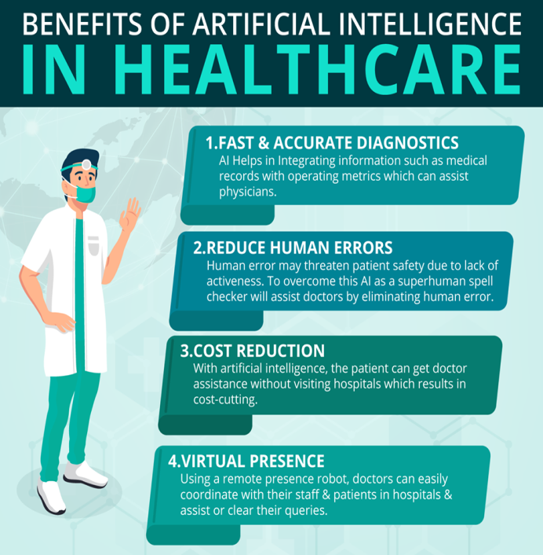
Fig. 1: Represents the benefit of AI in Healthcare System

- AI in Medical Image Analysis:
Medical imaging has reached greater heights with advent of machine and deep learning methods that employ pictures, including pathology, dermatology, cardiology, gastrointestinal, and ophthalmology. To analyse or categorise the seriousness of the malady, machine-learning calculations utilize information from computed tomography (CT), attractive reverberation imaging (MRI), ultrasound, pathology, fundus picture, and endoscope [7 – 13]. Convolutional neural arrange calculation, one of a few profound learning calculations, keeps up solid execution in picture design investigation and has appeared to be supportive in surveying restorative pictures with complicated design [14, 15]. One good thing about chest CT conclusion, Siemens Wellbeing made AI-based AI-Rad Companion Chest CT program [16]. GE Healthcare is additionally creating AI-based restorative picture innovation. Moreover, Philips Healthcare is endeavoring to showcase its Intelli Site Pathology Arrangement within the domain of advanced pathology diagnostics and has made Intelli Space Revelation, an open stage for AI investigation and execution [17]. For the creation of the Therapeutic Imaging Cloud AI stage, Arterys' Cardio AI, Liver AI, and Lung AI program have obtained FDA authorization [18]. In expansion to the occasions portrayed over, a number of businesses—including Zebra Restorative Vision and AI doc—are looking for to advertise AI-based therapeutic picture examination and innovations. By getting authorization from the Service of Nourishment and Sedate Security, a number of companies in Korea, including Vuno, Lunit, JLK Assessment, and Deepnoid, have started commercialising AI-based restorative picture examination (Fig. 2).
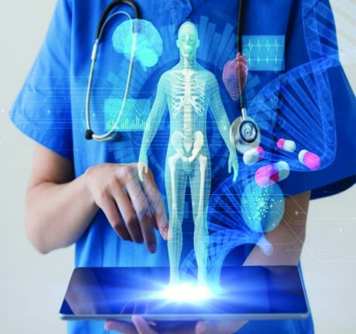
Fig. 2: Represents the AI based Medical imaging of Human body

- AI enabled IoT Devices and Diagnostic Tools:
The improvement and commercialization of items and administrations that can offer assistance clients progress their wellbeing by gathering wellbeing information from standard of living employing a combination of Internet of Things (IoT) advances and wearable gadgets could be a fervently challenged showcase among various innovation behemoths like IBM, Google, Apple, and Samsung. In 2017, after getting FDA consent, Apple included a profound learning framework that can recognize atrial fibrillation to its wristwatch. AI empowered IoTs learn the user's typical heart rates amid rest and work out utilizing photoplethysmography and accelerometer sensors, and convey a caution flag in case there's a huge takeoff from the anticipated values (Fig. 3). The profound learning calculation accurately deciphers Electro Cardio Gram (ECG) information as well. A profound learning framework was utilized to assess 91,232 single-lead ECGs in a later research, and the results illustrated great demonstrative execution comparable to that of cardiologists. Patients with a cardiovascular ailment or unremitting renal malady with sharp blood potassium levels would advantage most from the application of the ECG design investigation strategy to shrewd gadgets [19]. Other cutting-edge therapeutic contraptions are too being made by worldwide enterprises, such as non-invasive glucose meters [20, 21]. In expansion to determining and identifying disarranges based on the assembled real-time information, such bio-signal reconnaissance gadgets might well be used for infection conclusion and treatment in different healing center settings, such as the intense care setting, working room, crisis room, and recuperation room. The association between Medtronic and IBM to make Sugar IQ, a diabetes administration framework has been established [22]. Besides, machine learning has been utilized in cases of in-vitro discovery of maladies like tuberculosis and dementia. Meanwhile, ponders have revealed that detailed enhancement in demonstrative affectability and specificity by applying machine learning to multi-biomarker investigation have been utilized in real-world cases to classify cancer-related biomarkers [23, 24, 25 and 26].
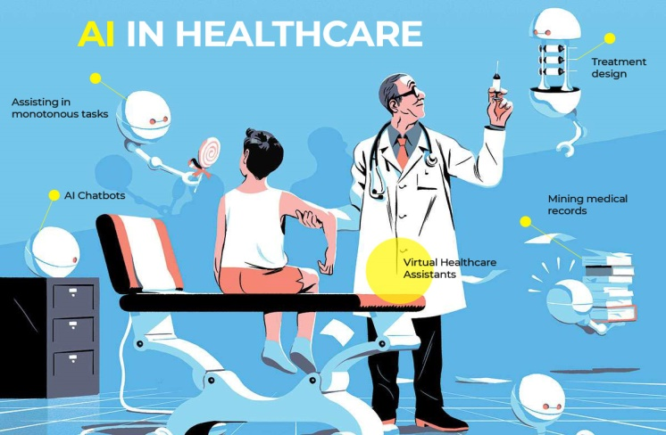
Fig. 3: Represents the AI based IoT Devices and Diagnostic Tools

- Utility of AI in Maintaining Electronic Medical Record (EMR):
A few endeavors are presently being done to form AI frameworks utilizing EMRs. Within the US, EMR firms including All scripts, Athena Wellbeing, Cerner, e Clinical Works, and Epic are investigating how to utilize AI to move forward healing centered treatment methods [27]. EvidNet is creating multi-hospital clinical huge information examination innovation in Korea based on shared information models, observational wellbeing information sciences, and informatics (CDM) [28, 29]. Moreover, IBM has created Watson for Oncology, which offers cancer patients the foremost individualized treatments, and its clinical trials are presently beneath advance [30]. In terms of Korean businesses, Selvas AI and Line Strolls are carrying out comparable investigations (Fig. 4).
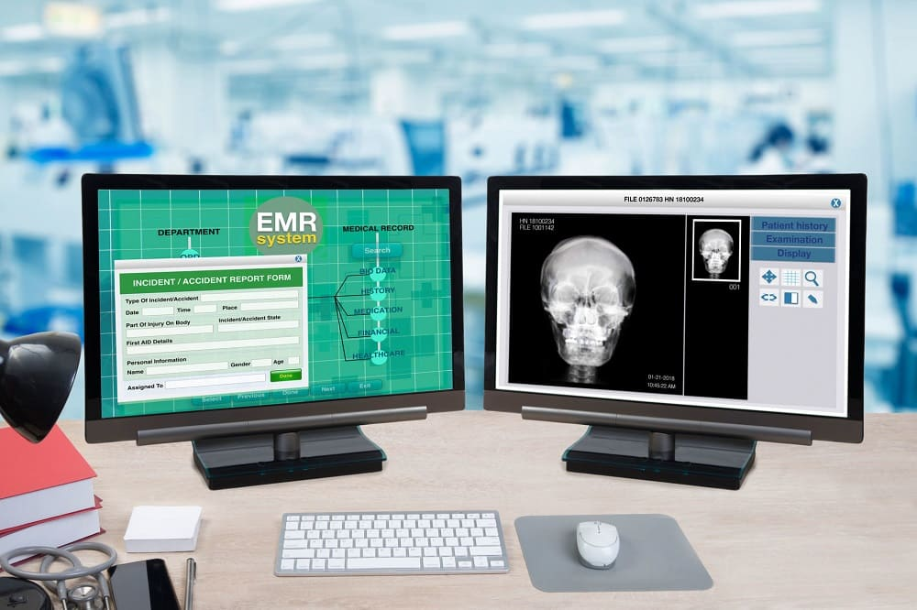
Fig. 4: Represents the AI based Electronic Medical Records
- PROBLEMS INVOLVED IN AI EMBEDDED HEALTHCARE SYSTEM
- Safety and Liability Issues:
In the case of a medical mishap, the current healthcare system presumes that the medical personnel are solely to blame. AI-based
medical technology has the potential to impair doctors' judgement in a variety of ways and occasionally have unfavourable
effects that lead to medical errors. Liability difficulties would develop in such situations, and under the existing healthcare
system, it is quite possible that the medical facility or the doctors who introduced the AI-based medical technology would be
held accountable. As a result, doctors must develop their ability to apply and comprehend AI algorithms as well as be aware of
any potential legal ramifications of doing so [31]. Additionally, efforts should be undertaken in academia and politics to clarify
the liability concerns and assess the risks of medical accidents based on the varied characteristics of AI technology [32]. New
regulations should be put in place for the construction and operation of AI monitoring centres at healthcare facilities as well as a
national safety monitoring centre to keep an eye on the security of AI-based medical technology. Additionally, a framework for
assessing culpability and raising patient and medical staff knowledge of medical errors that may occur while using AI-based
medical technology has to be devised.

- CONCLUSION
Future health care and present medical technology are predicted to benefit from improvements brought forth by AI technologies.
By analysing the acquired medical data, the currently available AI-based health care technologies have demonstrated
exceptional achievements in properly diagnosing and categorising patient states as well as forecasting the progression of
illnesses. Therefore, it is anticipated that these technologies will help the medical team in making therapeutic decisions and
ultimately improve the outcomes of those treatments. However, there are currently a number of concerns about privacy,
dependability, safety, and responsibility with AI-based health care solutions. In addition to technology breakthroughs,
widespread public knowledge of AI, the creation of defined rules, and systematic improvements will be necessary in the future
for the AI technologies to be more actively employed in health care.
REFERENCES

1. Miller DD, Brown EW. Artificial intelligence in medical practice: the question to the answer? Am J Med 2018; 131(2):129
– 133.
2. Kirch DG, Petelle K. Addressing the physician shortage: the peril of ignoring demography. JAMA 2017; 317(19):1947 -
1948
3. Combi C, Pozzani G, Pozzi G. Telemedicine for developing countries. Appl Clin Inform 2016; 07 (04):1025 - 1050.
4. Bresnick J. Artificial intelligence in healthcare market to see 40% CAGR surge; 2017.
5. Erickson BJ, Korfiatis P, Akkus Z, Kline TL. Machine learning for medical imaging. Radiographics. 2017; 37(2): 505 - 515.
6. Hu W, Cai B, Zhang A, Calhoun VD, Wang YP. Deep collaborative learning with application to the study of multimodal
brain development. IEEE Trans Biomed Eng 2019; 66(12): 3346 - 3359.
7. Ting DS, Cheung CY, Lim G, Tan GS, Quang ND, Gan A, et al. Development and validation of a deep learning system for
diabetic retinopathy and related eye diseases using retinal images from multiethnic populations with diabetes. JAMA 2017;
318(22): 2211 - 2223.
8. Patel V, Armstrong D, Ganguli M, Roopra S, Kantipudi N, Albashir S, et al. Deep learning in gastrointestinal endoscopy.
Crit Rev Biomed Eng 2016; 44(6): 493 - 504.
9. Komura D, Ishikawa S. Machine learning approaches for pathologic diagnosis. Virchows Arch 2019; 475(2): 131 - 138.
10. Currie G, Hawk KE, Rohren E, Vial A, Klein R. Machine learning and deep learning in medical imaging: intelligent
imaging. J Med Imaging Radiat Sci 2019; 50(4): 477 - 487.
11. Gulshan V, Peng L, Coram M, Stumpe MC, Wu D, Narayanaswamy A, et al. Development and validation of a deep learning
algorithm for detection of diabetic retinopathy in retinal fundus photographs. JAMA 2016; 316(22): 2402 - 2410.
12. Ting DS, Pasquale LR, Peng L, Campbell JP, Lee AY, Raman R, et al. Artificial intelligence and deep learning in
ophthalmology. Br J Ophthalmol 2019; 103(2): 167 - 175.
13. Park HJ, Kim SM, La Yun B, Jang M, Kim B, Jang JY, et al. A computer-aided diagnosis system using artificial intelligence
for the diagnosis and characterization of breast masses on ultrasound: added value for the inexperienced breast radiologist.
Medicine (Baltimore) 2019; 98(3):e14146.
14. Jiang F, Jiang Y, Zhi H, Dong Y, Li H, Ma S, et al. Artificial intelligence in healthcare: past, present and future. Stroke Vasc
Neurol 2017; 2(4):230 – 243.
15. Soffer S, Ben-Cohen A, Shimon O, Amitai MM, Greenspan H, Klang E. Convolutional neural networks for radiologic
images: a radiologist's guide. Radiology 2019; 290(3): 590 - 606.
16. Fischer AM, Varga-Szemes A, Martin SS, Sperl JI, Sahbaee P, Neumann D, et al. Artificial intelligencebased fully
automated per lobe segmentation and emphysema-quantification based on chest computed tomography compared with global
initiative for chronic obstructive lung disease severity of smokers. J Thorac Imaging 2020;35 Suppl 1:S 28 - 34.
17. Philips. Intelli Space discovery. https://www.usa.philips.com/healthcare/product/HC881015/intellispacediscovery. Updated
2020. Accessed August 19, 2020.
18. WELCOMEAI. Arterys - Cardio AI. https://www.welcome.ai/tech/healthcare/arterys-cardio-ai. Updated 2020. Accessed
August 19, 20.
19. Hannun AY, Rajpurkar P, Haghpanahi M, Tison GH, Bourn C, Turakhia MP, et al. Cardiologist-level arrhythmia detection
and classification in ambulatory electrocardiograms using a deep neural network. Nat Med 2019; 25(1): 65- 69.
20. Vahlsing T, Delbeck S, Leonhardt S, Heise HM. Non-invasive monitoring of blood glucose using colorcoded
photoplethysmographic images of the illuminated fingertip within the visible and near-infrared range: opportunities and
questions. J Diabetes Sci Technol 2018; 12 (6):1169 - 1177.
21. Fernández-Caramés TM, Froiz-Míguez I, Blanco-Novoa O, Fraga-Lamas P. Enabling the internet of mobile crowdsourcing
health things: a mobile fog computing, blockchain and IoT based continuous glucose monitoring system for diabetes
mellitus research and care. Sensors (Basel) 2019; 19 (15):E3319.
22. Mobihealthnews. Medtronic, IBM Watson launch Sugar.IQ diabetes assistant. https://www.
mobihealthnews.com/content/medtronic-ibm-watson-launch-sugariq-diabetes-assistant. Updated 2018. Accessed August 19,
2020.
23. Ahmed MR, Zhang Y, Feng Z, Lo B, Inan OT, Liao H. Neuroimaging and machine learning for dementia diagnosis: recent
advancements and future prospects. IEEE Rev Biomed Eng 2019; 12:19 - 33.
24. Kim JP, Kim J, Park YH, Park SB, Lee JS, Yoo S, et al. Machine learning based hierarchical classification of frontotemporal
dementia and Alzheimer's disease. Neuroimage Clin 2019; 23:101811.
25. Beccaria M, Mellors TR, Petion JS, Rees CA, Nasir M, Systrom HK, et al. Preliminary investigation of human exhaled
breath for tuberculosis diagnosis by multidimensional gas chromatography - time of flight mass spectrometry and machine
learning. J Chromatogr B Analyt Technol Biomed Life Sci 2018;1074-1075:46-50
26. Long NP, Jung KH, Yoon SJ, Anh NH, Nghi TD, Kang YP, et al. Systematic assessment of cervical cancer initiation and
progression uncovers genetic panels for deep learning-based early diagnosis and proposes novel diagnostic and prognostic
biomarkers. Oncotarget 2017; 8(65):109436 - 109456.
27. Healthcare IT News. Next up for EHRs: vendors adding artificial intelligence into the workflow.
https://www.healthcareitnews.com/news/next-ehrs-vendors-adding-artificial-intelligence-workflow. Updated 2018.
Accessed August 20, 2020.
28. EvidNet. https://en.evidnet.com/. Updated 2020. Accessed August 20, 2020
29. Hripcsak G, Duke JD, Shah NH, Reich CG, Huser V, Schuemie MJ, et al. Observational health data sciences and informatics
(OHDSI): opportunities for observational researchers. Stud Health Technol Inform 2015; 216:574 - 578.
30. IBM. Clinical trial recruitment with AI. https://www.ibm.com/watson-health/learn/clinical-trial recruitment. Updated 2020.
Accessed August 20, 2020.
31. Price WN 2nd, Gerke S, Cohen IG. Potential liability for physicians using artificial intelligence. JAMA 2019;322(18):1765.
32. Reed C. How should we regulate artificial intelligence? Philos Trans A Math Phys Eng Sci 2018; 376(2128):20170360.

