SMART FARMING –FUTURE OF AGRICULTURE
Dr ( Mrs) T. GEETHA JEBARATHNAM KUTTIBAI
PROFESSOR AND HEAD ,
SCHOOL OF AGRICULTURE ,
BHARATH INSTITUTE OF HIGHER EDUCATION AND RESEARCH
CHENNAI,TAMILNADU ,INDIA
World Food production need to be increased by 70% during 2050 as stated by the UN Food and Agriculture Organization owing to the shrinking land resources and the tremendous growth of the world population exponentially. Despite the fact, the scarce availability of fresh water and arable land ,migration of agriculture workforce ,linked with declined yield trends had further pushed too far the problem. Ratification of super highway in agriculture had been a head start to combat the declining agricultural workforce. Though agriculture has undergone many revolutions, regardless of the domestication of animals and plants, way back a millennium ago, the standardized adoption of crop rotations , other farming amendment practices a few centennial ago or the application of technologies like plant breeding, and inorganics for yield escalation and pest and weed control a decennial ago the green revolution In the dawn of the new millennium ,the thrust in agriculture is undergoing a fourth revolution triggered by the opportunity of exponentially increasing use of information and communication technology (ICT). The cutting edge technologies, for instance unmanned aerial vehicles with powerful, lightweight cameras preferred for farm management improvements ,create a technical revolution that will generate tremendous changes in agricultural practices. Such subtle changes in practice come not only big challenges but with enormous scope particularly the minimized site-specific application of inputs, viz; fertilizers and pesticides, in precision agriculture systems will mitigate leaching problems as well as the emission of greenhouse gases ,reduce labour requirement ,input cost that eventually lead to increased net income . Wherein the optimal, site-specific weather forecasts, yield predictions, and probability maps for diseases and disasters based on a densenetwork of weather and climate data will allow cultivation of crops in an optimal way ,to achieve the ultimate target of a farmer .
The Agriculture Industry isn't an exception as of now the Industrial Internet of Things (IoT) has disrupted many industries. Relentlessly till the end of 2018, the connected agronomics market ranked at USD 1.8 billion universally is expected to grow to USD 4.3 billion by 2023 at a Compound Annual Growth Rate (CAGR) of 19.3% .The IoT technology has realized the smart wearable's, connected devices, automated machines, and driverless cars. However, in agriculture, the IoT has brought the greatest impact.In fact, few of the recent report tells that the IoT device installation will see a compound annual growth rate of 20% in the agriculture industry. And the no. of connected devices (agricultural) will grow from 13 million in 2014 to 225 million by 2024. Site-specific information also enable new insurance and business opportunities for the entire value chain, from technology and input suppliers to farmers,processors, and the retail sector in developing and developed societies .In fact the so called precision agriculture is the approach of using IoT technology to ensure optimum application of resources beyond achieving high crop yields and turn down the operational costs. IoT in agriculture technologies comprise specialized equipment, wireless connectivity, software and IT services.

A Way Forward
Smart farming and networks across all actors of the agri -food sector can provide a concerted path out of locked-in technologies towards sustainable agriculture bydiversification of technologies, crop and livestock production systems. Collateral to the discourse and apprehension of “smart cities,” the possibilities of ICT will lead to a diversity of farming systems rather than one globally uniform and rapidly accepted farming. Even if farmers have not produced a certain crop before, technical innovations contributing to diversification are further assisted by management advice if given with high reliability and clarity. However, although the “Internet of Things,” including agricultural machinery, can be used to manage standard farming situations, the farmer still needs to serve as both scientist and steward, to be on the look out for unanticipated circumstances. Crop pests in treatment of diseases or in monitoring and treating livestock and diseases need only be tackled when certain thresholds, determined with new ICT applications are reached. Smart farming is focussed on the use of data acquired through various sources (historical, geographical and instrumental) in the management of farm activities. Smart farming employs themselves through their ability to record the data hardware (IoT) and software (SaaS) , capture the data and give functional insights to manage all the operations on the farm both pre and post - harvest. The data, accessible all the time and full of data on all facets of finance and field operations is well organized that can be monitored from anywhere in the world. IoT have the potential to transform agriculture in many aspects and these are the main ones. Data collected by smart agriculture sensors, in this approach of farm management, a key component are sensors, control systems, robotics, autonomous vehicles, automated hardware, variable rate technology, motion detectors, button camera, and wearable devices. This data can be used to track the state of the business in general as well as staff performance, equipment efficiency. The ability to foresee the output of production allows to plan for better product distribution.
Agricultural Drones: Ground-based and aerial-based drones are being used in agriculture in order to augment various agricultural practices crop health monitoring, irrigation, crop spraying, planting, and soil and field analysis.
Livestock tracking and geo-fencing: Farm preneurs , in order to monitor the well-being, and health of their cattle can utilize wireless IoT applications to collect data regarding the location. This information helps to prevent the spread of disease and also lowers labor costs.

Smart Greenhouses: A smart greenhouse designed with the help of IoT intelligently

monitors as well as controls the climate ,maintains ideal microclimate conditions, enhance

irrigation and fertilizer application practices ,prevents theft and improve security and control

infection and avoid disease outbreak ,eliminating the need for manual intervention.

Predictive analytics for smart farming :A farm centric analysis is imperative for any peasant to make judicious decisions regarding the cropping schemes, agronomic practices ,calendar of operations from seed to seed, post-harvest management to predict performance of the crop Artificial network use information collected by sensors from the farm includes parameter such as soil, temperature, pressure, rainfall, and humidity contributes the farmers to get an accurate soil data either by the dashboard or a customized mobile application.

Applications of IoT in Agriculture:

1. Climate Conditions:
Agro meteorology as a whole ,plays a pivotal role in agriculture. Having inadequate knowledge about climate and weather parameters and its impact on farming heavily deteriorates the quantity and quality of the crop production. But IoT solutions enables real-time weather conditions, sensors are placed inside and outside of the agriculture fields . The compilation of data from the environment favours the right choice of crops that performs the best in the particular climatic conditions. Perhaps IoT system is made up of sensors that can detect real-time weather conditions like humidity, rainfall, temperature, wind speed, direction, dewfall, atmospheric pressure ,soil temperatures, hours of sunshine and more very accurately and raise crops to evade all losses . Innumerable sensors are available to detect all these parameters and configure accordingly to suit your smart farming requirements. These sensors monitor the condition of the crops and the weather surrounding them. If any disturbing weather conditions are found, then an alert is sent and warnings to overcome the aberrations during the disturbing climatic conditions is accustomed which eventually increases the productivity and help farmers to reap more agriculture benefits.

2. Precision Farming:
Precision agriculture / Precision farming is one of the most eminent applications and best accomplishment of IoT in agriculture .Further it makes the farming practice more precise and controlled by realizing smart farming applications such as livestock monitoring, vehicle tracking, field observation, and inventory monitoring. The goal of precision farming is to analyze the data, generated via sensors, to react accordingly. Precision farming helps farmers to generate data with the help of sensors and analyze that information to take intelligent and quick decisions. There are numerous precision farming techniques like irrigation management, livestock management, vehicle tracking and many more which play a vital role in increasing the efficiency and effectiveness. With the help of precision farming, analysis of soil status and other related parameters to increase the operational efficiency also detects the real-time working conditions of the connected devices to detect water and nutrient level.

3. Smart Greenhouse:
According to a particular set of instructions IoT has enabled weather stations to automatically adjust the climate conditions to make our green houses smart. Adoption of IoT in greenhouses makes the entire process cost-effective with increased accuracy, simultaneously has eliminated the human intervention. For instance, using solar-powered IoT sensors builds modern and inexpensive greenhouses and these sensors collect and transmit the real-time data which helps in monitoring the greenhouse state very precisely in real-time. Apart from this the water consumption and greenhouse state can be monitored via emails or SMS alerts with the help of the sensors. Automatic and smart irrigation is carried out with the help of IoT sensors, help provide information on the pressure, humidity, temperature and light levels.

4. Data Analytics:
As the conventional database system does not have enough storage for the data collected from the IoT sensors cloud based data storage and an end-to-end IoT Platform plays an important role in the smart agriculture system. These systems are estimated to play a far –reaching role for better performance of activities. In the IoT world, sensors are the primary source of collecting data on a large scale and this data is analyzed and transformed to meaningful information using analytical tools. The data analytics helps in the analysis of weather conditions, livestock conditions, and crop conditions, soil status ,weed persistence,soil and crop residues etc. The data collected leverages the technological innovations to make better decisions, with the help of the IoT devices. The real-time status of the crops by capturing the data from sensors is perceived and usage of predictive analytics, provides an insight to make better decisions related to all agricultural practices.IoT in the Agriculture backed with the trend analysis helps the farmers in understanding upcoming weather conditions from crop quality to soil status and all practice until harvesting of crop

5. Agricultural Drones:
Technological advancements have almost revolutionized the agricultural operations and the introduction of agricultural drones is the trending shift. The Ground and Aerial drones are customized for assessment of crop health, crop monitoring, planting, crop spraying, and field analysis. With proper strategic approach and planning based on real-time data, drone technology has given a high rise and transformation to the agriculture industry. Drones with thermal or multispectral sensors identify the areas that require changes in irrigation requirement of specific crops and alert irrigation frequencies, once the crops start growing; sensors indicate their health and calculate their vegetation index. Eventually smart drones have reduced the environmental impact as on -site specific technologies are obviously carried out keeping all resources at limited applications. Moreover, the weed infestation monitored and immediate remedies in action leads to a profitable farming, hence the resultant effect of drone technology trigger a massive reduction and least persistence of inorganics in the groundwater.

Conclusion
IoT enabled agriculture has helped, implement modern technological solutions to time tested knowledge bridging the gap between production, quality, quantity and productivity. Data ingested by obtaining and importing information from the multiple sensors for real time use or storage in a database ensures swift action and in turn less damage to the crops but making a successful crop production. The farm to table that is ethically sourced, with consistent end to end intelligent operations and improved business process execution, produce gets processed faster which is a favourable outcome of smart agriculture. Labour being the scarce commodity for the past few decades, the inception of IoT as a driving force for increasing agricultural production in a cost-effective way is a promising feature that encourages agriculture back to farm, a boon to economy as an individual and nation wide.Perhaps in future ,smart farming characterize the drop in the use of pesticide and fertilizer but rise in the overall efficiency is certain and realization that the IoT as a driving force for ample opportunity for businesses willing to join in. In fact IoT technologies will aslo trace out the hazardous residues in soil and economic and biomass output ensuring better food traceability, which in turn will lead to increased food safety. Besides the right usage of chemicals in minimal quantities , and shift in the use of organics adequately will be beneficial to the environment, generating sustainable farming , which is ecologically safe and economically viable..
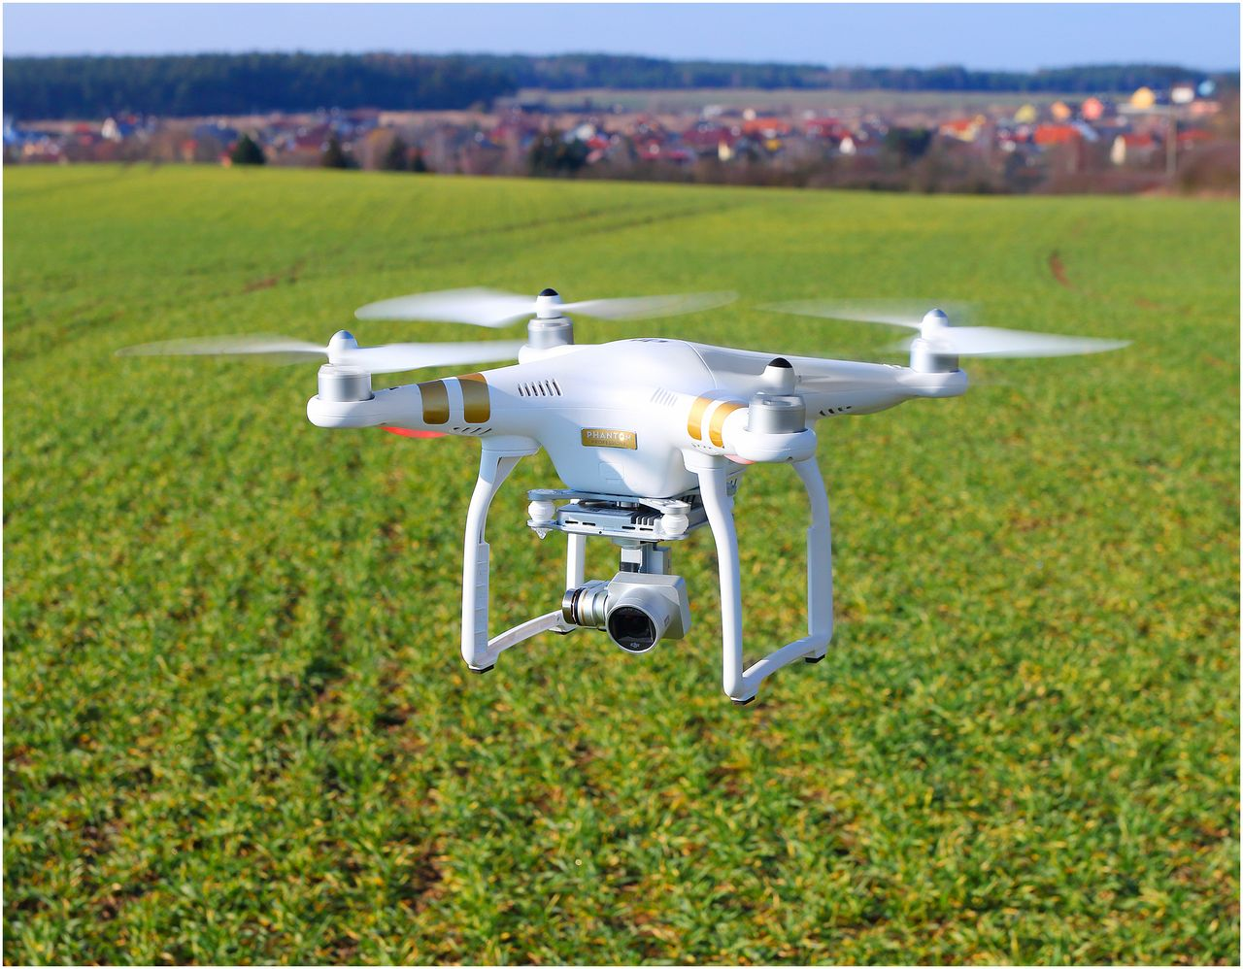

Therefore, smart farming is worthy of its enormous potential to deliver a more productive and sustainable form of agricultural production, based on a more precise and resource-efficient approach .This as a turn-key for emerging new farms will finally realize the eternal dream of bright future as a whole to feed our population, which may explode to 9.6 billion by 2050.

