Trends for shaping the future in Pharma and Nursing: A Review
Sailesh Narayan¹, Abhilasha Mittal²
1 Usha Martin University, Department of Pharmacy, Ranchi, Jharkhand.
E-mail: drsaileshnarayan@gmail.com
2.NIMS University, Faculty of Pharmacy, Jaipur, Rajasthan.
E-Mail: abhilashamittal24@gmail.com

Introduction
The pharma sector has made a significant shift toward digital transformation. Participants from the pharmaceutical industries invest in digital healthcare subjects. However, as with other popular topics, there is a lot of commotion that is difficult to cut through. You probably already know that the medical profession is beginning to recognise the significance of the cultural trend toward digital health. Knowing what is coming is always the first step in changing that.
- Addition of patients in the advisory board of pharma Sector
Patients should be considered as equal partners in hospitals, pharmacies, and even pharmaceutical firms since they take responsibility for their own health and, as a result, hold their own future in their hands. Patients with knowledge of a particular firm's goods should be included on the advisory board of a pharmaceutical company.
If the precise requirements of the clients are well-known, it would be simpler to manufacture new items. Even decades after the initial designs were created, only with their assistance would it be able to establish a futuristic healthcare system.
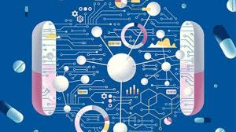

2. "Around the pill" method for digital health
Pharma businesses will place more emphasis on novel techniques relying on technology to appeal to providers and payers rather than traditional drug manufacture and marketing. "Around the pill" is about more than just creating and dispensing medications; it's about creating a medication and integrating digital health technology into it.
These are frequently non-clinical, patient-support activities that can improve patient outcomes and strengthen the entire healthcare system. Through these initiatives, patients receive more than just a tablet, and pharmaceutical companies are able to capitalise on the data and feedback they collect as well as the potential loyalty of patients who value the extra attention.
But producing good solutions is not always simple. There are only a few excellent instances, mySugr being one of them. The startup's strategy for managing diabetes is a gamified one, in which they reinterpreted diabetes as a monster that can be controlled, a la Tamagotchi. The app encourages patients to maintain a healthy blood glucose level by having them complete challenges, earn points, and receive individualised information. The pharma behemoth Roche bought mySugr in 2017 and retained the team on board to continue growing. The business later created the mySugr Bundle by combining the software with its current Accu-Chek Guide glucose metre.

Electronic pills

For particular people with particular diseases, digital tablets and pharmaceuticals with embedded electronic circuits may be beneficial. Instead of smartphone logging apps, these refer to ingestible drugs with inbuilt electronic circuitry.

For those who routinely take medications, for instance, these pills may aid in adherence. AblifyMycite, a medicine developed by the now-defunct pharmaceutical business Proteus, was the first tablet to receive FDA approval. It was intended to treat psychiatric illnesses like schizophrenia and bipolar disorder.The pill's sensor activates as soon as a patient swallows it because of the stomach's acidic environment, and it then starts to send Bluetooth signals to an external patch. The smartphone app will then receive a notification that the medication was consumed. For patients with severe diseases like schizophrenia and severe depression, such medications are game-changers because forgetting to take a drug can have significant repercussions.
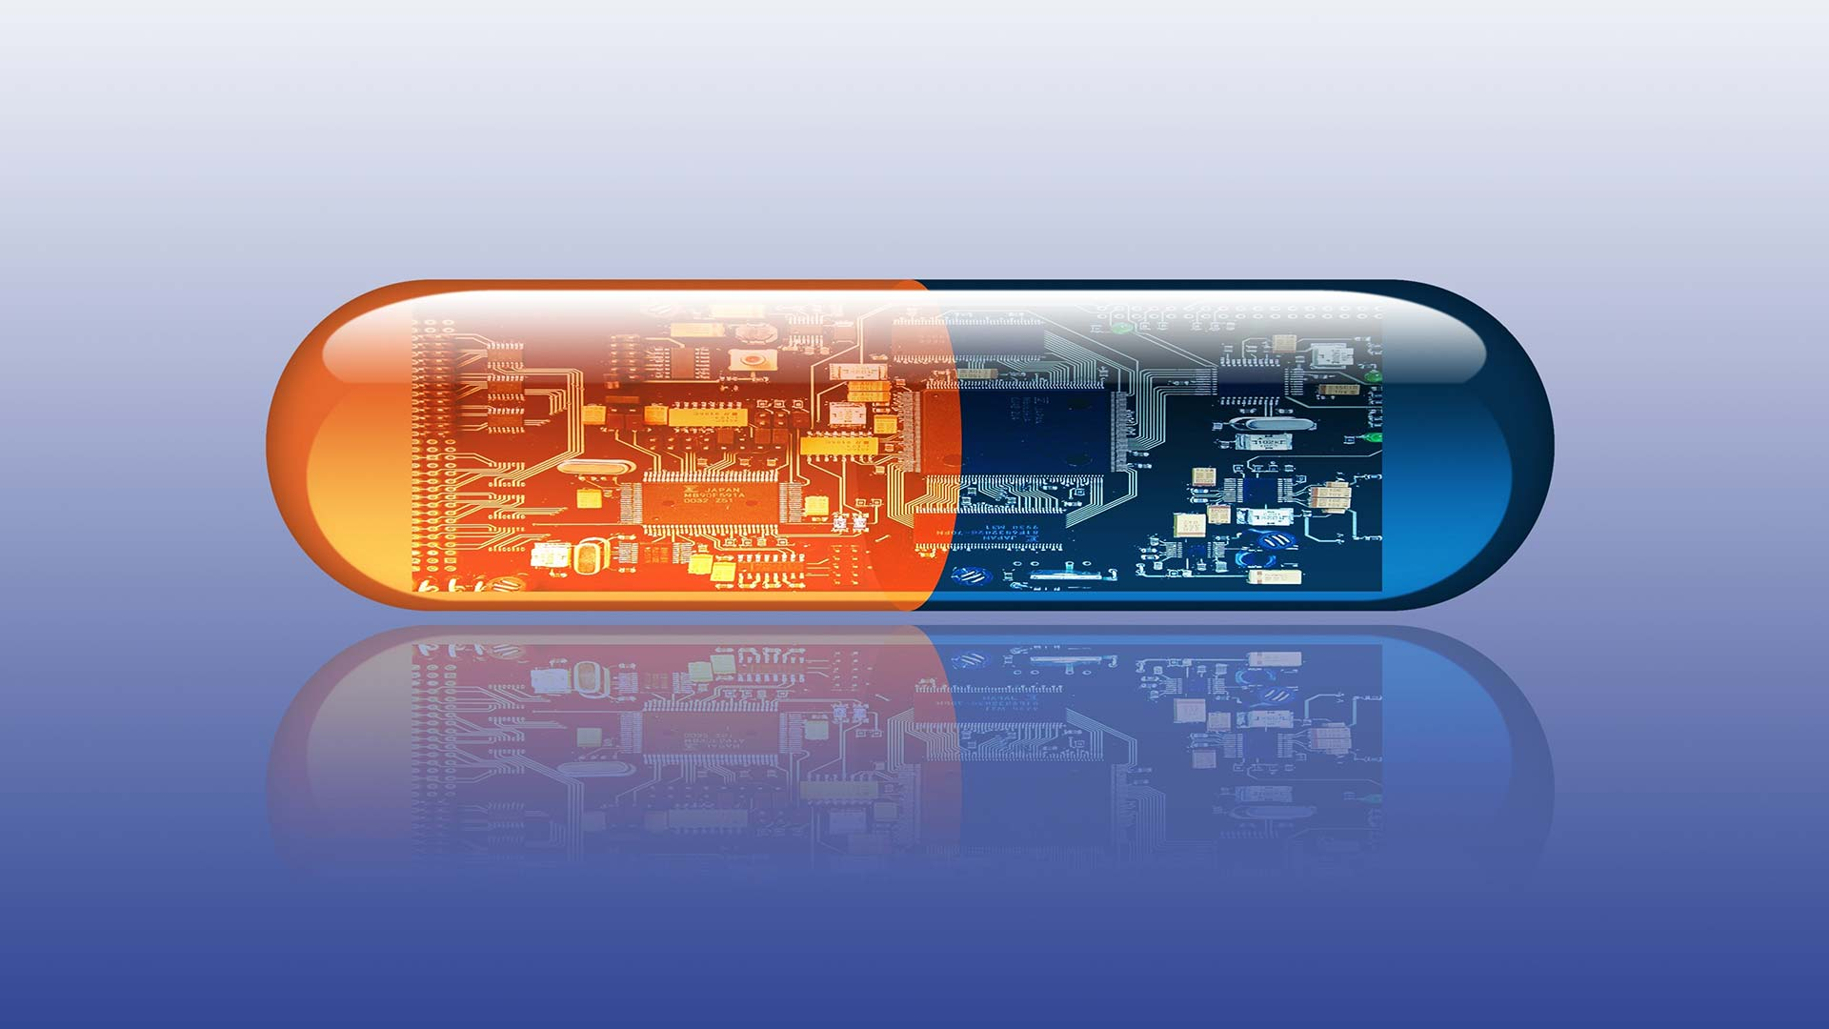
The present and the possible future of digital pills

4. Computer Stimulations

Computer stimulations are used to carry out in silico experiments. In silico studies entirely avoid animal testing and adverse effects on both human and animal participants, in addition to being time and money efficient.

According to a new study, in silico trials can accurately duplicate human clinical studies. Research shows that these studies are unquestionably effective. However, these did not start to be utilised more frequently until COVID-19. The epidemic overcame the medical community's resistance to such technological use since it became urgently necessary to conduct speedy and successful trials.

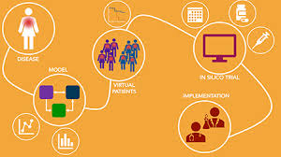

5. Virtual reality in opposition against narcotics

Hospitals are embracing virtual reality (VR). You may help as a doctor without ever using a scalpel. If you are a medical student, you may learn more about the human body and be better prepared for actual surgery. You might be able to more successfully combat your potential paranoia, schizophrenia, or fear of heights as a patient with mental health issues.

But one of the most effective uses of medical VR is in the realm of stress management and pain management for people with chronic pain. Instead of developing brand-new painkiller varieties, pharmaceutical corporations could want to explore entering the market.The Cedars-Sinai Medical Center's Brennan Spiegel and his team are testing with the technology. In the case of VR therapies, they even discovered a sizable decrease in pain scores. In the future, according to Spiegel, patients will be prescribed the necessary VR treatment by professionals in VR pharmacies.

6. Precision medicine through pharmacogenomics
Precision medicine is "an emerging strategy for illness treatment and prevention that takes into account individual diversity in genes, environment, and lifestyle for each person," according to the National Institutes of Health (NIH). Several trends in precision medicine are linked to the pharmaceutical industry. On the one hand, scientists test cancer medications that specifically target malignant cells without harming healthy tissues, such as those used to treat cervical cancer. On the other hand, medical professionals work to incorporate genetics into the process of developing tailored and targeted therapeutics. One approach to this is through pharmacogenomics.
Pharmacogenomics is the study of variation in drug response resulting from genetic make-up. It contends that, in contrast to popular belief, not every person is affected by drugs in the same way. There are already some who strongly advise genetic testing prior to the prescription of any anti-clotting medication, such as Warfarin.

7. Drugs produced with 3D printing
Researchers from all over the world are working on potential solutions, from a team that printed a small kidney to modern tools like BioAssemblyBot. New techniques that might enable the printing of cardiac tissue customised to a patient. The lengthy list is presented in a therapeutic environment.
Within the next five to ten years, according to UK-based FabRx, printed pills will be commercially viable, and within the next ten years, 3D printing will likely be accessible in all major hospitals. Whether we will print out medications at home or at the very least at the neighbourhood pharmacy? The latter is more plausible, but perhaps in 20 years, home-based pharmacy using 3D printers won't be viewed as science fiction.
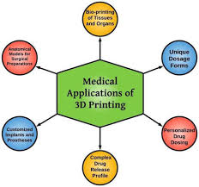

8.Artificial intelligence(AI) used to make medical decisions
By mining medical information, creating treatment plans, accelerating medical imaging, or even by creating new drugs, A.I. will soon revolutionise healthcare. Drug development methods based on artificial intelligence are becoming more widely used. A.I. makes discovering new medicines more affordable and efficient.
An experimental drug typically requires $2.9 billion and 12 years to develop from concept to market, according to estimates. A.I. can greatly reduce these numbers.
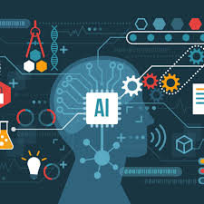

9. New FDA and medication guidelines are required.
I think the medical profession as a whole agrees that regulations governing medication production, in addition to digital health gadgets or health apps, are out of date. The waves of digital innovation are unprepared for by regulatory organisations.
With the emergence of the we are not waiting Twitter movement for diabetic people, we could see it. The patients believed it worked and they needed it, so they began using the so-called artificial pancreas without FDA or any other approval. Regulators must act more quickly in response to the quick development of digital health solutions in order to stay ahead of potentially hazardous DIY solutions.
Direct-to-consumer genetic testing businesses are another instance of rules stifling innovation. They first emerged on the market about ten years ago. The FDA, however, put restrictions on 23andme's operations in 2014, claiming that the company's health information offerings were not comprehensive or clear enough for clients. Therefore, the genetic testing company reduced its activity primarily to provide ancestry information. They have created family trees and connected long-lost relatives. However, the FDA renewed its approval of 23andme's services, which attempt to inform users of which diseases they are predisposed to, in April 2017.

10. Using augmented reality, entertaining drug descriptions
A vein scanner for AR called AccuVein can help nurses locate veins more easily, while EyeDecide can help patients communicate their eye condition to their doctor more effectively. There are many encouraging signals that AR will soon enter the pharmaceutical industry.
Current Pharmacy Practice Trends
Similar to other business sectors, the pharmacy industry experiences rapid shifts in business trends that frequently reflect those affecting the healthcare sector as a whole.
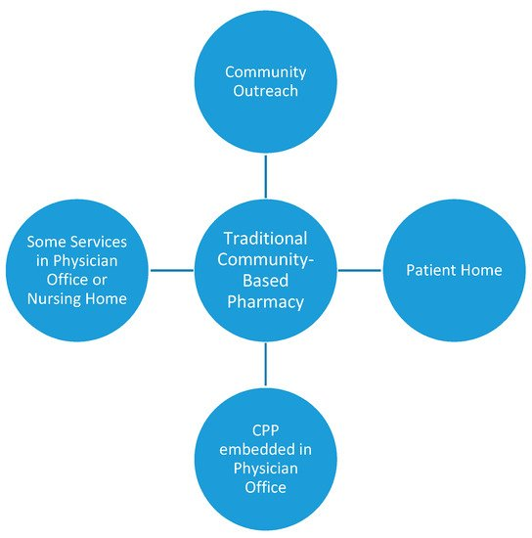
Increasing innovations
The increase in innovation creates an emerging field in the pharma sector. Pharmacy operations have become quicker and more effective while also enhancing patient safety thanks to new health information technology (HIT) and the growing popularity of robotic dispensing technologies. Tech developments have also contributed to more simplified and coordinated workflows, which are helping pharmacies optimise operations throughout their whole drug supply cycle.
Pharmacies are able to counteract the worsening economic conditions, which are causing profit margins in all pharmacy industries, by enrolling more technological solutions. Pharmacies are able to re-prioritize resources thanks to automation solutions, which range from robotic devices to integrated workflow and pharmacy software. This enables them to increase operational efficiency based on centralised service models and expand value-added services like telepharmacy, long-term care, and mail order.
Specialty pharmacies are still expanding.
Specialty pharmaceuticals will continue to generate more money for the pharmacy business than standard brand-name medications. They already account for over 30% of the prescription market, and growth for speciality medications is anticipated to approach 40% over the following five years. Given the crucial clinical criteria, there are specific issues that community and retail pharmacies should think about and address in order to work toward positioning themselves in a position to handle the rising volume of these more expensive speciality pharmaceuticals.
Patient goals: individualised, one-on-one care
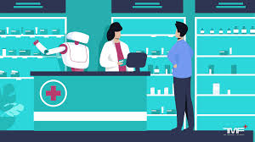
One advantage of the widespread use of robotic dispensing systems in pharmacies is that it has relieved pharmacists and pharmacy staff of some of the more tedious tasks that were previously put in their charge. This has allowed them to spend more time interacting with patients as an active member of their multidisciplinary healthcare team. A persistent primary care provider deficit is also anticipated, which will make investing in automated systems even more crucial over the course of the following few years. Because of this, it will remain crucial for pharmacies to accept these changes in order to maintain a competitive edge and satisfy patients' changing needs. Any pharmacy's strategy should focus on operational adaptability and a readiness to change to meet these difficulties.
Demographic and legislative shifts
The population of America is getting older. The number of Medicare beneficiaries has increased as a result of this reality; as of 2017, there were more than 42 million beneficiaries registered in Medicare. As a result, it is more important than ever to be able to provide for these beneficiaries' needs. networks. As a result, pharmacies' ability to take part in these preferred networks has become crucial.
As part of the requirements to participate as determined by the Star ratings system, pharmacists are now required to follow a stricter set of performance standards in order to achieve this. High ratings allow pharmacies to participate in these highly sought-after preferred network plans. This grading system is designed to evaluate a plan's quality and performance for the services given.

The Pharma Industry's Trends and Innovations
The pharmaceutical sector is undergoing a significant transformation. The sector, which has historically been sluggish to accept new technologies, is currently going through significant changes as a result of the development of various technologies. Artificial intelligence (AI), additive manufacturing, blockchain, and other Sector 4.0 technologies are some of the major trends in the pharmaceutical industry
Pharma Industry Trends and Innovations highlights
In order to conduct this comprehensive study on the Top Pharma Industry Trends &Startups, we examined a sample of 1745 scaleups and startups from around the world. The outcome of this study is data-driven innovation intelligence that enhances strategic decision-making by providing you with a summary of startups& developing technologies in the pharmaceutical sector. These insights were obtained by utilising the 2 093 000+ startups&scaleups globally covered by our Big Data & Artificial Intelligence-powered StartUs Insights Discovery Platform. The platform finds pertinent startups&scaleups early on and provides a thorough overview of emerging innovations within a certain industry in a timely manner.
Top ten pharmaceutical industry trends
- Artificial Intelligence
- Big Data & Analytics
- Flexible Production
- Precision Medicine
- Additive Manufacturing
- Blockchain
- Extended Reality
- Real World Data
- Digital Therapeutics
- Curative Therapies

- Artificial Intelligence
The procedures of drug research and development are being sped up by the use of artificial intelligence (AI). Startups are investigating how to employ these technologies to solve problems in the pharmaceutical sector, including the automation and optimization of manufacturing processes as well as the development of successful marketing and post-launch strategies. The process of finding and developing new drugs requires the identification of patients, particularly when performing clinical trials. AI streamlines the process of determining eligibility requirements and patient inclusion. It also makes cohort identification quicker and less expensive.
- Big Data & Analytics
The medication discovery and development process generates enormous amounts of data, which the pharmaceutical industry needs to examine. Data management is an important area of concern for pharmaceutical businesses because they need third parties to share data with collaborators. Historical and real-time data held by pharmaceutical companies are becoming significant assets for predictive, diagnostic, prescriptive, and descriptive analytics thanks to the development of analytical methodologies. Additionally, practically all sorts of medical data, including patient records, medical imaging, and hospital data, to mention a few, are used with these analytics tools.

Flexible Production
Due to the shifting market dynamics, the pharmaceutical sector is investigating novel manufacturing techniques, such as small batches for precision medicine. Single-use bioreactors are also becoming more and more popular since they boost output and decrease downtime. By omitting challenging tasks like cleaning and validation between various production phases, these bioreactors accomplish this. The growing emphasis on biopharmaceuticals is being addressed by new varieties of bioreactor systems and continuous manufacturing techniques. Continuous manufacturing reduces waste, generates high productivity, and eliminates downtime in addition to having low energy requirements.

- Precision Medicine
The concept behind precision medicine is to approach every patient as a distinct individual. Omic and data analytic developments are revealing fresh insights into how the body reacts to medications. Personalized medicine is becoming a reality because to this information and cutting-edge production techniques like additive manufacturing. In order to identify the optimum dosage for pharmaceuticals based on age, sex, comorbidities, and other clinical characteristics, drug exposure models determine the pharmacokinetic and pharmacodynamic features of drugs.

5. Additive Manufacturing
Pharmaceutical companies are reevaluating their manufacturing procedures in response to the need for precision medicine. The development of sophisticated 3D printers that create tissues or cells is the subject of extensive research. The creation of pharmaceuticals, the engineering of organs, and regenerative medicine all benefit greatly from the 3D printing of human tissues. As a result, precision tablets and medical formulations based on physiology or age can be created. Tissue engineering, microfluidics, and bioink innovation are also boosted by the use of bioprinters.

6. Blockchain
Every step of the manufacturing and distribution of pharmaceuticals benefits greatly from the use of blockchain technology. Due to the sensitive nature of the data, the stakeholders in the pharmaceutical sector are, in general, very secretive about it. Blockchain technology is also being investigated as a means of combating the use of fake medications and inferior pharmaceuticals, which enter the pharmaceutical supply chain and result in the deaths of thousands of people each year. Blockchain is a viable tool for monitoring and safeguarding the pharma transaction ecosystem due to the digitization of transactions.

7. Extended Reality (XR)
Visualizations are now more possible than ever because to mixed reality (MR), virtual reality (VR), and augmented reality (AR). Pharmaceutical entrepreneurs are looking at the potential of extended reality technologies in the manufacturing and development of pharmaceuticals. Using extended reality tools, research teams can communicate in real time using location-based services that are useful and data-rich. Startups are using technologies and devices for extended reality to make human enhancement in the pharmaceutical industry a reality.

8. Real-World Data
Real-world information (RWE) and real-world data (RWD) are reshaping pharmaceutical sector developments. RWD consists of routinely gathered health reports, treatment information, and patient health status information. Due to its emphasis on research, the pharmaceutical business must ensure that the data it uses is trustworthy and useful. The pharma sector is changing due to the availability of real-world data made possible by the Internet of Things (IoT), sensors, and wearables.

9. Digital Therapeutics
Software-based evidence-based therapy interventions are delivered through digital therapeutics to prevent, manage, or treat behavioural, mental, and physical problems. These technological, non-pharmaceutical alternatives can be employed in place of or in addition to treatments, devices, or drugs. Each person can have more influence over their health and outcomes thanks to digital treatments.

10. Curative Therapies
There is a paradigm shift taking place in the field of medicine from managing ailments to healing them entirely. By obviating the need for lengthy treatments, curative therapies like cell and gene therapies are altering the way we handle chronic diseases or difficult-to-treat ailments. In gene therapy, genetic material is inserted into the cells to generate a protein that will help treat a disease or to make up for defective genes. The most popular vectors used for gene therapy are viruses that have been genetically altered.

Role of Nurse in Healthcare
Healthcare is a continuously converting and updating field. With improvements in technology, new care methods, and modern global events, the tendencies hospitals, and nurses need to hold a watch on are converting yr over yr.
Keeping up on all the pinnacle tendencies, and knowing the way to high-quality put together for them may be a frightening task. To make the manner of locating the largest tendencies for 2022.

Shortage of Nurse

The World Health Organization (WHO) estimates that there are 28 million nurses in the world. But given the number of patients and their demands, that figure is still insufficient. As a result, there is a global nursing deficit, and 6 million additional positions must be filled by 2030 in order to provide healthcare for all patients and their needs.

Demand of Nursing Job
As the nurse shortage continues to be felt throughout health care, the quantity of nursing jobs on the market also will still rise. With one-third of this nursing population nearing retirement age, an oversized number of recent nursing jobs will presently open up. These jobs are in variable levels of experience, permitting a spread to come back in.
In addition to the inflow of jobs from nurses retiring, there are extra jobs gap up round the country as healthcare systems expand their facilities to accommodate a growing population.

Online Nursing Programs

There is a strong need for additional education and good job security in the nursing field due to the great demand for qualified nurses. As a result, more universities and colleges now offer online degree programmes, particularly in nursing. Online learning offers nurses an opportunity to access higher education on their schedule, complete a degree while working full-time, and learn even when subject to pandemic rules and restrictions.

Higher Education

The range of nursing jobs which will be gap up within the coming back years has also diode to nurses needing high education. The nurses who are currently coming into the force are expected to own a similar level of data and skill as people who are in the field. this suggests they have a lot of education to jumpstart their careers. Higher education, appreciate Doctor of Nursing follow (DNP) programs, also are turning into more necessary for those nursing professionals who are wanting to have an area in leadership

Telemedicine
In 2020, there was a shift in how Americans interacted with healthcare thanks to COVID-19, and that included a staggering 20% of medical visits being handled digitally. There are claims that telemedicine income is anticipated to treble by 2023. The increased use of telemedicine has made it possible to provide more accessible patient care, telehealth, and chatbot choices, as well as automate nursing responsibilities.
With the flexibility that telehealth technology enables, patients may access their medical records and doctors from home, providing them more control over their health care and a sense of security in their own homes. Test results, requests for prescription refills, and appointments can all be entered into online portals. With the aid of telemedicine technology, patients and clinicians can connect virtually with doctors or nurses, saving both parties important time.
To provide patients more control over the care they receive, chatbot have been established. Patients can look up local specialists, make appointment reminders, and set reminders for taking their medications.

Visiting Nurses

The previous few years have demonstrated the critical need for visiting nurses in society to address varying demands. In order to assist the increasing patient numbers, we observed thousands of nurses stream into COVID-19 hot zones.

More options for career paths and specialisation

Healthcare requirements are getting more complicated. The range of specialisations that nurses can practise is expanding as a result. Nurses can select a career path that suits them because to their specialty in over 96 fields, including paediatrics, cardiac care, and intensive care. A nurse with a specialty is in greater demand than one without due to the increased complexity of healthcare. The job options for nurses are nearly limitless as the world population increases and more research and technical developments are made.

Nursing Care for Oneself

Despite being trained as caregivers, nurses occasionally neglect to take care of themselves. To care for our physical, mental, and spiritual wellbeing, we engage in self-care. Lack of self-care can result in mistakes, exhaustion, and burnout, which is expensive for patients, nurses, and the healthcare system. Many nurses have further neglected their own needs due to the strain of the pandemic and an increase in workload. Self-care should not decline but rather increase at times of high stress. Healthcare executives all across the world are taking the initiative to identify and treat self-care as an actual obligation as more research and data regarding the physical and mental stress of nursing become available. Nurses and the organisations they work for need to prioritise self-care.

Increased salaries and benefits
Due to the pandemic situations, which creates the high levels of stress, and this creates the shortage of the nurses as employers. They were give as compensation that keeps the nurses satisfied and equivalent to the amount of work they do. Without nurses the hospital will not take care of the COVID patient. Salaries and benefits increases as the situations develops.

Need for bilingual nurses

Bilingualism in particular is becoming more and more recognised in the United States. Across the states, more than 350 different languages are spoken. Hospitals are aiming to merge the two and provide a seamless providing of treatment rather than having a translator and a nurse. The demand for nurses who speak a second language will rise in the upcoming years.

Popularity of holistic care.

Patients take greater control of their health as they become more informed. Patients have started to get interested in treating all elements of their person after seeing how drastically COVID-19 has affected people, both physically and mentally. As a result, there is a rising need for nurses who can assist patients in identifying the underlying causes of their physical problems and who offer holistic care. In the upcoming years, there will be a continued need for educated nurses who have received training in administering care and handling medical operations.

Retirement of Nurses

Nursing professionals are retiring at progressively older ages. Those with nursing employment continued their jobs well into their 60s, starting when the economy slowed down. Nurses are still working despite the nursing shortage in the hopes of being of assistance. Nurses are switching from physically demanding jobs to desk work as they get older, but they can still assist patients. This tendency will continue as more motivated nurses enter the field.

Technologies

New medical technology is introduced to the market every day. To improve patient care, nurses must adjust to these technology. In order to speed up administration and improve accuracy, new technology is always being developed while also keeping the needs of patients and clinicians in mind. Nurses are expected to use computer equipment, such as laptop carts, to record and collect patient information and, if necessary, to research treatment possibilities.

The proportion of male nurses

One in ten nurses in the United States in 2011 were guys. The overall number of men had increased by 660% since 1981. Health care firms will continue to concentrate on attracting men to the industry in 2022 and beyond due to the global shortage of nurses.

