REVIEW ARTICLE ON THE CAUSE OF MELASMA AND ITS TREATMENT USING SELECTED TOPICAL AND ORAL MEDICATION

ABSTRACT
The skin condition known as hyper pigmentation commonly affects the face. Melasma treatment is a challenging task for us. Hyper pigmentation affects humans due to genetics, hormonal changes, and exposure to strong UV light, and medicine side effects. I discuss the etiology and the use of a few chosen topical and oral drugs in this article.

INTRODUCTION
The increased activity of epidermal melanocytes results in hyper pigmentation in the skin, which affects about 70% of women. The most common cause of hyper pigmentation, which can be either epidermal, dermal, or mixed, is prolonged exposure to the sun. The color of Melasma is pale brown. Upper lip, cheekbone, cheek, and forehead areas all exhibit hyper pigmentation. Some topical ointments, some oral drugs, and the application of sunscreen lotion are all part of the treatment.
Melasma ’s root causes include:-
- Genetics and hormonal changes.
- Prominent UV radiation
- Abundant usage of contraceptive drugs.
Other causes of Melasma include:-
1. Anti-epileptic drugs: These drugs may contribute to melanomas.
2. Genetics: Almost 50% of individuals with Melasma have reported.
3. Diethylstilbestrol: Diethylstilbestrol, a synthetic (man-made) estrogen-derived hormone that induces hyper pigmentation, is a potent anti-inflammatory.
4. Some soap is known to trigger Melasma.
5. LED screens: Hyper pigmentation brought on by prolonged usage of a laptop, Smartphone, and/or television.
1. Pregnancy: Hyper pigmentation is a typical complication of pregnancy.
2. Skincare items: - A few skincare items caused hyper pigmentation.
- Treatment of Melasma:-
- Guava: Guava provides our bodies with antioxidants and vitamins and also aids in fading the dark spots on our skin.
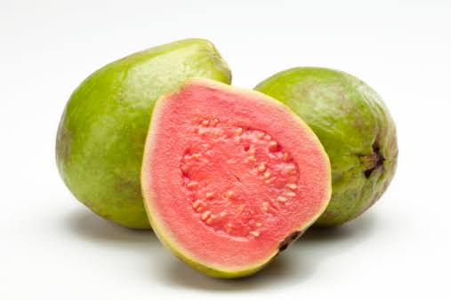
1st Figure (Guava)
2. Papaya: Papaya extract is a good source of antioxidants, enzymes, and vitamins A and C. The naturally occurring enzyme Papen can be found in papaya.
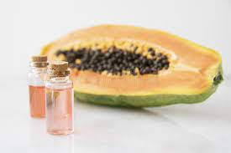
Figure 2-2 (Papaya Extract)
3. Rice: A brightening powder made from hydrolyzed rice protein. It contains proteins that have been made small enough to slip into the skin, which is essential for fading dark spots.

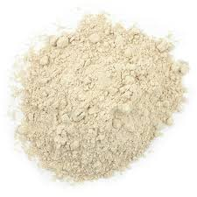
3rd Figure (Hydrolyzed Rice protein)
4. Aloe Vera: Melasma can be effectively treated with this component. Mucilaginous polysaccharide, which is present, can brighten the skin and get rid of brown spots. Dry skin is rehydrated with aloe Vera.
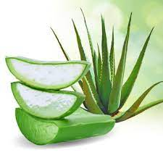
Figure (4) (Aloe Vera)
5. Hyaluronic acid: A type of Hyaluronic acid is called Hyaluronate. It extracts moisture from the dermis and transfers it to the epidermis, the top layer of skin. The elasticity and tone of the skin are influenced by Hyaluronic acid.
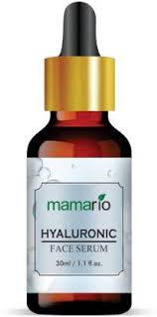
Figure (5) (Hyaluronic acid)
6. Glycerin: Glycerin balances the PH of human skin and aids in reducing water loss in human skin. It develops a layer of defense on human skin to maintain the health of the skin.

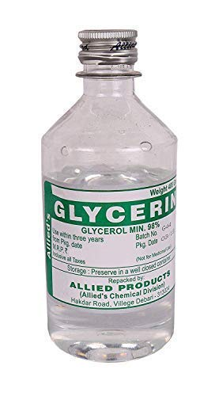
Figure (6) (Glycerin)
Dermatologist Recommendation: - Patients with Melasma are typically advised to use sun screen lotion or gel containing sunscreen.
- Iron oxide
- Titanium oxide and
- Zinc oxide.
- How can you shield your skin from the sun's rays?
I. Putting on a hat when outside.
2. Keep an umbrella on you.

3. When outside, always wear a cotton outfit.

IV. When spending time outside, you must always wear sunscreen lotion or gel with 30SPF (Sun protection formula).
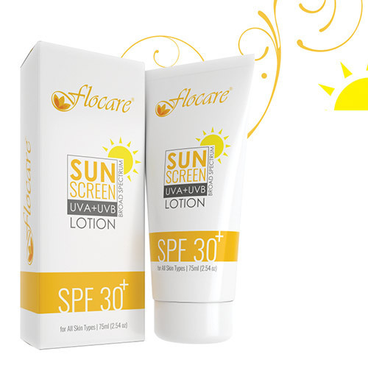
Figure (7) (Sunscreen lotion with 30 SPF)
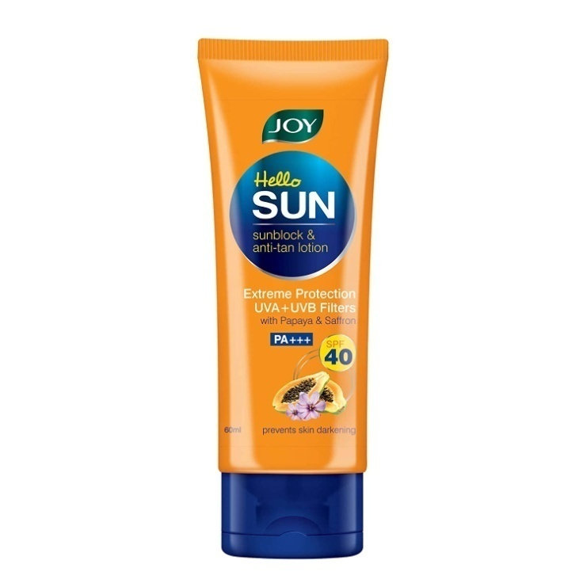
Figure (8) (Sunscreen lotion with 40 SPF)
- Medication: A skin specialist may recommend a drug to treat the significant pigmentation in your skin. Dermatologists may recommend the following medications,
A. Hydroquinone: Hydroquinone is a prescription-only drug that is frequently used to treat Melasma.

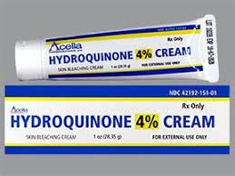
Figuring no. 9 (Hydroquinone cream)
B. Tretinoin with a mild corticosteroid: Both of these mixtures contain retinoid and a corticosteroid, which work together to lessen Melasma.
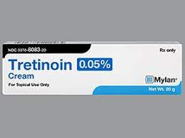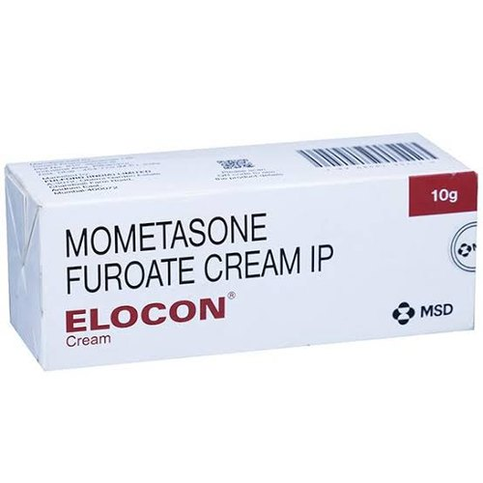
Figure 10 (Mometasone Furoate + Tretinoin)
C. Triple combination cream :- (hydroquinone, retinol, and corticosteroid) both hydroquinone and corticosteroids can aid with inflammation reduction and skin tone improvement.
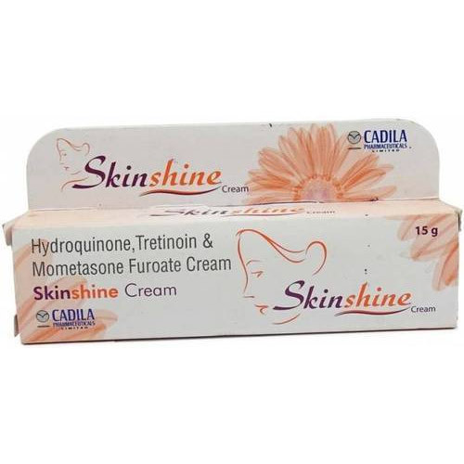
Figure number: 11 (Triple combination cream)
D. Azelaic acid: - Higher concentrations of (15 percent to 20 percent) Azelaic acid are also an effective treatment for removing dark spots caused by Melasma or hyper pigmentation.
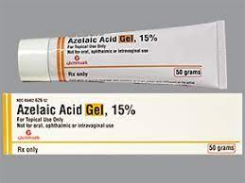
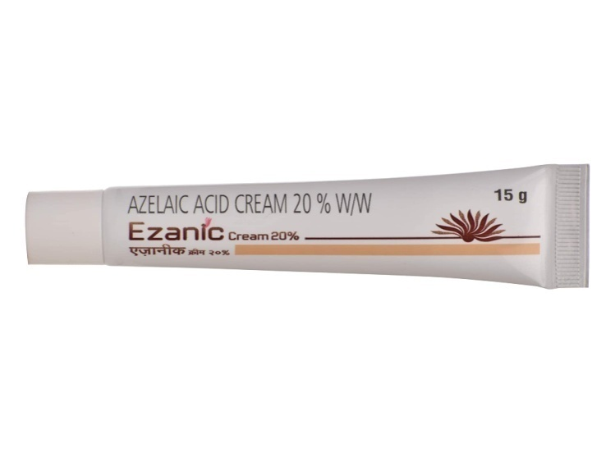
Figuring Number 12 (Azelaic acid 15 percent and 20 percent)
E. Kojic acid: Kojic acid is used to lighten scars, age spots, and skin in cases of primary and bereft. There are some antibacterial qualities in Kojic acid.
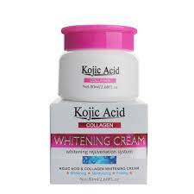
Figuring 13 (Kojic acid cream)
F. Vitamin C serum: - Vitamin C serum has antioxidant characteristics, which assist to lighten the skin and diminish the appearance of black spots on the face.
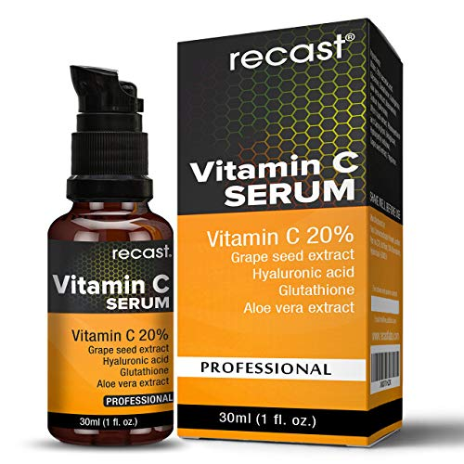
14th figure (Vitamin C serum)

G. Tranexamic acid tablet: - Tranexamic acid tablet for the skin can function as a brightening agent to lessen dark spots and clear to hyper pigmentation.
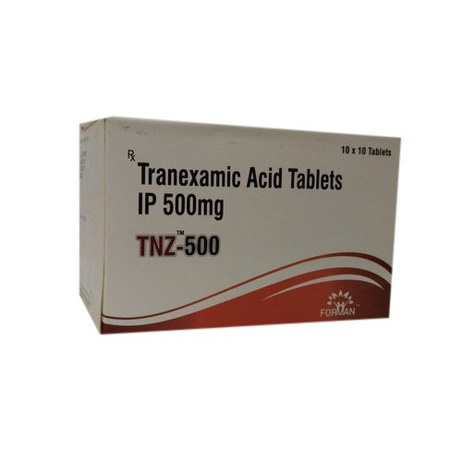
15th figure (Tranexamic acid tablet)
H. Tablet of vitamin D3: Hyper pigmentation can develop with vitamin D3 insufficiency. Vitamin D3 insufficiency can cause hyper pigmentation, which can be treated by reducing pigmentation and promoting skin radiance.

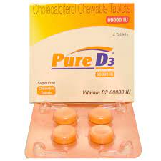
Image No. 16 (Vitamin D3 tablet)
- Vitamin C tablets: In the event of hyper pigmentation, vitamin C tablets aid in minimizing black spots and enhancing skin tone.
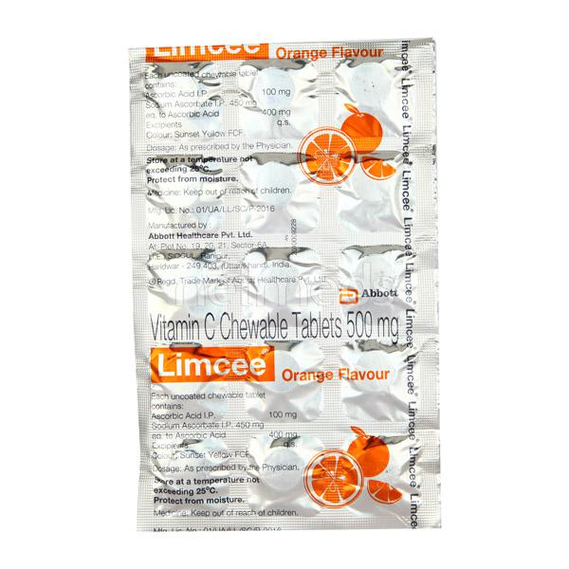
17th figure (Vitamin C tablet)
J. Methimazole tablet: - Methimazole is an anti thyroid tablet, it is helped to reduce Melasma.

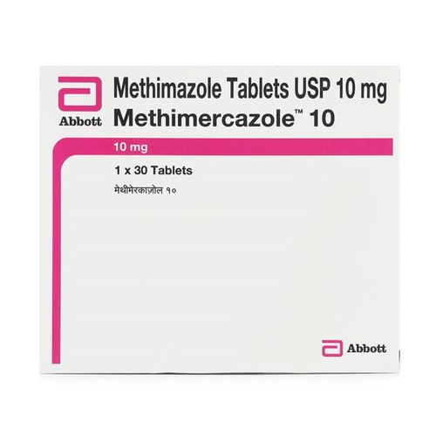
Figuring no. 18 (Methimazole tablet)
- There are medical procedures available to treat Melasma. –
- If medications do not work, skin specialists may recommend the following treatments to patients:
When drugs are not effective, skin specialists recommend alternative therapies to patients, including: a) micro needling
b) Chemical peel
c) Laser therapy
d) Plasma rich in platelets
a) Micro needling: This procedure results in the formation of micro scopic blood in the skin. The skin will glow after this treatment.

Figure No. 19 (Micro needles)
b) Chemical Peel: In this technique, a chemical solution is applied to the pigmentation area by a skin specialist. Chemical solutions can aid in the removal of pigmentation.
c) Laser and light treatment: Patients' skin will glow quickly after laser treatment. Patients should avoid exposure to sunlight following this treatment. Always apply sunscreen lotion before going out in the sun.
d) Platelet rich plasma: In this approach, we must draw a little amount of blood, put it in a machine that turns it into a layer, and then inject the layer of blood—known as plasma—into the skin affected by Melasma. Additionally, this procedure aids in reducing skin pigmentation.

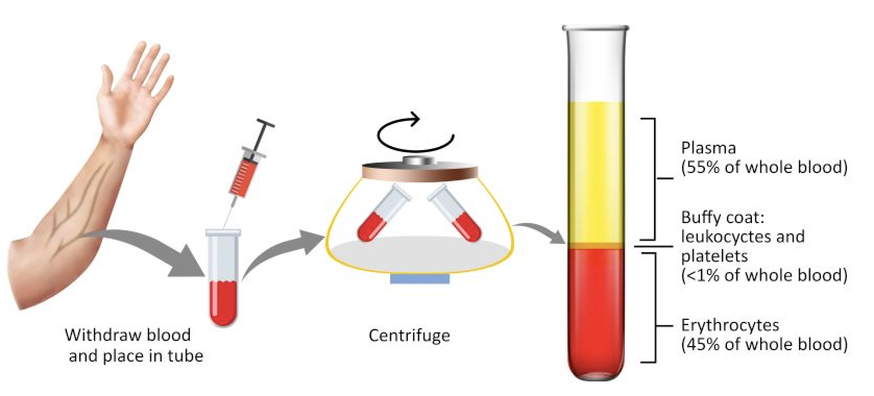
20th figure (PRP therapy)

RESULTS
Human skin develops brown, dark spots called hyper pigmentation, which is essentially a harmless pigmentation. Pigmentation is completely damaging and develops as a result of hormonal and genetic changes.
DISCUSSION
A skin condition known as hyper pigmentation causes extensive, symmetrical coloring. Melasma is primarily brought on by prolonged sun exposure, hormonal changes, and genetics or family history.
CONCLUSION
Black patches are a condition known as face hyper pigmentation with enhanced melanogenesis and a variety of pathologies.

REFERENCES

- Dermatology's American Academy (Melasma diagnosis and treatment)

- Journal of International Women's Dermatology (New oral and topical approaches for the treatment of Melasma).

- Online dermatology journal (A review of the latest research, pathological finding and investigational therapies).

4) International Dermatolology Journal

5) Baldochi, D., Oliveira, O.M.M.F., Tadiotti, A.C., and Leite, K.M.S.C. (2006). Characterization of the pectin methylesterase from Brazilian guava Plauma cultivars in terms of partial purification, heat stability, and kinetics. Chemistry of food, 94, 565-572 [11] 6) Manohar (B), Ramakrishna (P), and Udayasankar (K) (1991). Some of the tamarind's (Tamarindusindica L.) physical characteristics are concentrated. 13(4), 241-258 [12] Journal of Food Engineering
7) A.M. Ramos and A. Ibarz (1998). Juice and fruit puree density as a function of temperature and soluble solids content. 35, 57–63 of the Journal of Food Engineering

8) Lozano, J. E., Constenla, D. T., and Crapiste, G. H. (1989). Clarified apple juice's Thermophysical characteristics as a function of temperature and concentration. 663-668 [2] Journal of Food Science, 54(3).

9) Bonomo, P., Landim, L. B., Chaves, M. A., Fontan, R. C. I., DA Silva, N. M. C., Bonomo, R. C. F., Rodrigues, L. B., and Sampaio, V. S. (2010). Genipap Pulp's Thermophysical characteristics. Doi: 10.2202/1556-3758.1701 International Journal of Food Engineering, 6(3), Article 1. 1–12.

10)http://www.juicing-for-health.com/guava-nutrition.html

11) An experiment involving healthy senior people and the association between GSATM1 genotype was randomized, placebo-controlled, and cross-over. New York Academy of Sciences, 1067(1), 400–407.

12) Rejuven Res 2006; 9(2):227–230. Marotta F, Pavasuthipaisit K, Yoshida C, Albergati F, and Marandolo P. Relationship between ageing and susceptibility of erythrocytes to oxidative damage.

13) P. Dominguez de Maria, J.V. Sinisterra, S.W. Tsai, and A.R. Alcantara. A newly discovered and adaptable biocatalyst is papaya lipase, according to Biotechnol Adv 2006; 24(5):493-499.

14) Review on the nutritional, therapeutic, and pharmacological aspects of papaya (Carica papaya Linn), Nat Prod Rad 2008; 7(4):364-373. Krishna KL, Paridhavi M, and Jagruti Patel

15) Traditional and therapeutic uses of Carica papaya, J Med Car Pap 2013; 1(1):2320-3862, Arvind G, Bhowmik D, Duraivel S, Harish G. 15. Theivanai @ Vidhya R M, Natarjan Sudharkar. Carica papaya Linn, Int J Pharm Sci 2014; 6(2):168–173, potential medicinal characteristics. Traditional and therapeutic uses of Carica papaya, J Med Car Pap 2013; 1(1):2320-3862, Arvind G, Bhowmik D, Duraivel S, Harish G

16) Cancer statistics, 2003. Jemal A, Murray T, Samuels A, Ghafoor A, Ward E, Thun MJ. Cancer Journal Clin 2003; 53:5-26. [PMID: 12568441]

17) Aston DA, Horn-Ross PL, Holly EA, Brown SR. Cancer Causes Control. 1991; 2:299-305. Temporal patterns in the incidence of coetaneous malignant melanoma among Caucasians in the San Francisco-Oakland MSA. [PMID: 1932542]
18) SEER Cancer Statistics Review, 1973-1999. Ries L, Eisner M, Kosary C, Hankey B, Miller B, Clegg L, et al. National Cancer Institute, Bethesda, MD; 2002.

19) Stern RS, Weinstein MC, Baker SG. Childhood sunscreen usage reduces the risk of no melanoma skin cancer. Arch Dermatol. 122:537-45, 1986. [PMID: 3707169]

20) Olsson H, Westerdahl J, Masback A, Ingvar C, and Jonson N. Does using sunscreen increase your risk of developing malignant melanoma? 59–65. Melanoma Res. 1995; 5: [PMID: 7734957]

21) Sunscreen use with malignant melanoma, Westerdahl J, Ingvar C, Masback A, Olsson H. International Journal of Cancer. 2000; 87:145-50. [PMID: 10861466]
22) Quehenberger, F., Mullegger, R., Stranz, B., and Kerl, H. Wolf. In individuals with coetaneous melanoma, phenotypic indicators, sunlight-related variables, and sunscreen use were examined in an Austrian case-control research. 370–8. Melanoma Res. 1998; 8. [PMID: 9764814]

23) Green AC, Whiteman DC, Valery P, and McWhirter W. Children's melanoma risk factors in Queensland, Australia. 1997; 70:26–31 in Int J Cancer. [PMID: 8985086]

24) Do sunscreens increase or decrease melanoma risk: an epidemiologic assessment, Weinstock MA. 1999; 4:97-100 J Investing Dermatol Symp Proc [PMID: 10537017]

25) Coetaneous malignant melanoma, sun exposure, and sunscreen use: epidemiological evidence, Bastuji-Garin S, Diepgen TL. 2002; 146 Suppl 61:24-30. Br J Dermatol [PMID: 11966729]
26) IL Guevara and AG Pandya Treatment of Melasma with 4% hydroquinone, 10% glycolic acid, antioxidants, and sunscreen: safety and effectiveness. 2003; 42:966-72 Int J Dermatol.
27) Melasma (Chloasma): A review with current therapeutic options, Thappa DM. Indian Journal of Dermatol. 2004; 49:165-76.
28) A thorough analysis of the effectiveness of a triple-combination cream for the long- and short-term treatment of Melasma, Torok HM. 2006;7:223–30 for Am J Clin Dermatol.
29) Topical Melasma treatment, Bandyopadhyay D. Indian J Dermatol. 2009; 54:303-9.
30) The best care of recalcitrant hyper pigmentation diseases in patients with dark skin, Stratigos AJ, Katsambas AD. 2004; 5:161–8 in Am J Clin Dermatol.
31) Management of face hyper pigmentation. Perez-Bernal A, Munol-Perez MA, Camacho F. Am J Clin Dermatol 1:261-8 (2000).
32) Comparative assessment of topical Melasma treatments, Pandhi R, Kaur I, Handa S. Indian Journal of Dermatology, 47:76–9.
33) S. Ennes, R. Paschoalick, and M. D. Alchorne. A double-blind, comparative, placebo-controlled study of the efficacy and tolerability of 4 percent hydroquinone as a depigmenting agent in Melasma. J Dermatolog Treat. 2000; 11:173-9.
34) Silva A, Costa D, Haddad AL, Matos LF, Brunstein F, Ferreira LM, et al. a scientific experiment evaluating the use of a hydroquinone-infused skin-whitening compound versus a placebo for the treatment of Melasma. 2003; 42:153-6. Int J Dermatol
35) Topical hydroquinone in the management of various hyperpigmentary diseases, Amer M, Metwalli M. 1998; 37:449–50; Int J Dermatol.
36) Using Kojic acid in a gel with hydroquinone and glycolic acid, Lim JT treats Melasma. 1999; 25:282-4. Dermatologic Surgery
37) Chemical peelings used to treat various coetaneous hyper pigmentations, Cotellessa C, Peris K, Onorati MT, Fargnoli MC, and Chimenti S. Skin Surgery 1999; 25:450-4.
38) Glycolic acid with hydroquinone or Kojic acid combined for the treatment of Melasma and associated disorders. Garcia A, Fulton JE., Jr. 1996; 22:443–7 in Dermatologic Surgery.

