ICT in Online Learning: A Study in the Context of COVID: 19

*Mansi Singh, Assistant Professor, Journalism & Mass Communication, GNA University, Punjab.
** Dr. Amit Verma, Assistant Professor (Senior Scale), Journalism & Mass Communication, Directorate of Online Education, Manipal University Jaipur, Rajasthan Orchid id: https://orcid.org/0000-0001-8690-0285 Email id: Amitve4@gmail.com
*** Anand Barik, Assistant Professor, Journalism & Mass Communication, GNA University, Punjab.
**** Kritika Sharma, Research Scholar, Journalism & Mass Communication, Amity University Rajasthan.

The shutdown of educational institutes due to COVID-19 has been a critical worldwide incident that has prompted us to reconsider how we educate in all our countries. Among the various changes brought about by the crisis, digital technology became the primary means of delivering instruction. This research aimed to determine the role of information and communication technologies in online learning. The qualitative research method was employed to uncover and comprehend the reality of the field. The data gathering technique employed is a questionnaire, specifically a traditional questionnaire (printed), and an online form, specifically a Google form. They employed the Self-Administered Questionnaire and data collection procedures by submitting or delivering a set of questions to fill out to the respondents. The findings revealed that the use of numerous. Educators and students preferred digital media and platforms such as WhatsApp (92.6%), Google Classroom (22.2%), and YouTube (3.7%). The use of information and communication technology as a learning aid (58.3%), an online learning medium (33.3%), and a source of instructional materials (20.8%) in online learning.

Keywords: Information Technology, Online learning, Education, COVID: 19, Social Media Platforms.

Introduction
The epidemic caused by COVID-19 has pushed the government to create different policies in many sectors, including the education domain. The approach that the government has decided to pursue is known as online learning. It is intended to stop the chain reaction of the proliferation of COVID-19 in the community, particularly in schools. This regulation requires a social distance between professors and students during the learning process, which was traditionally conducted face-to-face but is now online.
When educational institutes were ordered to be shut down in most countries in March 2020 because of the COVID-19 epidemic, teachers had no choice but to convert their physical classrooms into online virtual learning environments. It was a serious problem on a global scale. According to research on identity and teacher training, a critical incident is an unforeseen circumstance that impedes the development of the planned activity and that, by exceeding a certain emotional threshold, puts the identity in crisis and obliges teachers to review their concepts, strategies, and feelings(Tripp, 1993; Butterfield et al., 2005; Monereo, 2010). In other words, a critical incident is an unexpected situation that hinders the development of the planned activity. Because these events provide us the opportunity to examine our most fundamental convictions, they have the potential to become valuable resources for training as well as altering teaching and learning techniques (Monereo et al., 2015).
Online education poses issues for students, teachers, educational institutions, and the larger community, particularly parents. Online education affects those involved in education, such as students, teachers, and educational institutions. In practice, instructors are tasked with finding strategies to continue delivering learning despite the available materials that are simple to access by students. Students are expected to be able to adapt to different scenarios and settings, such as the ones that exist today, and one of these is mental readiness. Therefore, learning, typically done face-to-face in a room already furnished with the necessary facilities, will need to be done at a distance and through various forms of learning technology media. It has been demonstrated that educational technology plays a very significant part in bringing about an overall improvement in the level of education received by students. In addition, the use of technology in educational settings can enhance both the efficacy and the efficiency of the learning and teaching process, making it simpler to accomplish educational objectives (Andri and Meri 2020).
In this particular research project, the function of information and communication technology in online education is discussed. Even though they go by different names, the current learning tools are influenced by the development of technology, which is expanding in step with the times. The use of information technology provides a solution for the way that learning is carried out in the modern world. The presence of a variety of media and online learning platforms that can support learning facilities from the comfort of one's own home is one way in which the online learning process is progressively supported by advancements in information and communication technology (Wilson 2020). When it comes to the teaching and learning process, every medium presents both opportunities and challenges.
Research Methodology
This particular study took a qualitative research approach. The research technique is a scientific approach to collecting data for certain purposes (Sugiyono, 2018). Research that generates descriptive data from written or spoken words from people and observed behaviour is called a qualitative method (Literate and Indonesia 2020). When more in-depth, meaningful data is needed, qualitative research methods are utilized to collect them. The meaning of something is the actual, factual facts underlying it, which gives it value (Sugiyono, 2015). They were utilizing a questionnaire to collect data from the field. The researcher created the questionnaire in either the traditional format (printed) or an online format, namely in Google form. Quick responses can obtain through Google forms (Yuliyanti et al, 2017). A method for collecting data known as the Self-Administered Questionnaire methodology involves submitting or emailing a list of questions to the respondents, with the expectation that they will fill them out on their own (Pulungan, 2017). Students at elementary schools were asked to participate in the research as a sample. During the COVID-19 pandemic and increased emphasis on data collecting, the role of information and communication technology in online education is regarded as more efficient. Due to the pandemic conditions currently exist; distributing surveys involves giving questionnaires to respondents in the form of Google Forms. It is done to facilitate the distribution process.

Data Analysis & Interpretation
1. Sample Characteristics
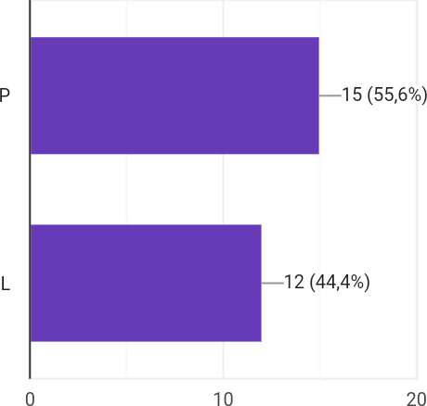

Figure 1. Gender
The number of samples that ultimately became respondents in this investigation was 27, with 55.6% of the participants being female and 44.4% of them being male. (See Figure 1). Respondents are pupils and primary school students in Pamekasan.

2. An Introduction to Online Education Regarding Information and Communication Technology
(A) Students' Use of Information and Communication Technology as an Online Learning Medium (Application)
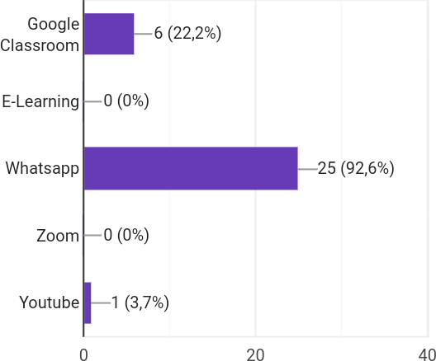

Figure 2 Media (Application) of Online Learning
A study conducted using Google Forms indicates that information and communication technology is used in the capacity of a medium (application) for education in elementary schools where online learning is implemented. The goal is to ensure that education can continue to be delivered to students even in the face of technological advances that make it possible to deliver instruction to students and teachers in different locations. Students utilize WhatsApp (92.6%), Google Classroom (22.2%), and Youtube (3.7%) more frequently than any other online learning media (applications). They enjoy using the media because it is thought to be straightforward. In addition to this, it does not eat up too much of your allotted internet space.
(B) Limitations That Students Encounter When Attending Classes via the Internet and Making Use of Other Forms of Information and Communication Technology
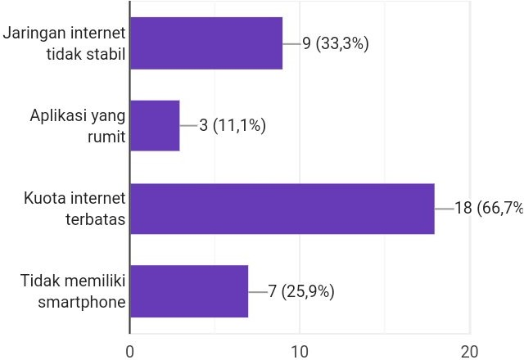

Figure 3: Some of the Limitations of Online Learning
Technology for information and communication is essential to the process of online education. Therefore, it is required that students have access to smartphones and be able to operate them. The hallmarks of this form of education include making consistent use of and reliance on the internet network. Therefore, if there is no internet quota and the internet network is unstable, this will become a barrier to online education. The findings of this study make it clear that the challenges that students encounter when engaging in online education include an unreliable internet connection (33.3% of respondents), complicated applications (11.1%), a limited internet quota (66.7% of respondents), and a lack of access to a smartphone. (25.9%). (See Figure 3).
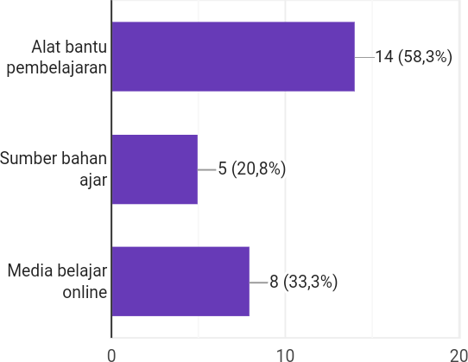
(C) The Importance of Applications of Information and Communication Technology in Online Learning

Figure 4: The Importance of Online Education and Its Applications
According to the research findings, information and communication technology play a very significant part in online education. The use of information and communication technology in online education as a learning aid (reported by 58.3% of respondents), an online learning medium (reported by 33.3% of respondents), and a source of teaching materials (20.8%). (See Figure 4)

Findings and Suggestions:
- Acquiring Knowledge about Information and Communication Technologies
As defined by Martin (1999), information technology is restricted to the computer technology (hardware and software) that processes and stores information. It also includes the communication technology used to send or distribute information. Based on the two definitions presented above, one may conclude that information technology can be thought of as the science required managing information to make it possible to search for or retrieve information with ease. In the meantime, the use of computer technology as an information processor and communication technology as a means of remote information transmission is required to manage this information appropriately, speedily, and efficiently (Andri 2017). During this time, communication technology refers to long-distance communication tools such as the telephone, fax machine, and television.
Because information and communication technology are inseparable components of education, the progression of information and communication technology has a part to play in the process of pointing the way toward a better future for the educational system as a whole. In both formal and non-formal education settings, the proliferation of various forms of online learning that use internet capabilities is symbolic of the role that information and communication technology plays as a facilitator of learning at a distance. It makes it a possible level of education to participate in educational activities that may complete at any time and in any location. To ensure that education can normally go despite the spread of the COVID-19 pandemic, the communication and information technology presently being developed must have the potential to be a medium or instrument that can utilize at this time. It is now possible to acquire knowledge through a web-based distance learning system because of advancements in information and communication technology (PJJ).
- Learning Conducted Online
An additional obstacle for the education community is to overcome so that teaching and learning can normally go despite the COVID-19 pandemic. Learning through the internet is one approach to address this issue. According to the Central Indonesian Dictionary (KBBI), the term "online" is just another word that belongs to the "network," which refers to being connected via various forms of digital networking such as the internet. "Online learning" refers to acquiring knowledge through the internet in a dispersed setting. Facilities are available for use in online learning. Additionally, infrastructure in the form of notebook computers, desktop computers, mobile phones, and support for internet networks is required. Learning over information and communication technologies such as the internet is an example of remote education known as online learning.
The issues COVID-19 Pandemic has caused for all aspects of human activity, including education, have inspired the development of this form of education that may complete online. This learning is somewhat distinct from the traditional learning that takes place in educational institutions like schools. The interaction between instructors and pupils is not faced to face but rather conducted remotely, which enables both parties to be located in a location of their choosing. Nevertheless, contact and providing information that makes it simpler for students to improve the quality of their learning are given a higher priority in online learning. On a more positive note, this learning is also highly helpful for maintaining a steady stream of education despite the pandemic. Online learning is being utilized to lessen and eventually stop the chain of transmission of COVID-19 in the educational setting.
Learning and teaching activities (KBM) are not carried out face-to-face in online learning. This is accomplished through internet technology in conjunction with a remote learning system. Due to the present epidemic, there are restrictions placed on schools that use a face-to-face teaching system. As a result, online learning is being used at all educational levels, including primary, secondary, and high schools (Sodiq, Mahfud, and Adi, 2021). Learning management systems include online education. Whose implementation is not done directly in the same location but through a platform that can aid in the teaching and learning process even though it is carried out remotely (Handarini and Wulandari 2020).
One-way and two-way learning models are utilized in online education delivery, respectively. When a teacher offers assignments or materials to students using online media, this is an example of one method that online learning can be carried out. The students are responsible for actively and independently studying the subject and completing the tasks. In the meantime, two-way online learning occurs when students and teachers are present in a virtual area designed specifically to facilitate the interaction process between teachers and students. This kind of interaction might give content and explain assignments that both students and professors can immediately follow.
- What Function Does Information and Communication Technology Play in Online Education?
In addition, the function that information and communication technology plays in the educational process is of critical significance, particularly in the context of a pandemic such as the one we are experiencing today. Because appearance COVID-19, it is imperative that all activities, including those about education and training, be carried out at home. The proliferation of online learning applications and platforms is a direct result of developments in information and communication technology, which provide growing levels of assistance to online education. Therefore, information and communication technology plays a significant part in the facilitation of the process of online learning. In other words, technology is a channel for learning-related interaction and knowledge transfer when implementing online learning.
Technology that enables information sharing and communication is essential for the successful deployment of online education. One of the many functions that information and communication technology plays in online education is that of a medium for instructors to disseminate course content and delegate work to students. According to Hendratno (2018), the role of information and communication technology in learning, in particular online learning is "as a learning infrastructure, as a source of teaching materials, as learning aids and facilities, as skills and competencies, as a source of research information, as a consultation medium as an online learning medium." It is in line with Hendratno's (2018) opinion (Yuliyanti et al., 2017).
Learning through the internet necessitates using various forms of media or educational aids that make it possible to use high-quality information technology and an internet connection to facilitate the acquisition of learning processes and knowledge through interactions. The information and communication technology widely employed in education, particularly online learning, serves as both a learning tool and facility. It also acts as a conduit for online learning between educators and students using digital platforms.
When it comes to online education, the following are some examples of digital platforms that may be utilized as learning media or as learning aids:
- Google Classroom
The application, Google Classroom, simplifies the educational process for students and their instructors. This Google Classroom makes it easier for educators to manage their learning and precisely and accurately communicate information to their pupils. In the context of online education, instructors can use a variety of Google Classrooms capabilities, including assignments, grading, communication, time-cost analysis, course archiving, mobile application access, and privacy settings. On the Google Classroom platform, supporting tools include Gmail, Youtube, Google Drive, Google Maps, and Google Translate.
- E-Learning
E-learning, also known simply as "online learning," refers to any media or education platform that uses information and communication technology. During the learning process, teaching, learning, and evaluation can all be delivered, supported, and improved with the use of electronic technology, thanks to e-learning.
- Whatsapp
WhatsApp is a platform widely utilized nowadays for various objectives, including personal and social ones. This platform is a tool that may use to carry out long-distance communication in the form of talks utilizing words, graphics, sound, or video. These types of conversations can be carried out using the platform. Teachers can use video or voice notes to communicate various information, including materials, questions for evaluation, and explanations. Whatsapp groups also can enhance learning in both directions by utilizing the video calling features. Even in classrooms with a small number of students, this technology allows professors and students to hold face-to-face meetings while simultaneously distributing course materials and tasks.
- Zoom
Video screen sharing is available using the Zoom in the meeting program, which supports a maximum of one thousand additional users and can accommodate as many as one hundred participants simultaneously. On the other hand, because it allows for an adequate amount of space to be occupied at a single gathering, this application greatly assists educators who wish to hold direct conversations with students through virtual rooms (ZAM 2021).

Conclusion
The world of education has been significantly altered due to the COVID-19 epidemic. Learning done face-to-face between educators and students needs to be converted to learning done at a distance. Technology is necessary for communication and information to participate in online learning. The development of information and communication technologies has been of great assistance to the field of online education. It is because there are now a variety of digital media and platforms available, such as WhatsApp, Google Classroom, and YouTube, and both teachers and students can utilize that. To function, the medium (application) needs access to the internet. Online education would not be possible without the assistance of information and communication technology. The function of information and communication technology (ICT) functions in online education as a potential supply of pedagogical content. In this approach, both teachers and students can continue to carry out learning activities successfully.

References:
- Andri, and Rogantina Meri Meri. (2020). “Peran Dan Fungsi Teknologi Dalam Peningkatan Kualitas Pembelajaran.” Jurnal Ilmiah Research Sains 1(1):122–29.
- Andri, Rogantina Meri. (2017). “Peran Dan Fungsi Teknologi Dalam Peningkatan Kualitas Pembelajaran.” Jurnal Ilmiah Research Sains 3(1):122–29.
- Butterfield, L. D., Borgen, W. A., Amundson, N. E., & Maglio, A. S. T. (2005). Fifty years of the Critical Incident Technique: 1954-2004 and beyond. Qualitative research, 5(4), 475-497.
- Handarini, Oktafia Ika, and Siti Sri Wulandari. (2020). “Pembelajaran Daring Sebagai Upaya Study from Home (SFH).” Jurnal Pendidikan Administrasi Perkantoran (JPAP) 8(3):465–503.
- Literate, Syntax, and Indonesia. (2020). “Mengembangkan Kepribadian Peserta Didik.”Jurnal Ilmiah 274–82.
- Monereo, C. (2010). La formación del profesorado: una pauta para el análisis e intervención a través de incidentes críticos. Revista Iberoamericana de educación, 52(1), 149-178.
- Monereo, C., Monte, M., and Andreucci, P. (2015). La Gestión de Incidentes Críticos en la Universidad. [Management of critical incidents in university]. Madrid: Narcea.
- Pulungan, Sahmiar. (2017). “Pemanfaatan ICT Dalam Pembelajaran PAI QUERY: Jurnal Sistem Informasi.” Sistem Informasi 5341(April):19–24.
- Sodiq, M., H. Mahfud, and F. P. Adi. (2021). “Persepsi Guru Dan Peserta Didik Terhadap Penggunaan Aplikasi Berbasis Web ‘Quizizz’ Sebagai Media Pembelajaran Di Sekolah Dasar.” Didaktika Dwija Indria 9(5).
- Sugiyono. (2015). “Daftar Pustaka Daftar Pustaka.” Pemikiran Islam Di Malaysia: Sejarah Dan Aliran 20(5):40–43.
- Sugiyono. (2018). Metode Penelitian Manajemen, Pendekatan: Kualitatif, Kuantitatif, Kombinasi (Mixed Methods), Penelitian Tindakan (Action Research), Penelitian Evaluasi. Bandung: ALFABETA.
- Tripp, D. (2011). Critical incidents in teaching (classic edition): Developing professional judgement. Routledge.
- Wilson, Agus. (2020). “Penerapan Metode Pembelajaran Daring (Online) Melalui Aplikasi Berbasis Android Saat Pandemi Global.” SAP (Susunan Artikel Pendidikan) 5(1).
- Yuliyanti, Resdiana Putri, Hobri, and Suharto. (2017). “Profil Pemecahan Masalah Aritmatika Sosial Siswa Kelas VII A SMPN 2 Jember Berdasarkan Tahapan Polya Ditinjau Dari Gaya Belajar V-A-K (Visual, Auditorial, Kinestetik).” Kadikama 8(3):31–41.
- ZAM, EMBUNG MEGASARI. (2021). “Peran Literasi Teknologi Informasi Dan Komunikasi Pada Pembelajaran Jarak Jauh Di Masa Pandemi Covid-19.” EDUTECH : Jurnal Inovasi Pendidikan Berbantuan Teknologi 1(1):11–20.

