ENERGY CROPS FOR BIOFUEL PRODUCTION
Brijesh Kumar*, Magan Singh**, Deepak Kumar*, Sandeep Kumar*, Rakesh Kumar*, and Birendra Kumar
* Ph.D. Research Scholar, **Senior Scientist,
Agronomy Section, ICAR-National Dairy Research Institute, Karnal (Haryana) 132001
Corresponding author email: kbrijeshkumar609@gmail.com
Abstract
Biofuels (biodiesel and bioethanol) produced from various biobased sources have recently attracted a lot of attention because of their potential to reduce net carbon dioxide emissions while lowering the growing reliance of the globe on fossil fuels. The goal might be to provide biomass-based alternative fuel that is both readily available and economically viable in order to meet both national goals for biofuel blending and the energy deficit. Currently, maize, sugarcane, molasses, wheat, and other grains crops, cassava, sugar beets, palm, soybean, rapeseed, etc. are used for biofuel production. Recent consideration has been given to lignocellulosic biomass as another potential feedstock because of its non-food competition and abundant supply. The yeast Saccharomyces cerevisiae is used to ferment the sugars found in sugar cane and sugar beets as well as those obtained from the starch in corn and other cereals in order to economically produce ethanol from a range of feedstocks. The additional bio-resources, in addition to cellulosic biomass being the ideal substitute for producing bioethanol and non-edible oil containing biomaterials for producing biodiesel for vehicle traffic, might make the energy sector sustainable. The production of biofuels from energy crops is essential to the growth of the global economy and the slowing of climate change. The CO₂ released during the combustion of biomass is absorbed by plants to grow. Because the quantity of CO₂ emitted during usage has already been fixed during plant growth, no net CO₂ is produced when agricultural biomass is used to generate energy.
Keywords: Biodiesel, Bioenergy, Biofuel, Energy Crops, and Ethanol

Introduction
Biomass energy production is just one of the sources of renewable energy that can be used to reduce the negative environmental effects of energy usage and production (McKendry, 2002). For satisfying current demand and securing a sustainable future fuel supply, crops biomass has the most potential to produce biofuels. The modern technology to produce biomass which leads to higher biomass production and efficient utilization of biomass resources. Agricultural produce and crop biomass are broadly classified as food-based portions, oil, and carbohydrates (such as maize/corn, sugarcane, and sugar beet), and non-food-based portion complex carbohydrates (such as leaves, stalks, cobs of maize stover, orchard, trimmings, rice husks, and straw) perennial grasses and animal waste (Chandra et. al., 2012). Energy crops have the potential to supply and help to fulfil the world's future energy needs. Additionally, agricultural fields provide energy farming as a substitute for traditional agriculture. Energy crops used in biofuel production are a relatively affordable and environment-friendly method of producing long-term energy. Currently, the majority of developed countries used energy-producing crops including corn, sugar beets, soybean, rapeseed, and wheat (McKendry, 2002). In addition to the primary source of biodiesel and bioethanol production are oilseed, sugar-producing crops, and some trees. These crops are also used for manufacturing food and feed and their raw materials are used for biofuel production. Consequently, it is an important issue for energy crops that are used as food products and which are used to produce biofuels considered in terms of food safety. Energy crops known as C₄ crops such as miscanthus, switchgrass, and sweet sorghum, may thrive with a high biomass production even on barren ground. Thus, energy farming is a novel form of agriculture that uses these crops to produce biomass for biofuel production (Ericsson and Nilsson, 2006). The idea of bioenergy crops is gaining popularity among the scientific community due to their ability to be renewed and eco-friendly characteristics. However, the global market uses food crops as bioenergy crops in a more typical way raising concerns about food security. Additionally, food crops and bioenergy crops compete for agricultural land, water, and nutrients needed by bioenergy plants. Wildlife habitat destruction and a rise in the spread of invasive plant species are two additional drawbacks associated with the use of bioenergy crops (Dipti and Priyanka, 2013). Biomass is a renewable source of energy that is related to the environment, economy, agriculture and rural development, manufacture of biofuels from biomass. Additionally, the production of biofuels from energy crops is essential to the growth of the global economy and the slowing of climate change.
Status of bioenergy in the world and India
Demand and supply worldwide
The demand for biofuel will increase by 41 billion liters from 2020 to 186 billion liters by 2026, demand increases at an average rate of 4% per year over the projection period. The biggest markets for biofuels are still the United States of America and Brazil. These countries are also responsible for the biggest increase in demand over the following five years. Currently, ethanol and biodiesel will account for 87% of the world's demand for biofuels at the end of the projected period. Shifts in both geography and fuel are observed in the market. In 2024, Asia overtakes Europe to become the third place in regional demand for biofuels. Renewable diesel and biojet demand are being increased by policies in Europe and the US increasing their global market share from 5% in 2020 to 13% in 2026. However, a bigger rise in production than in demand as Asian nations support rising domestic demand and increase exports of renewable diesel and biojet to meet the needs of markets in North America and Europe. Between 2022 and 2026, the total Asian supply will increase by 40% because of decreased domestic demand ethanol supply is falling in the United States. The rate of this drop was only somewhat countered by rising exports. In spite of a general fall in demand domestic, biodiesel production in Europe is expanding and replacing some imports keeping up with the demand for ethanol (IEA, 2021).
Source: IEA (2021), Renewables 2021, IEA, Paris https://www.iea.org/reports/renewables-2021.
Fig.1 Biodiesel demand by region (left) and by fuel (right) 2018-2026.

Source: IEA (2021), Renewables 2021, IEA, Paris https://www.iea.org/reports/renewables-2021.
Fig.2 Biofuel supply and demand growth by region (2022-2026).
Brazilian demand for biofuel increases by 27% between 2022 and 2026, or roughly 10 billion liters. But the demand for ethanol is rising to 2019 levels, accounting for almost half this growth. The primary causes of rising consumption include increasing demand for liquid transportation fuel, regulations requiring the blend of 15% biodiesel and 27% ethanol, and consumers’ sales of ethanol over the required levels. Sugarcane ethanol generally performs better than domestic maize ethanol production (IEA, 2021).
Demand and supply in India
India's ethanol use has increased thrice in the last five years; it is overtaking China as the third largest ethanol consumer by 2026. India accelerated their goal of mixing 20% ethanol into gasoline from 2030 to 2025 in January 2021, and it now plans to begin selling 20% blends in 2023. India supports ethanol production because it helps in cut down oil imports, reduces air pollution, and provides farmers financial assistance and job prospects. According to IEA analysis, increasing ethanol demand is also compatible with a net zero trajectory. India has already advanced much in terms of ethanol blending. India's ethanol demand tripled between 2017 and 2021, reaching an anticipated 3 billion liters of ethanol in 2021. The amount of ethanol added to gasoline has also increased. By the summer of 2021 ethanol blending has increased to 8% from 2% in 2017, putting India on target to reach 10% ethanol blending by 2022. In order to reach its 20% target, the nation has established guaranteed ethanol pricing per litre based on feedstock and established financial support for additional ethanol production capacity (IEA, 2021).
Fig.3 Ethanol demand in the accelerated case compared with capacity (2017-2026) (left) and production potential based on feedstock (right), India 2020-2026.
Note: the graph compares estimates of ethanol production potential from different feedstock with ethanol demand in accelerated cases.
Sources: IEA 2019, Analysis based on OECD 2019 market, and NITI Ayog, (2021). IEA (2021), Renewables 2021, IEA, Paris https://www.iea.org/reports/renewables-2021.
Energy crops
Biofuels are fuels made from biomass, such as bioethanol and biodiesel. Currently, maize accounts for roughly 60% of the ethanol generated, with sugarcane accounting for 25%, molasses for 2%, wheat for 3%, and other grains, cassava, or sugar beets making up the remaining amounts. Vegetable oils including palm, soybean, and rapeseed account for around 75% of biodiesel's composition, along with 20% of used cooking oils. The generation of all biofuels is not significantly influenced by more sophisticated technologies based on cellulose feedstock (such as wood, energy crops, or crop leftovers). National policies with three main objectives farmer support, lower greenhouse gas emissions, and/or greater energy independence have a significant impact on the global biofuel market (OECD/FAO, 2021).
Table 1: Biofuel production ranking and major feedstock used in biofuel production.
Countries | Production ranking (Base period) |  | Major feedstock
 | Ethanol | Biodiesel | Ethanol | Biodiesel
United States | 1(48.2%) | 2(18.1%) | Maize | Soybean oil/Used cooking oil
European Union | 4(4.8%) | 1(32.3%) | Sugar beet/Wheat/  Maize | Rapeseed oil/Palm oil/ Used cooking oil
Brazil | 2(26.7%) | 4(12.2%) | Sugarcane/Maize | Soybean oil
China | 3(8.3%) | 9(2.3%) | Maize/Cassava | Used cooking oil
India | 5(2.3%) | 15(0.5%) | Molasses | Used cooking oil
Canada | 6(1.6%) | 13(0.7%) | Maize/Wheat | Canola oil/used cooking oil/soybean oil
Indonesia | 20(0.1%) | 3(15%) | Molasses | Palm oil
Argentina | 8(1.0%) | 5(5%) | Molasses/Sugarcane/Maize | Soybean oil
Thailand | 7(1.4%) | 7(3.8%) | Molasses/Cassava/  Sugarcane | Palm oil
Colombia | 13(0.44%) | 11(1.3%) | Sugarcane | Palm oil
Paraguay | 14(0.42%) | 19(0.03%) | Maize/sugarcane | Jatropha
Source: OECD/FAO (2021), OECD-FAO Agricultural Outlook 2021-2030, OECD Publishing, Paris, https://doi.org/10.1787/19428846-en.
Table2: Biofuel yields from different feedstock in different countries.
Crop | Global/Nation  estimates | Biofuel | Crop yield  (Tonnes/ha) | Conversion efficiency (Liters/tonne) | Biofuel yield (Liters/ha)
Sugar beet | Global | Ethanol | 46.0 | 110 | 5060
Sugarcane | Global | Ethanol | 65.0 | 70 | 4550
Cassava | Global | Ethanol | 12.0 | 180 | 2070
Maize | Global | Ethanol | 4.9 | 400 | 1960
Rice | Global | Ethanol | 4.2 | 430 | 1806
Wheat | Global | Ethanol | 2.8 | 340 | 952
Sorghum | Global | Ethanol | 1.3 | 380 | 494
Sugarcane | Brazil | Ethanol | 73.5 | 74.5 | 5476
Sugarcane | India | Ethanol | 60.7 | 74.4 | 4522
Oil palm | Malaysia | Biodiesel | 20.6 | 230 | 4736
Oil palm | Indonesia | Biodiesel | 17.8 | 230 | 4092
Maize | United States of America | Ethanol | 9.4 | 399 | 3751
Maize | China | Ethanol | 5.0 | 399 | 1995
Cassava | Brazil | Ethanol | 13.6 | 137 | 1863
Cassava | Nigeria | Ethanol | 10.8 | 137 | 1480
Soybean | United States of America | Biodiesel | 2.7 | 205 | 552
Soybean | Brazil | Biodiesel | 2.4 | 205 | 491
Source: FAO, (2008). State of Food and Agriculture. https://www.fao.org/3/i0100e/i0100e.pdf
Biodiesel
Biodiesel is a liquid biofuel that can be used alone or in combination with diesel oil in diesel engines. It is produced chemically from vegetable or animal fats and alcohol. Vegetable oils, animal fats, and short-chain alcohols are the primary raw materials used in the manufacturing of biodiesel. Rapeseed (primarily in countries of the European Union), soybean (Argentina and the United States), palm (countries of Asia and Central America), and sunflower oil are the oils that are most commonly used to produce biodiesel worldwide. However, other oils, such as peanut, linseed, and safflower, as well as used vegetable oils and animal fats, are also used. Although ethanol is also a viable option, methanol is the most often utilized alcohol (Moniruzzaman et. al., 2017). As a solution to issues with environmental degradation, energy security, limiting imports, rural jobs, and agricultural economies, biofuels like biodiesel and ethanol are becoming more widely accepted on a global scale. Since more than 70% of the oil consumed in India is imported, the country has taken steps to look for alternatives to fossil fuels as the economic dependence on oil grows. In this context, the use of biofuels made from plant-based materials is significant.
Table3: Capacity of different crops to produce biodiesel
Microalgae/Plant | Microalgae/plant oil yield (L/ha/year) | Oil content (% wt. in biomass) | Required land  (M ha⁻¹) | Biodiesel productivity (kg/ha/year)
Microalgae (high oil content) | 136900 | 70 | 2 | 121104
Microalgae (low oil content) | 58700 to 97800 | 30 to 50 | 4.5 | 51927 to 85515
Oil plam | 5950 | 30 to 60 | 4.5 | 4747
Jatropha | 1892 | Kernel: 50 to 60  Seed: 35 to 40 | 140 | 656
Canola/Rapeseed | 1190 | 38 to 46 | 223 | 862
Soybean | 446 | 15 to 20 | 594 | 562
Corn/Maize | 172 | 44 to 48 | 1540 | 152
Note: Estimated oil content, yields, and land requirement for various biodiesel feedstock.
Source: (Berchmans et. al., 2008; Mata et. al., 2010; Atabani et. al., 2012).
Rapeseed and Canola
Rapeseed does well in soils with poor fertility but high sulfur content. It can be cultivated as a winter cover crop and have a high oil content (40–50%). In the European Union, it is the most significant raw material for the production of biodiesel. Additionally, its utilization has been constrained by low costs compared to wheat, which serves as its primary rival for crop rotation, and by poor yield per unit area. Rapeseed flour is utilized as a protein supplement in cow feeds because it has a higher nutritional value than soybean flour. There are sometimes when the terms "canola" and "rapeseed" are used interchangeably; canola is the outcome of rapeseed being genetically modified in Canada over the past 40 years to reduce the erucic acid glucosinolates in the oil, these compounds are problematic when used for animal and human consumption. Due to its superior quality and ability to lower blood cholesterol levels, canola oil is regarded as one of the best cooking oils along with olive oil (Romano and Sorichetti, 2010).
Soybean
Soybean is a legume of East Asian origin and the top soybean-producing nations are China, India, Brazil, Argentina, and the United States. In addition to glycerine, the manufacturing of biodiesel from soybeans results in the creation of useful by-products such as soybean meal and pellets (used as animal feed) and flour (which have a high content of lecithin, a protein). The yield grain of soybean is 2000 to 4000 kg ha⁻¹ produced. The oil content of the seeds is about 18% due to their high protein content (Romano and Sorichetti, 2010).
Oil Palm
The oil palm is a tropical plant with a 20-25 m height range and an average lifespan of 25 years. The fruit yields two types of oil: palm kernel oil (extracted from the nut of the fruit) and palm oil proper, which is derived from the pulp (after oil extraction palm kernel is used for animal feed). The top oil palm producing countries are Malaysia and Indonesia. Over the past years, there has been a steady rise in the demand for palm oil on a global scale. This oil is used for cooking as a component of margarine, an ingredient in butter, and an additive for baked goods. It is crucial to note that pure palm oil is semisolid at room temperature (20-20ºC) hydrogenated frequently combined with other vegetable oils, and occasionally partially hydrogenated, in applications (Agudelo et. al., 2004).
Sunflower
Sunflower's considerable significance is due to the superior quality of edible oil that is derived from its seeds. It is well recognized in terms of nutritional value, flavor, and taste. Additionally, the leftover cake from oil extraction is fed to livestock. Sunflower oil can be stored for a long time because it contains relatively little linoleic acid, as must be emphasized. Sunflower can be used in crop rotation with soybean and maize since it adapts well to unfavorable environmental circumstances, doesn't need specialized farming equipment, and doesn't need much water. The oil output of modern hybrids ranges from 48 to 52% (Romano and Sorichetti, 2010).
Peanut
Weather conditions during harvest have a big impact on peanut quality. The majority of uses for peanuts are for human consumption, peanut butter production, and a component of other processed foods products. Low-quality peanuts, especially rejected products from the candy business are used to produce oil. Cooking blends that use peanut oil are often utilized as flavorings in the confectionery business. The peanut high-quality, highly protein-based flour that is left over after oil extraction is utilized as animal feed in pellet form (Romano and Sorichetti, 2010).
Flax
A plant native to temperate regions with blue blossoms is called flax. The plant's stem produces the threads used to make linen, and its seeds yield linseed oil, which is used to make paint. Since flax seeds are a source of essential polyunsaturated fatty acids (PFAs) for humans, they are nutritionally valuable for human intake. Additionally, the cake that is left over after the oil has been extracted is fed to livestock. Although the plant can tolerate a wide range of humidity, temperature, and copious rain do not produce high yields of seed and fiber. Flax seeds have a protein content of 20 to 30% and between 30 and 48% oil content. It is significant to note that the oil of linseed is high in polyunsaturated fatty acids (PFAs), with 40 to 68% of the total being linolenic acid (Garcia, 2007).
Safflower
The safflower crop is a tropical plant grown in dry climates. Despite having a poor grain yield per hectare, seeds have a high oil content of between 30 to 40%. It has economic possibilities for dry areas as a result. Safflower is currently used to make bread, oil, and bird feed. There are two types, one with a high concentration of polyunsaturated fatty acids (PFAs) and the other high concentration of mono-unsaturated fatty acids (MUFAs) oleic acid, and linoleic acid. Safflower oil is of excellent quality and contains little cholesterol. In addition to being utilized for human consumption, and it is also used to make lacquers, soaps, paints, and other coating materials. Safflower oil is extracted using hydraulic presses without the use of solvents and refined using traditional techniques without the addition of antioxidants. Safflower flour is high in fibre and has a protein content of roughly 24%. It is used as a protein additive in animal feed (Romano and Sorichetti, 2010).
Castor oil
Castor oil plants are grown in warm tropical conditions with temperatures between 20 to 30 °C. The temperature must not drop below 12ºC as the seeds begin to germinate, it is crucial for higher seed production. The plant requires warm, humid weather during its vegetative, dry weather during the ripening and harvesting phases. It does well in a variety of soil types and needs a lot of sunlight during the crop growth period. Despite being drought-resistant, the castor oil plant requires at least five months of rain annually, and the total rainfall during the growth cycle must be between 700 and 1400 mm. Ricinolenic acid makes up around 90% of castor oil's composition. Because of the 1-5% ricin content, which can be eliminated by cold pressing and filtering, the oil is poisonous and inedible. In comparison to other vegetable oils, it is exceptionally polar due to the presence of hydroxyl groups in its molecules (Romano and Sorichetti, 2010).
Tung
A tree that does well in tropical and subtropical regions is the tung. Low annual rainfall and temperatures between 18 to 26°C are ideal for tung. The tung tree's dry nuts fall off around harvest time and are gathered from the ground. Beginning three years following the planting, nuts are produced. Non-edible tung nut oil is used for making paints, and varnishes, particularly for marine applications (Garcia, 2007).
Cotton
Cotton is the most commonly traded crop among non-food items. It is grown in more than 80 countries around the world. Cotton is traded as a form of raw cotton, fiber, or seeds after harvesting the crop. In cotton mills, raw cotton is separated from its fiber and seeds. Fabric and thread made from the cotton fiber are processed for use in the textile industry. Additionally, cotton seeds provide cotton oil and flour, the latter of which is high in protein content and used as livestock feed before being refined further for human uses.
Jojoba
Jojoba survives prolonged periods of drought, but irrigation is necessary to produce profitable yield at harvest. Although jojoba prefers warm weather, flowering needs a period of cold weather for full development. During the harvest season, rainfall must be extremely scarce (summer). After being planted, the plant takes ten years to attain its peak yield. Because jojoba oil is primarily used in cosmetic products.
Jatropha
Jatropha is a shrub that grows well in dry climates. The most well-known cultivar of Jatropha is Jatropha curcas, which needs less water and less management practice, it is suitable for warm climates with low fertility soil. Unpredictable rainfall or strong winds during the blossoming season may have a negative impact on productivity. The climate, soil, rainfall, and care given during planting and harvesting all affect yield. After three to four years jatropha plants start to produce seeds and the lifespan of plants is around fifty years. The oil yields depend on the extraction technique; it ranges from 28 to 32% for presses maximum up to 52% for solvent extraction. Jatropha oil is toxic and the seeds are poisonous. Jatrophic acid and globulin curcas are responsible for toxicity (as toxic as ricin) (Romano and Sorichetti, 2010).
Avocado
The avocado tree grows to a height of between 5 and 15 meters. The fruit weighs between 1.20 and 2.5 kg, and it takes between 5 and 15 months to reach harvest. Avocado fruit doesn't mature on the tree; it ripened after being picked. The pulp and pith of the fruit can be used to produce oil. It contains vital fatty acids, minerals, protein, vitamins A, B₆, C, D, and E, it has a high nutritional value. The fruit's pulp and oil have relatively modest levels of saturated fatty acids; they are highly high in mono-unsaturated fatty acids (MUFAs), with oleic acid accounting for nearly all of them (96%). The fruit has an oil content that ranges from 12 to 30% (Romano and Sorichetti, 2010).
Ethanol
Ethanol is straightforward liquid alcohol that is produced by the fermentation of sugars found in their natural forms, as well as from grains high in starch and lignocellulosic feedstocks (Halde et. al., 2019). This contributes to the world's efforts to address some air pollution issues, lower greenhouse gas emissions that contribute to climate change, and ensure environmental security. Currently, the yeast saccharomyces cerevisiae is used to ferment the sugars found in sugar cane and sugar beets as well as those obtained from the starch in corn and other cereals in order to economically produce ethanol from a range of feedstocks (U.S.EIA, 2022).
Sorghum
Sorghum (Sorghum bicolor L.) is also known as sweet sorghum. It produces more biomass and stores a significant amount of fermented sugars in the stems. The plant can be grown on marginal terrain since it needs less fertilizer and water. Sorghum has a strong drought resistance mechanism and C₄ photosynthesis rate agronomic traits. In comparison to crops like maize and sugarcane, less research has been done on the genetic and molecular characterization of sorghum characteristics (Paterson et. al., 2009). Because the stems of sweet sorghum have a high sugar content, more sugar-metabolizing enzyme activity is seen in stem development. The sorghum crop uses nitrogen effectively and produces higher biomass. During droughts, it stores sugar in the stem at a greater rate. Sweet sorghum crops need some improvement to increase crop productivity, and genetic mapping could identify desired traits (Swaminathan et. al., 2010).
Maize
Maize is a valuable feedstock crop for ethanol production and has a high grain yield and a higher rate of starch buildup in grains (Arates and Saddler, 2011). It is a crop that is preferred for bio-conversion because of its high volatile content and simple conversion method. The United States and other countries use maize to produce ethanol. The usage of maize in the manufacture of bioenergy fuels may push up food costs globally causing poverty and hunger. Through accidental recessive mutations in the genes regulating the conversion of sugars to starch in the endosperm of the corn kernel, the sweet corn variety of corn was created to address the issue. Sweet corn hybrids with dual uses and high photosynthetic efficiency could help farmers contribute to energy generation without compromising the environment or the food supply (Zhao et. al., 2010).
Oilseed Crops
Some oilseed crops are also used for biofuel production such as rapeseed, linseed, field mustard, sunflower, hemp, safflower, castor oil, olive, palm, and groundnut are examples of crops used to make oil. Vegetable oils could be converted to produce transportation biofuels or used directly as fuel for heating (Sims et. al., 2006).
Sugarcane
The main plant that produces sugar in warm temperate or tropical areas is sugarcane (Saccharum officinarum L.). The sugarcane crop is perennial in nature; it grows year-round in contrast to annual crops. Sugarcane feedstock is consistently accessible and costs significantly less than the other bioenergy crops (Yuan et. al., 2008). Getting sugars from the juice of sugarcane is the main reason to be grown. Sucrose is a raw material for biofuel manufacturing and makes up a sizable portion of sugarcane juice. For the purpose of boosting cellulosic biomass, sucrose content, and sugarcane germplasm, several breeding programs are now underway. Molasses is a byproduct of the sugar industry and it is used to make commercial bioethanol.
Switchgrass
The switchgrass (Panicum virgatum L.) is warm-season perennial C₄ grass grown in eroding and marginal soils. The grass is an environmentally beneficial crop for large-scale biofuel production since it grows more slowly and needs less water and fertilizers. But it takes around two years for switchgrass to fully develop (McLaughlin et. al., 2006). Especially in the area of plant breeding, the plant has received less consideration from the scientific community. Switchgrass cannot be distinguished from wild populations based on genetic makeup. Because of this, switchgrass has a lot of room for genetic development to produce biomass more effectively (Casler et. al., 2007).
Miscanthus
The tall, perennial grasses of the Miscanthus genus, which are used as decorative plants and comprise 14-20 species, are native to Asia (Heaton et. al., 2010). Its use as a feed crop is constrained by the plant's shape. In Europe, the plant is a leading example of an herbaceous biomass feedstock. Miscanthus plants have a high rate of carbon dioxide fixation, perform C₄ photosynthesis, and need less nitrogen and water than C₃ plants. Due to its quick growth, disease resistance, high output, and comparably lengthy productive life of 10-15 years, this grass is regarded as a dedicated energy crop (Villaverde et. al., 2010). Miscanthus was shown to produce more biomass than switchgrass. Growing miscanthus requires includes 2-3year propagation period for rhizome cuttings, higher irrigation requirements, and increased energy usage during greenhouse propagation.
Alfalfa
The first forage crop to be planted in North America is alfalfa (Medicago sativa L.) (Russelle 2001). Alfalfa stems burn in the gasification process to produce electricity because they are fibrous. The leaves are quite high in protein (Lamb et. al., 2007). The plant is used as both feedstocks for biofuel production and a source of animal feed (Delong et. al., 1995). The stem cell walls of alfalfa have polysaccharides and lignin contents that are higher, which results in a larger yield of stem dry matter and theoretical ethanol yields (Lamb et. al., 2007).
Reed Canary Grass
North America is home to the C₃ grass reed canary grass (Phalaris arundinacea L.). It is a perennial grass that grows quite tall and is good at internally recycling nitrogen from shoots to roots. Switchgrass and reed canary grass has a number of characteristics are similar, including slow growth and low yields. The grass produces considerably more biomass which suggests that it could produce a respectable quantity of biofuel (Tahir et. al., 2011).
Napier
Napier grass (Pennisetum purpureum) is a tall, tropical, perennial grass-favoured bioenergy crop since it is simple to establish and has drought tolerance. Napier grass's low lignin content and higher biomass yield per acre led to the recognition of its potential as a bioenergy crop (Yasuda et. al., 2014). The Napier grass biomass has higher volatile matter, a lower ash content, a higher carbon content, and higher nitrogen and sulphur content (Mohammed et. al., 2015). Napier grass reportedly produced 74.1% ethanol after being Simultaneously Saccharified and Fermented (SSF).
Bermuda grass
Bermuda grass is an additional plant used in bioenergy (Cynodon dactylon L.). It is a perennial grass with a limited lifespan that is mostly used for feed during the warm seasons. Due to its pioneering character and tolerance of salinity, Bermuda grass functions as a soil binder in sand dams of riverbanks or sea coasts (Grassland, 2011).
Agave
The monocot plant agave (Agave sp.) is indigenous to hot and dry areas of Mexico. Tequila is made from a plant called Agave tequilana. In place of sugar, agave nectar is utilized in cooking. The plant has thick, fleshy leaves that convert into sharp tips and grow in arid areas. The CAM pathway is utilized by agave in photosynthesis. It reduces water loss during transpiration by opening stomata for CO₂ uptake at night. The plant is used to produce textiles, sugars, and alcoholic beverages. Agave is the chosen feedstock for biofuels since it requires little water, can grow easily on wastelands, and doesn't compete with feedstocks for food crops (Escamilla-Trevio, 2012).
Eucalyptus
Eucalyptus (Eucalyptus sp.) is an Australian-origin tree. The plant has a broad genetic resource base and develops more quickly over an endless period of time. The plant can withstand a variety of difficult environmental factors, including acidic soils, fire, insects, low fertility, and drought. Eucalyptus is grown in tropical regions due to its quick growth and higher production. Around the world, 80% of plantations are made up of just four species and their hybrids (E. grandis, E. urophylla, E. camaldulensis, and E. globulus). Eucalyptus sp. (E. globulus), has a quicker development rate than one of the four species, it is the most suitable plant and is utilized in breeding programs. The thermo-conversion of eucalyptus oil from plant materials has enormous potential for the production of biofuel and bioenergy (Rockwood et. al., 2008).
Microalgae
Microalgae are a crucial source of raw material for the production of biodiesel, bioethanol, biomethane, and biohydrogen (Ahmad et. al., 2011; Chisti, 2008). Microalgae are more effective at photosynthesizing compared to terrestrial plants. By collecting carbon dioxide generated from plants microalgae reduce greenhouse gas emissions. Using effective environmental CO_{2,} they generate large amounts of biomass quickly (Schenk et. al.,2008). Through carbon sequestration, microalgae lower the atmospheric concentration of carbon dioxide. Microalgal biofuels have less impact on the environment and the world's food supply than conventional biofuel-producing crops (Patil et. al., 2008; Tilman et. al., 2009). Microalgae have an efficient rate of light and CO₂ conversion to photosynthates, and microalgae have a significant potential to mitigate global climate change (Patil et. al., 2008). Additionally, they could be picked at any time of the year. Microalgae offer extremely biodegradable, non-toxic biofuels. There are numerous initiatives underway to increase the production of biofuel by genetically modifying strains to make them more effective (Williams et. al., 2007). The increased rate of conversion into biofuels in the microalgae-derived fuel makes it greener than other bioenergy crops.
Dedicated Bioenergy Crops
The dedicated bioenergy crops (perennial herbaceous and woody plants) are made up of cellulose plants (such as eucalyptus, poplar, willow, and birch), perennial grasses (such as giant reed, reed canary grass, switchgrass, and elephant grass/Napier), and non-edible oil crops (such as castor, jatropha, physic nut, oil radish, and Pongamia, etc,). These crops can be harvested more frequently throughout the year with a longer harvesting season because they have a shorter life cycle (Boe and Lee 2007; Ranade et. al., 2008). The most promising crop specifically for bioenergy is Short Rotation Coppice (SRC) (Rae et. al., 2009). These plants are eco-friendly and could be useful in reducing climate change effects (Patersen 2008; Taherzadeh and Karimi, 2008). By reducing salinity, storing carbon, increasing biodiversity, and enhancing soil and water quality, these crops could address a number of environmental issues (Ehrlich and Pringe, 2008; Lal, 2008). According to Mola-Yudego and Gonzalez-Olabarria (2010), nations like Sweden and the UK are pioneers in the large-scale planting of specialized bioenergy crops.
Conclusion and Future Prospect
Bioenergy crop feedstocks (cellulose or sugar, starch plants) can play a significant role in the production of ethanol and biodiesel to support the rural economy, offer improved energy efficiency, and utilize environmentally damaged lands in a useful way. Drought resistant and capable of carbon sequestration is bioenergy crops. Energy crops that may be raised on a farm may help preserve natural forests by serving as a substitute for wood. Due to land change, deforestation, and the conversion of grasslands, the biodiversity of the area is declining. A massive planting of bioenergy crops could control these environmental variables. Prior to field planting, it is important to consider how bioenergy crops use water because they may alter the dynamics of soil water and nutrients. A suitable bioenergy crop ought to be suggested depending on the type of land. Utilizing this alternative renewable energy source could be aided by the use of bioenergy crops for energy production. Using current engine technologies, the commercial production of bioenergy fuels could help humanity become less dependent on fossil fuels for transportation. Numerous technologies have been created, and more innovations are currently being established. The biodiesel business has also been successful in reducing its negative effects on the environment, creating jobs, ensuring energy security, and reusing trash. Because of its beneficial qualities, including as nontoxicity, clean burning, renewability, and acceptability, biodiesel is viewed as a possible substitute for or addition to petroleum-based diesel. As a result, the biodiesel business has several opportunities. Algal oil and heterogeneous acid catalysts are replacing other feedstock in the biodiesel synthesis process. A more dependable and effective source is algae oil. It has the potential to produce yields that are more than 100 times higher per hectare than those available from oilseeds. Commercial-scale production of non-food feedstocks, such as microalgae, has been done without eating up arable land or causing deforestation. Heterogeneous acid catalyst usage also results in a cleaner and greater yields. It uses less expensive, more accessible feedstocks and reduces pre- and post-product expenditures. These elements, along with others like waste utilization and fewer emissions, will help make biodiesel a less expensive energy source with more substantial economic advantages and better environmental benefits.

References
Agudelo, S., John, R., & Benjumea Hernández, P. N. (2004). Biodiésel de aceite crudo de palma Colombiano aspectos de su obtención y utilización.
Ahmad, A. L., Yasin, N. M., Derek, C. J. C., & Lim, J. K. (2011). Microalgae as a sustainable energy source for biodiesel production: a review. Renewable and sustainable energy reviews, 15(1), 584-593.
Arantes, V., Saddler, J.N. Cellulose accessibility limits the effectiveness of minimum cellulase loading on the efficient hydrolysis of pretreated lignocellulosic substrates. Biotechnol Biofuels 4, 3 (2011). https://doi.org/10.1186/1754-6834-4-3
Atabani, A. E., Silitonga, A. S., Badruddin, I. A., Mahlia, T. M. I., Masjuki, H., & Mekhilef, S. (2012). A comprehensive review on biodiesel as an alternative energy resource and its characteristics. Renewable and sustainable energy reviews, 16(4), 2070-2093.
Berchmans, H. J., & Hirata, S. (2008). Biodiesel production from crude Jatropha curcas L. seed oil with a high content of free fatty acids. Bioresource technology, 99(6), 1716-1721.
Boe, A., & Lee, D. K. (2007). Genetic variation for biomass production in prairie cordgrass and switchgrass. Crop science, 47(3), 929-934.
Casler, M. D., Stendal, C. A., Kapich, L., & Vogel, K. P. (2007). Genetic diversity, plant adaptation regions, and gene pools for switchgrass. Crop Science, 47(6), 2261-2273.
Chandra, R., Takeuchi, H., & Hasegawa, T. (2012). Methane production from lignocellulosic agricultural crop wastes: A review in context to second generation of biofuel production. Renewable and Sustainable Energy Reviews, 16(3), 1462-1476.
Chisti, Y. (2007). Biodiesel from microalgae. Biotechnology advances, 25(3), 294-306.
Delong, M. M., Swanberg, D. R., & Oelke, E. A. (1995). Sustainable biomass energy production and rural economic development using alfalfa as feedstock (No. NREL/CP- 200-8098; CONF-9508104-). National Renewable Energy Lab.(NREL), Golden, CO (United States).
Dipti, P. (2013). Bioenergy crops an alternative energy. Int J Environ Eng Manag, 4, 265-272.
Ericsson, K., & Nilsson, L. J. (2006). Assessment of the potential biomass supply in Europe using a resource-focused approach. Biomass and bioenergy, 30(1), 1-15.
Escamilla-Treviño, L. L. (2012). Potential of plants from the genus Agave as bioenergy crops. Bioenergy Research, 5(1), 1-9.
FAO, (2008). State of Food and Agriculture. https://www.fao.org/3/i0100e/i0100e.pdf
García Penela, J. M. (2007). Selección de indicadores que permitan determinar cultivos óptimos para la producción de biodiesel en las ecoregiones Chaco-Pampeana de la República Argentina. INTA. INTA, Buenos Aires.
Index, F. G. (2010). A searchable catalogue of grass and forage legumes. Rome, Italy.
Halder, P., Azad, K., Shah, S., & Sarker, E. (2019). Prospects and technological advancement of cellulosic bioethanol ecofuel production. In Advances in eco-fuels for a sustainable environment (pp. 211-236). Woodhead Publishing.
Heaton, E. A., Dohleman, F. G., Miguez, A. F., Juvik, J. A., Lozovaya, V., Widholm, J., ... & Long, S. P. (2010). Miscanthus: a promising biomass crop. Advances in botanical research, 56, 75-137.
IEA, (2019). Fuel Economy in Major Car Markets. https://www.iea.org/reports/fuel-economy- inmajor- car-markets. (accessed august 2022).
IEA, (2021). Renewables 2021, IEA, Paris https://www.iea.org/reports/renewables-2021
Lamb, J. F., Jung, H. J. G., Sheaffer, C. C., & Samac, D. A. (2007). Alfalfa leaf protein and stem cell wall polysaccharide yields under hay and biomass management systems. Crop Science, 47(4), 1407-1415.
Mata, T. M., Martins, A. A., & Caetano, N. S. (2010). Microalgae for biodiesel production and other applications: a review. Renewable and sustainable energy reviews, 14(1), 217- 232.
McKendry, P. (2002). Energy production from biomass (part 2): conversion technologies. Bioresource technology, 83(1), 47-54.
McLaughlin, S. B., Kiniry, J. R., Taliaferro, C. M., & Ugarte, D. D. L. T. (2006). Projecting yield and utilization potential of switchgrass as an energy crop. Advances in Agronomy, 90, 267-297.
Mohammed, I. Y., Abakr, Y. A., Kazi, F. K., Yusup, S., Alshareef, I., & Chin, S. A. (2015). Comprehensive characterization of Napier grass as a feedstock for thermochemical conversion. Energies, 8(5), 3403-3417.
Mola-Yudego, B., & González-Olabarria, J. R. (2010). Mapping the expansion and distribution of willow plantations for bioenergy in Sweden: Lessons to be learned about the spread of energy crops. Biomass and Bioenergy, 34(4), 442-448.
NITI Aayog, (2021). Roadmap for Ethanol Blending in India 2020-25.
OECD/FAO, (2021). OECD-FAO Agricultural Outlook 2021-2030, OECD Publishing, Paris, https://doi.org/10.1787/19428846-en.
Paterson, A. H., Bowers, J. E., Bruggmann, R., Dubchak, I., Grimwood, J., Gundlach, H., ... & Rokhsar, D. S. (2009). The Sorghum bicolor genome and the diversification of grasses. Nature, 457(7229), 551-556.
Patil, V., Tran, K. Q., & Giselrød, H. R. (2008). Towards sustainable production of biofuels from microalgae. International journal of molecular sciences, 9(7), 1188-1195.
Petersen, J. E. (2008). Energy production with agricultural biomass: environmental implications and analytical challenges. European Review of Agricultural Economics, 35(3), 385-408.
Rae, A. M., Street, N. R., Robinson, K. M., Harris, N., & Taylor, G. (2009). Five QTL hotspots for yield in short rotation coppice bioenergy poplar: the poplar biomass loci. BMC plant biology, 9(1), 1-13.
Ranade, S. A., Srivastava, A. P., Rana, T. S., Srivastava, J., & Tuli, R. (2008). Easy assessment of diversity in Jatropha curcas L. plants using two single-primer amplification reaction (SPAR) methods. Biomass and Bioenergy, 32(6), 533-540.
Rockwood, D. L., Rudie, A. W., Ralph, S. A., Zhu, J. Y., & Winandy, J. E. (2008). Energy product options for Eucalyptus species grown as short rotation woody crops. International journal of molecular sciences, 9(8), 1361-1378.
Romano, S. D., & Sorichetti, P. A. (2010). Introduction to biodiesel production. In Dielectric spectroscopy in biodiesel production and characterization (pp. 7-27). Springer, London.
Schenk, P. M., Thomas-Hall, S. R., Stephens, E., Marx, U. C., Mussgnug, J. H., Posten, C., ... & Hankamer, B. (2008). Second generation biofuels: high-efficiency microalgae for biodiesel production. Bioenergy research, 1(1), 20-43.
Sims, R. E., Hastings, A., Schlamadinger, B., Taylor, G., & Smith, P. (2006). Energy crops: current status and future prospects. Global change biology, 12(11), 2054-2076.
Swaminathan, K., Alabady, M. S., Varala, K., De Paoli, E., Ho, I., Rokhsar, D. S., ... & Hudson, M. E. (2010). Genomic and small RNA sequencing of Miscanthus× giganteusshows the utility of sorghum as a reference genome sequence for Andropogoneae grasses. Genome biology, 11(2), 1-18.
Taherzadeh, M. J., & Karimi, K. (2008). Pretreatment of lignocellulosic wastes to improve ethanol and biogas production: a review. International journal of molecular sciences, 9(9), 1621-1651.
Tahir, M., Casler, M. D., Moore, K. J., & Brummer, E. C. (2011). Biomass yield and quality of reed canarygrass under five harvest management systems for bioenergy production. BioEnergy Research, 4(2), 111-119.
Tilman, D., Socolow, R., Foley, J. A., Hill, J., Larson, E., Lynd, L., ... & Williams, R. (2009). Beneficial biofuels—the food, energy, and environment trilemma. Science, 325(5938), 270-271.
U.S. Energy Information Administration (EIA), 2022. Biofuels Explained, Ethanol. Available online: https://www.eia.gov/energyexplained/biofuels/ethanol.php (accessed on august 2022).
Villaverde, J. J., Ligero, P., & de Vega, A. (2010). as a Source of Biobased Products Through Organosolv Fractionation: A Mini Review. The Open Agriculture Journal, 4(1).
Williams, C., Black, I., Biswas, T., & Heading, S. (2007). Pathways to prosperity: second generation biomass crops for biofuels using saline lands and wastewater. Agricultural science, 20(3), 28-34.
Yasuda, M., Ishii, Y., & Ohta, K. (2014). Napier grass (Pennisetum purpureum Schumach) as raw material for bioethanol production: Pretreatment, saccharification, and fermentation. Biotechnology and bioprocess engineering, 19(6), 943-950.
Yuan, J. S., Tiller, K. H., Al-Ahmad, H., Stewart, N. R., & Stewart Jr, C. N. (2008). Plants to power: bioenergy to fuel the future. Trends in plant science, 13(8), 421-429.
Zhao RenYong, Z. R., Wu, X. R., Bean, S. C. O. T. T., & Wang, D. H. (2010). Ethanol from grain crops. In Industrial crops and uses (pp. 84-103). Wallingford UK: CABI.

Major crops photo
- Jatropha
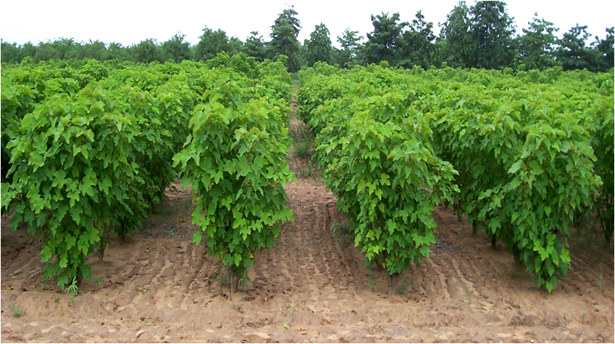
- Maize
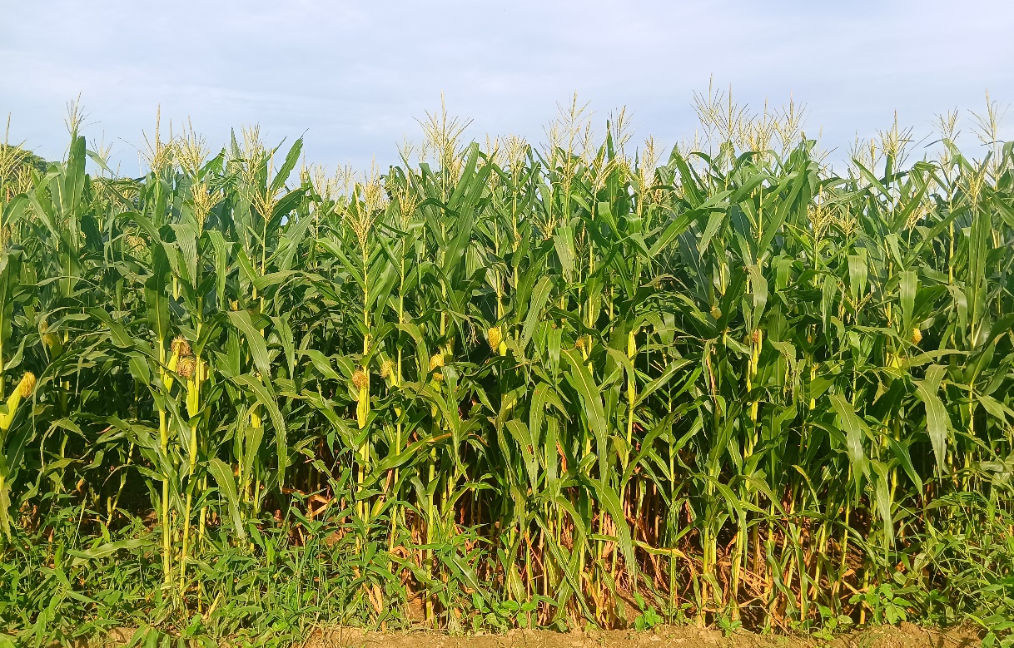
- Sugarcane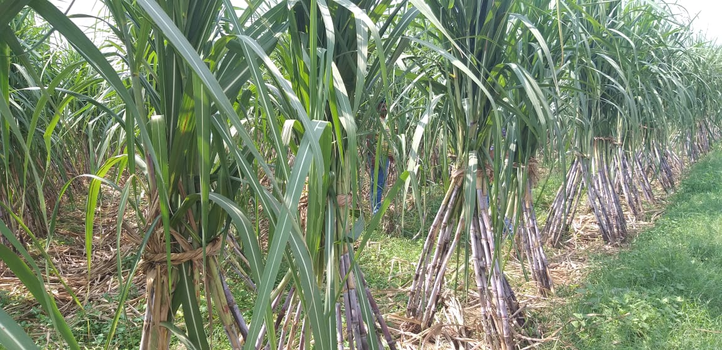
- Sorghum
