Book Title: Futuristic Trends in Renewable & Sustainable Energy
Chapter 6: Biomass energy: The magnitude of the possible Resource

Ankita Kumari, Priyanka Sati and Sudesh Kumar *
Department of Chemistry, Banasthali Vidyapith, Banasthali, 304022, India
Author’s Email: ankitakumari01955@gmail.com,
Author’s Email: satipriyanka789@gmail.com
*Corresponding Author: sudeshneyol@gmail.com

Contents
1.0 Introduction……………………………………………………….2-4
1.1 The Situation with Biomass energy……………………………………4-5
1.2 Bases of biomass-based vitality…………………………………………5
2.0 Experimental: Thermal conversion processes…………………………….5
2.1 Gasification……………………………………………………………….5
2.1.1 Standard fuel gas…………………………………………………...6
2.1.2 Gas sanitization…………………………………………………….7
2.1.3 Utilization of Result gases…………………………………………7
2.1.4 Other chemicals and oils for transportation…………………………7-8
2.2 Pyrolysis……………………………………………………………………9
2.2.1 The fundamentals of firm pyrolysis………………………………….9-10
2.2.2 Devices……………………………………………………………….10
2.2.3 Bubbling fluid beds………………………………………………….11
2.2.4 Portable beds and beds with circulation systems……………………11-12
2.2.5 Ablative pyrolysis……………………………………………………12
2.2.6 Dragged flow……………………………………………………….12
2.2.7 By-products…………………………………………………………...12
3.0 Applications of bio-oil……………………………………………………….13-14
3.1 Co-firing and co-processing……………………………………………15
4.0 Processes of Organic Change……………………………………………….15
4.1 Ethanol………………………………………………………………….15
4.2 Biodiesel………………………………………………………………15
4.3 Breathing and digestion……………………………………………….15-16
4.4 Biorefinery…………………………………………………………….16-17
5.0 Recent technological advancements………………………………………...18-19
6.0 Conclusions………………………………………………………………....20
7.0 Acknowledgement………………………………………………………….20
8.0 Conflict of interest………………………………………………………….20
9.0 Research Funding’s………………………………………………………….20
10.0 References………………………………………………………………….20-25

ABSTRACT
It is widely acknowledged that biofuels, whether usage of fluid, or hard fuel, electrical energy, have the potential to provide the bulk, anticipated renewable energy supply for future. The fundamental processes i.e., thermal, biological, and physical change can be used to create biofuels. These techniques makes various configurations or designs for chemical reactors. The focus of analysis is on thermo chemical change due to their superior efficiencies, lower costs, and more adaptability to extensive variety of energy, fuel, and biochemical alternatives. Quick pyrolysis and gasification methods are detailed, as well as the reactors that have been created the ideal circumstances for presentation. Characterized together with the minor products or, fluid, sizable amount of chemicals are fundamental crops.
Keywords: Biomass; bioenergy; pyrolysis; gasification; biofuels

1.0 INTRODUCTION
As a result, concerns about environment and the reliability the vitality supply. This regard because it is the renewable basis of secures carbon, that necessary assemble numerous needs. Forestry remainder a source of renewable power that is now accessible [1]. Wastes from business and industries, as well as municipal solid waste (MSW), include biodegradable components that can be used to create bioenergy. However, further process might be required before conversion of MSW [2]. Mechanical, or physical method outlined Fig. 1 can be used to transform biomass fuels and residues into energy. In contrast to the USA, where ethanol production is the main topic of discourse owing to supply security concerns, thermal processing is increasingly more prevalent in Europe and Canada [3].Since gasification may be more efficient than burning because of R&D funding. Although fast pyrolysis is still a relatively new technology, it has advantages of portability and ease of storage, as well as comparable higher power generation efficiencies at smaller scales of operation, which are more likely to be attained from bio-energy systems than from fossil fuel-fueled systems. On a residential, small industrial, and utility-scale, combustion systems are common. Due to their high conversion efficiency, prospective low prices, and great operational flexibility. The fundamental distinction between biological and thermal conversion is the single or individual products that biological conversion produces, such as ethanol or biogas. It often takes hours, days, weeks (anaerobic fermentation and farm digestion), or even years (landfill gas through digestion) for biological conversion to be completed. Thermal conversion commonly produces a wide range of frequently complicated products in only a few seconds or minutes. Catalysts are frequently employed to raise the caliber or variety of the goods. A list of number of the major crop that might exist made by biomass. In addition to a system for producing the biomass, a commercial process for using biomass to create fuel and energy comprises five key procedures in the conversion plant: [4]
1. Short-rotation of racket, plant waste, yearly reaped yields, and agricultural waste like grass are also sources of biomass. Chipping, harvesting, and transportation to the plant for conversion are all included in in-field processing.
2. Receiving, organizing, storing, and pre-treating feed to get the biomass ready for change
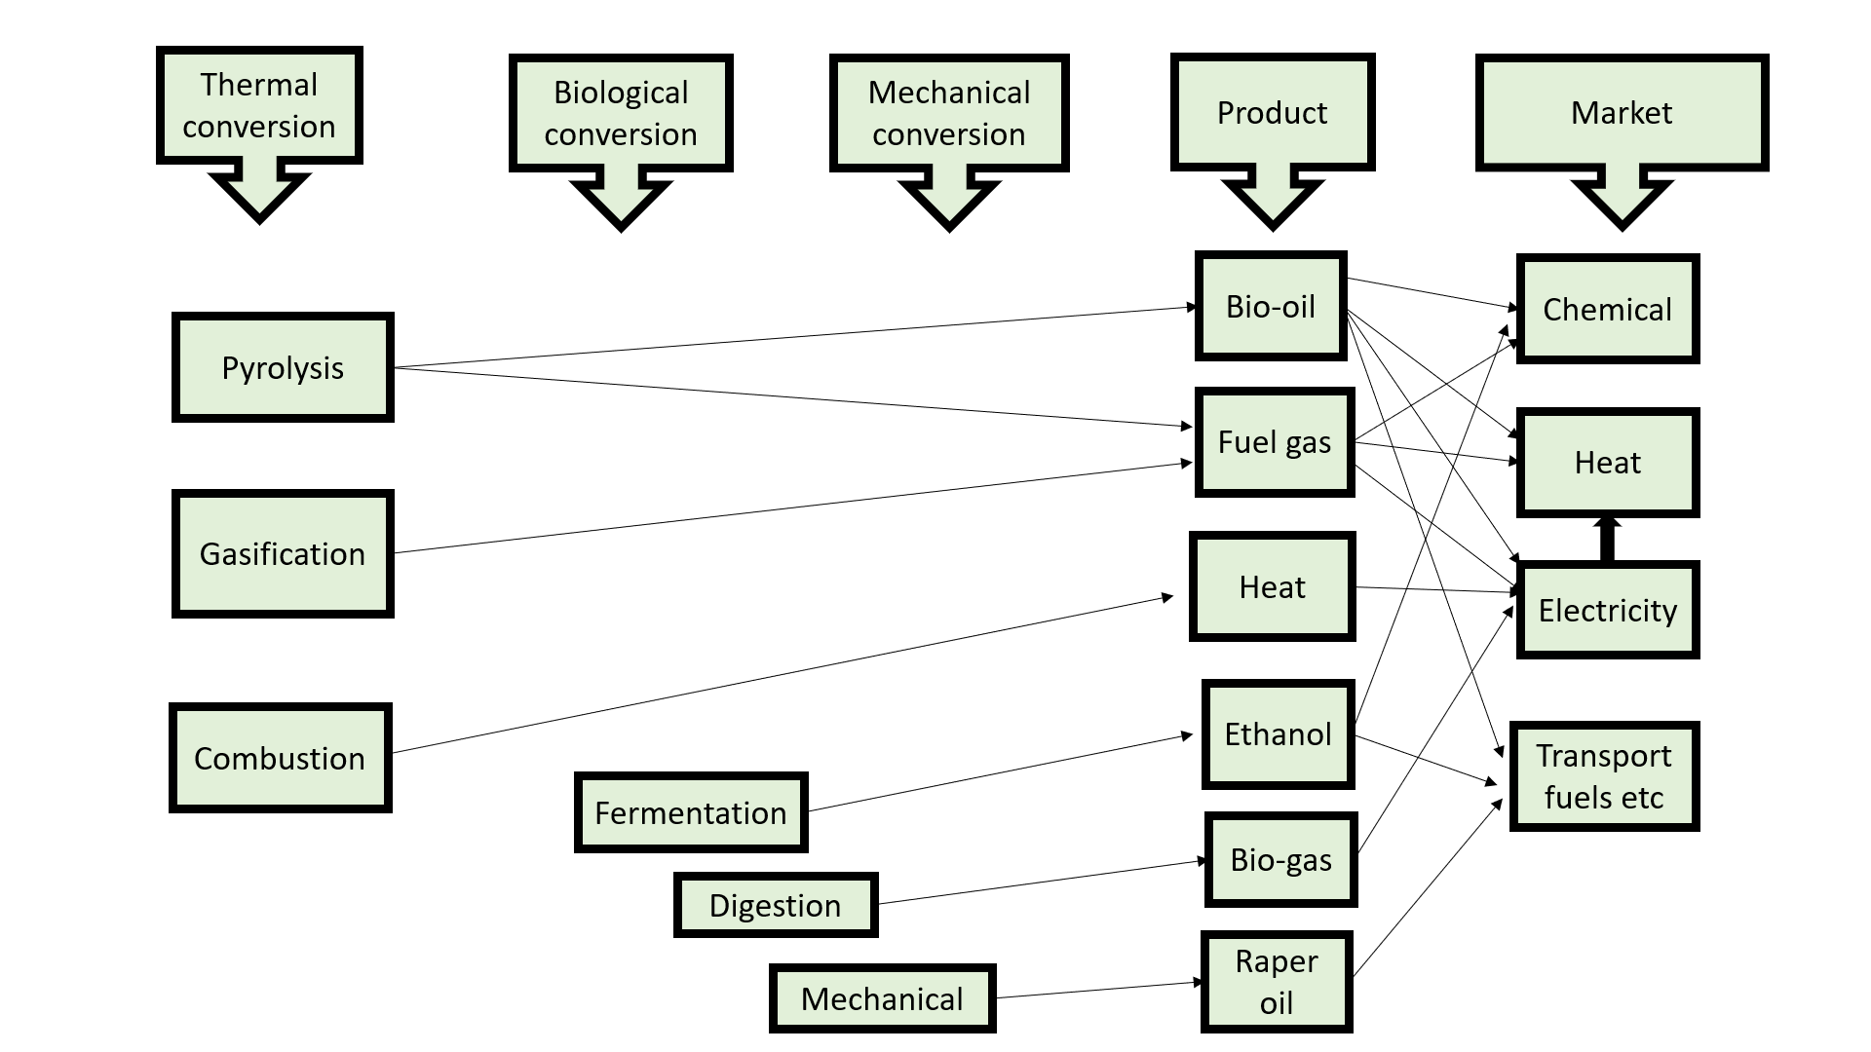
Figure 1. Procedures, goods, and applications for changes [4].
3. Gasification or pyrolysis to transform hard biomass into the useful type of vitality
4. Cleaning up or refining primary products
5. The transformation main creation into a marketable item, power, warmth, liquid biofuels, biochemical, etc.
1.1 The situation with biomass energy
Interesting, well-supported, advertised renewable biomass. They might increase the supply provide energy security without major fossil fuel deposits, and reduce net carbon emissions. With increased biomass energy exploitation comes the danger of managed monocultures in protected areas, agricultural pollutants in waterways, threats due to rivalry for terrestrial, and an increase in remaining carbon releases into the result of intensive manufacturing techniques. Opportunities abound, but there are also valid causes for fear [5]. Promises to employ cutting-edge biomass-to-fuel conversion processes, unique plant and microbial species, and accessible land or water to produce more usable energy. The ability of ecosystems on land and in the water to produce biomass energy naturally is the second component. The third step entails identifying alternative uses for the water and land resources that may be used to create biomass energy. Opportunities abound, but there are also valid causes for fear [6]. How large of a role biomass energy will play in the future of the worldwide vitality scheme will depend on intricate interaction of key elements. Promises to employ cutting-edge biomass-to-fuel conversion processes, unique plant and microbial species, and accessible land or water to produce more usable energy.
In this post, we rapidly go through each of these four elements with an emphasis on how they interact. The fundamental generation schemes, varying degrees of effectiveness, and their environmental impacts. Impacted by the presence of plants, arguing generating biomass energy existing farms or forestland is unlikely to have a much better effect on the climate than burning fossil fuels. The output of entire biomass areas that are neither forests nor agricultural land [7].
1.2 Bases of biomass-based vitality
Biomass energy may also originate after freshwater ocean ecosystems in addition to those on land. Examples of biomass energy include wood, potential upcoming vitality bases like hydrogen after modified. Before the industrial revolution, biomass energy predominated as the primary energy source [8].It still has a big impact today; in 2000, it made up [8], or about one-third of the energy [9]. The two other important non-fossil fuel energy sources, nuclear hydroelectricity, each offer a quantity of energy comparable to biomass [10].Sources account for 1% of total energy consumption [11].
2.0 EXPERIMENTAL: THERMAL CONVERSION PROCESSES
The three fundamental thermal processes employed to convert biomass into a useable vitality procedure. An overview of services and applications is depicted in Figure 2. Even though burning now a firm profitable technology by applications in the majority of industrialized and developing countries, its development is currently focused on finding answers to ecological difficulties. Widely established frequently utilized, several instances of specialized facilities use [12].
2.1 Gasification
When air is the oxidant, biomass and similar materials can partially oxidize, releasing a combination. The first phase in the sequence of activities at constitutes the gasification process is drying, and it takes place rather fast. The 2ndstage, pyrolysis, is also relatively quick but necessitates a difficult process to produce the tars that are so difficult to gasify. When air is employed as the oxidant, biomass and similar materials can partially oxidize. It can also be used to create fuel gas from biomass and similar materials. The important components in each occurrence. In the series of events that comprise the gasification process, 1st phase, desiccating, is a rather rapid response. The 2nd phase, similarly comparatively fast, but it involves a complicated procedure that creates difficulty to gasify.
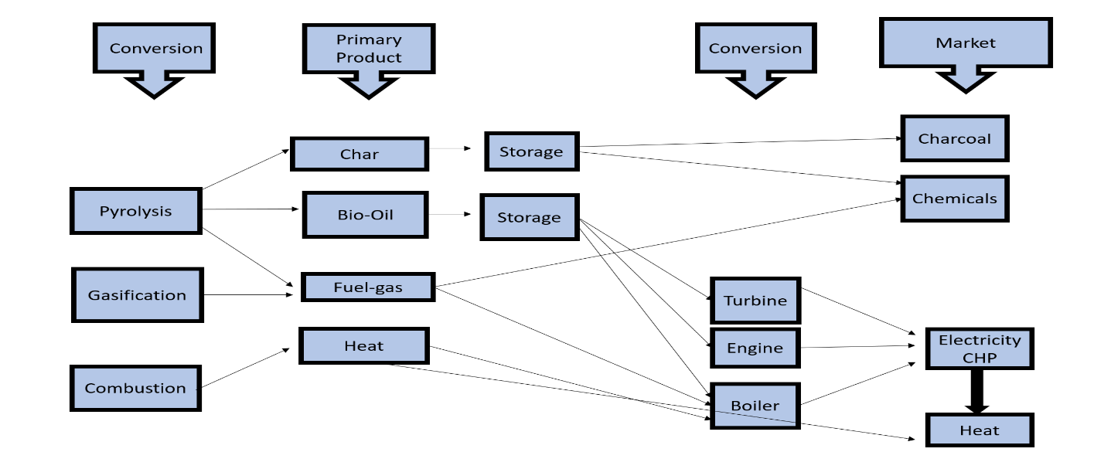

Figure 2.Processes for converting biomass to heat [12].

2.1.1Standard fuel gas
Quality criteria for fuel gas are fairly severe, especially aimed at turbines and runny oil mixture; provide some estimation for popular gasifies [13]. Tar is a one-of-a-kind challenge that is still technologically tough. There are two fundamental ways of removing tars, both of which have been widely explored and are still being researched [14].
• Catalytic cracking utilizing nickel or dolomite, for instance
• Thermal cracking, such as caused by direct contact or partial oxidation
Because storing or exporting the gas would be excessively expensive, it must be used as soon as possible. Cold gas efficiencies can 85%, while hot gas efficiencies in gasifies can exceed 95-97%. For combined cycle power generation, efficiency rates as high as 50% for bigger systems and as low as 35% for smaller applications have been proposed.
2.1.2 Gas sanitization
The components that have the potential to contaminate any or all of the gases produced during gasification. Cleaning is essential to protect downstream equipment from corrosion, and environmental problems.
2.1.3 Utilization of Result gases
Figure 3 summarizes many petroleum, power, and biochemical crops that may produce after producing gas. It is created by the use of oxygen, steam, or pyrolytic gasification. Due to the lack of diluents such as intact but impaired process efficiency and raise costs, gasification is better suited to the mixture transportation and product chemicals.
2.1.4 Other chemicals and oils for transportation
Syngas is made up of hydrogen and carbon monoxide (CO) (H₂). Nitrogen from air gasification, (CO₂), (CH₄), and higher hydrocarbons. Although they are commonly employed as diluents, many general and particular therapies have varying degrees of tolerance for each ingredient. Trace quantities of impurities such as sulfur (such as H₂S), chlorine (such as HCl, COCl), and nitrogen will also be present in a range of compounds (such as NH₃). For the majority of catalyst systems employed in the synthesis of alcohols and hydrocarbons, the levels of these trace components will most likely need to be reduced to a few parts per million. Gasification would be done using either solid or liquid biomass.
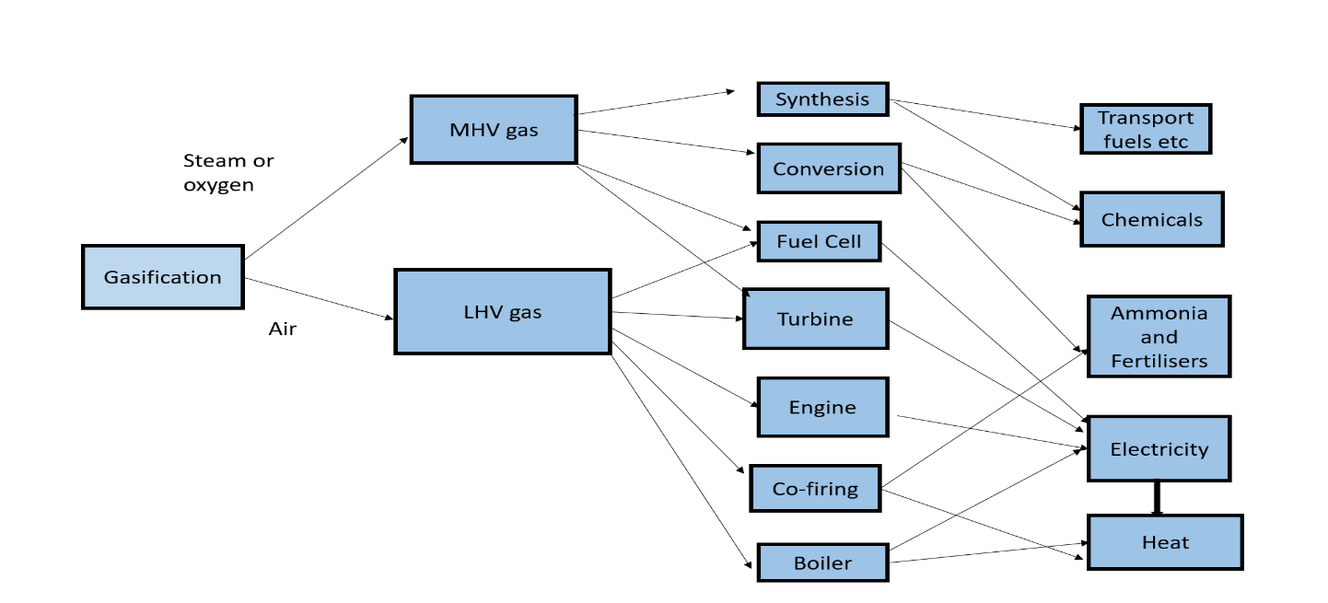
Figure 3. MHV is an abbreviation for medium heating value, which is often 15 MJ/Nm3; LHV is an abbreviation for low heating value, which is normally 5 MJ/Nm3 [13].
Unless significant amounts of biomass are imported, this tends to limit plant growth to the amount. Gasified, decreasing overall efficiency but allowing downstream chemical and transportation fuel synthesis to achieve the requisite economies of scale. Because liquids are simpler to feed than solid biomass into pressure gasifiers, the cost of gasifying bio-oil may be reduced as well. Syngas is the raw material for almost all of today's chemicals and fuels, including commodity chemicals, specialty chemicals, and conventional and unconventional transportation fuels. The diagram depicts various potential methods for producing hydrocarbon transport fuels. Five of these are very pertinent right now.
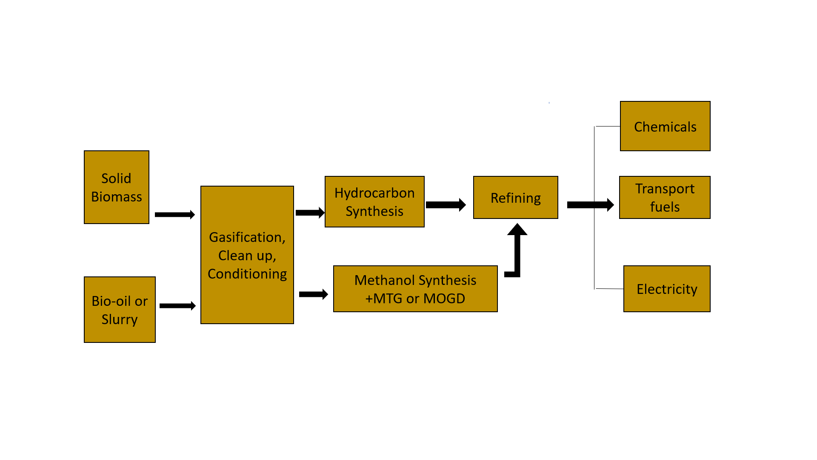
Figure 4. Biomass gasification is used to transport fuels. MTG stands for methanol to gasoline, whereas MOGD is for methanol to olefins, gasoline, and diesel [14].
2.2PYROLYSIS
The breakdown of heat is known as pyrolysis. Although it always the initial stage in combustion and gasification, the primary products are then completely or partially oxidized in these processes. Depicts the product distribution derived from various pyrolysis procedures. In comparison to solid biomass, at present of special attention due to ease and cost with which liquids may be stored and conveyed. For more information, several reviews have been generated, which should be consulted [15-16]. Pyrolysis happens in a matter of seconds or less. As a result, processes including heat and mass transmission, phase transitions, and chemical reaction kinetics are crucial. The key challenge is to heat the interacting biomass particles. The option for reaching a goal is to use tiny particles, as in the fluidized bed technologies mentioned below. Ablative pyrolysis is another process that rapidly transfers heat to the particle surface that comes into contact with the heat source. Heat transport to the reactor is a key technological difficulty in commercial systems under all conditions.
2.2.1 The fundamentals of firm pyrolysis
The method used breakdown biomass which produces primarily gases. While comparable to traditional pyrolysis techniques producing charcoal, fast pyrolysis is a new technology with well-regulated parameters that deliver high liquid yields. The following ingredients must be present in a fast pyrolysis approach for a liquid generation:
• Required at the reaction interface, generally needs excellently powdered.
• We explain how temperature impacts yields and product spectrum. The pyrolysis process and vapor phase are controlled at temperatures between 500 and 450 degrees Celsius.
•Hot vapor has residence duration of fewer than two seconds on average.
• To make bio-oil, the pyrolysis gases are quickly cooled.
Because the primary product, bio-oil, can be recovered at dry-feed rates of up to 75% wt, and all other demands are met, the only waste streams left are flue gas and ash. Fluid bed reactor feed must be finely powdered to enable a rapid pyrolysis process. The liquid these pieces generate must next be quenched, separated into solids (char), and collected. This process produces char and gas as byproducts. Because of its consistency and test comparability, wood has received the most attention, although almost 100 other biomass kinds have also been researched. Figure 6 depicts a typical fast pyrolysis process, including the essential preliminary steps, and backup.
2.2.2 Devices
The reactor is the most important component quick pyrolysis method. Most attention on research and development even though it probably only accounts for 10% to 15% of an integrated system's overall capital cost. However, control, improving liquid quality, and modernizing collecting methods are increasingly receiving greater focus. The following steps in the process include receiving, and managing. Later, it examined what these auxiliary phases' fundamental qualities are. A thorough analysis of this work has been published. Rapid pyrolysis methods for the creation of liquids have just lately been developed and tested [17].
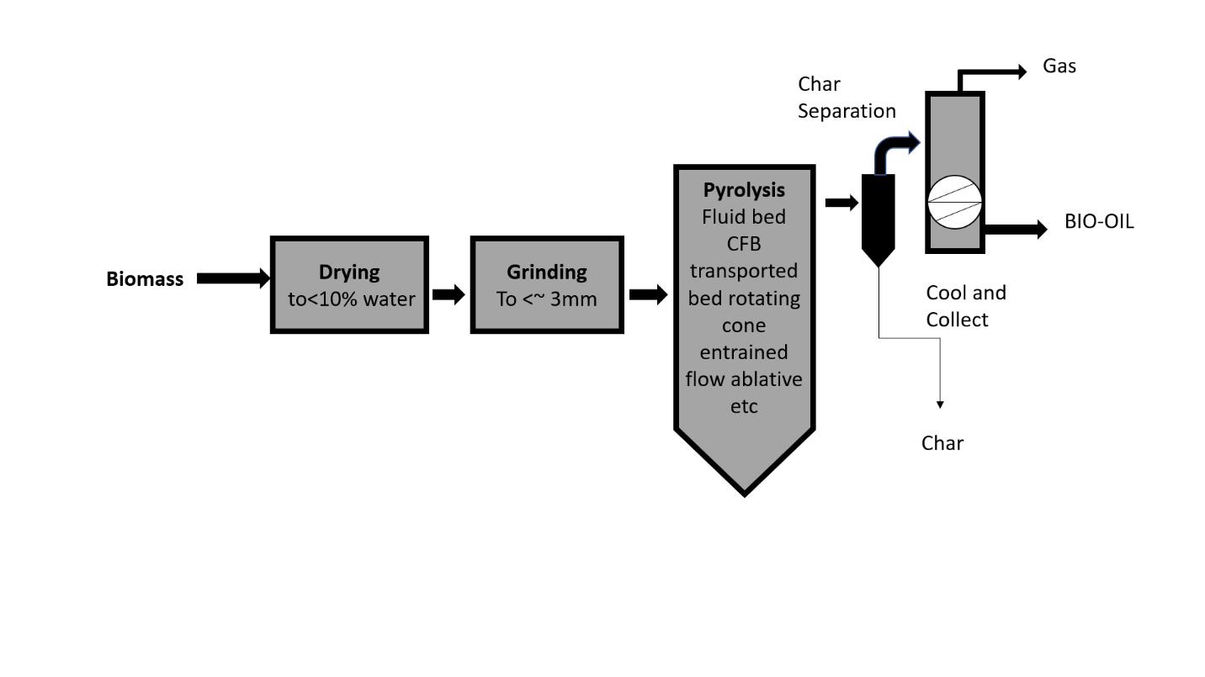
Figure 5. Theoretical quick pyrolysis procedure [17].

2.2.3 Bubbling fluid beds
The benefits often rather than include established skill to construct operate, high-quality extremely effective because of the high solids. Typically offer high per ton awhen utilizing wood as the raw material. Fast and efficient separation and elutriation are crucial because char works well as a catalyst for vapor cracking at the high temperatures associated with pyrolysis procedures. It is important to regulate the hydrodynamics of the two materials effectively. The early, groundbreaking research on rapid pyrolysis was done by Scott and colleagues [18–19] at the University of Waterloo.
The largest plant now in operation is at Dynamotive West Lorne, Ontario, Canada site, and more units up to 400 t/d are planned there as well. This facility's demonstration unit generates 100 t/d of dry biomass feed [20]. Additionally; there is a 2.5MWe gas turbine on the property that might be utilized to produce electricity both locally and for grid export.
2.2.4 Portable beds and beds with circulation systems
Circulating fluid beds (CFBs) share many characteristics with bubbling beds, with the exception that the char's residence time is almost identical to that of vapors. It may be suitable extremelyhigh despite the more complex hydrodynamics; in fact, this technology is commonly used petroleum and petrochemical industries exceptionally high. With the reactor (pyrolysis) temperature being substantially lower, the procedure is comparable. An alternative to the transportable [21]. Arrangement, centrifugal forces govern the transport rather than gas.
2.2.5 Ablative pyrolysis
It is clear how fundamentally different ablative pyrolysis and other quick pyrolysis methods are when compared to one another. Small biomass particles are required since all other methods are constrained. Ablative pyrolysis is a process in which pressure-induced heat transfer heated to the "melts" the timber. Pyrolysis front travels just one path through the biomass particle. The residual oil coating soon evaporates to form pyrolysis vapors that may be collected using conventional techniques. It also lubricates subsequent biomass particles when the wood is physically carried away. It is significantly unfair by pressure, wood velocity, heat exchange surface, reactoroutside temperature. Therefore, following are the main characteristics of ablative pyrolysis:
• A tall particle pressure was created on the heated reactor wall.
• High relative motion between the reactor wall and the particle
• Reactor wall temperature fewer than 600 ◦C
Reality, unlike other reactors, amount of warm input to the reactor quite than the rate at which the pyrolyzing biomass absorbs heat. Because inert gas is not required, the dispensation machinery is lesser and maybe more inexpensive. Because the approach is surface-area restricted, grading is more expensive. Further complicated by being physically powered. Aston University operates a small research Centre, in north Germany [22] lately ongoing up [23].
2.2.6 Dragged flow
Although dragged movement fast pyrolysis is a simple approach in, most attempts to put it into practice have failed ineffective heat transmission between a hot gas and a hard atom. Optimal heat transmission necessitates enormous plant sizes tough.
2.2.7 By-products
Generally, it is included approximately 25% of the byproducts, charcoal, and gas alone needs around and by-products' energy, the power to generate tremendous heat. The gas and/or wood can be burned to produce heat. Product of charcoal, more sophisticated arrangements char may be gasified (LHV) burned resulting gas to deliver process more effectively benefit of heat being considerably more effectively managed to avoid possible issues with direct char combustion slagging.
3.0 Applications of bio-oil
A lot of still applications, such as boilers, engines, and turbines for power group [24]. Figure 6 summarizes options. Bio-oil can also be extracted or derived into a diversity of chemicals such as, specialty, resins, [25] agrichemicals, fertilizers, and emissions manage. On a 250k, we have achieved at least 400 hours of operation.
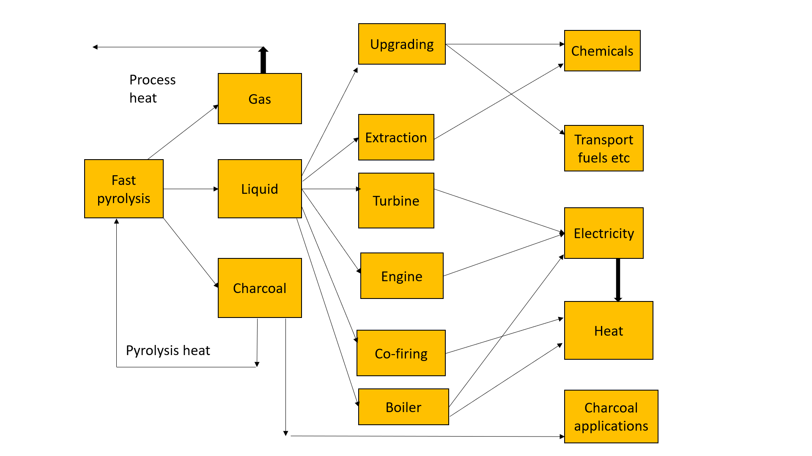
Figure 6. Applications for fast pyrolysis yield [24].
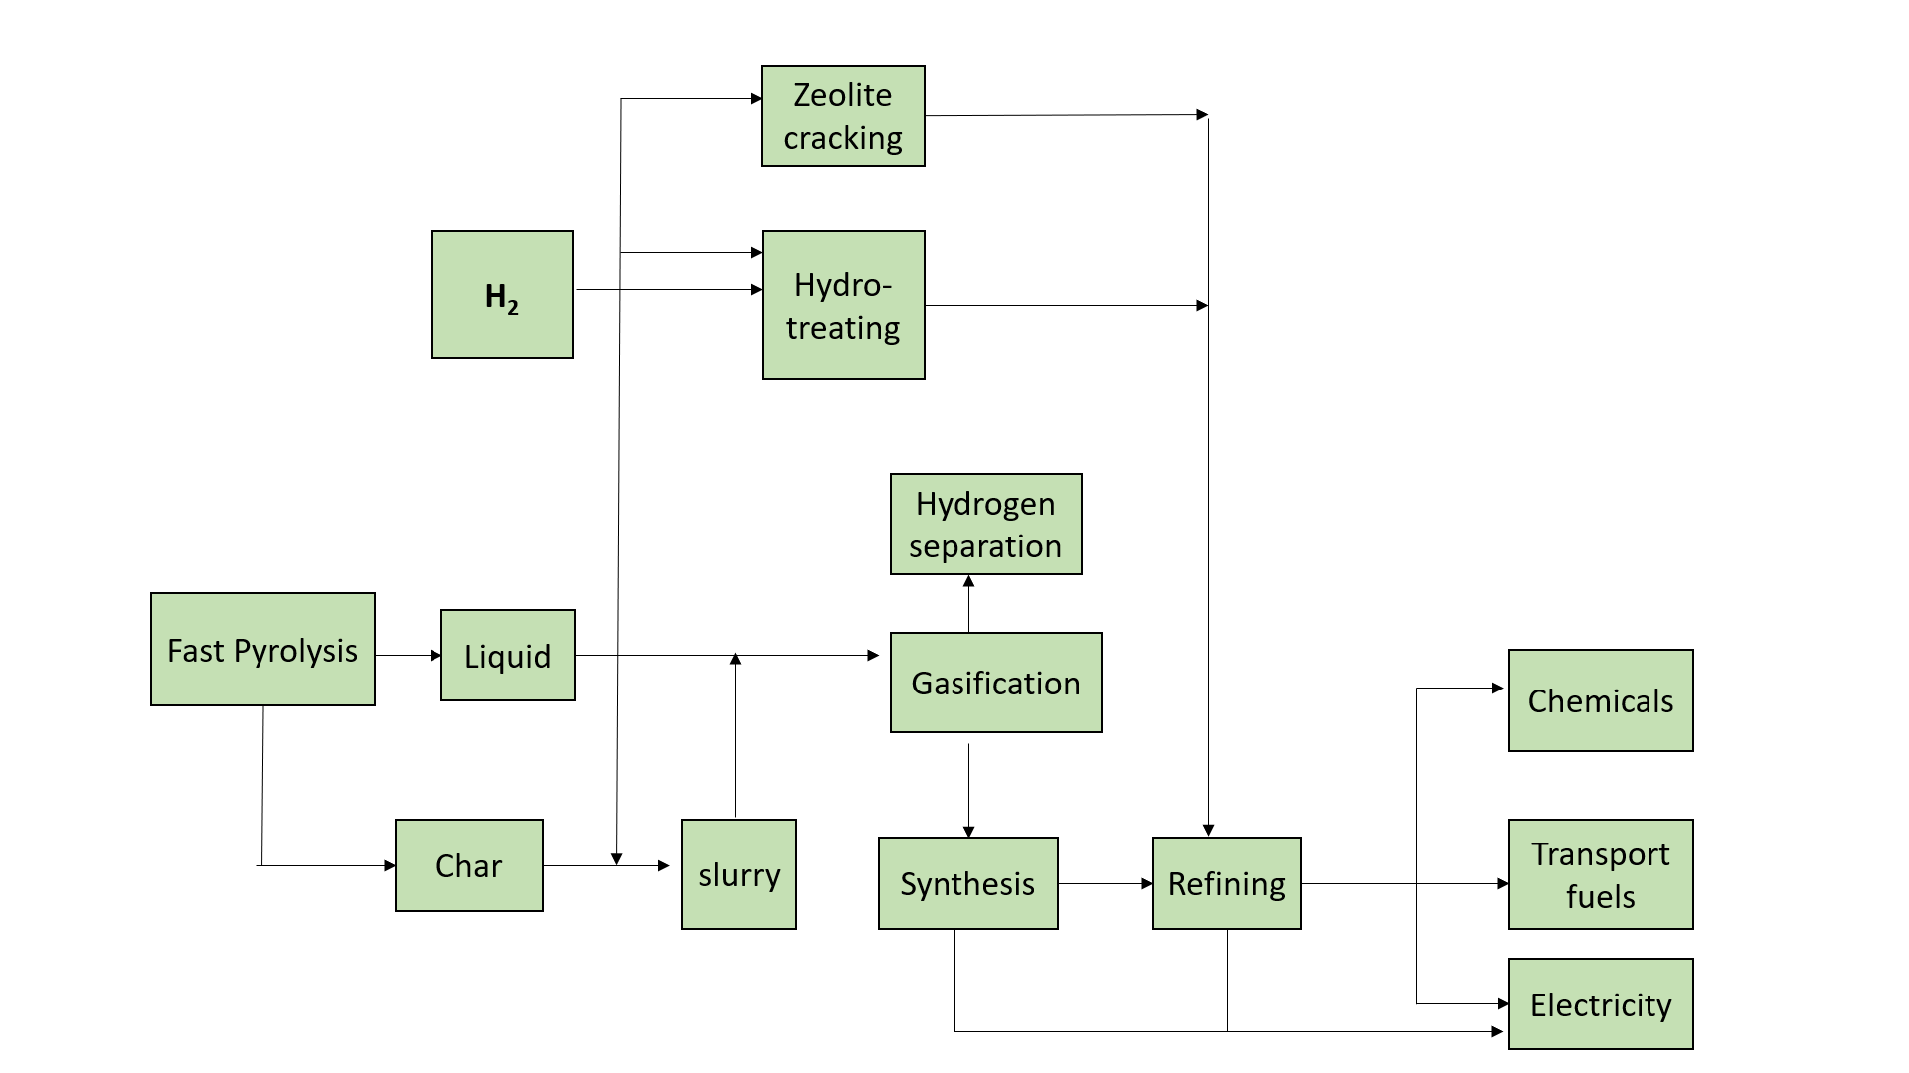

Figure 7. Biomass pyrolysis transports fuels [25].
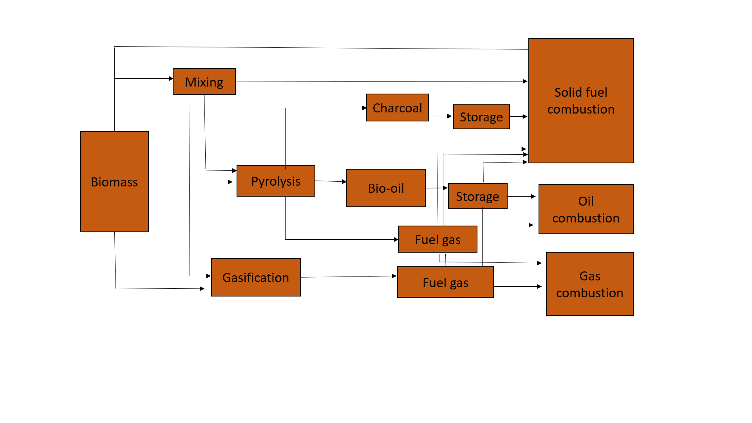

Figure 8. Biomass and biofuels co-processing in traditional warmth and control applications [26].
Experience with adapted dual-fuel engine, as well 2.5M W_{e} manufacturing air turbine [26]. Previously stated, converting bio-oil to transport fuels is technically possiblethenow inefficient. Figure 8.
3.1 Co-firing and co-processing
Because it enables the realization of complete economies of scale while simultaneously decreasing the requirements on product quality and cleaning, co-processing biomass with conventional fuels. The strongest chance for the market penetration of biomass now exists through co-firing.The boilers are the cornerstone of nearly all forms of co-firing. Several times, biomass is first gasified into fuel gas and then instantly singed already-current coal-fired boiler. Testing has been done in both gas and coal-fired power plants.
4.0 PROCESSES OF ORGANIC CHANGE
4.1 Ethanol
Before fermentation, hemicelluloses must be hydrolyzed sugars. Both enzymes and acid hydrolysis are employed [27-28].Carbohydrates like starch require. However, hemicelluloses conversion is more successful will boost conversion efficiency and will result in cost savings. The lignin is a byproduct that may be processed further to make refinery feedstock or aromatic compounds, or it can be burnt for process heat, notably to concentrate ethanol. "Biorefinery,” isa system that uses biomass as efficiently as possible from a technological, economic, environmental, and social standpoint. In terms of qualities, this outperforms ethanol [29].
4.2 Biodiesel
The ester produced when combines with methanol, and ethanol is known as biodiesel. Etherification since the raw product's high viscosity and other unwanted characteristics render it unsuitable for many purposes. Pressing is used to recover the raw oil, and often solvent extraction is added to increase yields. After being esterifies, this raw oil produces glycerin as a by-product and a product with reduced viscosity and greater stability. Due to the ester’s complete compatibility in usage as a desirable alternative transportation fuel. Thus, the price of the goods is great. Standard change skill uses processing, although, recently, a variety of straightforward and tried-and-true methods for handling used and waste oils and fats have been created. Processing animal fats and leftover cooking oils in a similar fashion also open up significant commercial potential while the waste products are still reasonably priced, albeit the scope is confined.
4.3 Breathing and digestion
Anaerobic digestion occurs when bacteria break down organic molecules. A typical amount of gas is produced by agricultural digesters. The normal range of concentrations in landfills is between 50 and 55 percent.More stringent quality requirements are required for this. Throughout a 20–25year lifespan, large landfill sites usually produce gas. The gas is gathered through a network of wells and piped to the consumer. The gas must be treated carefully to avoid or minimize problems when using it to create heat and/or power since it is wet and contains acidic components. Additionally, there are only relatively small extra costs associated with transporting gas to clients. On the other hand, as legal initiatives to restrict land filling in the European Union expand, it is projected that this resource will become less accessible over time. Wastewater manufacturing anddigestion for in-plant power production has been used successfully and effectively for many years.
4.4 BIOREFINERY
The notion of a Biorefinery, which maximizes technological, economic, environmental, and social criteria, is gaining popularity swiftly after years of manufacturing chemicals from bio-oil [30].Two contemporary examples of a Biorefinery include creating hydrogen with steam reforming the waste recovering phenolics for resin manufacturing and using heavy wastes from a liquid smoke synthesis control plants. Maximizing the utilization of products, byproducts, and wastes is the key feature and objective. A few methods for reaching this ideal are visible.

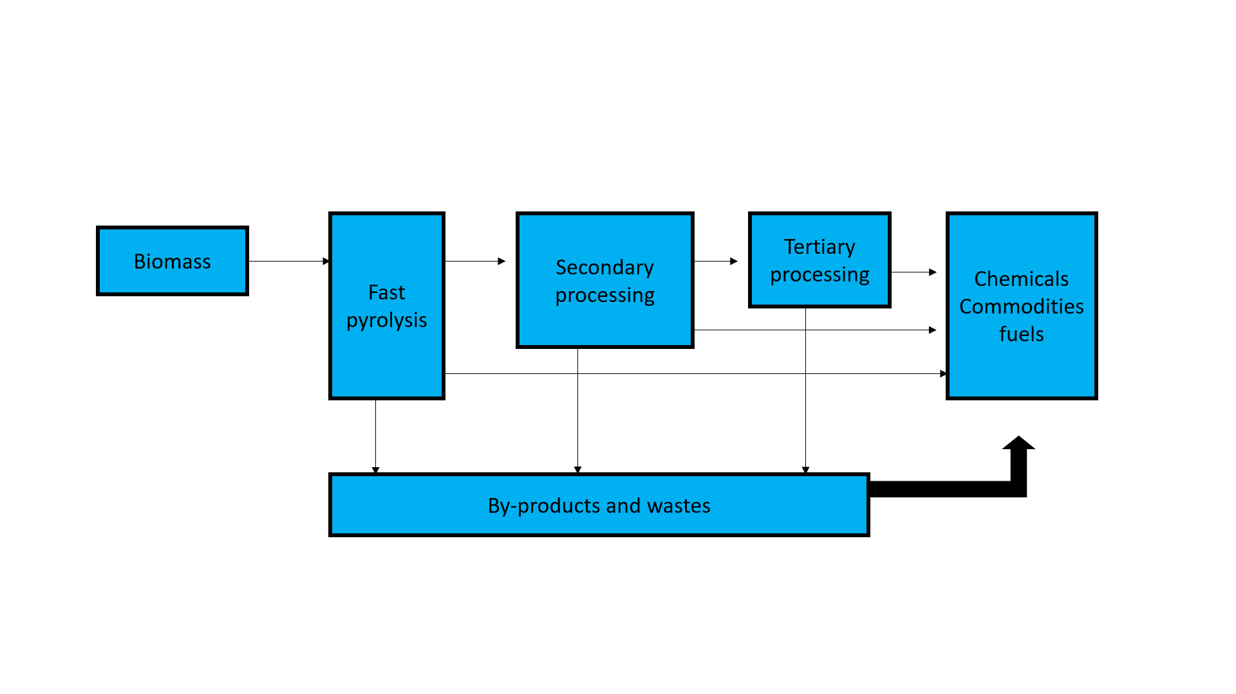
Figure 9.The notion of biorefinery [30].
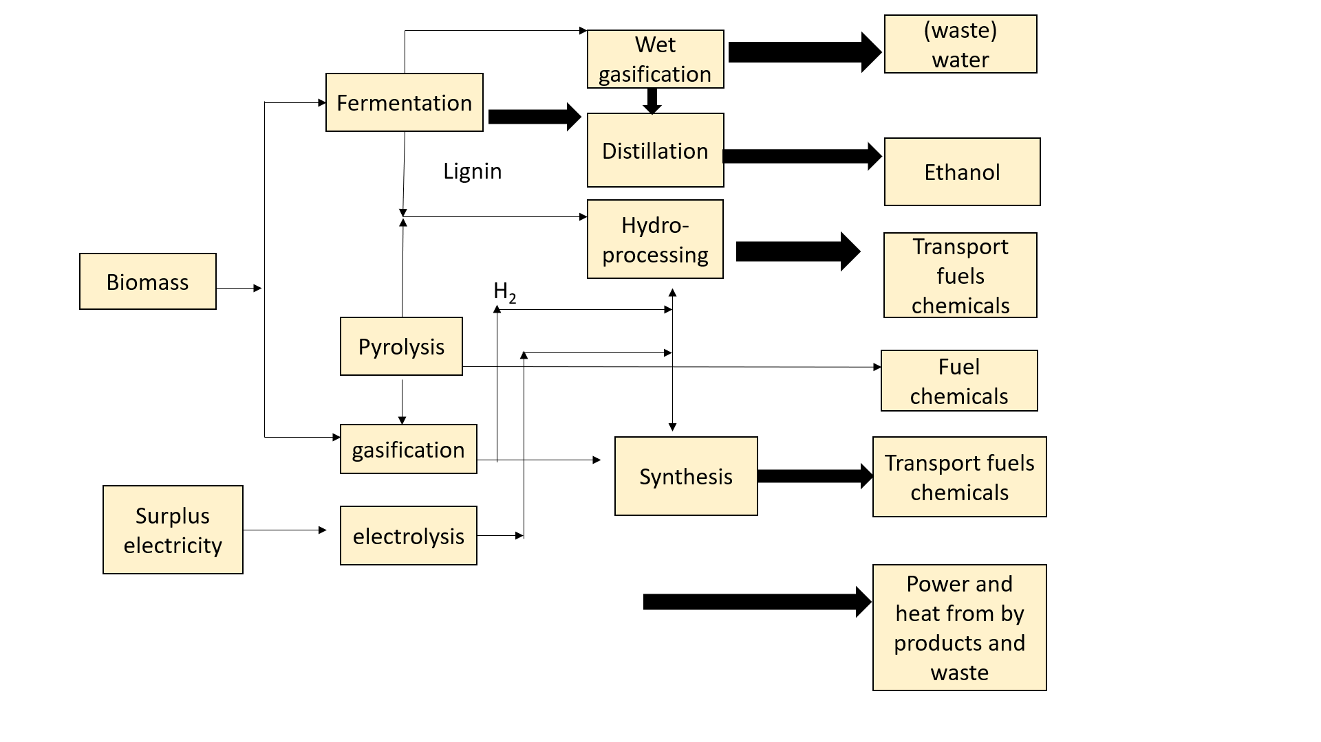

Figure 10. A biorefinery plan as a fuel chemical processing alternative [30].

5.0 Recent technological advancements
Though much of the recent biomass energy debate has focused on ethanol, biodiesel, and other liquid transportation fuels, the opportunities for biomass as a direct combustion fuel source can be similar or even greater. Biomass-powered heating and power plants are already in operation. Coal-fired power plants can replace up to 10% of their coal with biomass. Burning compressed biomass energy pellets as a heat source may be the most capableprofitable utilize with appropriate technologies [31].
Table-1:This graph depicts the energy potential of biofuel crops using current and future cellulosic technologies [31].
Feedstock Type | Feedstock mass 2002  (Mt y⁻1) | Gross biofuel conversion (GJ/ton) | Gross biofuel  Energy  (EJ yS1) | Net energy balance  Ratio(output/input) | Net biofuel  Energy  (EJ yS1) | Refs
Sugarcane | 1324 | 2 | 2.8 | 8 | 2.4 | [32]
Corn kernel | 696 | 8 | 5.8 | 1.25 | 1.2 | [33]
Cellulosic biomass | - | 6 | - | 5.44 | - | [34,35]
Palm oil | 36 | 30 | 1.1 | 9 | 1.0 | [36]
Soy oil | 35 | 30 | 1.0 | 1.93 | 0.5 | [36]
Rape oil | 17 | 30 | 0.5 | 2.5 | 0.3 | [33]

Crop-to-biomass energy conversion is likely to have climate effects, with increased global food prices stimulating deforestation or other land-use changes in areas far from increased biomass agriculture sites [37, 38]. Carbon dioxide fertilization will have little effect on biomass energy crops such as maize and switch grass because they have C₄ photosynthesis and are relatively insensitive to rising atmospheric CO₂ [39].Agriculture for biomass energy has the potential to expand beyond traditional food production areas by utilizing abandoned agricultural land, degraded land, and other marginal land with no competing uses [40, 41-42]. In contrast, nearly all major international assessments of future food supply predict global crop area expansion for food production [43, 44].

Table -2: Operating parameter ranges for pyrolysis processes [45].

 | Conventional pyrolysis | Fast pyrolysis | Flash pyrolysis
Pyrolysis temperature | 550-950 | 850-1250 | 1050-1300
Particle size | 5-50 | <1 | <0.5
Heating rate | 0.1-1 | 10-200 | >1000
Solid residence | 450-550 | 0.5-10 | <0.2

In general, biomass is made up of cellulose, hemicelluloses, lignin, and extractives such as proteins, ash, and pectin [46, 47]. Unfortunately, Changing World Technologies failed and was bought out by Ridgeline Energy Services in Canada [48, 49].
Phenolics, which are lignin degradation byproducts, are natural antioxidants and food additives [50, 51]. Vanillin, vanillic acid, dihydroconiferyl alcohol, and guaiacol are known to be produced by lignin guaiacol (G) units [52,53].
H (wt %) | C (wt %) | O (wt %) | Water Content (wt %) | Density (kg/m3) | Stability Behavior
8.8 | 70.9 | 20.3 | 1.5 | 100 |  | With time, viscosity and distillation characteristics changed
Table-3: Physical and chemical properties of high-pressure liquefied bio-oil [54].

The fact that the fossil fuel energy system already emits more carbon per year than all croplands highlight the challenge of replacing a significant portion [55].
Environmental greenhouse gas emissions have increased. This novel technology has the potential to be developed at a demonstration scale [56].
According to their source, this includes trees, algae, grass, urban wastes, agricultural wastes, forestry wastes, domestic wastes, municipal wastes, and industrial wastes [57-58].
Variables such as temperature, pressure, catalyst, and time are used to produce the desired products [59]. Hydrothermal processing technologies have recently been focusing extensive research for a variety of biomass types, counting agricultural wastes and algae [60, 61].

6.0 CONCLUSIONS
It is a sizable and rising attention to the current processing, produce vitality substances. Since pyrolysis,gasification with distinct commercial potentials, they shouldn't be viewed as competitors. Both the optimal in between conversion and the use of the main Conversion products and the essential border among biomass manufacture change both need considerableprogress in the respective technologies. Bringing thermal change technology earlier to power generation or chemical manufacture processes.
7.0 Acknowledgement-
It is my proud privilege, and special appreciation towards my supervisor Dr. Sudesh Kumar, professor of chemistry, Banasthali vidyapith, Department Of chemistry, Rajasthan, under his guidance for his keen enthusiastic interest, ever willing cordial help, most valuable guidance, and suggestions, constant encouragement and constructive criticism which made it possible to complete this study.
8.0 Conflict of interest- We have no conflicts of interest

9.0 Research Funding’s- No Funding Available

10.0 REFERENCES
- Bridgwater, T. (2006). Biomass for energy. Journal of the Science of Food and Agriculture, 86(12), 1755-1768.
- Jäger-Waldau, A., Szabó, M., Scarlat, N., & Monforti-Ferrario, F. (2011). Renewable electricity in Europe. Renewable and Sustainable Energy Reviews, 15(8), 3703-3716.
- Tanaka, N. (2010). World energy outlook 2010. International Energy Agency. Paris: IEA.
- Bioenergy, I. E. A. (1998). The role of bioenergy in greenhouse gas mitigation. Position paper, IES Bioenergy, New Zealand.
- Bridgewater, T., & Maniatis, K. (2004). The production of biofuels by the thermo chemical processing of biomass. In Molecular to global photosynthesis (pp. 521-611).
- Field, C. B., Campbell, J. E., & Lobell, D. B. (2008). Biomass energy: the scale of the potential resource. Trends in ecology & evolution, 23(2), 65-72.
- Raghu, S., Anderson, R. C., Daehler, C. C., Davis, A. S., Wiedenmann, R. N., Simberloff, D., & Mack, R. N. (2006). Adding biofuels to the invasive species fire Science, 313(5794), 1742-1742.
- Fernandes, S. D., Trautmann, N. M., Streets, D. G., Roden, C. A., & Bond, T. C. (2007). Global biofuel use, 1850–2000. Global Biogeochemical Cycles, 21(2).
- Sabine, C. L., Heimann, M., Artaxo, P., Bakker, D. C., Chen, C. T. A., Field, C. B., & Valentini, R. (2004). Current status and past trends of the global carbon cycle. Scope-scientific committee on problems of the environment international council of scientific unions, 62, 17-44.
- EIA (2007) Annual Energy Review 2006. Energy Information Administration, US Department of Energy
- US Energy Information Administration (Ed.). (2011). Annual Energy Outlook 2011: With Projections to 2035. Government Printing Office.
- Van Loo S and Koppejan J, Handbook of Biomass Combustion and Co-firing. Twente University Press, the Netherlands (2003).
- Bridgewater, A. V. (1995). The technical and economic feasibility of biomass gasification for power generation. Fuel, 74(5), 631-653.
- Bridgewater, A. V. (1994). Catalysis in thermal biomass conversion. Applied Catalysis A: General, 116(1-2), 5-47.
- Bridgewater, A. V. (2004). Biomass fast pyrolysis. Thermal science, 8(2), 21-50.
- Bridgewater, A. V. (2007). The production of biofuels and renewable chemicals by fast pyrolysis of biomass. International Journal of Global Energy Issues, 27(2), 160-203.
- Bridgewater, A. V. (2003). Renewable fuels and chemicals by thermal processing of biomass. Chemical engineering journal, 91(2-3), 87-102.
- Scott, D. S., Piskorz, J., & Radlein, D. (1985). Liquid products from the continuous flash pyrolysis of biomass. Industrial & Engineering Chemistry Process Design and Development, 24(3), 581-588.
- Scott, D. S., Legge, R. L., Piskorz, J., Majerski, P., & Radlein, D. (1997). Fast Pyrolysis of Biomass for Recovery of Specialty Chemicals. In Developments in thermo chemical biomass conversion (pp. 523-535). Springer, Dordrecht.
- Bridgwater, A. V., Sidwell, A., Colechin, M., Shanahan, G., & SharmanP, D. T. I. (2006). Global watch Mission Report: Bioenergy–a Scoping Mission to the USA and Canada, February/October 2005. UK DTI, London and PERA, Melton Mowbray, UK.
- Prins, W., & Wagenaar, B. M. (1997, April). Review of rotating cone technology for flash pyrolysis of biomass. In Proc. Int. Conf. Gasification and Pyrolysis of Biomass, Stuttgart (pp. 9-11).
- Bhaskar, T., Balagurumurthy, B., Singh, R., & Kumar, A. (2015). Biorefineries for Sustainable Production and Distribution. Biomass and Biofuels: Advanced Biorefineries for Sustainable Production and Distribution, 313.
- Peacocke, G. V. C., & Bridgwater, A. V. (1994). Ablative plate pyrolysis of biomass for liquids. Biomass and Bioenergy, 7(1-6), 147-154.
- Czernik, S., & Bridgwater, A. V. (2004). Overview of applications of biomass fast pyrolysis oil. Energy & fuels, 18(2), 590-598.
- Amen-Chen, C., Pakdel, H., & Roy, C. (2001). Production of monomeric phenols by thermo chemical conversion of biomass: a review. Bioresource technology, 79(3), 277-299.
- Leech, J. (1997, April). Running a dual fuel engine on pyrolysis oil. In Proc. Int. Conf. Gasification and Pyrolysis of Biomass, Stuttgart (pp. 9-11).
- Wyman, C. (1996). Handbook on bioethanol: production and utilization. CRC press.
- Pienkos, P. T., & Darzins, A. L. (2009). The promise and challenges of microalgal‐derived biofuels. Biofuels, Bioproducts and Biorefining: Innovation for a sustainable economy, 3(4), 431-440.
- Gal-Yam, A., Fox, D. B., Price, P. A., Ofek, E. O., Davis, M. R., Leonard, D. C., ... & MacFadyen, A. I. (2006). A novel explosive process is required for the γ-ray burst GRB 060614. Nature, 444(7122), 1053-1055.
- Kamm, B., Gruber, P. R., & Kamm, M. (Eds.). (2006). Biorefineries-industrial processes and products (Vol. 2). Weinheim: Wiley-VCH.
- Samson, R., Mani, S., Boddey, R., Sokhansanj, S., Quesada, D., Urquiaga, S., & Ho Lem, C. (2005). The potential of C4 perennial grasses for developing a global BIOHEAT industry. Bpts, 24(5-6), 461-495.
- Hill, J., Nelson, E., Tilman, D., Polasky, S., & Tiffany, D. (2006). Environmental, economic, and energetic costs and benefits of biodiesel and ethanol biofuels. Proceedings of the National Academy of sciences, 103(30), 11206-11210.
- Fulton, L. (2004). International Energy Agency (IEA) biofuels study–interim report: result and key messages so far. Biomass and Agriculture Sustainability, Markets and Policies, 105-112.
- Farrell, A. E., Plevin, R. J., Turner, B. T., Jones, A. D., O'hare, M., & Kammen, D. M. (2006). Ethanol can contribute to energy and environmental goals. Science, 311(5760), 506-508.
- Tilman, D., Hill, J., & Lehman, C. (2006). Carbon-negative biofuels from low-input high-diversity grassland biomass. Science, 314(5805), 1598-1600.
- Hunt, S. (2006). Biofuels for transportation. Report of Worldwatch Institute, Washington DC, USA.
- Morton, D. C., DeFries, R. S., Shimabukuro, Y. E., Anderson, L. O., Arai, E., del Bon Espirito-Santo, F., & Morisette, J. (2006). Cropland expansion changes deforestation dynamics in the southern Brazilian Amazon. Proceedings of the National Academy of Sciences, 103(39), 14637-14641.
- Laurance, W. F., Albernaz, A. K., Fearnside, P. M., Vasconcelos, H. L., & Ferreira, L. V. (2004). Deforestation in amazonia. Science, 304(5674), 1109-1111.
- Ainsworth, E. A., & Long, S. P. (2005). What have we learned from 15 years of free‐air CO2 enrichment (FACE)a meta‐analytic review of the responses of photosynthesis, canopy properties and plant production to rising CO2. New phytologist, 165(2), 351-372.
- Tilman, D., Hill, J., & Lehman, C. (2006). Carbon-negative biofuels from low-input high-diversity grassland biomass. Science, 314(5805), 1598-1600.
- Field, C. B., Campbell, J. E., & Lobell, D. B. (2008). Biomass energy: the scale of the potential resource. Trends in ecology & evolution, 23(2), 65-72.
- Hoogwijk, M., Faaij, A., Van Den Broek, R., Berndes, G., Gielen, D., & Turkenburg, W. (2003). Exploration of the ranges of the global potential of biomass for energy. Biomass and bioenergy, 25(2), 119-133.
- Bruinsma, J. (2003). World agriculture: towards 2015/2030: an FAO perspective. Earthscan. Food and Agriculture Organization, London/Rome.
- Rosegrant, M. W., Paisner, M. S., Meijer, S., & Witcover, J. (2001). Global food projections to 2020: Emerging trends and alternative futures. International Food Policy Research Institute.
- Demirbas. F. (2006). Current technologies for biomass conversion into chemicals and fuels. Energy Sources, Part A: recovery, utilization, and environmental effects, 28(13), 1181-1188.
- Mtui, G. Y. (2009). Recent advances in pretreatment of lignocellulosic wastes and production of value-added products. African Journal of Biotechnology, 8(8).
- Sánchez, C. (2009). Lignocellulosic residues: biodegradation and bioconversion by fungi. Biotechnology advances, 27(2), 185-194.
- Kumar, M., Oyedun, A. O., & Kumar, A. (2018). A review on the current status of various hydrothermal technologies on biomass feedstock. Renewable and Sustainable Energy Reviews, 81, 1742-1770.
- Tran, K. Q. (2016). Fast hydrothermal liquefaction for production of chemicals and biofuels from wet biomass–the need to develop a plug-flow reactor. Bioresource technology, 213, 327-332.
- Conde, E., Moure, A., Domínguez, H., & Parajó, J. C. (2011). Production of antioxidants by non-isothermal autohydrolysis of lignocellulosic wastes. LWT-Food Science and Technology, 44(2), 436-442.
- Garrote, G., Cruz, J. M., Moure, A., Domınguez, H., & Parajó, J. C. (2004). Antioxidant activity of byproducts from the hydrolytic processing of selected lignocellulosic materials. Trends in Food Science & Technology, 15(3-4), 191-200.
- Tsubaki, S., Sakamoto, M., & Azuma, J. I. (2010). Microwave-assisted extraction of phenolic compounds from tea residues under autohydrolytic conditions. Food Chemistry, 123(4), 1255-1258.
- Ruiz, H. A., Rodríguez-Jasso, R. M., Fernandes, B. D., Vicente, A. A., & Teixeira, J. A. (2013). Hydrothermal processing, as an alternative for upgrading agriculture residues and marine biomass according to the biorefinery concept: a review. Renewable and Sustainable Energy Reviews, 21, 35-51.
- Demirbas, A. (2004). Current technologies for the thermo-conversion of biomass into fuels and chemicals. Energy Sources, 26(8), 715-730.
- Potter, C. S., Randerson, J. T., Field, C. B., Matson, P. A., Vitousek, P. M., Mooney, H. A., & Klooster, S. A. (1993). Terrestrial ecosystem production: a process model based on global satellite and surface data. Global Biogeochemical Cycles, 7(4), 811-841.
- Kumar, M., Oyedun, A. O., & Kumar, A. (2018). A review on the current status of various hydrothermal technologies on biomass feedstock. Renewable and Sustainable Energy Reviews, 81, 1742-1770.
- Wörmeyer, K., Ingram, T., Saake, B., Brunner, G., & Smirnova, I. (2011). Comparison of different pretreatment methods for lignocellulosic materials. Part II: Influence of pretreatment on the properties of rye straw lignin. Bioresource technology, 102(5), 4157-4164.
- Tian, C., Liu, Z., Zhang, Y., Li, B., Cao, W., Lu, H., & Zhang, T. (2015). Hydrothermal liquefaction of harvested high-ash low-lipid algal biomass from Dianchi Lake: effects of operational parameters and relations of products. Bioresource technology, 184, 336-343.
- Yokoyama, S., & Matsumura, Y. (2008). The Asian biomass handbook: a guide for biomass production and utilization. The Japan institute of energy, 1, 61-62.
- Elliott, D. C. (2011). Hydrothermal processing (No. PNNL-SA-64437). Pacific Northwest National Lab(PNNL), Richland, WA (United States).
- Chiaramonti, D., Prussi, M., Buffi, M., Rizzo, A. M., & Pari, L. (2017). Review and experimental study on pyrolysis and hydrothermal liquefaction of microalgae for biofuel production. Applied Energy, 185, 963-972.

