TEACHERS PERSPECTIVES ON EMOTIONAL QUOTIENT, SPIRITUAL QUOTIENT, HAPPINESS QUOTIENT - EXCELLENCE IN HIGHER EDUCATION

Dr.G.SASIKALA
ASSISTANT PROFESSOR
PG & RESEARCH DEPARTEMENT OF REHABILITATION SCIENCE
HOLY CROSS COLLEGE
TRICHIRAPPALLI
TAMILNADU

E.mail: sasimano2003@gmail.com
Mob. No. 8903400923

ABSTRACT
Education plays an important role in the overall development of personality. The main goal of the education system is to adapt students to life as individuals with emotional, spiritual and well-being qualities to broaden their horizons and see the world with increased confidence and self-awareness. It is important for teachers who need to provide their students with the background they need to integrate their Emotional Quotient (EQ), Mental Quotient (SQ) and Happiness Quotient (HQ) to achieve all the above goals in order to create internal synergies and reveal powerful modeling roles.

There are numerous possibilities for teachers to enhance their influence beyond their own classrooms and positively impact their students' academic success, personal growth, and potential. Fairness, equality, and participation are encouraged, and teachers connect with, reward, and recognise their pupils in ways that inspire them to apply their knowledge and abilities for the good of society.

This concept paper focuses on how teachers' abilities affect student achievement in higher education. The purpose of the author's discussion on EQ, SQ, and HQ from the viewpoint of a teacher is to highlight the crucial role they play in fostering greatness in higher education.

Key words: Emotional Quotient, Spiritual Quotient, Happiness Quotient, Teachers Perspectives, Excellence, Higher Education

INTRODUCTION

The rapid global changes, tough competition and globalization in the educational industry have caused tremendous impact in the life of students from all over the world. In terms of overall personality development, education is crucial. Children who receive an education are empowered, inspired, and capable of tackling life's obstacles. They are a benefit to the family, the community, and the country.

“Education should contribute to every person’s complete development – mind and body, intelligence, sensitivity, aesthetics, appreciation and spirituality” -This fundamental principle has been forcefully reasserted by the International Commission on Education for Twenty-first Century (UNESCO, 1996). Most of the educators, especially from the 20th century onwards, lay stress on the social aspects of education in addition to the academic areas. They uphold that education is a life-long process by which an individual adapts herself/himself gradually and gracefully to the available physical, intellectual, emotional, social and spiritual environments.

In the International Commission on Education for the Twenty-first Century the important principle mentioned that "Education should contribute to every person's total development—mind and body, intelligence, sensitivity, aesthetics, appreciation, and spirituality" (UNESCO, 1996). Most educators place emphasis on the social components of education in addition to the academic areas, especially starting in the 20th century. They maintain that education is a lifelong process by which a person gradually and gracefully acclimates to the physical, intellectual, emotional, social, and spiritual contexts that are available.

In addition to providing a broad general education to all students, the most recent "National Curriculum Framework" (NCF, 2000 as well as NCF, 2005 for School Education by NCERT) places a strong emphasis on developing high standards of IQ as well as Emotional Intelligence Quotient (EQ) and Spiritual Intelligence Quotient (SQ). NCF (2000) even emphasises the importance of evaluating EQ and SQ in addition to IQ.
The flywheel of the entire dynamic educational engine is the teacher. Teachers should not only have a high IQ to function as a sea of knowledge and skills, but also a highly developed affective domain if they want to help students build their HQ, EQ, and SQ (with high EQ ,SQ & HQ). Only "emotional, spiritual & happiness intelligent teachers" are able to tune their students' worlds, read their situations, and connect them with others in these demanding times that are full of challenges, conflicts, and contradictions. Of course, while taking charge of their own emotional lives and having their inner being illuminated by happiness and spirituality.

EXCELLENCE IN TEACHING

The idea of "excellence" is widely accepted in a wide range of professions, and it is commonly used to describe a remarkable performance. In higher education, it can indicate various things depending on the situation. Holistic education is essential, as are educational methods and curricula that energise individual and systemic development. Through personal change, transpersonal educational approaches cultivate many levels of wholeness.

Excellence may be linked with an institution's prestige and reputation, but there are many factors to consider, including how students view their educational experience and the various purposes of the institutions. There are many definitions that are appropriate for various uses, aspects of quality assurance, and stakeholder involvement. The idea is broad enough to provide many opportunities for both theoretical and applied research.

Teaching excellence can be attained through

I Designing a learning environment that is interesting, inspiring, and intellectually stimulating.
ii) Supporting the spirit of critical evaluation and creative innovation based on recent research.
iii) Stressing the significance, applicability, and fusion of theory and knowledge with professional practise to create solutions to problems in the actual world

The idea of excellent teaching is debatable. A variety of definitions exist for what it means to be a "excellent" teacher, and these definitions are situated in a dynamic social, economic, and political environment. It has always been a challenge for higher education to evaluate the effectiveness of instruction. A teacher's ability to inspire students, organise presentations, engage students as participants in the lesson, and ensure that the content being taught satisfies the course's learning objectives are all examples of excellent teaching.

Both the level of student happiness and the students' performance on assessments can be used to determine excellence. Between deep learning and surface learning, there exist variances. Excellent teaching can be defined as the effective dissemination of knowledge that maximises students' chances of graduating from the course with the highest grade possible.

As an alternative, recognising excellence could act as a motivator for pupils to become interested in the subject and deepen their knowledge. The holistic development of students is education's ultimate goal. An individual must be socially adapt, emotionally stable, mentally stable, and physically fit in order to be fully developed.

EMOTIONAL QUOTIENT
Emotional quotient is another name for emotional intelligence. The development of college students is significantly influenced by their emotional quotient. The EQ of today's college students will have an impact on their studying, daily lives, physical and mental health, as well as the quality and prosperity of the entire country. Therefore, enhancing college students' EQ education and raising their EQ level are crucial topics in higher education that the entire community should be concerned about.
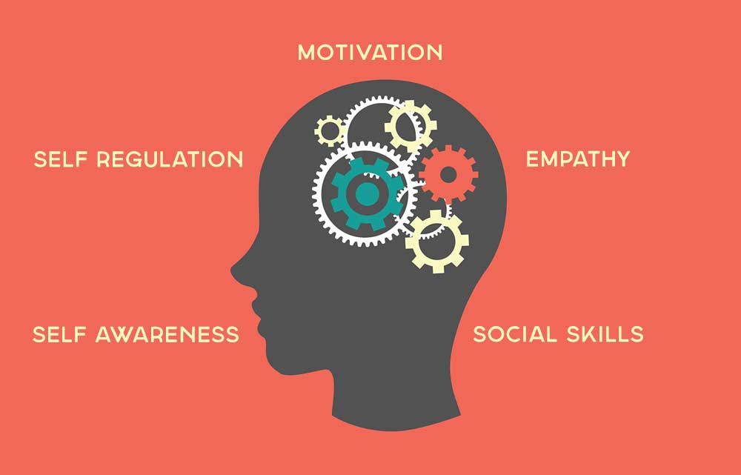

The term "Emotional Quotient (EQ)" was introduced to the field of emotional intelligence by American psychologist Daniel Goleman in 1995. It is believed that emotional quotient is a crucial personal survival skill; it is a crucial element that could unlock one's emotional potential and have an impact on both current and future levels of existence through the application of emotional intelligence. Although emotional components are more significant than mental ones, both are crucial to success. The ability to comprehend one's own emotions, appropriately manage emotions, be self-motivated, engage in cognitive emotion, and engage in interpersonal communication are all included in the emotional quotient.

The success of a person's profession is significantly influenced by their emotional quotient, which is a type of non-intelligent component. According to Daniel Goleman's research, the Emotional Quotient is responsible for 80% of the personnel success, with Intelligence Quotient accounting for only 20%.

Awareness of one's own and other people's emotions, including sympathy, comparison motivation, and the capacity to appropriately react to pleasure and pain, is a sign of emotional intelligence (Goleman, 1995). Or, to put it another way, emotional intelligence might be defined as "intelligence with feelings."

Adolescents can benefit much from learning about their emotions, how they interact with others, and how to take responsibility for their own behaviours. Furthermore, a thorough understanding of adolescents' emotions is crucial in assessing their psychological wellbeing in order to promote a smooth transition from adolescence to adulthood. The idea of "personal meaning" in adolescents' lives can thus play a significant role in regard to their emotional intelligence. According to Wong (1998), finding meaning in life involves having a purpose and working toward a goal or goals, as well as "creating sense, order, or coherence out of one's existence."

SPIRITUAL QUOTIENT

The importance of Emotional Quotient (EQ) and Intelligence Quotient (IQ) (IQ). EQ helps us become more aware of our own and other people's feelings. According to experts, EQ is a prerequisite for IQ. Being emotionally intelligent allows a person to think clearly in any circumstance, which automatically improves decision-making. Researchers have discovered that there is more to human intellect than just IQ and EQ. As a result, the "third Q," or "Spiritual Quotient-SQ," was created.

The phrase "spiritual intelligence," or SQ, is new. Although it seems familiar, the majority of individuals have never heard the phrase, never read about it, and have never brought it up in conversation. Some people might believe they understand what it means, but they might be conflating spiritual knowledge with spiritual intelligence. A manner of thinking is referred to as spiritual intelligence. We all have it from birth, utilise it every day, and live with it. It won't ever leave our possession. In her co-authored book SQ Spiritual Intelligence, the Ultimate Intelligence, Dana Zohar states that SQ is what we use to create our capacity for meaning, vision, and worth. It encourages communication between the mind and body as well as between reason and feeling.

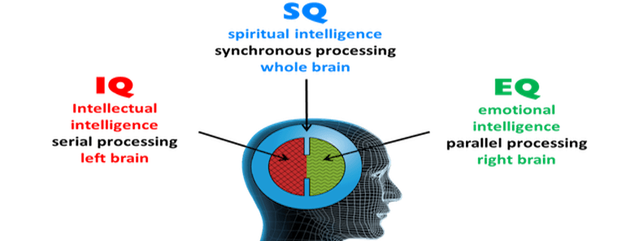

A framework for developing spirituality and leadrship by encouraging the following qualities is provided by Danah Zohar, a researcher in the subject of Spirituality and Leadership:

• Self-awareness: understanding what I value and believe in, as well as what drives me deeply.
• Spontaneity: ability to live in the moment and respond to it
• Being vision- and value-led: Living in accordance with one's vision and core values, acting on one's morals and deepest convictions
• Holism: feeling a sense of belonging and recognising bigger patterns, linkages, and connections
• Compassion: the capacity for intense empathy and "feeling-with"
• Celebrating diversity is recognising others for their differences rather than ignoring them.
• Field independence: defending one's beliefs while defying the majority
• Humility: Being humble is being aware of one's genuine place in the wider scheme of things.
Call for fundamental "Why?" inquiries: need to fully comprehend concepts, not only
superficially
• Ability to reframe: The capacity to reframe a situation or issue by stepping back and observing
• Positive use of adversity: learning from mistakes, disappointments, and suffering
• Sense of vocation: feeling called to serve and give back

Even if a person has a very high SQ, they may not practise any religion or hold any sort of belief. A person can also be religious and have a low SQ. We could use spiritual intelligence as a guide to help us distinguish between good and bad. On the other hand, spiritual intelligence is the supreme intellect with which we may address and resolve issues of meaning and worth, giving context to the intelligence with which we can determine whether one's course of action or life path is more meaningful than the others (Zohar and Marshall, 001).

HAPPINESS QUOTIENT

The Happiness Quotient (HQ) is a notion that roughly calculates how happy each individual has been in their lives. A paradigm that makes it simpler for individuals to impartially assess various aspects of their personal pleasure is the happiness quotient. These features are referred to as happiness quotients. The happiness quotient is made up of a total of seven quotients:
- Emotional happiness
- Physical happiness
- Social happiness
- Occupational happiness
- Intellectual happiness
- Environmental happiness
- Spiritual happiness

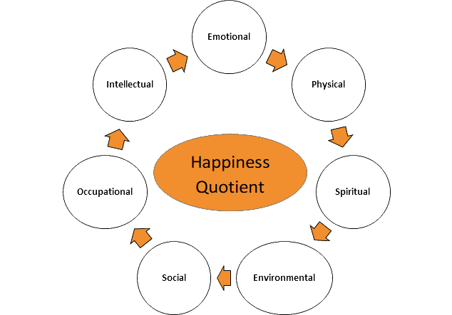

THE CONNECTION BETWEEN EQ, SQ AND HQ

Man, lives in society, which was connected by individuals for their personal benefit and is an alliance of individuals. The pitiable state of the society today makes us reflect on a variety of issues, including the decline of moral principles, emotional instability, disregard for one another, etc. These issues are brought on by a lack of EQ, SQ, HQ, and values. The kids need to learn about EQ, SQ, HQ, and Values in order to solve their challenges. Students, who are the product of schools, are the backbone of society. Schools frequently do not make the connections between spirituality and education.

It is necessary to make these potential modifications in attitudes, behaviour, and values. Along with enhancing all facets of educational quality and assuring excellence, everyone must meet the quantifiable learning outcomes, particularly in the areas of reading, numeracy, and crucial life skills. In a nutshell, a quality education enriches learners' lives and improves their overall quality of life while also meeting their fundamental learning needs.

Students can develop self-acceptance, anger management skills, friendship-making and friendship-keeping abilities, conflict-resolution skills, cooperation motivation, and the ability to express themselves by learning emotional, spiritual, and happiness skills. Fisher (1998) cited recent studies that highlighted the significance of spirituality for human health and welfare. People who are in good spiritual health exude a positive energy that aids in managing obstacles, are devoted to the truth, and frequently serve as an inspiration to others (Ingerson, 1998).

The human brain is incredibly complicated. The sum of a person's intelligences would not be represented by either their IQ alone or their EI (plus IQ). Computers have an extremely high (of course artificial) IQ, but not EI. While one's SQ allows him to ask the question "why should he be there in that particular situation in the first place?", one's EQ allows a person to judge the situation he is in and then to behave appropriately within it. In other words, he is working within the parameters of the situation and allowing the situation to guide him. SQ, in contrast to EQ, can grant him transformative power, the ability to change the situation by making a better one; that is, one's SQ can aid him/her in dealing with the problem by allowing him/her to direct the circumstance.

The human brain is built to coordinate these three intelligences, but they can also work independently because each has a particular area of strength. In an ideal situation, these three intelligences should cooperate and assist one another. Humans don't necessarily need to have high or low IQ, EQ, SQ, and HQ scores at the same time. All combinations are possible, including high IQ and lower EQ, SQ, and HQ; one does not need a higher IQ to have higher EQ, SQ, or HQ. To achieve in life, all three intelligences should be fully developed.

EXCELLENCE IN HIGHER EDUCATION

A key requirement of an institution is to instil in students’ particular values and concepts to help them develop their personalities in accordance with the demands of the time, yet academic institutions fail to fulfil this requirement. We must offer emotional, spiritual, happiness, and value education to pupils in order to help them build positive personalities. This will help the students feel better about themselves and value themselves more. Most aspects of our lives, including family, community, and schools, are influenced by our emotional quotient, spiritual quotient, happiness quotient, and values.

Students experience stress and strain during adolescence. It is a time of feeling and a moment in their mental growth when thoughts and ideas are developing. They experience a range of unfavourable emotions throughout this time, including anger, grief, blame, and fear. There are some emotions that are detrimental to learning and others that are beneficial. To manage bad emotions, education in the emotional, spiritual, and moral realms would be helpful.

Singh (2001) suggest that emotions can be positive and negative because they react to specific condition or situations. Hence, the Education has to be carefully given by keeping in mind the chief issues of emotionality, spirituality, happiness. Due to negligence of chief issues in today's education, incidents such as shooting in the classroom, using abusive language, suicidal cases etc., do occur in our colleges, school/society. Hence, emotional, spiritual, happiness& values aspects should also be stressed for the complete development of an individual. Such a vision should enlighten and guide future educational reforms and policies in relation to content methods. Emotional, spiritual & happiness quotient are observed to be essential for dealing with students in their learning environment, and to make proper decisions. EQ, SQ, HQ & values are therefore becoming an important area of study.

Singh (2001) argues that as emotions are a reaction to certain circumstances or conditions, they can be both positive and negative. Since emotionality, spirituality, and happiness are such important topics, education must be properly imparted. In our institutions, schools, and society as a whole, occurrences like shootings in the classroom, the use of abusive language, suicide situations, etc., do occur as a result of the neglect of major concerns in today's education. Therefore, it is important to emphasise emotional, spiritual, happiness, and value-related aspects as well for an individual's whole growth. Such a vision needs to illuminate and direct upcoming educational innovations and regulations around material delivery. It has been found that having a high emotional, spiritual, and happiness quotient is necessary for dealing with kids in a classroom setting and for making wise decisions. Values, EQ, SQ, and HQ.

Education systems do have an impact on students' behaviour, ideas, and beliefs. Because EQ, SQ, HQ & values assist students lead meaningful and useful lives, an education system (curriculum planners and administrators) must be aware of these factors. For this reason, the education system must be centred on EQ, SQ, HQ & values.

TEACHER’S PERSPECTIVES ON EQ, SQ &HQ THROUGHOUT THE EDUCATIONAL PROCESS

Passion is not an option in the creative, risk-taking vocation of teaching. Teachers that have a love for their profession are dedicated, enthusiastic, and intellectually, emotionally, and spiritually active in their interactions with students, as well as with their peers, parents, and the general public. For teaching to be of the highest calibre, this passion is necessary. As a result, educators are the leading forces behind the development of a learning society, national unification, and social cohesiveness. Without competent instructors, even the strongest social and educational systems are doomed to failure. Once we have good teachers, even the most serious flaws in the system can be mostly fixed.
Most educators place emphasis on the social components of education in addition to the academic areas, especially starting in the 20th century. They maintain that education is a lifelong process by which a person gradually and gracefully acclimates to the physical, intellectual, emotional, social, and spiritual contexts that are available. Therefore, it is important to take into account teachers' overall growth from the perspectives of EQ, SQ, and HQ throughout their careers in order to effectively carry out the educational process.

Teachers do have an impact on a student's personality. Children's growth is greatly influenced by parents' emotional, intellectual, moral, ethical, and spiritual spheres. A teacher can control the emotional and spiritual characteristics of her/his students to create a balanced environment in the classroom if they are emotionally and spiritually intelligent and joyful. Some of the key elements of an individual's emotional, spiritual, and happiness quotient are self-awareness, empathy, kindness, intuition, drive, awareness, social skills, forgiveness, reconciliation, and dedication.

Teachers must work as hard as they can to discover appropriate solutions to the issues that arise with their students. Education also has the concept of sharing "love" and knowledge flowing from the person to the family and eventually to all of humanity, so educators need have a strong background in areas like class management, educational communication, and psychology in order to do this. The ultimate objective is to develop people that are lovable, respectful, accountable, successful, self-assured, moral, aggressive, etc. As can be seen, both psychological health and education have as their primary goals.

The aforementioned competencies can be taught to students by educators. But for this process to work, developing self-awareness is necessary. In other words, educators should reflect on the purpose of knowledge, emotions, and life itself and be able to internalise the answers to the questions they pose. It is possible to question an educator's perspective on life, knowledge, love, and nature and to watch their comprehension, intolerance, and compassion in order to determine whether they possess an integrated EQ, SQ, and HQ competency. The behavioural kinds that educators should take into account in order to build and integrate these competences are listed below:

1. From the perspective of the pupils, the educators' disposition at the start of the academic term is crucial. Students' initial impressions are shaped by their positive attitudes, behaviours, and approaches.
. Teachers should be knowledgeable in their own fields of expertise and be able to communicate what they know effectively.
3. Both educators and students should place a high value on active and empathic listening.
4. Teachers need to pay attention to the psychology and feelings of their students.
5. Teachers should also instruct pupils on self-management, social interaction, self-motivation, and other life skills.
6. They should also encourage their students to participate in a variety of activities to broaden their general knowledge, which will help the development of their EQ, SQ, and HQ.
7. Throughout the educational communication process, educators can also employ comedy and true stories to educate both their own lives and those of their pupils.

CONCLUSION

Recent research demonstrates that having a high IQ does not ensure happiness, success, or respect in life. However, academic excellence and good grades are still appreciated in the majority of educational institutions. Sadly, the importance of social and emotional development as well as listening to the "other voice of mind" is underrated in educational communication. Students are typically socialised in the existing curriculum, given a solid foundation by developing their interpersonal communication abilities, and treated as secondary goals through this process.

Recent EQ studies have shown that those with strong emotional and social abilities lead happier and more fruitful lives. People who are emotionally uncontrollable are frequently discovered to have a troubled spirit and to be engaged in an internal conflict that impairs their ability to think clearly and concentrate. But those with high EQ and SQ appear to be in better positions in both their personal and professional life. High SQ level individuals have the capacity to inspire others. Therefore, it is extremely important for educators whose goal is to develop their students' minds, hearts, and souls to first learn how to integrate their IQ, EQ, SQ, and HQ.

In conclusion, it is crucial that EQ, SQ, and HQ competencies are integrated into higher education. Because of this, educators and educational institutions should strategically plan, manage, and assess this process. In order to do this, it is necessary to provide educators with
the necessary training in EQ, SQ, and HQ literacy.

REFERENCES

- Alam, Md. Mahmoud. (2012). Emotional Intelligence, Self efficacy and career maturity among the students of Hyderabad city. Journal of Community Guidance and Research, 29(2), Pp. 272-283.
- Bhangale, S. and Mahajan P., S. (2013).Spiritual Intelligence - Emerging Issue in Education. Retrieved September 7, 2015
- Daniel Goleman. (1997). Emotional Quotient. Shanghai: Shanghai science and Technology Press.
- Daniel Goleman (1995) Emotional Intelligence: Why It Can Matter More Than IQ
- E-book on IQ-EQ-SQ by Basic Foundation, www.folknet.in
- GOLEMAN, Daniel (1995), Emotional Intelligence; Why It Can Matter More ThanIQ, NY: Bantam Books.
- Yun Ming, Hai. (1997). Emotional intelligence. Beijing: China City Publishing House.

-----------------------x---------------------------------x----------------------------------x------------------

