INDIAN HIGHER EDUCATION INSTITUTION’S UNIVERSITY BENCHMARKING TOWARD QUALITY PRACTISES

INTRODUCTION
Higher education is in high demand in India, but there are also some issues with quality and sustainability. For a long time, the goal of the Indian higher education system was to create higher education institutions (HEIs) that would allow the students to complete their degrees on their own and look for employment. As a result, there are much more institutions and students enrolling in higher education. However, the system did not receive the necessary attention for quality and suitability of purpose. As a result, the system developed a number of gaps, including those in research, relevance, and skill development, which eventually led to problems with access, equity, quality, and employability. In order to solve these challenges, the system underwent a number of reforms and went through a number of stages of development but to a considerable extent they are still unanswered. The higher education system in India has to start taking the necessary steps to get back on track. The process would be greatly aided by the effective implementation of the worthwhile proposals made by the education commissioners and committees that are periodically established. As soon as the New Education Policy is released, the HEIs should be prepared to put its suggestions into practice. They should also have a constructive attitude. It is necessary to enhance organisations like the National Assessment and Accreditation Council (NAAC) and the National Board of Accreditation (NBA), which are in charge of quality control and serve as inspiration for other organisations.

In order to address the concerns relating to access, equity, quality, and employability, higher education in India has undergone a number of stages of transition. The goal of building higher education institutions (HEIs) was initially to provide students from rural and urban areas with the opportunity to graduate and find employment. The number of students enrolling in graduate and postgraduate programmes has significantly increased as a result of this. Universities and colleges have increased in number. The fields of science, business management, engineering, and medicine have all greatly risen. But there is now a quality crisis. Some of these colleges are understaffed and have inadequate facilities and infrastructure. The development of curricula, instruction, and assessment do not meet the requirements of academic standards.

The primary weakness in the Indian higher education system is the callousness with which various committees' commissions that are periodically established implement their recommendations. The system would have been among the best in the world if all the recommendations had been carried out as and when advised.

LITERATURE REVIEW
The term "quality" is frequently used but little understood because it has been defined differently in many settings (Mishra, 2007). According to Juran, quality is "fitness for use or purpose," according to Crosby, it is "conformance to standards," and according to Deming, it is "a predictable degree of uniformity and reliability at low cost and adapted to market" (Ali & Shastri, 2010). Higher education institutions are challenged to deal with the non-standard human aspect because it is assumed that students are both the customers and the "product" in this novel sector (Venkatraman, 2007).
Quality is always relative and refers to "whether one educational context has more or less quality than another, not whether it meets an absolute threshold standard so that it can be viewed as adequate quality, nor whether it reaches a high threshold and can be viewed as outstanding and of exceptional quality, nor whether a context is perfect, with no defects" (Gibbs, 2010). Although this philosophy has been transferred from industry to higher education due to forces that are requiring quality improvement in the higher education sector due to rapid change, many experts claim that there are significant barriers in the application of the concept of Total Quality Management (TQM) in higher education institutions. Quality in the business of education is in need of change in the educational processes, as it is becoming important in the world of competitive environment (Venkatraman, 2007). Many researchers have compared industry to education and have pointed out conceptual and substantial obstacles in the implementation of TQM in tertiary institutions.

According to Newby (1999), barriers can be divided into three major categories: (a) the management culture of some institutions, which is related to the inability to adapt creatively to the rate of change, ultimately leading to institutional atrophy and decline; (b) the traditional culture of higher education, as the barriers to implementing total quality approaches are more likely to be related to the prevailing culture of higher education and the propensity for organisations to "do what they have always done."

Academic excellence is a subject that higher education organisations all around the world frequently address. Numerous authors contend that excellence, like quality, is a rather ambiguous concept. In the European Union, encouraging excellence is crucial for constructing a culture and economy based on knowledge as well as for achieving the objectives of economic growth and job creation (Joosten, 2014). Academic research is another crucial component that has an impact on the formation and maintenance of quality in higher education institutions, adding to the concept of excellence.

The Bologna Process is carried out by quality assurance organisations, which focus on accreditation and quality assurance (Unit, 2005). The application of the following widely used framework of how quality can be assured is necessary, barring the changing needs of the higher education environment, in order to comprehend the criteria and adhere to the best practices (Harman, 1998): • Self-assessment; • Analysis of statistical data and/or use of performance indicators or the benchmarking of best practices; • Surveys of students, graduates, employers, professional bodies; • Testing of students' knowledge, skills, and competencies. Peer review by an expert panel typically involves at least some external panel members in one or more site visits. To ensure that each process serves its intended function, particular tools and methods must be used. Benchmarking is recognised as one of the best methods for evaluation and development. Benchmarking is "the process of self-evaluation and self-improvement through the systematic and collaborative comparison of practice and performance with similar organisations in order to identify strengths and weaknesses, learn to adapt, and to set new targets to improve performance," according to Blackstock et al. (2012). Benchmarking is defined as "a standard method for collecting and reporting critical operational data in a way that enables relevant comparisons among the performances of different organisations or programmes, usually with a view to establishing good practice, diagnosing performance problems, and identifying areas of strength" (Vlsceanu et al., 2004) in the UNESCO-CEPES Glossary for Basic Terms and Definitions. The contributing authors define benchmarking as a diagnostic tool, a self-improvement tool (a quality assurance tool) that enables organisations and programmes to compare themselves with others regarding some aspects of performance in an effort to find ways to improve current performance, an open and collaborative evaluation of services and processes with an eye toward learning from best practices, and a method of instructing an insular subject. The historical evolution of benchmarking in the higher education industry is discussed by Vlsceanu et al. (2004).

PURPOSE
This study aims to determine whether and to what extent higher education institutions can profit from the use of benchmarking techniques. Therefore, the purpose of this research is to highlight the framework and practical applications of quality improvement by presenting data that can be used to understand how benchmarking is being used as a rival tool for excellence in higher education institutions.

OBJECTIVES
- To comprehend the exceptional practices used by universities or business schools in seven key areas.
- To comprehend the amenities and infrastructure needed by business school students in India.
- Whether this alignment or material is routinely evaluated for alignment or not, the courses are either aligned with industry needs or they are not.
- To comprehend the significance of curriculum in light of industrial fitness.
- To comprehend the standards for effective teachers in the Indian environment.
- To comprehend the amenities and infrastructure needed by business school students in India.
- To determine whether marketing automation solutions for CRM or recruitment support.

LIMITATIONS
The results of this action research are very significant as long as they are supported by credible sources and influential educational institutions. However, this study may be said to have one unique limitation that could affect the results. For all intents and purposes, the research sample is small and comprises a total of 10 universities. However, it is debatable to what extent this degrades the caliber of our findings. This thesis does not see the small sample size of the research specimen as a drawback given that every research has constraints, whether it is conducted by undergraduate and master's level dissertation students or seasoned academics. The researcher gathered 60 submissions, but due to colleges' high standards and dedication to excellence, she chose to focus on them. Because the N/A element affected the induction of high percentages in several sections of the quantitative study as well as of the codified and subsequently statistically reported qualitative analysis, this particular attitude explains the low variances given by some of the findings. The discussion of restrictions is focused on a project with specific length requirements as specified by this university's regulatory framework. A broader engagement would go above the permitted levels of involvement given how thoroughly the research action has been studied. However, this approach can be used to more extensive specimens in future research on this area of study.

RESEARCH METHODOLOGY
This study focuses on the use of benchmarking as a self-improvement tool and examines quality in higher education as it is enhanced and improved. In order to comprehend how benchmarking is being used as a competing tool for quality in higher education institutions, it is necessary to understand the structure and applications of quality assurance. Data collection seeks to provide: (a) insights on bench marking’s distribution; and (b) illustrative attitudes regarding specific types of benchmarking and the tested techniques and instruments for doing it. In order to provide an analysis focused on benchmarking with significance and implications for the pursuit of excellence in higher education institutions, this paper combines the evidence gathered through an extensive review of the theoretical literature with extensive empirical research on tertiary institutions around the world.
SCOPE OF THE STUDY

The research objectives are the specific accomplishments the researcher hopes to achieve by the study. A clearly defined research objective will help the researcher to focus on the study. Research objectives are usually expressed in lay terms and are directed as much to the client as to the researcher. Research objectives may be linked with a hypothesis or used as a statement of purpose in a study that does not have a hypothesis. Even if the nature of the research has not been clear to the layperson from the hypotheses, s/he should be able to understand the research from the objectives.

PROBLEM DEFINITION:-

A research problem is a statement about an area of concern, a condition to be improved, a difficulty to be eliminated, or a troubling question that exists in scholarly literature, in theory, or in practice that points to the need for meaningful understanding and deliberate investigation. In some social science disciplines the research problem is typically posed in the form of a question. A research problem does not state how to do something, offer a vague or broad proposition, or present a value question.
SOURCE OF DATA

This research report on the basis of primary data. I did in depth analysis in the help of review literature and read all the materials related this research report i.e. Indian Higher Education Institution’s University Benchmarking toward Quality Practices.

I gain some useful knowledge or information about merger and acquisition in the help of previous study and research on Indian Higher Education Institution’s University Benchmarking toward Quality Practices.

I read some Journals which are upload on Sodhganga and Sodhgangotari by the UGC to helps the aspirants to read that and gain some useful information and that information put on their respective topic like dissertation, thesis, project report etc.
This study on the basis of only secondary data so that naturally some unbiased are occur because the data was not original, the data was second hand that I am used.
RESEARCH DESIGN
Descriptive research has been found fit for this thesis as the research has been based on secondary data. Flexibility in the design is needed as the broadly defined problem can be transformed into one with more precise meaning.
- The phenomena associated with the subject population such as profitability, liquidity and efficiency have been described.
- It has been sought to explain the associations in different variables through the method of Regression Analysis.
The main method which has been used in context of research design for this study is:
- Google forms
- Review of Literature
- Review of Journals
- Visit on Websites
- Visit on National Digital Library
SAMPLE DESIGN
Non-probability Judgment sampling has been used in this study as the samples were not selected randomly, but after a purposeful cognitive study.
Types of Research:-
Primary Data:
Primary data is data that is collected by a researcher from first-hand sources, using methods like online surveys (Google form), interviews, or experiments. It is collected with the research project in mind, directly from primary sources. The term is used in contrast with the term secondary data.
Secondary Data:
The secondary data sources are:
Internal documents and publications Newspaper, articles, journals and websites

Sample Size:

My sample for the project was 60 respondents, since it was not possible to cover whole state in the available time of period, it was necessary to me to take a sample size for 60 respondents.
RESEARCH RESULTS
This exploratory study aims to point out the structure and applications of quality improvement, by providing evidence for understanding the implementation of benchmarking as a competing tool for quality in higher education institutions. Various authors have underpinned that a culture of quality entails strategic management that involves a number of planning processes for the improvement of quality that leads to excellence. Academic excellence reveals the linkage of quality assurance to benchmarking, while changes in the academic scene call for substantial transformations due to business and industry demands. The conduction of empirical research was made to examine the reliability of benchmarking as a successful tool for quality in higher education and to acquire better realization of its applicability by tertiary institutions that already practice it. In other words, this study examines the various viewpoints on the matter of assessment and searches for the particular benchmarking types and tools that lead to successful outcomes.
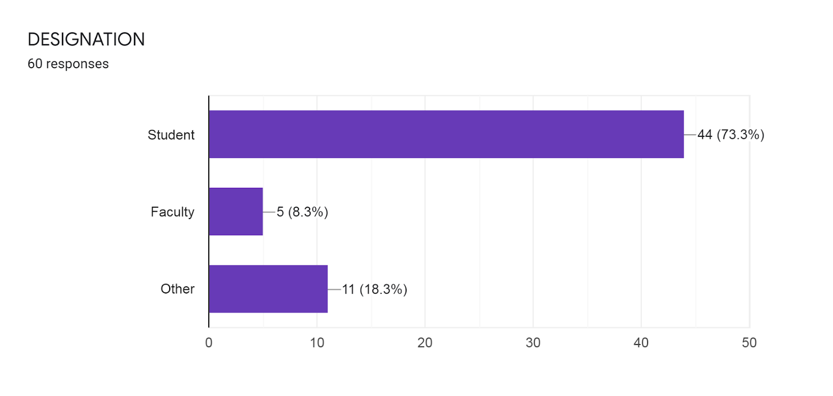

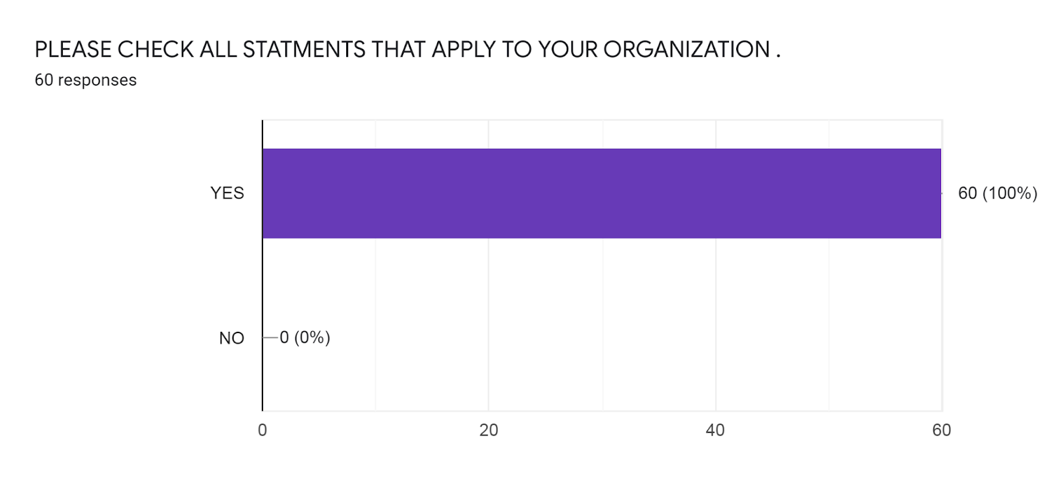
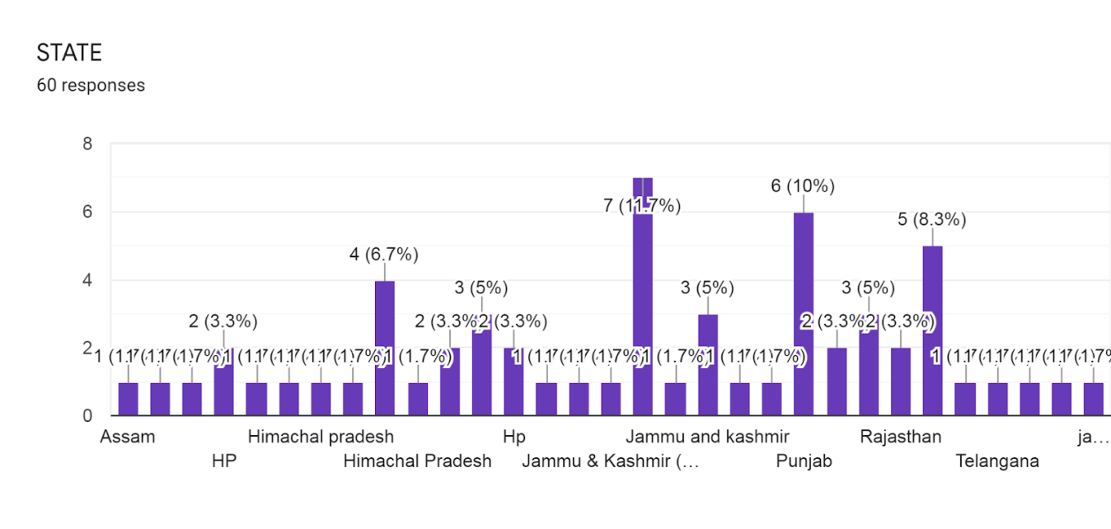
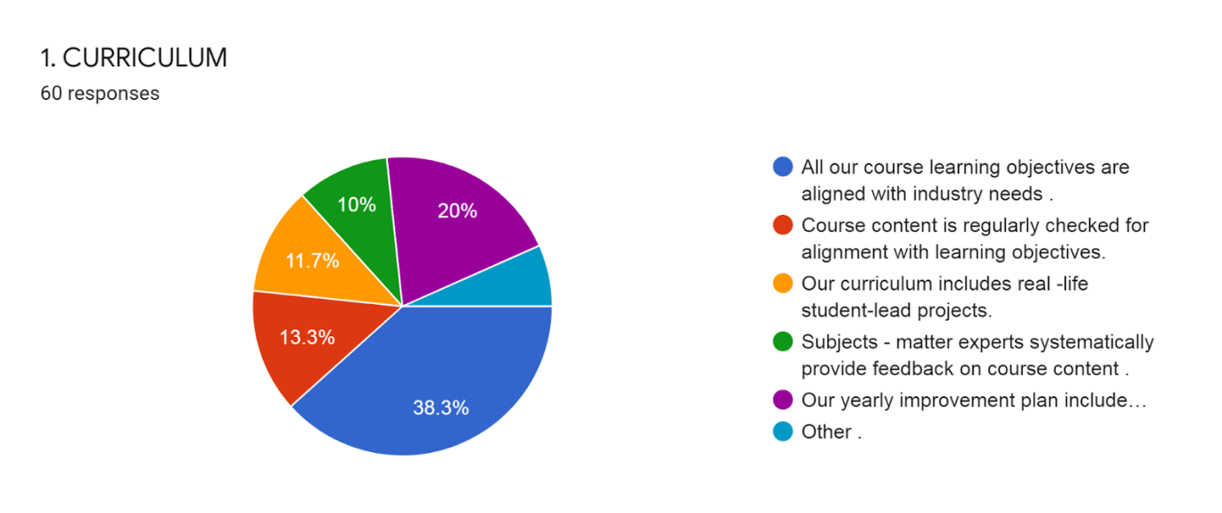

INTERPRETATION:
Out of 60 respondents 38.3% are goes with all our courses learning objectives that are aligned with industry needs:
- 20% are go with our yearly improved plan include student success and satisfaction.
- 13.3% are go with course content is regularly checked for alignment with learning objectives.
- 11.7% are go with our curriculum includes real life student leads projects
- 10% are going with subject – matter experts systematically provide feedback on course content.
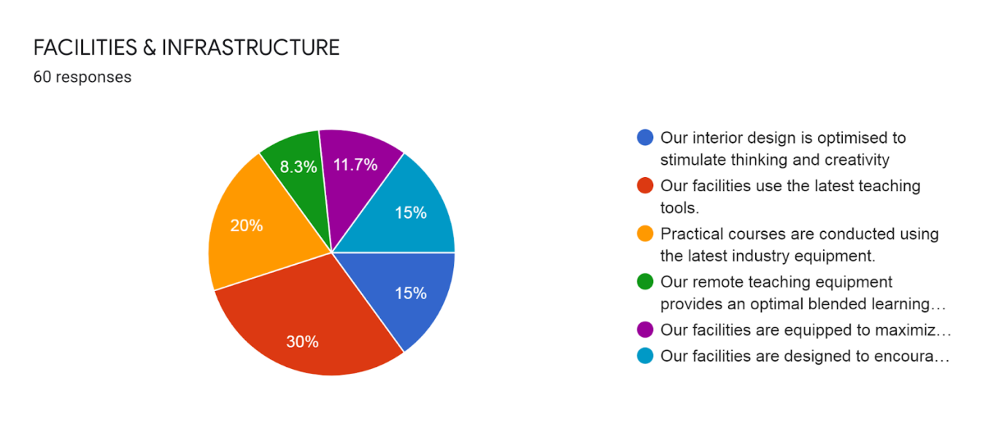
INTERPRETATION:
Out of 60 respondents 30% are goes with the facilities use the latest teaching tools.
- 20% are go with Practical course are conducted using the latest industry equipment.
- 15% are going with our facilities designed to encourage socialization.
- 15% are go our interior design is optimized stimulate thinking and creativity.
- 11.7% are going our facilities are equipped to maximize the learner’s comfort.
- 8.3% are going with our remote teaching equipment an optimal blended learning experience.

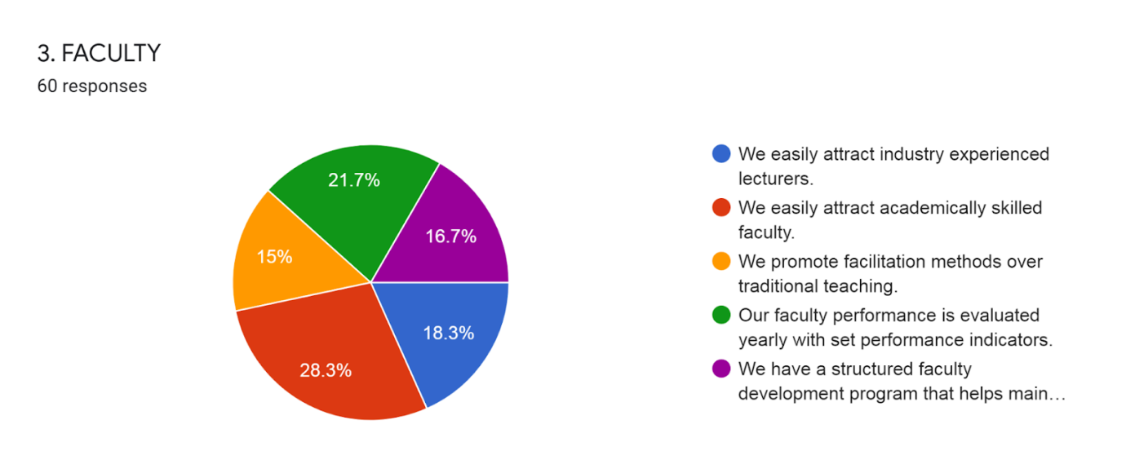
INTERPRETATION:
Out of 60 respondents 28.3% are go with We easily attract academically skilled faculty.
- 21.7% are go with our faculty performance evaluate yearly with set performance indicators. 18.3% are going we easily attract industry experienced lectures.
- 16.7% are go with we have a structured faculty development program that maintain industry relevancy.
- 15% are go with we promote facilitation methods over traditional teaching.
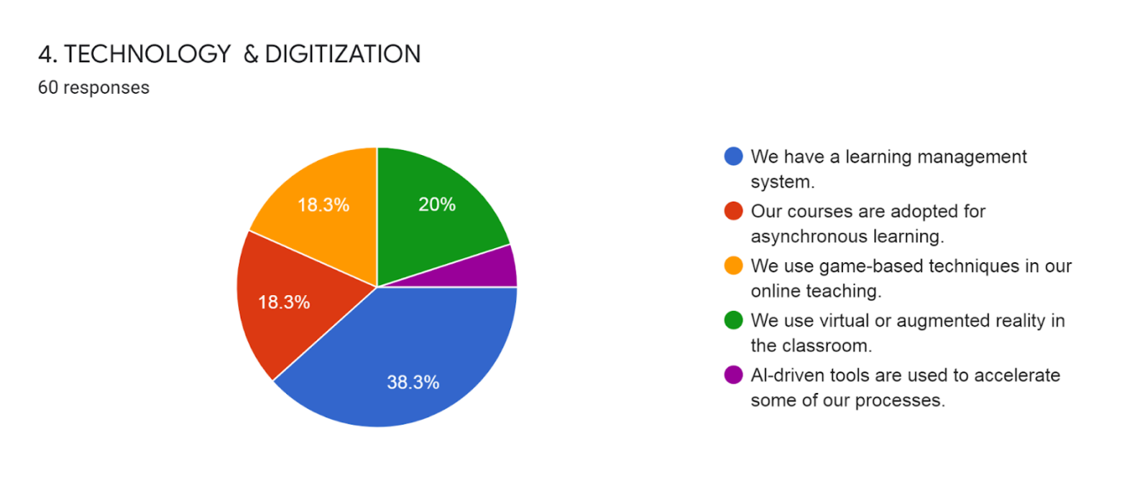

INTERPRETATION:
Out of 60 respondents 38.3% of the people are go with the We have a learning management.
- 20% are go with we use virtual or augmented reality in the classroom.
- 18.3% are go with our courses are adopted for asynchronous learning.
- 18.3% are go with we use game- based technique in online teaching.
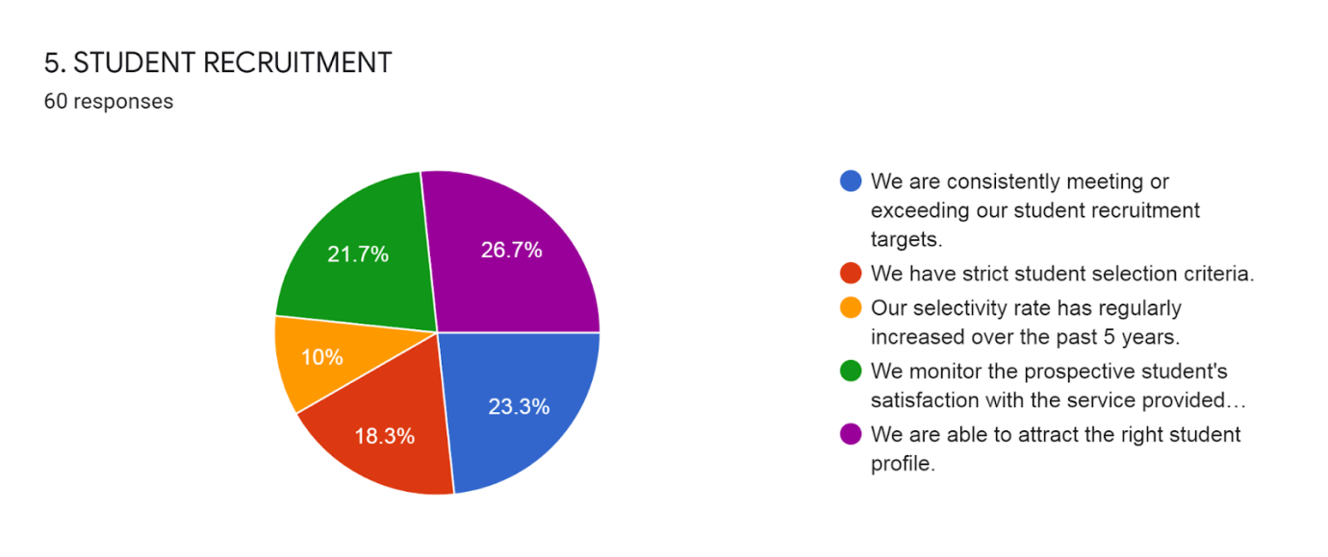
INTERPRETATION:
Out of 60 respondents 26.7% are going with we are able to attract the right student profile.
- 23.3% are go with we are consistently meeting or exceeding our student recruitment targets.
- 21.7% are go with we monitor the prospective student satisfaction with the service provided by the recruitment team.
- 18.3% are go with we have strict student selection criteria.
- 10% are go with our selectivity rate has regularly increased over the past 5 years.

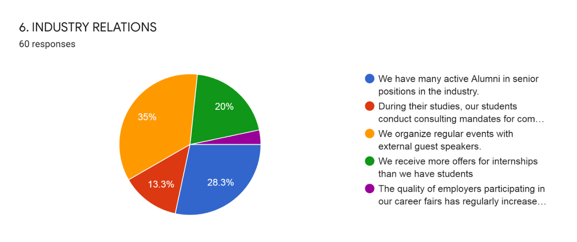
INTERPRETATION:
Out of 60 respondents 35% are go with we organize regular events with external guest speakers,
- 28.3% are go with we have many active alumni in senior positions in the industry.
- 20% are go with we receive more offers for internships than we have students.
- 13.3% are going with during their studies, our students conducting consulting mandates for companies.
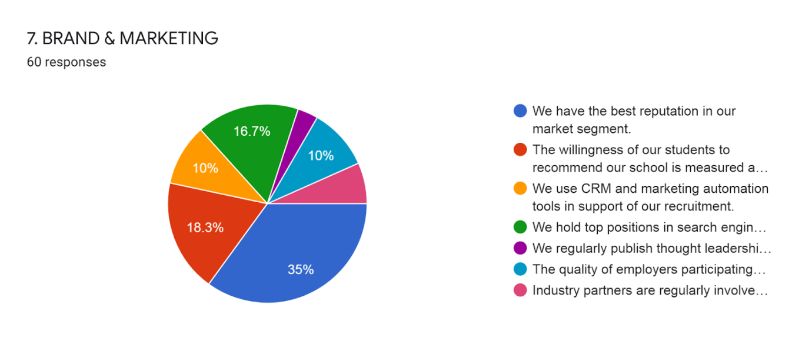

INTERPRETATION:
Out of 60 respondents 35% are go with We have the best reputation in our market segment.
- 18.3% are going with the willingness for our students to recommend our school is measured and exceeds 85%.
- 16.7% are go with we hold top positions in search engine results on key topics.
- 10% are go with we use CRM and marketing automation tools in support of our recruitment.
- 10% are going with the quality of employees participating in our career a fair has regularly increased over the past 5 years.

FINDINGS
The findings of this research indicate that benchmarking can improve academic excellence by means of comparison and assessment. The study finds that process performance measurements can bring considerable outcomes of enhancement, improvement and transformation in higher education systems.
VALUE
The value of this paper lies in the identification and presentation of several ideas and tools which can successfully be applied to higher education institutions in order to achieve excellence by using benchmarking practices.
SUGGESTIONS
- Competitive advantage, but seldom to reduced costs;
- Reorganization of the support of the organization and a reduction of the overhead of national universities considered of superiority;
- Improvement of quality in both research and education;
- High decrease on administrative costs;
- Reduction in total costs of student attendance;
- Grant application costing in the support for research and also to the sharing of certain costs with other local universities;
- Increased success in recruiting and improvement of enrolment management;
- Better service and consistency in getting a question answered or resolving a service issue;
- A much higher level of competence than the financial resources imply (retained equity, or endowment), much higher efficiencies than those of other local institutions;
- Increased improvement and more satisfying evaluations from departments taking part in benchmarking projects;
- Specific indicators in the field of research and use of these information during re-accreditation processes;
- Determination of position among peer institutions, as data is used to ensure that they stay competitive in attracting, retaining and graduating students;
- Staff reduction by about 30%, when redesigning the internal financial function by implementing external benchmarking, and reduction of space by using UK benchmarks on the amount of space used by university functions;
- Reduction in costs by benchmarking of Professional Services (project) and competitive advantage by benchmarking in terms of quality of research and education.

CONCLUSION
Despite many shortcomings, India is making progress in the field of higher education. The need for students to master a variety of abilities, including digital skills, is growing. In order to raise the rate of employability at this pivotal time, it is imperative to resolve the discrepancies between the skills taught and those needed in the job. Similar to this, institutions of higher education should create a strong research ecosystem with a focus on collaborative research initiatives to increase their visibility on a worldwide scale. However, developing such an ecosystem is difficult and calls for close collaboration between the executive branch, academic institutions, and regulatory organisations.
The higher education system in India has to start taking the necessary steps to get back on track. The process would be greatly aided by the effective implementation of the worthwhile proposals made by the education commissioners and committees that are periodically established. As soon as the New Education Policy is released, the HEIs should be prepared to put its suggestions into practice. They should also have a constructive attitude. It is necessary to enhance organisations like the National Assessment and Accreditation Council (NAAC) and the National Board of Accreditation (NBA) that are in charge of quality assurance.
Furthermore, the majority of respondents (50%) stated that they regularly and yearly examine their strategic plans in order to satisfy their ongoing desire for development by implementing diagnostic benchmarking in their strategic planning and control. As a result, there is a greater need for higher education institutions worldwide to evaluate their strategic plans now in order to learn more about the results of such strategies. Unquestionably, the evaluation process is a mark of how well tertiary institutions construct quality planning to advance in the field of continuous improvement. No university should ignore gauging students' satisfaction with teaching and learning from a more business-like perspective, seeing them as customers in the higher education sector.
The outcomes of study analysis are made more understandable by a statistical approach, which attributes a 62% to 38% ratio of internal to external appraisal of educational programmes. As a result, for quality enhancement, self-assessment is described, which refers to creating improvements within the organisation, and external evaluation refers to outside experts judging whether objectives have been achieved. Thus, internal benchmarking is mostly discussed in this evaluation process, perhaps as a result of the burden of expensive external evaluation, bureaucracy, and the propensity to maintain university autonomy. Institutional processes can be assessed continually or irregularly, as is common known.
The results of the research analysis were statistically allocated to the region of process evaluation, with permanent evaluation holding a 25%, periodical evaluation holding a 65%, and evaluation that varies due to process content holding a 5%. The development of this research focuses on the most important obstacle to the benchmarking concept: continual improvement through evaluation. It's interesting to note that most participants appear to be completely focused on periodic evaluation as opposed to ongoing evaluation. This particular finding is consistent with the research on I the unseen and intangible nature of higher education's product in comparison to manufactured goods and (ii) the common challenges to implementing TQM successfully in higher education posed by the non-standard human factor.
According to the analysis of submissions 21, all of the surveyed universities (100%) use the evaluation results to improve the quality of their work. Benchmarking can be seen as a process for improvement and a chance to discover best practices, pinpoint exceptional criteria, and set and meet them. Although there are many different benchmarking kinds, the participants in this survey contributed vital information that allowed for the identification of the main benchmarking type employed by higher education institutions. According to the analysis of the research, 36% of internal benchmarking and 32% of competitive benchmarking were used by organisations to assess their performance and compete for national or international recognition.
Process performance measures and questionnaire design were identified as the best tools with a respective 18% quota after statistical research looked at the co-occurrence of tools used by institutions to benchmark. Process mapping and project management, both of which have a 16% quota, are the following highly used tools. Institutions must be able to connect the benchmarking process to the goals they have. When choosing a benchmark, they should take into account the following factors: (a) the caliber of their benchmark partners/competitors; (b) whether they choose their benchmark internally or externally, nationally or internationally; (c) the benefits and drawbacks of group size; (d) the degree of group homogeneity; and (e) whether the benchmark is trustworthy and keen to benchmark with broadly comparable objectives. The results of the research analysis comprise a search for suitable rivals in the top rankings in addition to the above-mentioned search regions. A qualitative analysis was done to determine the amount of complexity, standardization, and paradigm of this process.
Only 22 respondents, however, provided information on what this process comprises, including (a) discussions with faculties and participation bodies, (b) talks with top management, and (c) internally set criteria. The results highlight the importance of first identifying, evaluating, and comparing rivals offering comparable educational services before settling on a standard. Due to the complexity of the higher education industry, an investigation of the external operating environment is a complex procedure that involves hidden challenges. International rankings enable for comparisons against competitors who have the appropriate performance levels because academic standards and cultures of quality can vary across national boundaries.
According to a comparative analysis, half of research universities (regardless of the nation in which they are located) exchange useful information with rival providers of related services and have the chance to exchange knowledge by using benchmarking as a key tool to enhance their institutional and educational procedures. A tiny percentage of respondents also mentioned the existence of specific associations that facilitate data exchange across institutions of higher learning.
Universities are aware of rankings and use benchmarking to gather information about their rivals from already-existing data sources. The development of benchmarking in participants' institutions was seen to have given them competitive benefits, according to the qualitative study. According to the results of this action research, benchmarking practices have the following major impacts: I a decrease in administrative or total costs; (ii) a leveling up of competitiveness; (iii) an increase in management and student enrollment; and (iv) an improvement in the quality of both research and education. As a result, the majority of the universities questioned expressed satisfaction with the benchmarking practices used in their schools.

Annexure -1
REFERENCES
- Achtemeier, S.D., Simpson, R.D. (2005). Practical Considerations When Using Benchmarking for Accountability in Higher Education. Innovative Higher Education, Vol. 30, No. 2.
- Ali, M., & Shastri, R.K. (2010). Implementation of total quality management in higher education. Asian Journal of Business Management, 2(1), p. 9-16.
- Arthur, L., & Cox, E. (2014). From evaluation to research. International Journal of Research & Method in Education, 37(2), p. 137.
- Blackstock, D., Burquel, N., Comet, N., Kajaste, M., dos Santos, S. M., Marcos, S., ... & Sixto, L. C. V. (2012). Internal Quality Assurance Benchmarking. ENQA Workshop Report 20. ENQA (European Association for Quality Assurance in Higher Education). Avenue de Tervuren 36-38-boite 4, 1040 Brussels, Belgium. p. 8.
- Brusoni, M., Damian, R., Sauri, J.G., Jackson, S., Kömürcügil, H., Malmedy, M., ... & Rostlund, A. (2014). The concept of excellence in higher education. ENQA Occasional Paper, 20, p. 20.
- Consortium for Excellence in Higher Education. (2003). Benchmarking Methods and Experiences. Sheffield: Sheffield Hallam University.
- Gibbs, G. (2010). Dimensions of quality. York: Higher Education Academy. p. 11.
- Harman, G. (1998). The management of quality assurance: A Review of International Practice, Higher Education Quarterly, 52(4), 345-364.
- Henkel, M. (1999). The Modernizations of Research Evaluation: The Case of the UK. Higher Education 38(1), 105-122.
- Hogg, R. V., & Hogg, M. C. (1995). Continuous quality improvement in higher education. International Statistical Review/Revue Internationale de Statistique, 35-48.
- IAU. (2007) International Handbook of Universities – UNESCO. Palgrave-Macmillan. 19th Edition.
- Lund, H., & Jackson, N. (2000). Creating the Conditions for Benchmarking: A Brief History of Performance Assessment in UK HE. Benchmarking for Higher Education. The Society for Research into Higher Education (SRHE) and Open University Press, Buckingham.
- Joosten, H. (2015). Excellence for All: A Nietzschean-inspired approach in professional higher education. Educational Philosophy and Theory, 47(13-14), 1516- 1528.
- Kekäle, J. (2015). A human resources model supporting academic excellence. Tertiary Education and Management, 21(2), p. 1. 25
- Kettunen, J. (2012). External and internal quality audits in higher education. The TQM Journal. 24(6), 518-28.
- Lutfullayev, P. (2007). Research on Benchmarking in higher education: An overview. In Regional Conference on Quality in Higher Education. Research on Benchmarking in Higher Education: An Overview, p. 5.
- Mishra, S. (2007). Quality assurance in higher education: An introduction. National Assessment and Accreditation Council, India and commonwealth of Learning, Vancouver.
- Mueller, R.A. (2015). Do values drive the plan? Investigating the nature and role of organizational values in university strategic planning. Tertiary Education and Managemen, 21(1), 50-51.
- Newby, P. (1999). Culture and quality in higher education. Higher Education Policy. 12(3), 261-75.
- Ossiannilsson, E. (2012). Benchmarking e-learning in higher education: lessons learned from international projects. ACTA University Oulu, 436.
- Selesho, J. M. (2014). Enhancing the Culture of Quality Assurance in Higher Education: Perspectives of Managing Institutional Accountability. Mediterranean Journal of Social Sciences, 5(1), 405.
- Smith, H., Armstrong, M., & Brown, S. (1999). Benchmarking and threshold standards in higher education. Psychology Press.
- Unit, U., H., E. (2005). Guide to the Bologna Process. 1 Oliver's Yard, 55 City Road, London EC1Y 1SP United Kingdom: SAGE Publications Ltd.
- Venkatraman, S. (2007). A framework for implementing TQM in higher education programs. Quality Assurance in Education, 15(1), 92-112.
- Vukasovic, M. (2014). Institutionalisation of internal quality assurance: focusing on institutional work and the significance of disciplinary differences. Quality in Higher Education, 20(1), 44-63.
Annexure -2
QUESTIONNAIRE
1. CURRICULUM
- All our course learning objectives are aligned with industry needs.
- Course content is regularly checked for alignment with learning objectives.
- Our curriculum includes real -life student-lead projects.
- Subjects - matter experts systematically provide feedback on course content.
- Our yearly improvement plans include student success and satisfaction.
- Other.
2. FACILITIES & INFRASTRUCTURE
- Our interior design is optimized to stimulate thinking and creativity
- Our facilities use the latest teaching tools.
- Practical courses are conducted using the latest industry equipment.
- Our remote teaching equipment provides an optimal blended learning experience.
- Our facilities are equipped to maximize the learner's comfort.
- Our facilities are designed to encourage socialization.
3. FACULTY
- We easily attract industry experienced lecturers.
- We easily attract academically skilled faculty.
- We promote facilitation methods over traditional teaching.
- Our faculty performance is evaluated yearly with set performance indicators.
- We have a structured faculty development program that helps maintain industry relevancy.
4. TECHNOLOGY & DIGITIZATION
- We have a learning management system.
- Our courses are adopted for asynchronous learning.
- We use game-based techniques in our online teaching.
- We use virtual or augmented reality in the classroom.
- Al-driven tools are used to accelerate some of our processes.
5. STUDENT RECRUITMENT
- We are consistently meeting or exceeding our student recruitment targets.
- We have strict student selection criteria.
- Our selectivity rate has regularly increased over the past 5 years.
- We monitor the prospective student's satisfaction with the service provided by our recruitment team.
- We are able to attract the right student profile.
6. INDUSTRY RELATIONS
- We have many active Alumni in senior positions in the industry.
- During their studies, our students conduct consulting mandates for companies.
- We organize regular events with external guest speakers.
- We receive more offers for internships than we have students
- The quality of employers participating in our career fairs has regularly increased over the past 5 years.
7. BRAND & MARKETING
- We have the best reputation in our market segment.
- The willingness of our students to recommend our school is measured and exceeds 85%.
- We use CRM and marketing automation tools in support of our recruitment.
- We hold top positions in search engine results on key topics.
- We regularly publish thought leadership content in support of the industry.
- The quality of employers participating in our career fairs has regularly increased over the past 5 years.
- Industry partners are regularly involved for feedback on industry needs and course design.

