Future Trends of Radiology

-Dr.Prajwith K J Rai & Dr.Akash kumar Sivakumar

Introduction
Radiology is a subspecialty of medicine which uses radiation to diagnose and cure illnesses. Diagnostic radiology and interventional radiology are the two main divisions of this specialty. A radiologist is a doctor who is skilled in or practices radiology.
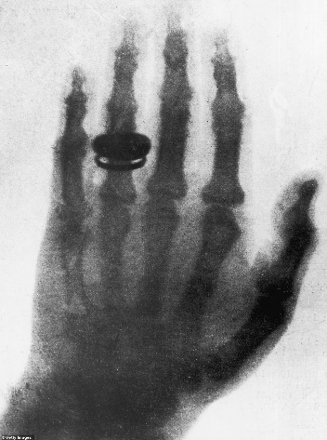
In 1895, Wilhelm Conrad Röntgen, a German mechanical engineer and physicist discovered the Röntgen-Rays or X-rays when he accidentally noticed that florescent screen placed in a light proof area, a couple of feet away from a energized cathode ray tube, started to glow.He was honoured with the first Nobel Prize in Physics in 1901 for the same. Since the origin of radiology as a medical speciality it has been a keystone in healthcare. It is one of the most swiftly advancing branches in medicine. Technology has progressed by leaps and bounds, pushing the boundaries of imaging for the benefit of mankind. Radiology has moved from conventional analogue systems to digital image acquisition modalities, Computed tomography, MRI etc.
Fig:1. The First X-ray
Virtual Imaging, Dynamic Imaging, Endovascular Radiology and Interventional Radiology are recent developments in the field of radiology. Better molecular imaging, artificial intelligence and genetics will shape radiology in the future. Modern medicine requires a true integration of administrative abilities, technology, and medical expertise to be practised successfully.

Emerging trends in radiology
The start of a New Year and decade, presents an opportunity to be grateful for the successes of the previous years and to consider the difficulties that need to be overcome and also be prepared for what comes next. For radiologists, the landscape may not appear the same year-after-year due to ongoing advancements in medical technology.
Advanced Combination imaging, Artificial intelligence and integrated 3D imaging are the future of radiology. By learning about these developments, radiologists will be better prepared to assess developing technologies and feel secure using the tools they chose.
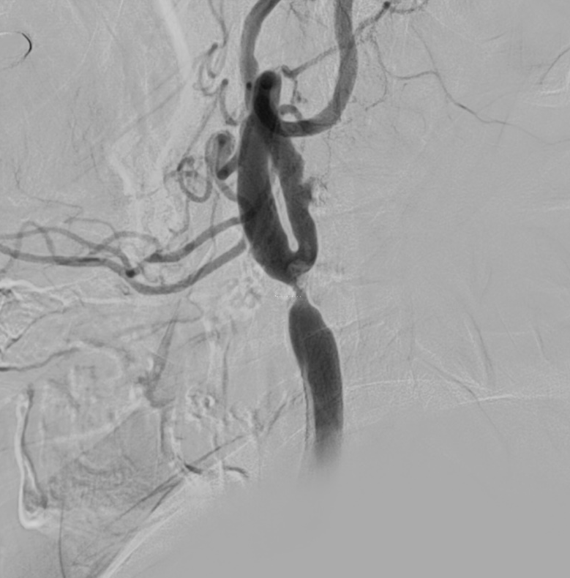

Fig.2.Digital subtraction angiogram of common carotid artery lateral view, depicting significant stenosis in the distal CCA

Artificial intelligence
In contrast to the natural intelligence exhibited by animals, including humans, artificial intelligence (AI) is intelligence displayed by robots. Many applications, including drug development, remote patient monitoring, medical diagnostics and imaging, risk management, wearable’s, virtual assistants, and hospital management, are now more increasingly relying on AI. Deep learning algorithms used in Artificial Intelligence (AI) have made incredible strides in picture identification applications.
In the past, Radiology professionals used visual evaluation of medical pictures to diagnose, classify, and monitor illnesses. When it comes to automatically identifying complex patterns in imaging data, AI techniques excel in comparison to qualitative judgments of radiographic features. (1) The therapeutic potential of artificial intelligence in Onco-radiology is enormous.
Solitary pulmonary nodules can be recognised using artificial intelligence, which can also be utilised to assess the nodules in subsequent imaging. According to a recent study by Andres F. Abadia et al, the sensitivity of AI in complex lung illness is comparable to that of a skilled radiologist, and the tool aids in the discovery of previously undetected lesions. Due to the rising patient load and requirement for quicker turnaround times, AI also makes it possible for specialists to analyse for lung nodules more quickly and confidently, which is advantageous to both patients and hospitals. (2)
Li-Qiang Zhou et al. investigated the use of artificial intelligence in the study of focal liver lesions, diffuse liver disease staging, the evaluation of focal liver lesions, segmentation of the liver, the assessment of liver image quality (IQ), and the prediction of treatment response. They came to the conclusion that deep learning is quickly developing into an incredibly promising tool for liver image tasks, enabling the identification and evaluation of liver lesions, facilitating liver clinical care, and forecasting the effectiveness of liver treatment.(3)
Andreas D. Lauritzen and colleagues stated in a 2022 article in the RSNA journal that Artificial Intelligence (AI)-based screening might identify normal, moderate-risk, and suspicious mammograms in a breast cancer screening programme, which may lessen the burden of the radiologist. Across all breast densities, AI-based screening performed consistently. (4)
The discipline of artificial intelligence (AI) has expanded significantly in recent years, and it has been used in brain molecular imaging to enhance image quality, shorten the time a patient must spend in a scanner, and support clinical interpretation of images and physician decision-making. AI could be used to create diagnostic predictions for brain tumours, which are characterised by aberrant tissue growth and can be benign, malignant, primary, or metastatic. AI is also useful for identifying neurodegenerative illnesses. (5)
Radiologists will use AI in their daily work to assist physicians be more productive and capable of making accurate diagnoses. AI has the capacity to quickly sort through enormous amounts of imaging data, enabling radiologists in prioritising worklists and diagnoses.
By supplying qualified radiologists with pre-screened images and identified features, a seamlessly integrated AI component within the imaging workflow will boost productivity, reduce errors, and fulfil targets with minimal manual input. As a result, significant initiatives and regulations are being made to promote AI-related technology advancements in medical imaging.(6)

Advanced Combination imaging
One of the best examples of radiology advancements that are enhancing the accuracy and effectiveness of radiology reporting is the ability to mix many modalities to produce superior images. In interventional radiology, hybrid CT-fluoroscopy is among the best examples of integrated imaging. Other examples of combination imaging include PET/CT and PET/MRI.
Conebeam CT/CT-Fluroscopy, which enables radiologists to use fluoroscopy, CT, or both while doing treatments, is essentially a CT scanner and angiography system that share a same patient bed. Regarding the advantages, the device makes it simple to transition between CT and fluoroscopy in a matter of minutes, enhancing both efficiency and patient satisfaction. Cone beam CT is now routinely used for endovascular procedures in the majority of instances.
Numerous studies have demonstrated that CBCT delivers superior anatomic visualisation compared to conventional CT and biplane fluoroscopy, allowing high accuracy instrumentation placement, enhancing operation results, and reducing risk of complications.(7)
A PET scan and a CT/MRI scan are both included in a PET/CT scan and PET MRI scan. The CT/MRI component of the scan generates a 3-D image that displays the anatomy of the patient. The results of the PET scan show cellular activity and function. The PET scan is distinctive because it captures the radiation the patient emits, whereas the CT/MRI collects anatomical component that show the same area from a different angle.
A CT scan by alone creates detailed images of the body's tissues and organs, whereas a PET scan by itself reveals areas of elevated activity within the body. The scans work as a team to provide a clear double diagnosis by showing exactly where the problems are and what might be causing them.

3D Fusion Imaging and 3D Printing
Rapid thin-section CT and isotropic MRI collections enable 3D post processing, an established technology. All human parts and systems can be imaged using three-dimensional post processing, and the majority of contemporary PACS can offer basic three-dimensional capability such the creation of MIP images and multiplanar reformatted images.
Fig.3.Reformated 3D images of the Lumbosacral vertebral bodies (gives a better understanding)
The 3D fusion of whole-heart dynamic 3D cardiac magnetic resonance perfusion (3D-CMR-Perf) image data with CT coronary angiography (CTCA) image data is known as fussion imaging. According to a study by Jochen von Spiczak et al, 3D fusion of CTCA/3D-CMR-Perf makes it easier to correlate the anatomic location of coronary lesions with deficiencies in myocardial perfusion brought on by stress, which aids in improving the diagnostic evaluation of CAD. (8)
--While advanced visualisation is used in radiology to aid in diagnosis and communication with referring clinicians, there is still a need to render Digital Imaging and Communications in Medicine (DICOM) images as three-dimensional (3D) printed models that can offer tactile feedback and tangible depth information about anatomical and pathologic states. Preoperative planning, intraoperative usage including patient-specific instrument guidance, and custom-tailored implants, prosthesis and trays are all examples of uses for 3D printing. (9)

Simulation and virtual reality.
It is crucial for students to experience the issue in order to develop their critical thinking skills and their confidence in their ability to analyse and apply evidence-based management. Because of this, simulation becomes a crucial component of medical education. The method enables testing a learner's ability to apply their knowledge to circumstances that are close to those in the real world by placing them in an unfamiliar environment. Our future curriculum will include simulation to strengthen this critical thinking ability and simulation is ideally suited to do so.
Technology advancements have made it possible for several simulated reality technologies, such as virtual reality (VR) and augmented reality (AR). Both technologies enable the immersion of a simulated object in three dimensions (3D). While VR mimics a virtual environment, AR superimposes virtual elements over the background of the actual world.
With the use of this technology, volumetric medical pictures from CT and MRI scans can be displayed, providing a more realistic portrayal of the three-dimensional nature of anatomical structures that is helpful for diagnosis, instruction, and procedure planning. (10)

Endovascular and interventional radiology

Radiology has a specialty called interventional radiology (IR). Interventional radiologists use small incisions on the body to perform minimally invasive surgical operations in addition to interpreting your medical imaging. A few of the sophisticated treatments carried out by interventional radiologists include angioplasty, stenting, embolization, thrombolysis, RFA, and biopsies.
Fig:4. Digital subtraction angiogram of cerebral circulation A-P and Lateral view, Depicting normal left internal cerebral angiogram

Interventional radiology (IR) has advanced significantly in recent years in terms of technology applications, healthcare quality, training, expansion, and even recognition. If the current structure, mentality, and mainstream ideology are not changed, IR's survival will be in jeopardy given the scope of its success in almost all facets of medicine, the growing clinical responsibilities of interventionalists, and the inability to handle the massive growth of services and procedures in the field. (11)

Conclusion

The future of Radiology looks good as a subject and a profession, not only is it going to make the work of the Radiologist a lot easier, it is also going to reduce errors and improve their efficiency significantly. There is immense hope as to how it can help the Medical fraternity on the whole and we as doctors are looking forward to it
Now the comes the debate as to, how will The Radiologist adapt to this change, just like the Physicians refresh their protocols every now and then in view of advancing research study, and the Surgeons are now doing all Laparoscopic and Minimally Invasive procedures which about 20-30 years back was unheard of. The Radiologist will also adapt! Who is he who doesn’t want to change, as we all know that ‘Change is the only constant’.

