Overview of Medical Device Regulation

Dr. P. Charulata Sree
Dental Intern
Rungta College of Dental Sciences and Research
Bhilai, India
charulata014@gmail.com

ABSTRACT
Medical devices are designed and manufactured for use in healthcare, and not solely medicinal or nutritional. Government and Authorized Entities supervise the introduction, maintenance, safety and performance of the device. A new regulatory framework, MDR (EU) 2017/745 Medical Devices Regulation was officially published on May 5, 2017 and implemented on May 26, 2017. It is carried out by a conformity assessment depending on risk based classification of the device. The regulation has introduced UDI system (Unique Device Implementation) to support device traceability with the help of a numeric code or an alphanumeric code. Custom made device (CMD) in a dental setting have to undergo certain legislative requirements in EU and UK to get their regulatory approval.

Keywords—Medical devices, Regulatory affairs, Medical device regulation, Custom made devices.

INTRODUCTION

‘Medical device’ refers to any instrument, apparatus, appliance, software, implant, reagent, material or other article intended by the manufacturer to be used, alone or in combination, for human beings. It is designed and manufactured for use in healthcare, and not solely medicinal or nutritional. They have an elementary role in saving lives by providing innovative healthcare solutions for the diagnosis, prevention, monitoring, prediction, prognosis, treatment or alleviation of disease. Government and Authorized Entities supervise the introduction, maintenance, safety and performance of the device. Although they poses potential risk, especially those which have to be implanted, national regulatory agencies try their level best to protect society from unreliable products. In a general context, the new implantable biomaterials have to undergo necessary test involving in vivo and in vitro tests, physical and chemical characterizations as well as clinical investigations. Stakeholders can expedite the innovation process in the field by gaining knowledge on concepts relating to market approval and maintenance process of the device.
Stanford Biodesign framework concised innovation process into ‘three I phases’- identifying clinical needs, inventing solutions and implementing systems to address them. Different phases requires assistance from clinicians, inventors and developers but regulation is a universal theme influencing the whole cycle of a device.

THE NEW EUROPEAN UNION REGULATION:

A new regulatory framework governing market access to the European Union was designed and taken into consideration to provide uniform technological evolution throughout EU. MDR (EU) 2017/745 Medical Devices Regulation was officially published on May 5, 2017 and implemented on May 26, 2017. The manufacturers are given a three year transition time to meet the requirements in MRD by carrying out a conformity assessment depending on risk based classification of the device. The regulation has introduced UDI system (Unique Device Implementation) to support device traceability with the help of a numeric code or an alphanumeric code. Additionally MDR has developed ‘Eudamed’, a platform to collect key information from all EU countries in a single database. This approach aims to reinforce traceability and transparency in medical device market.

CLASSIFICATION OF MEDICAL DEVICES:

Table 1 Classification of medical devices

CLASSIFICATION | EXAMPLES
CLASS 1 | Wheelchairs, Stethoscopes, Spectacles
CLASS 2A | Dental fillings, Surgical clamps, Tracheotomy tubes
CLASS 2B | Condoms, Lung ventilators, Bone fixation plate
CLASS 3 | Pacemakers, Heart valves, Implanted cerebral simulators

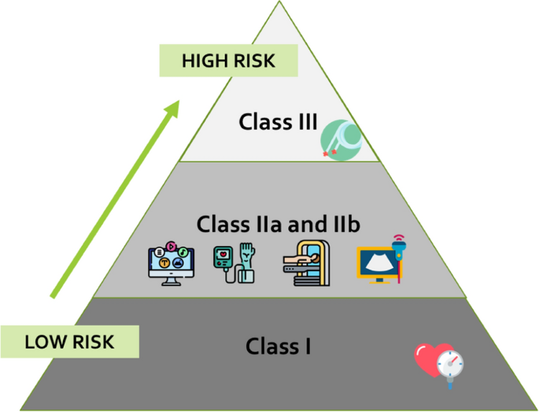

Figure 1 Risk based classification of medical devices.

Most Class 1 medical devices must be registered with FDA but are not required to undergo a premarket review, although they have to fulfil general controls like manufacturer registration and notification to the FDA before marketing, good manufacturing practices, appropriate branding and labelling and general post market reporting procedures. Medium risk devices are cleared for market if there are consistent evidences that they are similar to other devices already on the market (Substantial Equivalence) or may require a “De Novo” review for devices for which there is no predicate. High-risk devices demonstrate safety and effectiveness through clinical trials, conducted in accordance with Good Clinical Practices (GCP).
In certain circumstances which are in the interest of public health or patient safety, a competent authority may authorize placing a device on market which has not undertaken a conformity assessment. Humanitarian Device Exemption Program targets products aimed for rare diseases. It is based on the fact that randomized clinical trials are impractical in rare disease population. In spite of that the devices approved under this exemption are put through certain restrictions like approval from relevant institutional review board before use.

REQUIREMENTS NEEDED TO MEET CONFORMITY ASSESMENT:

- Annex I of the MDR-
Benefits must outweigh risks and achieve the claimed performance.
Chemical, physical and biological properties for medical devices.
Instructions for use and correctly labelled devices.
- Technical documentation (Annex II of the MDR)
- Common specifications (Articles 8 and 9 of the MDR)

REGULATORY UNCERTAINITY IN DEVICE MARKET:

According to a study by Stern A.D, although early mover have a regulatory advantage in drugs, the case is opposite in medical devices where pioneer entrants spend 34% (7.2 months longer) to get their regulatory approval. Hence the process delays small firm’s entry into market making them unlikely to be a pioneer in new device market. Device approval time can be expedited by publishing objective regulatory guidelines.

REGULATION OF COUSTOM MADE DEVICES IN A DENTAL SITTING:

Custom made device (CMD) refers to any device that is specifically made in accordance with a qualified medical practitioner’s written prescription which has specific design characteristics intended for the sole use of a particular patient. This includes removable (dentures, obturators) or fixed (inlay, onlay, crowns) prosthodontic appliances, speech prosthesis, bruxism splints, devices for trauma prevention (buccinators flap appliances, mouthguards), orthognathic surgery (arch bars) and obstructive sleep apnoea management.

Table 2 Classification of custom made devices in dental setting.

CLASSIFICATION | EXAMPLES
CLASS 1 | Arch bars, Buccinator flap appliances, special trays
CLASS 2A | Removable and fixed prosthodontic devices, orthodontic appliances, removable sleep apnoea devices
CLASS 2B | Dental implants
CLASS 3 | -

Legislative requirements in pertaining CMD’s in EU and UK can be summarised as:
- Inform competent authority.
- Appoint a person for regulatory compliance
- Appoint an authorised representative for placing device in market.
- Keep up to date to improve quality management system.
- Follow Annex 1 requirements which are applicable to CMD’s.
- Prepare documentation and statement regarding the design, manufacturer and performance of the device produced.
- Retain a copy of the statement for a minimum of five years.
- Review and document experience in post production phase.
- Report serious incidents and field safety corrective actions (if any).

CONCLUSION:

The cornerstone of most regulatory systems in the world is by classifying medical products into drugs, biologics and medical devices. However, new and innovative products pose a challenge to this existing product classification. Emerging innovative products such as 3D bioprinting, nanobiomaterials and materials used for tissue engineering need a more streamlined regulatory evaluation encourage innovation and expedite safe and effective delivery of medical devices to patients.

REFERNCES

- Guerra-Bretaña RM, Flórez-Rendón AL. Impact of regulations on innovation in the field of medical devices. Res Biomed Eng. 2018. DOI: 10.1590/2446-4740.180054
- Bianchini, E., Mayer, C.C. Medical Device Regulation: Should We Care About It?. Artery Res 28, 55–60 (2022). https://doi.org/10.1007/s44200-022-00014-0
- https://assets.publishing.service.gov.uk/government/uploads/system/uploads/attachment_data/file/640404/MDR_IVDR_guidance_Print_13.pdf
- Innovation under regulatory uncertainty: Evidence from medical technology – Ariel Dora Stein - https://www.sciencedirect.com/science/article/abs/pii/S0047272716301669?via%3Dihub
- Green JIJ. Medical Device Regulation: Requirements for Dental Professionals Who Prescribe and Manufacture Custom-Made Devices. Primary Dental Journal. 2021;10(1):64-88. doi:10.1177/2050168420980980

