ISOLATION AND CHARACTERIZATION OF COW DUNG MICROFLORA AND ITS EFFECTIVENESS OF Citrus Limon BIO-ENZYME

*KRISHNAVENI.R¹, SATHYA I¹, AMEERA.S¹, ARTHI.K¹, JANARANJANI.S¹
1. Assistant professor and Head, Department of Microbiology.
Idhaya College for Women. Kumbakonam.
1. Sathya I, Ameera S ,Arthi K, Janaranjani . S, UG Student
Department of Microbioogy. Idhaya College for women. kumbakonam.
Corresponding Author; krishnavenimicro@gmail.com
ABSTRACT:
Cow manure act as a good fertilizer. It contain more nutrients beneficial microbes. It supports growth useful microbes. When it was mixed with soil it improve the soil and maintain moisture. The present studies carried out isolation of cow dung microflora and its antimicrobial properties against bio enzyme citrus limon. The bacterium like shigella species 23mm inhibition and proteous species17 mm inhibition against citrus limon

INTRODUCTION
Cow dung more contain more beneficial microbes and various Nutrional components vitamins, cellulose, oxygen, carbon, mucus, potassium, nitrogen, it is being used in Agricultural and religious purpose.
A micro organisms such as bacilli species coccus . Muhamed and Amusa 2003. According to Ware et al ., 1988 the gut of cow contains Lactobacillus plantarum, Lactobacillus casei, lactobacillus acidophilus, B.A Saccharomyces corevisiae act as probiotic Ware Funssin D R, Read PL et AL.,( 1988 ) Generally old cow dung has more soil microbes and Actinomices Muhamed and Amusha ( 2003 ). There are many Proofs to confirm that. Nene YL . ( 2001 )Which might be due to secretion of antimicrobial metabolites by cow dung and cow urine as antifungal and anti bacterial properties .Sharma and Singh, 2015 )Antimicrobial drugs has great effect on infection diasease caused by resistant microbes 1929 ( Fleming et.al., 1929 ) ( Kardosand and Demain, 2011.,( Kaarla et al., 2015). Naiem et al .,2006 ) ( Sikarwar and Batra, 2011 ). ( Abo – State et al.,2012 ) A Cow dung rich in Enterobacter aerogenes, Escherichia coil, Klebsilla oxytoca, Klebsilla pneumonia Morgarella morganii, Pasteurella species, and Pseudomonas species, Nocardia, Mucor species and Rhizopus species . ( Nene 1999)( Sawast et al.,., 2007 ) . ( Randhawa and Kullar, 2011 ) Cow Dung has been used as a antifungal agent.( Muhamed and Amusha 2003) ( Dhama et al., 2005 ). (Joseph and Sankerganesh 2001) ( DHAMAKA et al., 2013 )cow dung shows antimicrobial properties against against Candida species, Escherichia coli, pseudomonas species and staphylococcus aureus by revealing the antimicrobial property ( Daviud odemi et al., 2007 )
Cow dung as booster in the decomposition of organic material (Adegunloye et al., 2007 ). Cow dung act as organic Fertilizer, (V. Muralikrishna et al., 2017 ( B. Sharma et al.,2019)

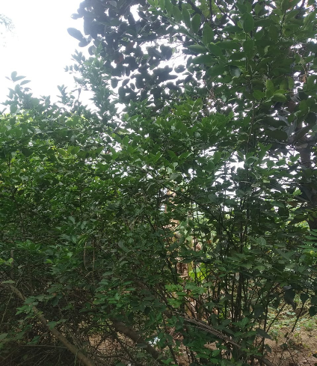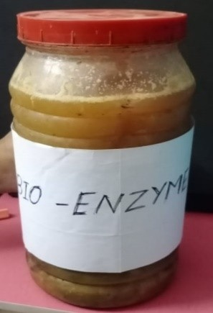
Citrus limon HerbalPlant Bio Enzyme Citruslimon.,

Bio Chemical Charecteristic Of Shigella Species.,
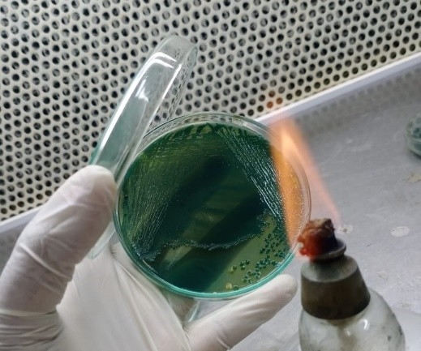
a) Shigella Sp, Hekteon Entric Agar

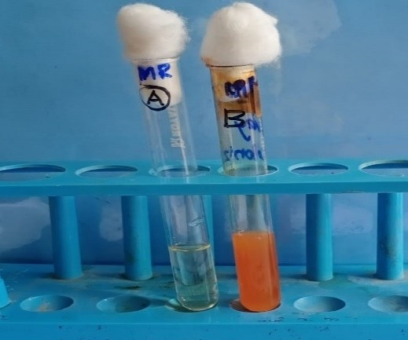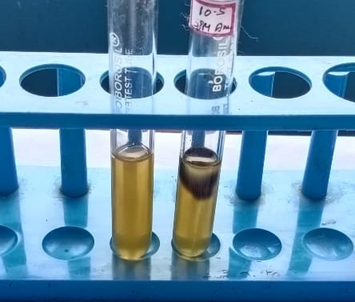b) MR -Positive b) Indole Negative

b )Urease Test-Positive a) Klebisella Pneumoniae Species
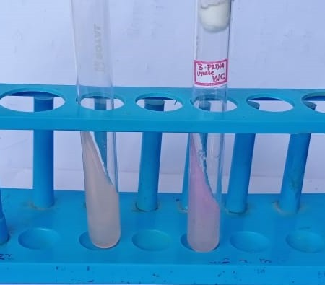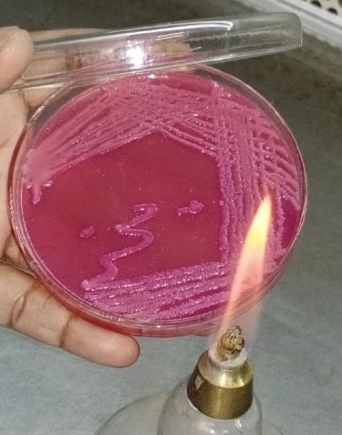

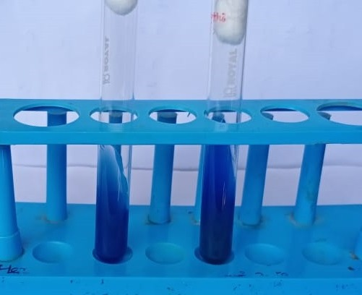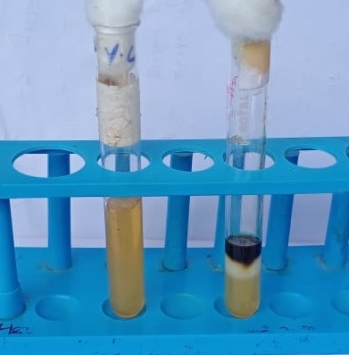 b) Indole NegativeTest Simmon’s Citrate Test- Positive

Biochemical characters of Proteus species.
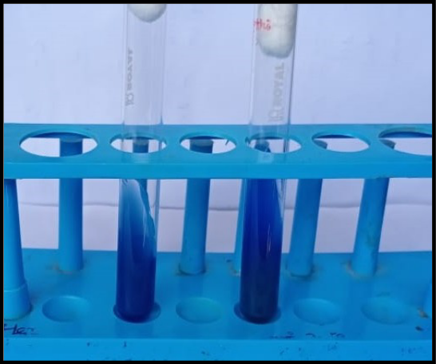
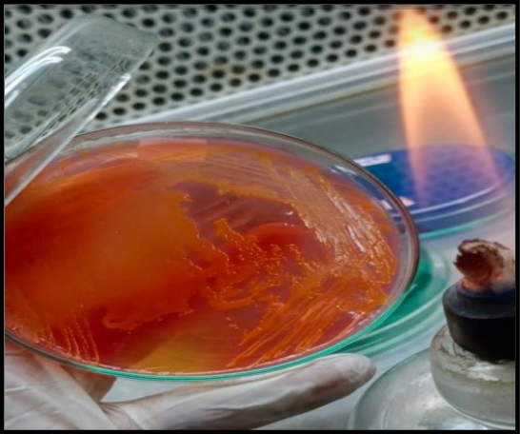

Simmon’s Citrate Test - Positive

Table: 4 Testing Antimicrobial Sensitivity of Isolates Against Bio – Enzyme (Citrus Limon)

S.NO | TESTED ORGANISM | ZONE OF INHIBITION
1. | Klebsiella species | 14mm
2. | Proteus species | 15mm
3. | Shigella species | 17mm

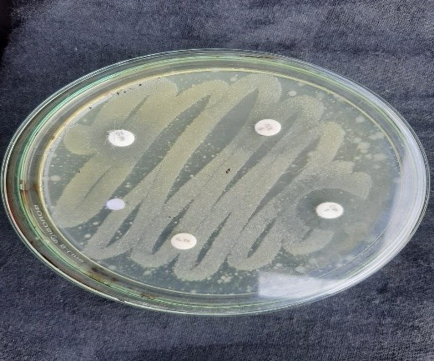Antimicrobial activity of isolated microbes
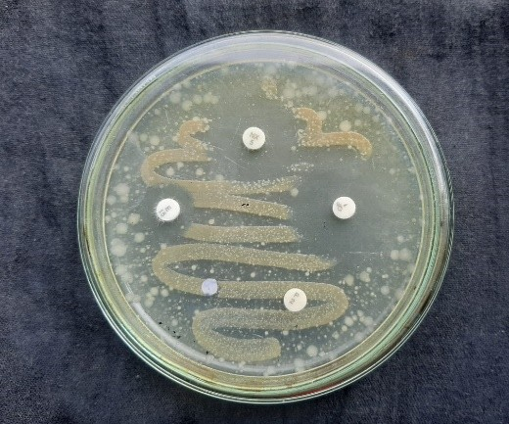Klebisella Pneumoniae Disc diffusion method- Shigella Species.,

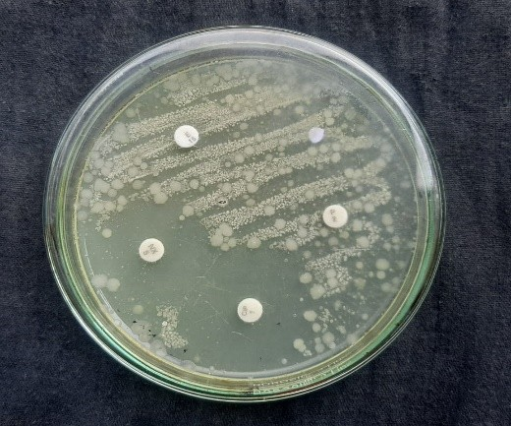Disc diffusion method- Proteus species.,

RESULT AND DISSCUSSION
In present study, the of cow Dung samples collected from Thirukaliththattai locates at Kumbakonam, Thanjavur District, Tamil Nadu. Samples carried out laboratory for further Microbial load investigation. The microbes like Klebsiella species, shigella species, and Proteus species isolated. Testing of antimicrobial activity of isolates with Citrus limon
Klebsiella species 14 mm in zone of inhibition in muller hinton Agar medium. Proteus species
15 mm in zone of inhibition, Shigella species 17 mm zone of inhibition observed.this study concluded Citrus peels bio enzyme is a antimicrobial agent. (sawantetal., 2007). Cowdung has been used from ancient times in Ayurvedic Treatments, used for biogas production and increasing crop productivity Desriac F, et al., (2013). cow dung also consist of beneficial microflora, yeast as reported by (Muhammad and Amusa , 2003). (Swain,M.R. and Ray,R.C,2006), Cellulase producing bacteria (Bai,S.etal.,2015)Hong-li, Z. et al.,2015). Enzymatic activities (Vijayaraghavan,P.etal.,2016). Methanogenic Bacteria( Pradha,P.andGireeshbabu, K. 2012) , Antibiotic resistant strains (David,O.M. and Odeyema, A.T, 2007 ) ,Antibiotic susceptibility (Teo, K.C and Teoh, S.M.2011) and Ammonia producing bacteria are well reported. (Radha,T. K and Rao, D.L.N. 2014). Patel, et al., 2015. Phytochemicalanalysis was performed by each cow dung extract present the flavonoids,Glycosides, tannins, saponins and phenols. Various literature reports (Li et al., 2015; Sagar et al.,2018) describe fruit peels of Mango (Mangifera indica), Pomegranate (Punica granatum), Apple (Malus pumila), Mosambi (Citrus limetta),

REFERENCES
Abo-State MA, Mahdy HM, Ezzat SM, Abd El Shakour EH and ElBahnasawy MA. (2012). Antimicrobial resistance profiles of Enterobacteriaceae isolated from rosettabranchofriverNile,Egypt.WorldAppliedSciencesJournal.19:1234-1243.

Adegunloye DV, Adetuyi FC, Akinyosoye FA, Doyeni MO (2007). Microbial AnalysisofCompostUsingCowDungasBooster.Pak.J.Nutri.6(5):506-510.

David OM, Odeyemi AT (2007). Antibiotic resistant pattern of environmental isolates of Listeria monocytogenes from Ado-Ekiti, Nigeria. Afr. J. Biotechnol. 6(18):2135-2139

Dhama K, Chakraborty S and Tiwari R. (2013). Panchgavya therapy (Cowpathy) in safeguarding health of animals and humans-a review. Res OpinAnim Vet Sci. 3:170-178.

Fleming A. (1929). On the antibacterial action of cultures of a penicillium, with special reference to their use in the isolation of B. influenzae. Br. J. Exp. Pathol. 10:226–236.

Joseph B and Sankarganesh P. (2011). Antifungal efficacy ofpanchgavya.
International Journal of PharmTech Research. 3:585-588.

Kardos N and Demain AL. (2011). Penicillin: the medicine with the greatest impact on therapeutic outcomes. Appl. Microbiol. Biotechnol. 92:677–687.

Muhammad S and Amusa NA. (2003). Invitro inhibition of growth of some seedling blight inducing pathogens by compost-inhabiting microbes. Afr. J. Biotechnol.2:161-164.

Muralikrishna.V., V. Manickam, I. V. Muralikrishna, V. Manickam,Solid
Waste Management, Environ. Manage. (2017) 431– 462. https://doi.org/10.1016
/B9 78-0-12-811989-1.00016-6.

NaiemiAlN, Heddema ER, Bart A, EdeJonge CM, Grauls V, Savelkoul PH and Duim B. (2006). Emergence of multidrugresistant gram-negative bacteria during selective decontamination of the digestive tract on an intensive care unit. Journal of Antimicrobial Chemotherapy.58:853-856.

Nene YL (1999) Utilizing traditional knowledge in agriculture. Traditional knowledge system of India and Sri Lanka, pp32–38

Randhawa GK, Kullar JS (2011) Bioremediation of pharmaceuticals,pesticides,
and petrochemicals with gomeya/cow dung. ISRN Pharmacol.
doi:10.5402/2011/362459

SawantAA,HegdeNV,StraleyBA,DonaldsonSC,LoveBC,KnabelSJ,Jayarao
BM (2007) Antimicrobial-resistant enteric bacteria from dairy cattle. Appl Environ
Microbiol 73:156–163

Sharma, B. and Singh, M. (2015). Isolation and charactreization of bacteria from cow dung of desi cow breed on different morpho-biochemical parameters in Dehradun. International journal of Advances in Pharmacy, Biology and Chemistry, Vol:4(2).

B. Sharma, B. Vaish, Monika, U.K. Singh, P. Singh, R.P. Singh, Recycling of Organic Wastes in Agriculture: An Environmental Perspective, Int. J. Environ. Res. 13 (2019) 409–429.https://doi.org/10.1007/s41742-019-00175-y

Sikarwar AS and Batra HV. (2011). Prevalence of antimicrobial drug resistance of Klebsiellapneumoniae in India. International Journal of Bioscience, Biochemistry and Bioinformatics.1:211-215.
Ware Fungsin, D.R., Read, P.L., Mantredi, E.T. (1988). Lactation performance of two large dairy herds fed Lactobacillus acidophilus strain BT 1386. J. Dairy Sci, 71:219-222.

