CHEMICAL STABILITY OF DRUGS
Ashu¹, Kavita Sapra²
- Department of pharmaceutical sciences, Maharshi Dayanand University, Rohtak, Haryana
- Amity institute of Pharmacy, Amity University, Gurugram, Haryana
ABSTRACT
Stability of drug is the capacity of the pharmaceutical dosage form to maintain the chemical, physical, microbial and therapeutic properties during the time of storage and usage by the patient. Stability studies are done to determine the expiry date of products and to choose formulations and container closure techniques that are appropriate in terms of stability in order to assess storage needs and shelf life. There are various types of stability studies which we can consider to determine shelf life of pharmaceutical products like Physical stability, Chemical stability and microbiological stability. All of these are important but among them Chemical stability is more important as changes in chemical structure leads to loss of therapeutic activity of drug.
KEY WORDS: Chemical Stability, Shelf life, Expiry date determination, Structural changes
INTRODUCTION
During storage and patient use, the pharmaceutical dosage form must be able to maintain its chemical, physical, microbiological, and therapeutic qualities.
As defined by the United States Pharmacopeia (USP), the extent to which a drug substance or product "retains, within the stipulated conditions, the same traits and attributes that it possessed at the time of its manufacture," is known as the stability of the drug product. Also, Stability of drugs is determined by the rate of changes that occur in the pharmaceutical dosage forms.
The phrase "drug stability" describes how well a pharmaceutical substance can maintain its therapeutic characteristics over the course of its storage or shelf life. Drug manufacturers are required to do routine stability testing on their medications in accordance with FDA standards known as Current Good Manufacturing Practices, or CGMPs, to assure their efficacy. As novel medication compounds arise, ongoing research is needed to create formulation strategies and stability testing techniques.
• Expiry date: Expiry date on every formulation indicates that drug cannot be used after this date because the amount of drug is lowered and become less than its therapeutic concentration. In addition, some products which are resulted from drug degradation are harmful and toxic to patients.
Note! The expiry date of some pharmaceutical formulations will be shortened when the medicine container is opened since the drug's concentration will be reduced during use and by a few outside influences. Example:
1. Eye drops and ear drops: can be used only for one month after opening thedrops.
2. Syrups and suspension of antibiotics: an be kept at room temperature for one week and kept at 4 C for two weeks before consumption.
3. Tablets and capsules: are stable in their packaging, however the expiration date will change once they are taken out.
4. Ampoules: Due to the inclusion of preservatives, multidose vials are stable for 24 hours but ampoules must be used right away
Importance of Stability studies of drugs:
- The decomposition of the active medicine could result in the formation of the harmful product.
- To maintain the product's strength for use with regard to all functionally linked features during the duration that it is on the market, protecting the manufacturer's reputation.
- Due to a decreased concentration of the medicine in the dosage form, the instability of the active drug and its products may result in undermedication.
- The stability of the medicine is predicted using the kinetics principles of changes in physical appearance brought on by instability.
- To establish commercial expiration date of the drugs
- To support the stability of the drug product used in clinical and non-clinical investigations
- To establish the control limits for lot release and establish levels for specified requirements (such as API, preservatives, etc.)
Objectives of Stability studies of drugs:
- To determine the shelf life of the drug product.
- To choose formulations and container closure techniques that are appropriate in terms of stability in order to assess storage needs and shelf life.
- To determine how the changes in the quality occurs under the presence of several environmental factors ( pH, humidity, light and temperature) with time.
- To ensure that no alterations to the formulation or manufacturing process have been made that could impact the drug's stability.
- The primary goal of a stability research is to create a drug product's stability profile so that a prediction of the product's shelf life may be produced before it is introduced to the market.
Adverse effects of instability of drugs:
- Loss of active drug.
- Loss of content uniformity.
- Production of toxic material.
Drug stability is affected by following factors:
1.Temperature: Drug degradation is caused by an increase in oxidation, reduction, and hydrolysis reactions at high temperatures.
2. pH: Drug stability is also impacted by pH.
· Weekly acidic and basic medications exhibit good solubility when they are ionised, and they also disintegrate more quickly when they are ionised.
• Many pharmaceuticals are stable between pH 4 and 8.
• So, if a medicine solution's pH needs to be altered to increase solubility and the new pH causes instability, a solution to this problematic issue is to add a water miscible solvent to the final product.
Stability will be improved by: -
- Suppressing ionisation
- decreasing the high pH needed to produce solubility
- Increasing solubility and - decreasing water activity by making the solvent less polar. For this, 20% propylene glycol, for instance, is added to chlordiazepoxide injection.
3.Moisture:
a. Moisture acts as catalyst for chemical reactions such as oxidation, hydrolysis and reduction reaction.
b. Water also promotes microbial growth.
4.Light: affects drug stability through its energy or thermal effect which lead to oxidation.
5.Drug incompatibility: There may be chances of reactions between components of pharmaceutical dosage forms itself orbetween these components and cover of the container.
6.Oxygen: Exposure of drug formulations to oxygen affects their stability.

Types of Stability of drugs
There are three types of stabilities of drugs which must be followed:
1. Physical stability
2. Microbiological stability
3. Chemical stability
1.Physical stability of drugs
Possibilities due to physical instabilities are:
A. Crystallization in medicinal preparations: Root causes
a. Polymorphism phenomena, such as the transformation of chloramphenicol from an amorphous to crystalline form.
b. Saturated solution: Solute precipitation may happen at various temperatures.
c. When using a very fine powder, a portion of the suspending agent will dissolve before crystallising.
B. Loss of volatile ingredients from drug dose forms:
Examples:
Elixirs, spirits, aromatic waters, and a few pill varieties that contain aromatic water (Nitro-glycerine tablets)c.
C. Loss of water:
This can be seen in the following dosage forms:
a. Saturated solution
b. Emulsions
c. Creams
d. Pastes
e. Ointments
These dosage forms have humectants added to them to absorb atmospheric moisture and stop it from escaping the dosage forms.
For instance, glycerin
D. Absorption of water:
This phenomenon can be seen in the following pharmaceutical forms:
a. Powders: powders may liquify or degrade after absorption of water.
b. Suppositories:In case of suppositories, Bases made from hydrophilic substances such as Glycerin, Gelatin, polyethylene glycol.The consistency of these forms becomes jelly-like appearance.
e. Change in crystalline form:
Example: Cocoa butter which is capable of existing in four polymorphic forms.
2.Microbiological stability:Microbial contamination is a verybig problem for all formulations containing moisture. There are different sources for microbial contamination.
Sources of Microbial Contamination:
1. Water
2. Air
3. Raw materials, containers and closures
4. Instruments and apparatus
3.Chemical stability
Medicine loss owing to a chemical reaction that reduces the drug's potency is the most straightforward example of drug instability. Drug degradation caused by a chemical reaction has an impact on a pharmaceutical product's shelf life. The shelf life of a product may be impacted by the degradation of other ingredients contained in the formulation, such as antioxidants or preservatives. Degradation can sometimes produce hazardous compounds, which shortens a product's shelf life. For instance, the antifungal medication flucytosine is converted into the carcinogen fluorouracil.
When a substance is degraded, the results might occasionally have an unfavourable appearance. For instance, the oxidation of epinephrine results in vividly coloured compounds.
Drugs seldom undergo spontaneous chemical deterioration; instead, it is brought on by the presence of additional reactive molecules in the dose form. It usually happens because there is water around. The primary goal of creating a dosage form is to protect it against chemical deterioration.

Chemical deterioration processes
- Hydrolysis:
Hydrolysis is the reaction of compound in presence of water. Pharmaceutical products contain water which may be present as a contaminant or as an ingredient, and most common reason for chemical degradation is hydrolysis. Hydrolytic reactions are common in carboxylic acids derivatives likeesters and amides.
Ester on hydrolysis give a carboxylic acid and an alcohol (Fig 1). Bond polarization by anadjacent oxygen atom makes the carbon of carboxyl group electron deficient. Therefore, chances of nucleophilic attack by water areincreased at this carbon atom. For example, aspirin (acetylsalicylic acid)is hydrolysed to salicylic acid and acetic acid (Fig. 2).
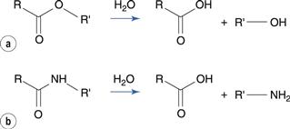
Fig. 1 hydrolytic reactions, (a) Esters (b) Amides.
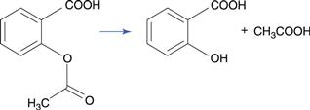
FIG. 2 salicylic acid and acetic acid from aspirin
When an acid and a base are present, hydrolytic processes involving amides, esters, and similar compounds are catalysed. The nucleophilic attack of the hydroxyl ion at the electron-deficient carbon atom during ester hydrolysis, for instance, results in the production of a tetrahedral intermediate (Fig. 3 a, b). which is then followed by the alcohol being ejected (Fig 3 c).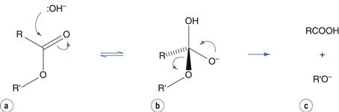
FIG. 3 Ester hydrolysis in the presence of base as catalyst.

The protonation of the carbonyl group is the initial step in the hydrolysis of an ester in the presence of an acid catalyst. And give resonance structures in (Fig. 4 a) (Fig 4 b, c). Positively charged carbon atoms encourage water's nucleophilic assault, which results in the formation of a tetrahedral intermediate (Fig. 4 c) (Fig 4 d). The alcohol is lost as a result of H+ being transferred within a molecule (Fig. 4 e) (Fig 4 f).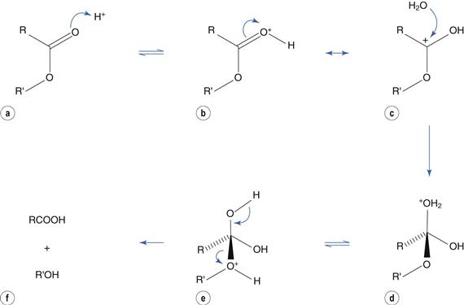
FIG. 4 Ester hydrolysis in presence of acid as a catalyst.

The oxygen atom in amides is more electronegative than the nitrogen atom, making them more susceptible to hydrolysis than esters. Paracetamol and lidocaine are two medications that include amides. Because of the strong polarisation of the amide bond by the nearby, highly electronegative chlorine substituents, chloramphenicol, an antibacterial medication, has a higher likelihood of hydrolysis than other amides (Fig. 5). Chloramphenicol eyedrops must therefore be kept in a refrigerator.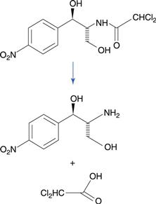
FIG. 5 Hydrolysis of chloramphenicol
Because penicillin and cephalosporin antibiotics contain the lactam group, a cyclic amide, and because this group is highly hydrolyzable, it is crucial. The four-membered -lactam ring's bond strain is what gives the molecule its reactivity. Different hydrolysis products are produced. A significant hydrolysis product for benzylpenicillin is benzylpenicilloic acid (Fig 6). The side chain of penicillins contains an amide group, however this group is less prone to hydrolysis than the -lactam ring. Because of how quickly it is hydrolyzed by the stomach's acidic environment, benzoylpenicillin cannot be given orally. Penicillins that can be used orally, such amoxicillin are comparatively less prone to hydrolysis.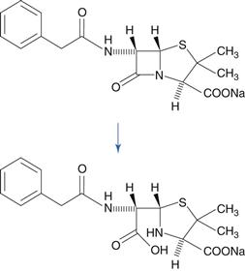
FIG. 6 β-lactam ring of benzylpenicillin on hydrolysis give benzyl penicilloic acid.
- Oxidation:
The number of carbon-to-oxygen bonds increases or the number of carbon-to-hydrogen bonds decreases during oxidation processes. These processes frequently lead to the chemical instability of medicines. They also cause the degradation of vegetable oils, which are occasionally used in pharmaceutical products as a solvent or as an emollient in emulsions and creams. Oxidation reactions are frequently intricate and result in a wide range of degradation products. Table 1 compiles typical cases.
Table 1
Drug oxidation reactions
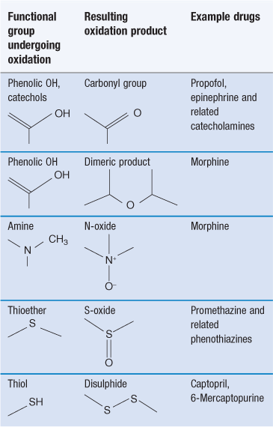
Autoxidation is the term for oxidation involving molecular oxygen that occurs at room temperature. The bulk of these reactions involve free radicals, which are chemical objects with an unpaired electron. There are three main phases in free radical oxidations, despite the fact that they are frequently convoluted. The oxidation of numerous medicines and vegetable oils is summarised in the diagram below.
Low concentrations of free radicals are formed during the beginning phase. The production of free radicals for the medication RH can be shown as:
Initiation is facilitated by light and the presence of heavy metals, which are typically found as trace contaminants in pharmaceutical products.Free radical concentration rises dramatically during the propagation phase.
Hydroperoxides (ROOH), which arise when oxygen is present, then react further to produce stable oxidation products. Degradation quickens during this phase, which could have devastating effects for the product.
- Isomerisation:
Isomerization is the process by which pharmaceuticals are transformed into their optical or geometric isomers. The obtained isomers have limited potential for healing. One could consider this kind of conversion to be a form of drug breakdown.
For example: In acidic conditions, the tetracyclines undergo epimerisation to form 4- epi tetracycline which is toxic.
- Photochemical decomposition:
Many pharmaceutical compounds like phenothiazine tranquilizers, hydrocortisone degrade on exposure to light which causes loss of potency of drug. Photodecomposition does not occur only during storage it may occur during the usage of the product.
- Polymerisation:
Polymerization is the process through which two or more molecules join to create complex compounds. Polymerisation generally occurs during storage of dosage forms. For example: Formaldehyde hydrate may polymerise in aqueous solution to form paraformaldehyde, which deposits as white precipitates in the solution.
Stability-indicating Method:
A sensitive, accurate, and stability-indicating test and approach that does not allow for interference from other peaks and enough to identify and analyse the degradation products/impurities. A stability-indicating method is a quantitative analytical procedure that has been demonstrated to be able to detect changes over time in the pertinent properties of the drug substance and drug product under particular storage conditions. For the long-term stability study trending to be accurate, stability-indicating assay analytical methodologies need to be discriminating and confirmed.

REFERENCES
  - Brahmankar, D.M. and Jaiswal, S.B. (2009)
Biopharmaceutics and pharmacokinetics. 2nd edition, Vallabh prakashan, Delhi,
  - ICH Q1A (R) Stability testing of new drug substances and products, International Conference on Harmonization, Switzerland, Geneva 1993.
  - ICH Q3A. Impurities in New Drug Substances, Tripartite International Conference on Harmonization Guideline Q3A, Switzerland, Geneva 1994.
  - Waterman K.C., Adami R. C.: Int. J. Pharm. 293, 101 (2005)
  - Glass B.D., Nov·k C., Brown M.E.: J. Thermal Anal. Cal. 77, 1013 (2004).
  - Alsante K.M., Huynh-Ba K.C., Baertschi S.W., Reed R.A., Landis M.S. et al.: AAPS PharmSciTech 15, 237 (2014).
  - Drygas A.: AptekarstwogdaÒskie: 1399-1939, GdaÒskieTowarzystwoNaukowe. Ossolineum, Wroc≥aw 1983.
  - http://www.polfa-tarchomin.com.pl/index. php/o-firmie/historia/
  - Welch H.: Chem. Eng. News 27, 1615 (1947).
  - http://www.fda.gov/AboutFDA/WhatWeDo/ History
  - Meyers E.L.: Drug standards 27, 84, (1959).
  - Medicinal compounds. U.S. Patent No. 2,073, 659 (1937).
  - Ayres G.H., Vienneau E.M.: Ind. Eng. Chem. Anal. Ed. 12, 96 (1940).
  - Forbing J.W.: U.S. Patent No. 1,984,733 (1934).
  - Lyndall G., Smith, F.D.: U.S. Patent No. 2,041, 869 (1936).
  - Lehman R.A.: Exp. Biol. Med. 64, 428 (1947).
  - Gunn J.A.: Br. Med. J. 2, 155 (1939). 18. Herman H.F., Wenner W.: U.S. Patent No. 2,465,308. (1949)
  - http://cst-kh.edu.ps.

