Behaviour of Free-surface Profile in Single-layer Fluid Flow Problem

Srikumar Panda

Assistant Professor

Department of Mathematics

Vidyasagar College, Kolkata, INDIA

shree.iitg.mc@gmail.com

ABSTRACT

The behavior of the free-surface profile in single-layer flow over an undulated bottom is analyzed. To formulate the problem, it is assumed that the fluid is incompressible as well as inviscid. Based on linear theory, the problem is formulated as a mixed boundary value problem. Perturbation analysis in conjunction with Fourier transform technique is applied to solve the governing boundary value problem, and the free-surface profile is determined mathematically. Also, the role of Fourier transform technique is highlighted in an elaborate way. The behavioral changes of the free-surface profile are also studied. Finally, the effect of undulated bottom profile is also explained.

Keywords—Fluid flow; Linear theory; Mixed BVP; Froude number; Bottom profile

# INTRODUCTION

Many researchers considered free-surface flow problems to model diverse circumstances occurring in atmospheric science as well as in oceanography. Solutions of such fluid flow problems are helpful to analyze the mechanism of wave generation. Various challenges have been faced by the scientists to study the free-surface flow over random bottom topography. Hence, the fluid flow problem has been a topic of interest in mathematical as well as physical sciences.

From the available literature, it is found that the problems involving free-surface fluid flow over obstacles are examined by many applied mathematicians and physicists. The consideration of the free-surface flow over an arbitrary bottom has been increasing rapidly, and a considerable progress has been prepared in this direction. For instance, Forbes and Schwartz [1] studied the fluid flow problem over a semicircular obstruction attached to the bottom of a running stream. They have calculated the wave resistance using a numerical approach. Vanden-Broeck [2] explained the problem of Forbes and Schwartz [1] numerically, and conferred the subsistence of supercritical solutions. They have shown that supercritical solutions depend on the Froude number, a physical quantity. Later on, Forbes [3] presented a numerical solution for the critical flow over a semicircular obstruction. In the presence of surface tension, Yong [4] considered the fluid flow problem in the presence of a concave bottom, and shown the existence of nonlinear capillary-gravity waves. Dias and Vanden-Broeck [5] considered the fluid flow problem over a triangular obstacle, and explained the problem numerically using series truncation method. Shen *et al*. [6] studied the fluid flow problem numerically in the presence of a semielliptical bottom. Using numerical method, Dias and Vanden-Broeck [7] analyzed the steady flow problem, and confirmed the existence of supercritical flows with waves downstream only. Using a new and simpler approach, Panda *et al.* [8] solved the nonlinear flow over a random bottom. Higgins *et al.* [9] offered an analytical series method to attain the solutions of three different kinds of fluid flow problems: supercritical flow, transcritical flow and subcritical flow. It is worthy to mention here that the above studies were intensive on the solution of the steady flow. In case of unsteady flow, Grimshaw and Smyth [10] deliberated a theoretical study of a stratified fluid with the help of weak nonlinear theory. Stokes *et al*. [11] applied numerical approach to investigate the unsteady flow in the presence of a submerged point sink. For the case of time dependent flow (i.e., the submerged obstacle is moving), Milewski and Vanden-Broeck [12] solved the time dependent problem by applying weak nonlinear theory. From the above-mentioned literature, it is clear that a specific type of bottom topography such as semi-circle [1, 2], semi-ellipse [13], a step [14], triangle [15], is considered in most of the cases due to the simplification. Hence, the flow over random bottom topography is continuing unanswered. This is because of the governing boundary value problems become mixed and coupled and therefore their explicit solutions are not possible always.

In the present study, a two-dimensional potential flow over a random bottom having a small obstruction is analyzed using linear theory. It is assumed that the fluid is incompressible and inviscid. The physical problem is formulated as a mixed boundary value problem (BVP). Using perturbation analysis along with Fourier transform technique, the aforesaid BVP is solved to determine the analytical expression of the free-surface profile which is unknown at the beginning. In addition, the role of the Fourier transform technique is highlighted. Also, the behavior of the unknown free-surface profile is analyzed.

# DESCRIPTION AND FORMULATION

We have considered a two-dimensional potential free-surface fluid flow in which the fluid is inviscid and incompressible. The fluid is flowing from the left to the right over an irregular bottom *y* = B(*x*) having a small undulation. The flow domain is depicted in Figure 1. Let us assume that the *x*-axis is measured along the undisturbed bottom and the *y*-axis is measured vertically upward. It is also assumed that the flow is uniform with a constant velocity *c*at the far upstream. Let *H* be the upstream depth of the fluid and *ρ* be the density of fluid. Let $ϕ$ (*x*,*y*) be the velocity potential thus the velocity of the fluid, $\overline{q},$ can be expressed as $\overline{q}=\left(\frac{∂ϕ}{∂x}, \frac{∂ϕ}{∂y}\right)$. The free-surface, which is unknown at the beginning, is given by $y=η\left(x\right).$ The effect of the surface tension is neglected here and the flow is stationary. Hence, the partial derivatives with respect to the time vanish. The consider problem is prepared dimensionless using *H* as the length scale and *c* as the velocity scale. Therefore, the study proceeds solely with dimensionless variables.

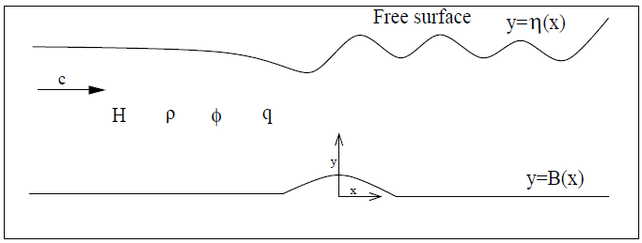

**Figure 1: The flow domain.**

Due to the consideration of the aforesaid assumptions, the *equation of continuity* becomes the Laplace equation

|  |  |
| --- | --- |
|  | (1) |

As all fluid particles stick to the surface, the kinematic condition at the free surface becomes

|  |  |
| --- | --- |
|  | (2) |

where denotes normal derivative at a point (*x*,*y*) on the surface.

Applying Bernoulli’s equation, the other condition on the free surface is written as

|  |  |
| --- | --- |
|  | (3) |

where denotes the Froude number with acceleration of gravity *g*. In the present work, the subcritical flow is only considered. Hence, the Froude number is considered as small. In particular it is less than 1 i.e., *F*<1.

The condition of no penetration at the bottom gives rise

|  |  |
| --- | --- |
|  | (4) |

Further, the conditions at the far upstream are

|  |  |
| --- | --- |
|  | (5) |

The objective of the present work is to determine the unknown parameters $ϕ$ (*x*,*y*) and $η(x)$. These unknowns can be obtained once the boundary value problem (1)-(5) is solved. In the subsequent section, the aforesaid BVP is solved using perturbation analysis in conjunction with the Fourier transform technique.

# SOLUTION PROCEDURE

It is supposed that the undulating bottom topography is specified bywhereis a small non-dimensional quantity and represents the maximum height of the undulating bottom. As the height is small, then the solution of the boundary value problem (1)-(5) can be derived with the help of perturbation expansion. Now, the velocity potential and the free-surface profile can be stated asymptotically as

|  |  |
| --- | --- |
|  | (6) |
|  | (7) |

where and  denote the first-order velocity potential and free-surface profile, respectively. As ε is very small, the consideration upto the first-order terms are enough. Now, the velocity potentialand the free-surface profilecan be determined once the parametersand  are evaluated. Hence, the parametersand will be determined in the following part. Using relations (6) and (7) in (1)-(4); and then comparing the first order terms of on both sides of all equations, the following mixed boundary value problem is obtained:

|  |  |
| --- | --- |
|  | (8) |
|  | (9) |
|  | (10) |
|  | (11) |

where and are, respectively, the first order derivatives of *f*(*x*)and with respect to *x*.

In order to solve the mixed boundary value problem (8)-(11), the first-order potential and the bottom profile *f*(*x*)are assumed such that the Fourier transforms of and *f*(*x*) exist, which are well-defined as

|  |  |
| --- | --- |
|  | (12) |

with inverse

|  |  |
| --- | --- |
|  | (13) |

and

|  |  |
| --- | --- |
|  | (14) |

where *M*(*k*) fixes the bottom profile. For the free-surface profile, let us define as

|  |  |
| --- | --- |
|  | (15) |

Using Fourier transform and its inverse; and applying the equations (14) and (15), the solution of the BVP (8)-(11) is obtained as

|  |  |
| --- | --- |
|  | (16) |

where

|  |  |
| --- | --- |
|  | (17) |

with

|  |  |
| --- | --- |
|  | (18) |

It is worthy to note here that the relation

|  |  |
| --- | --- |
|  | (19) |

is called as *dispersion relation.* It can be proved (confirmed in Section IV) that the dispersion relation (19) has two real roots: one is positive real root and another one is negative real root having the same magnitude as that of the positive real root. It should be noted that the positive real root of the dispersion relation plays a very crucial role in the study of fluid flow problem as it indicates the wave number of the downstream waves. It can be noticed, from relations (15) and (17), that the first-order free-surface profile(hence the free-surface profile) depends on the shape of the bottom profile. Hence, it is very much important to know the shape of the bottom profile. In the present study, the below bottom profile is choosen to establish the further results:

|  |  |
| --- | --- |
|  | (20) |

where *L* indicates the half length of the bottom obstacle.

Applying relations (14), (17) and (20), *a*(*k*) is derived as

|  |  |
| --- | --- |
|  | (21) |

Now, applying the value of *a*(*k*) into the relation (15), the first-order free-surface profile is derived as

|  |  |
| --- | --- |
|  | (22) |

From the relation (22), it is clear that the integrals contain a simple pole on the real axis at the zero of *E*1(*k*). Therefore, we can use the Cauchy principal value having an indentation below the singularity to determine the above integration (22). Applying the residue theorem, we have obtained the following free-surface profile:

|  |  |
| --- | --- |
|  | (23) |

where *k*0 indicates the positive and real root of the dispersion relation (19).

From the above relation (23), the following observations can be made:

the free-surface represents oscillatory nature which indicates a wave having a constant amplitude.

the free-surface possesses downstream waves headed by a wave-free region at the upstream.

# COMPUTATIONAL RESULTS AND DISCUSSION

In the present section, some of the numerical results which are important for the present study are discussed. For instance, a detail discussion on the real roots (*i.e*., the wave number) of the dispersion relation (19) is provided in a tabular form. Also, the effects of several system parameters on the free-surface profile are presented.

The roots of the aforesaid dispersion relation are calculated with the help of Newton’s method for several values of Froude number (*F*) for *D* = 0.7 and *γ* = 1. These roots are tabulated in Table 1. From this table, it can be observed that the dispersion relation (19) has two non-zero real roots. Out of these two real roots, one is positive and another one is negative having same magnitude. This affirms the theoretical observation reported in Section III. In addition, it is also clear (*refer* Table 1) that the wave number (real positive root of the dispersion relation) decreases, *i.e*., the wave length increases with the Froude number *F*.

### **Table 1: Real roots of the dispersion relation (19)**

| Parameter value | F=0.2 | F=0.3 | F=0.4 | F=0.5 | F=0.6 |
| --- | --- | --- | --- | --- | --- |
| Real roots | 24.99999,  -24.99999 | 11.11111,  -11.11111 | 6.24995, -6.24995 | 3.99730, -3.99730 | 2.75541, -2.75541 |

Figure 2 illustrates the behavior of the free-surface profile  for two distinct values of Froude number such as *F*=0.5 and 0.6 with =0.1 and *L*=1. From the figure, it is clear that the nature of the free-surface profile is oscillatory with same peak. This phenomenon indicates that the free-surface profile represents downstream waves having constant amplitude. The wavy nature arises due to the interaction of the fluid with the undulated bottom. It is also clear (*refer* Figure 2) that the amplitude of the downstream wave increases as the Froude number increases. It is well known that the wave number decreases (i.e., wavelength increases) as the speed of the fluid increases. Again, from the relation the speed of the fluid increases as the Froude number increase. Hence, the wavelength of the downstream wave increases as the Froude number increases. This phenomenon is also observed in Figure 2.

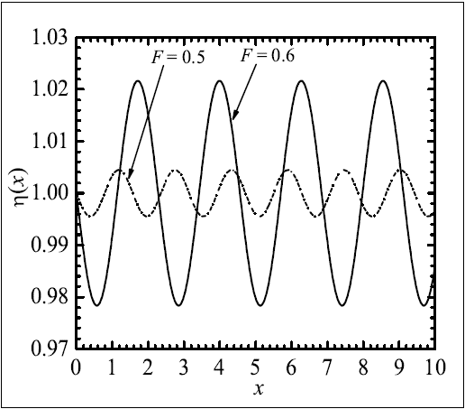

**Figure 2: Free-surface profile for =0.1, *L*=1.**

Figure 3 describes the effect of the height of the undulated bottom on the free-surface profile. In the present figure, the free-surface profile is shown for three distinct values of the bottom height= 0.01, 0.05 and 0.1 with *F*=0.6 and *L*=1. From the physical intuition, it is obvious that the amplitude of the downstream wave increases as the height of the bottom increases. This phenomenon is also noticed (*refer* Figure 3) in the present study. In this figure, we have kept the Froude number same (i.e., *F* = 0.6) for each free-surface profile (or downstream wave). And we have noticed that the wavelengths of the downstream waves are same (*refer* Figure 3). This is completely consistent with the phenomenon that the wavelength depends on the Froude number.

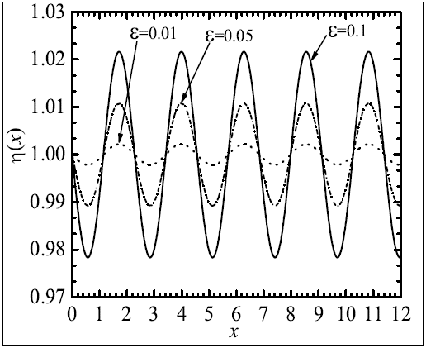

**Figure 3: Free-surface profile** **for *F*=0.6, *L*=1.**

# SUMMARY

Problem involving fluid flow in a single-layer having an undulated bottom is studied using linear theory. Perturbation analysis and Fourier transform technique is applied to solve the governing mixed boundary value problem. The behavioral changes of the free-surface profile are examined. It is noticed that the free-surface profile represents downstream waves having constant amplitude. Also, the amplitude of the downstream wave increases as the height of the bottom increases. Further, the wavelength of the downstream wave increases as the Froude number increases.

##### REFERENCES

1. L.K. Forbes and L.W. Schwartz, “Free-surface flow over a semicircular obstruction,”J. Fluid Mech., vol. 114, pp. 299-314, 1982.
2. J.-M. Vanden-Broeck, “Free-surface flow over a semi-circular obstruction in a channel,”Phys. Fluids, vol. 30, pp. 2315-2317, 1987.
3. L.K. Forbes, “Critical free-surface flow over a semi-circular obstruction,” J. Engrg.Math., vol. 22, pp. 3-13, 1988.
4. Z. Yong, “Resonant flow of a fluid past a concave topography,” Appl. Math. Mech.-Engl. Ed., vol. 18(5), pp. 479-482, 1997.
5. F. Dias and J.-M. Vanden-Broeck, “Open channel flows with submerged obstructions,”J. Fluid Mech., vol. 206, pp. 155-170, 1989.
6. S.P. Shen, M.C. Shen, and S.M. Sun, “A model equation for steady surface wavesover a bump,” J. Engrg. Math., vol. 23, pp. 315-323, 1989.
7. F. Dias and J.-M. Vanden-Broeck, “Generalised critical free-surface flows,” J. Engrg.Math., vol. 42, pp. 291-301, 2002.
8. S. Panda, S.C. Martha, and A. Chakraborty, “An alternative approach to study nonlinear inviscid flow over arbitrary bottom topography,” Appl. Math. Comp., vol. 273, pp. 165-177, 2016.
9. P.J. Higgins, W.W. Read, and S.R. Belward, “A series-solution method for freeboundary problems arising from flow over topography,” J. Engrg. Math., vol. 54, pp. 345-358, 2006.
10. R.H.J.Grimshaw and N. Smyth, “Resonant flow of a stratified fluid over topography,”J. Fluid Mech., vol. 16, pp. 429-464, 1986.
11. T.E. Stokes, G.C. Hocking, and L.K. Forbes, “Unsteady flow induced by a withdrawalpoint beneath a free surface,” ANZIAM J., vol. 47, pp. 185-202, 2005.
12. P. Milewski and J.-M. Vanden-Broeck, “Time dependent gravity capillary flows pastan obstacle,” Wave Motion, vol. 29, pp. 63-79, 1999.
13. S.P. Shen, M.C. Shen, and S.M. Sun, “A model equation for steady surface wavesover a bump,” J. Engrg. Math., vol. 23, pp. 315-323, 1989.
14. A.C. King and M.T.G. Bloor, “Free surface flow over a step,” J. Fluid Mech., vol. 182,pp. 193-208, 1987.
15. F. Dias and J.-M. Vanden-Broeck, “Open channel flows with submerged obstructions,”J. Fluid Mech., vol. 206, pp. 155-170, 1989.