Overview on Application of Fermentation techniques for Pharmaceutical Production

Dr. Tanuja Nautiyal
Department of Applied Chemistry
Akhilesh Das Gupta Institute of Engineering &Technology, Delhi, India tanujanautiyal@gmail.com
Dr. Nidhi Sharma*
Department of Applied Chemistry
Vivekananda School of Engineering &Technology
VIPS-Technical Campus, Delhi, India
nidhisharma@vips.edu* Corresponding author

ABSTRACT
The main premise of Industrial microbiology is to facilitate microbial growth on a large scale along with chemical transformation for the production of commercial products. This process is called Fermentation. Fermentation is an anaerobic process by which cells generate energy. The energy is derived from oxidation utilizing an endogenous organic compound as an electron acceptor. In this chapter, the variety of microorganisms and their application in fermentation technology for pharmaceutical and food industries are discussed. The process of production of ethanol, an important component of fermentation from renewable feedstock, and its further application in industries are described. Further, the Utilization of fermentation technology in the pharmaceutical industry has also been reviewed.

Keywords— Fermentation; Antibiotic; Pharmaceuticals; Microorganisms; anaerobic

INTRODUCTION

Fermentation is the method by which microorganisms produce many useful products; they help in making bread, cheese, antibiotics, and many amino acids [1]. It is the process of getting energy by carrying out anaerobic oxidation of organic substances, like starch and glucose, and by using an electron transfer chain [2].
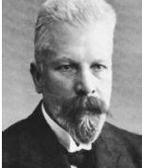
Figure. 1 Source https://www.sciencehistory.org/historical-profile/louis-pasteur [3]
According to Louis Pasteur, the fermentation is essentially an anaerobic respiration process. Fermentation and Cellular respiration are two closely related methods; a cell can derive energy from glucose. Glycolysis is the initiation step for both methods [4]. It involves breaking down of glucose. Glycolysis is the primary and known method involved for generation ATP. The evidential proof indicates that existence of O₂ on the Earth’s atmosphere and in organelles in cells are originated from glucose of glycolysis process [5]. The opposite of cellular respiration is fermentation, where electrons are donated to an exogenous means from outside and through an electron acceptor, such as oxygen, and the most common substrate of fermentation are sugars containing glucose [6].
One prominent example is the use of yeast in baking bread. Bread swells and becomes spongy because yeast produces CO₂ as a by-product which makes it rise [2,7].
Likewise, many useful products are obtained by the action of microorganisms in the process of fermentation [Figure:2].
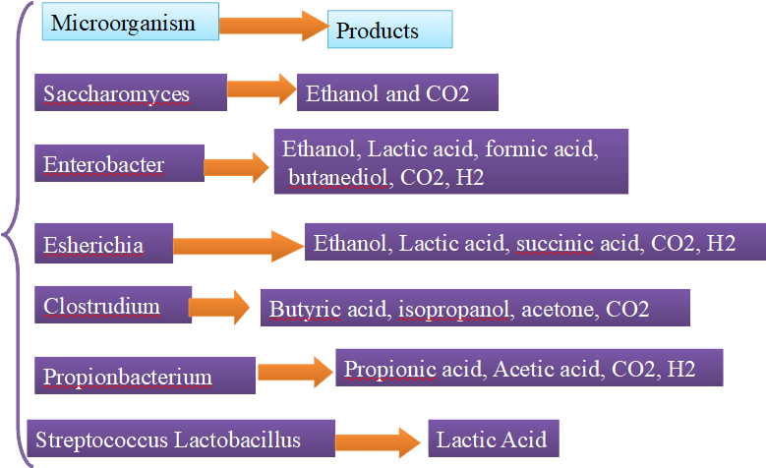
Figure. 2 Microorganisms used in Fermentation Process

Industrial Fermentation and its requirement

- Culture Medium: sterilized medium for microbial growth, type of microorganism, the quantity of microorganism and physiological state.
- Seeding: Inoculum required for initiation
- Fermenter: the fermenter where the fermentation process takes place on a large scale.
- Techniques of Fermentation:

Surface Techniques: Microorganisms grow on the surface of the solid substrate or liquid medium e.g., Mushroom, bread, cocoa, tempeh
Submersion Techniques: Microorganisms cultivated in a liquid medium. The technique is generally applied for protein, antibiotics, enzymes, biomass, and sewage treatment [6,8]
- Division of Fermentation on the basis of culture:
- Batch Fermentation
- Continuous Fermentation
- Fed-Batch Fermentation
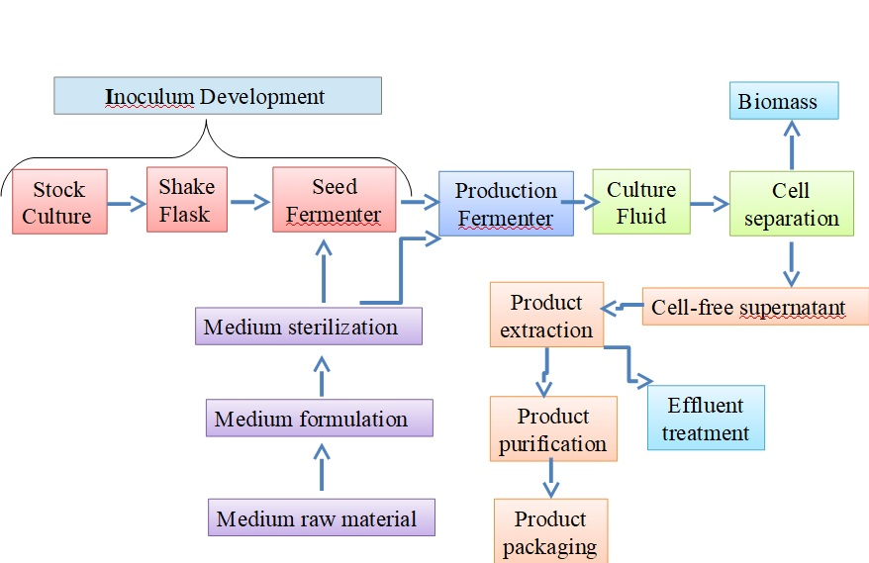
Figure. 3 Block diagram of fermentation Process

One of the industrially significant processes of fermentation is Alcoholic Fermentation.
- Alcoholic Fermentation
Under anaerobic condition, yeast and a few other microbes forms ethanol and carbon dioxide as by products by utilizing the chemical process of alcoholic fermentation [8]
C₆H₁₂O₆ + ATP → Alcohol + CO₂ +Pyruvate
Alcoholic Fermentation is carried out to regenerate NAD+ so that more ATPs are generated.
Pyruvic acid + NADH→ Alcohol + CO₂ + NAD+
NADH: Nicotinamide adenine dinucleotide Hydrogen (reduced)
NAD+: Nicotinamide adenine dinucleotide

(i) Production of Ethanol by fermentation:
Use of renewable feedstock, substrate, and fermentation process are three major steps for the production of ethanol on an industrial scale [8].
For Inoculum preparation and requirement of flocculation, Ethanol tolerant and non amylotic yeast (Saccharomyces cerevisiae) is used [9]. The culture was maintained at 40°C by intermittent subculturing over Mannitol egg Yolk Polymyxin agar (MYPD) agar. In the process, finger millet hydrolysate supplemented with 2% yeast extract and 1% urea is taken in a flask and autoclaved at the temperature of 12 °C for 20 minutes.
After cooling down to ambient temperature, a loopful of cells from a colony on YPD plates was transferred to each flask. Yeast cells were pre-cultured at 30 °C on a rotatory shaker for 24 hours. The cells were harvested by centrifugation, the pellets were washed thrice with 30M/L Ethylene di amine tetra acetic acid (EDTA) and finally washed and kept in sterile deionized water.

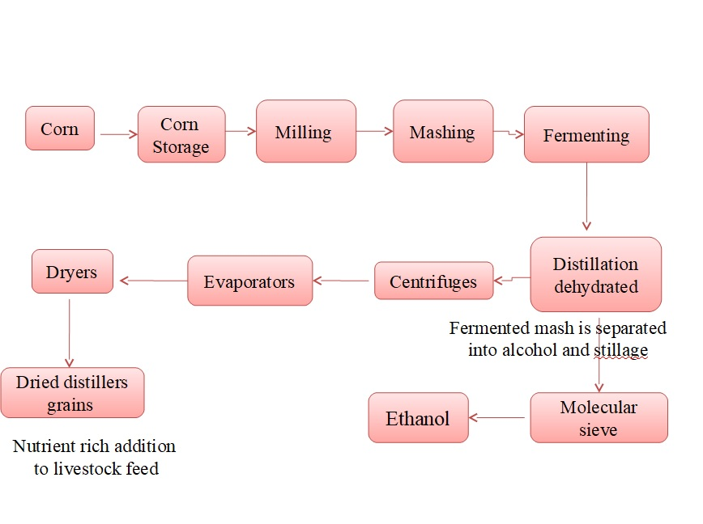
Figure. 4 Ethanol Production: process of converting corn into ethanol

(ii) Production of Antibiotics by fermentation
Antibiotics are molecules that hinder the growth of microorganisms, (both bacteria and fungi). The first antibiotic was discovered by Alexander Fleming in 1928 from the filamentous fungus Penicilium notatum [10]. During World War II penicillin had been used to treat many wounded soldiers [11].
(a) Production of Penicillin
The manufacturing of penicillin takes place via two processes: upstream and downstream processing. Upstream processing uses a technology to synthesize the product, it includes the exploration, development, and production while the extraction and further purification of a biotechnological product from fermentation is referred to as downstream processing; the products in a fermenter are impure and dilute, so their purification is carried out by downstream processing. It includes filtration to separate the microbial cells from the liquid medium and which is followed by chemical purification and concentration of the final product. For purification; it is dissolved and precipitated as a sodium salt or potassium salt to separate it from other substances in the medium.
In the steps of production of penicillin, the fermentation process requires the culture, the microbe, and the raw material, in this process the raw material is corn steep liquor (a major carbon source) and yeast extract, nitrogen source, and some nutrients are added to the fermenter other substrates added to the fermenter and the mould mycelium is filtered from the harvested product. After 40 hours, fungus starts secreting Penicillin and it is extracted by using, an organic solvent (butyl acetate) in which it is dissolved and precipitated, washed, filtered, and dried for the final product. We get penicillin G which is butyl penicillic acid.
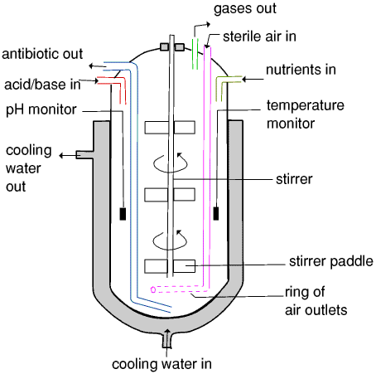
Figure. 5 Production of Penicillin
The resulting penicillin G can be enzymatically and chemically modified to make a variety of penicillins with slightly different properties. The group of penicillins includes more than 20 antibiotics which are divided into several categories [11,12].
- Natural Penicillin: (Penicillin G, Procaine, Penicillin V, Benzathine)
- Penicillinase-Resistant Penicillin: (Cloxacillin, Dicloxacillin, Methicillin, Nafcillin, Oxacillin).
- Amino-penicillin (Ampicillin, Amoxicillin, Bacampicillin).
- Extended Spectrum Penicillins Extended-spectrum penicillins include both alpha- carboxypenicillins and acylamino-penicillins [12].
(b) Production of Cephalosporin
Broad-spectrum beta-lactam antibiotics is closely related to the Penicillins, it is obtained from the fungus, Cephalosporium acremonium, which inhibits the cell wall synthesis and is used to reduce the risk of post-operative infections in surgical procedures [12].
Conversion of Penicillin V or Benzylpenicillin to a Cephalosporin can be carried out by chemical ring expansion, like Cephalexin. Cephalosporin C was first isolated in 1952, It is produced as the fermentation product of Cephalosporium acremonium [13,14].
Method of Cephalosporin production
- Medium: Methyl oleate, Ammonium chloride, Glucose, Metallic salts
- Production of Cephalosporin C was induced by methionine,
- Fermentation is carried out at 25° C, pH (5-8) and for 1-20 days,
- Finally, the extraction of product from the culture fluid was carried out by adsorption method [15].
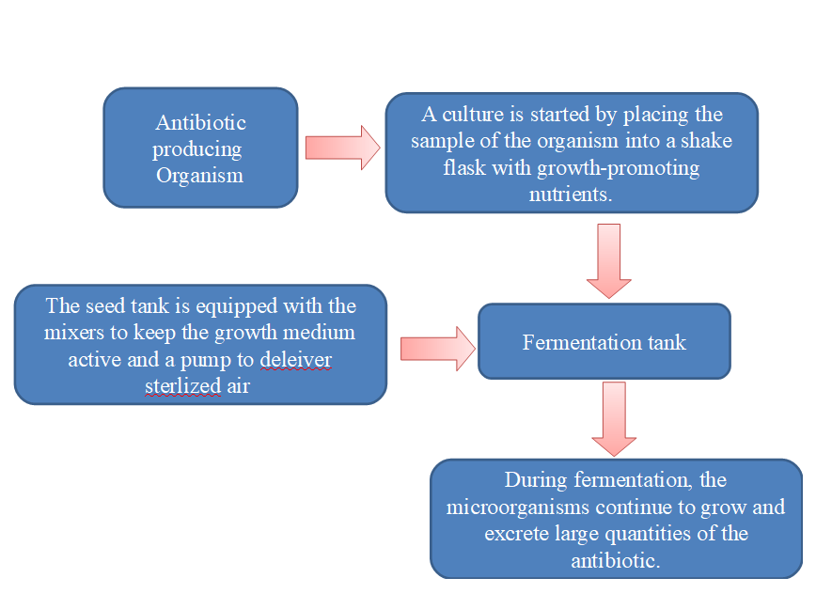
Figure. 6 Cephalosporin Production block diagram

III The advantages of Fermentation
- Fermentation improves the shelf life of food product by controlling the enzymatic deterioration of plant tissues.
- Fermentation enhances the texture, flavour and odour of foods.
- Fermentation is used to generate new energy sources such as ethanol.
- The vitamin content of some foods can be increased.
- Fermentation enhances digestibility.
- The toxicity of some foods may be decreased.
- Fermented food prevents the development and outgrowth of harmful bacteria.
- It preserves, detoxifies, and enriches food,
- Enhancing shelf life of food.
- Health-related products (important contribution to human nutrition)
- Fermentation is useful for the waste treatment
- Enzymes catalysed fermentation reactions are considered to be highly specific.
- Energy efficient technology as it can work well in mild operating conditions. Low operating cost[16].
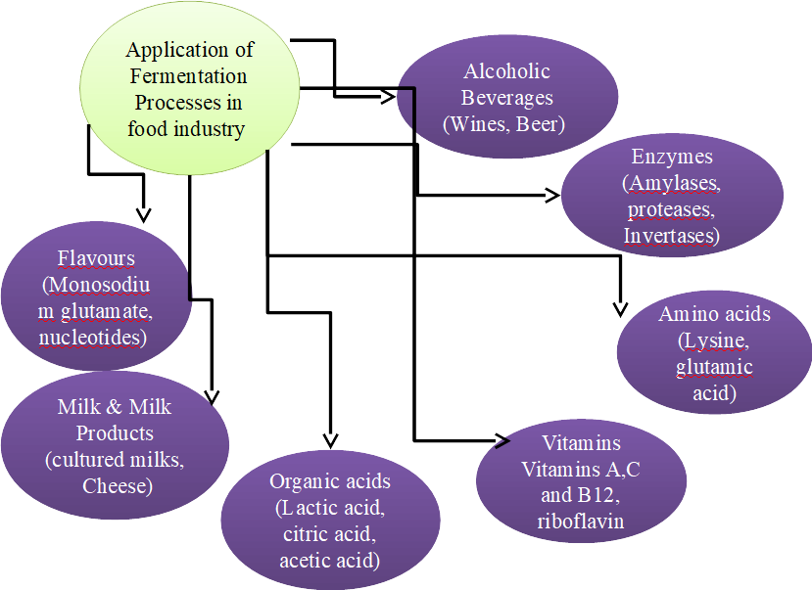

Figure. 7 Fermentation in Food Industry

IV Precautions required for Fermentation:
- Instances of food poisoning accidents in lactic acid fermentation and contamination due to aspergillus flavus in rice wine and soybean sauce have been reported.
- The threat of toxic contamination by microbial growth exists in food products obtained through fermentation.
Safety measures are required to be undertaken to counter the instances of poisoning due to usage of Fermentation products.

V Recent Perspectives
Outbreak of Covid 19 pandemic; severe acute respiratory syndrome coronavirus 2 (SARS-CoV-2) bring into forefront the development of Covid 19 vaccine based on gene therapy technology. Many companies across globe have developed licensed COVID-19 vaccine for the prevention of highly infectious disease using RNA vaccine technology and adenovirus vector vaccines although research has been conducted to ascertain the efficacy of vaccine against mutating virus and its viability for long term prevention. [16,17].
Over the long-term usage, microorganisms specifically bacteria acquire antibiotic resistance, research work has been carried out on developing anti-microbial nanoparticles which act as a barrier and prevents bacteria to penetrate across the membrane. Nanoparticle membranes plays a key role in prevention of infection and has been used in making masks during pandemic times [18].

VI Conclusion and Future Scope
Fermentation technology has been associated with pharmaceutical industry since time immemorial, of late it has gained widespread usage due to innovations and development in field of genetic engineering, tissue culture, bioengineering, microbiology and advancement of computational methods such as Artificial intelligence tools. In future also, Fermentation technology will remain relevant and progressively driven due to rapid advancement in the field of biopharmaceuticals new drug discovery, usage of implantable biomaterials and diagnostic tools [19,20].
Due to multifunctionality of the fermentation process, environmentally benign and target-specific nature, the Fermentation technique will be a major contributor to enhance Industrial output and achieving Agricultural Sustainability. In fact, it has been presumed that Agriculture 2.0 has been driven by Fermentation Technology [20].

REFERENCES

- Ranjana Sharma, Prakrati Garg, Pradeep Kumar, Shashi Kant Bhatia and Saurabh Kulshrestha, “ Microbial Fermentation and Its Role
in Quality Improvement of Fermented Foods”, Fermentation 2020, 6(4), 106.
- Balarabe, Musa Maryam, Mohammed Sani, Sambo Datsugwai, and Idris Shehu, “The Role of Biotechnology in Food Production and
Processing”, Industrial Engineering. 2017; 1(1): 24-35.
- https://www.sciencehistory.org/historical-profile/louis-pasteur
- P.F. Stanbury, A. Whitaker and S.J.Hall, “Principles of Fermentation Technology”, 2nd ed., Butterworth Heinmann, Oxford, 2000
- J.S.Morton, “Glycolysis and Alcoholic Fermentation” Acts & Facts,1980, 9 (12).
- M.L. Shuler and F. Kargi, “Bioprocess Engineering Basic Concepts”, 2nd ed., Prentice Hall, Upper Saddle River, NJ, 2002
- Fermentation Technology (Vol: I and II Set) by H.A. Modi, 2009
- Ber, et al., “Simultaneous saccharification and fermentation of sugar beet pulp for efficient bioethanol production”. BioMed Res. Int.,
10, 2016
- S.M Hassanein and N.K.Soliman, “Effect of Probiotic (Saccharomyces cerevisiae) Adding to Diets on Intestinal Microﬂora and
Performance of Hy-Line Layers Hens”, J. Am. Sci. 2010,6, 159–169
- C.Barreiro, J. F. Martin and C.Garcia-Estrada, “Proteomics Shows New Faces for the Old Penicillin Producer Penicillium
chrysogenum”. Journal of Biomedicine and Biotechnology, Volume 2012. DOI: 10.1155/2012/10510
- J. Benson, History of Antibiotics Steps of the Scientific Method, Research and Experiments". Experiment resource.2012, 423
- D. M. Zanca and J. F. Martin J F, Carbon catabolic regulation of the conversion of penicillin N into cephalosporin C, J Antibiotics, 36
(1983) 700-708.
- J.Yu, Q. Liu, Q.Liu, X. Liu, Q.Sun, J.Yan, X. Qi , and S. Fan, “Effect of liquid culture requirements on antifungal antibiotic
production by Streptomyces rimosus” MY02, Bioresource Technol. 99 (6) 2008 2087-2091.
- Q. Song,Y Huang, and H. Yang, “Optimization of fermentation conditions for antibiotic production by Actinomycetes YJ1 strain
against Sclerotinia sclerotiorum”, J Agr Sci. 4 (7) (2012) 95-102.
- A J G Cruz, T Pan, R C Giordano & M.L G C Araujo, “Cephalosporin C production by immobilized Cephalosporium acremonium
cells in a repeated batch tower bioreactor”, Biotechnol Bioeng, 85 (2004) 96-102.
- Hironori Nakagami, “Development of COVID-19 vaccines utilizing gene therapy technology”, Int Immunol., 2021 Sep 25;33(10):521-
527. doi: 10.1093/intimm/dxab013.
- Gandarvakottai Senthilkumar Arumugam, Kannan Damodhara, Mukesh Doble, Sathiah Thennarasu, “Significant perspectives on various viral infections targeted antiviral drugs and vaccines including COVID-19 pandemicity”; Mol Biomed., 2022 Jul 15;3(1):21. doi: 10.1186/s43556-022-00078-z..
- A.Surendiran, A, S. Sandhiya, S. C. Pradhan, C. Adithan,”Novel applications of nanotechnology in medicine”. Indian J. Med. Res.
2009, 130, 689–701
- J. Milano et al., “Microalgae biofuels as an alternative to fossil fuel for power generation”, Renewable Sustainable Energy Rev.,
58(Supplement C), 180
- Netsanet Shiferaw Terefe, Food Fermentation CSIRO Food and Nutrition, Werribee, VIC, Australia Ó 2016 Elsevier Inc

