Tractor Wheel Slip Measurement and Optimization
Manojit Chowdhury, Ajay Kushwah*
Division of Agricultural Engineering, ICAR-Indian Agricultural Research Institute, New Delhi-110012.
*Corresponding author email address: ajaykushwah98@gmail.com

ABSTRACT

Tractor wheel slip plays an important role in improving tractive efficiency and performance of the tractor. Excessive wheel slippage results in more wheel spin without tractor movement and energy loss through tire. Due to under slippage the tire sticks to the soil and requires more tractive effort for its movement resulting in wastage of fuel and power. Wheel slip should be measured during tractor operations within the field. This chapter discusses the techniques available for wheel slip measurement. The measurement of wheel slip can be obtained by different traditional and sensor-based methods. The traditional method, which includes velocity and distance measurements for a number of revolutions, is time-consuming and less accurate. The sensor (Hall effect, Radar, Proximity and rotary encoder) based methods are capable of real-time slip estimation during tractor operation and indicating the slip status to the driver. Currently, machine vision-based technique has also been introduced for wheel slip measurement. However, more research should be carried out to determine its accuracy and acceptance in real-time tractor wheel slip measurement. Wheel slip should be optimized (8-15%) to enhance the tractive performance, fuel efficiency and field capacity.

Keywords – wheel slip; slip optimization; radar sensor; hall sensor; proximity sensor

- INTRODUCTION

Tillage is considered as one of the most significant farming operations for seedbed preparation, seed germination, and subsequent crop growth. The operations are divided into two categories; primary and secondary tillage. The primary tillage operations require more energy than the secondary tillage [24]. Draft force is needed to pull any tillage implement at specific operating speed and depth. Draft force depends upon soil moisture, texture, organic matter content and type of implement a tractor is pulling. Inadequate draft leads to decrease the tractive efficiency of a tractor and increases the fuel consumption as well as tractor tire slippage [27]. The main purpose of tractor is to perform drawbar work using drawbar power. Drawbar power is defined as the drawbar pull multiplied by actual velocity. It was calculated that the soil-tire interaction wastes 20–55 percent of the tractor's total energy [7]. This wasted energy results in wear of the tire and soil compaction up to a certain limit.
Tractor wheel slip is an important parameter in order to achieve higher tractive efficiency and tractor performance [3]. Wheel slip can be defined as the relative speed difference between tractor speed and the angular speed of the tractor driving wheel [4,19]. Slip can be generated in two ways: either the tire's rotating speed is greater or less than its free rotating speed. or tire’s plane of rotation is angled to its direction of travel (slip angle). Slip occurs when the applied force on tire exceeds the available traction of the tire. The force is applied on the tire by longitudinally or laterally. Longitudinal force occurs when the engine or brake apply torque to the driving wheel and as a result tractor may be accelerated or decelerated. When the tractor drives around a curve, it generates lateral force. A tractor requires force to change direction; ultimately, lateral force is provided by the tires and the ground. There are two types of contact (static and dynamic) that tires make with the surface it is moving on. Static contact occurs when there is no slippage between the tire and surface because of the higher coefficient of friction thus provides better traction. Dynamic contact provides less traction as there is a relative slippage between tire and the surface.
According to reference [21] and [29], Wheel slip is crucial for enhancing tractive performance. Tractor performs most effectively when the slip is managed within a specific recommended range [9]. It is estimated that due to slip, while pulling an object the engine's power is only used between 60 and 70 percent through the soil, even on soft or sandy soil it may be dropped to 50%. [2]. According to previous research, tractors and tires must be maintained to achieve optimum wheel slippage at 8–15% to improve tractive performance [28,11,23]. Excessive slippage (greater than 15%) results in excessive wheel spin and fuel energy loss through the tyre, that is inefficient. The degree of wheel slip indicates whether the proper combination of tyre pressures, tractor weight or ballasting, and tractor speed was chosen, resulting in the necessary traction for optimum performance and fuel savings [16]. Wheel slip can also predict how quickly a tractor's drive train and tyres will wear out and how long they will last. Too little wheel slip could mean that the drive train is under stress or that too much weight is being carried. On the other hand, a high level of wheel slip indicates that the tires are wearing out too quickly and that fuel is likely being squandered by unnecessary rotations. Increasing the surface area of contact between the tractor wheels and the soil and decreasing anomalous slippage are the two main ways to improve tractive effort. Tractor loses a substantial amount of energy while operating in the field because of rolling resistance and traction wheel slippage. The trade-off between minimising rolling resistance and maximising wheel slip leads to maximum tractive efficiency. Slip can be controlled by reducing the depth and speed of operations but tractor operator can only sense the slip when it exceeds 30% for minimum 6 sec duration [16]. Thus, it results in wastage of energy and fuel as well.
Numerous attempts have been made to measure slip because of its significance. For the precise measurement of slip, several researchers have employed a variety of techniques, including the Doppler radar effect [18,8,12,20,3], electrical circuits utilising photo-transducers [13,22,10,15] etc. The objective of this chapter is to provide an overview of the techniques available for tractor wheel slip measurement.

- TRACTOR WHEEL SLIP MEASUREMENT

Flexing of the tractor wheel (tire) and shear inside the soil reduces the distance travelled and travel speed when a tractor is pulling a load. Slip occurs when a traction device or wheel creates pull that is called net traction. It is calculated as the ratio of the actual speed reduction to the theoretical speed using the following formula:
$S=\left(1-\frac{V_{a}}{V_{t}}\right)×100$ (1)
Where:
S = Tractor wheel slip
$V_{a}$= Tractor actual velocity
$V_{t}$= Tractor theoretical velocity

- Slip measurement by velocity of drive wheel for a no. of revolution with and without load
Reference [11] and [2] showed that the slip can be calculated by the velocity of drive wheel method. Wheel velocity was calculated for a known no. of revolution with or without load condition. In this method, a test tractor or towing tractor pulled by an additional tractor (towed tractor) on tar macadam or hard surface in different gears setting for a fix number of rotations of the rear wheel (Figure 1). Time required and distance travelled for completing the fixed revolutions were recorded. The same procedure was followed with load (with towed tractor) and without load (without towed tractor). The rear wheel velocity with load and without load was calculated by dividing the travelled distance by the time required to complete the ten revolutions. The observed slip can be estimated using the following equation.
$S\left(\%\right)=\left(1-\frac{V_{l}}{V_{nl}}\right)×100$ (2)
Where:
V_{l} is the rear wheel speed with load
V_{nl} is the rear wheel speed without load

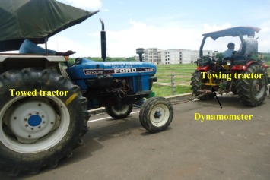
Figure 1: Slip measurement with towing and towed tractor (Source: Kumar et al. 2017)

- Slip measurement by distance traveled for a no. of revolutions
In this method of slip measurement, a distance of say 100 ft is marked using two ranging rods in the field. A mark is placed inside the tire that can be observed from the tractors seat or an additional person may observe the no of rotation of the wheel to travel that distance. The circumference of the tire is determined by placing a string or measuring tape around the center part of the ribs. Number of revolutions of wheel is counted to complete the marked distance. Then the wheel circumference is multiplied by no. of revolutions of wheel to calculate the actual travel distance. The actual travel distance is divided by the marked distance (100 ft) to calculate slip.
Another method for tractor wheel slip measurement is by distance travelled method with and without load condition. In this method, the distance travelled for known no. of revolutions (say 10 revolutions) is measured using measuring tape. The distance is measured for load and no-load condition. Load condition represents tractor with any implement system and in no-load condition tractor is running without any implement. Finally, slip is calculated using the following formula:
$S=\frac{d_{0}- d_{l}}{d_{0}}×100$ (3)
Where:
d_{o} = distance travelled at no load condition for fixed number of rotations
d_{l} = distance travelled at load condition for the same no. of rotations

- Hall effect sensor-based wheel slip measurement system
Reference [3], [5] and [1] developed hall effect sensor-based slip measurement technique. Discs mounted with magnetic pins were placed on both rear and front wheels. The magnetic pins disc installed on the front wheel indicated the actual speed and magnetic pin discs installed on the rear wheels represented the theoretical speed of tractor. The diameter of the front mounted and rear mounted disc were 25 cm and 50 cm respectively. Eighteen and thirty-six numbers of magnetic pins were mounted on the front and rear wheel discs. Three hall effect sensors were attached to each magnetic pins disc to produce magnetic pulses from each of the magnets of the mounted disc. The hall effect sensors were connected to the microcontroller and 12 V DC power supply. The number of pulses was counted and processed by the microcontroller to calculate the actual and theoretical velocities of the test tractor. The speeds were displayed in the LCD. The slip measurement device was validated by comparing with manually calculated slip (Equation (3)) and obtained good correlation between the slip values with coefficient of determination (R²) value of 0.986. Equations (4) and (5) were used to calculate the actual and theoretical speeds of operations and the percentage slip was calculated using equation (1).
Actual speed, $V_{a}=\frac{2ᴨr_{f}N_{f}}{t}$ (4)
Where:
$$N_{f}=\frac{Total pulse generated during time \left(t\right)}{Pulse generated per revolution}$$
Theoretical speed of operation (V_{t}) = $\frac{V_{rL}+V_{rR}}{2}$ (5)
$V_{rL}=\frac{2ᴨr_{L}N_{L}}{t}$
$V_{rR}=\frac{2ᴨr_{R}N_{R}}{t}$
Where:
r_{f} = front wheel rolling radius
N_{f} = number of rotations of front tire
r_{L} = rear wheel rolling radius (left)
r_{R} = rear wheel rolling radius (right)
N_{L} = number of rotations of rear wheel (left)
N_{R} = number of rotations of rear wheel (right)
t = time
V_{rL} = rear wheel angular velocity (left)
V_{rR} = rear wheel angular velocity (right)

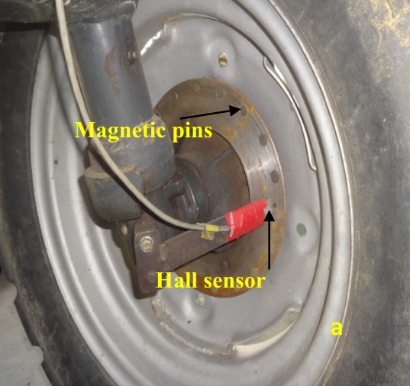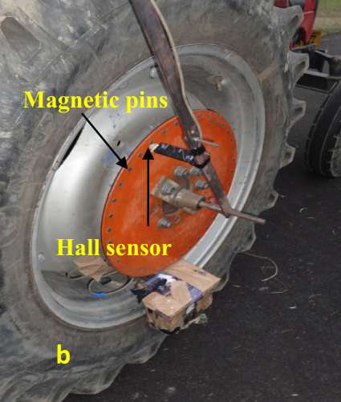
Figure 2: (a) Actual speed measurement (b) Theoretical speed measurement (Source: Kumar et al., 2016)

- Proximity sensor-based wheel slip measurement system
Reference [6] developed an electronic slip measurement system by calculating the actual and theoretical speed of the tractor using proximity sensors. The actual and theoretical speed of the tractor were measured using three inductive proximity sensors while the tractor was operating in filed. Two inductive proximity sensors were attached on the housing of the final drive of the rear wheels to measure the theoretical velocity while it underwent slippage, and one inductive proximity sensor was mounted on the kingpin rod of the front wheel to detect the actual velocity. To calculate the tractor's theoretical speed, 0.06 m diameter two mild steel rings having eight spokes of 0.5 m height was installed on each of the steel rings. The rings were installed on each rear wheel’s inner side in a manner that the sensor and spokes were separated by only a 2 mm gap (Figure 3 (a)). The tractor actual velocity was determined by placing a 0.13 m mild steel ring having eight spokes of same dimension as previous one on front wheel rim. The sensor was affixed to the rim with a 3 mm gap between them. When the wheel rotated the spokes crossed through the fixed proximity sensor, a pulse was created and recorded in the developed embedded system, which included a microcontroller, an LCD, and a power supply. As there were eight spokes on the front and rear wheel rims, thus in one revolution of the wheel eight pulses were generated. The output data (Pulses) along with time was analyzed by the microcontroller program. Equations (6), (7) and (8) were used to calculate slip, actual speed and theoretical speed in the developed embedded system. The maximum velocity between the rear two wheels was taken as the theoretical velocity.
Wheel slip (%) $S=\left(1-\frac{V}{V_{t}}\right)×100$ (6)
Actual speed, $V=\frac{2×ᴨ×R_{f×}N_{f}}{n×t}$ (7)
Theoretical speed of operation, $V_{tr}=\frac{2×ᴨ×Rr×Nr}{n×t}$ (8)
Where:
N_{f} = number of pulses on the front wheel proximity sensor generated in time t
R_{f} = front wheel rolling radius
n = number of spokes on the front wheel circular ring
Nr = number of pulses on the rear wheel proximity sensor generated in time t
Rr = rear wheel rolling radius
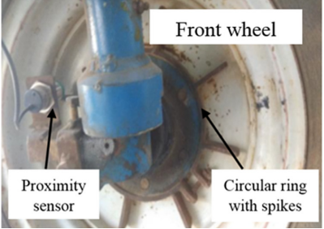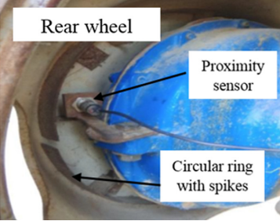
Figure 3: Wheel slip measurement set-up (Source: Nataraj et al., 2021)

- Rotary encoder-based slip measurement system
Reference [16] developed rotary encoder-based technique for wheel slip measurement. Wheel slip is the function of actual and theoretical speeds. Two encoders were connected on the rear wheels that calculated theoretical speed of the tractor and one encoder was attached on the front wheel to calculate actual speed of travel. Theoretical speed was calculated by multiplying the average readings from the rear wheels encoder and the distance travelled in one revolution of the rear wheel. Similarly, the actual speed of travel was calculated by multiplying the output reading of the front wheel encoder and distance travelled in one revolution of the front wheel. The output data were fed to the microcontroller to calculate actual speed, theoretical speed. Slip was calculated and displayed using equation (5). The following equations (9,10,11,12 and 13) were used to calculate the actual and theoretical speed.
$N_{f}= \frac{E_{f}×4}{360×T}$ (9)
$N_{r1}= \frac{E_{r1}×4}{360×T}$ (10)
$N_{r2}= \frac{E_{r2}×4}{360×T}$ (11)
Actual speed, $V_{a}= d_{f}×N_{f}$ (12)
Theoretical speed, $V_{t}=d_{r}× \frac{N_{r1} + N_{r2}}{2}$ (13)
Where:
$N_{f}$ is the revolution of front wheel
$E_{f}$ is the no. of pulses in time T from front wheel
$N_{r1}$ and $N_{r2}$ are the revolutions of the right and left rear wheel
$E_{r1}$ and $E_{r2}$ are the no. of pulses from right and left rear wheel in time T

- Radar sensor-based slip measurement system
Radar-based technique was used to determine actual speed of the tractor and the produced slip [3,14]. Radar ground speed sensor was installed in the test tractor below the foot rest. The radar ground speed sensor works on the principle of doppler effect that is an object that is moving has a frequency shift effect of the received electromagnetic wave. The quantity of the frequency shift can be measured by the radar ground speed senor to calculate the moving speed of tractor. According to the doppler principle:
$f_{d}= \frac{2}{Λ} ×V_{r}$ (14)
$Λ= \frac{1}{f_{s}} ×c$ (15)
$V_{r}= \frac{1}{2} ×f_{d}×Λ$ (16)
$V_{r}= \frac{1}{2} ×c×\frac{f_{d}}{f_{s}}$ (17)
Where:
$f_{d}$ is the frequency shift
$Λ$ is the radar wave wavelength
$V_{r}$ is the radial velocity of radar with respect to ground
$f_{s}$ is the frequency of radar transmitting
$c$ is the speed of the light

- Machine vision-based slip measurement method
Reference [25] used machine vision-based technique to determine tractor wheel actual velocity and wheel slip. A CCD Camera (MER-125-30UC) and lens (M0814-MP2) were used for capturing the ground images. The camera was mounted vertically facing the ground at a height of about 650 mm from the ground. A high precision Differential Global Positioning System (DGPS) was also used to measure the actual velocity and validate the accuracy of machine vision generated actual speed. The DGPS antenna and receiver was placed on the tractor so that it could monitor the speed of the tractor in real-time. To determine theoretical velocity of the tractor, the actual rolling radius of the wheel was estimated as theoretical velocity is the product of angular velocity and rolling radius. Tire pressure sensor was mounted on the valve of the tire to monitor real time tire pressure during operation. Calibration in advance was carried out to obtain a relationship between tire pressure and rolling radius to determine the rolling radius from real-time tire pressure. Angular velocity of the wheel was obtained from the rear wheel installed rotary encoder. Real-time angular velocity and rolling radius values were transmitted to data acquisition system. The encoder generated 1000 pulses per revolution and the pulse input was combined with the rolling radius to calculate theoretical velocity of the tractor. The slip value was calculated by putting the actual and theoretical velocities in equation (1).

- WHEEL SLIP OPTIMIZATION
Wheel slip optimization is the measure taken for maximizing the tractive performance and improving the fuel efficiency and field capacity. Wheel slip is a dominating factor in drawbar and tractive performance. Some percentage slip is required in tractor wheel to reduce wear in the power train and rolling resistance of the wheel. However, this produced slip should be optimum (8-15%) to obtain highest tractive efficiency for the tractor during the field operations. Every tractor has its position and draft control lever to adjust the draft and slip as well. Though, the draft control system is not the efficient method to optimize the slip as the depth of operation may vary by frequently shifting the levers. Adding extra weights on the wheel, reducing tire inflammation pressure, using dual wheels, tire ballasting, replacing old, worn-out tire are some of the measures if tractor is experiencing excessive wheel slippage. If slippage is less than the optimum range then weight should be removed and tire should be checked.
Reference [26] developed an automatic slip optimization technique using a 12 V DC motor. Whenever the generated slip deviated from the optimum range, the DC motor activated to adjust the draft control lever of the tractor. The DC motor was connected to the draft control lever through a chain of gear mechanism. The implement height was lowered or raised to maintain the optimum slip.
Reference [17] developed an automatic slip measurement and implement depth adjustment system to maintain the optimum slip range during tractor operation in the field. The optimum slip range was uploaded on the microcontroller. The microcontroller could compare the measured slip value with the optimum slip values. A stepper motor was connected to the hand operated depth control lever. Whenever the slip value exceeds the upper limit, the stepper motor rotated anti-clock wise to lift the implement and reduce the depth. On the other hand, if the slip value was recorded as lower than the optimum value, the motor rotated clock-wise to increase the depth of operation. However, if the slip value was within the specified range, no action was taken by the system.

REFERENCES

- A. Mahore, H.L. Kushwaha, A. Kumar and T.K. Khura, “A low-cost wheel slip measurement device for agricultural tractors,” The Indian Journal of Agricultural Sciences, vol. 92(3), pp.334-338, 2022.
- A.A. Kumar, V. K. Tewari, C. Gupta, and C. M. Pareek, “A device to measure wheel slip to improve the fuel efficiency of off road vehicles," Journal of Terramechanics, vol. 70, pp.1-11, 2017.
- A.A. Kumar, V.K. Tewari and B. Nare, “Embedded digital draft force and wheel slip indicator for tillage research,” Computers and Electronics in Agriculture, vol. 127, pp.38–49, 2016.
- ASAE, “Uniform Terminology for Traction of Agricultural Tractors, Self-Propelled Implements, and Other Traction and Transport Devices,” S296.2, ASABE Standards, St Joseph, MI, 1983.
- C. Gupta, V.K. Tewari, A.A. Kumar and P. Shrivastava, “Automatic tractor slip-draft embedded control system,” Computers and Electronics in Agriculture, vol. 165, pp.104947, 2019 Oct 1.
- E. Nataraj, P. Sarkar, H. Raheman and G. Upadhyay, “Embedded digital display and warning system of velocity ratio and wheel slip for tractor operated active tillage implements,” Journal of Terramechanics, vol. 97, pp.35-43, 2021 Oct 1.
- E.C. Burt, A.C. Bailley, “Load and inflation pressure effects on tyres,” Trans. ASAE, vol. 25 (4), pp.881–884, 1982.
- F.D. Tompkins, W.E. Hart, R.S. Freeland, J.B. Wilkerson and L.R. Wilhelm, “Comparison of tractor ground speed measurement techniques,” Transactions of the ASAE, vol. 31(2), pp.369-374, 1988.
- F.M. Zoz, “Predicting tractor field performance,” Trans. ASAE, vol. 15 (2), pp.249–255, 1972.
- G.J. Shropshire, G.R. Woerman and L.L. Bashford, “A Microprocessor based Instrumentation System for Traction Studies,” ASAE Paper No. 83-1048, St. Joseph, Michigan, 1983.
- H. Raheman and S.K. Jha, “Wheel slip measurement in 2WD tractor,” Journal of terramechanics, vol. 44, pp. 89-94, 2007.
- Khalilian, S. Hale, C. Hood, T. Garner and R. Dodd, “Comparison of Four Ground Speed Measurement Techniques,” ASAE Paper No. 89-1040, St. Joseph, Michigan, 1989.
- L. Erickson, W. Larsen and S. Rust, “Four-wheel drive tractor axle and drawbar horsepower: Field evaluation and analysis,” ASAE Paper No. 82-1057, St. Joseph, Michigan, 1982.
- L. Zhixiong, B. Xuefeng, L. Yiguan, C. Jiangxue and L. Yang, “Wheel slip measurement in 4WD tractor based on LABVIEW,” International Journal of Automation and Control Engineering, vol. 2(3), pp. 113-119. 2013.
- N.G. Musonda, F.W. Bigsby and G.C. Zoerb, “Four wheel drive tractor instrumentation,” ASAE Paper No. 83-1546, St. Joseph, Michigan, 1983.
- P.K. Pranav, K.P. Pandey and V.K. Tewari, “Digital wheel slipmeter for agricultural 2WD tractors.” Computers and electronics in agriculture, vol. 73, pp.188-193, 2010.
- P.K. Pranav, V.K. Tewari, K.P. Pandey and K.R. Jha, “Automatic wheel slip control system in field operations for 2WD tractors,” Computers and electronics in agriculture, vol.84, pp.1-6, 2012 Jun 1.
- R. Freeland, F. Tompkins and L. Wilhelm, “Portable instrumentation to study performance of lawn and garden ride-on tractors,” ASAE Paper No. 88-1079, St. Joseph, Michigan, 1988.
- R. Rajamani, “Vehicle dynamics and control,” Springer Science & Business Media, 2011 Dec 21.
- R.D. Grisso, M. Yasin and M.F. Kocher, “Tillage implement forces operating in silty clay loam,” Trans. ASAE, vol. 39 (6), pp.1977–1982, 1996.
- R.D. Wismer and H.J. Luth, “Off-road traction prediction for wheeled vehicles,” ASAE Paper No. 72-619, 1972.
- R.L. Jurek and B.C. Newendorp, “In-Field fuel efficiency comparisons of various john deere tractors,” ASAE Paper No. 83-1563, St. Joseph, Michigan, 1983.
- S. Ekinci, K. Çarman, “Effects of some properties of drive tires used in horticultural tractors on tractive performance,” J. Agric. Sci, vol. 23 (1), pp.84–94, 2017.
- S. Soylu and K. Çarman, “Fuzzy logic based automatic slip control system for agricultural tractors,” Journal of Terramechanics, vol. 95, pp.25-32, 2021.
- S. Zhu, L. Wang, Z. Zhu, E. Mao, Y. Chen, Y. Liu and X. Du, “Measuring method of slip ratio for tractor driving wheels based on machine vision,” Agriculture, vol. 12(2), pp.292, 2022.
- S.M. Ismail, G. Singh and D. Gee-Ctough, “Preliminary investigation of combined slip and draught control for tractors,” Journal of Agricultural Engineering Research, vol. 26(4), pp.293-306, 1981.
- S.M. Shafaei, M. Loghavi and S. Kamgar, “A practical effort to equip tractor-implement with fuzzy depth and draft control system,” Engineering in Agriculture, Environment and Food, vol. 12(2), pp. 191-203, 2019.
- T. Keller, “A model for the prediction of the contact area and the distribution of vertical stress below agricultural tyres from readily available tyre parameters,” Biosystems Engineering, vol. 92(1), pp.85–96, 2005.
- W.W. Brixius, “Traction prediction equations for bias ply tires,” ASAE Paper No. 87-1622, ASAE St. Joseph, MI 49085, 1987.

