GEOPHYSICAL INVESTIGATION OF GROUNDWATER EXPLORATION USING SELF-POTENTIAL AND RESISTIVITY METHOD IN VEPPILAIPATTI VILLAGE, SALEM DISTRICT, TAMIL NADU, INDIA

Gopal V¹*., Chandravijay M¹., Ranjith Kumar R¹., Anshu R², Krishnamurthy R.R¹.
Department of Applied Geology, University of Madras, Guindy Campus, Chennai-600 025.
Department of Geology, University of Madras, Guindy Campus, Chennai-600 025

*Corresponding Author

Dr. Gopal V
veegopaal@gmail.com

INTRODUCTION

Geophysics is a substance of study concerned with the physiological processes and physiological properties of the Object and its surrounding set surroundings, and the use of vicenarian methods for their analysis. The period geology sometimes refers exclusive to the geological applications. Material's contour, its gravitational and magnetic comic construction and arrangement, its mechanics and their opencast look in bag geomorphology, the its internal procreation of magmas, volcanism and careen formation. Over the bygone individual decades, geophysical surveying has prettified increasingly potent and helpful for module the submersed groundwater conditions (Murthy et al; 1968 and Raman et al: 2000).
GEOPHYSICAL EXPLORATION OF GROUNDWATER
Geophysical exploration is the technological measurement of material properties of the connective encrustation for enquiry of mineralized deposits or geologic artifact. With the uncovering of oil by geophysical methods in 1926, efficient method for locating oil and pigment deposits aroused the use and betterment of many geophysical methods and equipment. Geophysical methods notice differences or anomalies of somatic properties within the earth's freshness. Spacing, attraction, elasticity, and electrical resistivity are properties most commonly rhythmic. In the covering of geophysical methods for groundwater exploration, it is often misunderstood by more than they are misused to flat notice groundwater. The important exploratory techniques normally adopted are Geological methods, Geomorphological methods, Remote sensing methods, and Geophysical methods.

GEOPHYSICAL METHODS
Geophysical methods depend on confident physical properties of earth materials. The properties are plumbed and variations in their values in lateral or straight directions are made use of for assemblage underground content. The significant properties of rock that are made use are Gravity prospecting, Magnetic prospecting, Seismic prospecting, Electrical prospecting and Radiometric prospecting.

ELECTRICAL PROSPECTING
Electrical resistivity techniques are based on the activity of the earth to course of electric ongoing. The resistivity of a earth organization depends on its mineral composition and is influenced to a very sizable alter by the interstitial liquid accumulation tell there in. Electrical resistivity method involves the measurement of open cut possibility caused by the passageway of an exciting current. In real set measurements, a show of electrode arrangements are victimized.
ELECTRICAL RESISTIVITY METHOD
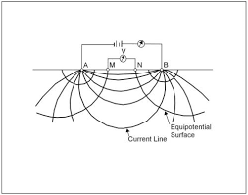
Electrical resistivity technique based on the measurement of surface potential caused by the flowing of an electric current on the ground from an artificial source is based on the validity of Ohm's law for linear conductors R-Av/1, where R is the resistance in Ohms, offered to the flow of current I and Av is the potential difference, in volts, across two end faces of the conducting material. The resistance of the m layer is directly proportional to its length L and inversely proportional to its cross-sectional area so that R α L/A. The electrical resistivity or the specific resistance, P of the conducting layer, then is Ρ= (A/L) R = (∆v / I) A/L
The above figure shows the arrangement and the current and potential lines in a homogeneous and isotropic medium. The potential difference between the two potential electrodes, M and N due to the current introduced by the two current electrodes, A and B.
ELECTRODE CONFIGURATION
In real-time field measurements, a variety of electrode arrangements or configurations are used, the difference being in the inter electrode distance and geometry. The most familiarly used configurations are the Wenner, Schlumberger and dipole-dipole arrangements. In the Wenner electrode array, the four electrodes, equidistant with respect to each other, are kept along a straight line, the outer two being the current electrodes. The inter electrode distance is commonly denoted by the letter 'a'. The relation for apparent resistivity for Wenner configuration.

Wenner electrode configuration
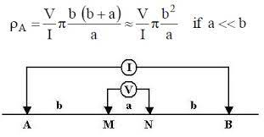
The Schlumberger electrode configuration is also a similar array like Wenner, but in this condition the potential electrodes are kept close to one another and away from the current electrodes, with the distance between the potential electrodes (MN) being generally kept less than 0.2 AB.
Schlumberger electrode configuration
HORIZONTAL PROFILING AND VERTICAL ELECTRICAL SOUNDING
Electrical resistivity techniques are supported on the greeting of the object to travel of galvanic prevailing. The resistivity of a shake object depends on its asphaltic schoolwork and is influenced to a really broad change by the interstitial food collection recognize there in. Electrical resistivity method involves the activity of layer possibility caused by the delivery of an electric underway. In factual earth measurements, a variety of electrode arrangements are utilized.
SELF-POTENTIAL
The self-potential (SP) strategy could be a detached electrical geophysical strategy based upon measuring of spontaneous or common electrical potential created within the soil due to: electrochemical intuitive between minerals and subsurface liquids, electro dynamic forms coming about from the flow of ionic liquids or thermoelectric components from temperature angles within the subsurface.

STUDY AREA
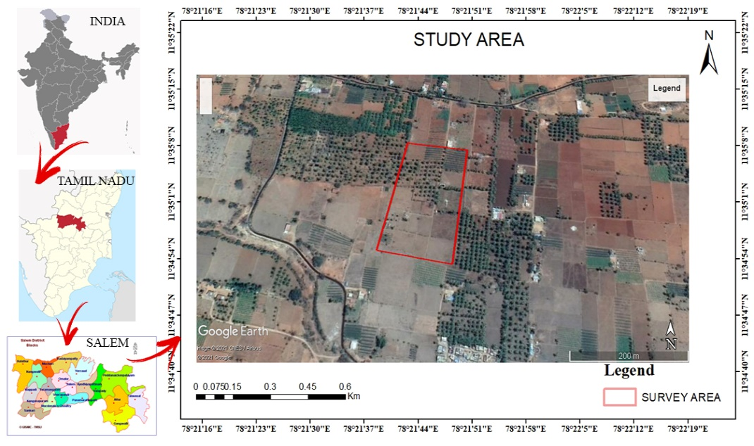
The study area is from Veppilaipatti village, Salem district, Tamil Nadu. This area lies between north latitude and longitude 11⁰35’03″ and 78⁰21’35″,11⁰35’03’’ and 78⁰21’39’’ and south latitude and longitude 11⁰34’51’’ and 78⁰21’33’’ , 11⁰34’56’’ and 78⁰21’38’’. Salem district is bounded north Tamil Nadu. It is located between on 11.669437°N Latitude, 78.140865°E Longitude at an average elevation of 278 m (912 ft) above the mean sea level except Yercaud hills. It has an area of about 7905.38 Kms with 38, 96,388 inhabitants. The city is surrounded by hills: Nagaramalai on the north, Jarugumalai on the south, Kanjamalai on the west, Godumalai on the east and the Shevaroy Hills on the northeast. Entire district comprises of a hard rock terrain of Archaean age and it has the principal rock type of granite and a semi-arid weather.
GEOLOGY AND GEOMORPHOLOGY OF STUDY AREA
Salem district is rich in mineral deposits like Magnesite, Bauxite, Granite, Limestone, Quartz and Iron ore. Geologically, the entire Salem district can be classified into hard rock formation. More than 90 percent of the district is underlain by hard rock of Archaean age. Quartz, Feldspar, and limestone those are resistant to weathering and also seen as patches in Charnockite and gneissic varieties and the above rock types found Sedimentary Formation. The granulite terrain of Salem area has witnessed two major periods of granitic activity – one during Late-Archaean to Early Palaeo-Proterozoic and the other during Neo-Proterozoic times. The granites of older event are restricted to the southern part of Salem district ie. North of Moyar – Bhavani – Attur Lineament (MBAL), while the younger Pan-African event is spread in the terrain south of MBAL. The rocks of the Khondalite and Charnockite groups have been subjected to regional magmatisation and retrogression with influx of quartzo-feldspathic material resulting in the formation of different types of gneiss such as biotite gneiss, hornblende gneiss, Augen gneiss, garnetiferous biotite gneiss, garnetiferous quartzo-felspathic gneiss depending upon the parent rock. The entire area of Salem district is a pediplain. The Shevaroy Hills on the northeast and Jarugumalai on the south side of the district constitutes the remnants of the much-denuded Eastern Ghats and rise to heights of over 1031 m above mean sea level. There are numerous small residual hills like Nagaramalai, Kanjamalai and Kodhumalai hills. The elevation of the area is ranging between 120 m and 200m above Mean Sea Level (MSL). The prominent geomorphic units identified in the district through interpretation of Satellite imagery are Structural hill, Pediments, Shallow Pediments, Buried Pediments and Alluvial plain.
The soils can be broadly classified into 6 major soils types including Red insitu, Red Colluvial Soil, Black Soil, Brown Soil, Alluvial and Mixed Soil. Majority of the district is covered by Red insitu and Red Colluvial soils. Block soils are mostly seen in Salem, Attur, Omalur and sankari taluks. Brown Soil is majorly seen in Yercaud and parts of Salem and Omalur taluks and the Alluvial Soil is seen along the river courses in Omalur and Sankari taluks. Mixed soil is occurring only in Attur taluk.
RAINFALL AND CLIMATE
Salem district gets rain beneath the impact of both southwest and northeast rainstorm. The northeast rainstorm primarily contributes the precipitation within the area. Precipitation information from six stations over the period 1901-2003 were utilized and a examination of the analysis appears that the ordinary yearly precipitation over the area shifts from approximately 800 mm to 1600 mm. It is the least around Sankari (800 mm) within the southwestern portion of the district. It continuously increments towards north, northeast and east and attains a greatest around Yercaud (1594.3 mm) within the northern portion.
The Salem district enjoys a tropical climate. The climate is charming amid the period from November to January. Mornings in common are more muggy than the evenings, with the stickiness surpassing 75% on a normal. Within the period June to November the evening mugginess surpasses 60% on a normal. Within the rest of the year the evenings are drier, the summer evenings being the driest. The hot climate starts early in March, the most elevated temperature being come to in April and May. Climate cools down continuously from almost the center of June and by December, the cruel day by day most extreme temperature drops to 30.2°C, whereas the cruel day by day least drops to 19.2°C and 19.6°C in January in Salem and Mettur Dam.
HYDROGEOLOGY OF THE STUDY AREA
Salem district is underlain completely by Archaean Crystalline arrangements with later alluvial deposits happening along the waterway and streams courses like Cauvery, Thirumanimutharu, Sarapangandhi are the vital waterways within the locale. But Cauvery, other streams stream as it were amid blustery seasons. Weathered, fissured and broken crystalline rocks and the later alluvial stores constitute the important aquifer frameworks within the area. The permeable arrangements within the area are represented by waterway alluvium. These alluvial deposits are kept to the Major Stream and stream courses as it were. Ground water happens beneath phreatic conditions. The greatest immersed thickness of these aquifers is up to 10 m depending upon the topographic conditions. The difficult solidified crystalline rocks of Archaean age represent weathered, fissured and broken arrangements of gneisses, stones, Charnockite and other related rocks.
OBJECTIVES OF THE STUDY
The major objective of present study is to explore the ground water.
- To portray the outcrop geology of the ponder area.
- To investigate sub surface breaks, weathered zone and water filled pores spaces at a chosen depth (Using 2D profiling)
- To choose appropriate area to vertical electrical sounding utilizing profile information 3D plot created from surfer.
- To investigate ground water potential of the chosen point and to choose a point to penetrate for high yielding bore well. (Using Vertical electrical sounding, Schlumberger electrode configuration).
MATERIALS AND METHODOLOGY
There are a few variations in electrical methods. In reality, biggest assortment of strategies is conceivable in electrical prospecting and it'll be no shock in case unused strategies are created in future. In electrical strategies either the characteristic electrical field in a region is examined or the ground is charged by an artificial electrical field and the dispersion of the electric field at the surface of the soil is explored.

METHODOLOGY FLOW CHART
ELECTRICAL RESISTIVITY PROSPECTING
Electrical resistivity procedures are based on the reaction of the earth to the stream of electric current. Among the geophysical methods, electrical resistivity strategies appreciates the most noteworthy popularity and are broadly utilized for both territorial and point by point groundwater overviews since of its way better settling control, less costs as well as run of appropriateness. Electrical resistivity strategies has been utilized in this study in order to Portray potential zones of ground water and to discover out the thickness of immersed zones, profundity to the basement topography.
APPARENT RESISTIVITY
The capacity to conduct current is an critical physical property of rock shaping minerals and this property is made utilize of in electrical prospecting. Electrical resistivity looking over is based on measuring of the resistivity 'p' of subsurface by passing a known electric current into the ground and measuring the potential difference between two points. This technique is based on the usage of Ohm's law for linear conduction which is represented as, $R=\frac{∆V}{I}$
R- Resistivity in Ohm's to the flow of current., I- Current in Amperes, V- Potential difference in volts across the two end faces of a conductor. The resistance of the media is directly proportional to its length L and is inversely proportional to its sectional are ‘A’, so that R proportional to L/A
i.e., R.=ρL/A (or) ρ=R. AL
While carrying out the overview within the field either coordinate current or low frequency substituting current presented into the ground, through two current electrodes(A, B) and the potential contrast is measured between another combine of (potential) electrodes (M. N). By considering the values of current, potential difference and the geometry of electrode arrangement it is conceivable to compute the resistivity of the fabric as
ρ= 2$π$ x $∆$V/ (1/AM-1/BM-1/AN+1/BN) x 1,
Where AM, BM, AN, and BN are the inter electrode distances.
The factor $\frac{2π x AV}{2a(1/AM-1/BM-17AN+1/BN)}$ is referred to as the geometric constant K, of the configuration used.
Hence, $ρ$= K. $∆V/I$, The resistivity measured by the above strategy is said to be the true resistivity of the medium as it were when the estimations are made over a homogeneous and isotropic medium. As the earth's subsurface by and large isn't so, the measured resistivity isn't the true resistivity and is said to be the apparent resistivity (pa).
ELECTRODE CONFIGURATION
In real field estimation, a assortment of electrode courses of action or arrangements are utilized, the contrast being within the inter-electrode distance and geometry. The foremost commonly utilized arrangement are the Wenner and Schlumberger arrangements.
Wenner Configuration
Within the Wenner electrode array, all the four anodes, equidistant with regard to each other, are kept along a straight line, the external two being the current terminals The associate terminal separate is commonly indicated by the letter 'a'. The relation for apparent resistivity pa, for Wenner configuration is given by, $ρ$a = 2$πaR$ , Where ‘a’ = distance between successive electrodes.
Schlumberger Configuration
The Schlumberger terminal setup is additionally a symmetrical cluster like Wenner, but contrasts in putting the two current terminals with a much bigger interval than that between the potential (inward) electrodes. As it were one set of cathodes either potential or current are moved to extended interims at a time whereas conducting profundity soundings not at all like in Wenner cluster where there are four electrodes are moved at the same time. The current anodes are signified by A and B, whereas the potential anodes are signified by M and N. The interval between M and N is signified by 'b' whereas the interval AB is signified by a'. The apparent resistivity is given by,
$ρ$a = KR, $K=π\frac{AM. AN}{MN}$ , K- Configuration constant, R= Obtained resistance
There are a few other electrode setups which are adjustments of Wenner and Shlumberger arrangements, such as Lee partitioning. Carpenter tri-electrode course of action, Single angement and Dipole system of electrode arrangement.

FIELD PROCEDURES
Resistivity methods are utilized for both lateral and vertical investigation
1. Resistivity profiling for lateral exploration,
2. Resistivity sounding for vertical exploration
RESISTIVITY PROFILING
Horizontal profiling is done to look at lateral variations within the subsurface in the region of intrigued. A arrangement of estimations of resistivity are carried out with consistent electrode dividing moving the complete terminal arrangements continuously to a number of focuses along a given line. The apparent resistivities so obtained are plotted on the central points of the cluster along a profile. This strategy is additionally named Constant depth traversing or Electrical trenching Structures like dyke, faults, shear zones (separated from changes in rock types) etc, which is generally related with lateral variations, can be examined by the profiling method.
VERTICAL ELECTRODE SOUNDINGS (V.E.S)
In resistivity sounding, the estimations are made at one area (keeping the middle of the electrode framework settled) for different values of current electrode divisions beginning from analy, little esteem to a few hundred meters, depending on the depth of interest. Usually since, in common, bigger the electrode division, more noteworthy will be the profundity of examination. The Variety of the apparent resistivity with current terminal separation this gotten would provide the variety within the electrical characteristics of the arrangement with profundity. This strategy (V.E.S) is most commonly connected for groundwater examinations and will be examined in detail in this extend work. For carrying out resistivity sounding, the taking after types of instruments are vital One resistivity meter, One DC current source or an AC generator with low frequency, Protects electrical cables, One match of current electrodes within the frame of iron stakes, One pair of potential electrodes, Hammer to fix the electrodes in the earth.
Resistivity study ought to be made paying due consideration to conceivable exasperating components such as pipe lines, wire wall, rail tracks, etc. These strategies cannot be utilized within the region of control plants, substations, tall pressure control lines and comparable sources of unessential soil streams which would unfavorably influence the exactness of the field estimations.
INTERPRETATION OF RESISTIVITY DATA
Elucidation of the electrical resistivity information in terms of the subsurface geology and hydrology shapes two most imperative stage within the investigation of groundwater. The point of translation of resistivity is to decide the thickness and resistivity of diverse horizons present. Interpretation of V.E.S information is both quantitative and subjective. The sort of V.E.S bend gotten demonstrates the qualitative nature of subsurface that will be anticipated in an zone. For case, a H sort bend in a difficult shake territory may be deciphered as comprising of (1) a dry top soil cover taken after by (2) moist weathered rock/regolith, underlain by (3) the bed rock. There are numerous ways to decipher the resistivity information beginning from observational strategy to Modern strategies utilizing quick computers. In this project work all the resistivity data are interpreted with the help of Auxiliary Point Chart (APC) Method.

SELF-POTENTIAL
The self-potential (SP) strategy may be a inactive electrical geophysical strategy based upon the estimation of spontaneous or natural electrical potential created within the soil due to: electrochemical interactions between minerals and subsurface liquids, electro kinetic forms coming about from the flow of ionic liquids or thermoelectric mechanisms from temperature angles within the subsurface. A few physical forms caused sources of SP are still hazy. Groundwater is thought to be common calculate capable for SP. Potentials are produced by the stream of water, by water responding as an electrolyte and as a dissolvable of distinctive minerals. Electrical conductivity to create possibilities of permeable rocks depends on porosity and on versatility of water to pass through the pore spaces depend on ionic mobilities, solution concentrations, viscosity, temperature & pressure.
RESULT AND DISCUSSION
Vertical electrical soundings were done in the field by utilizing shlumberger arrangement additionally self-potential itself. In all 3 soundings were done and analyzed. The least and most extreme values of AB/2 (current electrode division) chosen for the studies is 2 meters to 60 meters, the clear resistivity information of VES areas have been plotted on log-log graph and coordinated with the master curves for getting the layer parameters (resistivity and thickness). The depth sounding curves are classified based on layer resistivity combinations.
GEO-SURVEY EQUIPMENT
The geo-physical instrument was utilized for field work is DDR-2, which is the innate IGIS make from Hyderabad. The 3 Vertical Electrical depth Soundings (VES) were taken for basic examination of the subjective and quantitative elucidations. The readings are arranged underneath. The 3 numbers of sounding were at first coordinated manually with the master curves arranged for vertical electrical sounding by the Ernesto Orellana and Harold. Mooney, Intercien Costanilla De Los Angeles, Madrid 1966. At that point the deciphered information has been confirmed utilizing the computer program and subtle elements are as takes after:
ANALYSIS WITH "IPI2 WIN"
The interpreted resistivities and thicknesses of different layers. Solid line represents the interpreted data and solid line with circles represents the observed data.
The curve types obtained in the study area where 28 VES sounding was carried out include 11 H type curves (p1 > p2 <p3), 5 K type (p1 < p2 > p3), 4 A type (p1 <p2 < p3), 1 AA type (p1 < p2 < p3 < p4), 1 HK type (p1 > p2 < p3 > p4), 4 HA type (p1 > p2 < p3 < p4) and 1 KH type (p1 <p2> p3 <p4) respectively (Table.1).
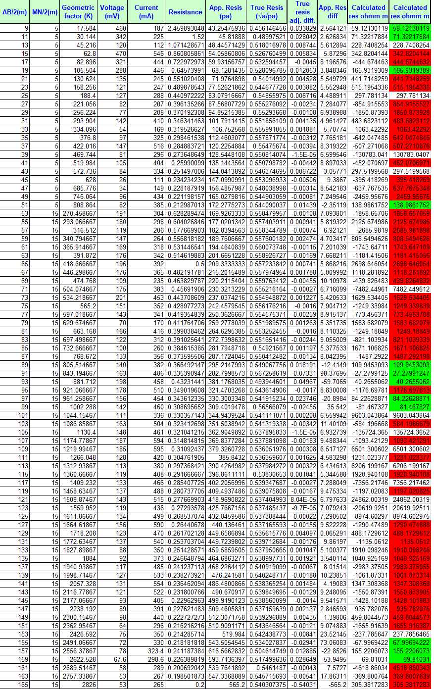
TABLE OF VES READING 1 :

TABLE OF VES READING 2:
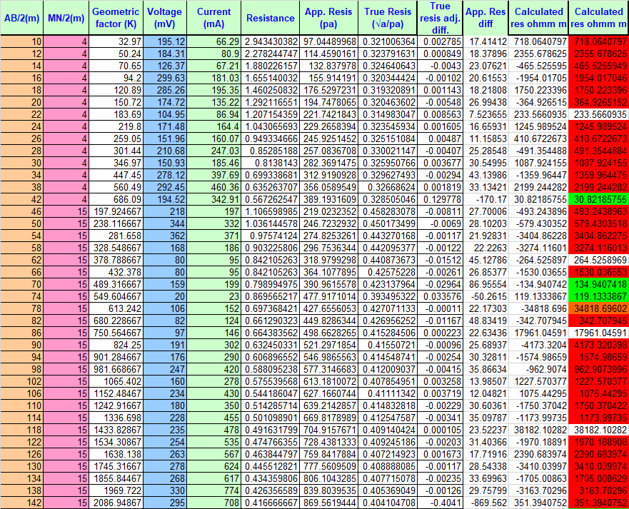

TABLE OF VES READING 3:
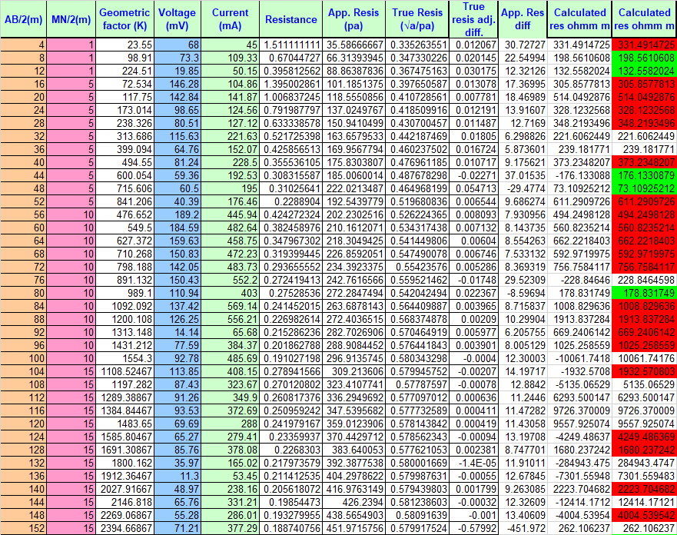

TABLE OF SELF-POTENTIAL DATA
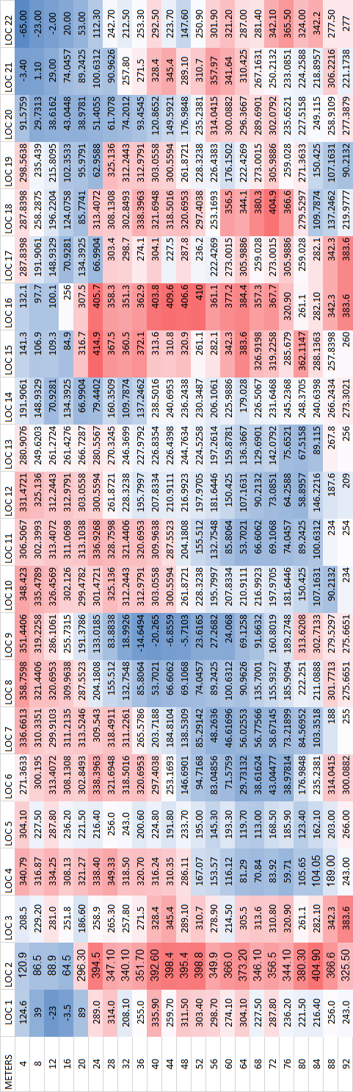
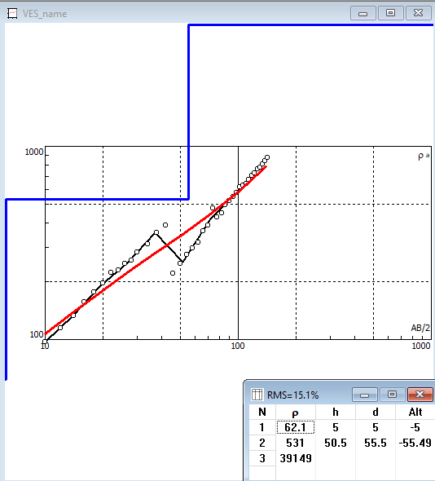
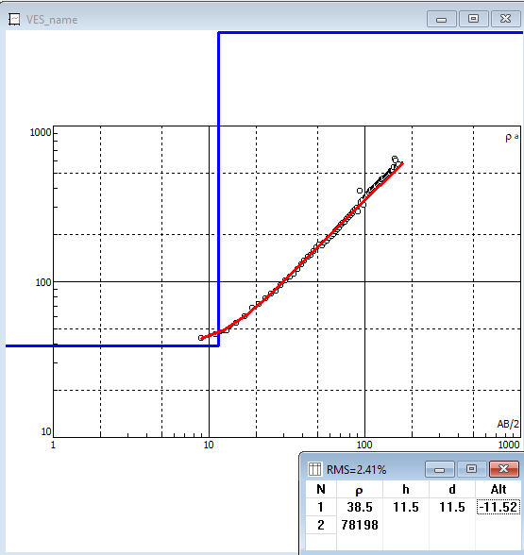
Fig - VES CURVE AT LOCATION 1 Fig - VES CURVE AT LOCATION-2
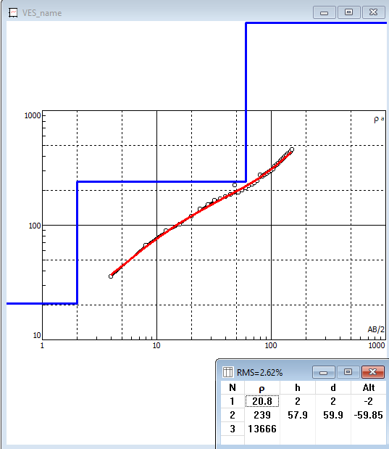

Fig - VES CURVE AT LOCATION 3

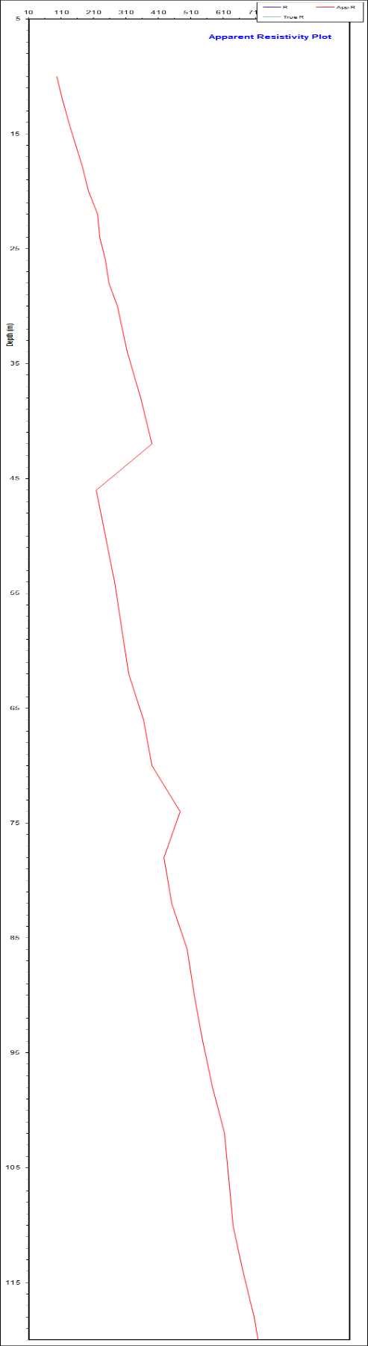
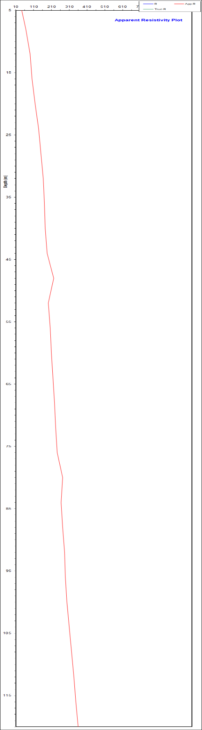
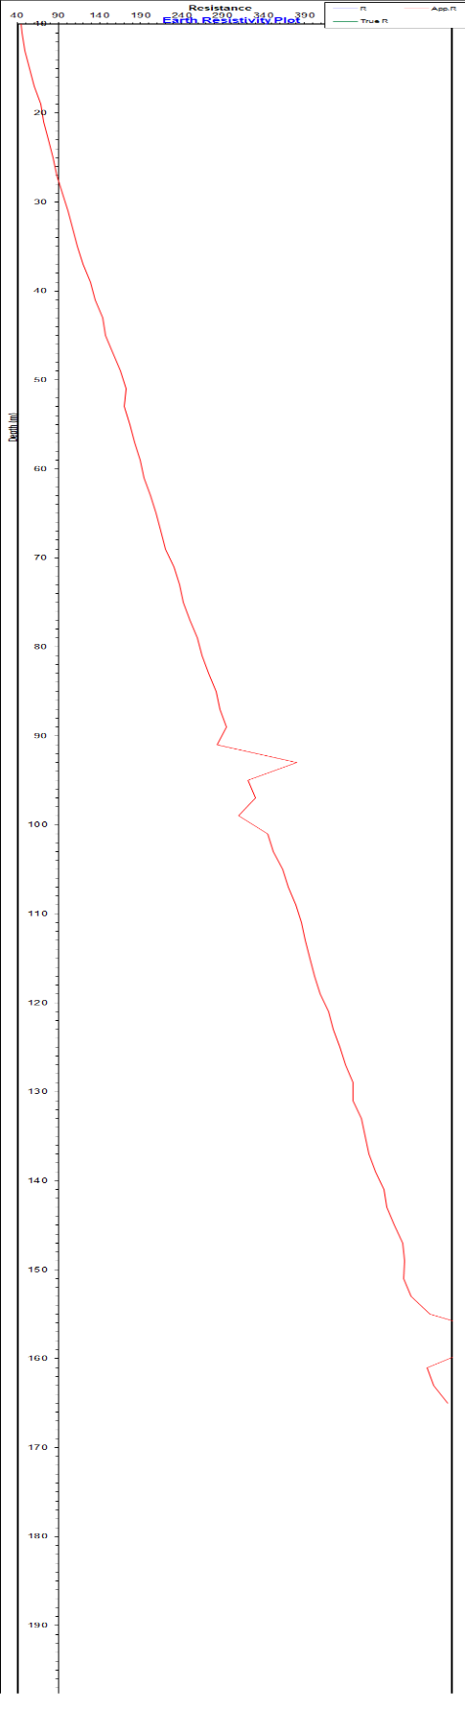
Fig-1 LOC 1.APPARENT RES PLOT VS DEPTH
Fig-2 LOC 2.APPARENT RES PLOT VS DEPTH
Fig-3 LOC 3.APPARENT RES PLOT VS DEPTH
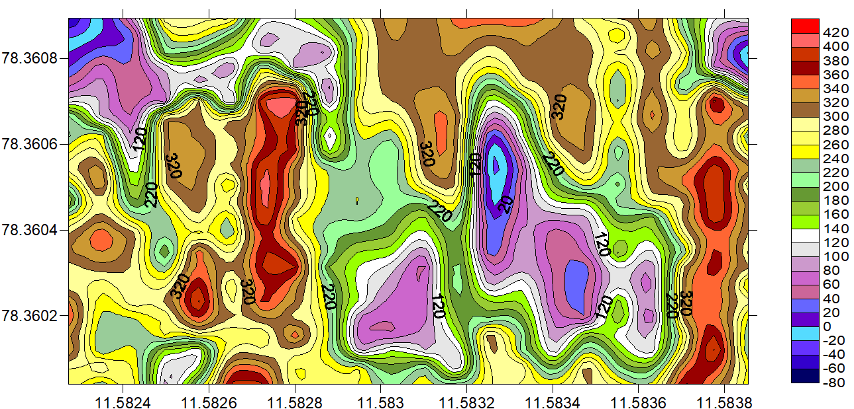
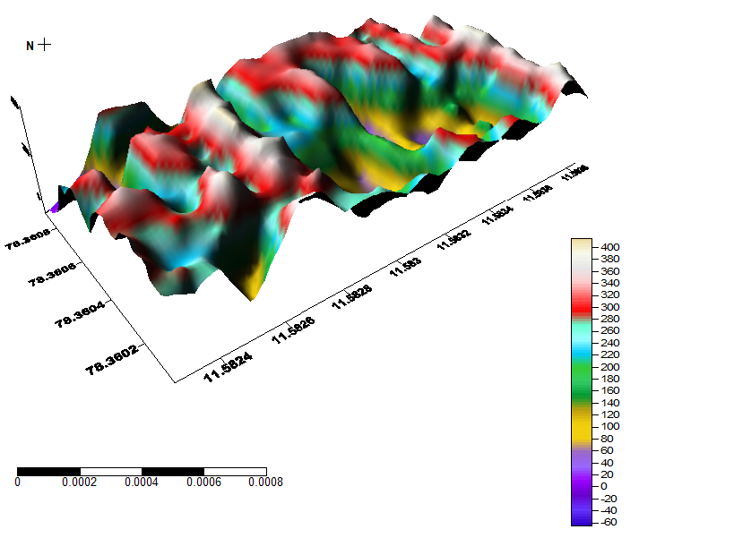

3D APPARENT RESISTIVITY PLOT APPARENT RESISTIVITY CONTOUR MAP
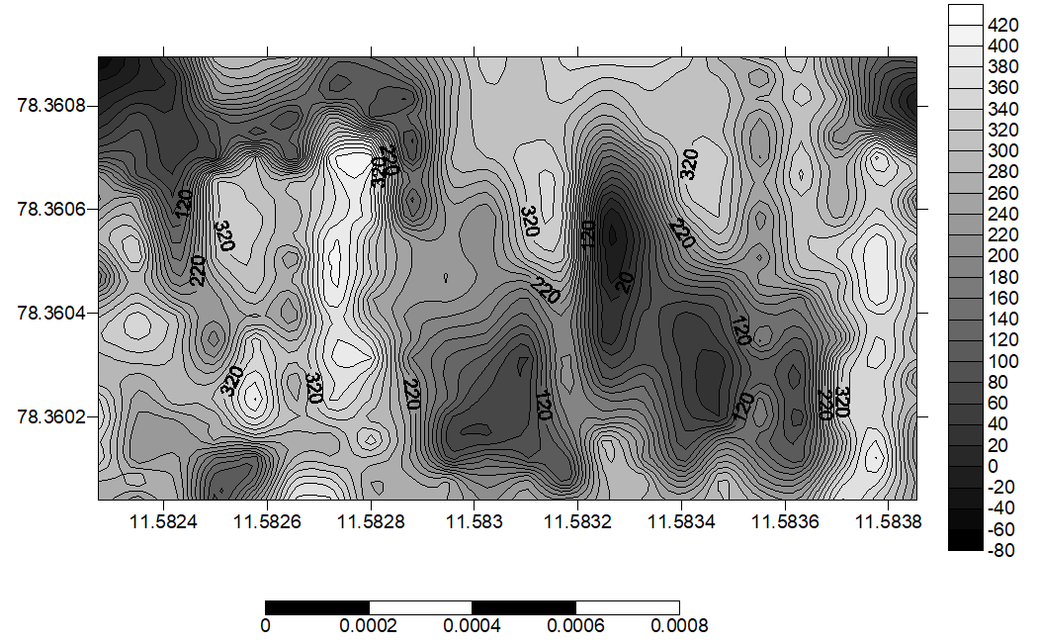

APPARENT RESISTIVITY CONTOUR MAP AND THEIR DEPTH
CONCLUSION
Ground water exploration has been done in part of the Veppilaipatti Village, Vazhappady Taluk, Salem District in Tamil Nadu using 2D profiling and VES using Schlumberger electrode configuration and self-potential method. Vertical electrical sounding strategy of the electrical resistivity strategy and self-potential strategy has demonstrated to be effective and exceedingly successful within the recognizable proof and outline of subsurface structures that are great for groundwater amassing in a crystalline basement complex range. The foremost portion of the consider region is overwhelmed by the A and H type curve which uncovers the number of subsurface layers, their thickness and their water bearing capacity inside the study. Based on self-potential information it shows the three negative values point within the zone considered as the streaming potential point within the area (the weathered water saturated point). At the same point took the VES based on Schlumberger strategy, distinguished three water bearing zone 67m, 30m and 73m depth. The explored VES (VES POINT 2, Depth at 73m) point recommended as high yielding well bore point among the study region. In conclusion it can be said that the electrical resistivity studies have helped in understanding the subsurface hydrology and the event of saline and brackish water within the middle portion of the study region and the surfer diagram uncovers that 3D subsurface of the study area.
SELECTED REFERENCES
Adeotil, L., Alile. O. M., Uchegbulam, O, and Adegbola, R. B. Geoelectrical Investigation of the Groundwater Potential in Mowe, Ogun State, Nigeria, British Journal of Applied Science & Technology 2(1): pp. 58-71.
Adepelumi, A. A., Akinmade, O. B., Fayemi, O (2013). Evaluation of Ground Water Potential of Baikin Ondo State Nigeria Using Resistivity and Magnetic Techniques: A Case Study. Universal Journal of Geoscience, Vol 1(2), pp. 37-45.
Emmanuel C. Okolie (2010). Geophysical investigation of effects of topographic complexities on groundwater potential in Ibusa, Delta State Nigeria, Archives of Physics Research, 1 (3): pp. 62-71. Jeyavel, T., Raja Kumar., Balasubramanian, A., Kumar, R.S., Dushiyanthan, C., Karthikeyan,
K., Thiruneelakandan, B., Davidraju, D., and Manoharan, K (2011). Delineation and evaluation of groundwater potential zones using electrical resistivity survey and aquifer performance test in Uppodai of Chittar - Uppodai water shed, Tambaraparani River Basin, Tirunelveli-Thoothukudi Districts, Tamilnadu, J. Ind. Geophys. Union Vol.15, No.2, pp.85-94.
Joseph Olakunle Coker, (2012). Vertical electrical sounding (VES) methods to delineate potential groundwater aquifers in Akobo area, Ibadan, South-western, Nigeria. Journal of Geology and Mining Research Vol. 4(2), pp. 35-42.
Kavidha, R., and Elangovan, K (2013). Delineation of Groundwater Prospective Zones by Electrical Resistivity Method in Erode District, Tamilnadu, India, Journal of Environment. Vol. 02, Issue 01, pp. 14-18.
Lateef, T.A. (2012). Geophysical Investigation For Groundwater Using Electrical Resistivity Method - A Case Study Of Annunciation Grammar School, Ikere Lga. Ekiti State, South Western Nigeria. IOSR Journal of Applied Physics (IOSRJAP) ISSN - 2278-4861 Volume 2, PP 01-06.
Murthy, B. V. S., Varaprasada Rao, S. M and Bhimasankara, M. V. L. S (1982). Structure and geology of the Munneru valley as inferred from gravity and magnetic surveys, J. Indian Acad.
Narasimha Prasad, N.B (2011). Geophysical investigation for groundwater exploration in Lakshadweep Islands - A case study, J. Ind. Geophys. Union Vol.15, No.4, pp.221-227.
Oseji. Julius Otutu and Ajnabi, O (2009). Hydrogeophysical investigation of groundwater potential in Emu kingdom, Ndokwa land of Delta State, Nigeria. International Journal of Physical Sciences Vol. 4 (5), pp. 275-284. Owen, R., Gvavav O.,and Gwaze, P(2005). Multi-electrode Resistivity Survey for Groundwater Exploration in the Harare Greenstone Belt, Zimbabwe. Hyrdogeology Joumal. Vol14, pp.244-252.

