**ISOLATION AND CHARACTERIZATION OF PHOSPHATE SOLUBLIZING MICROBES**

R.Krishnaveni*., N.Hira 1 .,Sumathi.T 2 S.Afrin Sahanaz 1 ., V.Nithya Sri 1

1. PG & Research Department of Microbiology, Idhaya College for Women, Kumbakonam.

2. Assistant professor in Zoology, A.D.M. College for Women, Nagapattinam.

*Corresponding Author: E-mail: [krishnavenimicro@gmail.com](mailto:krishnavenimicro@gmail.com)

1. **ABSTRACT**

In the present study carried out on isolation of Phosphate solubilizing capacity of microbes. The fungus isolated from soil *Aspergillus niger* and *Penecillum chrysogenum* and *Bacillus polymyxa* used for testing the effect of PH on phosphatase enzymes. The role of temperature in alkaline and acid phosphatase enzyme activity. Estimation of phosphatase enzyme activity. It is concluded the fungus *Aspergillus niger* and *Penicillium chrysogenum* shows maximum activity then bacterium.

1. **INTRODUCTION**

Phosphate solubilizing microbes are increasing yield in Agriculture crops. *Pseudomonas, Micrococcus, Aspergillus, Fusarium* are the phosphate solubilizing microbes. These microbes solubilizing inorganic phosphates. So the plant absorb phosphorous easily. Phosphorous is main source of plant nutrients. These phosphate solubilizing microbes convert unavailable form of phosphorous to available.

1. **MICROBIAL COUNT:**

Pikovskaya’s agar plates which is supplemented with phosphate. The soil samples were collected and after serial dilution technique .from the10 2 dilution one ml of soil sample was taken and streaked on Pikovskaya’s agar medium. The plates were incubated at 25o C for 4 -5 days. Transparent zones of clearing around the colonies of microorganisms indicate that the phosphate present in the medium.

1. **QUALITATIVE AND QUANTITATIVE MEASUREMENT OF PHOSPHATE SOLUBILIZATION IN CULTURE MEDIUM:**

**Quantitative measurement by Vanadium molydate method:**

**Qualitative measurement:**

The pikovskaya’s agar plate was prepared and well was made on the agar plate using gel puncher. Then the enzyme extracted was added onto the well at various concentration like 1µl, 3µl, 5µl, 7µl and 9µl and observed for the zone around the well.

1. **EXTRACTION OF PHOSPHATASE ENZYME:**

The fungi isolates like *Aspergillus* *niger* and *Penicillium* *chrysogenum* were isolated from garden soil.

The phosphate solubilizing microbes were grown in pikovskaya’s broth for 2 weeks. The fungal filtrate was filtered through whatman No. 42 filter paper, the fungal mat was then homogenized in a mortar and pestle using 0.02M tris buffer (pH 7.5), it was centrifuged at 16,000 rpm for 20 minutes and the supernatant was collected. The bacterial culture (*Bacillus* *Polymyxa*, and *aerobic spore former*) were grown in pikovskaya’s broth for 48 hrs. Then the broth is centrifuges at 6,000 rpm for 10 minutes. Then the pellet is treated with 0.02M tris buffer (pH 7.5) and homogenized using magnetic stirrer for 20 minutes. Then the macerate was centrifuged at 16,000 rpm for 20 minutes and the supernatant was collected.

1. **PURIFICATION OF ENZYMES:**

The enzyme extracted and taken in a conical flask. It was added 20% of ammonium sulphate salt and mix well by magnetic stirrer for 30 minutes. Then centrifuged at 4,000 rpm for 10 minutes. To that add 40°C of ammonium sulphate salt and macerate it using magnetic stirrer for 30 minutes. Again centrifuge at 4,000 rpm for 10 minutes. To the supernatant add 60% of ammonium sulphate salt and macerate it using magnetic stirrer for 30 minutes. Then again centrifuge at 4,000 rpm for 10 minutes and the pellet was collected and dissolved in tris buffer and stored at 4°C and then the dialysis process was carried out.

1. **ESTIMATION OF PHOSPHATASE ENZYME ACTIVITY:**

**Acid phosphatase assay:**

1ml of citrate buffer prepared of pH 4 for *Bacillus* *polymyxa*, and pH 5 for *Aspergillus* *niger*, *Penicillium* *chrysogenum* and *aerobic spore former.* . Then 1ml of enzyme extracted.it was added to the buffer, 1ml of p-nitro phenol phosphate was added to each test tube. Then the tubes were incubated at 30°C for *Aspergillus* *niger*, and *Penicillium* *chrysogenum* and 40°C for *Bacillus* *polymyxa* and *aerobic spore former* for 30 minutes. To this add 4ml of 0.1N of sodium hydroxide was added and the OD value was noted at 405nm.

**Alkaline phosphatase assay:**

1ml of Sodium carbonate and bicarbonate buffer was prepared of pH 8.5 for *Penicillium* *chrysogenum* and *aerobic spore former*, and pH 9 for *Aspergillus* *niger* and *Bacillus* *polymyxa* were taken in separate test tubes. 1m of culture filtrate obtained was added to this buffer and mixed for 5 minutes. 1ml of p-nitro phenol phosphate was added to each tube. Then the tubes were incubated at 30°C for *Penicillium* *chrysogenum*, *Aspergillus* *niger*, and *Bacillus* *polymyxa* and at 40°C for *aerobic spore former* for 30 minutes. To this add 4ml of 0.1N sodium hydroxide was added and then the OD value is noted at 405nm.

1. **RESULT**
2. **Characterization of *Aspergillus* *niger* and *Penicillium* *chrysogenum*:**

The *Aspergillus sp*  are widespread in soil.it appeared in transparent zone around the colonies When grown on pikovskaya’s agar medium, In sabouraud dextrose agar, black colonies were developed. Fig 1 A).

1. **Characterization of *Bacillus* *polymyxa* and *aerobic spore former:***

The *Bacillus* *polymyxa* were gram positive, rod shaped, spore- forming bacteria when observed on light microscopy (fig 1 B). Aerobic spore former were gram negative, rod shaped, spore forming, motile bacteria when observed under light microscopy (Fig 1 B).

1. **The effect of pH on phosphate enzyme:**

In the present study Table 1 shows the acid phosphatase of *Aspergillus* *niger*, *Penicillium* *chrysogenum*, and *aerobic spore former.* The maximum activity at pH 5 PH the fungus and. But acid phosphatase of *Bacillus* *polymyxa* shows the maximum activity of pH 4. Graph (1) alkaline phosphatase of *Penicillium* *chrysogenum* and *aerobic spore former* shows the maximum activity of pH 8.5. But alkaline phosphatase of *Aspergillus* *niger* and *Bacillus* *polymyxa* shows the maximum activity at pH (Fig2).

1. **The effect of temperature on phosphatase enzyme:**

In the present study, Table 2 shows the acid phosphatase of *Aspergillus* *niger* and *Penicillium* *chrysogenum* effective on 30°C. *Aerobic spore former* and *Bacillus* *polymyxa* effective on temperature 40°C. Graph (2) alkaline phosphatase of *Penicillium* *chrysogenum*, *Aspergillus* *niger* and *Bacillus* *polymyxa* effective on at temperature at 30°C. But alkaline phosphatase of *aerobic spore former* shows the maximum activity at temperature 40°C (Fig 2).

1. **The effect of various substrates on phosphatase enzyme:**

In the present study table 3A, 3B, in minimal medium it contains P-nitro phenol phosphate which act as a substrate, there was no growth observed in it. The minimal medium compared with pikovaskaya’s medium (Graph 3). The pikovskaya’s liquid medium showed a greater value. (Fig 2).

1. **Quantitative measurement of phosphate solubilization in culture medium:**

In this study, Table 4 the *Aspergillus* *niger* which shows highest solubilization when compared to *Penicillium* *chrysogenum*, aerobic spore former and *Bacillus* *polymyxa*. The *Penicillium* *chrysogenum* shows highest solubilization when compared to *Aspergillus* *niger*, *Aerobic spore former* and *Bacillus* *polymyxa* (Graph 4).

1. **Qualitative measurement on phosphate solubilization in culture medium:**

The enzymes extracted from the *Aspergillus* *niger*, *Penicillium* *chrysogenum*, *Bacillus* *polymyxa* and *aerobic spore former* are seen. In that it shows a very good zone of clearance. Even the 1µ of enzyme extracted showed the zone of clearance (Fig 2A).

1. **Extraction of phosphatase enzyme activity:**

In our study (Fig 3 & 4), the enzymes extracted successfully from phosphatase enzyme by *Aspergillus* *niger*, *Penicillium* *chrysogenum*, *aerobic spore former* and *Bacillus* *polymyxa*. The enzyme was purified by dialysis method which contains 60% of Ammonium sulphate salt.

1. **Determination of molecular weight by SDS PAGE:**

The bands were observed and the molecular weight was found to be 60 kilo Daltons.

1. **DISCUSSION**

In the present study,

Table.1 shows, Effect of pH on the phosphatase enzyme *Aspergillus* *niger*, *Penicillium* *chrysogenum* and *aerobic spore former* effective at the pH range of 5 followed by *Bacillus* *polymyxa* at the pH range of 4. In alkaline phosphatase activity higher at range of pH 9, lower at range of pH 8 by *Bacillus* *polymyxa*.

Table.2 shows, Effect of temperature on the phosphatase enzyme, in acid phosphatase *Aspergillus* *niger* shows maximum effect at 30oC. In alkaline phosphatase the *Aspergillus* *niger*, *Penicillium* *chrysogenum* effective at 30oC.

Table.3 shows, Amount of phosphatase solubilized in culture medium *Aspergillus* *niger* phosphatase solubilized (767µg) in tricalcium phosphate and (668µg) in monopotassium phosphate.

Table.4 shows, Estimation of phosphate solubilized by acid and alkaline phosphatase *Aspergillus* *niger* shows maximum acid phosphatase activity and *Bacillus* *polymyxa* shows minimum acid phosphatase activity.

In our present investigation shows, on qualitative and Quantitative measurement of Fungal cultures showed better activity than bacterial culture. On estimating phosphatase enzyme activity, the alkaline phosphatase enzyme showed the highest activity when compared to acid phosphatase enzyme. Phosphatase enzyme extracted and purified by Ammonium sulphate precipitation method and dialysis is carried out overnight. The molecular weight of the enzyme is identified using SDS PHAGE.

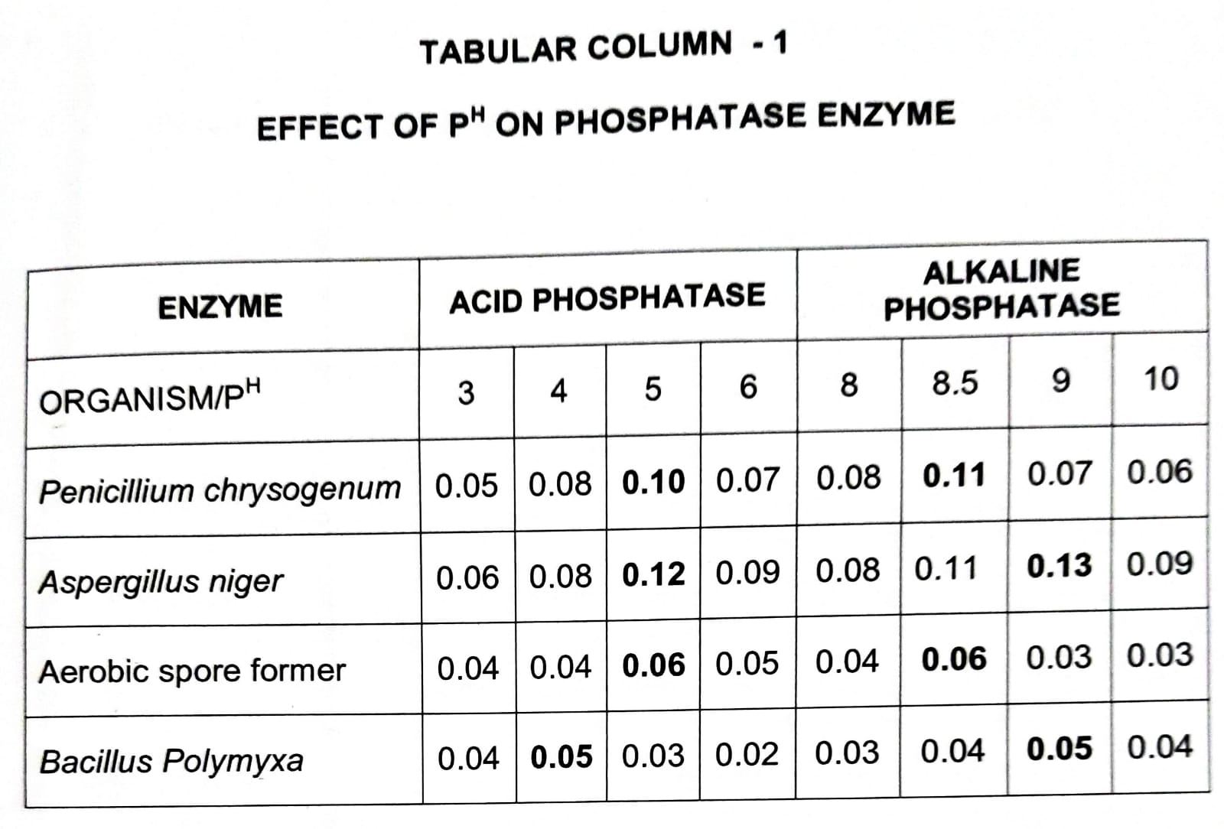



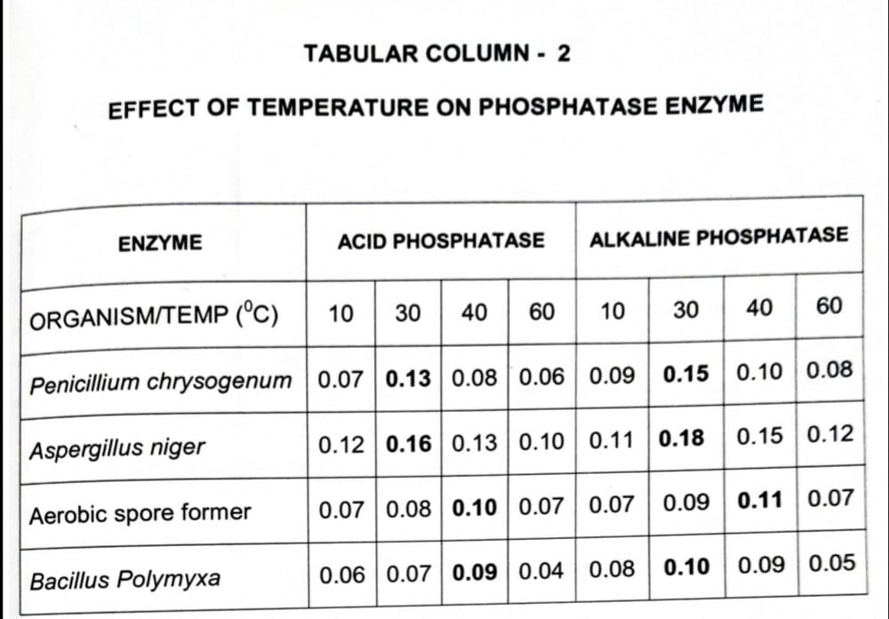



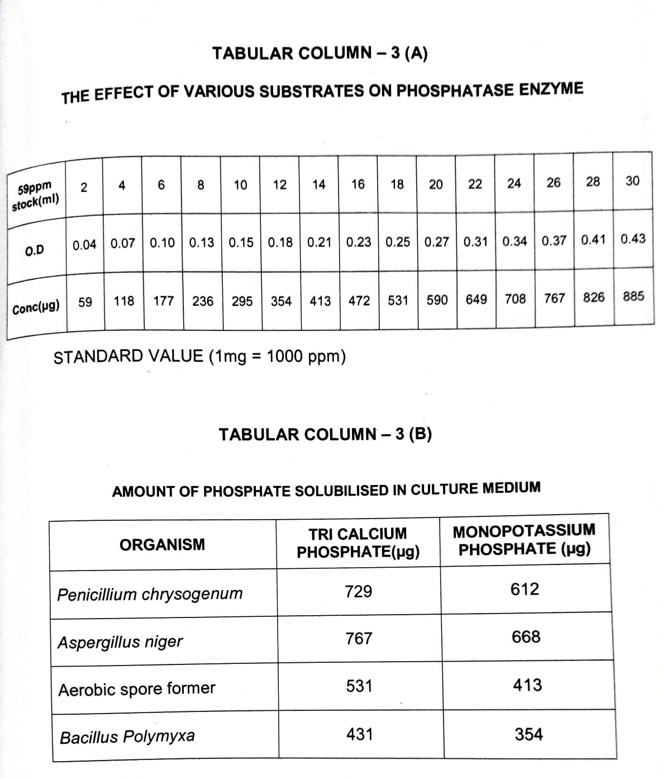



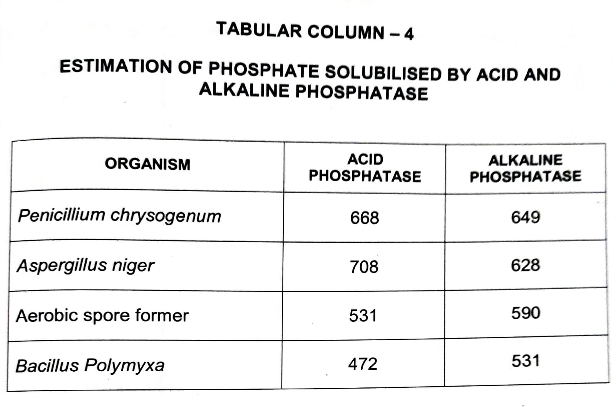

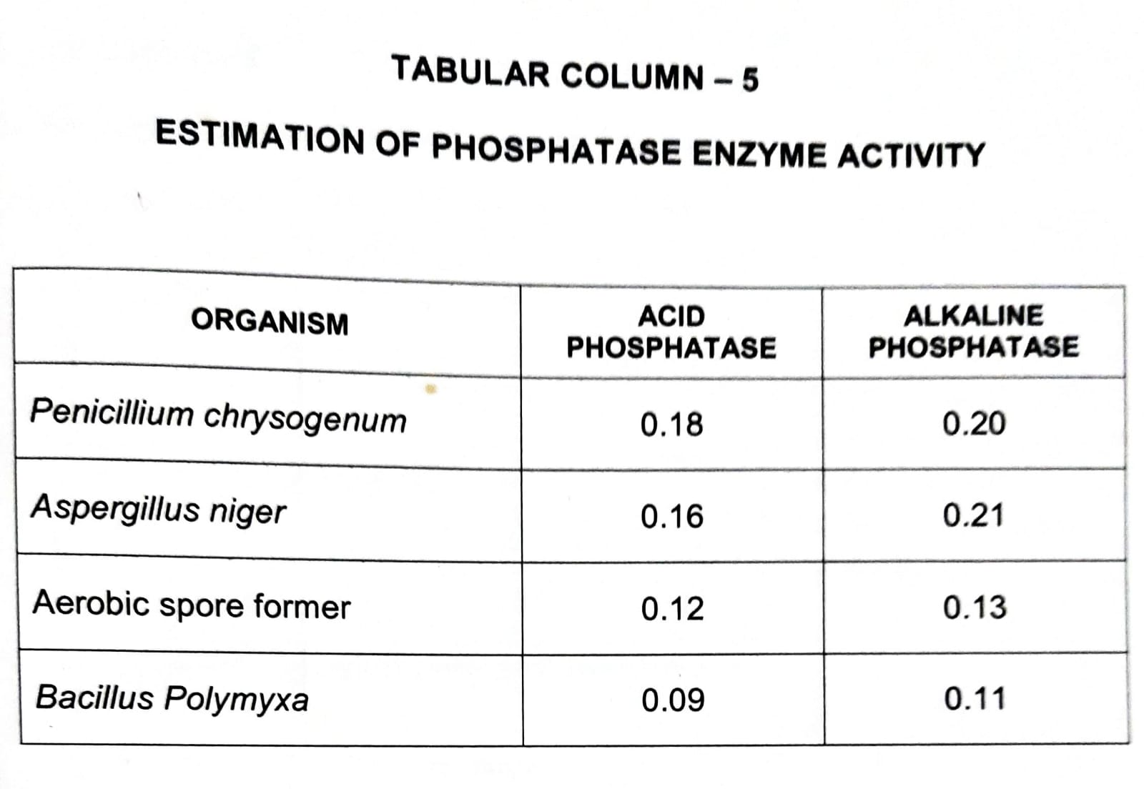

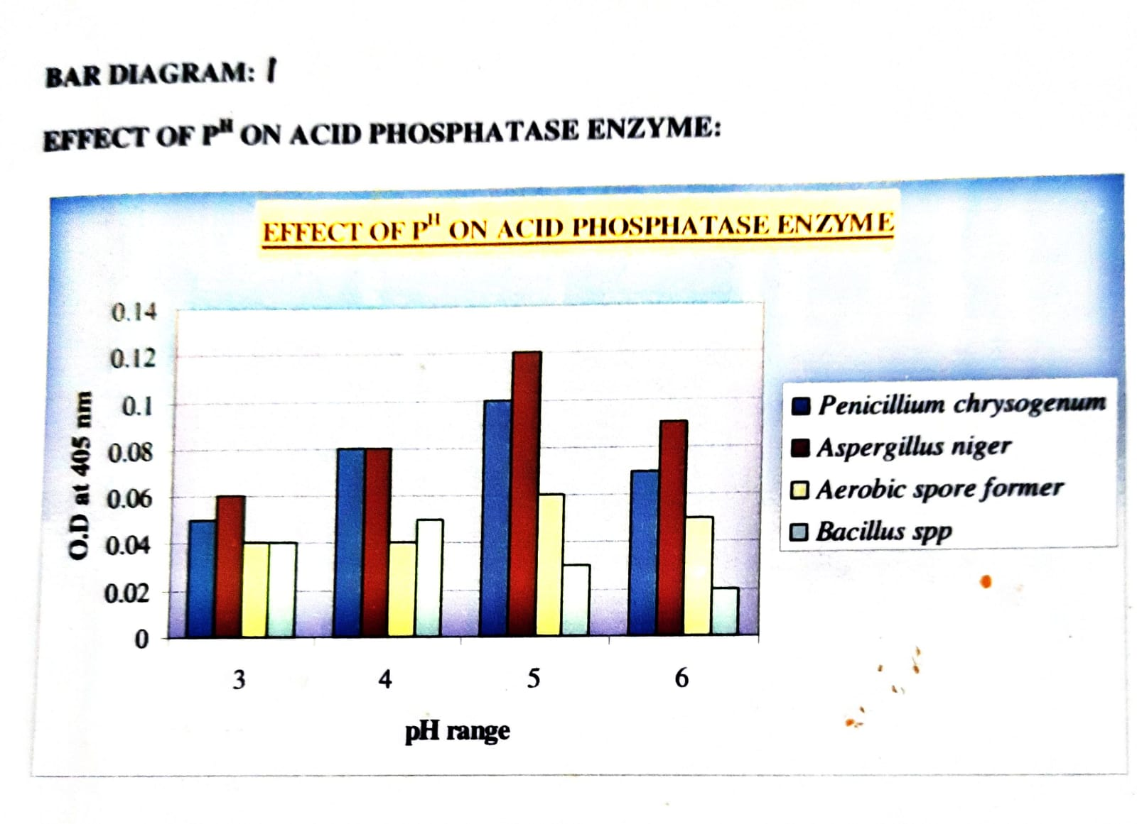

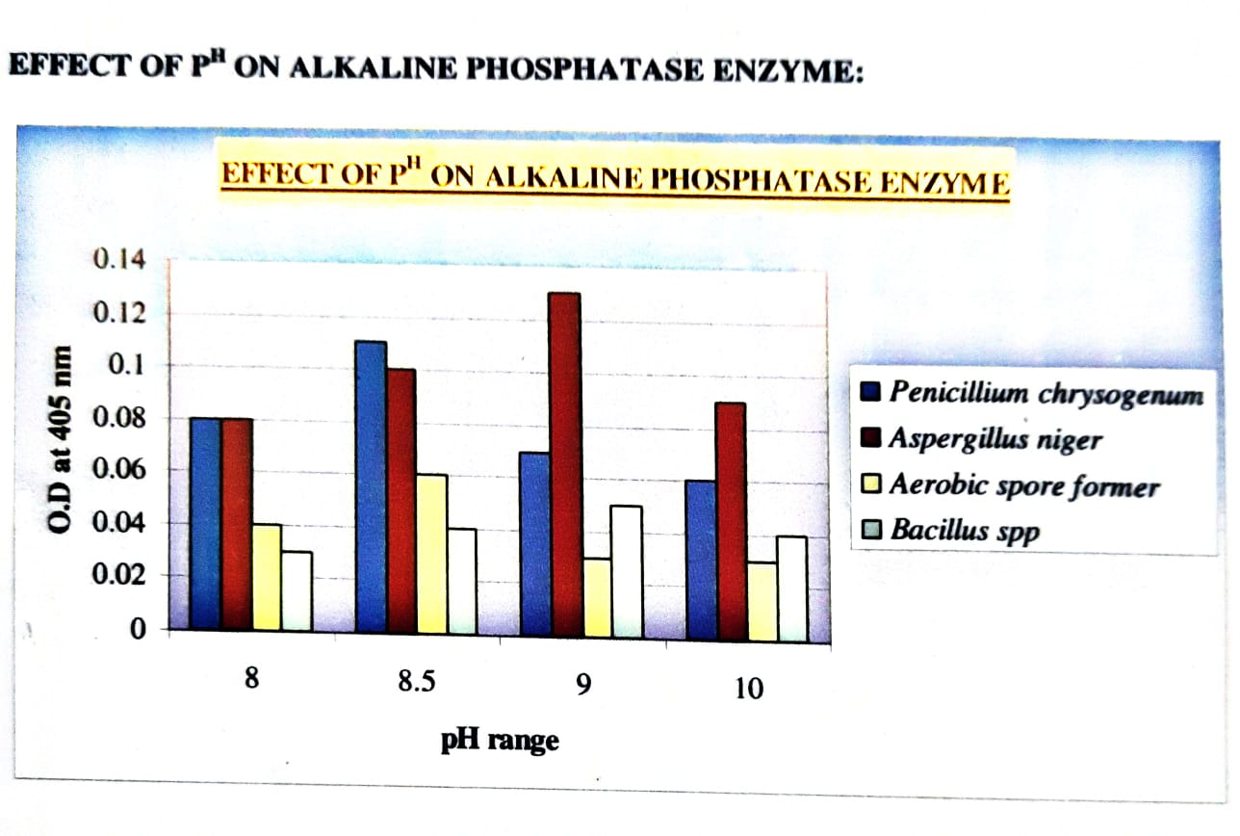

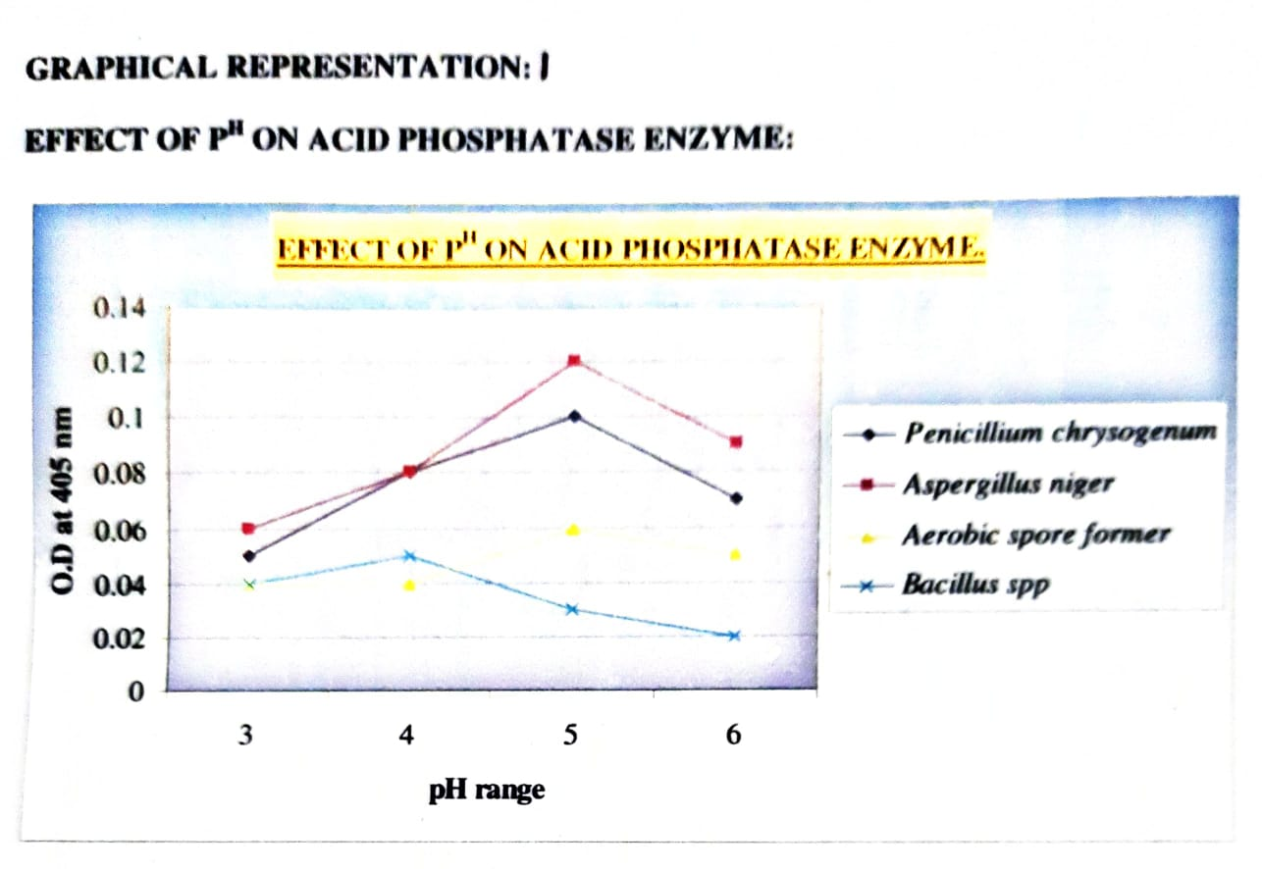

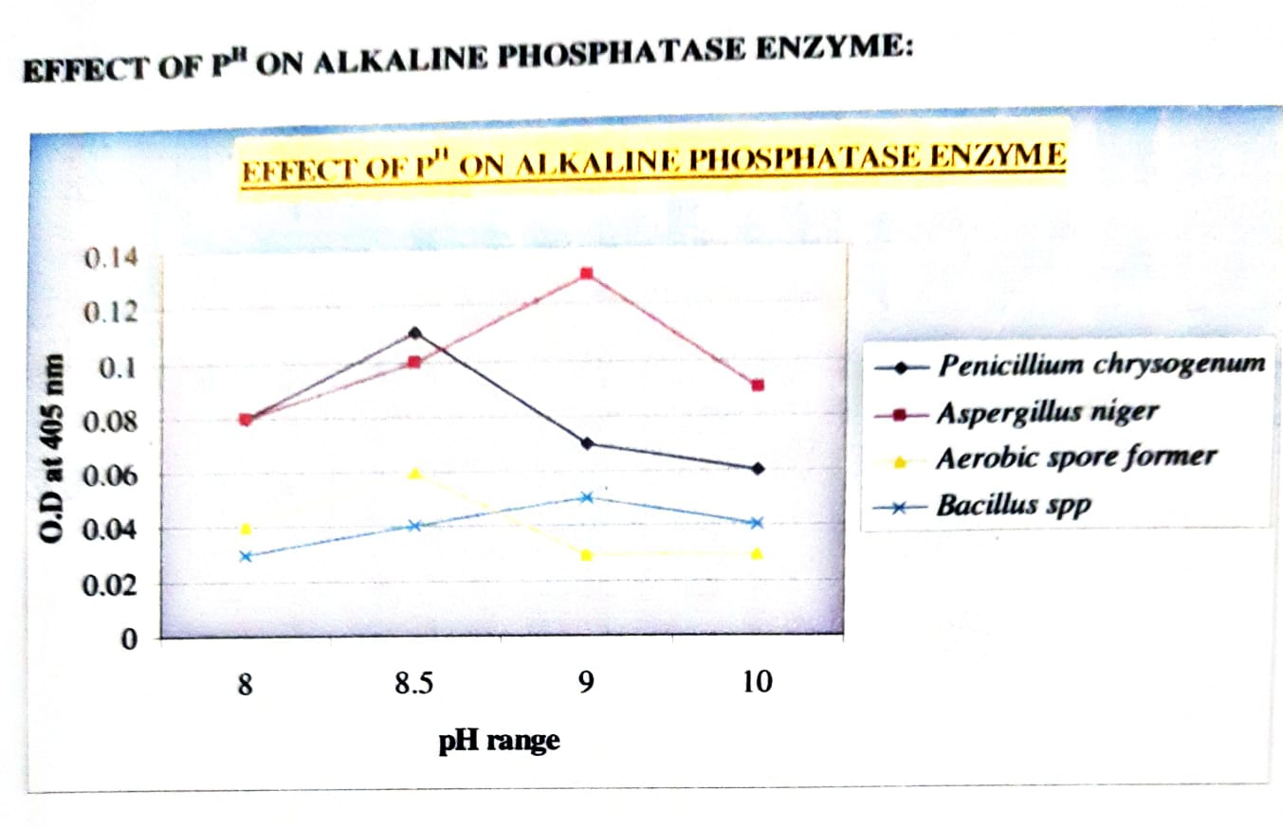

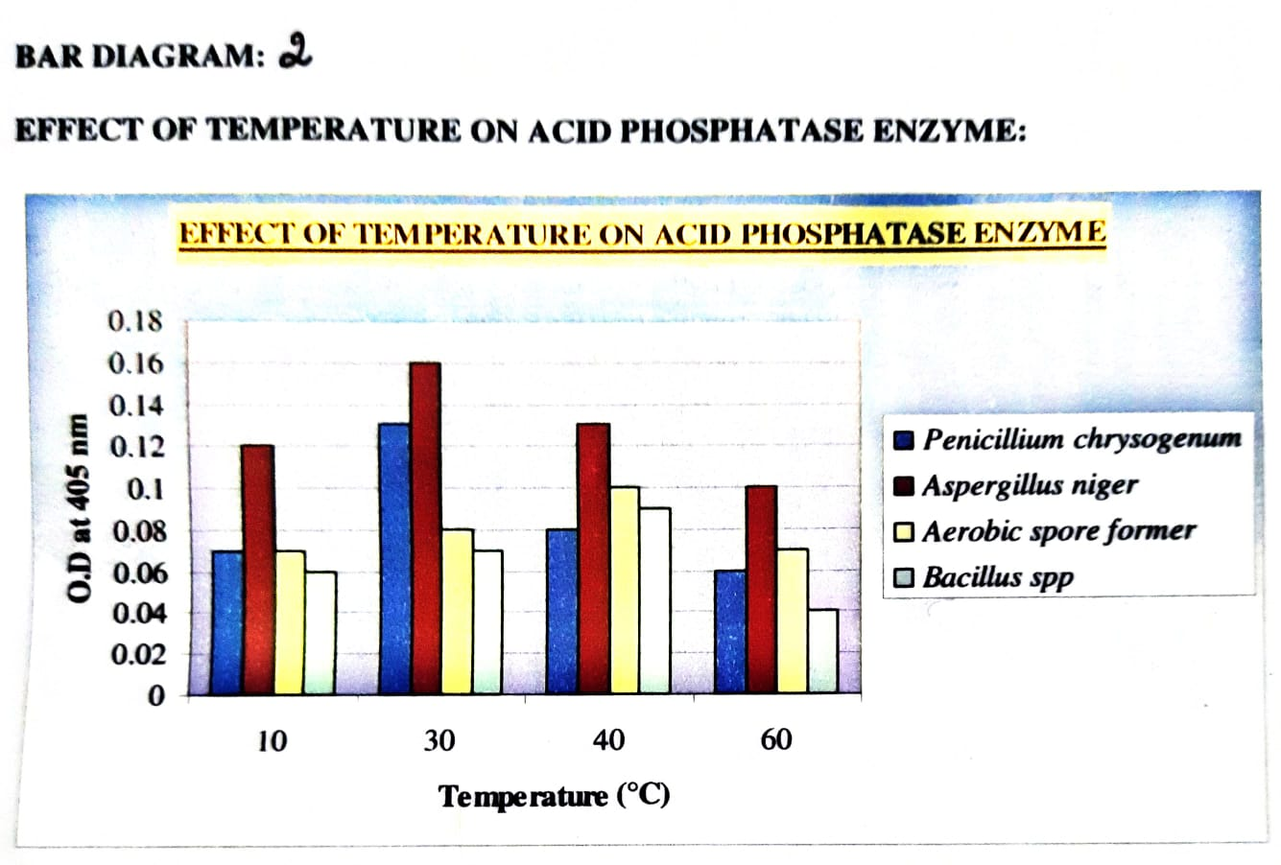

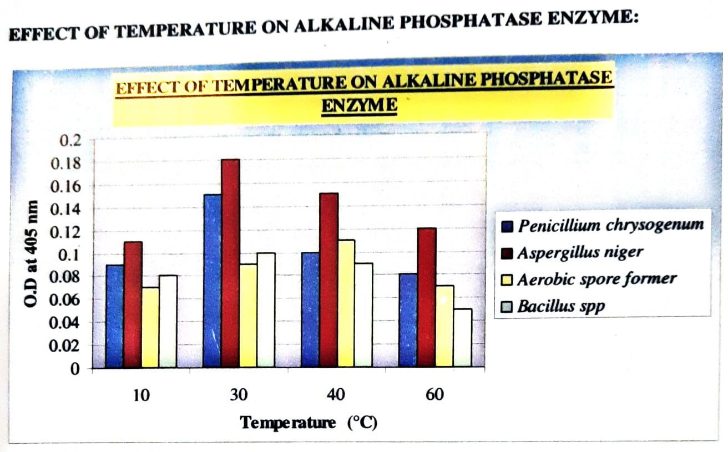

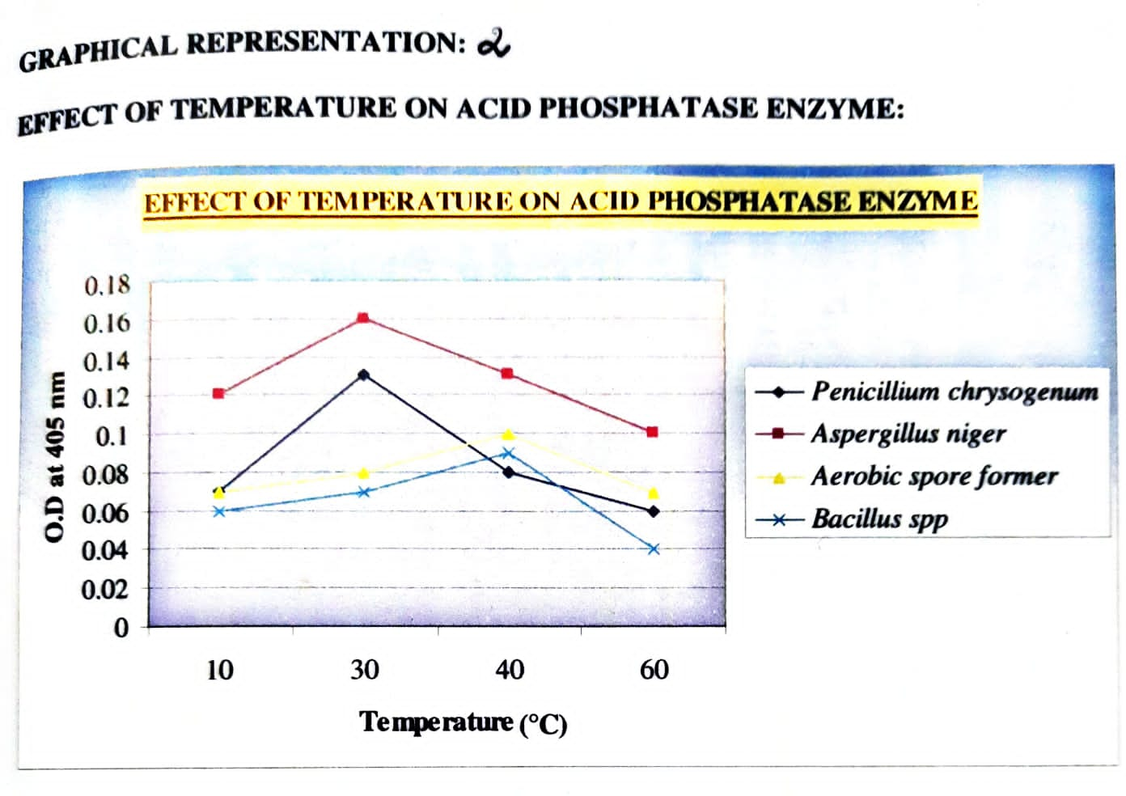

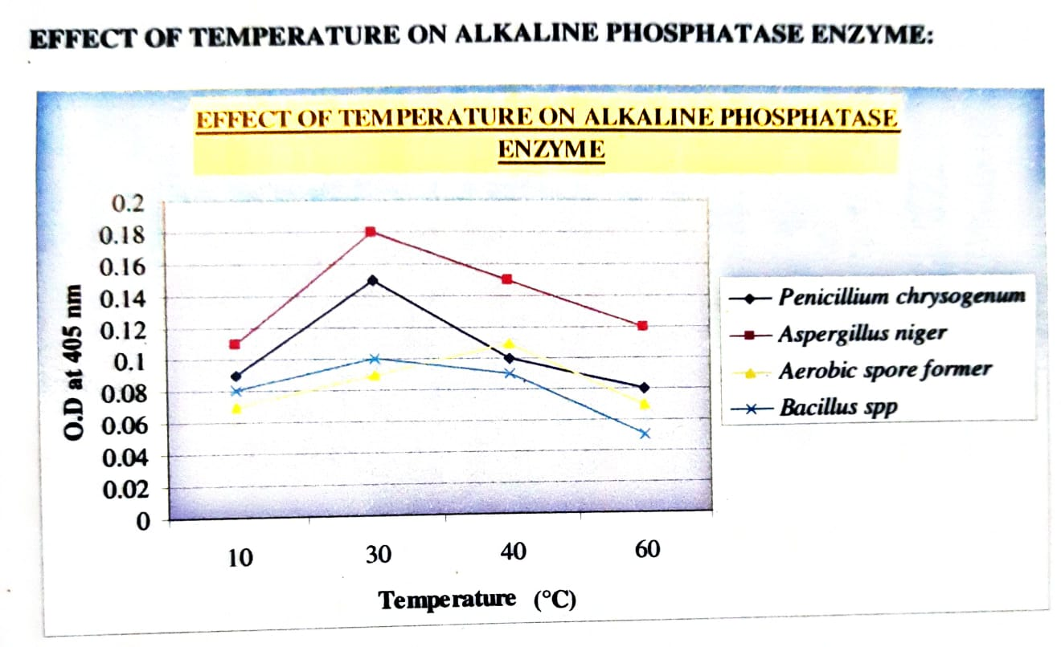

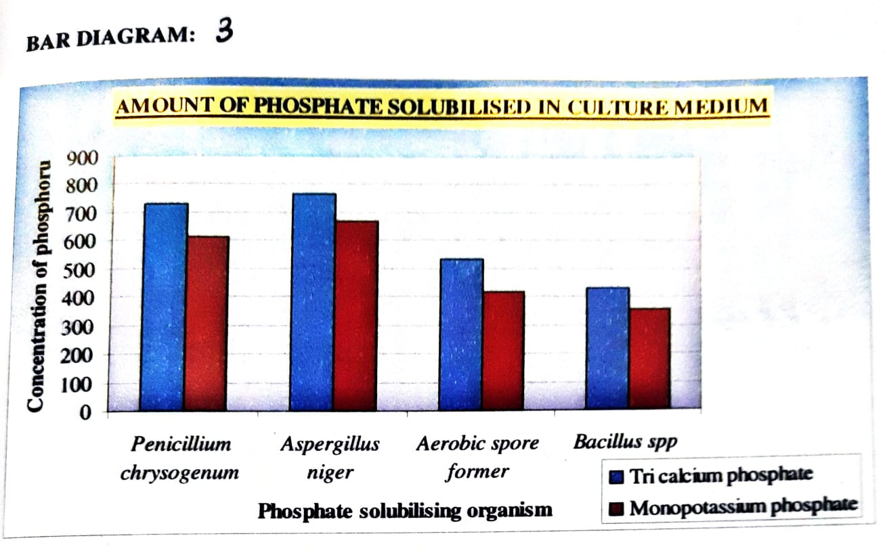

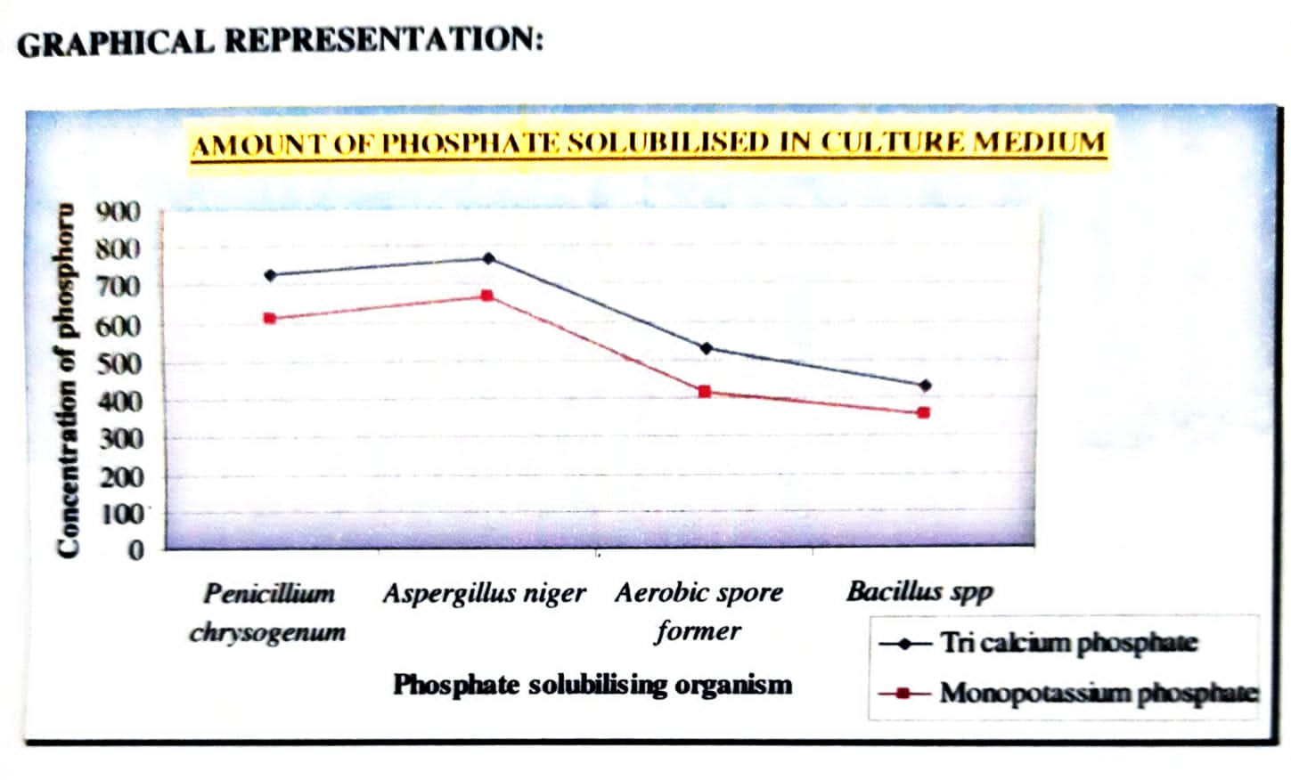

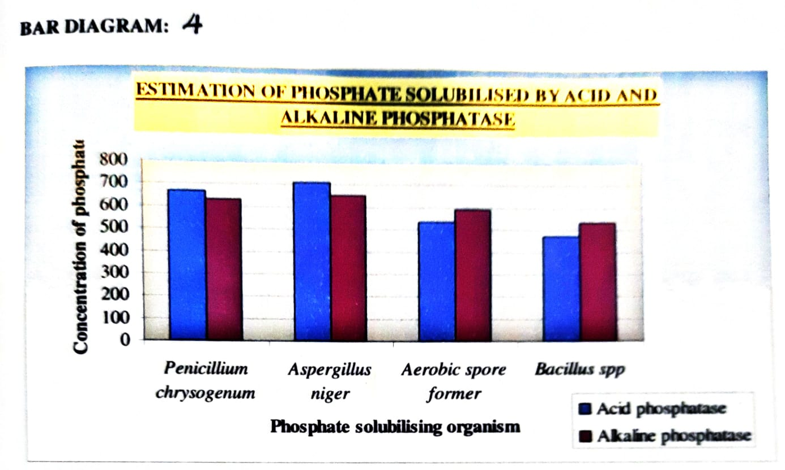



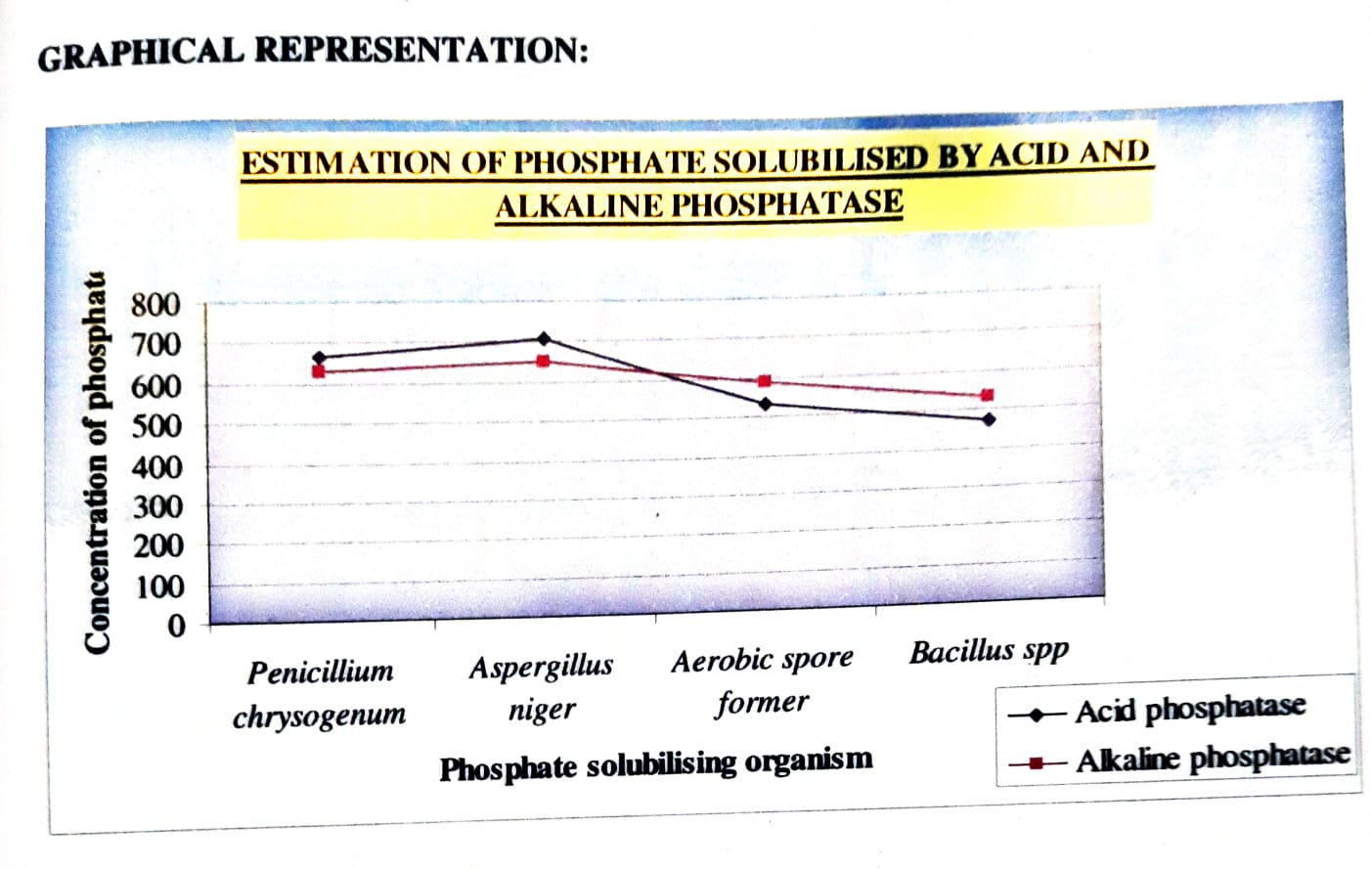

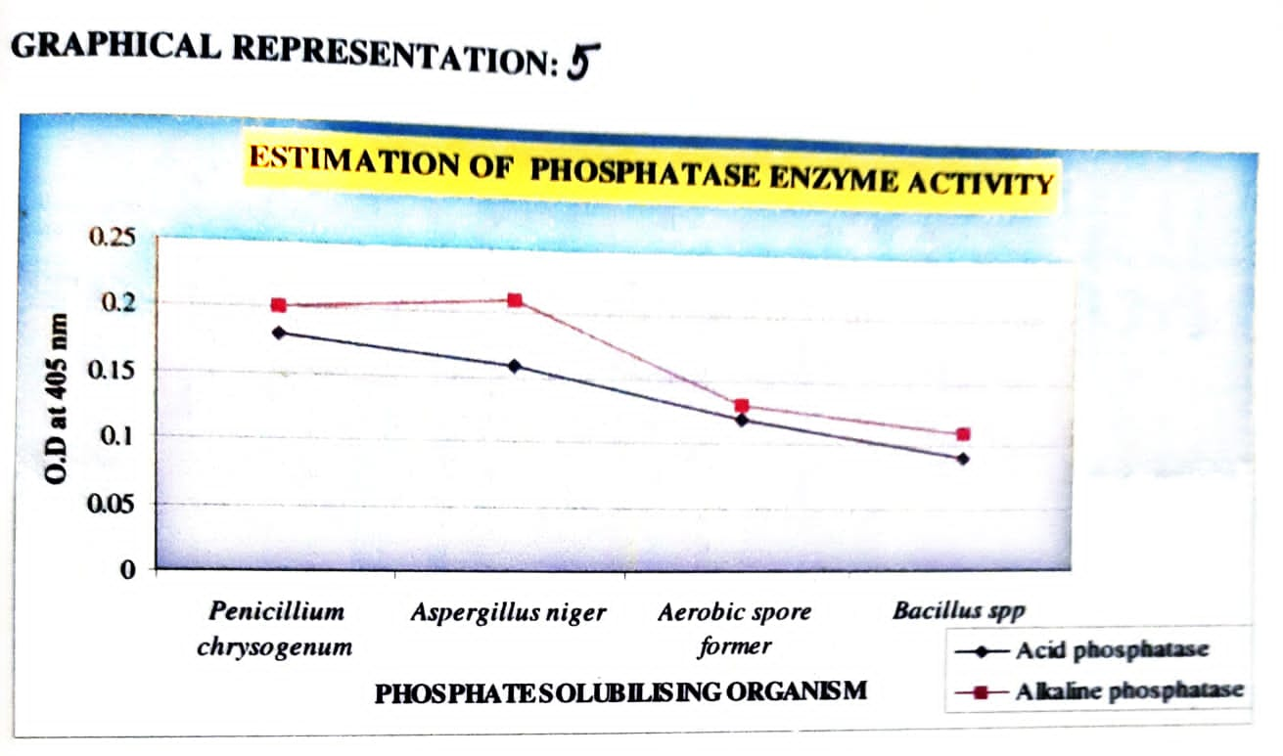

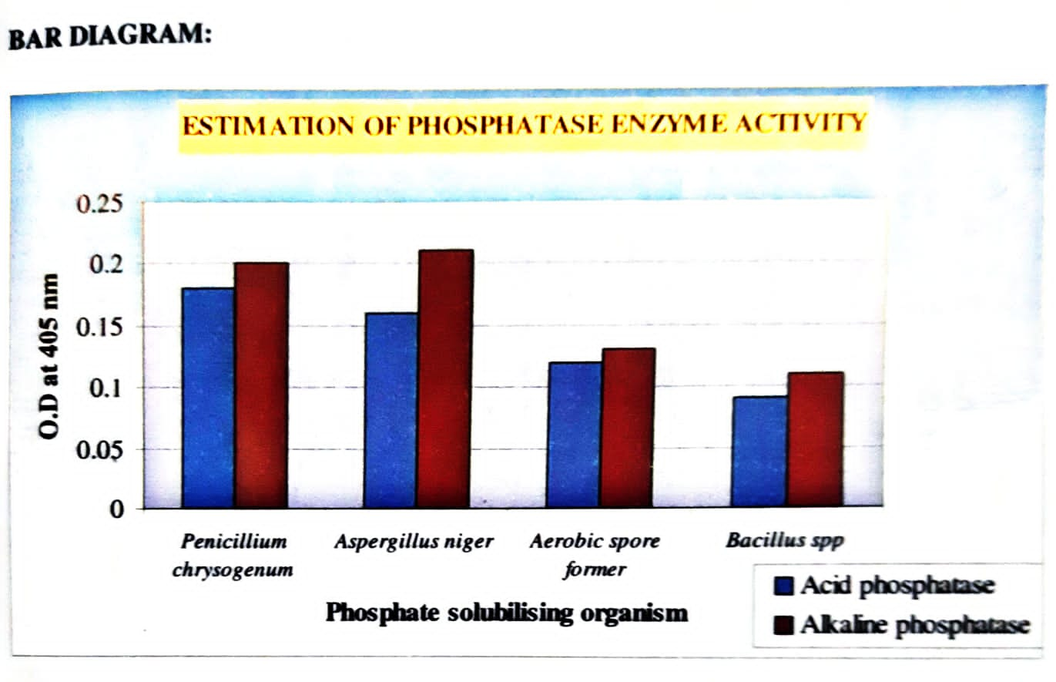

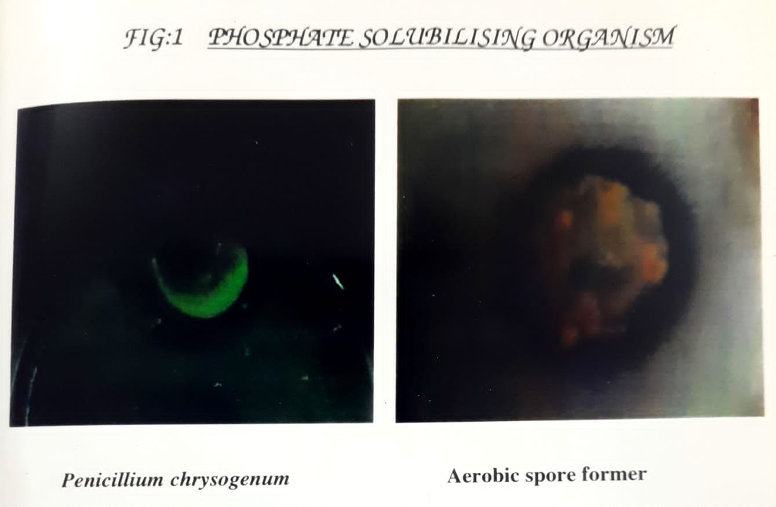 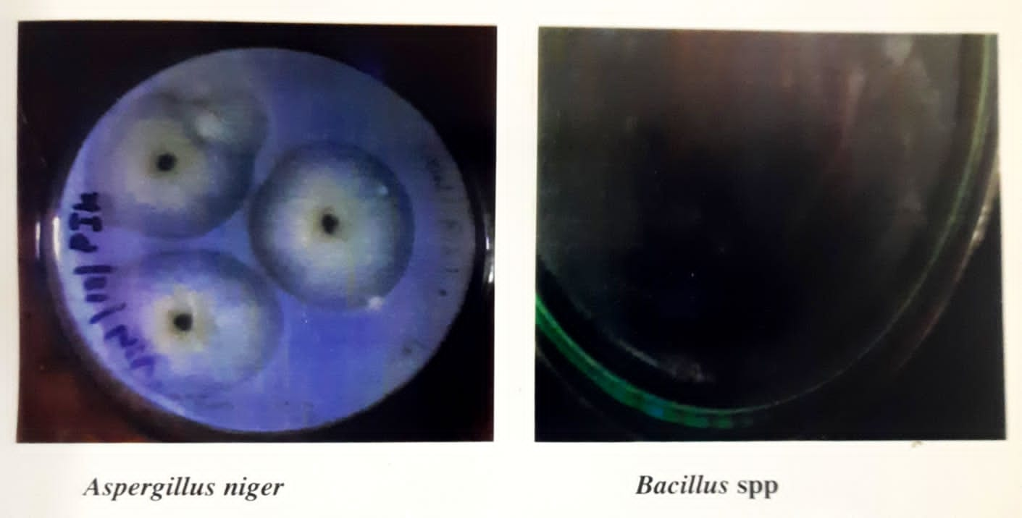

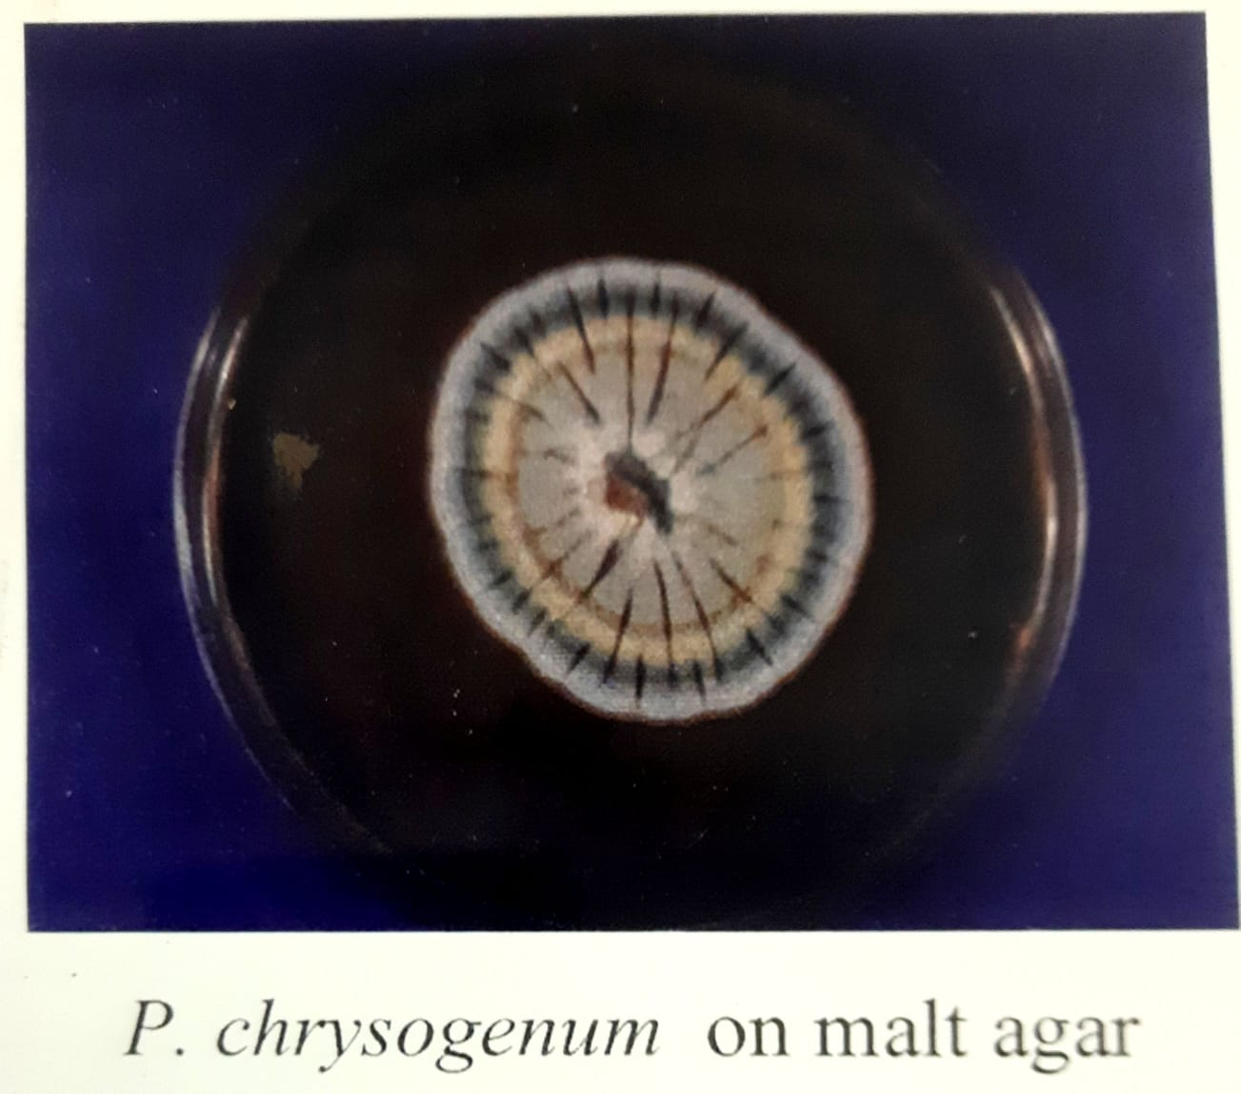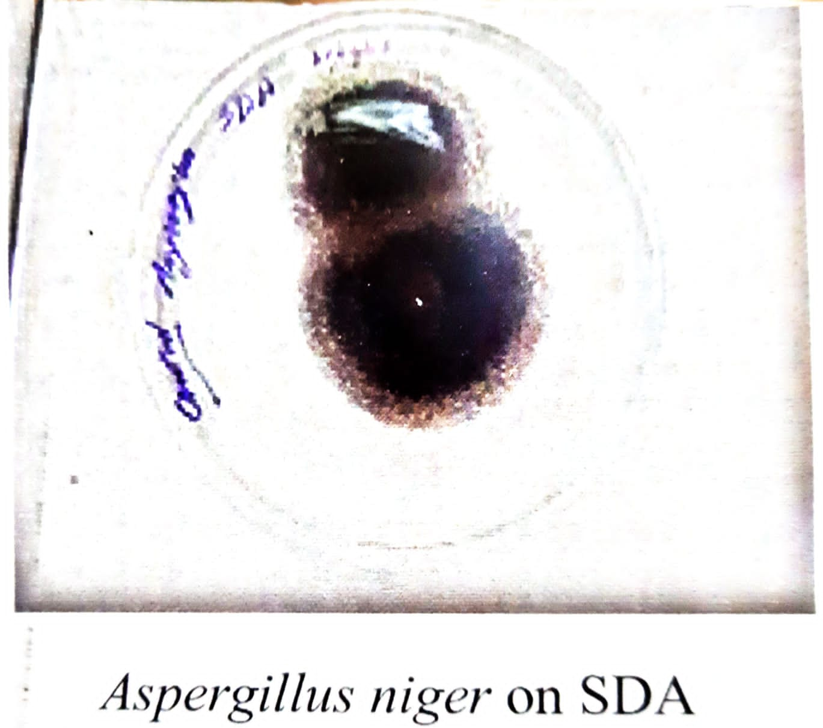

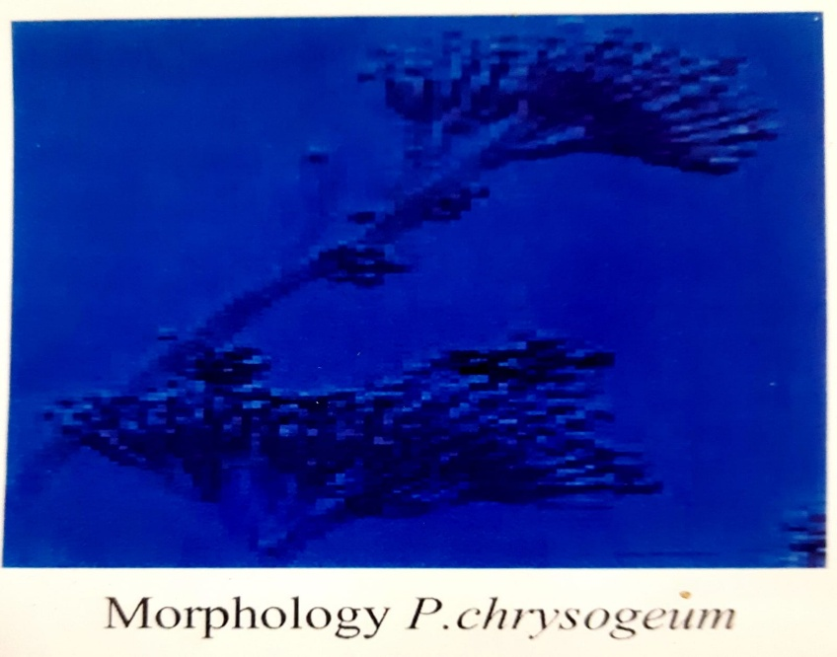

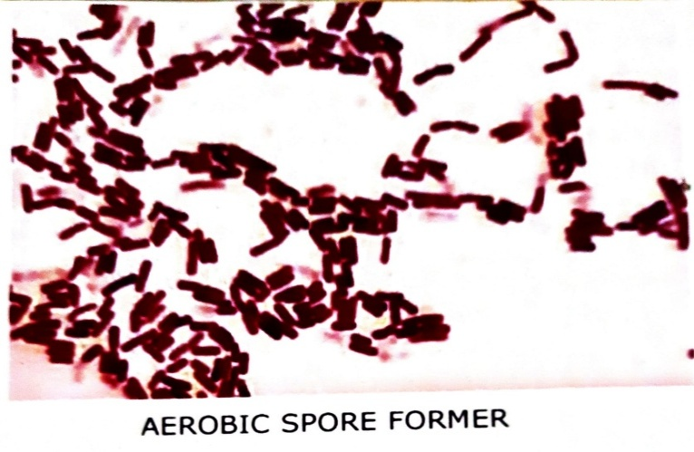

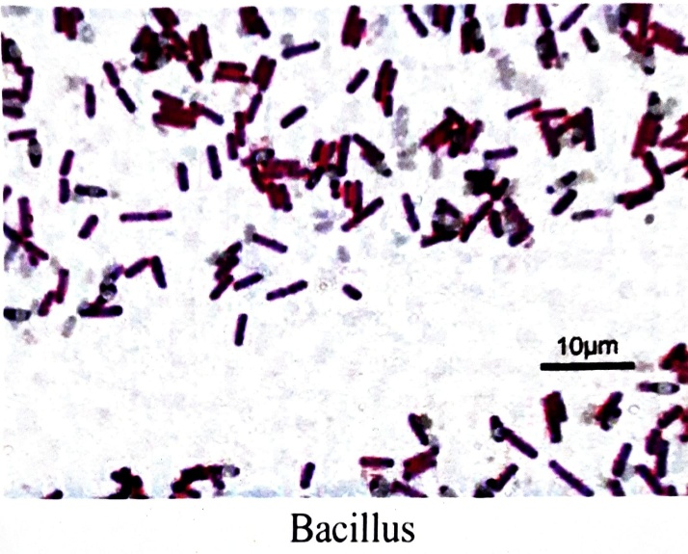

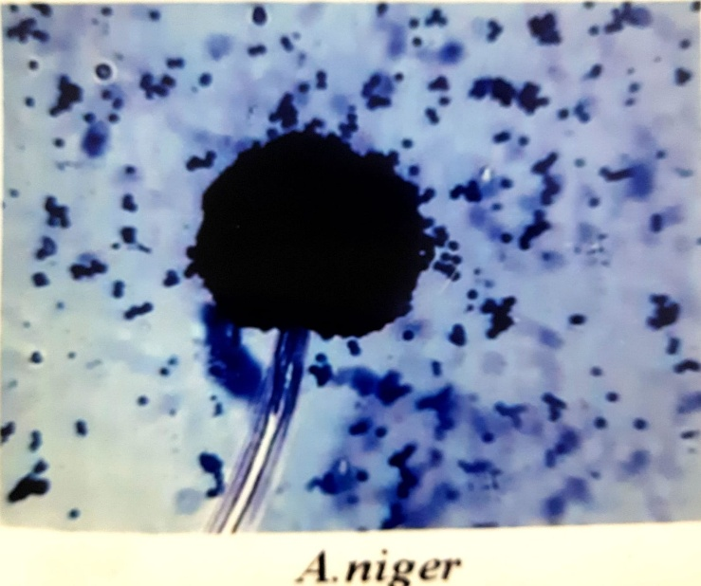

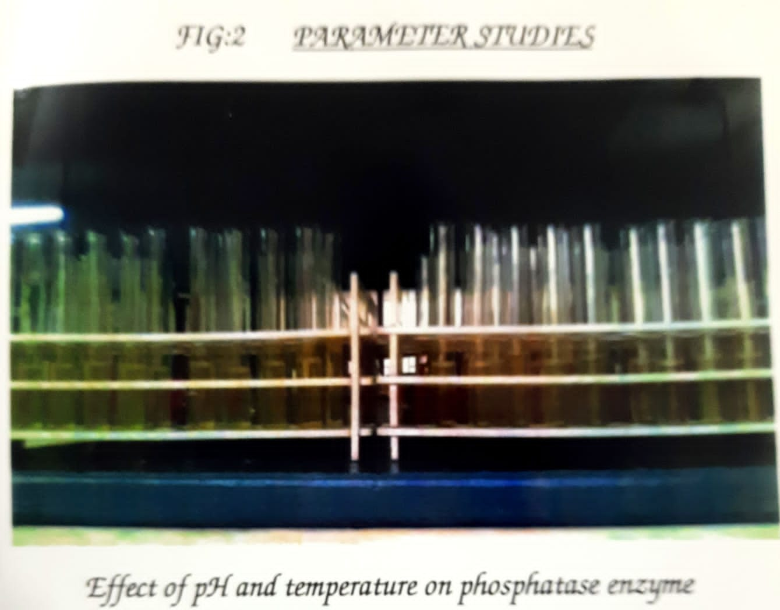

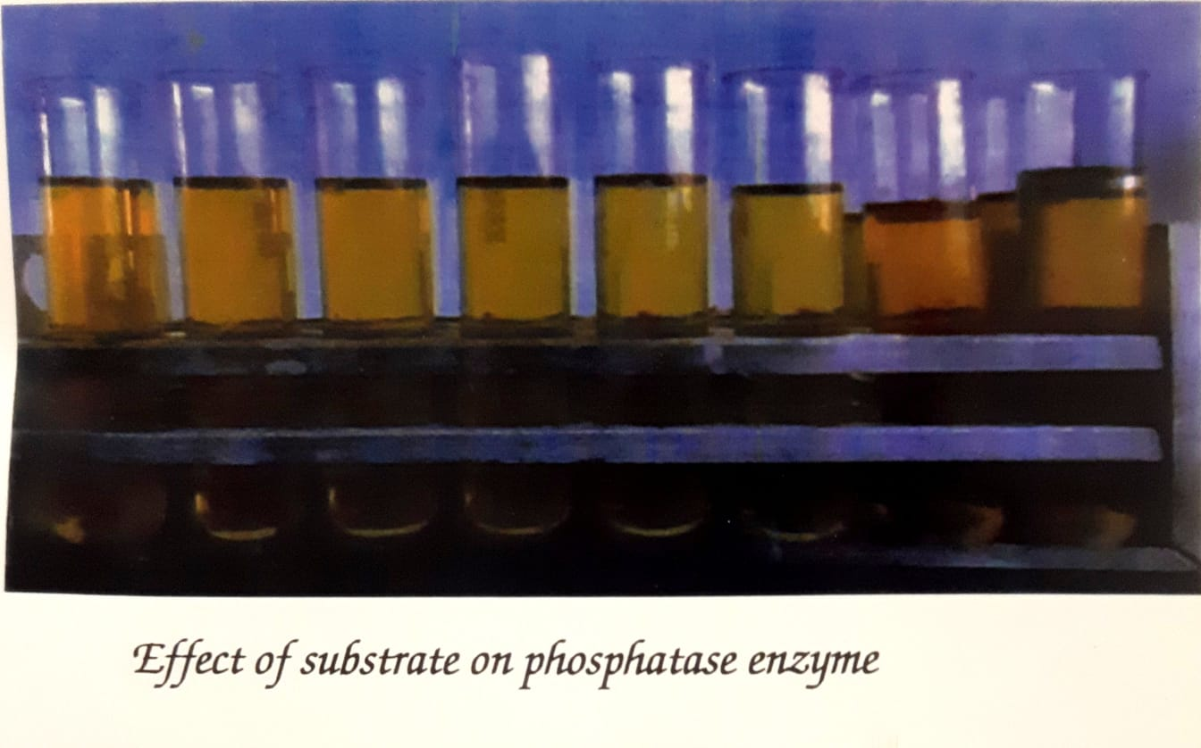

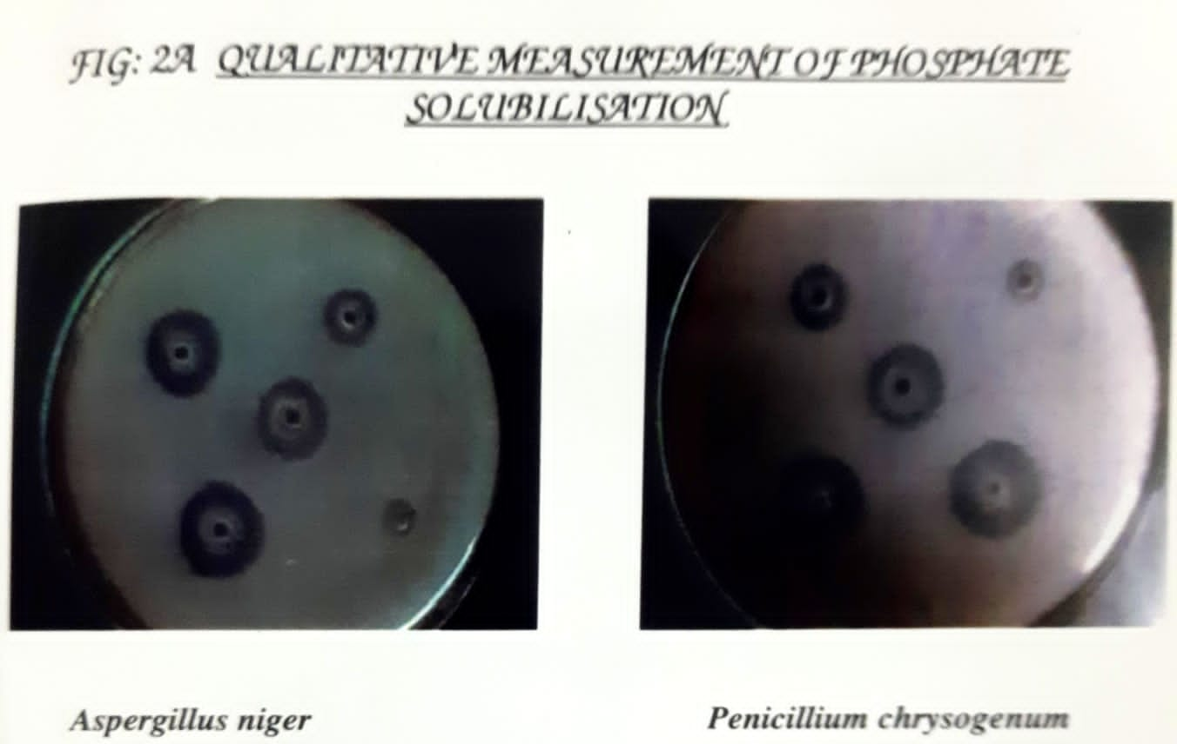

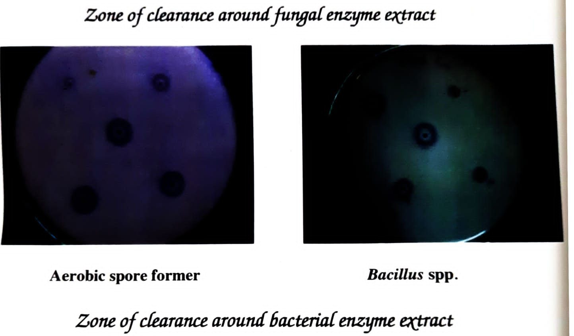

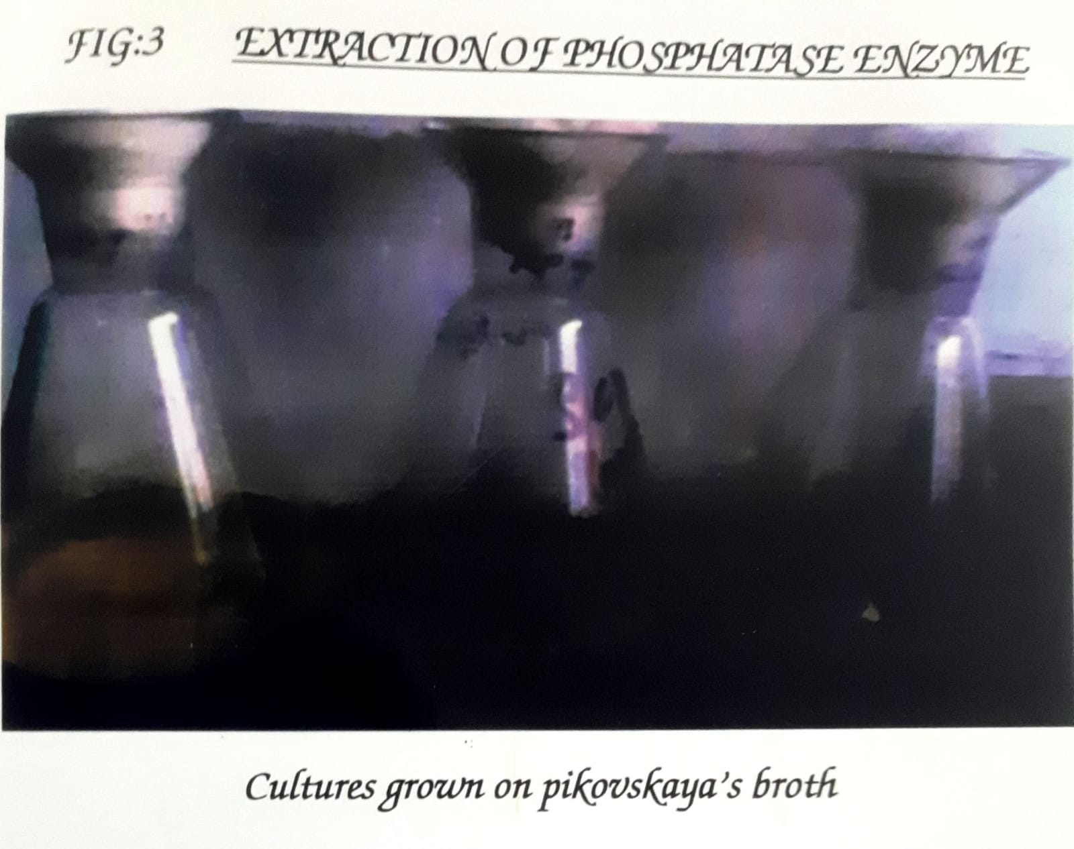

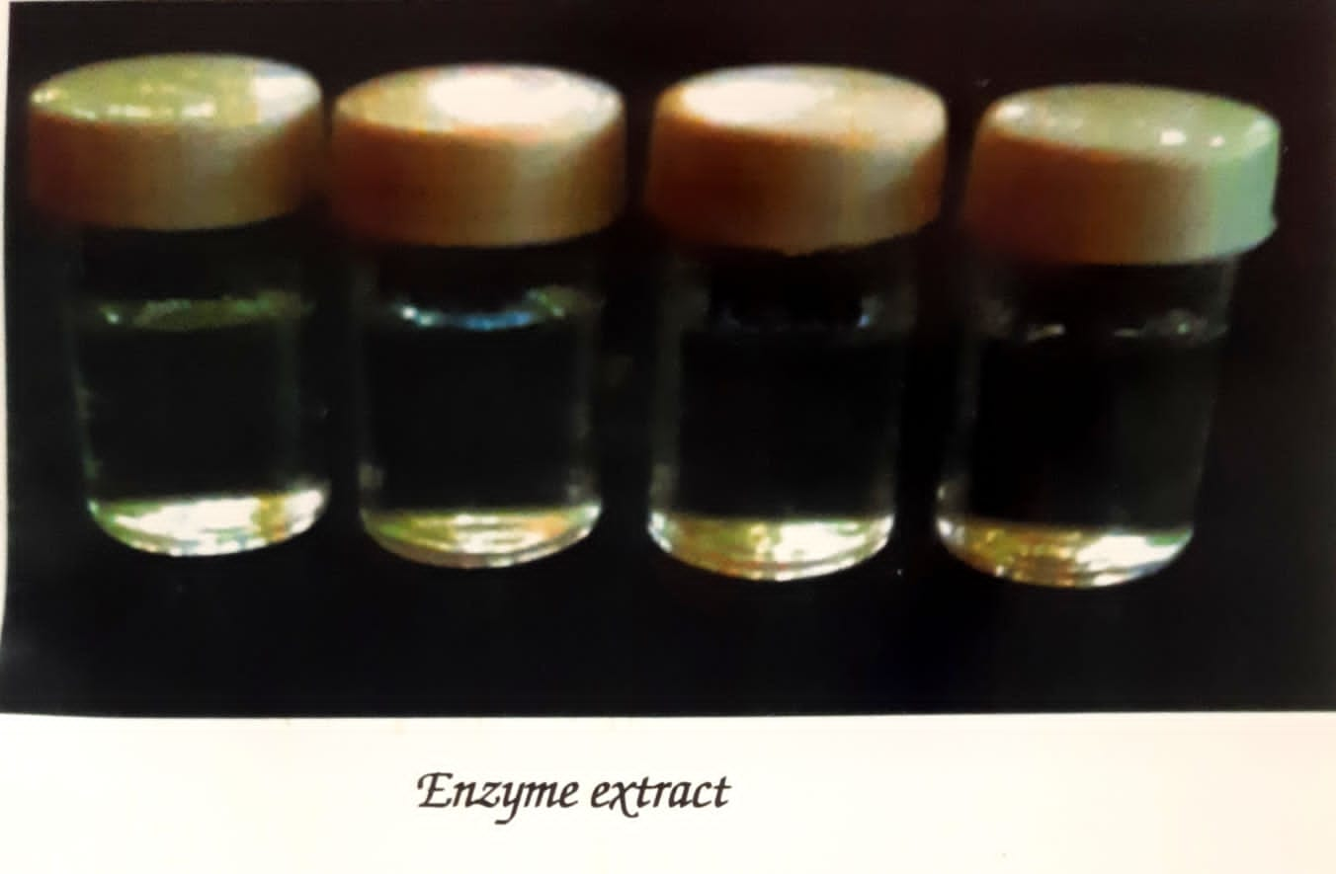

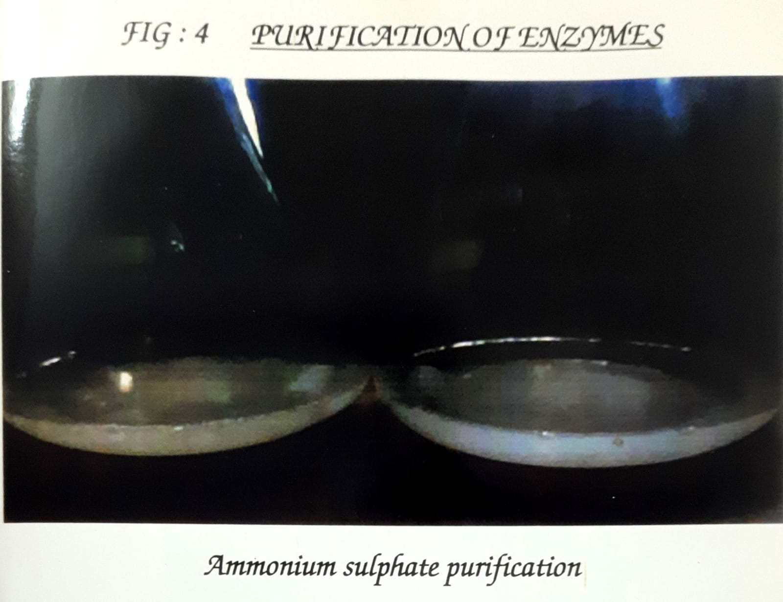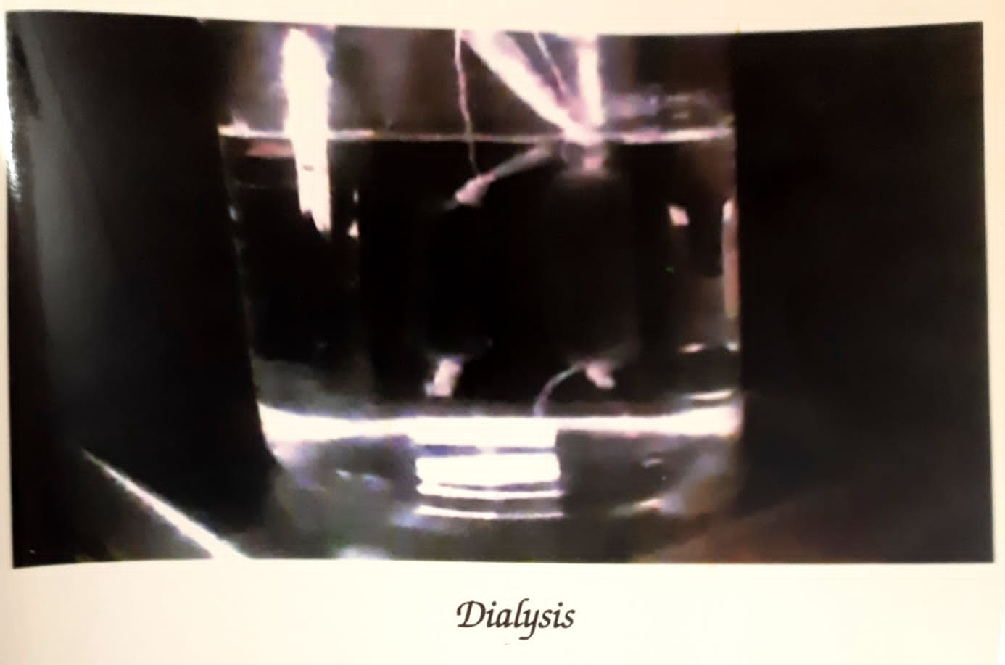

**DETERMINATION OF MOLECJLAR WEIGHT BY SDS PHAGE**

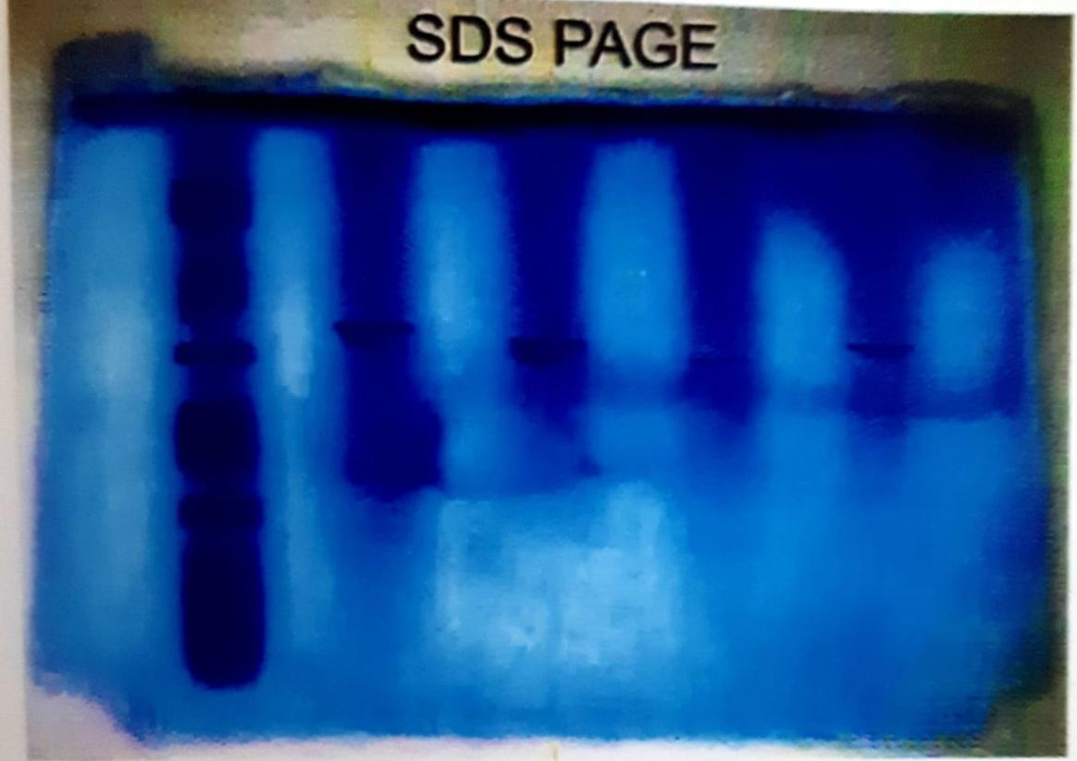

1. **SUMMARY**

Present work carried out on isolation on phosphate solubilizing microbes from soil. Microbes like *Aspergillus* *niger*, *Penicillium* *chrysogenum, aerobic spore former* and *Bacillus* *polymyxa* were isolated. In the present investigation the *Aspergillus* *niger* source highest solubilizing capacity the pikovaskaya’s medium good production of phosphate solubilizing microbes. So the present work concluded that using pikovaskaya’s medium for the production of phosphate solubilizing microbes.

1. **REVIEW OF THE LITERATURE**

**[1] Sundara Rao** and Sinha, (1963) found that the phosphate containing solid media that the microorganisms are capable of dissolving phosphates. Transparent zones of clearance, the microbial colonies indicate the extent of phosphate solubilization.

**[2] Francisco congregado et al.,** (1979) added dimethoate and marathon to the soil at 10 and 100ųg/g. This caused the initial stimulation of CO2 production. Total counts of bacterial propagates were increased.

**[3] Mukherjee and Subba Rao** (1982) proposed that the roots of higher plants provide an ecological niche to the soil microbes within the soil. This was done by genus of Pseudomonas and Bacillus. Those bacteria are able to solubilize available forms of Fe, Ca, Mg, Al, and P. The solubilization effect is generally due to the production of organic acids. (**Kucey**, 1983)

[4] The plant growth promoting rhizobacteria (PGRR) from rhizosphere enhance the growth of plants and reduce the damage from soil bone plant pathogens (**Kloepper** **et al**,).

[5] The most important role of soil organism in ecosystem is decomposing of organic matters, synthesize and release them as inorganic forms that plant can use (**Setiadi et al**., 1989).

**[6] Nautical et al**., (2000) observed that PGRR are able to exert a beneficial effect upon plant growth. N2 fixing and P- solubilizing bacteria may be important for plant nutrition by increasing N and P uptake by the plant playing a significant role as PGRR in the bio fertilization of crop.

**[7] Antananarivo Sharma et al**., (2002) done invitro studies on phosphate removal by *Citrobacter koseri* and *Micro coclus* variants revealed that they could remove phosphate upto 84 and 88% respectively from the gelatin and soap industry effluents.

**[8] Luis Henrique et al.**, (2006) isolated many enzymes produced by fungi. Isolation of filamentous fungi from the soil and humus, plant and sugarcane forty were isolated and examined for their ability to produce Xylanase, glucose- oxidase, alkaline phosphatase, acid phosphatase, phytase, pectinase, and amylase.

**[9] Stephen Joseph et al**., (2008) isolated phosphate solubilizing bacteria (PSB) possessing the ability to solubilize insoluble in organic phosphates from rhizosphere soil. The efficiency of phosphate solubilization was decreased in buffered media compared to non- buffered media.