TOPIC HUB

Pankaj Kunekar  pankaj.kunekar@vit.edu  Department of Artificial Intelligence and Data Science,  VIT Pune | Mihir Deshpande  mihir.deshpande20@vit.edu  Department of Artificial Intelligence and Data Science,  VIT Pune | Adwait Gharpure  adwait.gharpure20@vit.edu  Department of Artificial Intelligence and Data Science,  VIT Pune
Vedant Gokhale  vedant.gokhale20@vit.edu  Department of Artificial Intelligence and Data Science,  VIT Pune | Aayush Gore  aayush.gore20@vit.edu  Department of Artificial Intelligence and Data Science,  VIT Pune | Harsh Yadav  harsh.yadav20@vit.edu  Department of Artificial Intelligence and Data Science,  VIT Pune

Vishwakarma Institute of Technology, Pune 411037, Maharashtra, India

Abstract — Managing different assessment schemes has been a tedious task for teachers as well students. Creating different spreadsheets for every assessment makes the work clumsier and difficult to manage. Which also makes it hectic for students and teachers to maintain and assess them .
To solve this problem we decided to create a single platform to create, assess and manage all the respective subjects assignments and all the assessments. This will boost up the academic process and help professors and students to easily and efficiently go through their academics.Students can also form groups with other students and can get approved by the respective faculty.
Keywords— react, web-development, express, mongodb,

Introduction

The term "web technology" refers to all forms of technology used largely on the World Wide Web . It's an information system where Uniform Resource Locators may identify papers and other online resources. The usage of web technology is essential in order remotely managing and getting information.[1]
The advantages of web technology in our day to day life and in education after the pandemic are known to all. This enables us to save time and unnecessary efforts. We aim to achieve this goal. In college, Students have a multitude of assessments in addition to exams that are important, Assessments like Group Discussions, Viva Voce exams, Seminars, Course Projects and more. Keeping track of all these is a tiresome process, Students and Teachers currently use informal means like Excel spreadsheets and whatsapp groups to bring some structure. These methods can bring trouble for students that are out of the loop. We aim to solve this problem using Topic Hub

TopicHub is a Web-based Application that helps students and faculties to comfortably select the assignment topics and easily grade them. This project is based mainly on MERN stack and is developed with the emerging technologies such as ReactJS which help in creating a optimized frontend of our app, Express JS as Backend for creating API’s, Mongo-DB as database, also used chakra for the UI of our web Application.

Literature Review

1.Protrack: A Student-Teacher Project Management Tool : Protrack is a web based tool to create teams among students in cooperation with the teachers.
2.A portal of educational resources: providing evidence for matching pedagogy with technology:This paper focuses on TPK, the intersection between technology knowledge and knowledge as a crucial field of investigation.
3..College ERP Using MERN Stack : This application was developed for an engineering college to maintain and facilitate ease of access to information using MERN.
4.Node.js: Using JavaScript to Build High-Performance Network Programs : This paper discusses the importance of NodeJs in the web development field.
5.Using Node.Js to Build High Speed and Scalable Backend Database Server: This paper discusses the use case of Node Js in building the backend for a project.
6.Full Stack Web Development Teaching: This paper promotes learning and skill enhancement in the field of Web development with the emerging technologies.
7. The New Era of Full Stack Development:This paper is a concise study of the evolution of full stack web development.The paper discusses different technologies of full stack development.
8.Database-Driven Web Development Fundamentals : This paper discusses the fundamentals of database management in the development of web technologies.
9.Modern web application development technologies : This paper discusses the evolution of modern web technologies and also discusses the uses of web development in various fields.
10.Django-Based Web Application to Empower Skilled People : This paper mainly focuses on how Django can be useful in web development and future uses of the same.
11.HTML Educational Node.js System (HENS): An Applied System for Web Development: The paper introduces the reader to the Node JS and HTML framework for web development.
12.Web development with node.js : Paper demonstrates step-by-step instructions to develop a web application and deploy it on Heroku.
13. REST API Development with Node.js: This paper discusses the development of REST API’s using Node Js in the web development domain.
14.Using Express.js to Create Node.js Web Apps: This paper demonstrates the integration of ExpressJS with Node js.
15.Programming Web Services on the Cloud with Node.js : This paper demonstrates working of web services in integration with cloud services such as MySQL,MongoDb,.

System Design

TopicHub is a web based application that is used to keep track of all your assessments in a class. The system consists of two modes - one for the students and one for the instructor. The app is designed in a way where students and teachers can collaborate for transparency and clarity

Students view: When Students Access TopicHub, they are met with the option to Join a class, Create/Join a group with different members of the class, Access their subjects and subject teachers. They can also view their previous assessments in a modal in their subjects page, and choose the topic name for a new assessment that their teacher starts. The student can also view his/her information on the “My Profile” page.
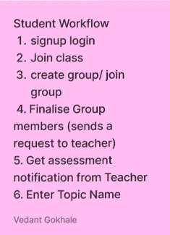

Teacher View
When Teachers use TopicHub, they can start a new class and share the class code with students, appoint different subject teachers for different subjects, Start new assessments, Approve/ Reject the topic selected by the students, and allot marks on assignments after evaluation. This makes the whole process smooth and easier.
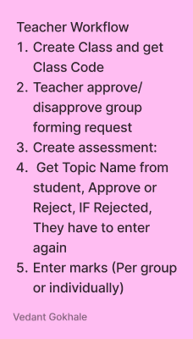

- FLOW DIAGRAM

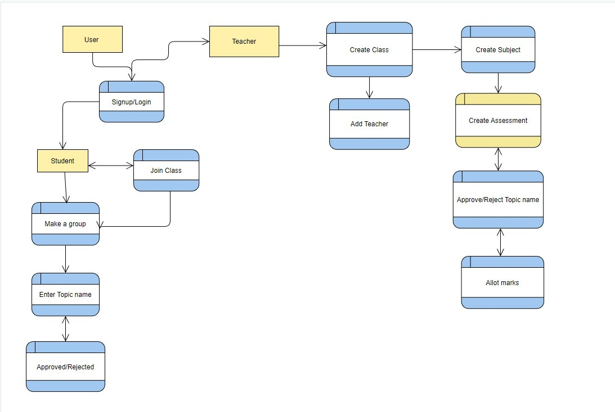

results and discussions

We created the WebApp for the desired task which is where we students can be able to add topics and the faculty can approve it.
Basically we created two login options:
1. For Students
2. For Teachers
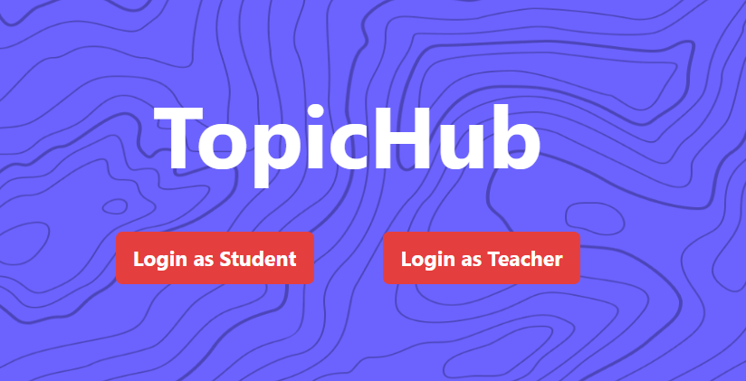
We also created two schemas in the database for achieving this.
In students login we implemented options like join class using ID, create a group, join a group, share group link etc.
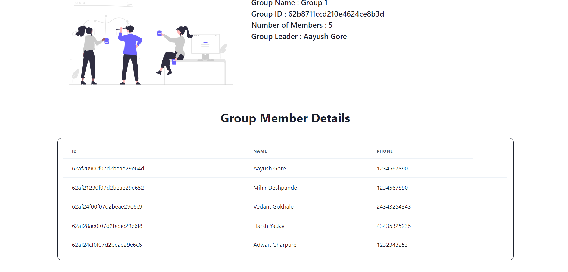
The above image shows the list of group members who have joined the group.
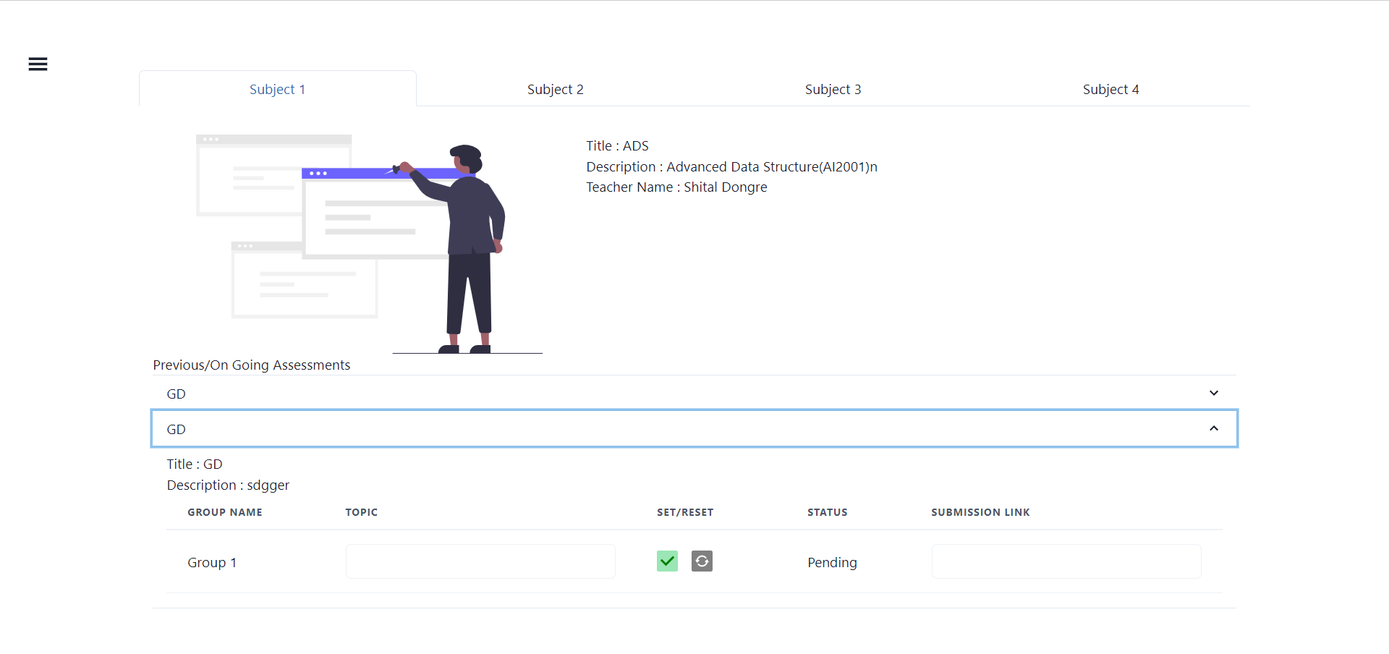
This image shows how the students can submit their topics and get accepted by the respected tutor.
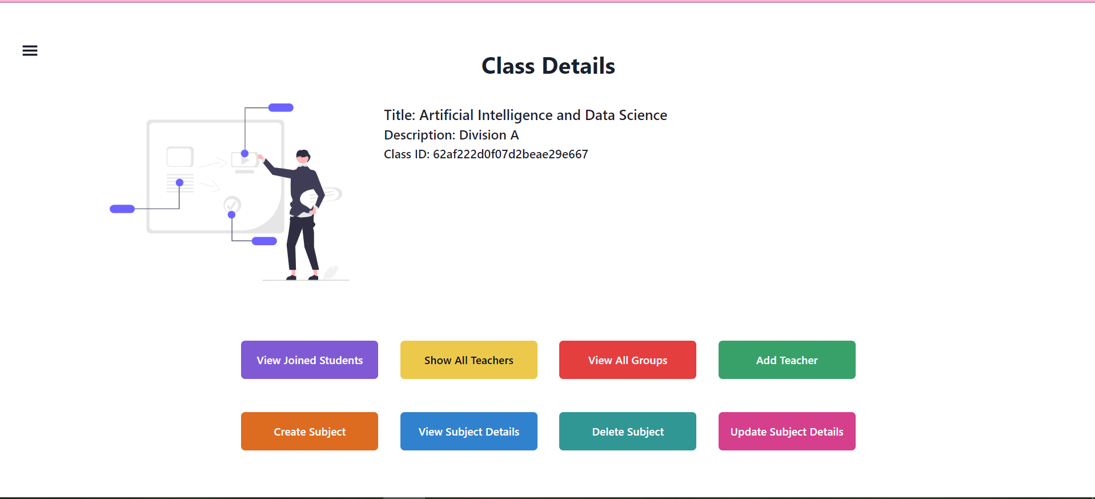
This image shows the options the class teacher has to grade, view , assess students.

Future Scope

As our project is highly scalable, we can implement various modules for more interaction between students as well as students and teachers like chatbots, video conferencing, etc. Also, we can add various features like where we can share assignments, docs, or the link to them. This project could be used by different universities for their own internal assessments.

Conclusion

Nowadays web applications are used in various different sectors. Web applications based on modern technologies are easy to scale and easy to run, and can be operated remotely from any part of the world. Though different applications are available currently, there is not a single web application that has both teacher and student interaction. Topic Hub gives a one-stop solution to get rid of different spreadsheets and provides an easy to manage application that can be used by both teachers as well as students simultaneously.

REFERENCES

[1].Protrack: A Student-Teacher Project Management Tool: Dr. V. Vijayakumara , R. Pradeep Kumara , Siddhartha , C. Harish Mohana , and V. Deepak Kumaran, 28 April 2021
[2]A portal of educational resources: providing evidence for matching pedagogy with technology: Nicoletta Di Blasa, Alessandro Fioreb , Luca Mainettib , Roberto Vergallob and Paolo Paolini: February 2014
[3] College ERP Using MERN Stack: Shubham Patil, Saurav Daware, Ameya Bhagat, Prof. Jayant Sawarkar.
[4].Node.js: Using JavaScript to Build High-Performance Network Programs.
[5].Using Node.Js to Build High Speed and Scalable Backend Database Server: S. L. Bangare , S. Gupta , M. Dalal , A. Inamdar; March 2016
[6].Full Stack Web Development Teaching: Current Status and a New Proposal: Anna Petrikoglou and Theodore H. Kaskalis
[7].Akshat Dalmia , Abhishek Raj Chowdary, 2020, The New Era of Full Stack Development, INTERNATIONAL JOURNAL OF ENGINEERING RESEARCH & TECHNOLOGY (IJERT) Volume 09, Issue 04 (April 2020).
[8].Database-Driven Web Development Fundamentals, Thomas Valentine, 2021.
[9] Modern web application development technologies.
[10]Django Based Web Application to Empower Skilled People: TUSHAR SAWANT1 , AFROJ SATWILKAR , VAIBHAV SHIRKE , SANTOSH V. JADHAV, May 2021
[11]HTML Educational Node.js System (HENS): An Applied System for Web Development,Brian Carter 2014
[12]Web development with node.js, Seikyung Jung 2018
[13]REST API Development with Node.js, Fernando Doglio, 2018
[14]Using Express.js to Create Node.js Web Apps,Azat Mardan, 2018
[15]Programming Web Services on the Cloud with Node.js,Ariel Ortiz, 2016

