UNCERTAINITY ANALYSIS AND FORECASTING OF PV POWER PRODUCTION

Prakhar Hari, Prachi Mishra, Pooja Singh
G.B. Pant University of Agriculture and Technology
Pant Nagar, Uttarakhand, India, GBPUAT, Delhi Technological University Delhi
prakharhari6766@gmail.com, mishraprachiece@gmail.com

ABSTRACT

As energy supply and the ecological condition becomes gradually tight and critical everywhere in the world, the discrepancy between electric power supply and demand stands out. The growth and application of conventional energy sources endure from increasing limitations. Solar energy is recognized as an ideal renewable energy power generation source. Photovoltaic power generation is an important solar energy utilization pattern, but the output of PV power plants is majorly random, with a changeable and infrequent nature. The current work introduces an empirical ground framework for the analysis of uncertainty and forecasting of photovoltaic (PV) power generation. It has a significant impact on power systems when its penetration increases to a high level since this resource has large variability and uncertainty, to make the analysis of our data smoother we developed a method to remove periodic component. We have worked on a method to manage the uncertainty of photovoltaic (PV) data by removing the periodic effect of the annual position of the sun in the sky. To determine predictable low-frequency component in the system operation we have used least squares method. This method can be applied to estimate the probabilistic characteristics of PV generation at numerous locations on the earth with differing solar radiation due to changing solar position. As different locations have their own geographical and ecological conditions, the probability distributions of the PV generation are also different. The change of solar position has a periodic behaviour, which is deterministic. This characteristic can be removed from the observed data to more accurately characterize the uncertainty. Forecasting the output power of PV plant is a significant problem for electric power departments to adjust dispatch planning in time, boost the reliability of electric system operation and the connection level of PV power plants and reduce spinning the reserve capacity of generation systems. A method combining the advantages of the wavelet decomposition (WD) and artificial neural network (ANN) to solve this problem. With the intelligence of ANN to address vi nonlinear relationships, theoretical solar irradiance and meteorological variables are chosen as the input of the hybrid model based on WD and ANN. The output power of the PV plant is decomposed using WD to separated useful information from disturbances. The ANNs are used to build the models of the decomposed PV output power. Finally, the outputs of the ANN models are reconstructed into the forecasted PV plant power. The presented method is compared with the traditional forecasting method based on ANN. They are applicable to analysing the variations of renewable energy sources with obvious uncertain components and non-stationary characteristic. In the proposed method, the Wavelet Transform is applied to have a significant impact on ill-behaved PV power time-series data, and AI techniques capture the nonlinear PV fluctuation in a better way.

Keywords- Photovoltaic (PV), PV power generation, Power prediction and forecasting of PV power, ANN and WD in PV power

I. INTRODUCTION

Photovoltaics (PV) continue to interest researchers and utility engineers in spite of still high, but slowly declining costs and low, but steadily improving efficiencies. It is generally accepted that PV will be one of the cost-competitive contenders for electric power generation in the future. Stand-alone PV systems with suitable energy storage are both technically and economically viable for certain remote applications at the present time. Since solar irradiance received at a site on the Earth’s surface shows periodicity and non-stationary characteristics due to the influence of Earth’s rotation and revolution, output power data of PV plants shows one-day periodicity. If an effective method to reduce the non-stationary characteristics of PV output power is not adopted, conventional power prediction methods cannot guarantee the precision of forecasting results, or even the convergence of the method.

Photovoltaic (PV) power generation has a signiﬁcant impact on power systems when its penetration increases to a high level since this resource has large variability and uncertainty. PV generation occurs only in the daytime as there is need for solar irradiation and its production is easily changed by the environmental conditions since the PV output depends on the sunstroke. The quantity and quality of the solar irradiance are variables related to the geographical location and time, which is predictable. However, the climatological conditions such as cloud and fog are less predictable. Therefore, the PV generation output is not easily controlled by the system operators. However, the power output of a PV system is recurring and stochastic in nature, as it depends on weather and solar radiation characteristics.

This intermittent nature creates various problems to operate and dispatch the power grid. Forecasting power output of PV systems is thus a challenging task as it highly depends on external conditions like solar radiation and weather characteristics. An accurate PV power forecasting is useful for the dispatching department to make alternate arrangements for conventional power, scheduling adjustment as well as overall planning. There are various approaches to forecast the power output of PV system, such as prediction model based on insolation is considered as the best effective method in practical applications, however, it uses a large amount of climatological data to solve differential equations, and implementation of this technique is costly. The description of PV power plant which is consider for analysis is described in below table.

Table 1 PV power plant description
Item | Data
Longitude | 79.4304’ E
Latitude | 28.3670’ N
Altitude | 268m
Azimuth | 0’
Tilt | 45’
Mounting disposition | Flat roof
Field type | Fixed tilted plane
Installed capacity | 100Kw
Technology | Multi-crystalline silicon
PV module | DESERV 3M6-325

II. PV POWER PRODUCTION ANALYSIS

Solar forecasting in a partially observable environment is a data analytics problem that includes both pattern completion and prediction. The power production of solar panel is observed and we have taken the power production output data of two years for the uncertainty analysis firstly a typical power production curve is measured by using the power output which is shown in figure 1.

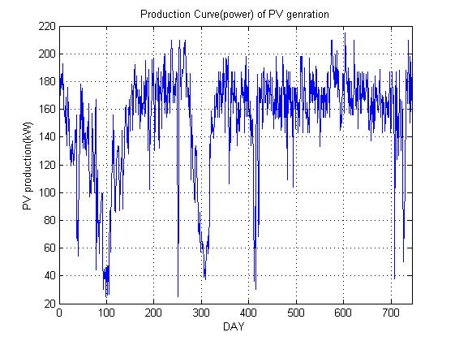
Fig.1 Production curve (power) of PV generation for two years

The corresponding pdf curve of PV production is shown in figure 2. In the absence of atmospheric factors, PV generation output is very predictable, since the Earth’s orbit around the sun can be determined to a high degree of precision. As the Earth moves in its orbit, the sun’s position in the sky may be calculated and, therefore, the PV production of a given installation may be estimated. The Fast Fourier Transform (FFT) method is applied to the PV generation data, as shown in Fig. 1, to obtain the amplitude spectrum in the frequency domain, as shown in Fig. 3. This figure indicates that there are periodic components in the data.

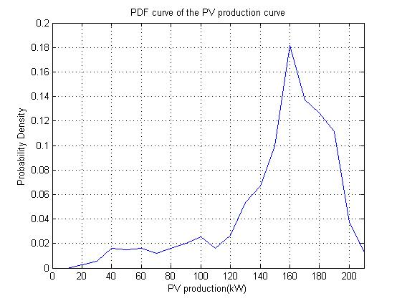
Fig.2 PDF curve of the PV production data in Fig.1
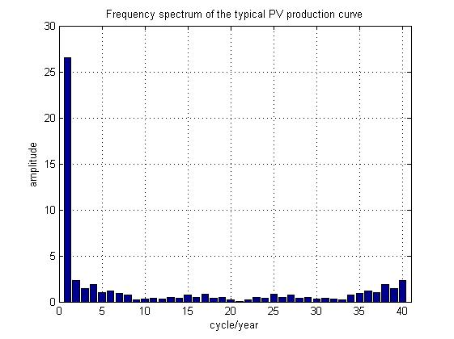
Fig.3 Frequency spectrum of the typical PV production shown in Fig.1

III. DETERMINATION OF UNPREDICTABLE COMPONENTS
The solar elevation angle (θs) for a speciﬁc location and solar time, which is the angle between the direction of the geometric centre of the sun and the horizon. The extra-terrestrial solar irradiance is approximately proportional to sin(θs), and this variation component is easily determined. It is useful to remove the indicated temporal variation of frequency 1 cycle/year (about) in the evaluation of the uncertainty of PV generation. To conclude this removal, the least squares method is applied; the PV production is assumed to be a linear function of sin(θs).
P=a sin θs + b -------(1)
Where a and b are the unknown parameters. Let Y be the measured PV output and be sin θs, a can be determined as
$a=\frac{n⋅\sum_{n}{x}y-\sum_{n}{x}Σy}{n⋅\sum_{n}{x^{2}}-{\left(Σ_{n}x\right)}^{2}}$ -----(2)
$b=\overline{y}-a\overline{x}$ -----(3)
where X’ and Y’ are the expected values of X and Y and n is the number of samples.
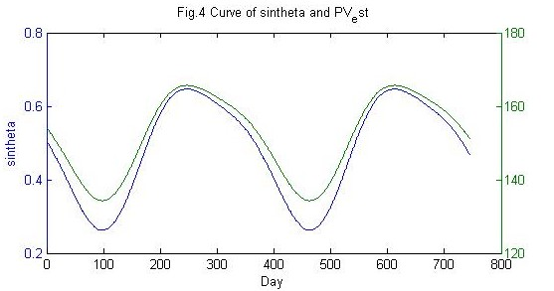
Fig.4 curve of sinθs and P=a sinθs+b for two years
Without considering the weather factors (for sunny days), the PV production is shown in Fig.4. The parameter is a residual of the linear model, which is considered to be the unpredictable component of the PV generation uncertainty. An important factor to consider is that the lowest frequency periodic component in PV production is the annual insolation variation. This periodic component occurs as a result of the annual position of the sun in the sky. In this work an approach is developed to remove this periodic component, thereby making the subsequent analysis of the data easier. This method observes the relationship between the PV production and changing solar position, and divides the PV generation data into predictable and unpredictable parts.

$ε$ = Y’ - (aX’+ b) -----(4)
In (4), the periodic effect due to changing solar position is removed from the PV generation data. By applying the least squares, the amplitude spectrum in the frequency domain and the PDF curve of the unpredictable component of PV production are shown in Figs. 5 and 6, respectively.

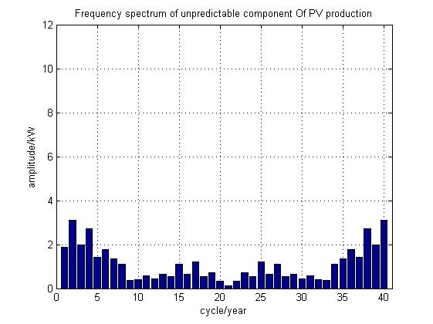
Fig.5 Frequency spectrum of unpredictable component of PV production

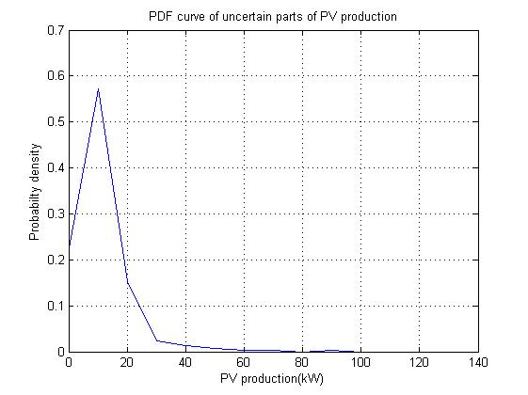
Fig.6 PDF curve of unpredictable component of PV production
According to Fig.6, the unpredictable uncertainty is still large after removing the impact of the changing solar position. The low impact indicates that the changing weather condition is the dominant factor for the PV generation uncertainty.

Fig.7 PDF curve of uncertain parts of the PV production after filtering the periodic components

As a comparison, another result is obtained by simply ﬁltering the annual periodic components of the PV production which is shown in Fig.3, and the PDF curve is shown in Fig.7. Table I compares the standard deviation and the coefﬁcient of variation (CV) of PV production for different cases. The results demonstrate that the PV production has a small and predictable variation on sunny days.

TABLE 2 COMPARISON OF THE UNCERTAINTY RESULTS OF PV PRODUCTION
 | Fig2 | Fig4 | Fig6 | Fig7
Standard deviation | 0.0520 | 10.7681 | 0.0855 | 0.1223
Coefficient of variation (%) | 0.0342 | 7.0778 | 0.0562 | 0.0804
*The coefﬁcient of variation is the ratio of the standard deviation to expected value of PV production.

IV. Forecasting of PV Production
This susceptibility power utilities against using PV power since the planning and overall balancing of the grid becomes very challenging. Developing a reliable algorithm that can reduce the errors associated with forecasting the near future PV power generation is extremely beneficial for efficiently integrating solar energy into the grid. PV power forecasting can play a key role in tackling these challenges. So, output forecasting of a PV system using a combination of wavelet transform (WT) and artificial intelligence (AI) techniques by incorporating the interactions of PV system with solar radiation and temperature data. In the proposed method, the WT is applied to have a significant impact on ill-behaved PV power time-series data, and AI techniques capture the nonlinear PV fluctuation in a better way.

A. WAVELET TRANSFORM
The scalogram is absolute value of the continuous wavelet transform (CWT) of a signal plotted as a function of time and frequency. The scalogram is used when we want better time localization for short duration high frequency event and better frequency localization for low frequency longer duration events. The contour plot shows the wavelet spread in time and frequency preserving the energy in the analysis stage.
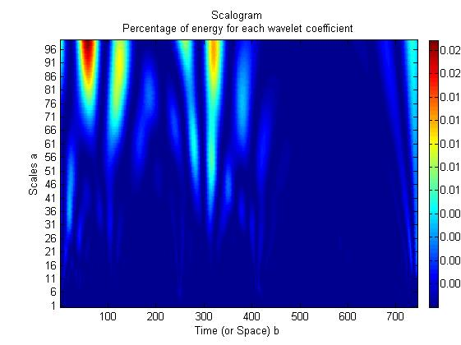
fig.8 Scalogram of percentage of energy of each wavelet coefficient.
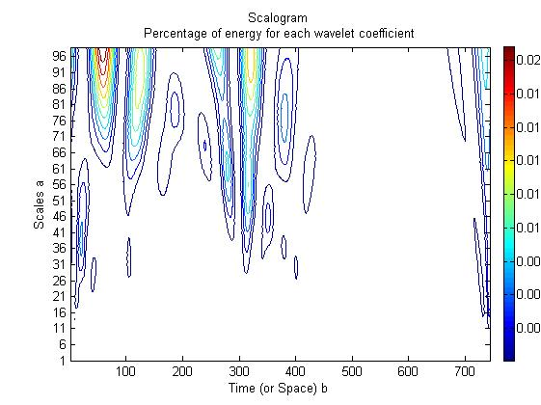
Fig.9 Contour of percentage energy for each wavelet coefficient

To obtain the decomposition i.e. analysis and reconstruction synthesis filter for the b-spline by orthogonal wavelet specify three vanishing moment in the synthesis and five vanishing moment in the analysis wavelet.

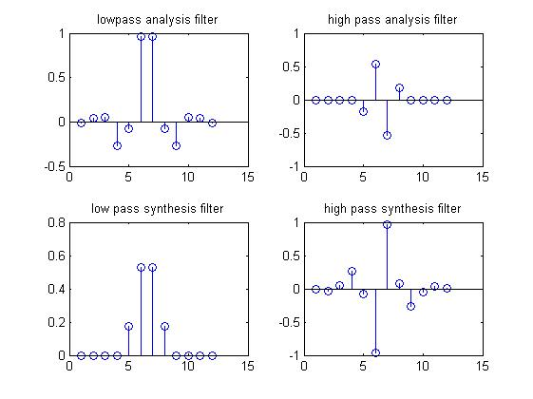
Fig10 The analysis and synthesis components of continuous wavelet component of signal x(n)

The solar PV power data series contain various instabilities, spikes, and different types of no stationarities. The WT can be considered as feature management tool to isolate these spikes. Therefore, solar PV power forecasting using WT can be used to improve the PV power forecast error. The WT can be divided into two categories: continuous wavelet transforms (CWT) and discrete wavelet transform (DWT). Hence by discrete wavelet transform (DWT) we have decomposed our PV power production into approximation and detailed coefficient at level one. Then we have reconstructed the power output by using these coefficients and then we are having compared the graph obtained.

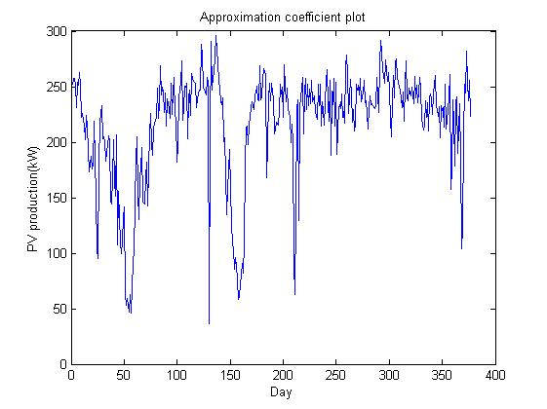
Fig.11 Approximation coefficient plot.

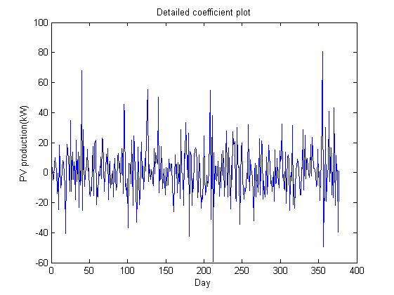
Fig.12 Detailed coefficient plot.
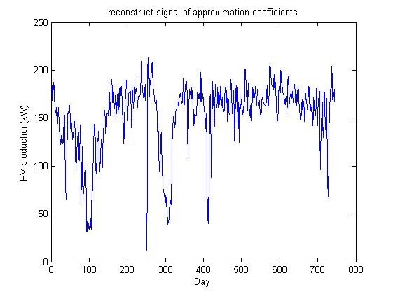
Fig.13 Reconstruction plot
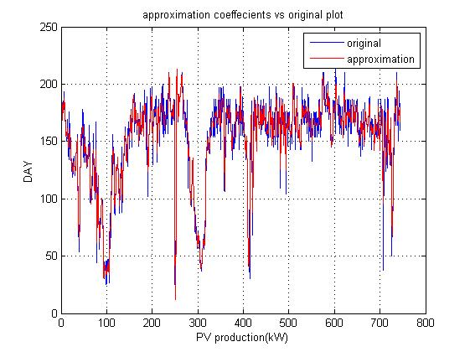
Fig.14 Comparison between approximation and original PV
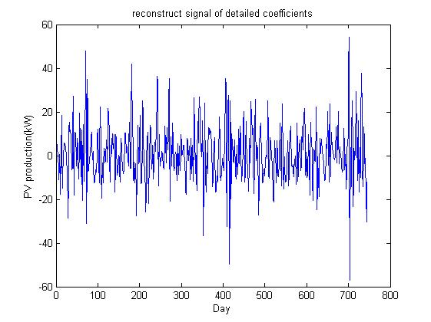
Fig.15 Reconstruction of detailed coefficients
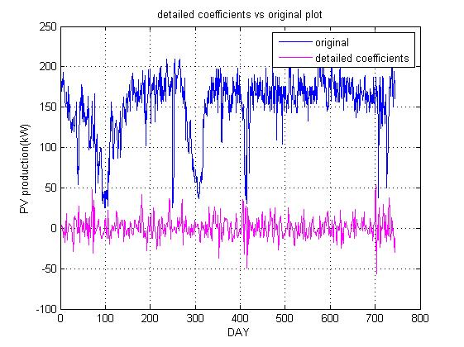
Fig.16 Comparison between original and detailed PV
B. WAVELET DECOMPOSITION
The wavelet transform method is a mathematical tool, much like a Fourier transform, that in analysing a time series signal, can be used to analyse nonlinear and non-stationary signals. The wavelet transform method decomposes a signal into different scale layers with different levels of resolution. The decomposition into different scales is made possible by the fact that the wavelet transform method is based on a square-integrable function and group theory representation. The wavelet transform provides a local representation (in both time and frequency) of a given signal, so it is suitable for analysing a signal with varying time-frequency resolution, such as the output power of a PV power plant.

The WD decomposes the given signal x(n) into its detailed smoothed layers. The signal for the power output of a PV power plant contains sharp edges and jumps caused by the ﬂuctuation of the solar radiation, and it has nonlinear characteristics and periodicity. By using the WD method, the output power of the PV power plant is decomposed into two parts, one is the smoothed version of the signal, and the other part contains the detailed version of the signal. Therefore, the WD method discriminates disturbances from the original signal, and can analyse them separately.

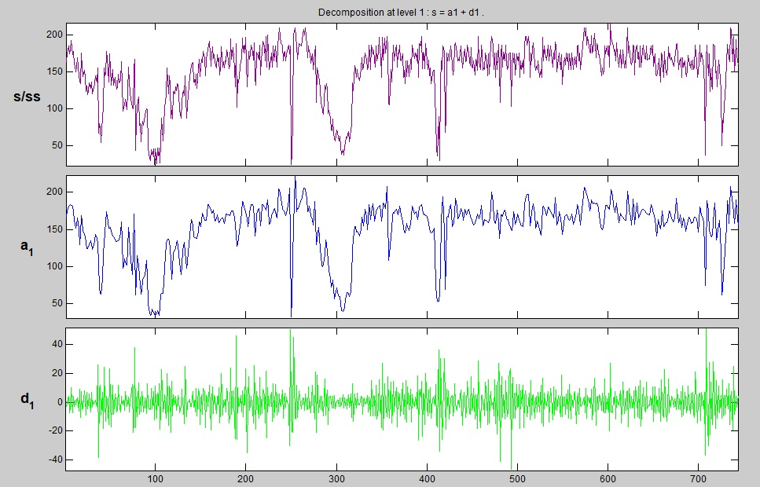
Fig.17 Decomposition of PV production at level 1.

Let x(n) be the discrete time signal, for output Power of a PV power plant x(n) is to be decomposed into detailed layers and one smoothed layer. From the WD method, the decomposed signals at scale 1 are A1(n) and D1(n), where A1(n) is the smoothed version of the input signal, and D1(n) is the detailed version of the input signal x(n) in the form of the wavelet transform coefficients.

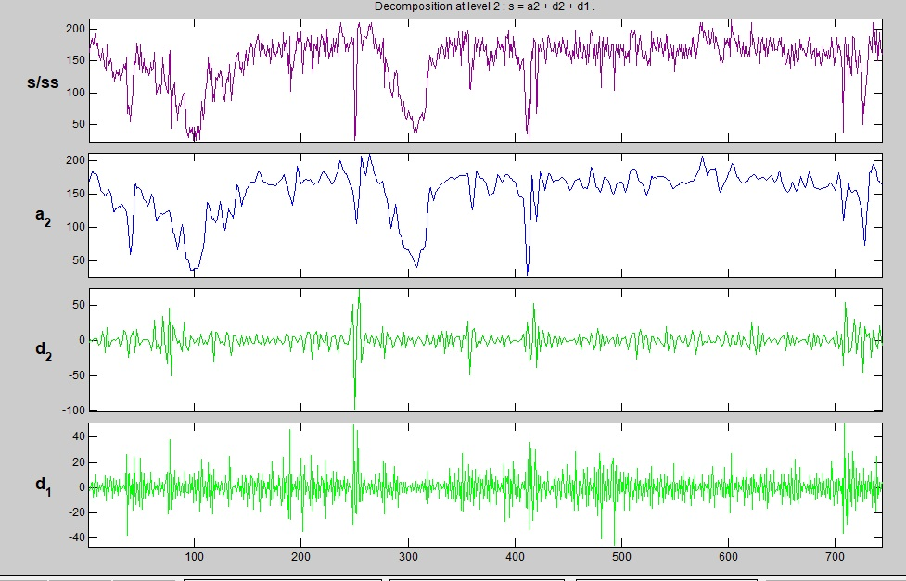
Fig.18 Decomposition of PV production at level 2
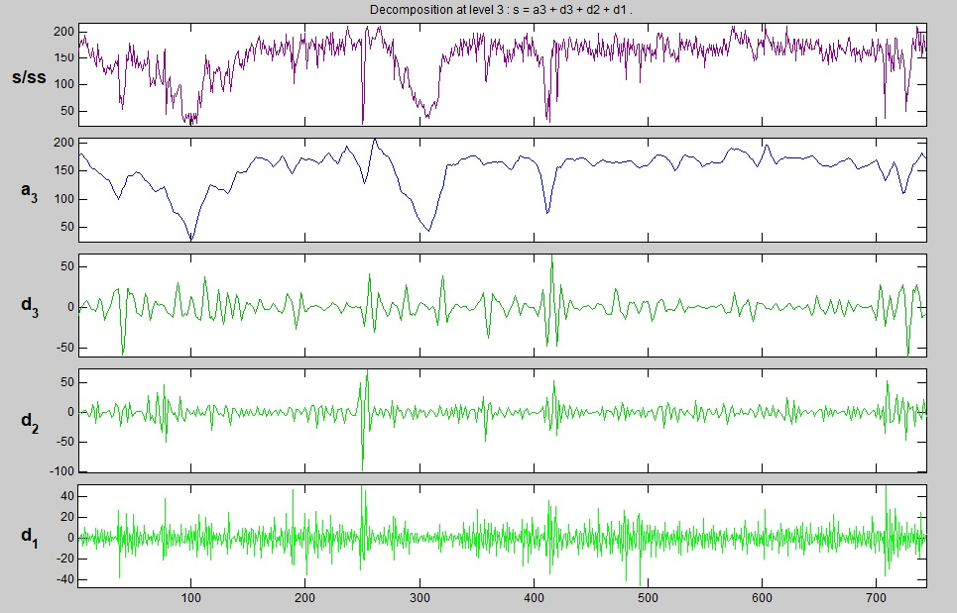
Fig19 Decomposition of PV production at level 3.

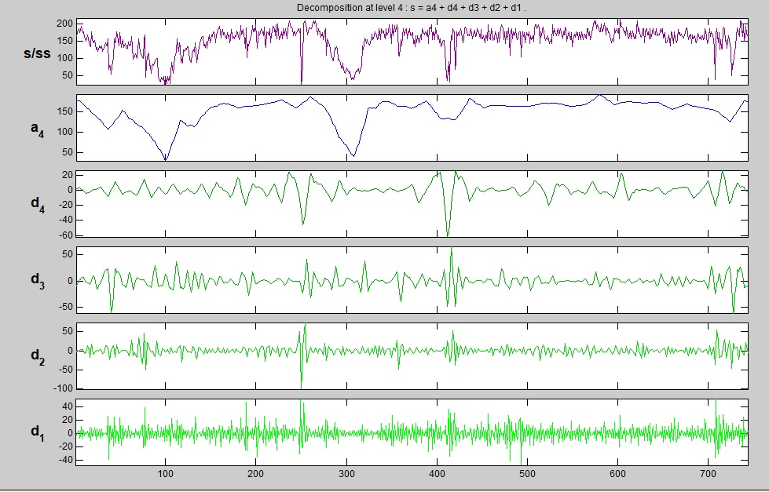
Fig.20 Decomposition of PV production at level 4

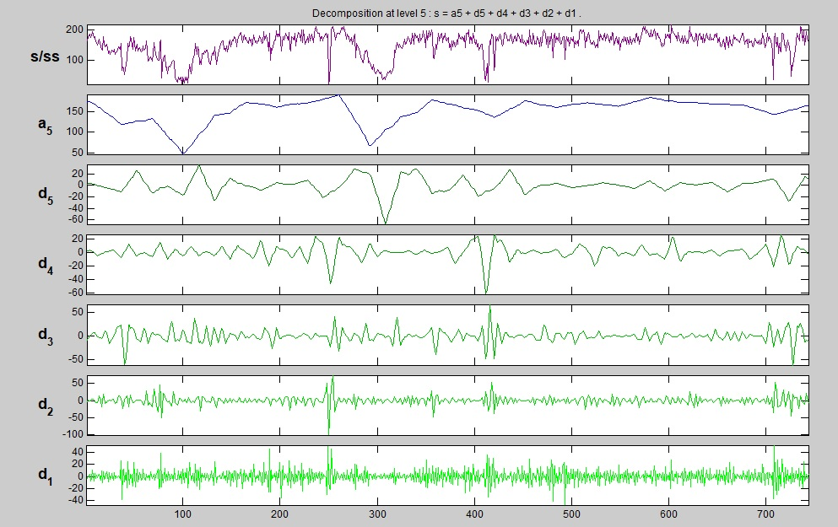
Fig.21 decomposition of PV production at level 5
Table 3 Layers Definitions of WD
Reconstructed Sequence | Definition | Meaning
A5 | Smoothed signal at 5th layer | Reflects change trend of output power of PV power plant, close to theoretically calculated solar irradiance
D5 | Detailed signal at 5th layer | Reflect composition and change rules of high frequency part of signal
D4 | Detailed signal at 4th layer
D3 | Detailed signal at 3rd layer
D2 | Detailed signal at 2nd layer
D1 | Detailed signal at 1st layer

V. POWER PREDICTION

In the physical sense, solar radiation is a direct influencing factor of the voltage effect of PV cells. The irradiance directly influences the output of a photovoltaic cell. Solar irradiance received by a PV array is influenced by the array installation angle, cloud quantity in the sky and solar position. Meanwhile, the output of a PV power plant is also influenced by meteorological conditions and its own characteristics, but for a known PV power plant, the output time series data of the PV system has a certain autocorrelation. This is because power plant information has been contained in the power output data of the given PV power plant, and complex analysis of the influence of random installation site and operation time on PV system performance degeneration can be avoided. So, we use ANNs to establish output power forecasting modelling for PV power plants.

According to the structure of the forecasting model. We have to train the approximation coefficients (A5, A4, A3, A2, A1) and detailed coefficients (D5, D4, D3, D2, D1) obtained from the wavelet decomposition of our PV production output. High frequency information (detailed coefficients D3, D2, D1) at other layers are treated as disturbances for establishing the model, so they are not used. 5-layer WD is carried out for the output power of the PV plant followed by the comparison between the approximation layer and detailed layer.

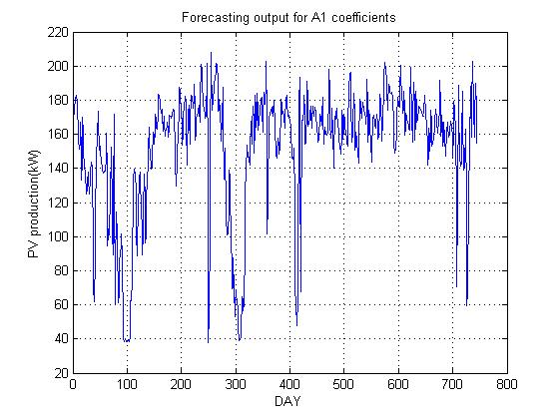
Fig.22 Forecasting output of A1 coefficients

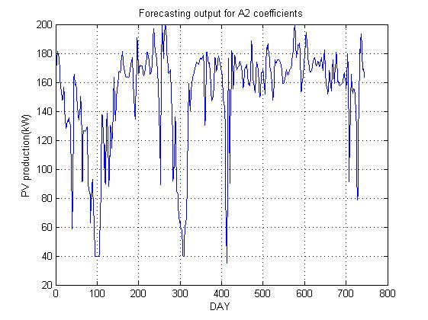
Fig.23 Forecasting output of A2 coefficients

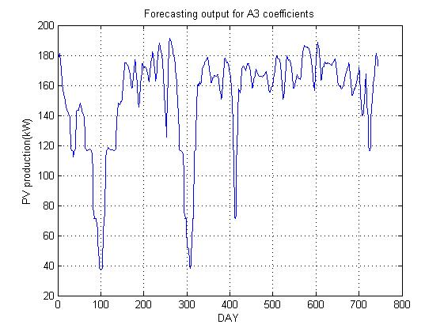
Fig.24 Forecasting output of A3 coefficients

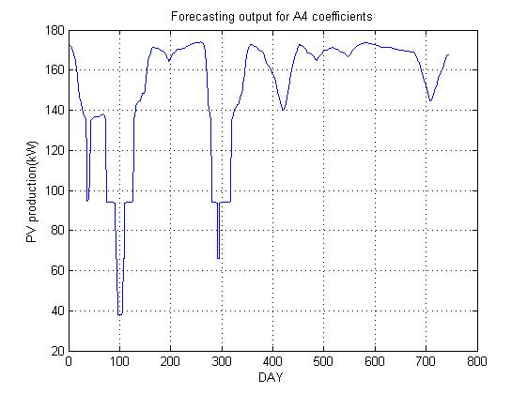
Fig.25 Forecasting output of A4 coefficients
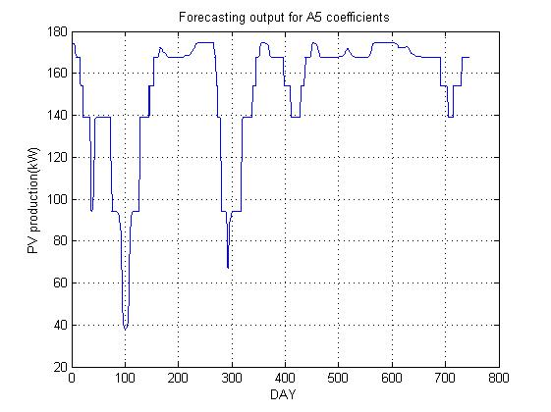
Fig.26 Forecasting output of A5 coefficients
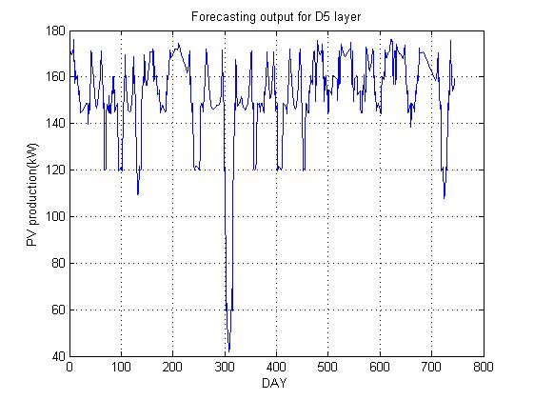
Fig.27 Forecasting output of D5 coefficients
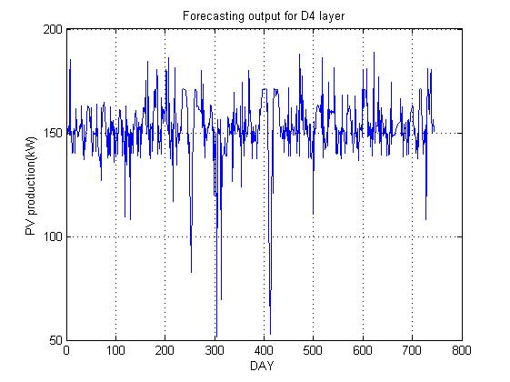
Fig.28 Forecasting output of D4 coefficients
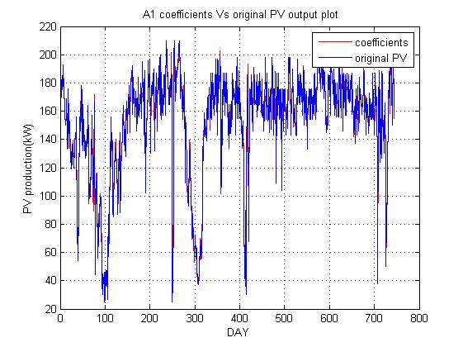
Fig.29 Comparison of original signal and forecast A1 coefficients
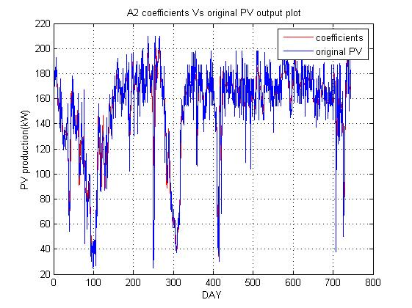
Fig.30 Comparison of original signal and forecast A2 coefficients
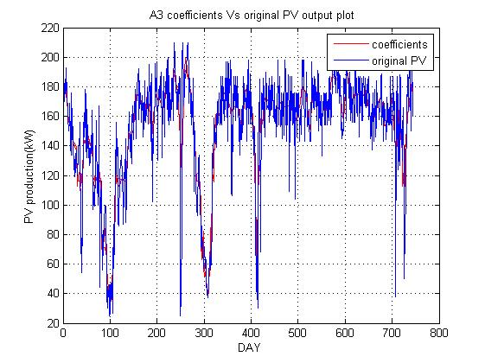
Fig.31 Comparison of original signal and forecast A3 coefficients
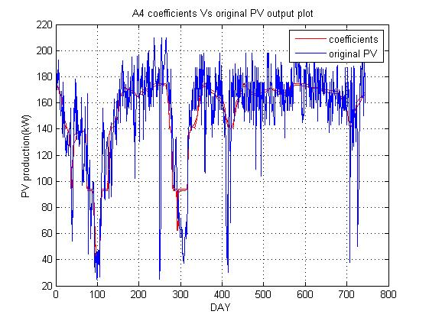
Fig.32 Comparison of original signal and forecast A4 coefficients
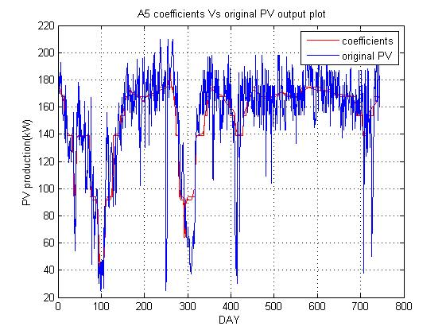
Fig.33 Comparison of original signal and forecast A5 coefficient

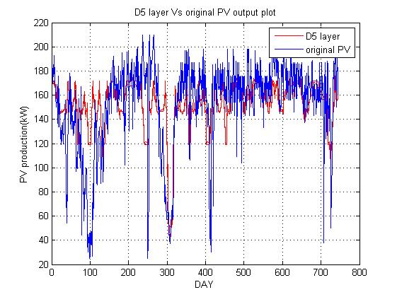
Fig.34 Comparison of original signal and forecast D5 coefficients

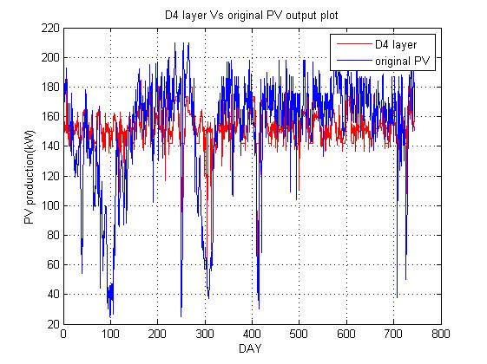
Fig.35 Comparison of original signal and forecast D4 coefficients

VI. ERROR CALCULATION IN POWER PREDICTION

We use root mean square error (RMSE), mean absolute error (MAE) and mean absolute percentage error (MAPE) indexes for the assessment of the forecast results based on WD + ANN. Their definitions are as follows:

$RMSE= \frac{\sqrt{∑|Pm\left(i\right)-Pp\left(i\right)|^2}}{c_{aP}*\sqrt{n}}*100\%$ …… (5)

$MAE= \frac{\sum_{i=1}^{n}{|Pm\left(i\right)-Pp\left(i\right)|}}{c_{aP}*n}*100\%$ …… (6)

MAPE = $\frac{1}{n}\sum_{i=1}^{n}{\left|\frac{Pm\left(i\right)-Pp\left(i\right)}{Pm\left(i\right)}\right|*100\%}$ …… (7)

where, Pm(i) is measured power at time i; Pp (i) is the forecast power at time i; n is the number of samples; Cap is the mean running capacity.

Calculation of mean running capacity in PV power forecasting is decided by the initial power of the photovoltaic inverter, installed capacity of the PV system and operation time. Factor Run(i) is defined to describe the working state of the PV plant at time i. When the measured power Pm(i) is higher than PS, the initial power of photovoltaic inverter, then Run(i) equal to 1, meaning that the PV plant is running, else, Run(i) is equal to 0, meaning that the PV plant is not running, as shown in Equation (8)

Run(i) = {1, if Pm(i) ≥ Ps
Run(i) = {0, if Pm(i) ≤ Ps …… (8)

The definition of Cap is shown in Equation (4.9)

Cap = $\frac{\sum_{i=1}^{n}{Run(i)}}{n}*\operatorname{Pr}{ }$ …… (9)

where, Ps is initial power of the photovoltaic inverter Pr is installed capacity of the PV system.

Table 4.3 Error in measurement
Error/ Layer | A1 | A2 | A3 | A4 | A5
RMSE (%) | 11.14 % | 15.73% | 19.35% | 24.29% | 24.10%
MAE (%) | 8.33% | 11.20% | 13.78% | 17.47% | 17,46%
MAPE (%) | 6.43% | 9.38% | 12.12% | 16.34% | 16.25%

The above table shows the error results obtained during the forecasting of PV production output comparing between wavelet decomposition of power output in five layers and the trained output obtained by using artificial neural networks. In the table it can be observed that error is escalating with the level of decomposition on the PV power production.

This approach increases the computational burden. A novel probabilistic model of PV generation is developed based on the environmental conditions that impact PV behaviour. The forecasting of power output of PV power plants based on WD and ANN. Due to the periodic and non-stationary characteristics of the power output series of a PV power plant, the wavelet analysis method is adopted to carry out multi-scale decomposition of the PV output. A smoothed signal and detailed signal of the PV output are obtained. Forecasting models at different signal layers are established through ANN. Finally, through construction of the forecasting results of different signal layers, the forecasting results of the PV power plant are obtained. Through comparison to the ANN method, it is shown that the forecasting method proposed in this work has better forecasting precision, and less algorithm convergence time. solar power is the best solution due to its abundant availability in our country and an immediate initiative should be taken to install a solar thermal plant in India for obtaining necessary experience on its design, installation, operation and maintenance.

REFERENCES

[1] A. Ahmad and J. Y. Khan, "Stand-Alone Distributed PV Systems: Maximizing Self Consumption and User Comfort using ANNs," 2018 IEEE International Conference on Communications, Control, and Computing Technologies for Smart Grids (SmartGridComm), Aalborg, 2018, pp. 1-6.
[2] A. Chersin, W. Ongsakul and J. Mitra, "Improving of uncertain power generation of rooftop solar PV using battery storage," 2014 International Conference and Utility Exhibition on Green Energy for Sustainable Development (ICUE), Pattaya, 2014, pp. 1-4.
[3] A. Grandjean, J. Adnot, and G. Binet, “A review and an analysis of the residential electric load curve models,” Renewable and Sustainable Energy Reviews, vol. 16, no. 9, pp. 6539–6565, Dec. 2012
[4] A. Kumar, M. Rizwan and U. Nangia, "Artificial Neural Network based Model for Short Term Solar Radiation Forecasting considering Aerosol Index," 2018 2nd IEEE International Conference on Power Electronics, Intelligent Control and Energy Systems (ICPEICES), Delhi, India, 2018, pp. 212-217.
[5] A. P. Meliopoulos, A. G. Bakirtzis and R. Kovacs, "Power System Reliability Evaluation Using Stochastic Load Flows," in IEEE Transactions on Power Apparatus and Systems, vol. PAS-103, no. 5, pp. 1084-1091, May 1984.
[6] A. Palm, “Peer effects in residential solar photovoltaics adoption—A mixed methods study of Swedish users,” Energy Research & Social Science, vol. 26, pp. 1–10, Apr. 2017
[7] A. Pan, Y. Tian, H. Zhao, X. Yang and J. Jin, "Power quality analysis of PV system of summer and winter," CIRED 2012 Workshop: Integration of Renewables into the Distribution Grid, Lisbon, 2012, pp. 1-4
[8] A. S. Al-Sumaiti, M. H. Ahmed, S. Rivera, M. S. El Moursi, M. M. A. Salama and T. Alsumaiti, "Stochastic PV model for power system planning applications," in IET Renewable Power Generation, vol. 13, no. 16, pp. 3168-3179, 9 12 2019.
[9] A. U. Haque, M. H. Nehrir and P. Mandal, "Solar PV power generation forecast using a hybrid intelligent approach," 2013 IEEE Power & Energy Society General Meeting, Vancouver, BC, 2013, pp. 1-5.
[10] B. M. Alluhaidah, S. H. Shehadeh and M. E. El-Hawary, "Most Influential Variables for Solar Radiation Forecasting Using Artificial Neural Networks," 2014 IEEE Electrical Power and Energy Conference, Calgary, AB, 2014, pp. 71-75.
[11] Bracale, A., Caramia, P., Carpinelli, G., Di Fazio, A.R., Ferruzzi, G.: ‘A Bayesian method for short-term probabilistic forecasting of photovoltaic generation in smart grid operation and control’, Energies, 2013, 6, (2), pp. 733- 747
[12] Canova, A., Giaccone, L., Spertino, F., Tartaglia, M.: ‘Electrical impact of photovoltaic plant in distributed network’, IEEE Trans. Ind. Appl., 2009, 45, (1), pp. 341–347
[13] D. Brunelli and M. Rossi, "Smart Grid Configuration Tool for HEES systems in smart city districts," 2016 International Symposium on Power Electronics, Electrical Drives, Automation and Motion (SPEEDAM), Anacapri, 2016, pp. 137-142.
[14] D. N.-y. Mah, G. Wang, K. Lo, M. K. H. Leung, P. Hills, and A. Y. Lo, “Barriers and policy enablers for solar photovoltaics (PV) in cities: Perspectives of potential adopters in Hong Kong,” Renewable and Sustainable Energy Reviews, vol. 92, pp. 921–936, Sep. 2018.
[15] D. Palmer, E. Koubli, I. Cole, T. Betts and R. Gottschalg, "Comparison of solar radiation and PV generation variability: system dispersion in the UK," in IET Renewable Power Generation, vol. 11, no. 5, pp. 550-557, 12 4 2017.
[16] D. S. Schiera, F. D. Minuto, L. Bottaccioli, R. Borchiellini and A. Lanzini, "Analysis of Rooftop Photovoltaics Diffusion in Energy Community Buildings by a Novel GIS- and Agent-Based Modeling Co-Simulation Platform," in IEEE Access, vol. 7, pp. 93404- 93432, 2019.
[17] D. Sbarbaro and R. Pena, "Dynamic output power optimization in hybrid PV/T panels," IECON 2016 - 42nd Annual Conference of the IEEE Industrial Electronics Society, Florence, 2016, pp. 114-119.
[18] M. Fan, V. Vittal, G. T. Heydt and R. Ayyanar, "Preprocessing Uncertain Photovoltaic Data," in IEEE Transactions on Sustainable Energy, vol. 5, no. 1, pp. 351-352, Jan. 2014
[19] Daniele Salvatore Schiera1, Francesco Demetrio Minuto1, Lorenzo Bottaccioli1 (Member, IEEE), Romano Borchiellini1, Andrea Lanzini (2017).

