Micro-propagation for fruit crops, a technology of production virus free plants
Shiwanand Pandey¹, Gaurav Singh Vishen² and Krishna Kumar Mishra³
¹ Chandra Shekhar Azad University of Agriculture and Technology Kanpur (Uttar Pradesh 208002
²Sam Higginbottom University of Agriculture, Technology and Sciences, Naini, Prayagraj, Uttar Pradesh 211007
³Gopal Narayan Singh University, Sasaram-Tilauthu Rd, Jamuhar, Bihar 821305
Email Corresponding Author:Pshiwanand94@gmail.com
Abstract
Micro-propagation for fruit crops represents the most promising areas of application at present time and giving an out look into the future. The rapid production of high quality, disease free and uniform planting stock is only possible through micro-propagation. New opportunities has been created for producers, farmers and nursery owners for high quality planting materials of fruits as well as other horticultural crops. Plant production can be carried out throughout the year irrespective of season and weather. However micro-propagation technology is expensive as compared to conventional methods of propagation by means of seed, cuttings and grafting etc. Therefore it is essential to adopt measures to reduce cost of production. Low cost production of plants requires cost effective practices and optimal use of equipment to reduce the unit cost of plant production.
Key word: Conventional, Disease, Micro-propagation, Production, Rapid
Introduction
Micro-propagation is the production of new plants under the ultra controlled environment within the culture vessel i.e., test tube. Commercial micro-propagation began in the United States in 1965 with orchid production. The first tissue culture Laboratory in India was established at Delhi University in 1950s. Micro-propagation is the widely applied aspect of plant biotechnology and as a result over 100 tissue culture laboratories have been established in India. Undeniably the most useful outcome of tissue culture has been in the micro-propagation of ornamentals, fruits, plantation crops, medicinal & aromatic plants and forest trees. At present most of the large commercial tissue culture laboratories are operative in states like Maharashtra, Karnataka, Kerala and Andhra Pradesh. Banana is the largest sold micro-propagated fruit crop in India and abroad. Strawberry is also catching up in our country.
Historical Background of Micro-propagation In 1902, a German physiologist, Gottlieb Haberlandt for the first time attempted to culture isolated single palisade cells from leaves in knop’s salt solution enriched with sucrose. The cells remained alive for up to one month, increased in size, accumulated starch but failed to divide. Though he was unsuccessful but laid down the foundation of tissue culture technology for which he is regarded as the father of plant tissue culture. Why do micro propagation? A single explant can be multiplied into several thousand plants in less than a year- this allows fast commercial propagation of new cultivar. Once established, a plant tissue culture line can give a continuous supply of young plants throughout the year. In plants prone to virus diseases, virus free explants (new meristems tissue is usually virus free) can be cultivated to provide virus free plants. Plant tissue barks can be frozen, and then regenerated through tissue culture. Plant cultures in approved media are easier to export than are soil grown plants, as they are pathogen free and take up little space (most current plant exportis now done in this manner. Micro-propagation In vitro propagation of plants vegetative by tissue culture to produce genetically similar copies of a new plants is referred to as micro-propagation or clonal propagation. Micro-propagation is a proven means of producing millions of identical plants under a controlled and aseptic condition, independent of seasonal constraints. It’s not only provide economy of time and space but also gives greater output and allows further augmentation of elite disease free propagules. The size of explant may vary from as small as 1.0-5.0 mm long meristem tip for meristem culture to a piece of shoot several centimeters long. Advantages of micro propagation
- From one to many propagules rapidly
- Multiplication in controlled lab conditions
- Continuous propagation year round
- Potential for disease free propagules
- Inexpensive per plant once established
- Precise crop production scheduling
- Reduce stock plant space
- Long term germplasm storage
- Production of difficult to propagate species
Disadvantages of micro propagation
- Specialized equipment/facilities required
- More technical expertise required
- Protocols not optimized for all species
- Relatively expensive to set up
Basic requirements of micro-propagation
In micro-propagation techniques, there is some basic requirement, viz
- Aseptic condition
- control of temperature
- Proper culture medium
- Sub-culturing
Other Implications of Micro propagation-
In addition to major use of tissue culture technique for rapid clonal multiplications of plants, this techniques is highly important for several purpose as under
- Production and maintains of pathogen free stock plants
- Long term in vivo conservation of germplasm
- Selection and regeneration of transgenic plants
- Conservation of germplasm
Micro-propagation Procedure
There are basically four stages of micro-propagation process, these are:
- Stage I- Explants establishment
- Stage II- Shoot multiplication
- Stage III- Root formation
- Stage IV- Acclimatization
- Stage I-The establishment of explants depends on several factors such as the source of explants, type of explants such as leaf, root, stem from mature or immature plants, explants sterilization, in vitro culture conditions such as culture media, composition, temperature, humidity, light etc. The explants showing growth are considered established.
- STAGE II- The established explants are sub-cultured after 2-3 weeks, on shoot multiplication medium. Auxins like NAA, 2,4-D and cytokinins like BAP, Kinetin is used in culture medium. It is well-established fact that cytokinins enhance shoot multiplication.
- STAGE III- The in vitro regenerated shoots are rooted in the medium containing auxins like NAA, IBA. The rooting can also be induced when in vitro shoots are exposed to stress conditions.
- STAGE IV- The in vitro plantlets thus obtained are hardened/ acclimatized before transfer to the field. The hardening is necessary as the tissue culture derived plants grow under high humidity conditions, have open stomata, lower epi-cuticular wax, thus leading to increased transpiration losses and resulting in mortality of plants.
Basis for plant tissue culture
Two hormones affect plant differentiation i.e. auxin and cytokinin
Generally the ratio of these two hormones can determine plant development
- High Auxin + Low Cytokinin = Root development
- High Cytokinin + Low Auxin = Shoot development
- Auxin and Cytokinin Equal = Callus development
Culture media have been developed by various workers for different crop species. The culture media developed by Murashige and Skoog (1962) and Gamberg, et al. (1968) are used with some modifications in various crop species. Transfer of tissue or callus from old culture media to fresh culture media is called sub-culturing. This is essential to maintain good health of the callus or tissues, because after some period, some nutrients are depleted in the culture media.
SOME factors are essential in the success of tissue culture
- Sterilization of equipment, glassware and the media
- Collection of tissue
- Sterilization of tissue
- Media composition
- Inoculation of tissue
- Incubation
TYPES OF CULTURE IN MICROPROPAGATION
- Callus culture
- Suspension culture
- Root tip culture
- Leaf Primordial/ leaf culture
- Shoot tip/ meristem culture
- Anther/ pollen culture
- Ovule/ embryo culture
- Protoplast culture

- Callus culture concerns the initiation and continued proliferation of undifferentiated parenchyma cells from parent tissue or clearly defined semi solid media.
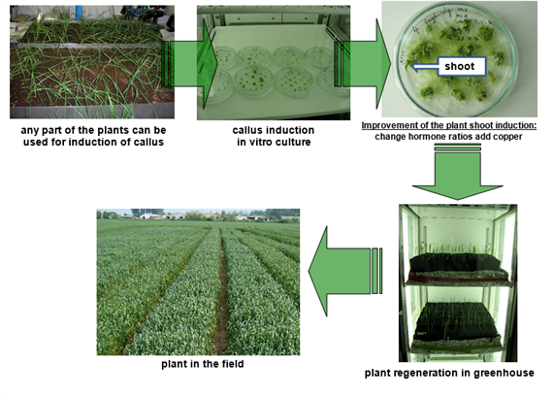
- Suspension culture
- A suspension culture refers to cell or groups of cells, dispersed and growing in an aerated liquid culture medium is placed in a liquid medium and shaken vigorously and balanced dose of hormones.
- Cytokinin induced adventitious buds in kiwi fruit in a suspension culture, sub-culture for about a week.
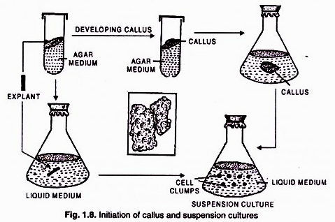

- Root tip Culture Isolated root tips of apical produce in-vitro root systems with indeterminate growth habits. These were among the first kinds of plant tissue cultures (White, 1934) and remain important research tools in the study of development phenomena.

- Leaf Primordial Culture
Leaf culture a form of tissue culture in which excised leaves, leaf material, leaf primordial are grown on a sterile growth medium. Mature leaves can be kept healthy under culture conditions for considerable periods. Leaf primordia have been used to study growth and differentiation processes.
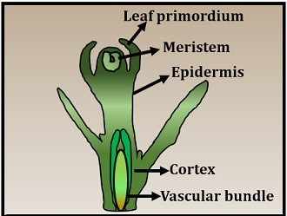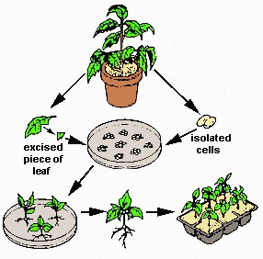
- Shoot tip/ Meristem Culture
- The culture of terminal part of shoot to a plant in-vitro condition or in lab called shoot tip culture.
- Mostly the shoot tip cultures used for obtain disease free plant without genetically changes.
- The shoot tip plant are more efficient to cultivation of differentiation in-vitro because cells of them newly generated and healthy comparison to other parts.
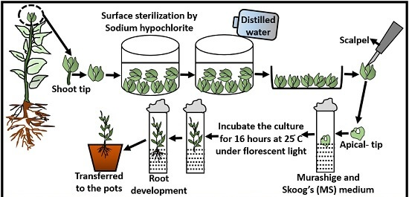

- Pollen/Anther culture
The culture of pollen grains which germinate in-vitro. Pollen culture (microspore culture) is a technique in which haploid plants are obtained from isolated pollen grains while in anther culture those are obtained from pollens, by placing anthers on a suitable, synthetic culture medium
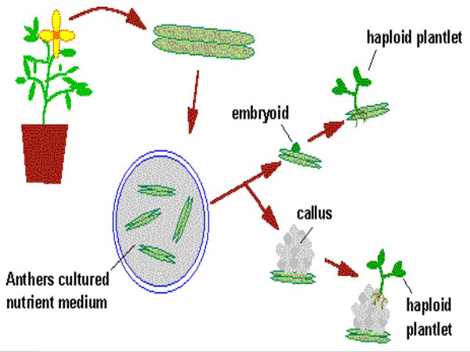

- Ovule/ovary Culture
Ovule culture technique is utilized for raising hybrids which normally fail to develop due to the abortion of the embryos at early stage. Ovules can easily be excised from the ovary and cultured a basal medium. The loss of hybrid embryo due to premature abscission of fruits may be prevented by ovule culture. In some cases, addition of fruits/ vegetables juice increases the initial growth.
- Protoplast culture
Protoplast culture involves the regeneration of the cell wall around the protoplast membrane. Once the cell wall has formed, cell division must be induced in the new cell.
Importance of protoplast -
- Study of osmotic behavior
- Study of IAA action
- Study of plasma lemma
- Study of cell wall formation
- Organelle isolation
- Study of morphogenesis
- Virus uptake and replication
- Study of photosynthesis
- Gene transfer
Micro-propagation of Fruit Crops
- Among fruit crops banana and strawberry are being propagated commercially on large scale.
- Grapes can be regenerated from auxiliary shoots, adventitious budding and via somatic embryogenesis but none of these methods as yet allows mass clonal propagation.
- Pomegranate has been micro-propagated through shoot-tip culture.
- Many reports have been published on the successful regeneration of kinnow from nucellus tissue but till date it has not been propagated commercially
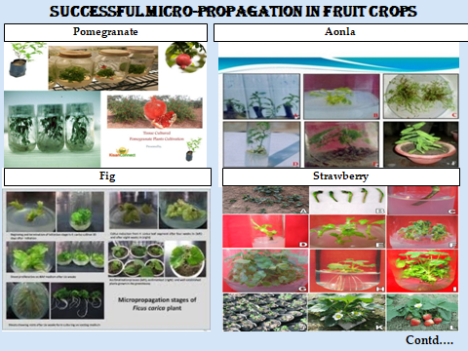
Application of Micro-propagation in fruit crops
- Clonal Propagation
- Soma Clonal Variation
- Production of Virus free Plant
- Production of Synthetic Seed
- Somatic Hybridization
- In-vitro Plant Germplasm Conservation
- Mutation Breeding
- Molecular Farming
- Genetic Engineering
- Clonal Propagation
Clonal propagation refers to the process of asexual reproduction by multiplication of genetically identical copies of individual plants. The clonal propagation is rapid and has been adopted for commercialization of important plants such as - banana, apple, pear, strawberry etc.
Benefits
- Rapid multiplication of superior clones can be carried out through out year, irrespective of seasonal variations.
- Multiplication of disease free plants, e.g. virus free plants of apple, strawberry, banana, pear etc.
- Multiplication of sexually derived sterile hybrids.
- It is cost effective process as it requires minimum growing space.
- Soma Clonal Variation
The genetic variation found in-vitro cultured cells are collectively referred to as soma clonal variation and the plants derived from such cells are called as ‘soma clones’. Larkin and Scowkraft in 1981 coined a general term ‘somaclonal variation’.
Basic features of Soma Clonal Variation- variation in number and structure of chromosome are commonly observed Regenerated plants with altered chromosomal changes often show changes in leaf shape and colour, growth rate and habit, and sexual fertility.
It is generally heritable mutations and persist in plant population even after plantation into the field.
Advantages of Soma-clonal Variation–
- Helps in crop improvement
- Creates additional genetic variants.
- Plants with resistant and tolerant to toxins, herbicides, high salt and even mineral toxicity.
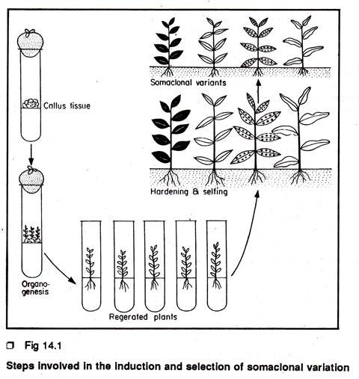
Soma clonal variation in different crops
Variation presence |  |  | Variation absence
Fruit | Explant source | References | Fruit | Explant source | References
Kiwifrui | Leaf blade and petiole | Prado, et.al.  (2008) | Banana | Shoot tip | Ray, et. al. (2006)
Oil palm | Zygotic embryo | Rival, et. al. (2013) | Almond | Axillary branching | Martins, et. al. (2004)
Papaya | Axillay shoot tip | Kaity, et. al. (2009) | Vitis Sp. | Nodal segment | Alizadeh, et. al. (2008)
- Production of Virus-free Plant
- In tissue culture application produced virus free plants. The viral disease in plants transfer easily and lower the quality and yield of the plants.
- It is very difficult to treat and cure the virus infected plants therefore the plants breeders are always interested in developing and growing virus free plants.
- In some fruit crops has become possible to produce virus free plants through tissue culture at the commercial level.
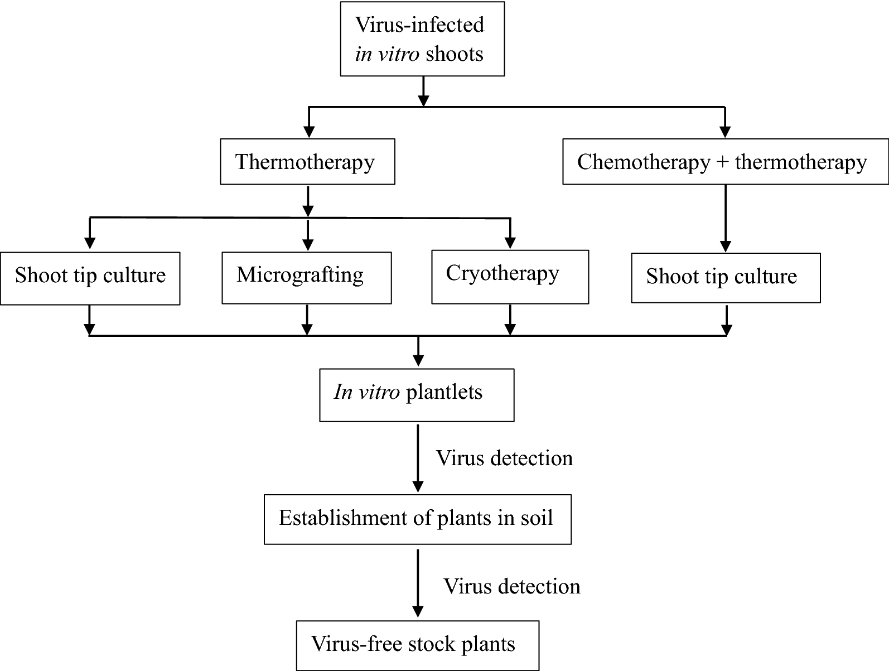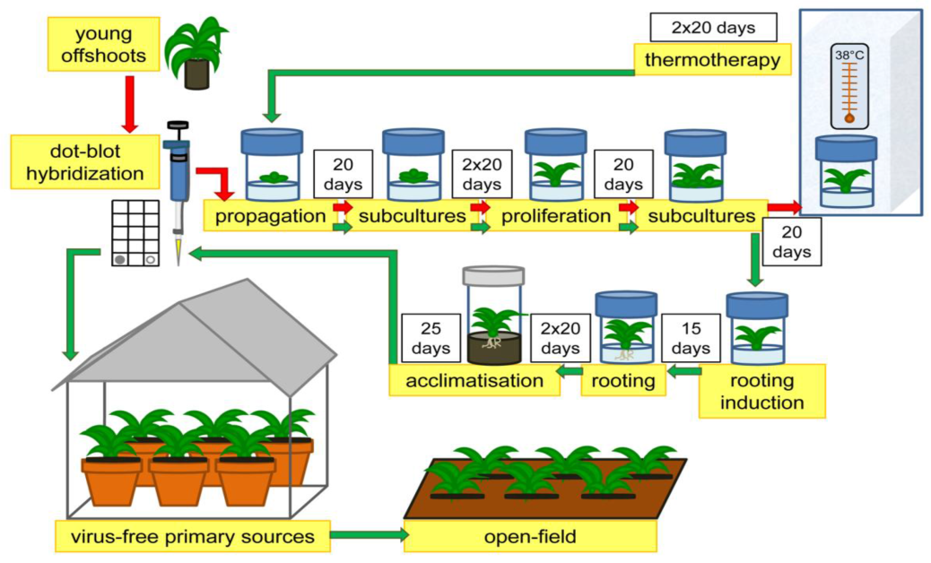
- Production of Synthetic Seeds
In synthetic seeds the somatic embryos are encapsulated in a suitable matrix (e.g. sodium alginate), along with substances like insecticides, fungicides and herbicides, these artificial seeds can be utilized for the rapid and mass propagation of desired plant species as well as herbicides varieties.
Encapsulation methods for synthetic seed
(A) Dropping procedure –
- The most useful encapsulation system. Drip 2-3 % sodium alginate drops from at the tip of the funnel and the somatic embryos are inserted
- Keep the encapsulation embryos complex in calcium salt for 20 min.
- Rinsed the capsules in water and then stored in a air tight container.
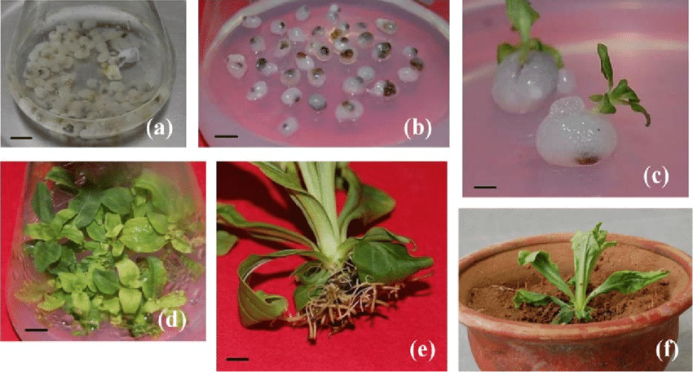
Synthetic seed production process
Explant selected from healthy plant

Induced callus in explant

Somatic embryo induced in callus

Somatic embryo proliferated

Maturation of somatic embryo

Encapsulation of somatic embryo

In-vitro germination

Acclimatization, induce fruit

Produce synthetic seed

Somatic hybridization
Isolation of protoplast

Fusion of protoplast of desired species/varieties

Identification of selection of somatic hybrid cells

Culture of hybrid cells

Regeneration of hybrid cells

Advantages of somatic hybridization
- Production of heterozygous lines in the single species which cannot be propagated by vegetative means.
- Studies on the fate of plasma genes.
- Production of unique hybrids of nucleus and cytoplasm.
Limitations of somatic hybridizations
- Poor regeneration of hybrid plants.
- Non- viability of fused products.
- Not successful in all plants.
- Production of unfavorable hybrids.
- Lack of an efficient method for selection of hybrids.
- No confirmation of expression of particular trait in somatic hybrids.
In-vitro Germplasm Application
- Germplasm refers to the sum total of genes present in a crop and its related species.
- The conservation of germplasm involves the preservation of the genetic diversity of a particular plant.
- This will insure he availability of valuable germplasm to breeder to develop new and improved varieties.
- Germplasm conservation depending on the crop species and method of preservation of genetic resources from 1 to 15 years.
- Important method of conservation of germplasm is cryopreservation
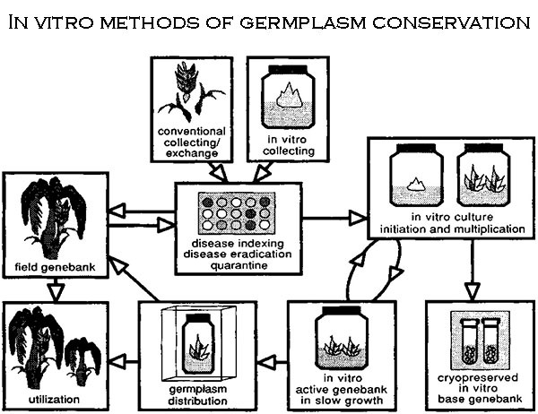

- Cryopreservation
- The germplasm is stored as a very low temperature using solid carbon dioxide (at-79 °C)
- Using low temperature deep freezers (at -80 ° C)
- Using vapor nitrogen (at -150 ° C)
- Using liquid nitrogen (at -196 ° C)
- Any tissue from a plant can be used for cryopreservation e.g. meristems, embryos, ovules, seeds, cultured plant cells, protoplasts, calluses, etc.
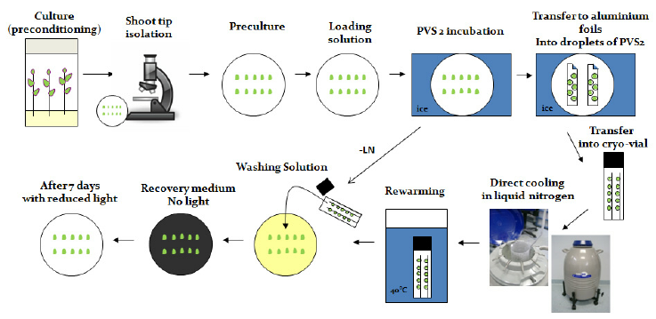
- Mutation Breeding
- Mutagenic agents, such as radiation and certain chemicals, then can be used to induce mutations and generate genetic variation from which desired mutants may be selected.
- Mutation induction has become a proven may of creating variation within a crop variety.
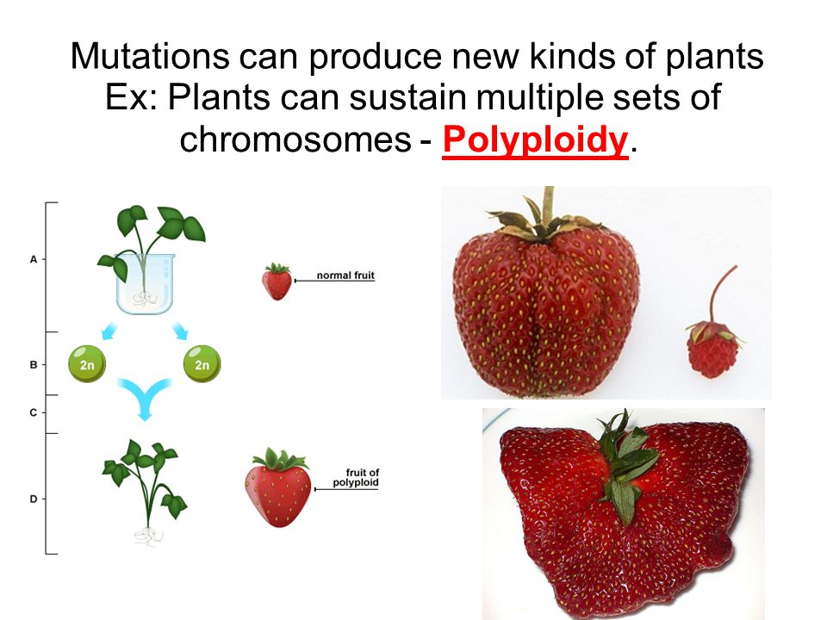
Mutation Breeding Procedure
Take shoot-tip area of explant (0.2 mm size)

Cultured on shoot induction medium

Stem segments incubated in growth chamber for 2 days

Active the lateral vegetative buds

Transferred into 50ml plastic tubes

35-40 ml EMS (Ethyl Methane Sulphonate) solution and placed on a shaker

60-90 RPM for the desired time

Explant were washed with sterile water 4-5 times

Shaken in sterile water for 1 hrs. at 60-90 RPM

Treated and washed stem segments were cut into small pieces about 4-5 mm in length

Transferred to fresh SIM for incubation in the growth chamber set at 25 ° C (± 1), 16/8

Light/ dark with light intensity 1500-2500 LUX for 3-4 weeks.
- Molecular Farming
- Molecular farming is the use of whole plant or plant cells/ tissue cultured in vitro for the production of valuable recombinant proteins
- The advantages of plant based systems can be summarized as follows-
- Plants are less expensive to setup and maintain than cultured cells.
- Plant based systems are extremely versatile.
- Which has been established as an economically viable alternative to mainstream production system and cells cultivated in large scale bioreactors.
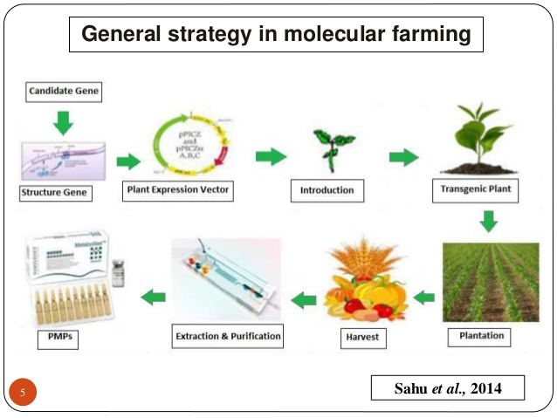

- Genetic Engineering
- Although genetic engineering and hybridization by conventional breeding can augment genetic variation in plants.
- In terms of quick returns, the time needed to produce a new genotype can be a critical factor for its commercial exploitation
Commercial application of genetic engineering
- In commercial horticultural production, research has centered mainly on fruits crop genetic engineering with limited amount on fruit crops
- Although genetically engineered crops are in widespread cultivation, most are horticultural.
References
- Buhara, Y. Buhara, Y. A., Mohammed, A., Mohammed, M., Arslan, M. Arslan, G. Ekrem, G. E. (2015) Clonal propagation and synthetic seed production from nodal segments of Cape gooseberry (Physalis peruviana L.), a tropical fruit plant. Journal of Agriculture and Forestry 39(5):797-806
- Chang, S., Mahon, E.L., MacKay, H.A., Rottmann, W.H., Strauss, S.H., Pijut, P.M. Powell, W.A., Coffey, V., Lu, H., Mansfield, S.D., (2018) Genetic engineering of trees: Progress and new horizons. Vitr. Cell. Dev. Biol. Plant. 54, 341–376
- Damiano, C., Frattarelli, A., Shatnawi, M. A., Wu, Y., Forni, C. andEngelmann, F. (2003). Cryopreservation of temperate fruit species:quality of plant materials and methodologies for gene bank creation.Acta Hortic 623:209–215.
- Das, D. K., Nirala, N. K., Reddy, M. K., Sopory, S. K. and Upadhyaya, K.C, (2006). Encapsulated somatic embryos of grape (Vitis vinifera L.):an efficient way for storage and propagation of pathogen free plantmaterial. Vitis. 45:179–84.
Yusuf, A. O., Culham, A., Aljuhani, W., Ataga, C. D., Hamza, A. M. (2015) Genetic diversity of Nigerian date palm (Phoenix dactylifera) germplasm based on microsatellite markers. Journal of Bioscience and Biotechnology, 7, 121–132.
- David, H., Domon, J. M., Savy, C., Miannay, N., Sulmont, G., Dargent,R. and David, A. (2006) Evidence for early stages of somatic embryo development in a protoplast-derived cell culture of (Prunus avium). Physiol Plant. 85:301–307
- Hussain, A., Ahmed, I. Q., Nazir, H. and Ullah, I. (2012) Plant Tissue Culture: Current Status and Opportunities, Recent Advances in Plant in vitro Culture, Annarita Leva and Laura M. R. Rinaldi (October 17th 2012).
- Isac, V.and Coman, M. (2012) Validated protocols for micropropagation of some fruit species to produce pre-basic plant material. Fruit growing research (XXVIII):1-5.
- Prado, M. J., Gonzalez, M. V., Romo, S., Herrera, M. T. (2007) Adventitious plant regeneration on leaf explants from adult male kiwifruit and AFLP analysis of genetic variation. Plant Cell Tissue and Organ Culture 88(1):1-10
- Rai, M. K., Jaiswal, V. S. and Jaiswal, U. (2009) Encapsulation of shoottips of guava (Psidium guajava L.) for short-term storage and germplasm exchange. Sci Hortic. 118:33–38
- Sahu, P. K., Tarun, Patel, S., Sahu, P., Singh, S., Tirkey, P. and Sharma, D. (2014) Molecular Farming: A biotechnological approach in agriculture for production of useful metabolites. International Journal of Research in Biotechnology and Biochemistry. (2): 23-30.
- Setargie, A., Mekbib, F. and Abraha, E. (2015) In vitro Propagation of Papaya (Carica papaya L.). World Journal of Agricultural Sciences 11 (2): 84-88.
- Sharma, S., A. Prakash and T. Ajinath (2009) In vitro propagation of Citrus rootstocks." Notulae Botanicae Horti Agrobotanici Cluj-Napoca 37(1): 84-88.
- Singh, P., Patel, R. M. and Kadam, S. (2013) n vitro mass multiplication of pomegranate from cotyledonary nodal explants cv. Ganesh. African Journal of Biotechnology. 12(20) 2863-2868.
- Tomar, U. K. and Dantu, P. K. (2013) Protoplast Culture and Somatic Hybridization. Cellular and Biochemical Sciences Book. 31 (8):885-890.

