TABLE OF CONTENT

I.INTRODUCTION
- BACKGROUND OF THE COOLING TOWER
- HEAT PIPE
- PRINCIPLE OF HEAT PIPE

II. LITERATUREREVIEW

III.PROBLEM DEFINITION

IV.METHODOLOGY
- COOLING TOWER WITHOUT HEAT PIPE
- COOLING TOWER WITH HEAT PIPE

V. CALCULATIONS

VI. MANUFACTURING PLAN
- FABRICATION PLAN STEPS
- PURCHASED COMPONENTS
- FABRICATED COMPONENTS

VII. OBSERVATIONS
- Table 1 WITHOUT HEAT PIPE
- Table 2 WITH HEAT PIPE

VIII. RESULTS AND DISCUSSIONS

IX. FUTURE ENHANCEMENT

X. CONCLUSION

XI. REFERENCES

Study of Cooling Tower with the Application of Heat Pipe on the Environment

Garima Khare¹, Garima Sharma², Jaspreet Singh Chhabra³
¹ Research Scholar, Department of Mathematics, School of Liberal Arts and Sciences,
Mody University of Science and Technology, Lakshmangarh, Rajasthan, India
garimashish188@gmail.com
² Assistant Professor, Department of Mathematics, School of Liberal Arts and Sciences,
Mody University of Science and Technology, Lakshmangarh, Rajasthan, India
sharmagarima2802@gmail.com
³ MS Student of University of Maryland Baltimore County in Engineering management
Jaspreetsinghchhabra123@gmail.com

ABSTRACT

People's needs are growing more and more in demand today, which is why industries are so important. However, to keep up with the rising demands, businesses need a lot of energy.Which can be fulfilled by setting up a power plant but more the power plants, more the use of cooling towers, which can affect, the effectiveness and the efficiency of the power plant?As well as the environment as more the power plants more the carbon footprint which means more effect on ozone layer So, to enhance such influencing factors and to tackle the question of how to save the environment.We came up with an innovation: we are applying heat pipe in the system or cycle of a power plant.We use heat pipes between the condenser and the cooling tower to see the factors affected by innovation. The effectiveness of the cooling tower and the entire power plant can be greatly improved by the use of a heat pipe, a device that operates on the principle of thermal conductivity and exhibits a capillary action to allow hot water coming from the condenser to automatically cool down without the aid of any external source before entering the cooling tower. A fantastic gadget where the phase transition takes place is the heat pipe.Water is the working fluid most frequently utilised in heat pipes. Water absorbs heat from the source at the hot end, changes phases to become vapour, and then travels via capillary action to the cold end. The cycle then continues as the fog at the stern end rejects heat from the atmosphere and transforms back into liquid water. This liquid water then travels back to the hot end to absorb additional heat from the heated source. The heat pipe's material is often determined by the fluid, heated basis, and other factors. Typically, copper-nickel alloys are utilised as alloy materials.

Keywords-Cooling Tower, Effectiveness, Efficiency, Heat Pipe

- INTRODUCTION

- BACKGROUND OF THE COOLING TOWER

A cooling tower is a device for heat rejection that focuses on losing heat to the environment by bringing cooling water's temperature down. Evaporative is the term used to describe this type of heat removal in cooling towers. It enables a small amount of chilled water to be discarded in flowing air to significantly cool the remaining stream of water. The air is released into the sky once the heat from the water stream transfers to it, raising the temperature and relative humidity to 100%.
In order to achieve more economical and energy-efficient functioning of systems that require cooling, heat removal devices like cooling towers are typically utilised to deliver lower water temperatures than "air cooled" or "dry" heat rejection devices, like the radiator in a car. Consider instances when a hot object was swiftly cooled by being covered in water, causing the heat to disperse and the object to cool quickly, such as an overheated automobile radiator. A moist surface cools more effectively than a dry one.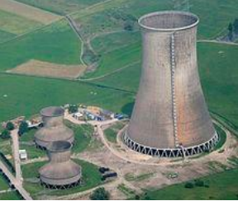

Figure 1 COOLING TOWER[1]

- HEAT PIPE

Based on a closed loop system, heat pipe functions. It is an amazing device that works silently and continually to produce a dependable part for our thermal management system. There is a little amount of working fluid inside the heat pipe, which is vacuum-sealed. The fluid circulates inside the wick structure that lines the heat pipe's inner diameter. The liquid vaporises when heat is applied through an electric heater because of the heat produced in the evaporative region. Due to the pressure created by the temperature difference, the fluid vapour quickly spreads to the opposite end of the heat pipe.At the opposite end, referred to as the condenser, the fluid releases its latent heat. The juice releases its latent heat, which an external heat sink rejects. The fluid changes back to liquid form, and the wick structure uses capillary force to passively push the liquid back to the evaporator. Heat transfer is quite effective when it uses the liquid and vapour phases.
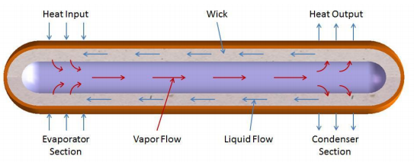
Figure 2 HEAT PIPE[2]

- PRINCIPLE OF HEAT PIPE

Thermal conductivity and phase transition theories underlie the operation of a heat pipe. It effectively moves heat across two solid contacts. When a liquid at a heated interface comes into touch with a solid thermally conductive surface, the liquid condenses into a vapour. When the smoke reaches the cold contact and condenses back into liquid, latent heat is released. It flows along the heat pipe. The cycle is repeated when the liquid returns to the heated interface. Due to the high heat transfer coefficient for boiling and condensation, this process uses capillary action, centrifugal force, or gravity to operate. Heat pipes are among the thermal conductors with the best efficiency. Thermal efficiency of a heat pipe is influenced by design elements like size, composition, wick structure, and working fluid.
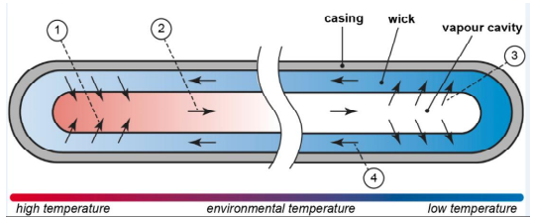
Figure 3 THEORY OF HEAT PIPE[3]

- LITERATUREREVIEW

He and Hoyano (2010) investigated the cooling effects of ceramic porous passive evaporative cooling walls. According to experimental findings, cooling efficiency peaked during bright days at 0.7. In windy situations, where the wind consistently blows at a speed of 1-3 m/s, cooling efficiency is higher. [4]
A ceramic evaporative cooling device that functions as a semi-indirect cooler was created by Gomez et al. (2005). The ceramic tube's annular channel is used to pass water that has been cooled in a cooling tower. The middle area is exposed to outside air. Cooled water vaporises by permeating pores. Recirculating interior air is conceivable with such a system, which is not achievable with a traditional evaporative cooling system. An experimental demonstration of such a 15 system yields temperature decreases of 5–12 oC under various circumstances. [5]
Regenerative evaporative cooling in a building has been explored by Khandelwal et al. (2010). Regenerative evaporative cooling systems showed a substantial potential for energy savings of up to 15.69%, while simple evaporative cooling systems offered 12.05%, according to the study's findings. The obtained interior temperatures range from 22 °C to 26 °C. [6]
El-Awad (2010) investigated the viability of evaporative cooler-based solar-assisted winter air conditioning systems. Solar heat is used by the evaporative air cooler to pre-heat the water supply. A theoretical model is created for a room with a volume of 3×3×3 m³. A typical power consumption of 0.1 kW is discovered. An estimated 150 LPD sun heater is needed for air conditioning with a 500 cfm air flow rate for at least four hours of operation, and a 250 LPD solar heater is needed for eight hours. [7]

REVIEW CONCLUSION

- It is discovered that incorporating the three following design techniques can boost the evaporative cooling system's cooling efficiency:
- Utilizing the right components for efficient evaporation
- Combining direct and indirect cooling techniques
- Using various pad materials in a range of thicknesses.
- The crucial variable that determines the use of evaporative coolers is the difference between the wet bulb temperature and the dry bulb temperature of the ambient air. Evaporative coolers are more beneficial when the difference is more noticeable.
- Various efforts have been made to investigate the impact of numerous parameters on the effectiveness of evaporative coolers. A given air flow rate is considerably impacted by the pad's material and thickness.
- Research has revealed that a lot of water circulation does not enhance performance. By enhancing pump performance, significant energy savings are attainable.

- PROBLEM DEFINITION

In areas with a lack of electricity and other power sources, cooling towers are widely used because we cannot afford to utilise our beneficial electric power to cool the equipment. In areas with an abundance of water, a cooling tower is a superior option, which also lowers the cost of the power plant. The purpose of our project is to evaluate if the cooling tower's heat pipe has improved the power plant's production.Since different working fluids operate at different temperatures, we must determine which working fluid to choose in accordance with the temperature range that our cooling tower can operate at [8]. We also consider which fluid should be used in the heat pipe in accordance with the temperature drop required in the cooling tower.Since water can operate between 30 and 150 degrees Celsius, it is typically utilised as a working fluid in heat pipes. Other functional fluids, such as methanol, which has a temperature range of -45°C to 120°C, can also be employed. Additionally, the heat pipe's material is chosen based on the intended outcome. The heat pipe material in our project is a copper-nickel alloy [10]. The use of the cooling tower's heat pipe is anticipated to improve both the cooling tower's efficiency and the efficiency of the power plant.
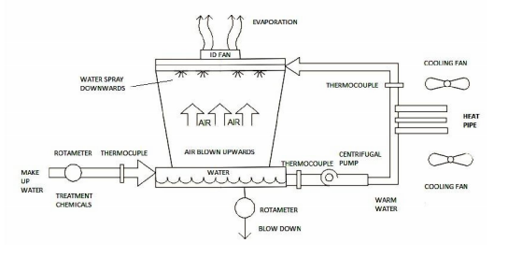
Figure 4 COOLING TOWER WITH APPLICATION OF HEAT PIPE

- METHODOLOGY

COOLING TOWER WITHOUT HEAT PIPE: -

- Firstly, we use a cooling tower without a heat pipe. In this, we cool the hot water from the power plant by evaporation of this hot water by flowing relatively calm air past through it.
- At the cooling tower's input and exit, we additionally compute the enthalpies of air and water.
- After this, we calculate the cooling tower's effectiveness and efficiency.

COOLING TOWER WITH HEAT PIPE: -

- Along with the cooling tower, we use a heat pipe to pre-cool hot water before it enters the cooling tower.
- Heat pipes of diameter 10mm and length 80mm and 2 in number are used.
- We also figure out the air and water enthalpies at the cooling tower's input and output.
- Effectiveness and efficiency measurements are made for the cooling tower.

CALCULATIONS
Given,
Pressure = 1.5 bar
The inner diameter of the cooker=22 cm
Initial height = 9.6cm
Final height = 9 cm
The heating time of the cooker = 1450 sec
Steam flow rate = 50.96 sec
Initial volume = (π/4) d² h
= π/4 * (22)² * 9.6
=3649.274 cm³
Final volume = (π/4) d² h
= (π/4) * (22)² *9
= 3420.549 cm³
Change in volume = final volume – initial volume
= 3649.274 – 3420.549
= 228.725 cm³
Volume flow rate = 228.725/50.96
=4.488 cm³ /sec
=4.488 *10⁻⁶ m³ / sec
@1.5 bar pressure
Vf = 0.001352 m³ / kilogram
Vg = 0.027378 m³ / kilogram
Vfg = 0.02 m³ per kilogram
Density = 1/ϱ = V_{f}+ xV_{fg} = 0.001352+0.7(0.026026)
ϱ = 51.098 kg/m³
Mass flow rate (m_{s}) = ϱ * Q
= 51.098 * 4.488 * 10⁻⁶
= 229.3282 * 10⁻⁶ kg/sec
For MW
Volume =750 ml
Time = 102 sec
Volume flow rate = 7.352 * 10⁻⁶ m³ / sec
Mass flow rate = 7.352 * 10⁻³ kg/sec

The formulas used above is taken from heat and mass transfer by PK Naag [9]

- MANUFACTURING PLAN

FABRICATION PLAN STEPS

- Firstly, we would calculate all the unknown parameters related to the design of the condenser and the cooling tower.
- After calculating parameters, we must purchase some components while fabricating some remaining parts.
- The following list shows the purchase and fabricating of components

- PURCHASED COMPONENTS
- Fan
- Pump
- Copper tube
- Connecting pipe
- Pressure cooker (boiler)
- Heat pipe
- Thermocouple
- Fan – We are using it to circulate air in the cooling tower.
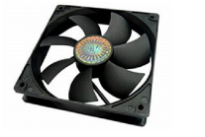
Figure 5 FAN [11]

- Pump – We use it to circulate the water in a dia -16mm copper pipe.
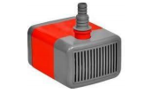
Figure 6 PUMP [12]

- Copper Pipe – We are using two different pipes of dia-16mm and dia-5mm lengths of 1.2m and 1m.
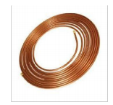
Figure 7 COPPER PIPES [13]

- Connecting Pipe – We are using these pipes to connect with copper pipes and a cooker for passing the steam.
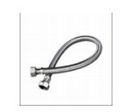
Figure 8 CONNECTING PIPE [14]

- Pressure cooker –We are using this to generate this steam as it works as a boiler.
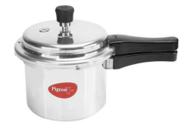
Figure 9 PRESSURE COOKER [15]

- Heat Pipe – We use this to extract heat from the water to increase the cooling tower's efficiency.
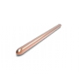
Figure 10 HEAT PIPE [16]

- Thermocouple – The steam, incoming water, and output temperatures are all being measured using this.
Figure 11 THERMOCOUPLE [17]

FABRICATED COMPONENTS

- Cooling tower –We are using this cooling tower to set the same condition used in the power plant.
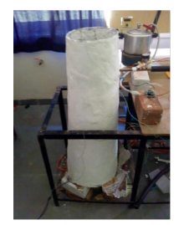
Figure 12 COOLING TOWER

- Condenser - We use this condenser to use the same condition present in the power plant condenser with the help of a pressure cooker (boiler) and copper pipes.
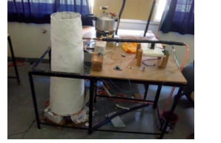
Figure 13 COOLING TOWER WITH CONDENSER

- We have manufactured a 1m height of the cooling tower of iron structure with an aluminium frame to support the system. We have kept the shape of the cooling tower as a frustum of a cone.
- Then, we coated the structure with the frame with a layer of plaster of Paris.
- We drilled a hole in the cooling tower diameter of 20mm to insert copper pipe from the condenser.
- We use counter flow concentric copper pipes with 19mm and 4.5mm diameters.
- Lengths of copper tubes are 1.4 and 1m for 16mm diameter and 4.7mm diameter pipes, respectively.

- OBSERVATIONS

Table 1 WITHOUT HEAT PIPE

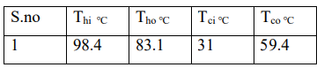
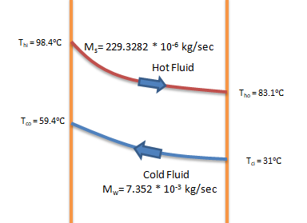
Figure 14 LMTD Curve -Without Heat Pipe

Table 2 WITH HEAT PIPE
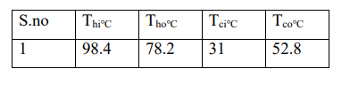
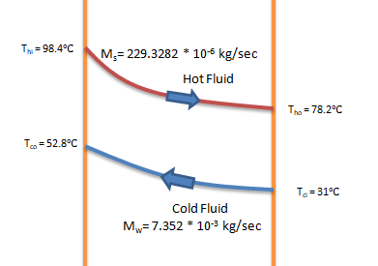
Figure 15 LMTD Curve -With Heat Pipe

CALCULATION: -
For counter flow heat exchanger
When cold fluid minimum
Effectiveness without heat pipe: -

€= (T_{hi}-T_{ho}) / (T_{hi}-T_{co})
€= (98.4-83.1) / (98.4-59.4)
€= 15.3 / 39
€= 0.3923

Effectiveness with heat pipe: -
€= (T_{hi}-T_{ho}) / (T_{hi}-T_{co})
€= (98.4-78.2) / (98.4-52.8)
€= 20.2 / 45.6
€= 0.4429

The formula used above is taken from the book of heat and mass transfer by PK Naag. [9]

- RESULTS AND DISCUSSIONS

The effectiveness of heat exchanger without heat pipe =0.3923. The point of heat exchanger with heat pipe = 0.4429. Based onthe above result,the effectiveness of the heat exchanger is increased significantly from a value of 39.23% when no heat pipe is used in arrangement to 44.29% when the heat pipes are used.
It can also be observed that the efficiency of the heat exchanger is generally increased when the heat pipe is used in a real power plant, boosting the efficiency of the entire power plant.
So, this experiment provides essential data to indicate the use of the heat pipe in the power plant to increase the overall efficiency.

- FUTURE ENHANCEMENT

The weather around us changes rapidly, leading to air quality at different seasons, which means more load on the power plant. So, the effectiveness of the heat exchanger, which increased by 5% in our experiment, can help us think of future carbon footprint and methane gas output. The use of heat pipes in future can be helpful as they will cool the water before it enters the cooling tower on a large scale.

- CONCLUSION

The characteristics of the cooling tower and the many forms of losses produced there are strongly tied to the cooling tower design. Heat transfer between air and water allows cooling to occur even while losses occur in the cooling tower. In ideal circumstances, the heat acquired by the atmosphere must equal the heat lost by the water. However, due to sun losses, it is not feasible in reality. With increased air flow rate, cooling tower performance rises, and with increased water-to-air mass ratio, features fall.

- REFERENCES

- HTTPS://EN.WIKIPEDIA.ORG/WIKI/COOLING_TOWER#/MEDIA/FILE:POWER_STATION_WESTFALEN._COOLING_TOWERS.JPG
- HTTPS://MYHEATSINKS.COM/HEAT-PIPE-SOLUTIONS/STANDARD-HEAT-PIPES/
- HTTPS://EN.WIKIPEDIA.ORG/WIKI/HEAT_PIPE#/MEDIA/FILE:HEAT_PIPE_MECHANISM.SVG
- HTTPS://WWW.SCIENCEDIRECT.COM/SCIENCE/ARTICLE/PII/S03601323090017 0X
- HTTPS://WWW.RESEARCHGATE.NET/PUBLICATION/44024693_THE_PHENOM ENON_OF_EVAPORATIVE_COOLING_FROM_A_HUMID_SURFACE_AS_AN_A LTERNATIVE_METHOD_FOR_AIRCONDITIONING
- HTTPS://KUNDOC.COM/QUEUE/PDF-ENERGY-SAVINGS-IN-A-BUILDINGUSING-REGENERATIVEEVAPORATIVE-COOLING-.HTML
- HTTPS://WWW.SCIENCEDIRECT.COM/SCIENCE/ARTICLE/PII/S03787788100037 86
- HTTP://SHODHGANGA.INFLIBNET.AC.IN/BITSTREAM/10603/11543/7/07_CHAP TER%202.PDF.
- HTTPS://WWW.SAPNAONLINE.COM/BOOKS/HEAT-MASS-TRANSFER-PK-NAG-0070702535-9780070702530
- HTTPS://WWW.ENERTRON-INC.COM/PRODUCTS/SELECTING-HEAT-PIPE/
- HTTPS://SHOP.CLARIONCOMPUTERS.IN/PRODUCT/ASUS-ROG-STRIX-XF120-PWM-CABINET-FAN/
- HTTPS://WWW.TRADEINDIA.COM/PRODUCTS/COOLER-PUMP-333-C6006200.HTML
- HTTPS://WWW.BOBVILA.COM/ARTICLES/COPPER-PIPE-TYPES/
- HTTPS://WWW.PEPPERFRY.COM/STAINLESS-STEEL-CHROME-PLATED-CONNECTING-PIPE-LENGTH-39-5-INCHES-BY-R-N-1779986.HTML
- HTTPS://WWW.AMAZON.COM/HAWKINS-CLASSIC-ALUMINUM-PRESSURE-COOKER/DP/B000E7BX96
- HTTPS://IN.ELEMENT14.COM/CCI/00C93480101/HEAT-PIPE-300MM-8MM-DIA/DP/1373311
- HTTPS://PI-PLATES.COM/THERMOPLATE/

