“Agritourism” – a model for natural resource sustainability and rural development
Sanjeeb Pal (orcid=0000-0003-0567-9086)
Author Affiliations
Professor - Amity School of Hospitality,
Amity University Rajasthan
Kant Kalwar, NH-11C, Jaipur Delhi National Highway
Rajasthan- 303002, India.

Corresponding author: sanjeebpal2002@gmail.com

Abstract:
CONTEXT: India is a country with diverse climatic conditions and a variety of cultural offerings with agriculture as the backbone. It is always observed that Natural calamities resulting from misuse or overuse of land resources cause havoc in terms of culture as well as the economic condition of the host population, especially the farmers. They desperately need guidance on sustainable agriculture and Agritourism practices as a source of alternate income.
OBJECTIVE: The present study covers these aspects and attempts to form a linkage with tourism resulting in both economic progress and resource sustainability.
METHODS: The Researcher follows a combination of Ethnographic Study and Case Study methods, by systematically deriving information from the results of findings that were conducted to address similar types of queries. Personal Interviews were conducted at selected places of Agritourism in the Maharashtra district of India, to compare and form a model for Agritourism development.
RESULTS AND CONCLUSIONS: The result shows that Visitors are willing to travel to these destinations as an attraction, and Agriculture forms a major part of the same. A systematic way of land use can help the farmers to sustain their agricultural produce and linking with tourism can result in an alternative source of income as well as sustainable development of the area.
SIGNIFICANCE: The Review and Analysis can result in further research on the area and could be a source of a Sustainable Model which could be followed throughout since proper use of land and uplifting of the economic conditions along with preservation of heritage is required globally.

Keywords: Agritourism, Sustainability, land use, economic development, Principles of Agritourism, Sustainable Development.

Introduction:
Agriculture has been the pillar of the Indian Economy for decades. It is more of our culture than just a profession. Recent developments in Technology and the way of producing more with less input may have added the necessary input required to excel in this field, but, the 2019-20 report on Economic Survey shows a decline in the impact of agriculture on the economy of the country. The decline may be attributed to the higher growth performance in other non-agricultural sectors. (Table 1).
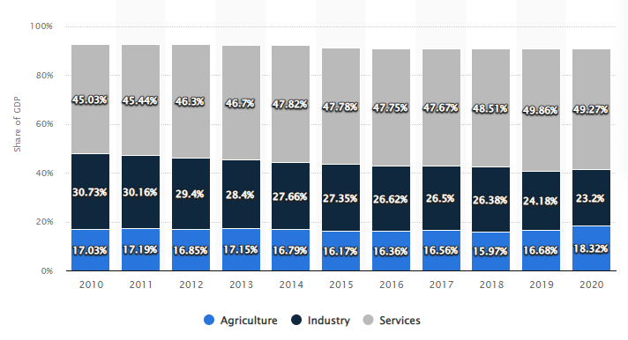
TABLE 1: Source: https://www.statista.com
Due to this reason Development of Rural Areas has become a Top priority for most developing countries (Fariborz Aref 2009)[1]. One major issue the Farmers in the 21st Century are facing is the problem related to Natural Calamity and how to overcome the disasters happening beyond the human call. Since natural calamities have a significant negative impact on agricultural production at the local level, it is very important to have assistance to affected households in terms of post-disaster employment opportunities ( DC Israel, RM Briones – 2012). This raises a very important question in mind as to- (Q1): “What could be a Sustainable diversification option to enhance the economic condition of the farmers’?
India is a country with a diverse cultural Heritage in place and most of the cultural sites may be located within the periphery of rural India. The locals or the host population are majorly concerned with ensuring the conservation of the cultural heritage, as well as the various rituals and festivals, celebrate locally. Some of the most important components of rural landscape are the important buildings and historic places as well as monuments and other physical resources which may be considered worthy of preservation (UNESCO 2013). Several mountainous regions in India are famous for their unique landscape, torrential rainfall, and agricultural richness – an example is the Garo, Khasi, and Jaintia Hills. The area is very rich in its floristic and biodiversity. These three places are further credited with the practice of “Sacred grove” or managing the forest with sustainable biodiversity conservation [17]. Even though agriculture and Tourism research bodies are growing but still proper evidence suggesting the associations between Agriculture and Sustainability of the Tangible Rural Heritage is missing [6]. It is also a known fact that most of the architectural and cultural heritage, along with the Natural resources of a particular place is always exploited in the name of tourism. These resulted in a value degradation of our Cultural, Historic as well as environmental heritage [16]. All these factors raise my second question– (Q2): Can Agritourism in linkage with Rural Tourism become a Model for sustaining the Rural Heritage as well as becoming an alternative means of generating income for the farmers?

Theoretical framework:
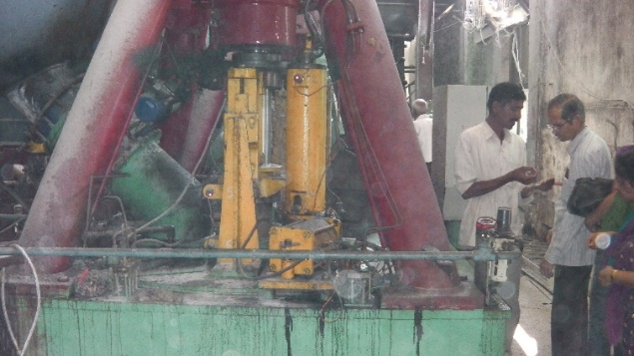
Agritourism and Rural Tourism are two terms that are very strongly interlinked. Along with farm production and processing, rural tourism usually consists of those activities that are related to Living in the country, its culture, religion, and everything that is understood by ethnography. Agritourism comprises trips of tourists to village farmlands and ranches which are well prepared with packages comprising events in country areas and trips to food processing plants.
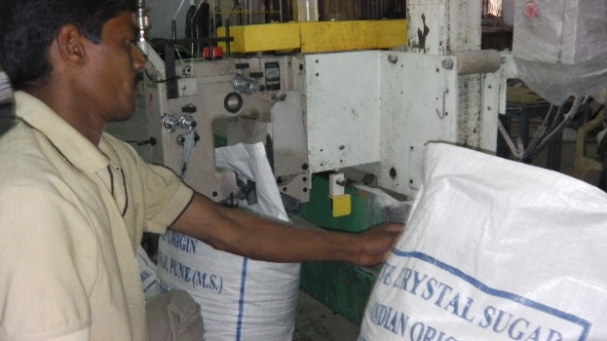
(a) (b)
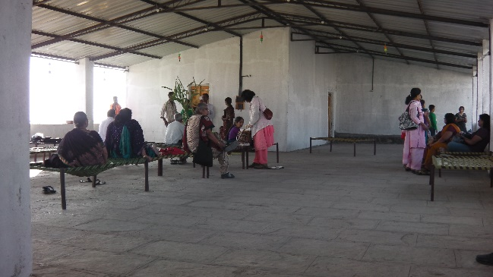
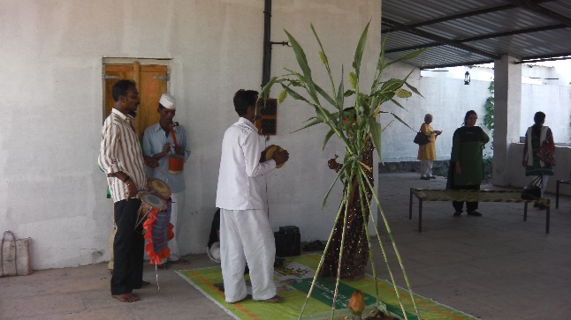
FIGURE 1 – (a) & (b) - Sugar Processing Unit at Baramati Agritourism Farm- Pune, Source: Author
(a) (b)
FIGURE 2- (a) & (b) Local Rituals & Food Service at Govind Bag- Agritourism Farm- Pune, Source: Author
Chantell LaPan & Carla Barbieri (2014),[2] established that Agritourism is a suitable tool to preserve Rural Tangible Heritage since the Cultural and Personal Values belong to the farmers. But to gain economically from the heritage assets, they should make the preservations sustainable through information about the historic buildings and site visits of the tourists. N. Ray et al (2012)[13] in their study concluded that Rural tourism is expected to emerge as an important factor for viable human growth including poverty alleviation, employment generation, environmental regeneration and development of remote areas, and empowerment of women. Singh, K., Gantait, A., Puri, G., Swamy, A. (2016) [18], in their paper has highlighted the want, scope, and marketing approach for Rural Tourism in the Indian context, thrust will be to promote village tourism as the primary tourism product to gain maximum socio-economic benefits from it. Sanjeeb Pal., Dr. Madhu Murdia. (2018)[14], in their study concluded that lack of awareness among farmers, lack of training opportunities to learn about Agri-tourism and execute projects, and absence of policies and infrastructure support that can support agritourism projects are some of the major challenges. Pal, S. (2016)[11], in his study on Agritourism Typology concluded that a suitable definition of Agritourism would be: Farming-related events offered on a working farm or other agricultural settings for entertainment or educational purposes. Santucci, F. M. (2013)[15], stated that since the early ‘80s, agritourism has represented a very good opportunity for increasing farm employment and income. Within the new paradigm of multifunctionality, agritourism has facilitated both horizontal and vertical diversification.
Another strong aspect was to look into the concept of Agri-Tourism from the point of view of the Tourist or the community. Does the tourist want to embrace community-based tourism without the frills of luxury on their lap? Dalen (1989)[4], in their study, spoke about new tourists who are modern idealists, and seek excitement and entertainment but are also interested in more intellectual and cultural activities. They refuse mass tourism and fixed itineraries. Another interpretation of the new tourist is Gray’s (1970)[7] wanderlust tourist who pursues multidestination holidays and seeks foreign cultural experiences to satisfy the hunger for learning as well as for exoticism. Fiorello, A., & Bo, D. (2012) [5] conducted a study through six case studies, under the conditions of the internal origin of the project, internal management, and economic, psychological, social, and political empowerment of the public and concluded that community-based ecotourism projects are designed to be sustainable and to meet the new tourist’s expectations for immersion in the local life, environmental conservation, and sustained quality of life of the host community.
Cucari, N., Wankowicz, E., & De Falco, S. E. (2019)[3], investigates the Albergo Diffuso as an example of sustainable community-based entrepreneurial land use. It represented a noteworthy model of sustainable tourism and showed how reciprocity of entrepreneurship and the territory creates value for all stakeholders both through enhancement of the landscape and attractive development of tourist destinations.

Research Methodology:
This paper uses a combination of the Ethnographic Study and Case Study method and pooled information required to systematically search and combine the results of studies that addressed a similar kind of question. Most of the data used in this editorial has been drawn from Secondary sources, ie. Scholarly publications, policy papers, and other relevant public bodies and international agencies. Some primary data were collected from observations and verbal discussions with some Agritourism farms in Maharashtra.
Case study of Lepchajagat: Sunny Rawat (2020)[12]- This study was conducted on a small village in the Darjeeling district of West Bengal called Lepcha Jagat, 19 km away from the town of Darjeeling. Tourists can get hands-on with the process of cultivation and interact with the pet animals and livestock on the farms. From tending chickens with your little one, feeding the pigs to riding a horse – everything can be availed within the farm destination. This kind of Tourism provides an opportunity for the travelers to embark on an agritourism adventure, knowing the nitty-gritty of farming techniques while staying on a local farm and touring the entire facility. The study revealed that this area got developed due to the introduction and combination of Tourism along with Agricultural activities. It enhanced the growth of the service sector and resulted in the conservation of rural ecology sustainably. The pattern has also resulted in environmental conservation through sustainable land use and resource conservation. It has also helped in linking the gap between the urban and rural population thereby creating room for economic parity and development.
A case study from Poncokusumo, Malang, Indonesia: Hakim L, Siswanto D, Rahardi B, Zayadi H (2019)[8]- This village is located on the South border line of Bromo National Park in Indonesia at the western side of Semeru sloping area. It falls around 40kms from eastern Malang with beautiful sightseeing surrounded by green apple plantations. The study focuses on Poncokusumo since ecologically it is a vital buffer zone area for biodiversity conservation in the national park system. Most of the land in the area is dominated by the cultivation of corn, vegetables like cabbage, citrus fruits, and green apples. It was discussed in the study that a lot of unsustainable changes took place due to intensive crop cultivation resulting from the desire for high economic benefit. The destination Poncokusumo had an outstanding resource for Tourist attractions and is located in the corridor system of tourist attractions. So, there was an opportunity to involve coffee-based tourism as a sustainable development strategy.
Cases of selected micro-entrepreneurs (Cavite, Laguna, and Rizal provinces), in the Philippines, Tugade, L. O. (2020)[20].: This study mainly focused on the motivational aspect of Agritourism and the reasons which lead to the acceptance of this concept. Personal hobbies and a deep urge to share and show the visitors the cultural heritage they inherited were one of the motivational factors. The farm owners also mentioned that the second -income source which contributed to the well-being of the owner is also another factor. Seasonality sometimes resulted in a disbalance of income from farming which was getting compensated through the introduction of Tourism and attaching it to their farm. Some farmers did invest a small amount of money to create some sort of infrastructure like a place to serve food or a place to stay and take rest for the tourist. Instead of selling the harvest to the whole sellers, they started selling it to locals which again created an alternate source of revenue for the host populations. Crop variety methods, conservation of agricultural lands, improvement of environmental practices, and education of visitors about environmental issues are among the ecological outcomes of agritourism practice.
When the owner of the “Parashar Paryatan Kendra”- Mr. Manoj was interviewed (2019), he mentioned that “I started the Agritourism Tourism Centre”, with an amount of only Rs 350 in 2010, I procured the land on lease for 5 years and then developed the whole model with the support of another 7 farmer friends. Today I have almost 7500 plus visitors who already visited my farm and it is growing year on year”. This show that Agritourism Models are now being picked up by many villagers to boost their income level. This particular village has been formed by 7 villagers and the result was visible from the guest comments received and checked from the trip advisor- “Had a great time at Parashar. Manoj and his team are fabulous hosts and ensured our stay was excellent. Manoj had arranged great excursions to a nearby scenic lake and a nearby grassland where we got a chance to spot a herd of blackbuck and deers. On the way, we also spotted a fox. Throughout our stay, we had some awesome traditional Maharashtrian food and snacks. Manoj’s knowledge of the local flora and fauna is great and loved this concept of Agri Tourism.”- (Source: https://www.tripadvisor.in/Hotel_Review-g297654-d3833413-Reviews-Parashar_Agritourism- Pune_District_Maharashtra.html)
The income generated through the introduction of the concept contributed a lot to their economic condition in the form of an alternate income., “I think this operation gives us that additional income which otherwise we miss., since most of the time the wholesalers do not pay us the amount as per our expectation” (Interview, 2019).

Discussions:
Agritourism may be deemed as one of the models which may result in fulfilling the gap between Tourism Promotion of a particular destination along with Sustainability of the destination in terms of the Tourism products as well the environmental concerns. The model of Agritourism promotion and set-up in a particular destination may broadly address the following issues which are all considered to be a very important factors in the development of a sustainable tourism destination.
a) Preservation of Heritage and Culture
Conservation/preservation/revitalization of our Cultural and Heritage features of Indian Villages, its traditional customs, and rich history are all somehow or the other linked with the growth and sustainability of our villages. The promotion of these villages through a unique form of tourism would go a long way in restoring and presenting our traditional Indian Culture.
b) Sustainable diversification in the economic condition of the farmers
Though India is considered to be a country that depends mainly on its Agriculture produce (66.7% of the population engaged in Agriculture - https://www.economicsdiscussion.net), still the Diversity in Agri produce is in a nascent stage. (Kumar, Anjani & Saroj, Sunil & Singh, R.K.P. & Jee, Shiv. 2016)[10]. If the farmers are trained in the production of different homegrown Vegetables and Fruit trees along with animal husbandry, it may allow farmers to increase their income. Here, the linkages between Tourism activities and Agriculture can work out as a model to open up a profitable market for the farm products and create an opportunity at a large for the regional Tourism market to go and enjoy their roots. This planting of different agricultural products helps the farmers in increasing their income and also improves soil health.
c) Conserving the Natural Infrastructure – Natural and cultural resources have always been an attraction for any kind of tourist. Conserving and Showcasing the Natural Infrastructure in the form of sightseeing attractions through the Host population may go a long way in promoting a sustainable mechanism for Heritage conservation. One option of promoting the heritage cuisines of India through the idea of Agritourism may go a long way toward sustenance.
d) Promote sustainable Indigenous farming practices
Since there is a huge gap between the Government’s policies on sustainable farming practices and the education of the farmers in most places, the farmers and the rural communities get into wrong ways to increase their farmland produces, which may result in severe damage to the environment as well as the farming community. For example, the locals in most of the Hill stations in India are cutting up trees to increase their farm produce for sustenance and land up farming near the bank of rivers. Farming too close to the riverbeds cause serious damage to the soil and result in heavy flooding and landslide during the rainy seasons. If the local farming pollution is sensitized to the importance of following a proper pattern of land use, it may result in better use and the same model may be used or copied in other places. Digging of trenches near the riverbanks may result in water conservation, cultivating shrubs near the river banks could help in sustaining soil erosion and planting of Indigenous trees shall help in controlling soil erosion and landslides. Farming away from the riverbanks shall help in preventing floods.
Basic principles required to embrace Agritourism successfully- a checklist.
Three basic principles are required for Agritourism to be -
1. Viewers have something to look for – flora & fauna, farms, and nature are some of the things that agriculture tourism can give to tourists. In addition to this, culture, dress, festivals and rural games can create considerable interest among agricultural tourists.
2. Doing something for visitors to get engaged - Participating in different activities relating to farming, swimming, rural rides, cooking, and participating in rural sports, which the tourists participate in and enjoy.
3. Visitors have the option to buy/carry - Option to carry some kind of souvenir as a remembrance to buy products made locally either for consumption or display
Things to see:- Options
The farm…
One of the very basic principles on which the whole concept of Agritourism works is to ensure that the visitors have an experience that they can carry with them. Tours to the farm are organized and the visitors are made to experience the different concepts used in farming along with the different processes. The main objective is to make the visitors aware of the different types of crops and vegetables, how they are grown and cultivated, and the harvesting methods. It also includes the handling of different types of farm animals and husbandry, like the milking process of cows, caring for other farm animals including the problems faced by the farmers more often and their plights. This kind of knowledge not only helps the visitors to understand the lifestyle of a farmer, his day-to-day hard work, and the problems faced during the process of farm to table but also increases the positive image of agriculture among the visitors.
Creative display….
It is a great idea to keep in display the different equipment used for farming both traditionally and today. There could be some displays directly as a part of the personal collection from the farm family.
Demonstration of Farming process……
Most of the visitors coming to be a part of Agritourism would like to experience the different processes involved in different farming activities. For example, starting from harvesting of sugarcane till the time sugar cane processing is done and the end by-product sugar is produced. It becomes more interesting when some form of traditional techniques are kept for demonstration and then the modern processes are explained.
The natural feature of the farm…..
Most of the farms may have some kind of natural features imbibed in the farm itself which sometimes become a major natural feature of attraction for the visitors. It could be a small natural waterfall to a small stream or pond. Anything related to water may become a popular natural factor for many tourists to enjoy.
Small animal husbandry with petting animals……
Farm animals and pets are always an attraction for any kind of farm setup. A small zoo on a farm is attractive to children. There are numerous animal friends one can have in the petting zoo, including goats, sheep, chickens, ducks, rabbits, ponies, and many more. The children may be allowed to get in direct contact with some animals where they may be allowed to feed them. The farm owner may keep a small shop with basic animal feeds, which could be sold to the visitors.
Things to do:- Options
Education & information for visitors…..
The farm should provide an opportunity for the visitors to experience and learn through entertainment. Some farms may provide guided farming and this type of activity becomes quite popular with the children’s community where they can learn from planting to harvesting crops. Some farms may offer classes in cooking, arranging flowers, or making herbal medicines. They depend on these activities to help build customers for their main products.
Pick your own……
The visitors may be allowed to pick up their farm products, especially vegetables and fruits. They can do the harvesting themselves under a guide and can carry the same with them. Normally a small fee could be charged before the actual event. Fishing may become a very entertaining activity in this regard. The visitors may also be allowed to cook themselves to enjoy the real freshness of organic farm produce.
Different kinds of therapy….
Organic fish therapy or fish spa is a very popular activity nowadays and could be a big scope of attraction under things to do while on a farm.
Option to buy/carry
Fresh and processed foodstuff…..
Visitors may like to buy fresh vegetables, fruits, milk and eggs, and herbal products from the farm. Processed food can also be organized for sale. Products like lime slices, tomato sauce, mango chutney, mangoes, buttermilk, curd and cheese, different types of pickles, etc can be sold as a part of the farm attractions.
Any Agritourism farm can have two different types of visitors- one a day tour and the other an overnight visitor.
- Tourist associated with agriculture and day visitors– it is offered as a tourist attraction directly connected with the agricultural environment, and agricultural products.
- Vacationer stays on the farm (farm tourism) – this form of the tour is directly linked with the farm visit where the visitors get the opportunity to get involved with different kinds of farming activities and along with the option to stay and enjoy the natural calmness of a farm.

Conclusion

The idea of Agritourism can go a long way in both preserving our Natural resources, especially those related to Agricultural produce as well as helping provide a sustainable alternate source of income for the farmers in India. The above study would open up further research in the area and the short framework of Agritourism may be further refined and implemented as a model for starting an Agritourism venture. The result from the discussion would also help in the further execution of strategies to reduce land degradation and avoid natural calamities in climatic sensitive areas of our country.

REFERENCES:
- Aref, F., & Gill, S. S. (2009). Rural tourism development through rural cooperatives. Nature and Science, 7(10), 68-73.
- Chantell LaPan & Carla Barbieri (2014) The role of agritourism in heritage preservation, Current Issues in Tourism, 17:8, 666-673, DOI: 10.1080/13683500.2013.849667.
- Cucari, N., Wankowicz, E., & De Falco, S. E. (2019). Rural tourism and Albergo Diffuso: A case study for sustainable land-use planning. Land use policy, 82, 105-119.
- Dalen, E. (1989). Research into values and consumer trends in Norway. Tourism Management, 10(3), 183-191.
- Fiorello, A., & Bo, D. (2012). Community-based ecotourism to meet the new tourist's expectations: An exploratory study. Journal of Hospitality Marketing & Management, 21(7), 758-778.
- Fuentes, J. M., Gallego, E., Garcı´a, A. I., & Ayuga, F. (2010). New uses for old traditional farm buildings: The case of the underground wine cellars in Spain. Land Use Policy, 27(3), 738 –748.
- Gray, H.P. (1970). International Tourism: International Trade. Lexington: Lexington Books
- Hakim, L., Siswanto, D., Rahardi, B., & Zayadi, H. (2019). Fostering coffee agroforestry for agrotourism development in degraded land in a buffer zone of a national park: A case study from Poncokusumo, Malang, Indonesia. Eurasian Journal of BioSciences, 13(2), 1613-1620.
- Israel, D. C., & Briones, R. M. (2012). Impacts of natural disasters on agriculture, food security, and natural resources and environment in the Philippines (No. 2012-36). PIDS discussion paper series.
- Kumar, Anjani & Saroj, Sunil & Singh, R.K.P. & Jee, Shiv. (2016). Agricultural Diversity, Dietary Diversity, and Nutritional Intake: An Evidence on Inter-linkages from Village Level Studies in Eastern India. Agricultural Economics Research Review. 29. 15-29. 10.5958/0974-0279.2016.00030.6.
- Pal, S. (2016). Agricultural Tourism-Typology study & Tourist perception concerning Maharashtra. KIMI Hospitality Research Journal, 1(1), 28.
- Rawat, S. (2020). Rural Tourism and Sustainable development in Darjeeling hills, West Bengal: Case study of Lepchajagat.
- Ray, N., Das, D. K., Sengupta, P. P., & Ghosh, S. (2012). Rural tourism and its impact on socio-economic condition: Evidence from West Bengal, India. Global Journal of Business Research, 6(2), 11-22.
- Sanjeeb Pal, & Dr. Madhu Murdia. (2018). Scope of Agritourism in Maharashtra (with reference to challenges in development). Journal of Advanced Research in Business Management and Accounting (ISSN: 2456-3544), 3(8), 01–09.
- Santucci, F. M. (2013). Agritourism for rural development in Italy, evolution, situation, and perspectives. Journal of Economics, Management, and Trade, 186-200.
- Shermin, A. F. (2017). Impacts of rural tourism on architectural and cultural heritage: The cases of Sualkuchi and Mawlynnong, North-East India. International Research Journal of Engineering and Technology, 4(11), 318-322.
- Singh, A. K. (2010). Probable agricultural biodiversity heritage sites in India: V. The Garo, Khasi, and Jaintia hills region. Asian Agri-History, 14(2), 133-156.
- Singh, K., Gantait, A., Puri, G., & Swamy, A. (2016). Rural tourism: need, scope, and challenges in the Indian context. Hospitality and Tourism: Challenges, Innovation, Practices, and Product. New Delhi: Adhyayan Publishers and Distributors, 32-47.
- Srivastava, S. U. R. A. B. H. I. (2016). Agritourism as a strategy for the development of rural areas case study of Dungrajya Village, Southeast Rajasthan, India. Journal of Medical and Dental Science Research, 3(6), 35-39.
- Tugade, L. O. (2020). Re-creating farms into Agritourism: Cases of selected micro-entrepreneurs in the Philippines. African Journal of Hospitality, Tourism and Leisure, 9, 1-13.
- United Nations Educational, Scientific and Cultural Organization – UNESCO. (2013). Tangible cultural heritage. Retrieved August 7, 2013, from http://www.unesco.org/new/en/cairo/culture/tangible-cultural-heritage/.
- Wagh, R., & Dongre, A. P. (2016). Agricultural Sector: Status, Challenges, and its Role in Indian Economy. Journal of Commerce and Management Thought, 7(2), 209-218.
- https://www.statista.com/statistics/271329/distribution-of-gross-domestic-product-gdp-across-economic-sectors-in-india/
- https://www.travelocity.com/Lepchajagat-Agritourism.d3000441020-aaAgritourism.Travel-Guide-Accommodation

