Microbial degradation of plastic/ polyethylene
AfeefaAteeq, Amar P. Garg* and Neha bisht

School of Biological Engineering & Life Sciences, Shobhit Institute of Engineering & Technology (Deemed-to-be-University) Modipuram, NH-58, Meerut 250110, India

afifaatiq6@gmail.com, amarprakashgarg@yahoo.com*, bishtneha1993a@gmail.com

Abstract
Plastic become a very important product in the economic sector because of the usage of plastic at a very large scale almost in every sector such as agriculture, building, and construction in fact in health and consumer goods also. Plastic is used in household items, food items, pharmaceuticals, detergents, cosmetics, sanitary wares, tiles, plastic bottles, artificial leather, and so on. The use of plastic in every sector poses a serious threat to the environment and every ecosystem. At the peak time of usage of plastic, there is a need for a method by which plastic can be degraded. The biological techniques are environmentally safe and eco-friendly. To overcome this problem the biodegradation method is needed to use. Disposal of plastic on both land and marine causes problems for humans, animals, and marine animals. The plastic gets affected by the microbes in the natural environment so the microbes may have the ability to degrade the plastics. It is very important to understand the interaction between microbes and plastics. Previous research stated that many microbes have survived and degraded plastics. In the present chapter we focus on the basic types of plastics than degradation types and how can we degrade the plastics through different methods. In the end, biological degradation is the easiest and most eco-friendly method to overcome this problem. Characterization of biodegradation is a very important part and the factor affecting the biodegradation of plastics. And which microbes have a great ability to degrade the plastics.
1. Introduction
Plastics are manmade heterochain polymers that originate from oil, coal, and natural gas. (S.T Azeko, 2015). And it was made by a Belgian chemist and clever marketer Leo Baekeland pioneered the first fully synthetic plastic in 1907. The 20th and 21st century was the age of plastics. Plastic is the loose term for chronicle materials that can be molded under heat and pressure and is called polymerization. But these plastic polymers are generally non-degradable and their accumulation leads to environmental pollution. According to Azeko (2015) 140 million tons of synthetic plastics are made annually worldwide. These are used for many purposes like food packaging, detergent, clothing, shelter, transportation, and chemical substances. These plastics are different types like polyethylene (LLDP, LLPE, MDPE, and HDPE), Polypropylene (PP), Polystyrene (PS), Polyvinyl Chloride (PVC), and Polyethylene terephthalate (PET) (Montazer et al.,2020).Nearly 300 million tonnes of plastic is produced worldwide most of the plastic is single-used plastic and shockingly, the 300 million tons of plastic weight is equivalent to the whole human population of the world (Thushari et al, 2020).
The disposal of plastics is a very big question for now because due to the resistance of plastics it remains in the same form everlasting. But plastics have a number of advantages alternately- the plastics are insubstantial, cost-effective, exceptionally durable, and moderately unbreakable (Isangedighi et al, 2018). But disadvantages of plastics are very dangerous because plastics do not break down in the environment due to their tendency to float, long-term perseverance, and iniquitousness in the marine environment for now plastic wastes possess a diversity of hazards to marine life (Thushari et al, 2020). It is now growing public concern over environmental decline with the disposal of plastics. Discarded plastics in landfills are a very big reason for a rapidly increasing percentage of solid waste and are harmful to the environment. (Ramann, 2012).
Not only landfill but the marine ecosystem is also get disturbed by plastic disposal and it is listed as one of the top ten environmental problems which should be solved globally since the United Nations Environmental Program issued the theme of World Environmental Day, “Beat Plastic Pollution” and proposed to all countries to work together to overcome from this problem (Muhoja et al, 2018). In 2018 European Commission issued the “Plastic Strategy in European Circular Economy” which proposed at least half of the plastic waste should be recycled by 2030. After these strategies more than 15 countries/regions successively issued policies to “ban plastic” and “limit plastic” including New York State, Washington State of America, EU member states, Hainan and Jilin provinces of China and India is also part of it. The actual measures focus on reducing, reusing, and recycling plastics, and its main aim is to stop the plastic on land before being delivered to oceans, seas, and rivers but it highly depends on the enforcement of government and raising public awareness about the environment (Muhoja et al, 2018, Taghavi et al, 2021). Even though the awareness about plastic waste is also increasing in many countries, numerous actions have also been taken the tackling plastic collection by motivating the active involvement of consumers, producers, industry, and companies but some other measures still need to be implemented for future and sustainable world. There are many other attempts that have been already taken to clean up the seawater but these attempts cannot clean the macro and microplastics from the sea and these should be cleaned up (Wang, 2021).
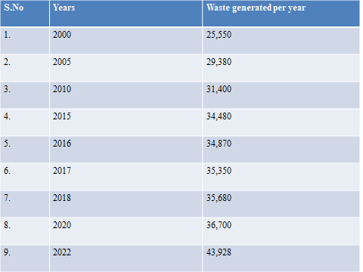
Table no. 1 Waste generated per year in the world
2. Plastic Pollution in Marine Environment
The collected plastics from the ocean can be classified into four categories based on their sizes: mega-plastics, macroplastics, mesoplastics, and microplastics. Microplastics come from manufactured or commercial products or cosmetic products. Microplastics are present in marine and coastal systems in a wide range. And polypropylene (PP), Polyethylene (PE) floats on the surface of oceans due to the light weight of plastics, while polystyrene (PS), polyvinyl chloride (PVC), polyamide (PA), and polyethylene terephthalate (PET) have higher density so they do not float on the surface of the oceans. Microplastics are widely distributed in every pelagic and benthic zone of marine systems. (Thushari et al, 2020; Taghavi et al, 2021).
There is a direct and indirect source of accumulation of plastic waste in the ocean. In the coastal and marine ecosystem, plastic pollution reaches from land and ocean-based sources. And mainly domestic activities, residential activities, tourism, and economic actions are major land-based plastic pollution. In the Marine, 75% of plastic pollution accumulates from land sources (Andardy, 2011). Coastal zones are highly populated and industrialized or urbanized areas. Residents used plastic products could directly discharge into the coastal zone not only the residential waste sometimes the whole containers are released into the drainage systems (Brown et al 2007; Taghavi et al, 2021).
A large amount of freshwater ecosystem with direction, plastic accumulate to the ocean through fast flow rate. The primary source of microplastics in Goiana Estuary, South America, are harmed river basins. (Lima et al, 2014).
3.Types of Plastics: (Isangedighi et al, 2018)
There are 7 different types of plastic present in the environment that are used worldwide for a very long period.
3. (A) Polyethylene Terephthalate: Introduced by J. Rex Whinfield& James T. Dickson in 1940. From PET plastic the beverages bottles are being made and interestingly it is produced by Coca-Cola and Pepsi.
3. (B) High-Density Polyethylene (HDPE): In 1953, Karl Ziegler & Erhard Halzkamp used catalyst & low pressure to create high-density polyethylene. It is used for pipes, drains & Culverts and used for a wide variety of products.
3. (C) Polyvinyl Chloride (PVC): It was made by a German Chemist in 1872. It is one of the most non-recycled plastic presents in the environment. It has been also called “Poison Plastic”.
3. (D) Low-Density Polyethylene (LDPE): It was the first Polyethylene that was produced. It has less weight than HDPE. This is only why the LDPE is considered a separate recycling material. Packaging & Containers are made from LDPE and 75% of LDPE comes from residential households (Taghavi et al, 2021).
3. (E) Polypropylene (PP): In 1951 J. Paul & Robert discovered polypropylene. It is mainly used in plastic woven bags, tarpaulins & ropes, injection molded products, film products, and pipes, etc.
3. (F) Polystyrene or Styrofoam (PS): Eduard Simon prepared medication from polystyrene in 1839. Hermann Staudinger a German chemist expands on its uses. Polystyrene is lightweight & easy to form into plastic materials. It is very harmful to the environment because it breaks effortlessly.
3. (G) Miscellaneous Plastics: Other remaining plastics are Polycarbonate, Polylactide, Acrylic, Acrylonitrile butadiene, Styrene, fiberglass, nylon, etc.
4. Types of Degradable Plastics:
4. (A) Photo degradable plastics: Photo degradable plastic is connected to the polymer backbone which is light sensitive. From giving a long time exposure to UV radiation it can be disintegrated. But when the radiation stopped supply because of the duration of sunlight on the land is low so it cannot degrade plastic. But if artificial photo-degradation light is used it can release toxic volatile compounds (VOCs) and it can cause various problems to the environment. (Lomonaco et al, 2020).
4 (B) Bio-Based Bioplastic:
Bio-based bioplastic has 100% of carbon from renewal resources like forestry and agricultural resources. Starch, corn, soyabean, and cellulose are examples of these resources. (Marichelvam et al, 2019). Bio-based plastics are beneficial for the environment because they can reduce fossil.
4. (C) Compostable Bioplastic: Composting is a subclass of biodegradation but every compostable material is not biodegradable in other environments such as marine, soil, and landfill. Composting can be divided into two classes home composting and industrial composting. In industrial composting conditions are controlled and home composting is slower than industrial composting (Meereboer et al, 2020). In composting the plastics are decomposed leaving any toxic compounds in the environment.
4. (D) Biodegradable plastics: Plastic that is degraded by the microorganisms in the natural environment is called as biodegradable plastic is disintegrated into biogases and biomass by the microorganisms. (Jain et al,2010) Microbes used plastic as their substrate.
5. How to degrade Plastic?:
There are many ways to overcome this problem which is associated with plastic waste. It could be recycling, energy recovery, band on specific products, and the production of biodegradable plastics. Recycling is an appealing method for thermoplastics, mainly for high volumes of used plastics like PETE and Polyethylene (PE) (Taghavi et al, 2021). It can decrease the use of natural resources as well as reduce the chances of global warming. Although, it only requires a separation technique for recycling that can be incorporated into the new products from pure raw materials. And from direct combustion, the recovery of energy can be achieved. And its advantages are also there it has the capacity to treat mixed plastic. But the special care is needed when dealing with PVC because incineration produces acid emissions in the environment. Waste to energy is also needed to control because it formed toxic compounds such as dioxins and furanes. (Xochitl et al, 2020).
On the other hand, if biodegradable plastics are also an alternative to overcome this problem because the functional property of biodegradable plastic is also an advantage. The brand name Eoflex® is producing complete biodegradable aromatic and aliphatic polyesters by BASF. They are making polyester by blending with bio-based polymers like starch or poly (lactic acid) (PLA), they are obtaining new and compelling properties of biodegradable plastics. And this is also the substitute for standard plastics such as polyethylene or polystyrene. And its application range is also very large waste bags to shopping bags from agriculture mulch film to knitted bags everything they are making. (Siegenthaler et al, 2012)
According to the degradation process, there are two pathways; synthetic plastics are of two types such as plastics with a carbon backbone and plastic with heteroatoms in the main chain. The plastics which have the backbone and only built carbon atoms are PE, PS, and PVC. On the other hand, the plastics which have heteroatoms in the main chain are PU and PET (Taghavi et al, 2021). And there are several types of polyesters that were used as alternatives to some petro-plastics. (Mohanan et al, 2020).
Bioplastics are biodegradable because they are either manufactured from biomass or fossils. In biodegradation, the microbes use polymers as their carbon source and some microbes use this polymer as a carbon source and energy. Microorganisms secrete different types of enzymes to degrade the plastic. Reducing polymer chain length by oxidation in plastics may be accessed by the microbes. And biodegradability in plastics can detect by the production of CO₂ and increasing microbial growth. (Trivedi et al, 2016)
Degradation through microorganisms is one of the easiest, most cost-effective, and eco-friendly processes, polymers like synthetic and natural both can be degraded through microbial degradation (Taghavi et al, 2021). Microorganisms use polymers as substrates for growth when they start degrading. Polymers degradation can be seen in various types such as cracking, erosion, discoloration, and phase separation. (Mukherjee et al, 2014)
Polymers basically made up of many monomers and monomers are mineralized. The monomers can pass through the cell membrane after depolymerization they enter the cell then they mineralized and biodegraded inside the cell. Physical and biological forces react to the breakdown of polymer. Physical forces involve heating, cooling, freezing, thawing, wetting, drying, etc. through cracking they cause mechanical damage. (Muthukumar et al, 2015).

6. Types of degradation:
6. (A) Photo- oxidative degradation: Light is the primary source of damaging polymers. When the polymer absorbs light the photodegradation process started. UV radiation degrades synthetic polymers. Some polymeric materials are used for various applications for a lifetime, the sunlight is the source of radiation for the degradation of plastic. (Ranby, 1989).
6. (B) Thermal degradation: Thermal and photochemical processes generally are the same in both the process oxidation takes part. The main difference in both the processes is the sequence of initial steps and site of reaction. In thermal degradation, the reaction takes part in the whole polymer but in photochemical degradation, reactions take part only on the surface area. For the initial stage of thermal degradation temperature and UV light are required. (Teare et al, 2000).
6. (C) Mechanochemical Degradation: In mechanochemical degradation, two processes take part mechanical and chemical. In this process the polymer chain breakdown by mechanical pressure and ultrasonic irradiations. Due to chain-side reaction, the branches are increased in number, and the molecular weight is decreased. The double bond concentration is also changed. (Striegel, 2003). In the air, the molecular weight of polyvinyl chloride is also reduced by mechanic chemical dichlorination with different oxide powders like SiO₂, CaO, Al₂O₃, and Fe₂O₃ (Inoue et al, 2004)
6. (D) Biological Degradation: biological degradation is the process of plastic being degraded by microorganisms. Microorganisms such as Bacteria, Fungi, and Actinomycetes degrade natural and synthetic plastics. Microbes used plastic as an energy resource and grow on the plastic and degrade from the surface area. (Alshehri, 2017)
6. (E) Ozone degradation: Ozone is present in the atmosphere which causes polymer degradation. Ozone presents in the environment in small amounts but ozone has a marked great effect on polymer. Ozone formed reduction in molecular weight by a change in mechanical properties of the polymer. The exposure of the polymer to ozone then formed different types of carbonyl groups. These products are based on ketones, lactones, esters, etc. (Allen et al 2003)
6. (F) Catalytic Degradation: Catalytic degradation basically a transformation of polymer into hydrocarbons which is a great field of interest. Catalytically degraded polymer produces oils and gases. By using this method of degradation of polymer not only the quality but the desired product can also be achieved. Different types of catalysts like Pt-Mo, and Pt-Co maintained by SiO₂ are used for degradation (Zeenat et al, 2019)
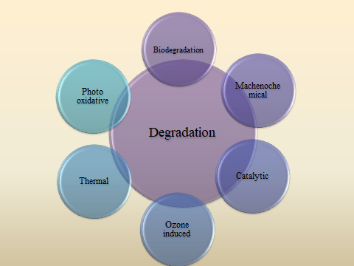

Fig. 1 Schematic diagram of types of degradation (Sangheethadevi et al 2015)
Aerobic Degradation: In aerobic biological degradation microorganisms large organic compounds break down into smaller organic compounds in presence of oxygen and microbes used oxygen as electron acceptors. And by-products of this reaction are water and carbon dioxide. (Priyanka and Archana, 2011)
Anaerobic Degradation: In this process, oxygen is not necessary for the breakdown of organic compounds through microbial action. Oxygen is an important component for the natural elongation of contaminates at hazardous waste sites. In the anaerobic degradation process anaerobic bacteria nitrate, iron, sulfate, manganese, and carbon dioxide an electron acceptor in place of oxygen for the breakdown of the large organic compounds into small organic compounds. (Gu, 2003)
Carbon (plastic) methane + carbon dioxide + water + carbon residual

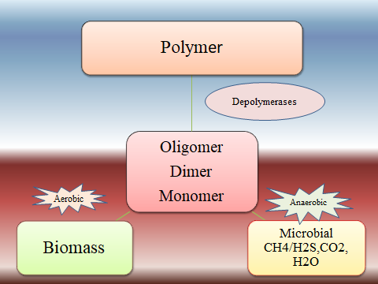
Fig. 2 Schematic diagram of polymer degradation under aerobic and anaerobic degradation (Gu et al, 2003)
7.Mechanism of plastic biodegradation: biological degradation of plastic start when the microbes are attached to the surface of the plastic and used plastic as their energy source after that secrete enzyme for the degradation of the enzyme(Danzo et al, 2018).

Microorganisms

Secretion of extracellular enzymes

Adherence of enzymes to the polymer surface

Cleavage of polymer chains

Biodegradation
End products CO₂ + H₂O, CH₄ and produced

Fig.3. Mechanism of enzymatic biodegradation of polymer (Alshehrie, 2017)
8. Polymer degradation by Microorganisms: microbial degradation of polymer includes biodeterioration, fragmentation, mineralization, and assimilation (Zeenat et al, 2021)

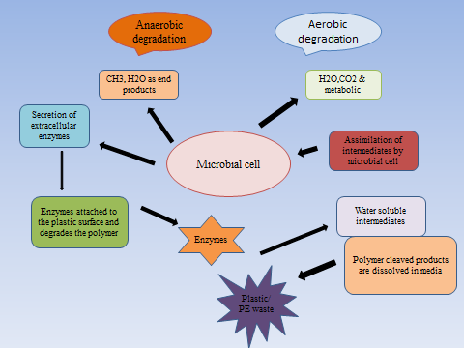

Fig. 4 Microbial degradation of plastic (S.Vankatesh et al, 2021)
8. (A) Biodetorioration: Biodetorioraton is a process in which the microbes affect the surface of plastics and change their physical, chemical, and mechanical properties. Chemical and structural changes depend only upon the polymer composition. Environmental conditions also affect the change in polymer properties. In the deterioration process substrate formation take part in plastic and biofilm formation (Vivi et al., 2019).
8.(B) Bio-fragmentation: Bio-fragmentation is the second step after biodeterioration in the bio-fragmentation enzymatic process takes action in the plastic polymer. In bacteria mostly oxygenase enzyme secretes and oxygenases enzyme have the ability to break down the polymer molecules and made carbon chain, alcohol, and peroxyl produts at the end. And these products are less harmful to the environment. (Pathak, 2017)
8. (C) Mineralization: After the bio-fragmentation process plastic polymer enters into the microbial cells via the cell membrane. Which monomers that are large in size cannot reach inside the cell they stay outside. The small monomers that enter the cell membrane microbes used the monomers as the energy source and this energy is used for biomass production of microbes. (Kale et al, 2015; Skariyachan et al 2017).
8 (D) Assimilation: The assimilation process is the last step for the degradation of atoms finally combined in the microbial cell for complete degradation. Now the secondary metabolites are transported either outside the cells or other microbes they further perform degradation and utilize these metabolites. In metabolites degradation the end products such as CO2, N2, H2O, and CH4. released during metabolites degradation. (Krzan et al, 2006)
9. Enzymatic Degradation of Plastic: Hydrolysable groups are absent in the carbon-carbon backbone so the degradation of plastic is a difficult task due to the microbial enzymes. In abiotic and biotic factors the reduction of molecular weight is the first achievement. Microbial enzymes attacked the carbonyl group of the polymer through which the degradation takes part. In enzymatic degradation, different enzymes are used such as laccase, manganese, urease, lipase, and protease. Laccase enzyme can degrade the polyethylene in only 48 hours of incubation. (Jaiswal et al,2019).
Factors affecting the degradation: factors that affect the biodegradation process can affect the organisms, substrate, and environmental factors (fig. 4).
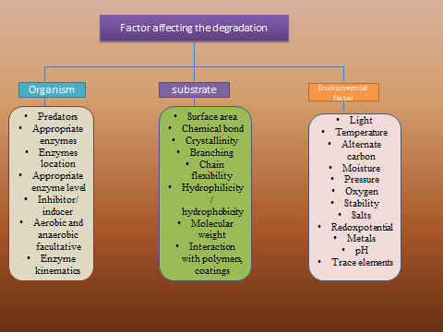
Fig. 5 Factors affecting the biodegradation process (Gu, 2018)

10. Microbial degradation of low-density polyethylene (LDPE): microbial degradation of polyethylene is the best and cheaper method to degrade polyethylene because the low-density polyethylene is a non-recyclable product that is circulated in the markets and homage and after disposal of this polyethylene it causes a serious problem to the environment. The usage of polyethylene is higher day by day polyethylene bags usage is nearly 500 billion to one trillion annually all around the globe (Madhu et al 2014)
Polyethylene is hydrophobic in nature microorganisms do not eat the plastic and they do not have any mechanism to digest the plastic easily. Microbes used plastic as a substrate for their growth. Polyethylene indicates degradation through cracking, erosion, discoloration, and phase separation. (Trivedi et al, 2016)
In previous studies and research, the microbes were isolated from the natural environment which has the ability to degrade polyethylene. Polyethylene and polypropylene were used for degradation (Park and Kim, 2019. Microbial species such as Streptococcus, Klebsiella, Micrococcus, Staphyloccocus, and Pseudomonas were identified as the degrading microbes of polyethylene (Das and Kumar, 2015). Apart from the bacteria fungus also has the ability to degrade polyethylene. Fungal species like Aspergillus oryza, Aspergillus nomius, and Aspergillus flavus have the ability to degrade polyethylene. (Muhoja et al, 2018, Taghavi et al, 2021). The additives which were used for the degradation of polyethylene oxidation were enhanced by which the molecular weight of polyethylene was reduced this was the reason the microbes can easily degrade the polyethylene (Skariyachan et al 2017).
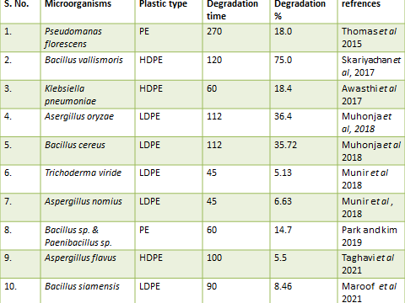
Table No. 2 Polymer degradation by microbes in previous studies.
11. Conclusion: The usage of plastics is spreading worldwide and plastic pollutes almost every ecosystem, so strict action should be taken against plastic usage. Plastic waste is around 10% in municipal waste and 85% in marine debris. The five heaviest plastic polluter countries are China, Indonesia, the Philippines, Vietnam, and Sri Lanka. These five countries contribute at least 56% of total plastic waste in the world. This is a matter of concern that how we use our resources which become an issue at the global level. Plastics are petroleum-derived polymer which is used for various purposes. Polythene bags are used all over the world. The degradation of polythene or plastic is a major concern because plastic degrades in the natural environment for almost thousands of years. Other than physical and chemical methods because these methods are tricky, time-consuming, and hazardous to the environment. The microbes have the potential to degrade polyethylene. And in this review article, we can see the benefits of biological degradation.
References:

Allen, Edge N.S, Mourelatou M, Wilkinson A, Liauw C.M, Barrio J.A, Quiteria V.R.S- Influence of ozone on styrene-ethylene-butylene-styrene (SEBS) copolymer (2003) Polym. Degrad. Stabil.79 (2), 297-307.
Alshehrei F- Biodegradation of synthetic plastic by microorganisms (2017) J. of Appl. Environ. Microbial 5 (1), pp 8-19.
Andardy A.L, Hamid S.h, X. Torikai A, - Effect of increased solar ultraviolet radiation on materials (2011) J. photochem.Photobiol.46 (1-3), 96-103.
Azeko S.T, Etuk-udo GA, Odusanya OS, Malatesta K, Anuku N, Soboyejo WO- Biodegradation of linear low density polyethylene by Serratiamarcescens subsp. Marcescens and its cell free extract (2015) j. of waste and biomass valorization 6 (6)pp. 1047-1057.
Browne A. M, Galloway T. S, Thompson R- Microplastic- An emerging contaminant of potential concern (2007) integrated environmental assessment and management 3 (4): 559-61.
Danzo D., Chow J, Streit W.R. 2018- Plastic: Environment and biotechnological perspectives on microbial degradation (2018) Appl. Environ. Microbial 85 (19).
Devi Sangeetha R., Kannan V.R, Nivas D, Kannan K, Chandru S, Antony R.A-biodegradation of HDPE by Aspergillus spp. from marine ecosystem of gulf of Mannar, India (2015) Marine pollution bulletin
Gamage T, Senevirathna J.D.M- plastic pollution in the marine environment (2020) heliyon6(8): doi:1016/j.heliyon.2020.e04709.
Gu J.D- Microbiological deterioration and degradation of synthetic polymeric materials:Recent research adances (2003) Int. Biodeter.Biodegr. 52 (2), 69-91
Inoue , T. Miyazaki, M. Kamithani, M. Kano, J. Saito- Machenochemicaldechlorination of polyvinyl chloride by co-grinding with various metal oxides (2004) Adv. Powder Technol. 15 (2), 215-225.
Isangedighi A.I, David G.S, Obot O.I – plastic waste in the aquatic environment: impact and management (2018) j. of Environment2 pp. 1-31
Jain R., Kosta S and Tiwari A- Polyhydroxyalkonates: Away to sustainable development of bioplastics (2010) chonicles of young scientist 1 (3).
Jaiswal S, Sharma B and Shukla P- integrated approaches in microbial degradation of plastics (2020) Environ. Technol. Innov. 17, 100567
Ji-Dong Gu- Microbiological deterioration and degradation of synthetic polymeric materials: recent research advances (2003) j. of int. biodeterioaration& biodegradation 52 pp. 69-91,
Kale S.K, Deshmukh A.G, Dudhare M.S and Patil V.B- Microbial degradation of plastic: A review (2015)J of Biochem. Technol6(2), 952-961
Krzan A, Hemjinda S., Miertus S, Corti A, Chiellini E- Standardization and certification in the area of environmentally degradable plastics. (2006)Polym.Degrad.Stabil91 (12), 2819-2833
Lima A.R.A, Barletta M. F, Costa, Ramos J.A.A, Dantas D.V, Melo P.A.M.C, Justino A.K.S, and Ferrierab G.V.B- changes in the composition of ichthyoplankton assemblage and plastic debris in mangrove creeks relative to moon phases (2014) J. of Fish biology 0 (0-0).
Lomonaco T, Manco E, Cortia A, Nasa J, Ghimenti S, Biagini D, Di Francesco, F. Modungo, Ceccarini A, Fucco R, Castelvetro V- Release of harmful volatile organic compounds (VOCs) from photo-degraded plastic debris: A neglected source of environmental pollution (2020) J. of Hazardous Matter 394, 122596
Marichelvam M.K, Jawaid M, Asim- Corn rice starch-based bioplastic as alternative packaging materials (2019) J. of Fibers 7 (32).
Maroof L, Khan, I. Yoo, H.S.Kim, S. Park, H.. Ahmed. B, Azam S- Identification and characterization of low density polyethylene- degradation bacteria isolated from soils of waste disposal sites (2021) Environ. Eng. Res. 26 (3) 200167
Meereboer , K.W. Misra, Mohanty A.M- Review of recent advances in the biodegradability of polyhydroxyalkonoate (PHA) bioplastics and their composites (2020) Green chem. 22, 5519.
Mohanan N, Montazer Z, Sharma P and Levin D.B- Microbial and enzymatic degradation of synthetic plastics (2020) Front. Microbial 11: 580709.
Montazer, Z., Habibi Najafi, M. B., & Levin, D. B. (2020). Challenges with Verifying Microbial Degradation of Polyethylene. Polymers, 12(1), 123. doi:10.3390/polym12010123
Muhnoja C.N, Makonde H, Magoma G, Lmbuga M- Biodegradability of polyethylene by bacteria and fungi from Dandora dumpsite Nairobi-Kenya.(2018) PLoS ONE 13 (7) e0198446
Mukharjee S. and Chatterjee S- A comparative study of commercially available plastic carry bag biodegradation by microorganism isolated from hydrocarbon effluent enriched soil (2014) Int. Curr. Microbiol. App. Sci3 (5)pp. 318-325.
Munir E, Harefa R.S.M, Priyani N, Suryantoi D- Plastic degrading fungi Trichodermaviride andAspergillusnomiusisolated from local landfill soil in Medan (2018) IOP Conf. Series: Earth and Environmental science 126, 012145.
Muthukumar T, Arvinthana A, Dineshram R, Venkatesan R and Doble M-Biodegradation of starch blended high density polyethylene using marine bacteria associated with biofilm formation and its isolation characterization (2014) Microbial & biochemical technology 6:3.
Park S.K and Kim C.G- Biodegradation of micro-polyethylene particles by bacterial colonization of a mixed microbial consortium isolated from landfills site. (2019)Chemosphere 222, 527-553.
Park S.Y, Kim C.G- Biodegradation of micro-polyethylene particles by bacterial colonization of a mixed consortium isolated from landfill site (2019) Chemosphere 222, 527-533
Pathak G and Nichter M- The anthropology of plastics: An Agenda for local studies of a global Matter of concern (2019) Medical anthropology quarterly33 (3): 307-326.
Priyanka N and Archana T- Biodegradability of polythene and plastic by help of microorganism: A way for Brighter future (2011) j. of Environmentaland analytical toxicology 1.
Raaman N, Rajitha A, Jayshree and Jagdeesh – biodegradation of plastic by Aspergillus spp. isolated from polythene polluted sites around Chennai (2012) J. of Acad, Indus. Res. 1(6) 2278-5213.
Ranby B- Photodegradation and photooxidation of synthetic polymers (1989) J. of Analytical and applied pyrolysis 15 pp. 237-247.
Sariyachan S, Setlur A.S, Naik S.Y, Naik A.A, Vasist K.S.- Enhanced biodegradation of low and high density polyethylene by novel bacteria consortia formulated from plastic-contaminated cow dung under thermophilic conditions (2017) Environ. Sci. Pollut. Res. 24,: 8443-8457
Siegenthaler K.O, Kunkel A, Skupin G, Yamamto M- Ecoflex and Ecovio: Biodegradable Performance- Enabling Plastics (2012) Advance in polymer science, Synthetic biodegradable polymer.
Striegel, A.M- Influence of chain architecture on the machenochemical degradation of macromolecules (2003) J. Biochem. Meth.56 (1-3) 117-139.
Taghavi N, Singhal N, Zhuang W, Baroutian S.- Degradation of plastic waste using stimulate and naturally occurring microbial strains (2021) Chemosphere 263, 127975.
Teare D, Emmison N, Ton-That, C. Bradley R.- Cellular attachment to ultraviolet ozone modified polystyrene surfaces.(2000) Langmuir 16 (6), 2818-2824.
Thomas B, Olanrewaju-Kehinde D, Popoola O, James E- Degradation of plastic and polythene materials byb some selected microorganisms isolated from soil (2015) World Appl. Sci. J. 33 (12), 1888-1891
Trivedi P, Hasan A, Akhtar S, Siddiqui H. M, Sayeed U and Khan M.- Role of microbes in degradation of synthetic plastics and manufacture of bioplastics (2016) J. of chemical and pharmaceutical research 8(3): 211-216.
Vankatesh S and Vijayalakshmi S- Microbial degradation of plastics: sustainable approach to tackling environmental threats facing big cities of the future (2021) journal of king saud university 33 (3), 101362.
Vivi V.K, Franchetti S.M and Angelis D. A- Biodegradation of PCL and PVC: Chaetomiumglobosom (ATCC 16021) activity (2019) 64(1-7).
Wang J, Zhao X, Wu A, Tang Z, Niu L- Aggregation and stability of sulfate-modified polystyrene nanoplastics in synthetic and natural waters (2020) Environ. Pollut.114240.10.1016/j.envpol.2020.114240.
XochitlQuecholac-Pina, Maria del Consuelo Hernandez-Barriel, Maria del Consuelo Manon-Salas, Rosa Maria Espinosa-Valdemar and Alethia Vazquez- Morillas- Degradation of plastics under Anaerobic conditions: A short Review (2022), Polymers, 12, 109; doi:10.3390.
Zeenat, Elahi A, Bukhari A.D, Shamim S, Rehyman A- Plastic degradation by microbes: A sustainable approach (2021) J. of king saud university 33.

