Synthesis and Applications of Functionalized Crown Ethers
Partha Pratim Das, Atul Kumar Stivastava
P.G. Dept. of Chemistry, Magadh University, Bodh-Gaya, Bihar
Email: parthapratimdasmu@gmail.com
Abstract: Chemistry of the crown ether has established itself as a new discipline since Pedersen's surprising discovery of dibenzo-18-crown-6 in 1967. The primary research goals of the scientific community across the globe were the synthesis of novel crown compounds and the characterization of their metal complexes. However over the years researchers have found several important applications of these crown ethers in numerous fields. Their extensive use in a variety of fundamental and applied chemistry fields heavily depends on methods for functionalizing them in order to produce compounds with the potential to perform a variety of tasks and be included into complex systems. The direct insertion of functional groups onto a pre-formed macrocyclic framework is a useful but understudied alternative to the traditional templated macrocyclisation method used to create functionalized crown ethers. While aromatic crown ethers are frequently derivatized through electrophilic aromatic substitution, the general method for the introduction of moieties on aliphatic crown ethers involves a photochemical or thermal/chemical activation initiated and radical-mediated cross dehydrogenative coupling. Direct functionalization methods simplify the synthetic process, allowing future altercations in the structural backbone and reveal novel applications for these multifaceted macrocycles in modern supramolecular research and industry. Following an overview of current functionalized crown ether syntheses, their uses in analytical chemistry are discussed in this chapter.
Keywords: Crown Ether, Macrocyclic, Supramolecular, fuctionlization

- History of Crown Ether
Crown ethers are macrocyclic compounds with several ethereal oxygen atoms joined together by organic spacers like "-CH₂CH₂-" groups. These macrocyclic compounds are some of the simplest. These substances came to light for the first time after C. J. Pedersen accidentally found the substance later known as dibenzo-18-crown-6 in the early 1960s¹. Due to the presence of free catechol as an impurity in the reaction mixture, he synthesised the predicted diol along with a little quantity of the crown ether while attempting to construct a linear diol starting from the catechol derivative. With a yield of 0.4%, he successfully isolated the crown ether, demonstrating his scientific ingenuity.

Scheme 1
It was discovered that dibenzo-18-crown-6 was only weakly soluble in methanol, but its solubility was significantly increased when alkali metal ions were added. He discovered that it was remarkably effective at complexing K⁺ ions². Worldwide excitement in Pederson's finding among chemists led to the rapid synthesis of numerous crown ethers for the complexation of alkali and alkaline earth metal ions. Pedersen's groundbreaking work earned him, along with Donald J. Cram and Jean-Marie Lehn, the 1987 Nobel Prize in Chemistry²⁻⁴. Currently, a vast variety of crown ethers with various ethereal O counts and diverse backbone topologies are known.
These are mainly divided into two categories; aliphatic and aromatic crown ethers. The most prevalent aliphatic crown ethers are cyclic oligomers of ethylene oxide (-CH₂CH₂O-), which are repeating units linked together. One or more ethylene groups from the macrocycle may be a component of an aliphatic moiety like cyclohexyl. Endocyclic aromatic rings in the structure of aromatic crown ethers define them as such. The most typical example is the benzene ring, which gives rise to benzocrown and dibenzocrown ethers. Below are some of the examples of these two categories:
Aliphtic Crown Ethers
Aromatic Crown Ethers
Figure 1
Flexible –CH₂CH₂- units and nucleophilic oxygen atoms produce an electron-rich cavity that can host the right guests. Crown ether’s interaction with metal ions has been the subject of investigations on complexation. It was shown that a number of variables, such as the relative sizes of the host and the cationic guest, the cation's charge, the number and placement of oxygen atoms, the ring's steric hindrance, and the solvent's competition, all play a role in the process²⁻⁵.
- Traditional Synthesis method via Template
These are initial synthetic methodologies for crown ethers using metal template. Templated techniques rely on the size complementarity between a metal cation that has been introduced and the cavity of the target macrocycle. By organising the polyether chain precursor into the proper conformation before cyclization, the latter serves as a template and minimises the production of polymeric side products. Li⁺, Na⁺, K⁺, and Cs⁺ favour serving as synthesis templates for cycles with 12, 15, 18, and 24 members, respectively. One such example is the synthesis of 18-crown-6 using K⁺ ion as template. Only 1.8 percent of 18-crown-6 is produced when hexaethylene glycol monochloride is intramolecularly alkylated with KOBu^{t} as the base. The yield of 18-crown-6 increased when tosylate was used as a leaving group in place of chloride. The yield in this case can reach up to ninety percent depending on the solvent utilised. Templated cyclization results in this atypically high yield of the cyclized product at a moderate concentration of reactants⁶. Here, the pottasium ion serves as a template to arrange the reactants so that the desired product gets produced with the higher efficiency. This cyclization reaction involves the deprotonation of the initial phenols or diols, and the base is crucial to the process. The yield of the macrocycle is significantly decreased if Bu^{n}₄NOH is used as the base instead of KOBu^{t}.
Scheme 2
General synthetic methodologies for one step [nucleophilic addition of a functionalised diol to an n-ethyleneglycol-ditosylate] and two step [open functionalized (n+1)-ethylene glycol chain created by the reaction of an n-ethylene glycol with a derivatized epoxide, followed by one-pot tosylation-macrocyclization procedure] has been shown below [Scheme 3]⁶. Benzo-crown ether is produced by reacting functionalized catechol with either an n-ethyleneglycol-ditosylate (or di-halogen) chain, or with a benzo-di-n-ethyleneglycol-ditosylate precursor to produce dibenzo-crown ether [Scheme 4]⁶.
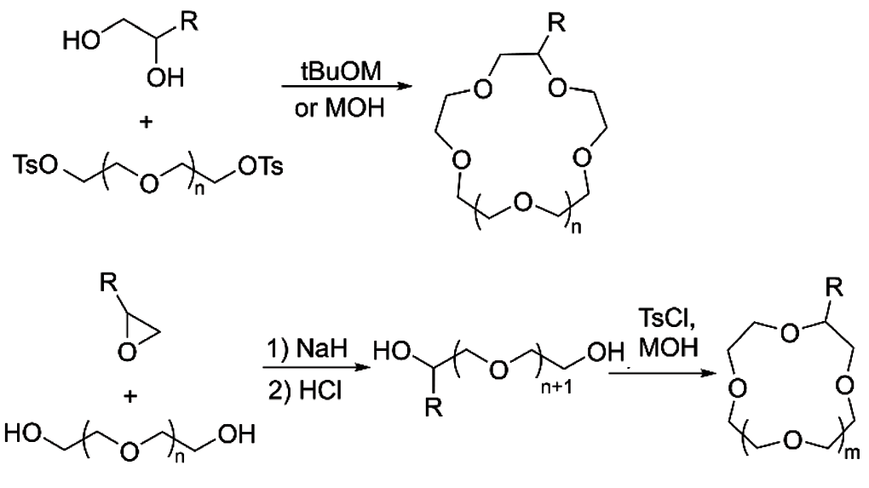
Scheme 3
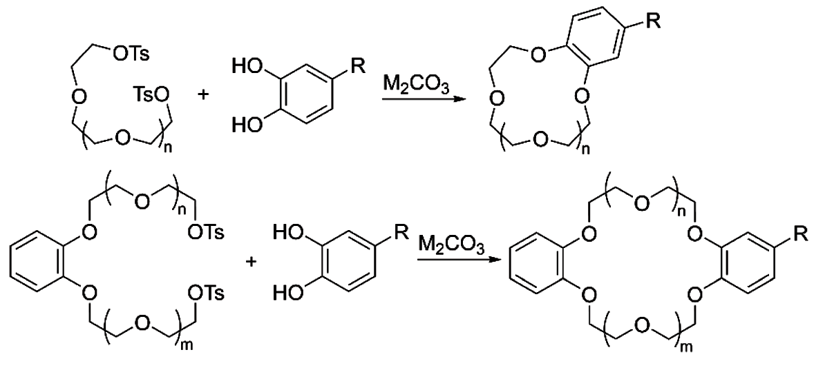
Scheme 4
- Host-Guest Chemistry of Crown Ethers
Crown Ether binds alkali and alkaline earth ions with specificity, creating complexes that are soluble in non-polar solvents due to their lipophilic nature and serve as carriers for the charged species, thus, they been widely employed in ion extraction⁷ and phase transfer catalysis⁸. They have been used as ion translocators and building blocks for synthetic channels that pass through lipidic membranes more recently⁹. Also, they can create stable supramolecular complexes with a range of organic guests in aprotic solvents, proving that, their complexing power is not just restricted to metal cations. One of the earliest examples of non-metallic guests was the arenediazonium salts¹⁰, which easily complex and stabilise with 18-crown-6 and 21-crown-7.
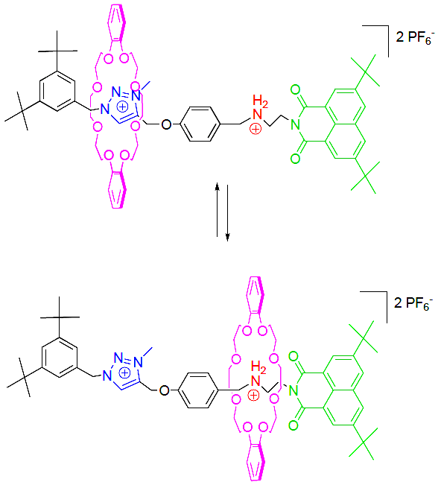
Scheme 5
Because of their abundance in π-electrons enriched aromatic groups, aromatic Crown ethers serve as hosts for variety of π-electron-poor visitors, including bipyridinium¹¹, diazapyrenium¹², bis-(pyridinium)ethane¹³, imidazolium¹⁴, and triazolium¹⁵ [Scheme 5]. Strong hydrogen bonds and donor-acceptor interactions in addition to electrostatic factors play a role in the synthesis and stability of these complexes.
Dibenzo-18-crown-6 primary alkylammonium ion complexes with primary ammonium cations¹⁶, have been the subject of in-depth research. Three alternating hydrogen bonds are formed between the ammonium group and the macrocycle's oxygen atoms as a result of the face-to-face interaction between the host and guest, creating extremely stable supramolecular structures. Stability of complexes generated with secondary and tertiary ammonium ions is significantly reduced as a result of this type of binding. Larger cavity crown ethers, such dibenzo-24-crown-8, combine with secondary alkylammonium ions to produce complexes where the cation enters the macrocycle's cavity¹⁷. Due to their ability to thread the right-sized crown ethers, secondary ammonium guests with axle-like designs¹⁸ can produce pseudorotaxanes¹⁹, which are practical supramolecular progenitors to mechanically interlocked molecules. By the virtue of being such multifaceted host molecule, of late, crown ethers have become major resource for mechanically interlocked systems in numerous rotaxane and catenane frameworks²⁰ and also found application in several moleculear machines²⁰⁻²², such as; molecular switches²³ (pH, redox or light sensitive) and molecular pumps²⁴.
- Functionalized Crown Ethers
Recently functionalization of crown ethers has gained immense interest in order to be inserted into dendrimers²⁵, polymers²⁶, metal organic frameworks²⁷. If one considers the functions of natural ionophores, for instance, one can see that they are created in a way that satisfies nature's functional requirements and functions effectively in a biological system. As a result, scientists started looking towards functionalizing supramolecules, which would eventually act as a link between the synthesis and the functional facet.
There are two basic methods for producing functionalized crown ethers: direct functionalization of already-formed crown ethers or templated macrocyclisation utilising starting materials that have already been functionalized. It's crucial to identify methods for performing selective reactions. In comparison to synthesis using the template approach, adding substituents to premade macrocycles is a better option, especially true for aliphatic ones, for which the derivatized precursor preparation typically necessitates a sizable number of steps, leading to waste of time and resources in comparison to one-step direct functionalization. The functionalized groups must be stable towards basic environment and heating under the macrocyclic ring enclosure reaction too. The lack of effective protocols and procedures that are meticulously specified and tested is the main drawback of direct techniques. Another downside of direct functionalization techniques is that high yields of the final product are typically only possible with an excess of the initial crown ether.
  - Direct functionalization of aliphatic crown ethers
Aliphatic Crown ethers are typically functionalized primarily through radical mediated cross dehydrogenative coupling reactions. The α-C(sp³)-H bond is selectively oxidised to the α-C(sp³)-X (X = C, N, or F) bond²⁸⁻³⁰ by the following three steps; (a) electrophilic radical generation, (b) hydron abstraction generating radical at electronically rich α-position, and (c) reaction of radical with coupling partner [Scheme 6]. Either photochemical or thermal/chemical activation can result in the production of an electrophilic radical. Under inert atmosphere, these reactions are often carried out and either fractional distillation or chromatography is used to easily purify the derivatives. Compared to thermal/chemical processes, approaches that rely on photochemical radical production have been shown to produce greater yields.
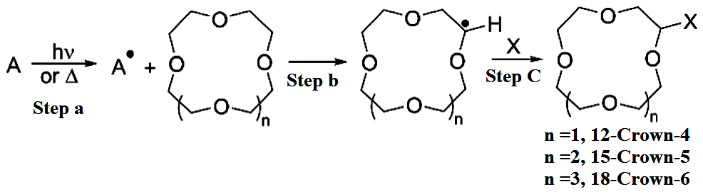
Scheme 6
4.1.1 Direct functionalization of aliphatic crown ethers by photochemical activation
According to the nature of the R group on the keto moiety, irradiating a 1:1 mixture of 18-crown-6 and a ketone with a Hg lamp for several hours yielded the corresponding mono-functionalized derivatives in low to moderate yields³¹ [Scheme 7].
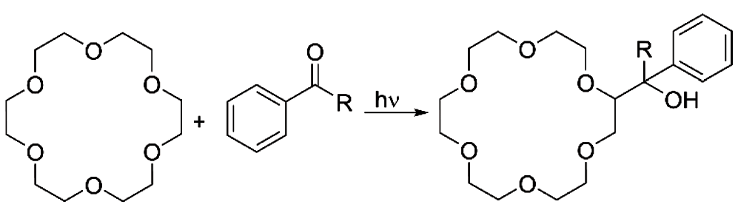
Scheme 7
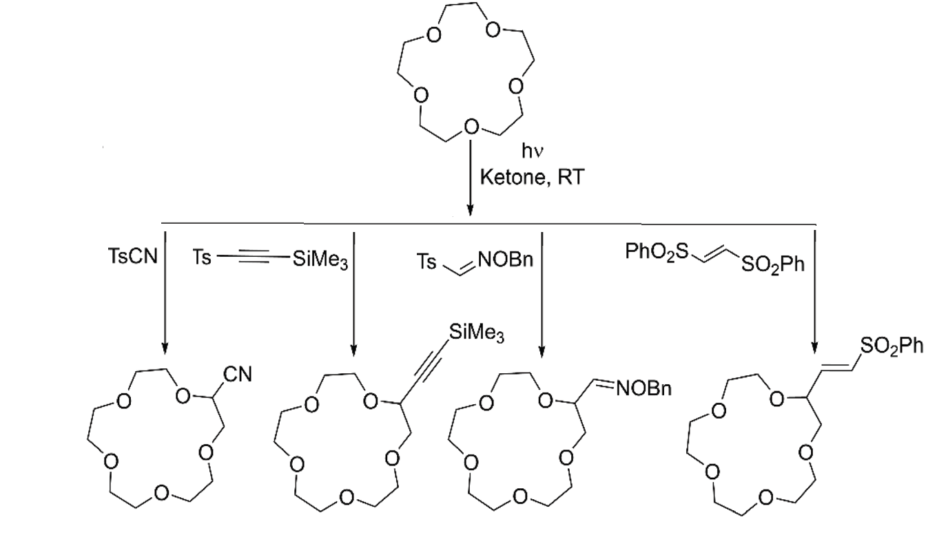
In order to create a generic approach for converting electron-rich C(sp³)-H bonds into C(sp³)-C bonds, scientists took advantage of the ability of photochemically generated oxyl radicals to extract a hydrogen atom through homolytic C-H bond cleavage.
Scheme 8
Here, the coupling partner is introduced as a tosyl derivative, introducing cyano³², alkynyl³³, alkenyl³⁴, and aldoxime³⁵ functional groups. The ketone solely serves as a photosensitizer in the process. A combination that has an excess of 15-crown-5 and one equivalent of both the kenone and coupling partner at room temperature undergoes high yield mono-functionalization when exposed to Hg lamp [Scheme 8]. The time frames of reaction are dependent on the coupling partner.
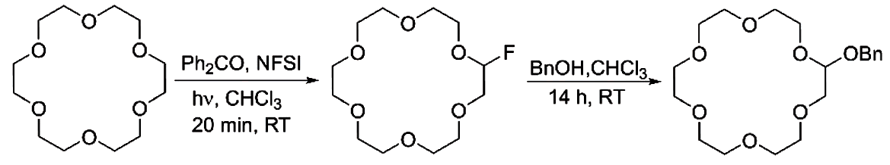
The scientific community employed a similar method for mono-fluorinating cyclic ethers to produce derivatives suited for nucleophilic substitution modification. Into one equivalent of 18-crown-6 in CHCl₃, catalytic quantity of benzophenone, and N-fluorobis(phenyl)-sulfonimide (NFSI) as a fluorine source are added, which is then exposed to 320–390 nm radiation for 20 minutes at ambient temperature. A transitory monofluorinated macrocycle is produced in high yield by this procedure, and when benzyl alcohol is added in the second phase of the reaction, it undergoes nucleophilic substitution, producing a benzyl alcohol adduct in moderate yield as well [Scheme 9]³⁶. Additionally, mono-florination was carried out utilising copper(III) fluoride complex, which served as both a radical capture and hydrogen atom abstraction catalyst³⁷.

Scheme 9
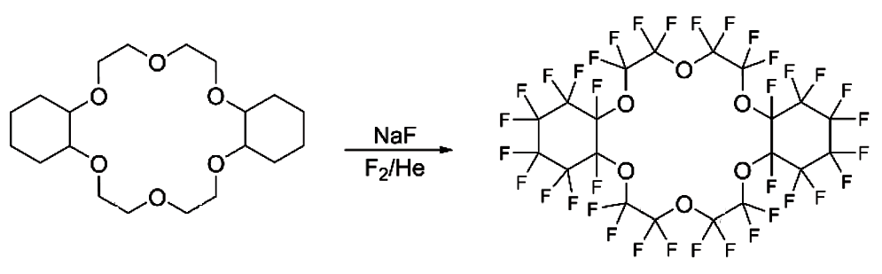
Only per-fluorination of aliphatic crown ethers and its cyclohexano derivatives have been studied before the recent investigations on direct mono-fluorination. The general process involved coating NaF with the selected precursor crown ether and then subjecting the solid combination to a flow of fluorine gas in a cryogenic fluorination reactor under inert circumstances³⁸ [Scheme 10].

Scheme 10
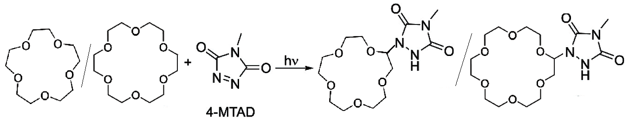
Product yield was low to moderate because it depends on a number of factors. Triazolinedione chemicals are widely used in the domains of click chemistry and polymer science. The formation of these occurs by a photochemical coupling reaction involving cyclic ethers and 4-methyl-1,2,4-triazoline-3,5-dione (4-MTAD)³⁹. After many days of slow addition of 4-MTAD to an excess of 15-crown-5/18-crown-6 under continuous laser irradiation (wavelength = 514.5 nm), the appropriate mono-functionalized α-urazolyl derivatives were formed [Scheme 11].
Scheme 11
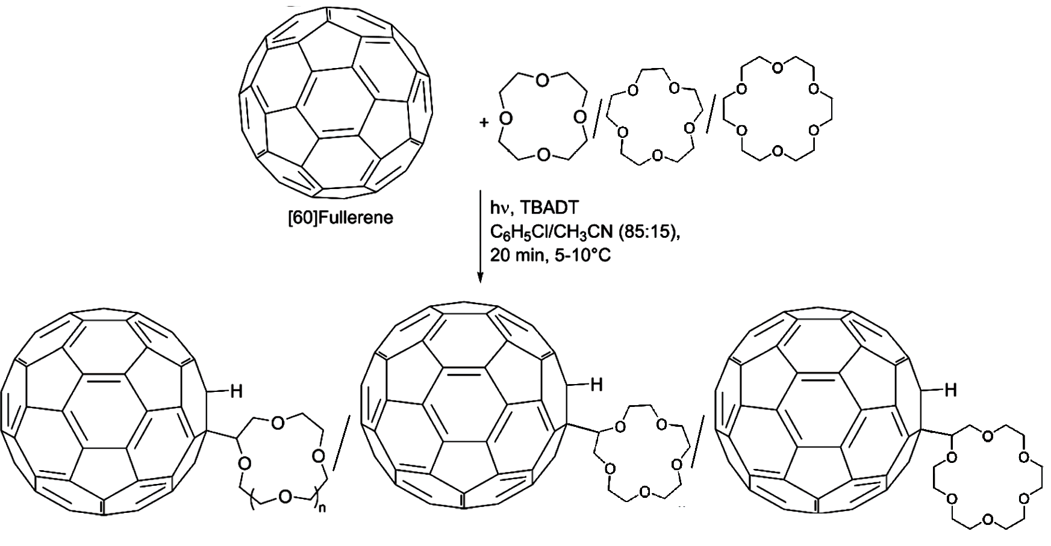
Because of the photophysical and electrochemical characteristics of the resultant adducts and their prospective uses in ion sensing and fluorescence switching devices, covalent attachment of Crown ether to [60]-fullerene (C-60) has garnered interest. Direct coupling of Crown ether to [60]-fullerene (C-60)⁴⁰ was accomplished photochemically [Scheme 12] with the help of the photosensitizer tetrabutylammonium decatungstate, TBADT [(nBu₄N)₄W₁₀O₃₂]. The process involved exposing 100 equivalent of 12-cron-4/15-crown-5/18-crown-6 to a combination of one equivalent of C-60, and 0.5 equivalents of TBADT in chlorobenzene/acetonitrile (85:15) solution for 20 minutes at 5-10°C using a Xenon light.

Scheme 12
4.1.2 Direct functionalization of aliphatic crown ethers by thermal/chemical activation
Addition of crown ether to olefins has been done by treatment with di-t-butylperoxide (DTBP) at high temperature to produce a radical that would then attack the double bond of the substrate, resulting in the production of the final product that had been alkylated. The addition of peroxide and olefin slowly to a very large excess of 18-Crown-6 (Crown ether: olefin: DTBP = 20: 2: 1)⁴¹. In Scheme 13, the methodology is shown. The process has been used to functionalize 12-Crown-4, 15-Crown-5, and 18-Crown-6 with allyl chloride in order to introduce 8-hydroxyquinoline [Scheme 14]⁴².
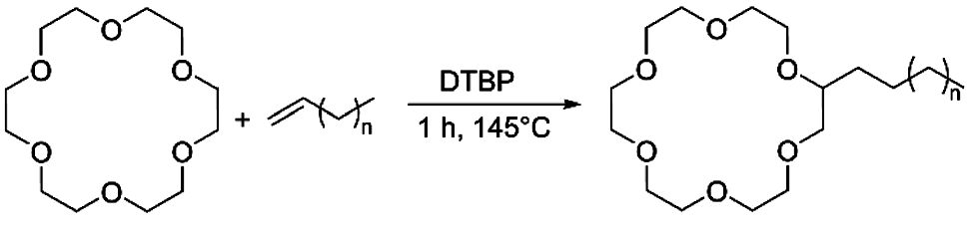
Scheme 13
Scheme 14
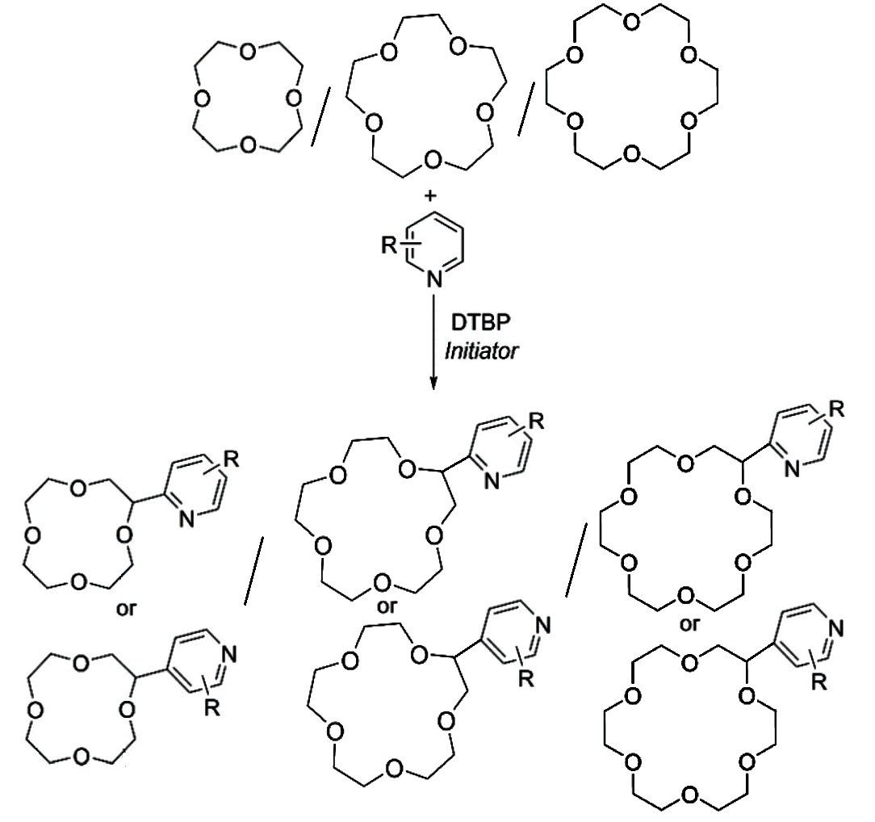
Scheme 15
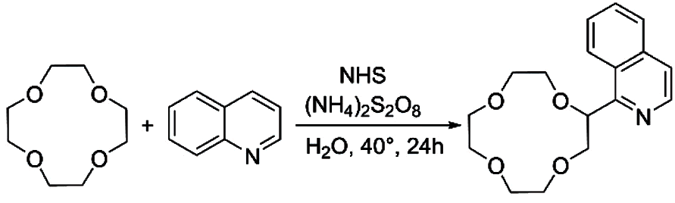
Scheme 16
High regioselectivity and good yield were achieved when di-t-butylperoxide was employed as a hydrogen abstractor (activated by photoirradiation) in the presence of radical initiators to functionalize crown ethers with N-aromatic bases⁴³ [Scheme 15]. Similar type of Cα-heteroarylation was performed mediated by N-hydroxysuccinimide (NHS). The process involves oxidizing NHS to produce a reactive N-radical form using ammonium persulfate (APS)⁴⁴. The produced radical performs hydrogen abstraction on the ether before moving on to regioselectively attack the heteroaromatic base [Scheme 16] with high yield.
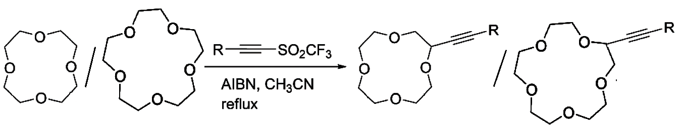
The direct alkynylation of 12-crown-4 and 15-crown-5 was accomplished using a novel method that uses trifluoromethyl radical's reactivity towards C-H hydrogen abstraction for the introduction of the alkyne functional group on numerous classes of compounds. The conversion to the appropriate mono-alkynylated product occurred in good yields when an excess of these ethers and one equivalent of acetylenic triflone were heated in CH₃CN in the presence of a catalytic quantity of azobisisobutyronitrile (AIBN) as the radical initiator [Scheme 17]⁴⁵.

Scheme 17
4.2 Direct functionalization of aromatic crown ethers
Aromatic Crown ethers are generally functionalized by electrophilic substitution reactions of the aromatic moiety. These preparations were made possible by the availability of synthetic methodologies to form functionalized catechols. The lack of control over the number of groups introduced in the Crown ether architecture is one of this strategy's weaknesses. According to the introduced functional groups, the section is organised.
4.2.1 Direct functionalization with halides
In his review⁴⁶, Pluzhnik-Gladyr primarily concentrated on three direct halogenation methods; (A) in this case, molecular halogens are utilised. With this method, it is possible to produce di-halogenated benzo-crown ether and tetra-halogenated dibenzo-crown ether in good yields, but the strong reactivity of elemental halogen species makes it impossible to make monofunctionalized derivatives [Scheme 18]. (B) N-halosuccinimides are used in this one. Though dibenzo-crown ether only reacts in organic solvents (CHCl₃ or CCl₄) or in mixes of ethanol and water, but benzo-crown ether can be easily halogenated with this method in aqueous media catalysed by addition of acid [Scheme 19]. (C) Hypohalites in water can be used to directly halogenate substances. Multiple halogen atoms are added under acidic conditions, whereas the process can be controlled under basic conditions to produce monohalogenated products [Scheme 20].
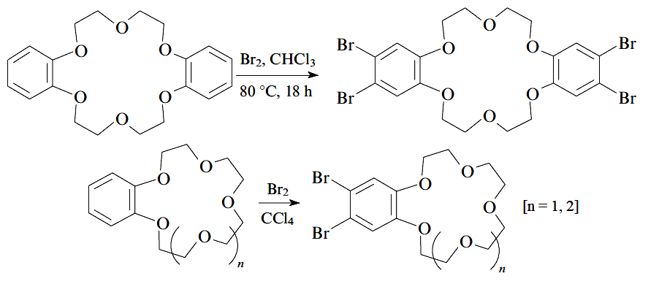
Scheme 18
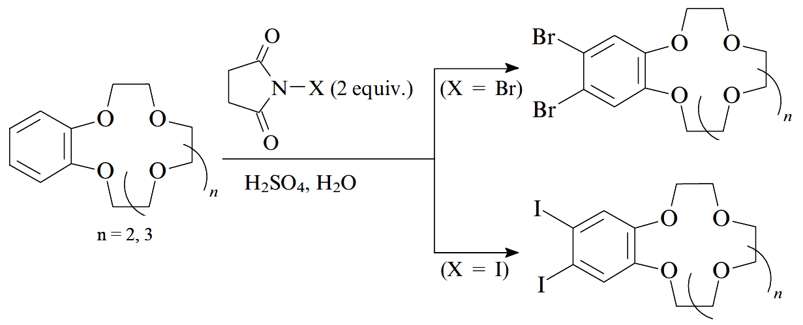
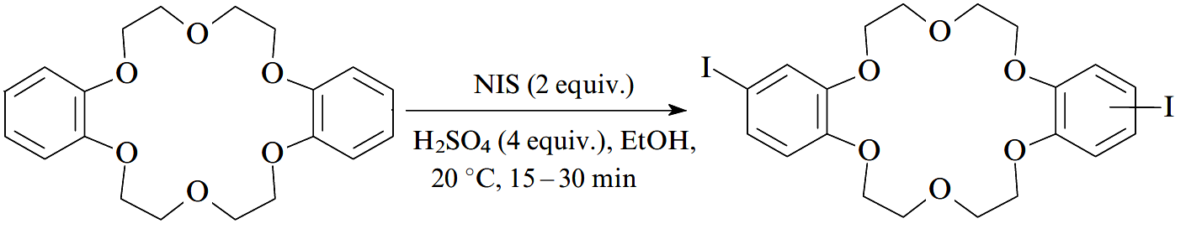
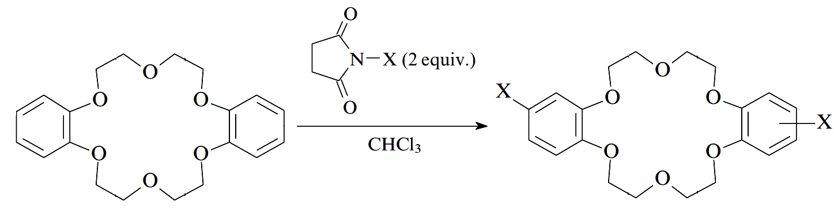
Scheme 19
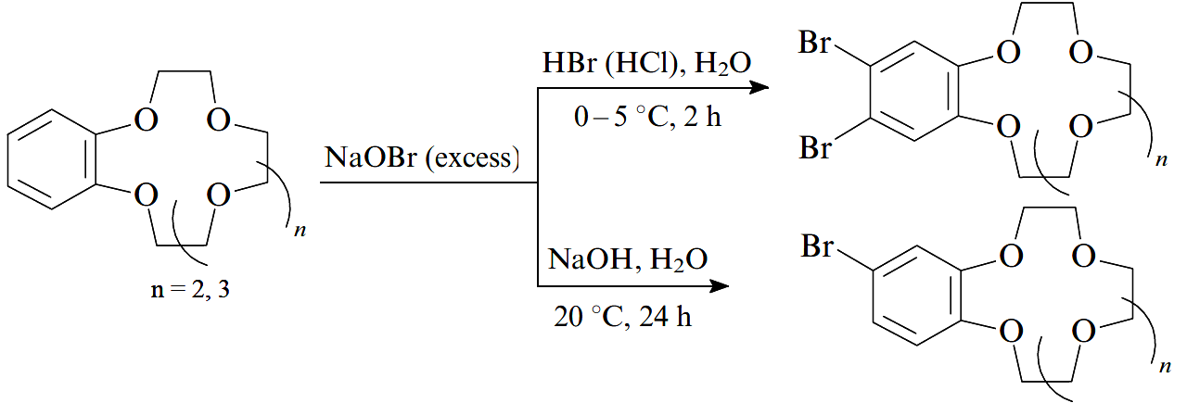
Scheme 20
Selectivity is the direct halogenation's most difficult challenge. Mono-substituted derivative is generally formed with low yields as the reaction leads to the formation of mixtures of mono-substitued and di-substituted species (anti- and syn- isomers too). Recently, sodium bromide (NaBr) and ceric ammonium nitrate [(NH₄)₂Ce(NO₃)₆] mediated bromination of dibenzo-24-crown-8 in acetonitrile was reported [Scheme 21]. At room temperature, the reaction moves quickly with a yield of 39% for the monobrominated derivative⁴⁷.
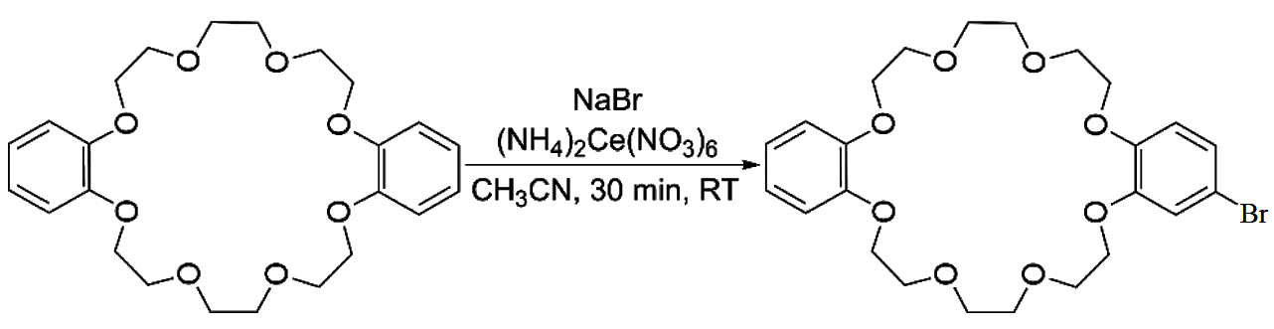
Scheme 21
4.2.2 Direct halomethylation
Direct halomethylation of crown ethers are done by several routes. For example; (A) bromomethylation using paraformaldehyde and hydrogen bromide in acetic acid⁴⁸ (B) bromomethylation by the combination of paraformaldehyde, sodium bromide and sulphuric acid⁴⁹, (C) chloromethylation by formaldehyde and gaseous hydrochloric acid⁵⁰, etc. All these pathways provide higher yields in general [Scheme 22].
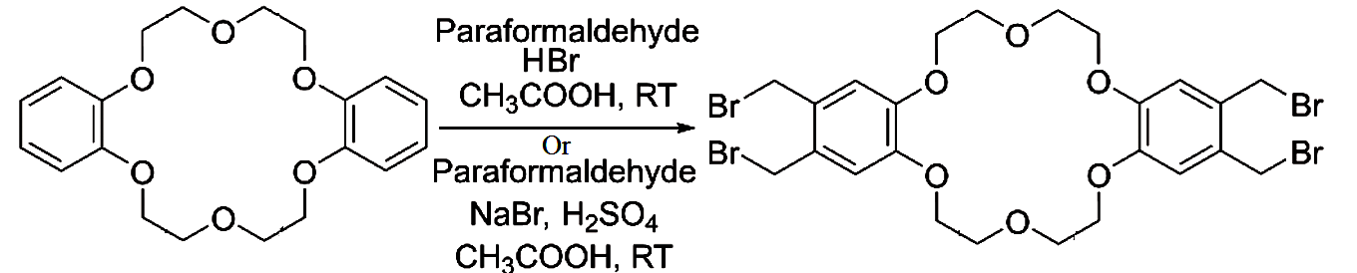
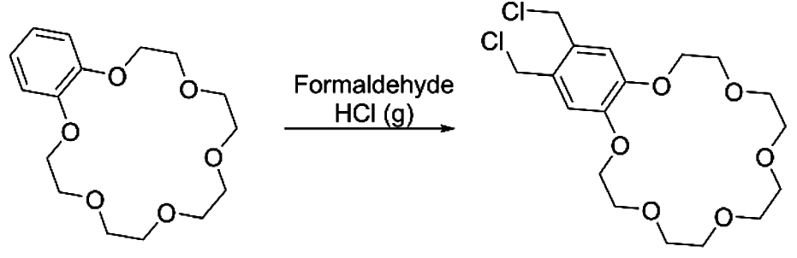
Scheme 22
4.2.3 Direct functionalization with nitro- and amine- groups
Following the widely established standard procedures for the nitration of aromatic compounds, direct functionalization of aromatic crown ethers with nitro groups is performed. For instance, the syn- and anti- isomers are produced in a good yield when dibenzo-24-crown-8 reacts with nitric acid in the presence of either acetic acid⁵¹, which aids in the generation of the electrophilic species [Scheme 23]. Few other methodologies include, formation of tetra-nitro derivatives of different dibezo-crown ethers, synthesised in high yields by substituting H₂SO₄ in place of CH₃COOH in the nitrating solution⁵², nitration by using potassium nitrate and excess polyphosphoric acid (PPA)⁵³ for both benzo-crown ether and dibenzo-crown ether. Since they may be quickly and quantitatively reduced to amino compounds, which can then be transformed into various functional groups for usage in polymers or further derivatization with chromophores^{51,54,55}, nitration is a very valuable procedure. Di- and tetra-modified amino functionalized crown ethers cannot be kept for a long time since they oxidise quickly and need to be handled in a controlled environment^{52,55}. A method utilising sodium azide in polyphosphoric acid had been published⁵⁶ for the direct amination of dibenzo-crown ether. An equimolar combination of the substrate ether and NaN₃ is heated in neat PPA at 100 °C to initiate the reaction [Scheme 24], which produces the mono-amino-functionalized derivative in high yield.
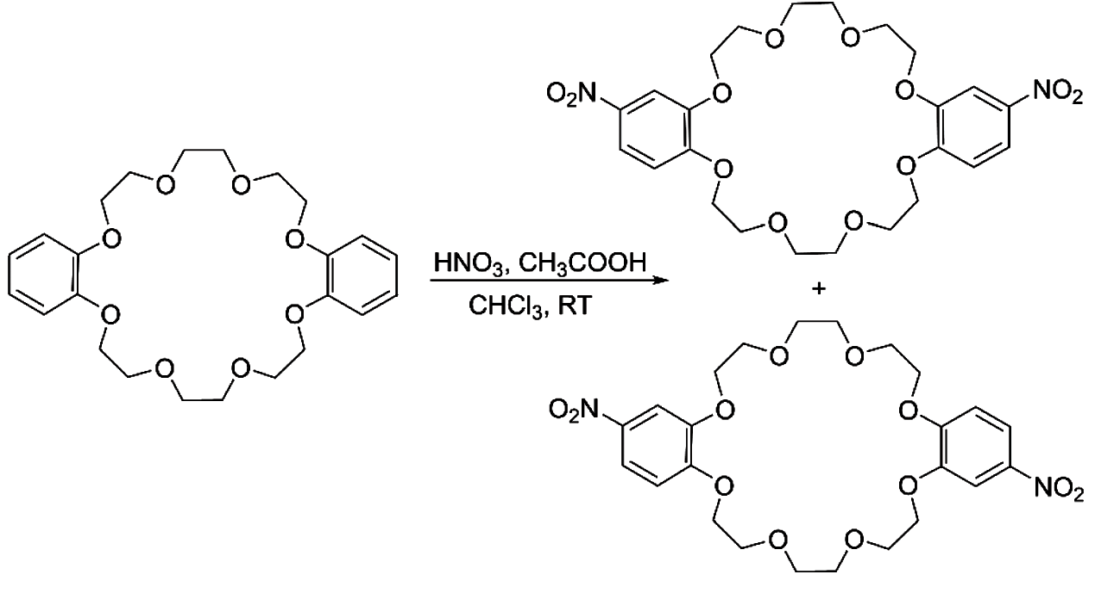
Scheme 23
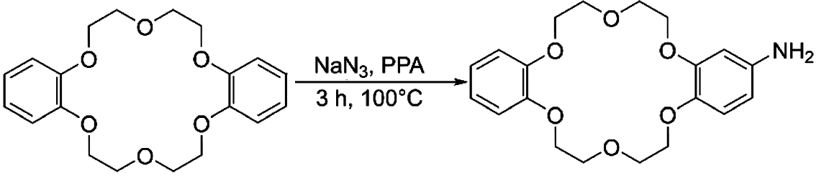
Scheme 24

4.2.4 Direct functionalization with formyl- group
Since formyl-benzo crowns are readily convertible to a variety of functional groups, they constitute important intermediates. The Vilsmeier-Heck reaction, which involves treating the substrate with N-methylformanilide in the presence of phosphoryl chloride at 90 °C for 4 hours to produce a mono-functionalized derivative with a moderate yield⁵⁷, was used to first achieve direct formylation of Benzo-15-crown-5 [Scheme 25].
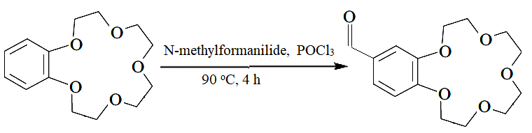
Scheme 25
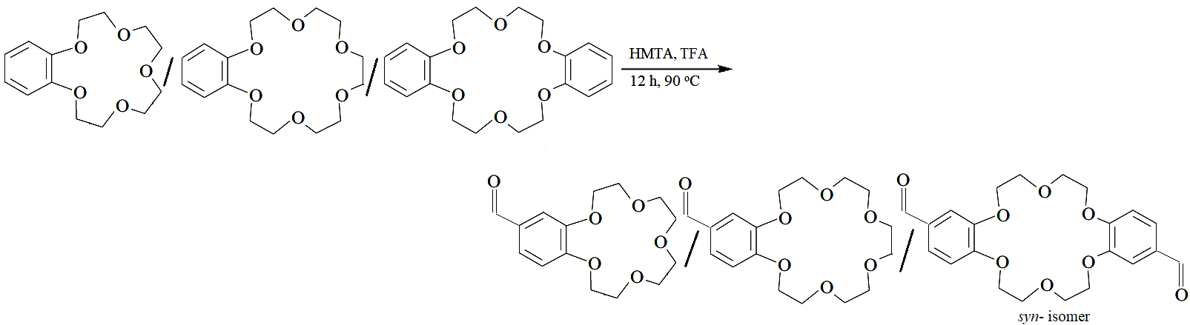
Similarly, the traditional Duff reaction was used to formylate benzo-15-crown-5, benzo-18-crow-6, and dibenzo-18-crow-6 by combining the substrate with hexamethylenetetramine (HMTA) in the presence of trifluoroacetic acid (TFA), stirring at 90 °C for 12 hours, and resulting in mono- and di-functionalized benzo and dibenzo crown ethers⁵⁸ [Scheme 26]. Here, only syn-isomers of dibenzo crown ether were formed.
Scheme 26
4.2.5 Direct functionalization with acyl- groups
Similar to formyl derivatives, acyl derivatives are acceptable precursors for a variety of functional groups. Carboxylic acids/anhydride and polyphosphoric acid have been used to directly acylate benzo crown ether and dibenzo crown ether⁵⁹ [Scheme 27]. The reaction can proceed using carboxylic acid in the presence of Eaton's reagent (phosphorus pentoxide and methane sulfonic acid) too⁶⁰ [Scheme 28]. While modified dibenzo crown ether were produced as a mixture of syn- and anti- isomers, benzo crown ether were mono-functionalized. Both routes produce comparable yields.
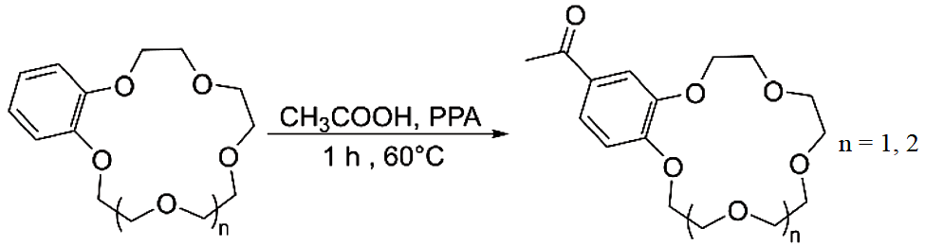
Scheme 27
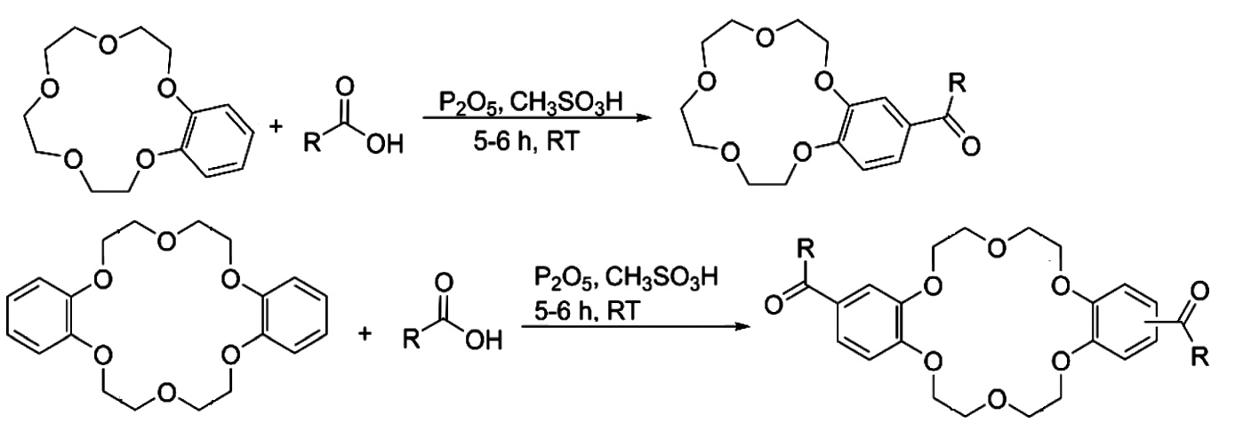
Scheme 28
When derivatizing dibenzo crown ethers, acetates have also been employed as a source of acetyl group⁶¹. In this method, the counter cation of the acetate ion undergoes complexation. It was proven that the rate and regioselectivity of the reaction are correlated with the size of the acetate's counter cation.
4.2.6 Direct functionalization with alkyl- groups
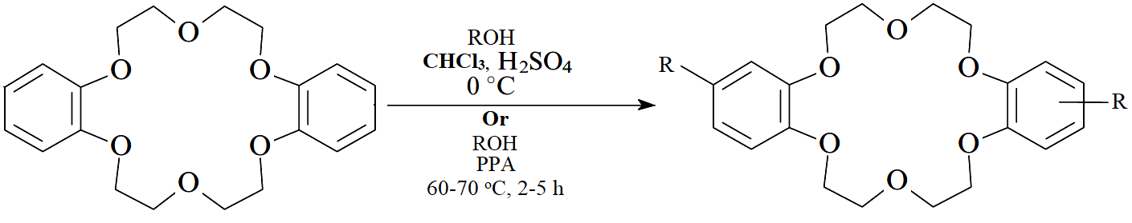
Crown ethers that have already been acylated, can be reduced to produce alkyl derivatives. There are more synthetic techniques as well, such as using combination of alcohols with sulfuric⁶² or polyphosphoric acids⁶³ [Scheme 29]. These approaches not only produced regioisomers but also had poor control over how many functional groups were added to the substrate.
Scheme 29
4.2.7 Direct Functionalisation with sulfonate and sulfonyl chloride groups
Utilizing sulfuric acid in acetonitrile, benzo crown ether and dibenzo crown ether were sulfonated⁶⁴. Although high yields for both the mono-sulfonation of benzo crown ether and the di-sulfonation of dibenzo crown ether have been documented, more recent literature reports have confirmed that di-sulfonated species are typically produced as mixtures of isomers, each of whose properties can be very different from one another. Sulfonated crown ethers are isolated as tetrabutylammonium salts, due to their greater solubility in water and other protic solvents [Scheme 30]. The use of potassium sulphate in polyphosphoric acid is a substitute method for sulfonation⁶⁵ [Scheme 31]. Treatment with sulfonyl chloride can easily transform sulfonated crown ethers into its chlorosulfonate derivatives. Chlorosulfonic acid in chloroform is used for direct chloro-sulfonation of aromatic crown ethers⁶⁶.
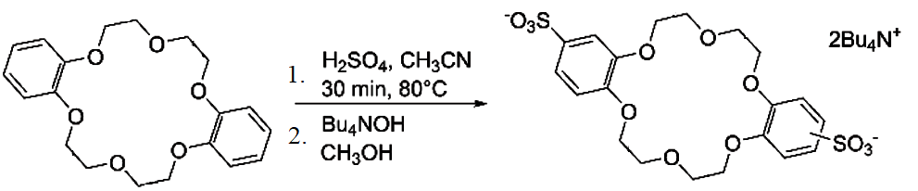

Scheme 30
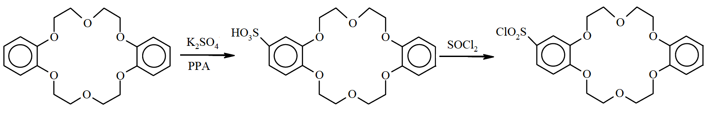
Scheme 31
There are numerous direct functionalization methodologies for incorporating several groups of importance, are reported in literature. Here our sincere effort has been to enlighten those which are versatile and most frequently used by scientific community all over the globe.
- Applications of Functionalized crown ethers
  - Application in chromatography
Functionalized crown ethers are broadly used for analytical purpose. Crown ethers can be used in ion chromatography because of their ability to interact with alkali or alkaline earth metal ions in a specific way.
Chromatography can be approached in one of two ways from an operational standpoint [Scheme 32]. (a) used in mobile phase; cations in solution form complexes having the appropriate anions (A-) in a mobile phase that contains crown ethers (CE), producing lipophilic ion pairs (M⁺-CE:A⁻). These are then dispersed in a stationary lipophilic phase⁶⁷. (b) Crown ethers, which in a mobile phase form complexes with cations, are dynamically (physically adsorbed) or covalently loaded into a stationary phase. Thus, cations are distributed between a stationary phase and a mobile phase.
(a)
(b)
Scheme 32
    - Ion Chromatography on Dynamically-bound Crown Ethers
Using the crown ethers listed below [Figure 2] coated on octadecyl-silanized silica (known as ODS), researchers reported the chromatographic separation of alkali metal ions. When alkali metal ions were analysed using a 1:1 methanol-water eluent, it was discovered that the retention times increased in the following order: Li⁺ < Na⁺ < Cs⁺ < Rb⁺ < K⁺, which is an indirect indicator of the stability of the metal complexes with crown ethers⁶⁸.

Figure 2

    - Ion Chromatography on Covalently-bound Crown Ethers
The following crown ether polymers [Figure 3] were created by poly-condensing benzo-crown ethers with formaldehyde in the presence of phenol, toluene, or xylene, as well as by condensing dibenzo-crown ethers with formaldehyde^{69,70}. The polymer particles placed on a chromatographic column, were utilised for the ion chromatography of several transition, alkali and alkaline earths metal salts⁷⁰.

Figure 3
The retention behaviour, as expected, reflects the stability of each metal complex involved. The type of the counter anions has a significant impact on the separation because these chromatographies are reliant on the formation of ion pairs in the stationary phase.
  - Application in ion-selective electrode
Because they are neutral carriers, crown ethers can be used as ion-selective components (ion carriers) in liquid membrane electrodes. The researchers have examined many macrocyclic carriers. Few are described below;
    - Lithium-Selective Electrode
Crown ether-based lithium-selective electrodes were described below;

The membrane included the 16-crown-4 derivative mentioned below. They got a linear response with a nearly Nernstian slope over the activity range of 10⁻⁴ to 1 M Li⁺ solution⁷¹. Similar electrode system using 12-crown-4 was also reported⁷² [Figure 4]. However, in both situations, selectivity towards the proton was greater than Li⁺, necessitating an increase in the pH of the sample solution above 5. The dibenzo-14-crown-4 - PVC membrane electrode's Li⁺ selectivity was improved by adding an organophosphorus chemical⁷³ to the membrane.

Figure 4
    - Sodium-Selective Electrode
For a Na⁺-selective PVC membrane electrode, neutral carriers based on bis-(12-crown-4) derivatives are suitable⁷⁴. The compounds that were employed for this purpose are bis-(l2-crown-4) derivatives A and B in Figure 5. The measurement of Na⁺ in human urine and serum using the coated wire electrode based on crown ether B was successful⁷⁵. The electrode had a very long lifespan. Even after 300 measurements, there was no sign of deterioration. During this time, neither the selectivity factor nor the response slope changed.

Figure 5
    - Potassium-Selective Electrode
For K⁺-selective membrane electrodes, bis-(15-crown-5) ethers are helpful. Compound A, [Figure 6] which has been bis-(benzo-15-crown-5) functionalized, was used on a PVC membrane electrode⁷⁶. The connecting polyoxyethylene chain's length affected the selectivity and responsiveness to K⁺. In the range of 10⁻⁵ to 0.1 M K⁺, the electrode using Compound A (n=0) displayed an almost Nernstian response, and a good selectivity of 4000 times over Na⁺ was shown. The plastisizer in the PVC membrane affects the electrode performance of diester functionalized bis-(benzo-15-crown-5) ether, compound B [Figure 6], and o-nitrophenyl octyl ether (NPOE) provided a better response (a near Nernstian slope and rapid response time) than diphenyl phthalate⁷⁷.

Figure 6
  - Application in Colorimetry
For the majority of the metal ions, ion-selective chromogenic (colorimetric, photometric) reagents have been known for a while and have proven useful. However, efforts to create alkali metal selective reagents have long been ineffective. The discovery of crown ethers made it possible to create chromogenic reagents that are selective for both alkali metals and alkaline earth metals. In theory, the design process for alkali or alkaline earth metal selective colorimetric reagents is not all that different from that of other conventional chromogenic chelating agents. Designing crown ether reagents for colorimetry in aqueous solutions was hampered by the fact that the stability of crown ether-metal complexes in aqueous solutions is incredibly low. As an alternative, extraction photometry or photometry in non-aqueous media were chosen. Crown ether dyes carrying one and two dissociable protons, respectively, were generated to extract alkali and alkaline earth metal ions. The functions of metal binding and metal detection might be carried out independently by crown ether and protonic chromophore, respectively. The two roles, however, cannot be separated in actual reagents since the anionic chromophore can more or less support the crown ether's ability to bind metals.
5.3.1 Monoprotonic Crown Ethers
The distribution of the derivatized 4’-picrylamino-15-crown-5 dyes [A, Figure 7], between water and chloroform is greatly preferred by the latter. Potassium ions and rubidium ions were drawn into the chloroform solution when it came into contact with an alkaline solution of alkali metal salts⁷⁸. Following the production of ML (metal complex) species in the organic solution, the colour of the chloroform solution changed from orange (HL species) to blood red (L- species). Lithium ion was not extracted, and sodium ion extraction was subpar. The resulting reactions are demonstrated below [Scheme 33]. Similar substances⁷⁹ [B, Figure 7] were also created from benzo-18-crown-6, which was shown to extract potassium ion the most successfully and to have a 1:1 composition in the extracted complex. The picryl-amino proton's acidity rises when a nitro group is added to the benzo crown ether's 5'-position. Since the proton dissociation process of the reagent is implicitly involved in the extraction constants, an increase in the proton dissociation constant results in an increase in the extraction constant, which in turn indicates that metal extraction can occur at a lower pH area.

Figure 7

Scheme 33
5.3.2 Diprotonic Crown Ether Dyes
Adding a chromophore with two dissociable protons to crown ethers, results in dyes that are predicted to extract divalent metals, especially alkaline earth metals, with great precision. Diaza-crown ethers were easily converted into p-nitrophenol type reagents [A, Figure 8] and p-(p-nitropheny1azo)phenol type reagents [B and C, Figure 8]^{80,81}. These displayed remarkable alkaline earth metal ion extraction capabilities. These chemicals do not disperse into an aqueous solution and are soluble in organic solvents. Scheme 34 details how these reagents extract alkaline earth metal ions.

Figure 8

Scheme 34
Divalent metal extraction is not at all hampered by alkali metal ions. Selectivity for metal extraction is Ca²⁺ > Sr²⁺ > Ba²⁺ > Mg⁺. They are used to measure Ca²⁺ in blood serum because they are very efficient in extracting calcium ions. The reagents that is particularly sensitive to Ca²⁺ is the 4-(2.4 Dinitrophenylazo)phenol type reagent [C]. Since other divalent metal ions including Cu²⁺, Pt²⁺, Cd²⁺, and Zn²⁺, also form stable complexes with the crown ether reagents, they tend to interfere with the performance of these crown ether reagents. Since Pb²⁺ complex of [A] is so stable, it has actually been utilised as a photometric reagent for Pb²⁺-selective extraction. By utilising masking chemicals like sarcosine dithiocarbamate and nitrilotriacetic acid (NTA), these interferences can be eliminated.
5.3.3 Uncharged Crown Ether Dyes
The interesting family of uncharged crown ethers shown in Figure 9 changes colour as it interacts with alkali and alkaline earth metal ions⁸²⁻⁸⁵. The molecules of these crown ether dyes contain electron donor and acceptor sites, and when visible light is absorbed; an electronic charge is transferred from the donor to the acceptor. The incorporation of crown ether structures allows the metal ion to concurrently interact with either the donor site or the acceptor site of the molecule, affecting the energy level of the electrons responsible for light absorption. On the complex formation, the spectral change can occasionally be exceedingly sharp.

Figure 9
  - Application in Lithium Ion Batteries
Performance of the battery in the lithium manganite/carbon (LMO-GR) cell was governed by the activity of the lithium manganite. Positive electrode's [Lithium manganite] dissolved Mn ions moved to the negative electrode and accumulated there, impairing the operation of the cell in lithium-ion batteries. Levi's group developed crown ether-based polymer, poly-(vinylbenzo-18-crown-6) [A, Figure 10], to reduce dissolved Mn ions from getting deposited at the negative electrode, by trapping. Likewise, a capacity improvement of 26% was achieved after 100 cycles of the LMO-GR. The benzene ring served as a hard link connecting the macrocycle and the polymer backbone, and this link determined how well Mn ions could be trapped⁸⁶. The polymer serves as a Li-ion battery additive.
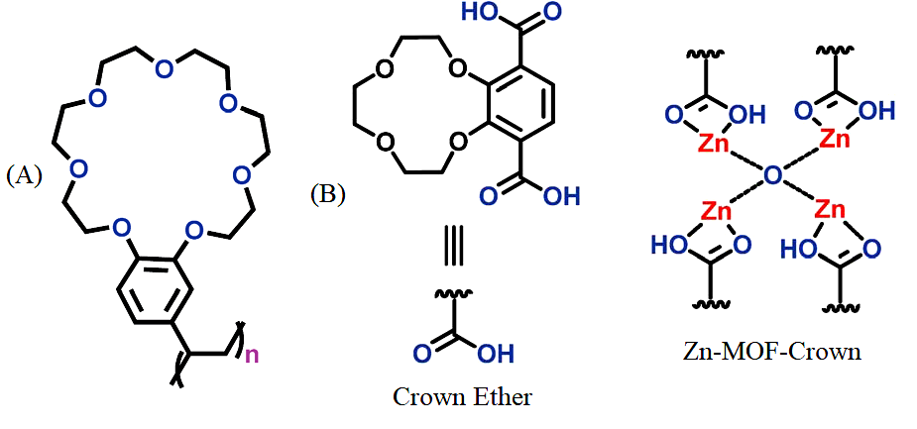
A microporous 12-crown-4 unit Zn-based metal-organic framework (Zn-MOF-Crown) was reported. It could serve as the anode material for a lithium ion battery with a 273 mA h g⁻¹ charging capacity. More significantly, after 500 cycles, it still held 88 percent of its capacity. Because of the interaction between the Li⁺ ions and crown ether during charge and discharge, the integrity of the MOF structure was never compromised [B, Figure 10]. Interestingly, the Zn-MOF-Crown had improved electrochemical performance with a charge capacity of 348 mA h g⁻¹ and long-term cycling ability when it complexed with Li⁺ ions and an adduct was produced. This indicates that the addition of crown ether might enhance the efficiency of green energy systems.

Figure 10
5.5 Functionalized crown ether assisted morphological tuning of CuO nanosheets
Dibenzothiazolyl dibenzo-18-crown-6 ether (DDCE) aided hydrothermal production of Cupric oxide nanosheets was reported as a new and simple process. This crown ether has a cavity with extra hetero atom binding sites, such nitrogen and sulphur. Additionally, it is suitable with aqueous hydrothermal process since it is soluble in aqueous solutions and decomposes above 85 °C. This task-specific functionalized crown ether directs the growth of Cupric oxide crystals to take on various morphologies by acting as a structure-directing group. It has been noted that DDCE just serves as a structure-directing agent and does not participate in the response. CuO nanosheets, synthesised by the assistance of crown ether shows improved and encouraging electrochemical characteristics. The size, porosity, and shape of the material are affected by the DDCE concentration.⁸⁷
5.6 Crown Ether-Functionalized Polybenzoxazine for Metal Ion Adsorption
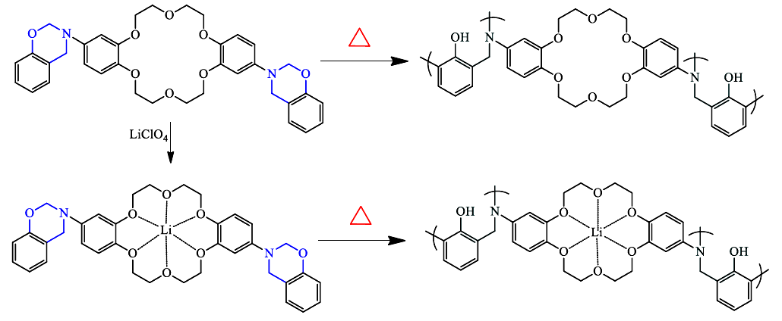
Crown-ether BZ is a benzoxazine monomer that has been functionalized with crown ether. The thermal stability and ring opening polymerization of the crown-ether BZ monomer under various forms of thermal treatment were examined. DSC research showed that this crown-ether BZ monomer exhibited a relatively low curing temperature (210 °C), due to the flexibility of the crown ether moiety on the main chain backbone structure, which stimulated the ring opening polymerization. DSC also looked at the particular metal-crown ether interactions of the crown-ether BZ/LiClO₄ complexes. Li+ ions drastically lowered the curing temperature to 186 °C, indicating that the metal ions were an efficient catalyst and promoter that sped up the polymerization of the crown-ether BZ monomer [Scheme 35]⁸⁸.
Scheme 35
5.7 Miscellaneous Applications
Functionalized crown ethers have several uses in a variety of scientific fields of interest, including the development of dynamic crystalline polymers⁸⁹, molecular transporters⁹⁰, mechanically planar chiral rotaxanes⁹¹, interlocking polymers⁹², and higher order structures⁹³. These are also employed for catalysis⁹⁴, sensing⁹⁵, self-assembly⁹⁶, electrochemical ion transport⁹⁷, molecular recognition⁹⁸, metal ions sequestration⁹⁹, stimuli-responsive gel–sol transition¹⁰⁰ etc.
References:
- C. J. Pedersen, J. Am. Chem. Soc., 1967, 89, 7017–7036.
- C. J. Pedersen, Angew. Chem., Int. Ed. Engl., 1988, 27, 1021–1027.
- J.-M. Lehn, Angew. Chem., Int. Ed. Engl., 1988, 27, 89–112.
- D. J. Cram, Angew. Chem., Int. Ed. Engl., 1988, 27, 1009–1020.
- J. W. Steed and J. L. Atwood, Supramolecular Chemistry, Wiley, Chichester, 2nd edn, 2009.
- (a) B. R. Bowsher and A. J. Rest, J. Chem. Soc. Dalton Trans., 1984, 1421–1425. (b) I. Ikeda, S. Yamamura, Y. Nakatsuji and M. Okahara, J. Org. Chem., 1980, 45, 5355–5358. (c) G. W. Buchanan, A. Moghimi and C. I. Ratcliffe, Can. J. Chem., 1996, 74, 1437– 1446.
- R. Schettini, M. Sicignano, F. De Riccardis, I. Izzo and G. Della Sala, Synthesis, 2018, 4777–4795.
- J. Wang and S. Zhuang, Nucl. Eng. Technol., 2020, 52, 328–336.
- S.-P. Zheng, L.-B. Huang, Z. Sun and M. Barboiu, Angew. Chem., Int. Ed., 2021, 60, 566–597.
- J. Krane and T. Skjetne, Tetrahedron Lett., 1980, 21, 1775–1778.
- L. Pospisil and R. Fuoco, J. Electroanal. Chem., 1988, 240, 105–116.
- P. R. Ashton, S. E. Boyd, A. Brindel, S. J. Langford, S. Menzer, L. Perez-Garcia, J. A. Preece, F. M. Raymo, N. Spencer, J. F. Stoddart, A. J. P. White and D. J. Williams, New J. Chem., 1999, 23, 587–602.
- S. J. Loeb and J. A. Wisner, Angew. Chem., Int. Ed., 1998, 37, 2838–2840.
- N. Noujeim, K. Zhu, N. Vukotich and S. J. Loeb, Org. Lett., 2012, 14, 2484–2487.
- G. Ragazzon, A. Credi and B. Colasson, Chem. Eur. J., 2017, 23, 2149–2156.
- R. M. Izatt, J. D. Lamb, N. E. Izatt, B. E. Rossiter, Jr., J. J. Christensen and B. L. Haymore, J. Am. Chem. Soc., 1979, 101, 6273–6276.
- P. R. Ashton, E. J. T. Chrystal, P. T. Glink, S. Menzer, C. Schiavo, N. Spencer, J. F. Stoddart, P. A. Tasker, A. J. P. White and D. J. Williams, Chem. Eur. J., 1996, 2, 709–728.
- J. Groppi, L. Casimiro, M. Canton, S. Corra, M. Jafari-Nasab, G. Tabacchi, L. Cavallo, M. Baroncini, E. Fois and A. Credi, Angew. Chem., Int. Ed., 2020, 59, 14825–14834.
- E. Ishow, A. Credi, V. Balzani, F. Spadola and L. Mandolini, Chem. Eur. J., 1999, 5, 984–989.
- C. J. Bruns and J. F. Stoddart, The Nature of the Mechanical Bond: From Molecules to Machines, Wiley, Hoboken, 2016.
- V. Balzani, A. Credi and M. Venturi, Molecular Devices and Machines – Concepts and Perspectives for the Nanoworld, Wiley-VCH, Weinheim, 2008.
- S. Erbas-Cakmak, D. A. Leigh, C. T. McTernan and A. L. Nussbaumer, Chem. Rev., 2015, 115, 10081–10206.
- G. Ragazzon, C. Schäfer, P. Franchi, S. Silvi, B. Colasson, M. Lucarini and A. Credi, Proc. Natl. Acad. Sci. U. S. A., 2018, 115, 9385–9390.
- G. Ragazzon, M. Baroncini, S. Silvi, M. Venturi and A. Credi, Nat. Nanotechnol., 2015, 10, 70–75.
- D. Alivertis, V. Theodorou, G. Paraskevopoulos and K. Skobridis, Tetrahedron Lett., 2007, 48, 4091–4095.
- D. Xia, P. Wang, X. Ji, N. M. Khashab, J. L. Sessler and F. Huang, Chem. Rev., 2020, 120, 6070–6123.
- W. Gong, W. Zhang, F. A. Son, K. Yang, Z. Chen, X. Chen, J. Jiang, Y. Liu, O. K. Farha and Y. Cui, Chem, 2021, 7, 190–201.
- T. Newhouse and P. S. Baran, Angew. Chem., Int. Ed., 2011, 50, 3362–3374.
- S. A. Girard, T. Knauber and C.-J. Li, Angew. Chem., Int. Ed., 2014, 53, 74–100.
- A. K. Bagdi, M. Rahman, D. Bhattacherjee, G. V. Zyryanov, S. Ghosh, O. N. Chupakhin and A. Hajra, Green Chem., 2020, 22, 6632–6681.
- M. Tada and H. Hirano, Photochemistry of host-guest complex I, Tetrahedron Lett., 1978, 51, 5111–5114.
- S. Kamijo, T. Hoshikawa and M. Inoue, Org. Lett., 2011, 13, 5928–5931.
- T. Hoshikawa, S. Kamijo and M. Inoue, Org. Biomol. Chem., 2013, 11, 164–167.
- Y. Amaoka, M. Nagatomo, M. Watanabe, K. Tao, S. Kamijo and M. Inoue, Chem. Sci., 2014, 5, 4339–4345.
- S. Kamijo, G. Takao, K. Kamijo, M. Hirota, K. Tao and T. Murafuji, Angew. Chem., Int. Ed., 2016, 55, 9695–9699.
- R. Beniazza, B. Abadie, L. Remisse, D. Jardel, D. Lastécouères and J.-M. Vincent, Chem. Commun., 2017, 53, 12708–12711.
- J. K. Bower, A. D. Cypcar, B. Henriquez, S. C. E. Stieber and C. Zhang, J. Am. Chem. Soc., 2010, 142, 8514–8521.
- T.-Z.- Lin, W.-H. Lin, W. D. Clark, R. J. Lagow, S. B. Larson, S. H. Simonsen, V. M. Lynch, J. S. Brodbelt, Si. D. Maleknia and C.-C. Liou, J. Am. Chem. Soc., 1994, 116, 5172–5179.
- F. Risi, A.-M. Alstanei, E. Volanschi, M. Carles, L. Piazzala and J.-P. Aycard, Eur. J. Org. Chem., 2000, 617–626.
- M. D. Tzirakis and M. Orfanopoulos, Angew. Chem., Int. Ed., 2010, 49, 5891–5893.
- J. B. Zeleconok, V. V. Orlovskij, S. S. Zlotskij and D. L. Rachmankulov, J. Prakt. Chem., 1990, 5, 719–722.
- Y. B. Zelechonok, V. V. Orlocskii, S. F. Zelechonok, S. S. Zlotskii and D. L. Rakhmankulov, Chem. Heterocycl. Compd., 1990, 26, 121.
- N. Okugawa, K. Moriyama and H. Togo, Eur. J. Org. Chem., 2015, 4973–4981.
- S. Liu, A. Liu, Y. Zhang and W. Wang, Chem. Sci., 2017, 8, 4044–4050.
- J. Xiang, W. Jiang and P. L. Fuchs, Tetrahedron Lett., 1997, 38, 6635–6638.
- S. M. Pluzhnik-Gladyr, Russ. Chem. Rev., 2016, 86, 172–203.
- P. Mobian, N. Banerji, G. Bernardinelli and J. Lacour, Org. Biomol. Chem., 2006, 4, 224–231.
- A. Cygan, J. F. Biernat and H. Chadzynski, Pol. J. Chem., 1979, 53, 929–933.
- Y. Nakamura, A. Asami, T. Ogawa, S. Inokuma and J. Nishimura, J. Am. Chem. Soc., 2002, 124, 4329–4335.
- J. Otsuki, K. C. Russell and J.-M. Lehn, Bull. Chem. Soc. Jpn., 1997, 70, 671–679.
- W. M. Feigenbaum and R. H. Michel, J. Polym. Sci., Part A-1: Polym. Chem., 1971, 9, 817–820.
- S. A. Duggan, G. Fallon, S. J. Langford, V.-L. Lau, J. F. Satchell and M. N. Paddon-Row, J. Org. Chem., 2001, 66, 4419–4426.
- A. D. Grebenyuk, A. A. Andreev, I. A. Stempnevskaya, M. G. Levkovich and A. K. Tashmukhamedova, Chem. Heterocycl. Compd., 2000, 36, 1449–1456.
- (a) D. R. Patil, D. R. Chendam, A. G. Mulik, S. D. Jagdale, P. P. Patil and M. B. Deshmukh, Synth. Commun., 2015, 45, 1902–1911. (b) T. Liu, C. Bao, H. Wang, Y. Lin, H. Jia and L. Zhu, Chem. Commun., 2013, 49, 10311–10313.
- (a) J. D. Pike, D. T. Rosa and D. Coucouvanis, Eur. J. Inorg. Chem., 2001, 761–777, (b) G. J. Kirkovits, R. S. Zimmerman, M. T. Huggins, V. M. Lynch and J. L. Sessler, Eur. J. Org. Chem., 2002, 3768–3778.
- A. S. Lyakhovenko, A. V. Aksenov and M. M. Kugutov, Chem. Heterocycl. Compd., 2010, 46, 1138–1139.
- E. M. Hyde, B. L. Shaw and I. Shepherd, J. Chem. Soc. Dalton Trans., 1978, 1696–1705.
- F. Wada, H. Hirayama, H. Namiki, k. Kikukawa and T. Matsuda, Bull. Chem. Soc. Jpn., 1980, 53, 1473–1474.
- D. Vazquez-Garcia, A. Fernandez, M. Lopez-Torres, A. Rodriguez, A. Varela, M. T. Pereira, J. M. Vila and J. J. Fernandez, Organometallics, 2011, 30, 396–404.
- W. W. Parish, P. E. Stott and C. W. McCausland, J. Org. Chem., 1978, 43, 4577–4581.
- N. Z. Saifullina and A. K. Tashmukhamedova, Chem. Heterocycl. Compd., 2001, 41, 973–976.
- S. A. Kotlyar and E. I. Klimova, Chem. Heterocycl. Compd., 1990, 26, 1313–1314.
- A. K. Tashmukhamedova, I. A. Stempnevskaya, N. Z. Saifullina and M. G. Levkovich, Chem. Heterocycl. Compd., 1986, 22, 1461.
- T. Sasaki, S. Umentani, M. Masui, S. Tsurubou, T. Kimura and Z. Yoshida, Bull. Chem. Soc. Jpn., 1998, 71, 371–377.
- A. D. Grebenyuk, L. V. Zotova and A. K. Tashmukhamedova, Chem. Heterocycl. Compd., 2001, 37, 822–826.
- L. N. Markovskii, D. M. Rudkevich and V. I. Kal’chenko, Russ. J. Org. Chem., 1989, 25, 1995–2000.
- L. R Sousa D. H. Hoffman L. Kaplan and D. J. Cram, J. Am. Chem. Soc., 1974, 96, 7100-7101.
- K Kimura E. Hayara and T. Shono, J. Chem. Soc., Chem. Commun., 1984, 271-272.
- E. Blasius. K-P. Janzen W. Adrian, G. Klautke, R Lorscheider, P.-G. Maurer. V.B. Nauyen, T. Nguyen-Tien. G. Scholten and J. Stockemer, Fresenius Z. Anal. Chem., 1977, 284, 337-360.
- E. Blasius, K-P. Janzen, W. Adrian, W. Klein, H. Klotz, H. Luxenburger, E., Mernke, V.B. Nguyen T. Nguyen-Tien, R Rausch, J. Stockemer and A Toussaint, Talanta 1980, 27, 127-141.
- KM. Aalmo and J. Krane, Acta Chem. Scand., 1982, A36, 227-234.
- V.P.Y. Gadzekpo and G.D. Christian, Anal Left., 1983, 16, 1371-1380.
- T. Imato, M. Katahira and N. Ishibashi, Anal Chim Acta, 1984, 165, 285-289.
- T. Shono, M. Okahara, I. Ikeda, K. Kimura and H. Tamura, J. Electroanal. Chem., 1982, 132, 99-105.
- H. Tamura, K. Kumami, K. Kimura and T. Shono, Mikrochim Acta., 1983, II, 287-296.
- K. W. Fung and K. H. Wong, J. Electroanal. Chem., 1980, 111, 359-368.
- K. Kimura, T. Maeda, H. Tamura and T. Shono, J. Electroanal. Chem., 1979, 95, 91-101.
- (a) M. Takagi, H. Nakamura and K. Ueno, Anal. Lett. 1977, 10, 1115-1122 (b) H. Nakamura M. Takagi and K. Ueno, Talanta, 1979, 26. 921-927.
- H. Nakamura, M. Takagi and K Ueno, Anal. Chem., 1980, 52, 1668-1671.
- H. Nishida, M. Tazaki, M. Takagi and K Ueno, Mikrochim Acta., 1981, I, 281-287.
- M. Shiga, H. Nishida, H. Nakamura, M. Takagi and K. Ueno, Bunseki Kagaku, 1983, 32, E293-E300.
- J.P. Dix and F. Vogtle, Angew. Chem., 1978, 90, 893-894.
- J.P. Dix and F. Vogtle, Chem Ber.. 1980, 113, 457-470.
- J.P. Dix and F. Vogtle, Chem Ber. 1981, 114, 638-651.
- G. Hollmann and F. Vogtle, Chem Ber., 1984, 117, 1355-1363.
- F. Hu and T. Song, RSC Adv., 2017, 7, 54203-54212.
- S. D. Jagadale, A. M. Teli, S. V. Kalake, A. D. Sawant, A. A. Yadav and P. S. Patil, J. Electroanal. Chem., 2008, 816, 99-106.
- M. G. Mohamed and S. -W. Kuo, Macromolecules 2020, 53, 2420–2429.
- B. H. Wilson and S. J. Loeb, Chem, 2020, 6, 1604–1612.
- C. Schäfer, G. Ragazzon, B. Colasson, M. La Rosa, S. Silvi and A. Credi, ChemistryOpen, 2016, 5, 120–124.
- E. M. G. Jamieson, F. Modicom and S. M. Goldup, Chem. Soc. Rev., 2018, 47, 5266–5311.
- M. Zhang, D. Xu, X. Yan, J. Chen, S. Dong, B. Zheng and F. Huang, Angew. Chem. Int. Ed., 2012, 51, 7011–7015.
- C.-S. Kwan and K. C.-F. Leung, Mater. Chem. Front., 2020, 4, 2825–2844.
- C. Yoo, H. M. Dodge and A. J. M. Miller, Chem. Commun., 2019, 55, 5047–5059.
- A. V. Tsukanov, A. D. Dubonosov, V. A. Bren and V. I. Minkin, Chem. Heterocycl. Compd., 2008, 44, 899–923.
- K. Ghosh, H.-B. Yang, B. H. Northrop, M. M. Lyndon, Y.-R. Zheng, D. C. Muddiman and P. J. Stang, J. Am. Chem. Soc., 2008, 130, 5320–5334.
- Tetsuo Saji and lwao Kinoshita, J. Chem. Soc. Chem. Commun., 1986, 716-717.
- P. Bauerle and S. Scheib, Adv. Mater., 1993, 5, 848-853.
- S. Petrescu, S. Avramescu, A. M. Musuc, F. Neatu, M. Florea and P. Ionita, Mater. Res. Bull., 2020, 122, 110643.
- Z. Qi, P. M. de Molina, W. Jiang, Q. Wang, K. Nowosinski, A. Schulz, M. Gradzielski and C. A. Schalley, Chem. Sci., 2012, 3, 2073-2082.

