ANESTHESIA
DIVYA.T, Department of Microbiology,
Bharathidasan University,
Tiruchirappalli , India,
divya.tactinomycetes@gmail.com
NARMATHA.S, Department of Microbiology,
Bharathidasan University,
Tiruchirappalli, India,
narmathasaravanan44@gmail.com

The anesthesia technician is working mostly inside the operation theater full day. He will be assisting the anesthesiologist in the anesthetic management of various patients, belonging to different categories of physical status. Therefore, it is essential that he acquire a basic simple knowledge of anesthesia.
- DEFINITION OF ANESTHESIA
Anesthesia is a controlled reversible modification, modulation or depression of various modalities of CNS , (Pain perception , wakefulness, motor activity, respiration , reflexes , etc.) ANS, (Vasomotor tone ,heart rate ,etc.) and peripheral nervous system. (Mainly in regional anesthesia)by using , small , incremental, titrate doses of various pharmacological agents to achieve a specific physiological goal .The goal being the protection of the patient caused by pain of surgery , handling of tissues and viscera, and the retraction of muscles.
2.GUEDEL’S CLASSIFICATION OF ANESTHESIA In 1920 Arthur E Guedel, recorded his observations of the changes in physical signs that occurred in such an orderly sequential pattern when the patient inhaled progressively increasing concentrations of ether vapor thereby the patient was taken into surgical anesthesia.
Stage 1: Analgesia or Disorientation- This phase can begin in an operative anesthesia storage area where the patient is on medication and may be beginning to feel its effects, but has not yet fainted . This stage is commonly referred to as the ‘ induction stage’ . The patient is sedated but willing to speak. Breathing is slow and regular. At this stage, patient progress from analgesia without amnesia to analgesia with concomitant amnesia. This stage ends unconsciously.
Stage 2: Excitement or Delirium ; This stage consists of features such as disinhibition, delirium , uncontrolled movements , loss of the eyelash reflex , hypertension , and tachycardia . At this stage , airway reflexes are intact and often hypersensitive to stimuli. Airway manipulations during this phase of anesthesia should be avoided , including placement and removal of endotracheal tubes and deep suction maneuvers. At this stage , the risk of laryngospasm ( involuntary tonic closure of the vocal cords ) is increased and may be exacerbated by airway manipulation .The resulting combination of spasticity , vomiting , and rapid , irregular breathing can compromise the patient’ s airway . Fast-acting drugs help minimize the time spent in stage 2 and ease the transition to stage 3.
Stage 3: Surgical Anesthesia – This the target level of anesthesia for procedures requiring general anesthesia . Cessation of eye movements and respiratory depression are hallmarks of this stage. Airway manipulation is safe at this level . Four levels are described in this phase. At level 1, there is regular spontaneous breathing , constricted pupils , and focused gaze. However ,the eyelids , conjunctiva, and swallowing reflexes usually disappear in this plane . At level 2 , the loss of pupillary light reflex causes the intermittent cessation of breathing.This level is called ‘ true surgical anesthesia ‘ because it is ideal for most surgeries. Finally, level 4 is characterized by irregular breathing , paradoxical chest movements , and complete diaphragmatic paralysis leading to apnea.
Stage 4: Overdose –This stage occurs when high amount of anesthetic agents are administered relative to the amount of surgical stimulation , exacerbating already severe brain or medullary suppression . This stage begins with respiratory arrest and ends with possible death . At this stage , skeletal muscles are relaxed and the pupil is fixed and dilated . Blood pressure is usually weak , lint-bearing , and significantly lower than normal due to heart pump depression and peripheral blood flow vasodilation . Without cardiovascular and respiratory support , this stage is fetal. The goal of the anesthesiologist is therefore to transfer as soon as possible and keep it so during surgery.
3.TRAID OF ANESTHESIA We can know that general anesthesia in whatever form it is administered , it comprises of only three aspects commonly known as The Triad of Anesthesia.
A) Hypnosis [Sleep]- Keeping the patient in good degree by using a drug which induces sleep and continuing it throughout the anesthesia , e.g., thiopentone sodium , midazolam , diazepam , etc.
B)Analgesia –Keepingthepatient in good degree of sleep by using analgesics or narcotics , e.g morphine , fentanyl , pethidine ,pentazocine, etc.
C)Reflex suppression – Reflexes induced by the surgical procedure suppressed , mainly by using muscle relaxants supported by analgesics.
Once pain induced by surgery is relieved by analgesics , usually tissue handling and retraction of muscles causes further reflexes.
4.WHAT IS BALANCED ANESTHESIA?
Modern anesthesia , no longer relies on dangerous levels of unconsciousness to achieve muscle relaxation . The principle is to use drugs for muscle relaxation and to keep the patient at a swallow safe level of anesthesia with good pain relief and reflex suppression . It is commonly called Balanced Anesthesia.
5.CLASSIFICATION OF ANESTHESIA
There are four main classes of anesthesia. They are following ,
1.General Anesthesia
2.Regional Anesthesia
3.Total Intravenous Anesthesia[TIVA]
4.Dissociative Anesthesia
A) GENERAL ANESTHESIA
Surgeons should understand the basic principles of general anesthesia. The main purpose of general anesthesia is to control the autonomic reflexes so that the patient is unconscious and painless. He has five main classes of anesthetics ; intravenous (1V) anesthetics , inhalation anesthetics ,sedatives , synthetic opioids , and neuromuscular blockers. Each class has specific strengths and weakness in achieving the primary goal of general anesthesia. Knowledge of these properties and major side effects can prove beneficial to surgeons.
METHODS OF ADMINISTRATION OF GENERAL ANESTHESIA
Based on the methods of administration of a volatile anesthetic agent like ether , general anesthesia was classified into four types namely ;
Open method [ Open drop method]
- In this technique usually a Schimmel-Busch mask is used.
- This mask has an oval metal frame on which eight layers of gauze is stretched so that it forms a hood-like structure.
- This mask can be kept on the face of the patient which will cover the nose and mouth .Now the patient will breathe atmospheric air through the layers of gauze.
- A gamgee pad split at the center longitudinally may be kept under the mask to fill the uneven contour of the face so that air does not enter into the mask.
- Now form a dropper ether is dropped on the center of the mask so that by capillary action, the ether spreads to the periphery of the mask, making the gauze layers soaked with ether.
- When the patient breathes in through the mask , the ether gets vaporized and reaches the alveoli through the tracheobronchial tree from where it diffuses through the alveolar capillary membrane into the bloodstream.
- By gradually increasing the number of drops , the concentration of the ether vapor inhaled is increased and so the concentration of blood . This will take the patient slowly into the surgical anesthesia .
The major drawbacks of this method are;
- Polluting the atmosphere( Fig. 1.1).
- Wastage of anesthetic as the vaporization occurs during expiration also and ether vapor is lost into the atmosphere.
- Liquid ether may fall on eyes cause irritation ( Fig-1.2A and B)
- As the anesthesia is continued the latent heat of vaporization is taken from the metal mask and gauze layers and the temperature falls almost near 0. So that vaporization is grossly reduced making the concentration delivered inadequate for surgical anesthesia .
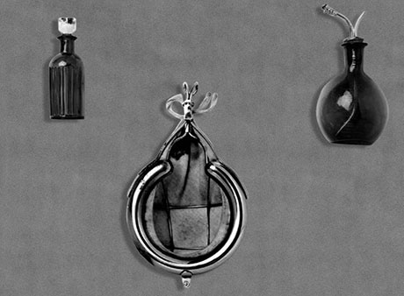
- To obviate this problem , two different masks can be used alternatively.
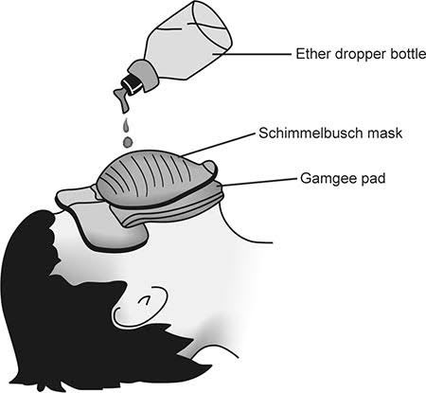
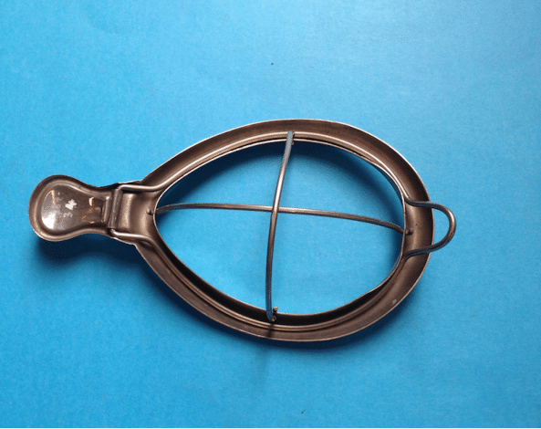
Fig. 1.1Schimmel-Busch mask and dropper bottle
Fig1.2A and B Open drop method of administration of ether
Semi open Method
- This is generally the same technique as the open method , but to prevent the concentration of ether vapor getting dissipated into the atmosphere , a tubular structure is fitted on the mask .
Semi closed Method [System]
- This system is used in the anesthetic machine.
- The anesthetic mixture is comprising of Oxygen (O₂), Nitrous oxide (N₂O) , and the vapor of a volatile anesthetic agent like ether , halothane , etc.
- The mixture is delivered from the anesthetic machine into the breathing system which is known as the Semi closed breathing system .
- This system is also called Magill’s breathing System or Mapleson a System.
- This system opens to the atmosphere through an expiratory valve to release the expiration , at all other times ,it is a closed system , so that this method is known as semi closed system.
- The components; Bag mount , Reservoir bag , a Corrugated rubber tube , Angle mount , Heid brink’s expiratory valve and the Mask are shown in (Fig 1.3 )
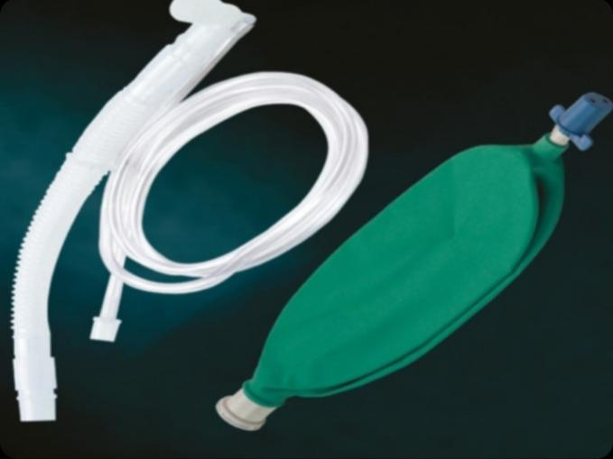
Fig1.3Semi closedbreathingsystem(Magill’sBreathingSystem)
Closed Technique [System]
- In this technique, the circuit is closed and the patient breaths the anesthetic mixture repeatedly from the system
- During inspiration and expiration , the system is closed . So, the patient has to breathe the same anesthetic mixture again and again .
- The soda lime present in the system absorbs CO₂ exhaled by the patient and so there is accumulation of the CO₂.
- This is the most commonly used methods.
- There are two types of closed systems available. One is the To and fro system (Fig 1.4 ) and the other is the cycle system (Fig 1.5) .
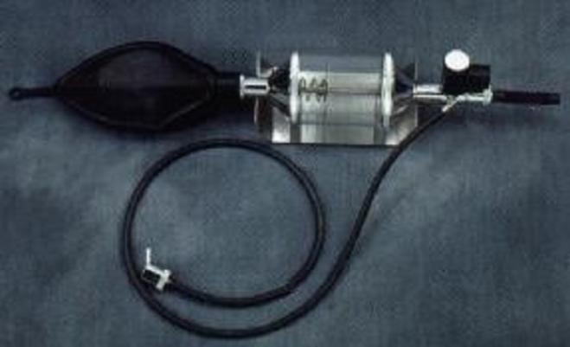
- The semisolid and closed systems are in common use.
Fig1.4 : The“To and Fro”closed breathing system
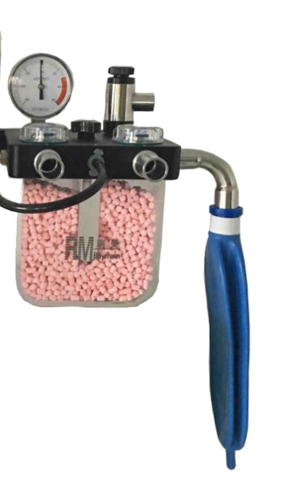
Fig1.5:Circle type closed breathing system
COMPLICATIONS Side effects are common with the administration of anesthesia . These can include transient confusion or amnesia , dizziness , retentivity , nausea, vomiting, chills, and sore throat . Older , sicker patients undergoing lengthy procedures are at increased risk of great complications, including persistent confusion , amnesia, coronary failure , pneumonia , thromboembolism and cerebrovascular accident . Death as a result of anesthetic agent is rare and estimated to be approximately one in1,50,000.
CLINICAL SIGNIFICANCE:
INTRAVENOUS ANESTHETICS: Patients better tolerate intravenous ( 1V) induction , but inhalational induction is commonly utilized in children or where 1V access is problematic . All 1V anesthetic can produce rapid unconsciousness betting on the dosage and rate of administration . Redistribution from the brain to muscle and fat together with metabolism ends up in awakening , propofol may be a phenol agent with the rapid onset and short duration of action may be used for induction and maintenance of anesthesia .The profound respiratory depression may be caused by an induction dose . Propofol offers the advantage of effortless awakening with minimal residual sedation even with prolonged infusions Additionally , its antiemetic properties, making it popular for outpatient procedures . Etomidate is an 1V anesthetic associated with antifungal drug ketoconazole . Use of etomidate a typically limited to induction , and repeated doses or infusion mustn’t be used. Pain and phlebitis are common side effects which may be reduced with prior 1V injection of Lidocaine. The risk of nausea or vomiting makes etomidate a less ideal drug to be used in an ambulatory setting . Ketamine could be a dissociative anesthetic meaning it distorts the perception of sight and sounds moreover as producing feelings of detachment from environment and self . Unique among 1V anesthetics , ,ketamine produce intense analgesia .The crucial side effects of ketamine include increased secretions, the chance of laryngospasm and hallucination.
Dexmedetomidine could be a selective alpha -2 receptor agonist with sedative , sympatholytic and analgesic properties . Advantages of dexmedetomidine include better patient tolerance , hemodynamic stability , and preservation of patent airway. These qualities make it a preferred agent for conscious fiberoptic intubation.
INHALATIONAL ANESTHETICS:
Inhalational anesthetics are liquids at ambient temperature and pressure. These liquids are transformed by vaporization into gas for rapid absorption in and elimination by the circulation. These medications are absorbed in alveoli, and therefore anesthetics concentration within the brain is directly associated with alveolar concentration. Inhalational agents are commonly used for maintenance of anesthesia. A key measure of those medications is that minimal alveolar concentration (MAC), which is that concentration which will prevent the movement in 50% of the patients in response to a painful stimulus sort of cutting. Importantly, inhalation general anesthetics MAC is incredibly high (104%) meaning is unlikely to provide general anesthesia as one agent. Inhalation anesthetics is an odorless non halogenated agent that may be combined with the halogenated anesthetics to hasten induction and emergence. It can support combustion especially if delivered with the high oxygen concentration, thus should be avoided in laser endoscopy.
Halothane was a commonly used agent historically, but has been replaced by other halogenated agents like sevoflurane, which offers smoother mass induction, quicker emergence and fewer myocardial depression and arrhythmogenic potential then halothane . Halothane also carries a risk of allergic hepatitis. Sevoflurane and desflurane are non –flammable, volatile halogenated agents which are completely fluorinated analogs of isoflurane. Fluorinated agents produce rapid awakening compared to isoflurane especially in the obese patient following prolonged surgery. Isoflurane which contains fluoride isn’t completely fluorinated. Desflurane notably can cause coughing or laryngospasm. Small concentrations of inhalational agents may severely depress ventilatory response to acute hypoxia so patients should be closely monitored during transport to the post-anesthetics care unit. The allogenated volatile anesthetics are potent triggers of autosomal dominant disorder(MH) and must be avoided in patient with a private or case history of MH because of the high risk of morbidity and mortality related to MH. Autosomal dominant disorder is an inherited genetic condition resulting from an abnormal ryanodine receptor in muscle tissue. MH is triggered by volatile anesthetics and succinylcholine and ends up in muscle rigidity, rhabdomyolysis, high temperatures, acidosis, organ failure, and possibly death. MH is treated with dantrolene.
INTRAVENOUS SEDATIVES:
Benzodiazepines are commonly used as pre medications for general anesthesia or as anxiolytics in patients undergoing local anesthesia. Midazolam(Versed) is the most commonly used preoperative sedative and can cause anxiolytic, sedation and amnesia. Diazepam (valium) causes venous irritation when injected, unlike midazolam which is painless. Midazolam also has a faster onset of action than lorazepam. Lorazepam is a long-acting sedative-hypnotic and is not usually used for anesthesia. All benzodiazepines suppress the respiratory response to hypercapnia. Therefore, providers should pay attention to patients with COPD or respiratory failure.
SYNTHETIC OPIOIDS:
Synthetic opioids are particularly potent opioids and are restricted to routine use in operating rooms where ventilator support is readily available. Like other opioids , these drugs can cause meiosis, respiratory depression, bradycardia, constipation, and urinary retention. Synthetic opioids include alfentanil, sufentanil, remifentanil, and fentanyl. Semisynthetic opioids include hydromorphone, hydrocodone, oxycodone. Type 1V synthetic opioids provide rapid and potent analgesia. Fentanyl is 100 times more potent than morphine and sufentanil is 1000 times more potent. Remifentanil is an expensive, ultra-short-acting opioid that produces minimal “drug hangovers” and no residual analgesia. These properties are useful for procedures that require rapid recovery from anesthesia. However, rapid tolerance can develop, resulting in the increased need for post operative opioids. All opioids can cause severe respiratory depression and chest wall stiffness.

NEUROMUSCULAR BLOCKING DRUGS:
Neuromuscular blocking drugs (NMBDs) act on the postsynaptic membrane of nicotinic cholinergic receptors. These can be divided into competitive (non-polarized) and non-competitive ( polarized) .
Succinylcholine is a noncompetitive NMBD that binds tightly to receptor sites and mimics the effects of acetylcholine to induce the fasciculation. Intermittent bolus or infusion may cause prolonged paralysis or bradycardia, Susceptible patients are at risk for malignant hyper thermia. In patients with undiagnosed myopathy, it can cause rhabdomyolysis , hyperkalemia , and cardiac arrest and should only be used in pediatrics if specifically indicated. Succinylcholine achieves the maximal blockade within 1 minute and has a short duration of action(less than 10 minutes). This makes succinylcholine a commonly used drug in rapid serial intubation. Competitive NMBD binds loosely to nicotinic cholinergic receptors and competes with acetylcholine at the neuromuscular junction. These drugs include atracurium, cisatracurium, pancuronium, vecuronium, and rocuronium. Maximum occlusion is achieved in 1-3 minutes, and the duration of action of these drugs exceeds 40 minutes, depending on the dose and drug used.
B) REGIONAL ANESTHESIA
Reversibly blocking the modalities of peripheral nerve conduction by applying certain pharmacological agents known as local anesthetics, in appropriate concentration and volume , on the appropriate nerves in the appropriate place , so that one region of the body innervated by these nerves is made insensitive to pain and is devoid of the reflex stimulation by surgical procedures .

- The central nervous system is spared .
- This is achieved by application of certain pharmacological agents called local analgesics or local anesthetics.
- These are drugs such as xylocaine or bupivacaine.
- They are applied at the appropriate location on the concerned nerve, nerves, plexuses or nerve.
- Now other drugs like narcotics or opiates, e.g., Morphine, pethidine, etc. which act on specific opioid receptors in the nervous system and block the main modality-pain perception.
- These opioids do not affect the other modalities like motor or autonomic function.
PHARMACOLOGY OF LOCAL ANESTHETICS:
The anesthesia technician many times prepare the solutions of local anesthetics as per instructions of the anesthesiologist. Hence , it is essential to know the basic pharmacology, availability and toxicity of commonly used drugs.
- In 1855 cocaine was isolated from the Erythroxylon coca.
- In 1844 Carl Koller demonstrated cocaine anesthesia on the cornea.
- In 1947 xylocaine was first used in anesthesia.
- In 1963 Bupivacaine was introduced. A long-acting drug.

C) TOTAL INTRAVENOUS ANESTHESIA (TIVA):
Total Intravenous Anesthesia (TIVA) is a technique that uses a combination of drugs administered only intravenously via a syringe pump, without the use of inhalants (gas anesthesia). There is a strong rationale for the use of TIVA in patients unable or disadvantaged to administer inhaled anesthetics , or in scenarios where conventional anesthetic , delivery systems may not be available for practical. In other cases , using TIVA may make the process more efficient and beneficial to the patient.
In addition to TIVA, Target Controlled Infusion (TCI) is an algorithm-based, user-friendly technology for caregivers.
- TIVA is purely an anesthetic technique
- It is used in cases where post-operative pain management will be required.
- It can be performed with a single drug or combination of drugs. A drug’s pharmacological profile (pharmacokinetics) helps clarify its clinical significance and thus aids in drug selection. The most commonly used drugs groups include sleeping pills and short –acting opioids . The discovery of propofol in the 1970s revolutionized the use of TIVA .It is currently the only intravenously effective hypnotic drug suitable for induction and maintenance of anesthesia. This propofol-based TIVA technique has many advantages , including rapid recovery of consciousness and psychomotor function , accelerated recovery , antiemetic effect , and reduced the occurrence of postoperative nausea and vomiting .Propofol can be combined with opioids , muscle relaxants , NSAIDs ,etc. Depending on the patient’s case or the type of intervention performed.
- When using TIVA via TCI, short-acting opioids are preferred. It was seen that TIVA via a TCI allows rapid emergency from anesthesia in elective inpatient surgery. Similar results have also been noted in outpatient surgeries.
- As TIVA is conducted exclusively via an intravenous infusion , the choice must be made from either a peripheral or a central venous access device.
D) DISSOCIATIVE ANESTHESIA:
The need has been enormous for a method of producing analgesia and amnesia in patients for short periods of time without depressing respiration and circulation . Ketamine is the best solution to this need since its use is characterized by catalepsy , amnesia and analgesia . The state has been designated as dissociative anesthesia since the patient truly seems dissociated from his environment . During this state blood pressure and pulse rate are more likely to elevated than depressed. The minute volume of respiration generally is not decreased to a significant degree unless too large a dose is given too rapidly . Pharyngeal and laryngeal reflexes usually remain active enough to protest against aspiration of the foreign material into the trachea-bronchial tree.
Ketamine is not the perfect agent and undoubtedly more satisfactory drugs will become available for production of dissociative anesthesia . In some patients exhibit an excitement stage during induction and a greater number exhibit psychomotor activity during recovery that may require medication with phenothiazine , diazepam or barbiturate . The greatest deterrent to the widespread use of ketamine has been the unpredictable unpleasant dreams that about 15% of patients experience during recovery . These can be diminished , but not predictably eliminated , by protection of the patient from undue sensory stimulation during recovery.

5. PREANESTHETIC ASSESSME
Preoperative patient assessment is an important starting point for developing an effective anesthesia plan. Pre-anesthetic evaluation includes a good medical history , physical examination , and required laboratory tests. The work of gathering the necessary information and exchanging this information between different providers is important.
The guidelines of the American Society of Anesthesiologists (ASA) indicate that a paranesthesia visit should definitely include the following.
- Interview with patient or guardian to review medical history medication and the anesthesia history.
- Proper physical examination
- Review of the diagnostic data ( laboratory , ECG X-ray , physical examination)
Only solution to effective preanesthetic checkup is the use of mnemonic that covers the all aspects of pre-anesthetic assessment completely. The mnemonic is A_{2,} B_{2,} C₂, D₂, E₂, F₂, and G₂.
A-Affirmative: The history of current surgical condition , including details of progression to current condition. Details of previous illnesses and treatments should be collected .
A- Airway : Perform a detailed airway assessment and establish an airway management plan. Always have a plan B incase plan A fails.
B-Blood hemoglobin , Blood loss estimates , and Blood availability : Check your hemoglobin levels and takes steps to improve them . Assess blood requirements based on expected the blood loss and preoperative hemoglobin. Ensure blood availability.
B-Breathing : Note the breathing rate , breathing pattern and dyspnea.
C-Clinical examination : Assess the pulse rate , rhythm and blood pressure . Do detailed systemic examination. Assess your tolerance for effort .
Co-morbidities: Look for Co-morbid diseases like diabetes , hypertension , asthma , and epilepsy and optimize the end organ problems .
D-Drugs being used by the patient : Elicit the details of current drug therapy and allergies to plan anesthesia.
D-Details of previous anesthesia and surgeries : Examine previous anesthesia and surgical details to anticipate anesthesia problem.
E- E valuate investigations : Find suitable studies to guide anesthesia management.
E-End point to take up the case for surgery ;End point to take up the case for surgery should be decided to avoid unnecessary postponement if further optimization is not possible .
F-Fluid status : Follow fasting guidelines appropriate to the age and surgery .
F-Fasting: Adequate fasting periods are recommended for each age group to prevent aspiration .
G-Give physical status : Assign a physical status classification .
G-Get consent : Discuss surgical issues and anesthesia risks with the patient and family to obtain proper consent .
6. USUAL DRUGS USED BEFOR OR DURING ANESTHESIA
The Anesthesia technician must have a knowledge on the common drugs used on a patient undergoing surgery.

Atropine sulphate | Available as 0.6mg/ml-1ml ampoules
Hyoscine Butyl Bromide(Buscopan) | Available as 20mg/ml-1ml ampoules
Glycopyrrolate | Available as 0.2mg/ml-1ml ampoules
Adrenaline Tartrate | Available as 1mg/ml-1ml ampoules
Dopamine hydrochloride | Available as 200mg in 5 ml-5ml ampoules
Dobutamine hydrochloride | Available as 250mg in 5ml-5ml ampoules
Noradrenaline | Available as 2mg/2ml and 4mg/2ml-2ml ampoules
Isoprenaline hydrochloride | Available as 2mg/ml – 1ml or 2ml ampoules
Ephedrine hydrochloride | Available as 30mg/ml-1ml ampoules
Digoxin (Lanoxin) | Available as 0.25mg/ml-2ml ampoules
Diazepam | Available as 5mg/ml- 2ml ampoules
Midazolam | Available as 5mg/ml-1ml ampoules,1mg/ml-10ml vials
Morphine sulphate | Available as 10mg/ml-1ml ampoules
Naloxone hydrochloride(Opioid antagonist) | Available as 0.4mg/ml-1ml ampoules
Pethidine hydrochloride | Available as 50mg/ml-1ml ampoules
Pentazocine lactate | Available as30mg/ml-1ml ampoules
Butorphanol tartrate | Available as 1mg/ml -1ml ampoules
Fentanyl citrate | Available as 50mic/ml-2ml ampoules
Alfentanil hydrochloride | Available as500mic/ml-1ml ampoules
Sufentanil citrate | Available as50mic/ml-1ml ampoules
Thiopentone sodium | Available as amorphous powder0.5gm or1gm vials
Propofol (2-6 Di-isopropyl Phenol) | Available as1% or2% solution in 10 ml or 20 ml ampoules
Ketamine hydrochloride | Available as50mg/ml-2ml ampoules or 10 ml vials
Protamine sulfate | Available as 10mg/ml-5ml ampoules
Low molecular weight Heparin(Gasparini sodium) | Available as40mg/vial
Doxapram Hydrochloride | Available as 20 mg /ml – 5 ml ampoules
Dexamethasone | Available as 4 mg/ml-2 ml vials
Hydrocortisone Hemi succinate | Available as crystalline powder 100 mg in a vial. To make 2ml.
Methyl Prednisolone Sodium Succinate | Available as 500 mg powder in a vial . To make 5 ml.
Sodium Bicarbonate | Available as 7.5% in 10 ml or 25 ml ampoules.
25% Dextrose | Available as25 ml ampoules.
Calcium Chloride | Available as 10% solution ( 100 mg/ml) – 10 ml ampoules.
Calcium Gluconate | Available as 100 mg / ml- 10 ampoules.
Oxytocin (Pitocin) | Available as5 unit /ml-1 ml ampoules.
Methyl Ergometrine ( Methergine) | Available as 2 mg/ml -1 ml ampoules.

REFERENCE:
Manual of Anesthesia for Operation Theater Technicians – S . Ahanatha Pillai.
https://www.ncbi.nlm.nih.gov/books/NBK557596/#:~:text=Definition%2FIntroduction,loss%20of%20autonomic%20system%20reflexes.
https://www.ncbi.nlm.nih.gov/books/NBK493199/#:~:text=The%20primary%20goal%20of%20general,opioids%2C%20and%20neuromuscular%20blocking%20drugs.
https://www.ncbi.nlm.nih.gov/pmc/articles/PMC6081200/
https://www.ncbi.nlm.nih.gov/pmc/articles/PMC2044888/
https://www.ncbi.nlm.nih.gov/pmc/articles/PMC3819859/

