Bacteria as the Pioneers in Bioremediation of Hazardous Environmental Pollutants
Sachith A¹, Vandana S¹, Preetham R¹, Praveen T¹, Kavyasree D S¹, Keshavamurthy M^{2*}
¹Department of Microbiology, Vijaya College, Jayanagar, Bengaluru-560 011, India
^{2*}Department of Microbiology, Acharya Bangalore B-School, Bengaluru – 560 091, Karnataka, India.

ABSTRACT
Bioremediation is the biological process by which microorganisms degrade hydrocarbons as a source of carbon. Environmental pollution has skyrocketed over the past few years due to harmful human activities. Chemical treatment on pollutants has only a limited effect, and hence bacteria and fungi are employed to efficiently degrade substrates like heavy metals, petroleum hydrocarbons and plastics. There are various factors such as temperature and pH of the environment, availability of nutrients, water and oxygen. Bioremediation of pollutants can be carried out either at the site of pollution (in-situ) or by transporting them to treatment plants (ex-situ). Bacteria possess a number of biological pathways and enzymes which are specific to persistent pollutants. Advanced studies in biotechnology have helped in enhancing these processes. However, every scientific technique has its own pros and cons, and so does the process of bioremediation.
Keywords - Bioremediation; microorganisms; heavy metals; crude-oil; plastics; mineralization.
I. INTRODUCTION
The earth is full of microbes, and each one has an impact on the environment in which it is thriving. They are found in all corners of the world from the E. coli on cell phones to tardigrades in the international space station. They thrive in all kinds of environments and do tasks ranging from a simple yeast fermenting sugar to alcohol to planktons in the sea being the largest producers of oxygen for the planet. There are 100 million times more bacteria in the oceans than there are stars in the universe. Life is not possible without them as they are friendly as well as pathogenic too. The relationships between microorganisms and other organisms are called microbiome. When measured or observed by humans, the effects of microbes on their environment may be advantageous, harmful or unsuitable. They have positive effects on the environment because of their metabolic activity, interactions with plants and animals, and utilization in biotechnological and food production processes [1].
Due to growing human activity on energy resources, unsafe agricultural practices and rapid industrialization has escalated over the past few decades. Heavy metals, nuclear waste, herbicides, greenhouse gasses and hydrocarbons are a few of the toxic contaminants that raise issues for the environment and pose threat to public health [2]. Bacteria, fungi and other microbes, because of their inborn capability to adapt and grow in adverse environmental conditions have developed methods to survive, including degradation of organic chemical substances around them [3].
The process of Bioremediation uses biological processes to remove organic and inorganic pollutants, with bacteria and fungi being the most crucial species for detoxification, reformation or immobilization [4]. The chemical makeup and concentration of contaminants, the physicochemical properties of the environment, and other factors all affect how effective bioremediation is in practice. For the biodegradation of a variety of organic substances, numerous mechanisms and pathways have been identified; for example, it is finished in the oxygen’s presence and absence [5]. In the past forty years, there have been several bioremediation studies undertaken worldwide. These studies cover bioremediation goals, types of contaminants, characteristics of microorganisms as bioremediation agents, bioremediation strategies and various bioremediation technologies. These investigations combine fieldwork and diagnostic testing [6]. According to the strategy employed, the types of bioremediation are of two types, such as; In situ and Ex situ bioremediation. In the context of in situ, the contaminants are treated in the same site using biological systems. On the contrary, Ex situ are treated in other places from the actual site. Bioremediation is accomplished by bacteria in one or more of the following ways: Biosorption, Complexation, Bio Assimilation, Enzymatic transformation, Mineralization [7].
II. FACTORS AFFECTING BIOREMEDIATION
Bioremediation involves the removal, degradation, detoxification of organic chemical compounds from the environment, carried out by bacteria and fungi. These organisms are involved through their biochemical pathways using enzymes. They act as biocatalysts and assist in the breakdown of complex pollutants that are otherwise accumulated in nature, which hinder the normal functioning of the ecosystem. Wild species of organisms are employed in specific fields of importance, such as in enzymatic degradation of petroleum and plastics, and furthermore, other essential applications like in mitigating heavy metals pollutants [7]. There are a variety of physical, chemical and biological factors that affect the rate of bioremediation.
A. Temperature
Increase in the temperature of the environment, increases the rate of degradation by bacteria. A case study in the United Arab Emirates, isolated an active strain of anaerobic thermophilic bacteria, which underwent a series of batch experiments to study the effects of bacteria on the degradation of crude oil. The range of temperatures varied from 35 to 75. An increase in the efficiency of degradation of the substrate was observed on increasing the temperature. However, adverse temperatures can alter the protein structure, and also change the cell permeability [8]. The enzymes participating in the degradation pathway have an optimum temperature. Therefore, their metabolic turnover will not be the same for every temperature [5].
B. pH
The efficiency of bioremediation by bacteria is highest at the optimal pH of 6.5 to 7.5. An experiment conducted by the University of Benin involved bioremediation of crude oil polluted water using a consortium of microorganisms. It was found that among a series of samples, the highest bioremediation parameter- BOD (Biochemical Oxygen Demand) was maximum within the optimal pH [8].
C. Concentration of oxygen
Most microorganisms require oxygen for their regular physiological and biochemical processes. Absence of oxygen hinders these processes, and eventually leads to the death of the microorganism. In one of the experiments, the values 2.5 to 10 ppm (parts per million) of oxygen were considered optimal for effective bioremediation by the organisms [9].
D. Availability of nutrients
Nutrients are significant in supporting all biological activities in living organisms, and hence in bioremediation. Studies have shown that although microorganisms require a large number of nutrients for their normal physiological and biochemical functions, nitrogen and phosphorus play a vital role in the bio-degradation process of organic hydrocarbons, especially in colder climates [10].
E. Moisture content
Moisture content has a very significant influence on the degradation of biological materials like petroleum, especially at 25-40% capacity. The rate of degradation is related directly to an increase in the availability of water. Bioremediation methods rely on having the microbes in the right place with the right environmental factors for degradation to occur for bioremediation to be successful. Before employing bioremediation techniques, the following questions must be addressed: Is the pollutant biodegradable? Is biodegradation occurring at the site? [In situ]. If the waste does not decompose completely, where will it biodegrade? And so on. These inquiries can be answered by performing site characterization as well as treatment studies [11].

III. BIODEGRADATION OF HEAVY METAL CONTAMINANTS
The elements with a high atomic weight and a density at least five times greater than that of water are known as heavy metals. Their widespread distribution in the environment as a result of their numerous industrial, residential, agricultural, medical, and technical applications has raised questions about their possible consequences on both human health and the environment [12]. Historical nonferrous factories have caused emissions that lead to large geographic areas of metal contaminated sites. At least 50 sites in Europe were found contaminated with metals like Zinc, Cadmium, Copper, and Lead. Several techniques, based on granular differentiation were developed to reduce the metal's content. However, the soil obtained is just sand. The other methods like chemical leaching or electrochemistry do release soil without any salts, but there are traces of metal content [13].
Microbial Bioremediation has emerged as an optimistic approach, to reduce the concentration of heavy metals in the environment; considering the capability of microbes, especially bacteria, to form a chelate (a compound containing a ligand bonded to a central metal atom at two or more points.) and convert these compounds into less toxic substances. Despite the toxicity exerted in the environment, these microbes can survive against it thanks to their coping mechanisms [14]. The entire process of Microbial Bioremediation is an efficient, economic and environmentally friendly technique that spares the cost of the cleanup process associated with heavy metal contamination [15].
The major sources of heavy metal in the environment are agricultural practices, industrial solid wastes, inland effluents and atmospheric sources [16] (Figure 1 and 2). Several researchers have stated that some potential microbes are able to tolerate heavy metals; either they remove them from the environment or break them down to completely benign compounds and then use them in their respective metabolic processes for growth .
Bacteria are one of the most important microbial candidates for bioremediation; however, only a few studies have been conducted in this area. More extensive and comprehensive studies are necessary to extract the best out of bacterial systems, as “heavy-metal contaminant eliminators''. Bioremediation is only effective when environmental conditions permit the growth of microorganisms and promote their activity. It is considered as a safe and accommodating technology as it relies on microbes that thrive naturally and pose no risk to the environment and the people who live in the surrounding area. Microbial resistance toward pollutants, specifically heavy metals are very much important in bioremediation methods. A few microorganisms including bacteria, fungi and algae are mentioned in the following table 1.
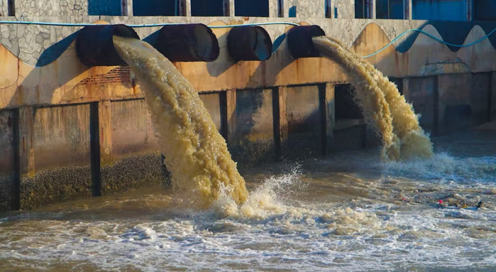
Figure 1: Heavy metal pollution in wastewater from industries. [40]

Table 1: Bioremediation of heavy metals by microorganisms
Microbial group | Species | Metals degraded | Metal ion concentration (mg/L) | Reference
Bacteria | Bacillus cereus | Chromium | 1500 | (Nayak et al, 2018)
 | Bacillus subtilis |  | 1 | (Singh et al, 2013)
 | Vibriofluvialis | Cobalt | 100 | (Jafari et al, 2015)
 | Cellulosimicrobium sp. (KX710177) | Lead | 50 | (Bharagava and Mishra, 2018)
 | Acinetobacter sp. B9 | Nickel | 50 | (Bhattacharya and Gupta, 2013)
Fungi | Aspergillus sp. | Chromium | 100 | (Congeevaram et al, 2007)
 | Saccharomyces cerevisiae(Y) |  | 570-25 | (Benazir et al, 2010)
 | Aspergillus niger | Nickel | 0 | (Tastan et al, 2010)
 | Candidapara psilosis | Mercury | 0.1 | (Muneer et al, 2013)
Algae | Nostoc sp. | Cadmium/  Lead | 1 | (Kumaran et al, 2011)
 | Spirogyra sp. | Copper | 5 | (Mane and Bhosle, 2012)
 | Spirulina sp. | Chromium | 5 | (Mane and Bhosle, 2012)

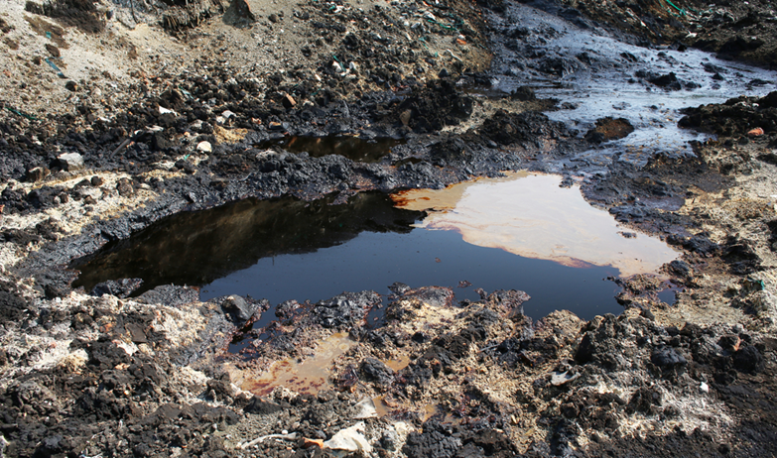

Figure 2: Soil polluted with heavy metals [41]

IV. BIODEGRADATION OF OIL CONTAMINANTS
Crude oil is a naturally available, unrefined form of petroleum that can be used as a source of energy. Petroleum products that can be extracted conveniently from crude oil include gasoline, diesel, jet fuel, waxes, lubricants, etc. These petroleum hydrocarbons (PH) are perhaps the most essential sources of energy for various industries [17]. They can be called a major source of environmental pollution, and anthropogenic activities like accidental spillage and run-offs from industries can have either direct or indirect consequences on health of all life [18]. Frequent accidental leakages or illicit dumping of crude oil wastes in oceans disrupts many marine ecosystems [19]. Petroleum hydrocarbons have very high bioaccumulation potential and resist biodegradation. Due to their chemical composition and physical nature, these toxic compounds persist even on degradation treatment. Aromatic compounds are especially difficult to break down due to their complicated structure. For example, polycyclic aromatic hydrocarbons (PAH) like phenanthrene are carcinogenic and harmful for the environment[20].
Such problems can be dealt with by employing microorganisms that are capable of bioremediation. By growing in close proximity to naturally occurring petroleum hydrocarbons in the environment, such bacteria have evolved which use such compounds as a source of carbon and energy [21]. Advances in biotechnology have facilitated screening of such organisms and their use to reduce pollution. It is a very economical and easy method of cleaning the environment (Figure 3).
The biochemical degradation pathways in bacteria usually degrade petroleum hydrocarbons by oxidation. However, species that do not contain the particular oxygenases metabolize other compounds like alkanes or breakdown resin or aromatic compounds. At present, over 79 different genera of petroleum degrading bacteria have been identified [22]. Pseudomonas putida is a classic example of an engineered superbug that degrades hydrocarbons to a more degradable form. Some other examples are listed in Table 2. Dispersants are chemical compounds that are added to a suspension of oil and water in order to emulsify the oil into tiny droplets, and make it easier for the microbes to degrade [23]. Commonly used substances include talc powder, soap powder, sulphonates, etc.
In a recent study, samples of cyanobacterial mats were collected from oil-contaminated mudflats in the Gulf of Suez and Solar Lake. A good rate of degradation of aliphatic and aromatic compounds was observed in both mats. Species of Phormidiumand Oscillatoria bloomed soon after. The study concluded that aerobic heterotrophic bacteria were the prime decomposers of oil. Oxygen required by these bacteria was supplied by photosynthetic cyanobacteria [24] (Figure 4).
Salinity has a major part to play in the acceleration of the biodegradation process of petroleum hydrocarbons. Higher the salinity of the environment, lower the amount of enzyme produced and hence, a reduction in degradation of substrate [25].
Table 2: Biodegradation of petroleum products by microorganisms
Microbial group | Species | Compounds degraded | References
Bacteria | Rhodococcus sp. | Cyclohexane | (Lee and Cho, 2008)
 | Oleispira antarctica | n-alkanes(C10-C18) | (Yakimov et al, 2003)
 | Mycobacterium cosmeticum | Monoaromatics | (Zhang et al, 2016)
 | Neptunomonasnaphthovoran | Polyaromatics | (Hedlund et al, 1999)
 | Pseudomonas sp. | Resins | (Venkateswaram et al, 1995)
Fungi | Trichoderma harzianum | Naphthalene | (Mollea et al, 2005)
 | Aspergillus Sp. | Crude oil | (Zhang et al, 2016)
 | Cunninghamella elegans | Pyrene | (Cerniglia and Yang, 1984)

V. BIODEGRADATION OF PLASTIC WASTE
Plastics are synthetic polymers. Since their invention in 1907 they have revolutionized the world and are now indispensable to mankind. Plastics are non-biodegradable. As a result of extensive use plastics accumulate in the environment and cause environmental pollution. Plastics are usually dumped in landfills, incinerated, very little is recycled but these are highly ineffective and they release harmful residues in the environment. Thus, there has to be a new environmentally friendly way to get rid of plastic and overcome this problem. Bio-degradation of plastic is a process by which plastic is decomposed by enzyme activity. Plastic biodegradation happens in multiple steps and has fewer to no side effects [26].
A. Effects of plastic
Global plastic production reached 368 million tons per annum in 2019, a figure which is predicted to double over the next 20 years. It is estimated that 5 to 13 million tons of plastic enter the oceans every year from coastal areas. Numerous problems have been created by plastic in the sea. over 700 species of life have been affected ranging from problems such as ingestion of plastic by aquatic life, straws and nets choking turtles and more. Plastic and additives get broken down to microscopic scales and end up in fishes, even in the marine species that are harvested for human consumption. Thus, ending up in the human body. Nearly one fifth of all marine life show plastic ingestion. Small plastic particles enter the pores of seeds and block it, preventing it from germinating and growth of plants in water and land [27]. Microplastics (1 to 5000μm particles) gained widespread attention after the discovery of massive garbage patches in the ocean. Biomonitoring fetal placenta, human stools, provide direct evidence of exposure of microplastics in infants and children. Microplastics which are of the order 20µm in size were reported to cross biological membranes [28]. Components such as bisphenol A found in PC and PVC can cause reproductive problems in ovaries. Phthalates contained in PVC lead to testosterone disorders and disrupt sperm mobility. The styrene monomers found in polystyrene plastics are carcinogenic [29].
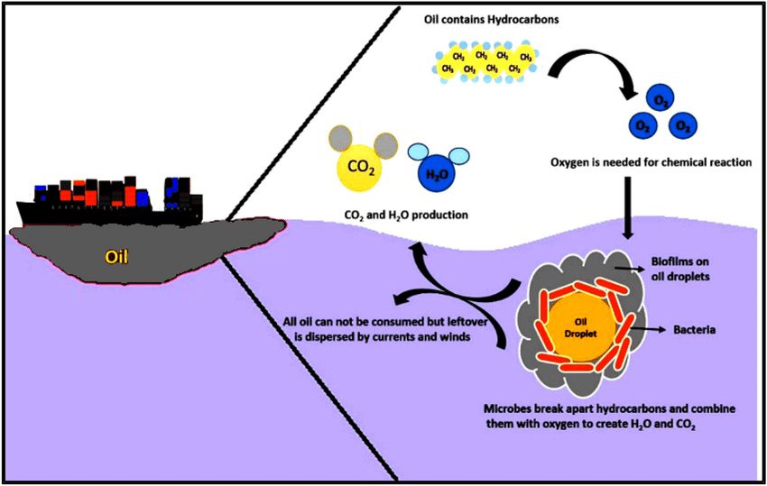

Figure 3: Overview of microbial bioremediation of oil spills [44]
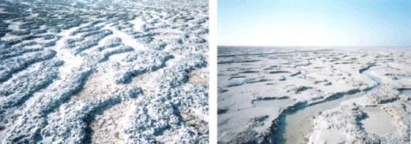

Figure 4: Microbial mats showing a whitish top layer of salt resulting from high evaporation [45]

B. Mechanism of plastic degradation
Plastic waste biodegradation takes place in several stages, they are biodeterioration, depolymerization and assimilation. Biodeterioration is processes by which several microbes with the help of abiotic factors break down polymers into smaller ones. Further breaking of plastic takes place in depolymerization as well. In the next step, depolymerization is where the microbes secrete catalytic compounds in the form of enzymes and free radicals to form biofilms helping them to break the polymer chains progressively [30]. The biodeterioration process is accelerated by the biofilm's films formed by the microorganisms on the plastic surface. Microbes attach on the surface of an object and colonize and multiply on it. Extracellular polymeric substance (EPS) produced by the organisms to help them break down the plastic surface [31]. EPS enlarges the surface pores by penetrating the plastic surface and forms holes. This encourages physical deterioration of the plastic. It also stimulates the production of many acidic compounds like nitrous acid, nitric acid or sulfuric acid, citric, fumaric, gluconic, glutaric, glyoxylic, oxalic, and oxaloacetic. This changes the overall pH of the plastic surface and aids in the further breakdown process [32]. Depolymerization is facilitated by depolymerase enzymes secreted by microbes; the products formed by this reaction are oligomers, dimers, and monomers that are simpler than polymers. These are further processed in the presence of oxygen molecules into microbial biomass, CO2, and H2O. While anaerobic degradation will give microbial biomass, CO2, H2O, and CH4 or H2S [33]. During depolymerization the degraded monomers and simpler molecules enter the cell through microbial semi permeable cell membranes, which are broken down and used as carbon source and energy. The last process of deterioration of plastic is mineralization. In this process changes the toxic and hazardous compounds that are left, into more environmentally friendly products. At the end of this process the biodegradable materials or biomass is converted into gasses, water, salt, minerals and other residues. The formed gasses include carbon dioxide, methane, and nitrogen components [34][35].
C. Plastic degrading bacteria
The first plastic degrading bacteria that was identified was Ideonellasakaiensis, by a group of Japanese scientists from Kyoto Institute of Technology. Ideonellasakaiensisuses two enzymes to digest Polyethylene Terephthalate (PET) at a surprisingly mild 30 °C. The residue after digestion is the monomers terephthalic acid and ethylene glycol. It will take some tweaking before I. sakaiensisand its enzyme can start munching down on huge dumps of plastic. As of now I. sakaiensis’s enzyme are too slow to act on an industrial scale [36].
Over the years researchers have identified and isolated many plastic eating microorganisms, they are listed in table 3. D.nigrificans and Pseudomonasalcaligenes are some of the PE degrading bacteria that were isolated from plastic waste contaminated soil [37], Enterobacter sp. D1 isolated from the guts of Galleria mellonella[38] and P. putida MTCC 2475 isolated from garden soil. P. putida MTCC 2475 reduced milk cover weight about 63.1 – 73.3% within 1 month incubation [39].
Table 3: Plastic degrading bacteria
Type of Plastic | Bacteria | Degradation | References
Polyethylene | Bacillus amylolyticus | 32% of PWL | (R. C. Patil, 2018)
 | Pseudomonas fluorescens | 22% of PWL | (R. C. Patil, 2018)
 | Streptomyces SSP4 | 11% of PWL | (S. A. Soud, 2019)
 | Streptomyces coelicoflavus | 30% of PWL | (M. K. Duddu et al, 2015)
Low-Density Polyethylene | Bacillus carbonipphilus | 34.55% of PWL (mineral agar) | (J. K. Shresta et al, 2019)
 | Escherichia coli | 23.57% of TPBWL | (S. Mukherjee et al, 2014)
Polyethylene Terephthalate | Bacillus subtilis | 74.5% of PWL (Nutrient Broth) | (K. Asmita et al, 2015)

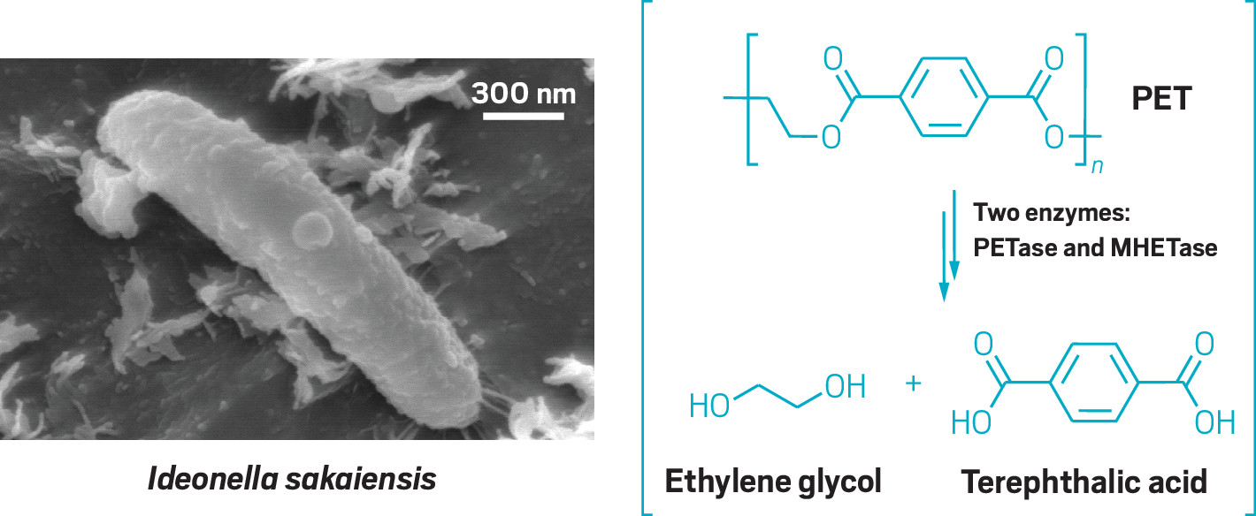Figure 4: A)Ideonellasakaiensis - degrades polyethylene terephthalate B) Conversion of polyethylene terephthalate to ethylene glycol and terephthalic acid. [33]
VI. CONCLUSION
Bioremediation by microorganisms is an eco-friendly, sustainable, and a very valuable way to remove contaminants, pollutants, toxins, nuclear wastes from groundwater, soil, oceans, and other environments. Bioremediation depends on stimulating the growth of certain microbes that break down pollutants into harmless gasses like carbon monoxide, small amounts of water and other non-toxic residues. It can be done on the site of contamination itself (in situ) or away from the location (ex situ), depending on the conditions in the contaminated site. ‘In-situ’ would be the best and cost effective whereas ‘ex situ’ would be inefficient and expensive and additional costs such as gathering and transportation would be a behemoth task. The limitations of biodegradation by microorganisms are that it is mostly restricted to biodegradable compounds and mostly dependent on the combination of the right nutrients, temperature, pH and surroundings or else they will hinder the bioremediation process. The only way to overcome this drawback is to genetically modify these organisms to be more efficient, fast and economically feasible. But these methods are still in their infancy and through genetic engineering and biotechnology. With new advances coming along we need to develop new and better techniques. Scientists are now treading in uncharted waters and we as mankind have to take up this new venture in the future to save ourselves, by rectifying and repairing the damage that has been created by humans. Because if we don't, it is the microorganism that will survive, because they are the ones who came before us and they are the ones who will remain after us.
References
[1] P. Chanda, S.R. Joshi (2022). “Understanding the Small World: The Microbes”. In: Verma, P. (eds) Industrial Microbiology and Biotechnology. Springer, Singapore. https://doi.org/10.1007/978-981-16-5214-1_1

[2] C.C. Azubuike, C.B. Chikere and G.C. Okpokwasili(2016), “Bioremediation techniques-classification based on site of application: principles, advantages, limitations and prospects”, World J MicrobiolBiotechnol, 32(11): 180

[3] H.A. Ahmad, S. Ahmad, Q. Cui et al., “The environmental distribution and removal of emerging pollutants, highlighting the importance of using microbes as a potential degrader: A review”, Science of The Total Environment, Volume 809, 2022, https://doi.org/10.1016/j.scitotenv.2021.151926.

[4] B. Ramesh et al., (2021). “ Microbial Interaction with Metals and Metalloids”. In: Maddela, N.R., García, L.C. (eds) Innovations in Biotechnology for a Sustainable Future. Springer, Cham. https://doi.org/10.1007/978-3-030-80108-3_13

[5] E. Abatenh, B. Gizaw, Z. Tsegaye, M. Wassie (2017), “The Role of Microorganisms in Bioremediation- A Review’’. Open J Environ Biol 2(1): 038-046.

[6] J. Sharma (2019), “Advantages and limitations of in situ methods of bioremediation”. Recent Adv Biol Med., Vol. 5, Article ID 955923, 9 pages. https://doi.org/10.18639/RABM.2019.955923

[7] C. Kapagunta, A. Majumder, (2018), “Importance of bioremediation and its future prospects”, [online] Project Guru. Available at: https://www.projectguru.in/importance-bioremediation-future-prospects/

[8] D. Hazaimeh, E.S. Ahmed, “ Bioremediation perspectives and progress in petroleum pollution in the marine environment: a review”. Environ Sci Pollut Res 28, 54238–54259 (2021). https://doi.org/10.1007/s11356-021-15598-4

[9] A. Alemzadeh, (2018). “Roles of Plants and Bacteria in Bioremediation of Petroleum in Contaminated Soils' '. In: Kumar, V., Kumar, M., Prasad, R. (eds) Photobiont and Ecosystem Restitution. Springer, Singapore. https://doi.org/10.1007/978-981-13-1187-1_2

[10] J. Walworth and S. Ferguson (2008),”Nutrient requirements for bioremediation”, DOI:10.1017/CBO9780511535956.009

[11] S. Kordjazi, K. Kamyab and Hemmatinejad, N. Super-hydrophilic/oleophobic chitosan/acrylamide hydrogel: an efficient water/oil separation filter. Adv Compos Hybrid Mater 3, 167–176 (2020). https://doi.org/10.1007/s42114-020-00150-8

[12] M. Balali-Mood, K. Naseri, Z. Tahergorabi et al., (2021) Toxic Mechanisms of Five Heavy Metals: Mercury, Lead, Chromium, Cadmium, and Arsenic. Front. Pharmacol. 12:643972. doi: 10.3389/fphar.2021.643972

[13] P. Badodekar (2021). “The potential of PGPR in bioremediation of soils with heavy metal contamination”. International Journal of Agricultural and Applied Sciences, 2(2):20-27. https://doi.org/10.52804/ijaas2021.224

[14]G.Henao, Sarah, and T.G.Herrera. "Heavy metals in soils and the remediation potential of bacteria associated with the plant microbiome." Frontiers in Environmental Science (2021): 15.

[15] K. Mishra, Geetesh(2017), “Microbes in heavy metal remediation: a review on current trends and patents”, Recent patents on biotechnology, Vol. 11, No. 3, pp. 188-196. https://doi.org/10.2174/1872208311666170120121025
[16] J. Morrison, L.D. Nafta, J.A. Davis, C.C.Fuller, “Chapter 1 - Introduction to Groundwater Remediation of Metals, Radionuclides, and Nutrients with Permeable Reactive Barriers” ,Editor(s): David L. Naftz, Stan J. Morrison, Christopher C. Fuller, James A. Davis, Handbook of Groundwater Remediation using Permeable Reactive Barriers, Academic Press, 2003, Pages 1-15, https://doi.org/10.1016/B978-012513563-4/50005-0.
[17] D.B. Al-Hawash, M. Dragh, S. Alhujailyet al.,(2018), “Principles of microbial degradation of petroleum hydrocarbons in the environment”, The Egyptian Journal of Aquatic Research, Volume 44, Issue 2, Pages 71-76, https://doi.org/10.1016/j.ejar.2018.06.001. (https://www.sciencedirect.com/science/article/pii/S1687428518300244)
[18] M. Shakya, P. Verma, S. Kumar et al., (2021). Microbes: A Novel Source of Bioremediation for Degradation of Hydrocarbons. In: Panpatte, D.G., Jhala, Y.K. (eds) Microbial Rejuvenation of Polluted Environment. Microorganisms for Sustainability, vol 25. Springer, Singapore. https://doi.org/10.1007/978-981-15-7447-4_10
[19] I. Ossai, A. Ahmed, A. Hassan et al., (2020), “Remediation of soil and water contaminated with petroleum hydrocarbon: A review, Environmental Technology & Innovation”, Volume 17,https://doi.org/10.1016/j.eti.2019.100526.
[20]Hussein et al., (2019) “A review on zeolitic imidazolate frameworks use for crude oil spills cleanup” Advances in Geo-Energy Research, 2019, 3(3): 320-342, doi: 10.26804/ager.2019.03.10
[21] Lea-Smith, J David et al (2015) “Contribution of cyanobacterial alkane production to the ocean hydrocarbon cycle”. 112 (44) 13591-13596 https://doi.org/10.1073/pnas.1507274112 .
[22] J. Tremblay, E. Yergeau, et al., (2017), “ Chemical dispersants enhance the activity of oil- and gas condensate-degrading marine bacteria”. ISME J 11, 2793–2808,. https://doi.org/10.1038/ismej.2017.129
[23] P. Keramea, K. Spanoudaki et al., “ Oil Spill Modeling: A Critical Review on Current Trends, Perspectives, and Challenges”. J. Mar. Sci. Eng.2021, 9, 181. https://doi.org/10.3390/jmse9020181
[24]J.Bergi and R. Trivedi (2020). “Bioremediation of Saline Soil by Cyanobacteria". In: Shah, M. (eds) Microbial Bioremediation & Biodegradation. Springer, Singapore. https://doi.org/10.1007/978-981-15-1812-6_17
[25] Li Y, Li W, Ji L, Song F, Li T, Fu X, Li Q, Xing Y, Zhang Q and Wang J (2022) , “Effects of Salinity on the Biodegradation of Polycyclic Aromatic Hydrocarbons in Oilfield Soils Emphasizing Degradation Genes and Soil Enzymes” . Front. Microbiol. 12:824319. doi: 10.3389/fmicb.2021.824319
[26] A.P. Asiandu, A. Wahyudi, S.W. Sari (2021) , “A Review: Plastics Waste Biodegradation Using Plastics-Degrading Bacteria”. Department of Biology, Gadjah Mada University, Yogyakarta, Department of Biology, Sriwijaya University, Department of Sociology, University of Bengkulu, Indonesia, https://doi.org/10.47277/JETT/9(1)157
[27] V. Gambarini, O. Pantos, J. M. Kingsbury, L. Weaver, K. M. Handley, Gavin Lear(2021) “Phylogenetic Distribution of Plastic-Degrading Microorganisms”. https://journals.asm.org/doi/full/10.1128/mSystems.01112-20#con1 , https://doi.org/10.1128/mSystems.01112-20
[28] K. Kannan and K. Vimalkumar (2021) , “A Review of Human Exposure to Microplastics and Insights Into Microplastics as Obesogens”. Department of Pediatrics and Department of Environmental Medicine, New York University School of Medicine, New York, NY, United States https://doi.org/10.3389/fendo.2021.724989
[29] J. Ksenia, T. Backhaus et al., (2019), “Overview of known plastic packaging-associated chemicals and their hazards”, Science of The Total Environment,Volume 651, Part 2, Pages 3253-3268, https://doi.org/10.1016/j.scitotenv.2018.10.015.
[30] L. Marjayandari, M. Shovitri, PotensiBakteri Bacillus sp. dalamMendegradasiPlastik. Jurnal Sains dan SeniITS.( 2015) ;4(2):59-62.
[31] Chao Wang, Qiaoli Zhang et al., (2019),“Effects of CwlM on autolysis and biofilm formation in Mycobacterium tuberculosis and Mycobacterium smegmatis”, International Journal of Medical Microbiology, Volume 309, Issue 1, Pages 73-83, https://doi.org/10.1016/j.ijmm.2018.12.002.
[32] B. Sharma, H. Rawat, Pooja, R. Sharma “Bioremediation - A Progressive Approach toward Reducing Plastic Wastes”. International Journal of Current Microbiology and Applied Science. 2017 Dec 10;6(12):1116-31.
[33] A.K.Tiwari, M.Gautam and H.K Maurya.” Recent Development of Biodegradation Techniques of Polymer”. International Journal of Research-Granthaalayah. 2018 Jun 30;6(6): 414-52.
[34] S.S. Ali, T. Elsamahy et al., (2021), “Degradation of conventional plastic wastes in the environment: A review on current status of knowledge and future perspectives of disposal,Science of The Total Environment”, Volume 771, https://doi.org/10.1016/j.scitotenv.2020.144719.
[35] L. Manfra, V. Marengo et al., (2021), “Biodegradable polymers: A real opportunity to solve marine plastic pollution?”,Journal of Hazardous Materials, Volume 416, https://doi.org/10.1016/j.jhazmat.2021.125763.
[36] B. Halford (2016) “World’s first PET-munching microbe discovered” https://pubs.acs.org/action/doSearch?field1=Contrib&text1=Bethany+Halfordhttps://pubs.acs.org/action/downloadCitation?doi=10.1021/cen-09449-cover3&include=cit&format=ris&direct=true&downloadFileName=cen-09449-cover3
[37] M.A. Begum, B. Varalakshmi and K. Umamagheshwari “Biodegradation of Polythene Bag using Bacteria Isolated from Soil”. International Journal of Current Microbiology and Applied Sciences. 2015; 4(11):674-80.
[38] L. Ren, L. Men et al., “ Biodegradation of Polyethylene by Enterobacter sp. D1 from the Guts of Wax Moth Galleria Mellonella”. International Journal of Environmental Research and Public Health. (2019) May 31;16(11):1-11
[39] T. Ahmed, Shahid et al., “Biodegradation of plastics: current scenario and future prospects for environmental safety”. Environ Sci Pollut Res 25, 7287–7298 (2018). https://doi.org/10.1007/s11356-018-1234-9
[40] V. Lee ( 2022), “Heavy metals in wastewater: locating pollution sources using portable XRF”, https://www.watertechonline.com/
[41] K. Walter (2019), “Scientists rinse soils clean of dangerous heavy metals”, https://www.rdworldonline.com/
[42] Balan, Biji (2021). “Microbial biofilm ecology, in silico study of quorum sensing receptor-ligand interactions and biofilm mediated bioremediation”. Archives of Microbiology. 203. 10.1007/s00203-020-02012-9. https://www.researchgate.net/figure/A-quick-overview-of-microbial-bioremediation-of-oil-spills-in-seawater_fig4_343612034
[43] R. M. M. Abed, A. Al-Thukair, D. de Beer, (2006). “Bacterial diversity of a cyanobacterial mat degrading petroleum compounds at elevated salinities and temperatures.” FEMS Microbiology Ecology, Volume 57, Issue 2, August 2006, Pages 290-301 (https://doi.org/10.1111/j.1574-6941.2006.00113.x)
[44] H. Chandran, M. Meena and K. Sharma (2020) “Microbial Biodiversity and Bioremediation Assessment Through Omics Approaches”. Front. Environ. Chem. 1:570326. doi: 10.3389/fenvc.2020.570326
[45] W. Chen , F. Brühlmann et al., (1999). “ Engineering of improved microbes and enzymes for bioremediation”, Current Opinion in Biotechnology, Volume 10, Issue 2, (https://www.sciencedirect.com/science/article/pii/S0958166999800238)
[46] Hafiz Ahmad et al., , “The environmental distribution and removal of emerging pollutants, highlighting the importance of using microbes as a potential degrader: A review”, Science of The Total Environment, Volume 809, 2022, https://doi.org/10.1016/j.scitotenv.2021.151926.

