Genomics in Agriculture: a gate way toward development
Nidhi Singh*, Iram Naj, Rajul soni, Meenakhsi agney, Aaradhana patel
Department of Agriculture, Medi-caps University, Indore, India
Corresponding author email*- nidhinotes6@gmail.com
ABSTRACT
Currently genomics in agriculture is playing important role in advancement of agriculture. Genomics is agricultural is application of technology to decipher plant genes which ultimately leads to development of new, specific varieties of crops having superior traits. Innovations in genomics contributing progress in crop developments by improving desirable traits in agriculture. Several promising traits include higher yield crop, stress tolerance and pest resistance. Speedy development of crops and livestock with improved traits has been obtained with the application of genomics in agriculture. With the increasing population demand for food is increasing thus to meet this increasing food demand there is a urgent need to focus on advanced technologies to enhance crop production. Advent of recent advanced technology including next-generation DNA sequencing, many vital crop genomes including cereals, tuber crops, vegetables have been sequenced. Application of genomics in the field of agriculture has been discussed in this current book chapter.
Keywords- Genomics, Agriculture, Next-generation DNA sequencing, Technology
INTRODUCTION
In the present scenario, with the enhancing global population we need a drastic enhancement in food production in coming future. With rapid enhancement in global human population which is expected to reach 10 billions by 2050 global food security is one of the key challenge in the coming future (Arora, 2019). Suitable land for agriculture is also getting reduced at the same pace because of increasing urbanization as a result of increasing human population. Thus, farmers, breeders, scientist, researches has major challenge to produce more and more food. Methods like crossing and selection have been successfully used to improve the agronomic characters of cultivated crops including rice, wheat, maize, pulses and others. Application of genomics in agriculture is known as agri-genomics (Mishra and Pandey, 2021). Genomics has wide application in the field of agriculture and has wide potential to speed up the sustainable production and fighting with food hunger at international level. Advent of genomics in agriculture has opened up so many prospects to enhance agriculture production. Genomic technology can support farmers, breeders and researchers to decode genetic markers associated with desirable traits. Improvement in the quality and quantity of crop yields can be achieved with this advanced innovative technology. Lab to land application of genomics technology in crops like rice, wheat, pulse has resulted in major improvement in desirable traits which can also cope with drastic climate change. Genomics has also potential to minimize the number of trials and failures in scientific research. Decoding of genes associated with desirable traits in crops has wide prospects in bringing revolutionary change in the field of agriculture. Genomics assist in many ways to scientist for best utilization of genetic data to probe desirable features which can be ultimately transferred to another crop plants. Development of new improved trait such developing drought-sensitive crop more drought-tolerant using genomic assisted breeding programme (Thudi et al., 2014).
Considering application and future prospects of genomics in agriculture the present book chapter outlines the agri-genomics that is application of genomics in agriculture. Various genomic based methods with wide application in agriculture enlisted in Table1.
Table1: Genomics based approaches having prospects in the transformation of agriculture
S.No. | Approaches | Application | Reference
1 | Genomic selection | Exploitation of molecular genetic markers to design novel breeding programmes. | Jannink et al., 2010
2 | Genome Wide Association Mapping (GWAS) | Identification of genes associated with a particular disease (or another trait). | Uffelmann et al.,2021
3 | RNA-Seq/ Transcriptome shotgun sequencing | Identification of presence and quantity of RNA in a biological sample at a given time. | Yadav et al., 2022
4 | Microarray | Powerful tool to identify nucleic acid with mutation or transformation | Shalini et al., 2018
5 | Next-generation sequencing (NGS) | Sequencing of DNA/RNA and identification of mutation and variantsin it | Begum and Banerje, 2021
6 | Genome editing | Editing of target genes to improve crop nutritional value | Friedrichs et al., 2019

HISTORY OF GENOMICS

Timeline
Major events depicting history of genomics and genetics research is presented in Table2. Right from the discovery of DNA and sequencing of corona genes, all events are given here.
Table2: Timeline of History of genomics
S.No. | Year | Discoveries
1. | 1871 | Friedrich Miescher presence of ‘nuclein’ (now known as DNA) and associated proteins, in the cell nucleus.
2. | 1904 | Walter Sutton and Theodor Boveri propose the chromosome theory of heredity after finding that chromosomes occur in matched pairs, one inherited from the mother and one from the father.
3. | 1910 | - Albrecht Kossel is awarded the first Nobel Prize in Physiology or Medicine for his discovery of the five nucleotide bases, adenine, cytosine, guanine, thymine and uracil.
4. | 1950 | - Erwin Chargaff works out the pairing pattern of the bases A, C, G and T. He finds that concentrations of thymine and adenine, and cytosine and guanine, are always found in equal amounts in samples of DNA. This suggested that A always pairs with T and C always pairs with G.
5. | 1952 | - The Hershey-Chase experiments are carried out by Alfred Hershey and Martha Chase to demonstrate that DNA, rather than protein, carries our genetic information.
6. | 1953 | - James Watson and Francis Crick, with contributions from Rosalind Franklin and Maurice Wilkins, discover the double helix structure of DNA.
7. | 1961 | - Marshall Nirenberg, Har Gobind Khorana and colleagues, crack the ‘code for life’. They identify how the letters in DNA are read in blocks of three called a “codon”. Each codon specifies an amino acid which is added to the protein during synthesis.
8. | 1968 | - Marshall Nirenberg, Har Gobind Khorana and Robert Holley share the 1968 Nobel Prize for Physiology and Medicine for Nirenberg and Khorana’s work cracking the genetic code, and Holley’s work sequencing the first tRNA molecule.
9. | 1977 | - Frederick Sanger develops a DNA sequencing technique which he and his team” use to sequence the first full genome – that of a virus called phiX174.
10. | 1983 | - The polymerase chain reaction (PCR) is developed – a technique used for amplifying DNA – by Dr Kary Mullis at the Cetus Corporation in California, USA.
11. | 1985 | - Alec Jeffreys develops a method for DNA profiling. A DNA profile is produced by counting the number of short repeating sequences of DNA sequence found at ten specific regions of the genome.
12. | 1990 | - Human Genome Project is launched. The project aims to sequence all 3 billion letters of a human genome in 15 years.
13. | 1995 | - The first bacterium genome sequence is completed (Haemophilus influenza).
14. | 1999 | - Chromosome 22 is the first human chromosome to be sequenced as part of the Human Genome Project.
15 | 2000 | - The full genome sequence of the model organism Drosophila melanogaster (fruit fly) is completed. The genome of Arabidopsis thaliana, the first plant genome was sequenced.
16. | 2001 | First draft of the human genome sequence released
17. | 2003 | - Human Genome Project is completed
18. | 2005 | Oryza sativa (rice) genome was sequenced
19. | 2007 | - A new DNA sequencing technology is introduced that increases DNA sequencing output 70 fold, in one year.
20. | 2008 | - 1,000 Genomes Project launched – the first project that aims to sequence the whole genomes of a large number of people (2,500).
21. | 2020 | - Following the pandemic outbreak of COVID-19, the genome of the SARS-CoV-2 virus is sequenced.

Driving Discoveries in Agrigenomics
Emergence of agri-genomics is one of the biggest revolutions in the field of agriculture bringing rapid enhancement in the field of molecular breeding. Genomic assisted breeding program such as marker assisted selection, genomic selection enabled development of more suitable and adaptable varieties in the field of agriculture. Several technological developments have fueled the breakthrough of agri-genomics. Range of methods including next generation sequencing (NGS) and microarrays for genotyping and single nucleotide polymorphism (SNP) analysis (Bohra et al 2020). Rapid progress in NGS technology have resulted a drastic revolution to develop varieties of plant crops with superior and desirable traits such as abiotic and biotic stress tolerance and climate smart crops.

METHODS FOR PLANT GENOMICS

Next Generation Sequencing(NGS)
Next generation Sequencing (NGS) provides a powerful tool for discovery of domestication genes in crop plants and their wild relatives. The accelerated domestication of new plant species as crops may be facilitated by this knowledge (Boers et al., 2019). Major developments in the NGS technology have been depicted in Table2.
Table2: Key progress in the field of NGS
S.No. | Year | - Development in NGS technology | - Reference
1. | 2000 | - The first of the NGS technologies i.e. Massively parallel signature sequencing (MPSS) has been launched by Lynx Therapeutics Company and it was later bought by Illumina. | - Schuster, S.C., 2008.
2. | 2004 | The Roche GS20 i.e. new generation pyro-sequencing technology, the first NGS platform was marketed by 454 Life Sciences. | Schuster, S.C., 2008
3. | 2008 | - The first paper was published about studying the human genome sequence using NGS. | - Schuster, S.C., 2008
4. | 2014 | Illumina launched a new technology, called HiSeq X Ten Sequencer, and claimed to have produced the first $1,000 genome. | - Van Dijk et al 2014

Whole Genome Sequencing

Whole-genome de novo sequencing is used to study and understand novel species (Hamilton and Buell, 2012). Resequencing can be used to probe and discover SNPs and structural variants. This technology facilitate comparative genomic analyses and improving breeding and selection.

Epigenomics
This advanced technology has been applied in agriculture to discover adaptive responses in plants with respect to changing environment. Major use of this technique is to detect changes in DNA methylation, chromatin structure and RNA expression (Alvarez-Venegas et al 2019).

Transcriptome Sequencing
The study of gene expression dynamics in organisms has been revolutionized via RNA sequencing. Wide application of this technology is that it provides insight in to key molecules and mechanisms in development and during disease and stress conditions. Gene function can be understood in a much better and best way (Hao et al 2012).

Targeted Sequencing

Targeted sequencing with a focus on the exome or specific genes can be used for the identification of common and rare variants such as SNPs and CNVs. These variants can help inform breeding decisions and reveal causative mutations for parasite susceptibility or disease (Barba et al 2014).

SNP Genotyping
SNP genotyping by sequencing or microarray enables the whole-genome SNP profiling. SNP genotyping has been shown to work for GWAS, marker-assisted selction/ breeding, marker-assisted backcrossing, QTL screening, and trait mapping (Jenkins and Gibson, 2002).

Metagenomics

Metagenomics enables researchers to identify microbial populations associated with animal and plant development, detect known and novel pathogens in animal populations, enhance animal digestion, and improve plant health via analysis of root-associated bacteria (Hugenholtz and Tyson, 2008).

APPLICATION OF GENOMICS IN AGRICULTURE

Agri-genomics transforming future of agriculture
Agri-genomics is the application of genomics in agriculture, with a focus on plants, animals, and ubiquitous microorganisms (Mishra and Pandey, 2021). Agri-genomic technology is transforming traditional approaches to breeding of commercial species and monitoring and protection of wild populations. The main methods for agri-genomics are next-generation sequencing (NGS), microarrays, and polymerase chain reaction (PCR). Agri-genomics aims to find innovative solutions for protection and sustainable productivity for the food industry, and may provide insight into energy production or drug discovery. Genomic technologies are able to depict all the genes in a genome and their functions and manipulations of genes linked to specific phenotypic traits.

MAJOR APPLICATIONS
  - Crop improvement- It is very important to increase crop yields and livestock productivity to alleviate hunger and poverty in the developing world. Genomics is a promising tool for solving this urging problem. Genomic information enables researchers to identify genes associated with valuable traits. Gene editing technologies such as CRISPR/Cas9 can be used to introduce genes to promote disease or drought resistance, enhance the taste, texture, and help crops adapt to high salinity soils, etc. Genome editing needs to be validated via molecular methods such as PCR or sequencing.
  - Crop adaptation- Adapting crops to future harsher conditions of a major concern for food security. Agri-genomics is a potential method to improve the adaptability of crops through increasing agro-biodiversity. It is expected that wild relatives represent an important reservoir of adaptations to extreme environmental stresses. NGS can be used to identify wild relatives carrying adaptations that can be used for improvement of crop adaptation in breeding programs. It can also be used to identify genes and polymorphisms associated with adaptations for targeted improvement.
  - Development of bio-products- Next-generation sequencing promotes the development and commercialization of bio-products which affect applied fields like bio-control, stress protection, and arable land. For example, the microorganisms that potentially play a role in crop health and disease suppression can be identified with a culture-dependent approach using a next-generation sequencing-based platform and powerful bioinformatics analysis.

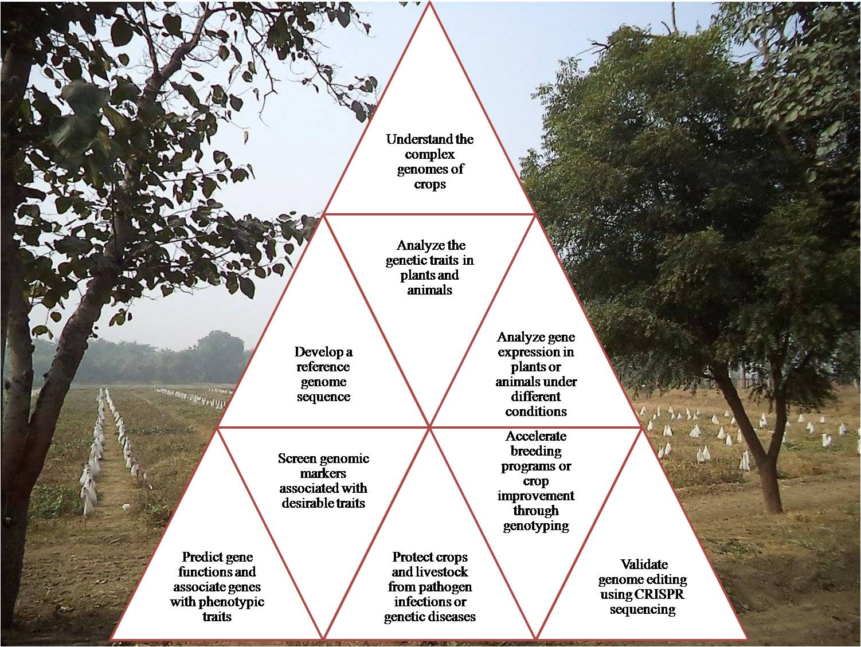

Figure1: Various aspects of agri-genomics

REFERENCES
Alvarez-Venegas, R., De-la-Peña, C. and Casas-Mollano, J.A. eds., 2019. Epigenetics in plants of agronomic importance: fundamentals and applications: transcriptional regulation and chromatin remodelling in plants. Springer.
Arora, N.K., 2019. Impact of climate change on agriculture production and its sustainable solutions. Environmental Sustainability, 2(2), pp.95-96.
Barba, M., Czosnek, H. and Hadidi, A., 2014. Historical perspective, development and applications of next-generation sequencing in plant virology. Viruses, 6(1), pp.106-136.
Begum, S. and Banerjee, R., 2021. Next Generation Sequencing Data Analysis and its Applications in Agriculture. Quarterly Research Journal of Plant & Animal Sciences/Bhartiya Krishi Anusandhan Patrika, 36(1).
Boers, S.A., Jansen, R. and Hays, J.P., 2019. Understanding and overcoming the pitfalls and biases of next-generation sequencing (NGS) methods for use in the routine clinical microbiological diagnostic laboratory. European Journal of Clinical Microbiology & Infectious Diseases, 38(6), pp.1059-1070.
Bohra, A., Saxena, K.B., Varshney, R.K. and Saxena, R.K., 2020. Genomics-assisted breeding for pigeonpea improvement. Theoretical and Applied Genetics, 133(5), pp.1721-1737.
Friedrichs, S., Takasu, Y., Kearns, P., Dagallier, B., Oshima, R., Schofield, J. and Moreddu, C., 2019. An overview of regulatory approaches to genome editing in agriculture. Biotechnology Research and Innovation, 3(2), pp.208-220.
Hamilton, J.P. and Robin Buell, C., 2012. Advances in plant genome sequencing. The Plant Journal, 70(1), pp.177-190.
Hao, D.C., Chen, S.L., Xiao, P.G. and Liu, M., 2012. Application of high‐throughput sequencing in medicinal plant transcriptome studies. Drug Development Research, 73(8), pp.487-498.
Hugenholtz, P. and Tyson, G.W., 2008. Metagenomics. Nature, 455(7212), pp.481-483.
Jannink, J.L., Lorenz, A.J. and Iwata, H., 2010. Genomic selection in plant breeding: from theory to practice. Briefings in functional genomics, 9(2), pp.166-177.
Jenkins, S. and Gibson, N., 2002. High‐throughput SNP genotyping. Comparative and Functional Genomics, 3(1), pp.57-66.
Mishra, R. and Pandey, D.K., 2021. Agri/Bioinformatics: Shaping Next-Generation Agriculture. In Bioinformatics for agriculture: High-throughput approaches (pp. 111-134). Springer, Singapore.
Mishra, R. and Pandey, D.K., 2021. Agri/Bioinformatics: Shaping Next-Generation Agriculture. In Bioinformatics for agriculture: High-throughput approaches (pp. 111-134). Springer, Singapore.
Schuster, S.C., 2008. Next-generation sequencing transforms today's biology. Nature methods, 5(1), pp.16-18.
Shalini, S., Singla, A., Goyal, M., Kaur, V. and Kumar, P., 2018. Omics in agriculture: Applications, challenges and future perspectives. Crop Improvement for Sustainability, pp.343-360.
Thudi, M., Gaur, P.M., Krishnamurthy, L., Mir, R.R., Kudapa, H., Fikre, A., Kimurto, P., Tripathi, S., Soren, K.R., Mulwa, R. and Bharadwaj, C., 2014. Genomics-assisted breeding for drought tolerance in chickpea. Functional Plant Biology, 41(11), pp.1178-1190.
Uffelmann, E., Huang, Q.Q., Munung, N.S., De Vries, J., Okada, Y., Martin, A.R., Martin, H.C., Lappalainen, T. and Posthuma, D., 2021. Genome-wide association studies. Nature Reviews Methods Primers, 1(1), pp.1-21.
Van Dijk, E.L., Auger, H., Jaszczyszyn, Y. and Thermes, C., 2014. Ten years of next-generation sequencing technology. Trends in genetics, 30(9), pp.418-426.
Wenqin Wang, Xuan H. Cao, Mihai Miclăuș, Jianhong Xu, Wenwei Xiong, "The Promise of Agriculture Genomics", International Journal of Genomics, vol. 2017, Article ID 9743749, 3 pages, 2017. https://doi.org/10.1155/2017/9743749
Yadav, P.K., Jasrotia, R.S. and Jaiswar, A., 2022. Genome informatics: present status and future prospects in agriculture. Bioinformatics in Agriculture, pp.47-59.

