STRUCTURAL AND TRANSPORT PROPERTIES OF SPRAY PYROLYSED Ce:CdO NANOCRYSTALLINE THIN FILMS
¹S.J.Helen, ²Suganthi Devadason*, ³M. Haris, ⁴T. Mahalingam, ⁵R. Chandramohan and ⁶SR. Srikumar
¹PG Department of Physics,Idhaya College for Women, Sarugani-63041, India
²Department of Physics, Hindustan Institute of Technology and Science,
Chennai-603103,India
³Department of Physics,Karunya University, Coimbatore-641114,India
⁴Department of Physics, Alagappa University, Karaikudi-630 003,India
⁵PG Department of Physics, Vidhyaa Giri College of Arts and Sciences, Puduvayal-630002,India
⁶Department of Physics, Kalasalingam Academy of Science and Engineering, Krishnankoil-626126, India
Corresponding Author e-mail: rathinam.chandramohan@gmail.com

Abstract
In this report undoped and Cerium (Ce) doped Cadmium oxide (CdO) thin films were deposited onto pre-cleaned glass substrates using a simple chemical spray pyrolysis technique. The effect of various levels of Ce-doping on the structural, morphological, transport (optical and electrical) properties of CdO thin films are reported. The thickness of the films are estimated using cross sectional SEM images that revealed that the films had an average thickness of 420 nm ranging from 360 to 480 nm. Minor changes in Morphology is observed with Ce doping with increasing concentration. The energy band gap values for 3 to 7 wt. % Ce doped CdO thin films are estimated to be in the range of 2.47 and 2.50 eV, respectively. The broadband emission observed (550 – 650 nm) in the photoluminescence spectra of CdO thin film indicates the defect-related luminescence. A low resistivity (10⁻⁴ Ωcm) and high conductivity (10⁴ cm⁻¹) are observed for 5 wt. % Ce-doped CdO thin films. The results of the photo responsivity studies revealed the increase in the photoresponse with the increasing Ce ions in CdO thin films. The thin films showed photo responsivity up to 70%.
1. INTRODUCTION
Futuristic material science looks exotic properties of novel materials, novel phenomena and exploring the application of such materials for novel applications. Oxide materials pose wide variety of oppurtunities and challenges. The understanding there properties, ferromagnetism at room temperature, phonon assisted phenomena are of potential areas for future research. Doping also produces wide variety of dilute magnetic properties making them potential candidate for spintronic applications.[1.2]. CdO is an excellent n-type material of the II –VI family of metal chalcogenides that are suitable for varieties of applications [3-5]. More attention in the last decade has been given to pristine and doped CdO thin films due to their wide range of applications in optoelectronics, such as transparent conducting oxide (TCO), smart windows, solar cells, optical communications, flat-panel displays, photo-transistors, in addition to other types of utilization such as infrared (IR) heat mirrors, gas sensors, low-emissive windows, thin-film resistors, etc.[6-12]. Many research findings report the doping of transition and or rare earth metallic ions in CdO films to tune the optical and electrical properties [12,13]. Dakhel [14,15], Ravikumar et al [16, 18, 19], Helen et al [17,21] and and Velusamy et al [20] reported the improvement of electrical properties and declination in the optical properties of metal doped CdO films deposited via vacuum evaporation method and spray pyrolysis respectively. Spray pyrolysis is a simple and suitable technique for large area deposition of any binary and ternary semiconducting compounds with superior properties particularly for TCO materials [16-23]. Ce³⁺ and Ce⁴⁺, are the two valence states of Ce. Ce⁴⁺ ions can substitute some of Cd²⁺ ions due to the matching ionic radius in CdO crystalline structure. The coordination number of Ce is 6 and ionic radii of Ce³⁺ and Ce⁴⁺ are 0.103 and 0.087 nm, respectively. This shows that Ce⁴⁺ has smaller ionic radius with respect to Cd²⁺ ion which is 0.097 nm and hence is more probable to occupy metallic sites by screening effect [20]. Velusamy et al [20] reported studies on spray pyrolysed Ce doped CdO thin films with a doping concentration less than 0.9 wt% percent. Mo doped CdO thin films spray pyrolysed using conventional spray system [21] is reported by our group Therefore, in this study the Ce atoms are doped to CdO thin films by altering the CdO spraying solution composition with relatively higher concentrations (3wt%, 5 wt% and 7wt %) of Ce precursor and the effect of various levels of Ce-doping using conventional spray system on the structural, optical, morphological and electrical properties of these thin films are studied.

2. EXPERIMENTAL TECHNIQUES
CdO and Ce doped CdO thin films were deposited onto cleaned glass substrates using spray pyrolysis technique. A spraying pyrolysis system Holmarc Model No. H0-TH-04 was used. The film growth is effectively managed by optimizing the different deposition parameters like spray rate, substrate temperature, dopant concentration and nozzle-substrate distance after undertaking several depositions. The glass substrates were ultrasonically cleaned prior to deposition and placed over the substrate holder maintained at 400 °C uniformly for all the depositions. The distance between the spray nozzle and the substrate was maintained as 18 cm to have a uniform coating of films. Cadmium acetate dihydrate (Cd(CH₃COO)₂•2H₂O) was used as the precursor material for preparing CdO thin films. 0.1 M of cadmium acetate dihydrate was prepared using a solvent of methanol and distilled water in 1:1 ratio. For preparing doped films suitable amounts of cerium chloride heptahydrate (Sigma, 99.9% purity) was used. The weight percentage of the cerium chloride solution was varied as 3, 5 and 7 wt. % respectively. Except dopant system the rest of the deposition conditions were kept uniform. The prepared solution was sprayed onto the preheated glass substrates using air as the career gas. For every concentration, several sets of films have been prepared and their structural, optical and electrical studies have been determined. Structural properties were carried out using an X- Ray Diffractometer (Pananalytical Xpert pro X) employing CuKα. The surface morphology and thickness were studied using scanning electron microscopy (SEM – Hitachi Japan) magnifications (30-30000) and energy-dispersive X-ray spectroscopy (EDS) was used to estimate the composition of the the spray coated thin films. Optical properties were studied using UV-Vis spectrophotometer (JASCO V-670). The electrical parameters of thin films were measured with a Hall-effect instrument (ECOPIA HMS 3000) and I-V characterization set-up (NI PXI - 1044) respectively.

3. RESULT AND DISCUSSION
3.1 Structural studies

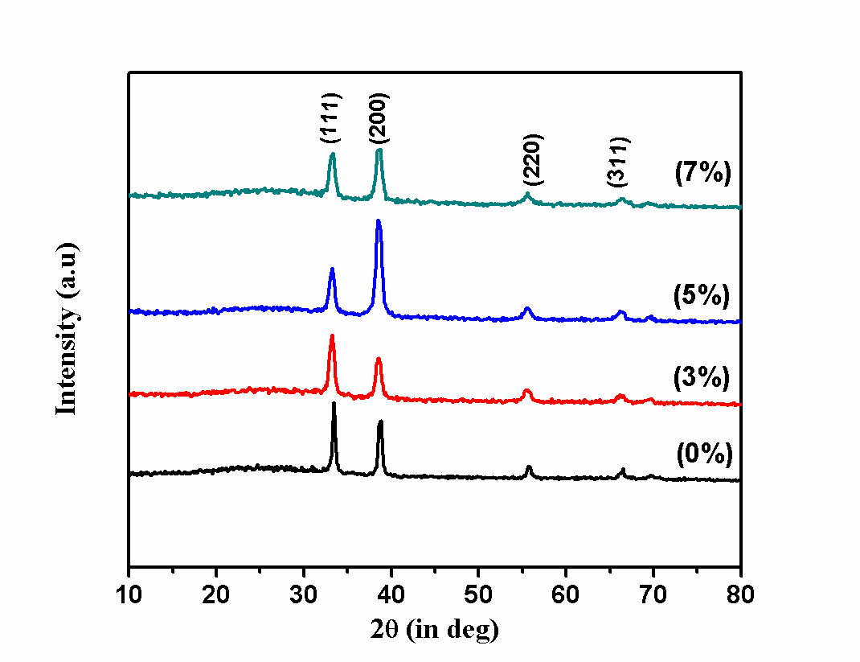
Figure. 1 XRD patterns of cubic undoped and Ce doped CdO thin films
Figure 1 shows the typical XRD patterns obtained for undoped and Ce- doped CdO thin films prepared in this study. The X- ray diffraction peaks corresponding to crystallographic planes (111), (200), (220) and (311) repectively are observed. The CdO thin films are found to be of polycrystalline nature. The most intense peak for undoped CdO thin films is along (111) plane and the diffraction peaks match with the JCPDF card No. 05-0640 belonging to the cubic crystal system of CdO. However with Ce incorporation the neibouring peak to (111) plane ie (200) peak intensity varied at the cost of (111). This may be due to micro-strain changes due to doping and can be related to the crystallization process in the formation of polycrystalline thin films. The microstrain is due to doping is due to difference in ionic radii of impurities Ce³⁺ or Ce⁴⁺ ion is different from that of the host Cd²⁺ ions. For the lesser Ce-doping (3 wt. %) in the precursor solution, the preferred orientation shifted from (200) to (111) plane. At higher doping concentrations the preferential orientation is reverted back to (200) plane. This is because of the substitution of Cd²⁺ by Ce³⁺ or Ce⁴⁺ ions within the CdO lattice and thereby randomly changing the nucleation and growth process of the deposited CdO thin films[15]. The crystallite size or crystalline length (D), texture coefficient (TC), dislocation density (δ), and microstrain (ε) were estimated from the diffraction data using usual procedures.
The size of the crystallites in CdO thin film is calculated using Debye Scherer’s formula from the XRD data; $D=\frac{0.9 λ}{β cosθ}$ (1)
where D is the grain size, β is FWHM of the observed peak, λ is the wavelength of the x-ray, θ is angle of diffraction [22] . It is observed that the crystallite size varied from 23 to 9 nm with progressive decrease with the increase in Ce- doping concentration. The dislocation density (δ) defined as the length of dislocation lines per unit volume, is estimated using the equation;
$δ=1/D^2$ (2)
where δ measures the amount of faults in a crystal.
The higher value of the dislocation density indicates the increased amount of defects in the films for 3 and 5% dopant concentration. Strain is calculated using the standard relation,
ε = β cos θ/4 (3)

The texture coefficient is calculated using the formula [23] (4)
where I₀ is the standard intensity, I is the measured intensity of (h k l) plane and N is the reflection number. The deviation of TC of a selected plane from unity implies the preferred orientation along that plane. The calculated TC values given in Table 1, suggest a value greater than unity for all the films indicating the thinfilms are textured well. The studies clearly indicate that the increase of TC value for (200) plane, from 1.587 to 2.079 with respect to Ce concentration and denote the increase of texturing of the surface prepared. The calculated stacking fault “α” values of CdO films suggest higher stacking fault for the (200) plane indicating an increase in disorder within the lattice sites for doped films. The Local strain (microstrain) correspond to minor atomic displacements with respect to their positions in crystals which can be free of any defects.
To perceive the contribution due to microstrain to the crystallite size Williamson–Hall method was employed. This is performed by drawing the Williamson Hall plot. This technique takes into consideration both the crystallite size of the crystals and the crystallographic distortions produced as a result of Lorentzian intensity distributions. As established in figure 2, (β cosθ) versus (4sin θ) plot a straight line with a y-intercept corresponding to the inverse of the regular crystallite size (D_{W–H}) and the slope relating to the average value of the microstrains. These values arrived were analysed and presented. The y-intercept allows finding out a mean value of the crystallite size. They were correlated with the other crystallite parameters in Table 1. The studies revealed that doping introduces more strains in the system. The surface reconstructs by sacrifycing the different metallic sites or vacant sites at the cost of crystallite size without changing the volume of the system. For 7% system the W-H estimate is little larger than usual Debye estimations. This may be associated with higher thickness of the thinfilm. Size-strain plot (SSP) Williamson-Hall method actually considers the broadening of peaks as a function of diffraction angle (2θ), which is assumed to be combined effect of size induced broadening and strain induced broadening.while Debye Sherrer approximates the shape and size of grains only.Hence there is a difference in the estimations by these two methods.
Generally doping won’t cause any shift and only minor variation in shape and intensity would be observed. Thin films deposition conditions and ambient are presented. The reason for variability is stated as the properties depending on factors of deposition. The dopant ion concentration is increased to enable more ions to occupy metallic sites. The spray pyrolysis conditions favour the uniform spreading of ions and subsequent reactions.

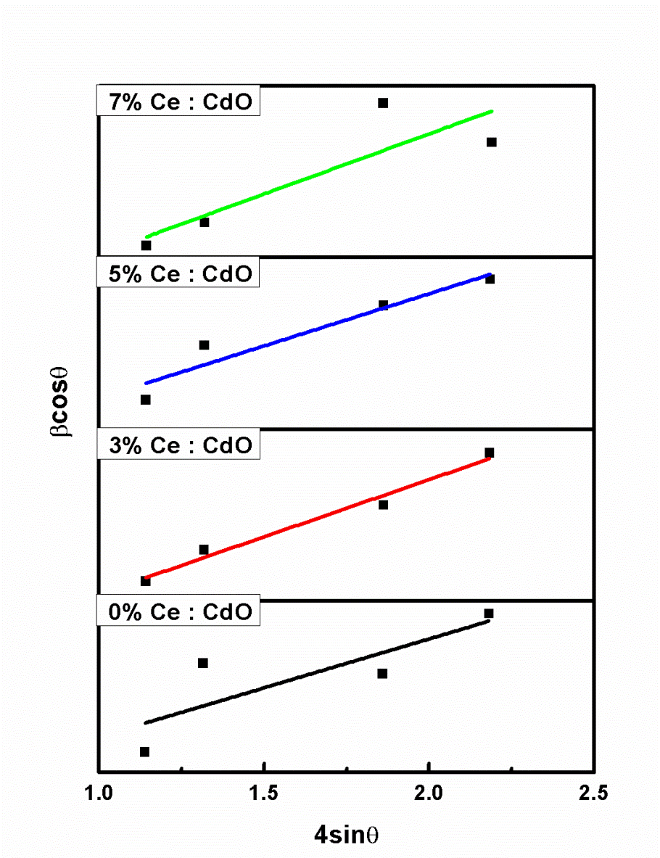
Figure 2 W-H plot of Ce doped CdO film

Table 1 Structural parameters of Ce: CdO thin films
Percentage of doping (%) | 2θ (200)  Degree | FWHM  (Radian) | D  (nm) | D _{W-H}  (nm) | Microstrain using formula  (x10⁻³) | Lattice strain  using W-H plot  (x10⁻³) | Dislocation density  (x10¹⁵)m⁻² | Texture coefficient | Stacking fault probability (α) | Thickness  (nm)
0 | 38.39 | 0.360 | 23 | 29 | 1.483 | 5.08 | 1.832 | 1.587 | 0.0032 | 360
3 | 38.47 | 0.733 | 11 | 13 | 3.019 | 5.77 | 7.579 | 1.327 | 0.0605 | 376
5 | 38.51 | 0.772 | 10 | 12 | 3.180 | 2.14 | 8.405 | 2.079 | 0.0731 | 468
7 | 38.53 | 0.851 | 9 | 23 | 3.505 | 3.00 | 0.102 | 1.543 | 0.0794 | 480

3.2 Morphological Studies
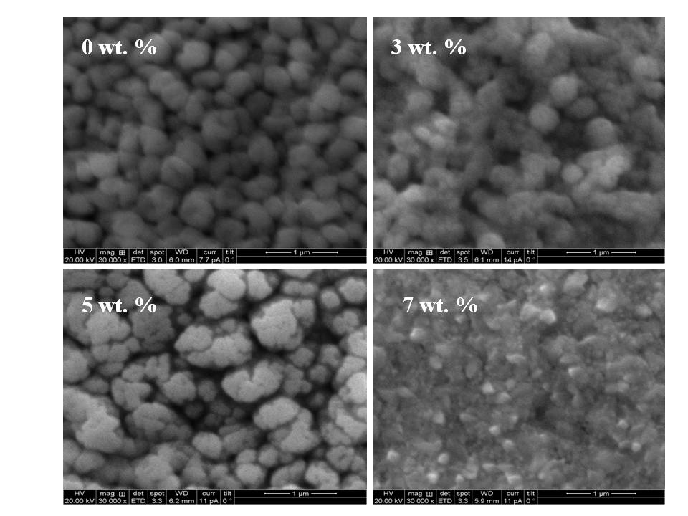
Figure 3(i)
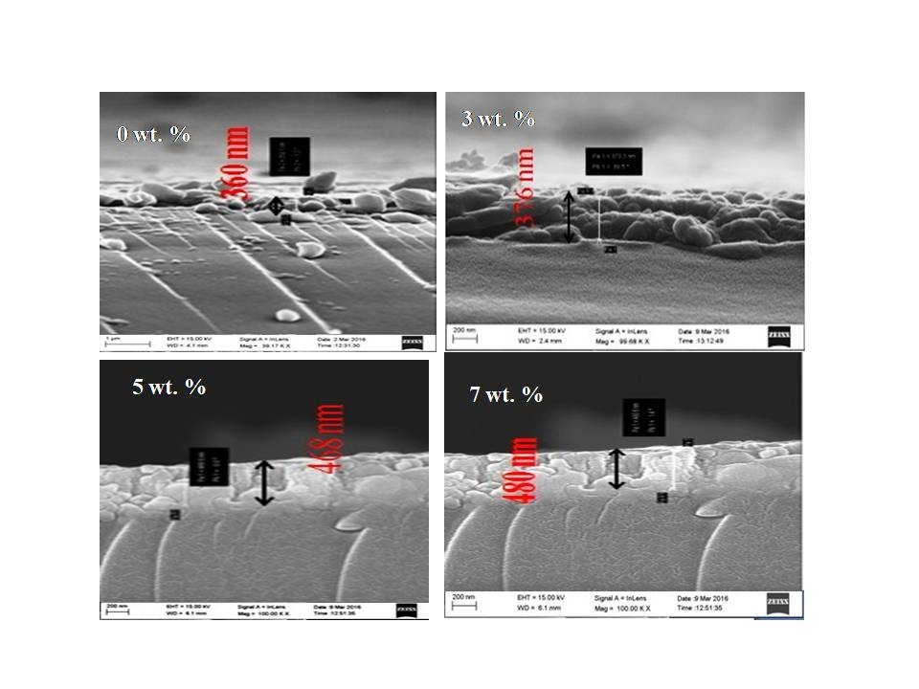
Fig 3 (ii)

Figure 3(i) FE-SEM Micrographs of pure and Ce doped CdO thin films (a) 0%, (b) 3% (c) 5% (d) 7% respectively Figure 3 (ii) The cross sectional image of pure and Ce doped CdO thin films (a) 0%, (b) 3% (c) 5% (d) 7% respectively
The surface morphology of undoped CdO thin film consists of uniformly distributed spherical shaped grains. The films deposited from 3, 5 and 7 wt. %, of cerium doped CdO surface microstructures are shown in figure 3(i) and 3(ii) Smoothening of surface with more agglomerations are seen in 3 wt. % Ce doped film and bigger sized grains appear on 5 wt. % Ce doped film. The surface image of the film doped with 7 wt. % of Ce has smaller sized grains and the surface microstructures show small voids amongst the stacking. The thickness of the film was measured using cross sectional SEM images and it varies from 360 to 480 nm as shown in Table .1.
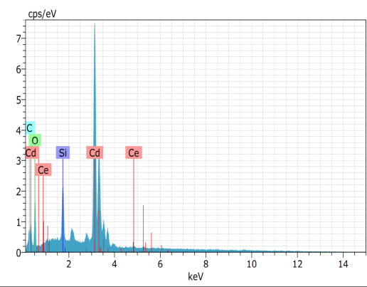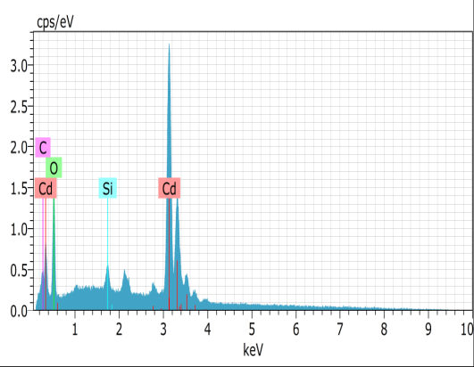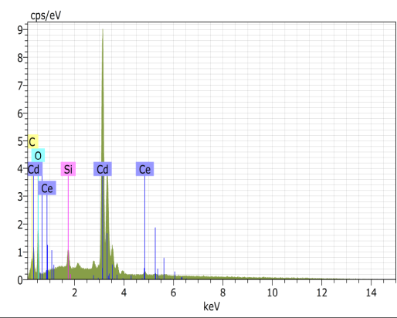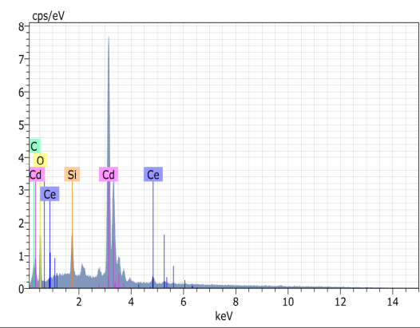
0%
3%
5%
7%
Figure 4 EDAX spectra of Ce doped CdO films
The EDAX spectra obtained for typical Ce- doped CdO films of different dopant concentration are shown in figure 4. This reveals the presence of Cd (L_{α} spectral lines),O (k_{α} spectral lines) and Ce (L_{α} spectral traces). Si from glass substrate is also present. No other impurity is observed. The ratio of intensities of Cd, O and Ce gave the relative weight and atomic ratios of Cd, O and Ce respectively. The measured ratios are given in Table 2, which clearly indicates the presence of Ce in the spray deposited doped CdO thin films. Atomic percentage is based on the number of atoms in a sample. The studies reveal that actual amount of dopant atoms present on the surface is less than that expected. However, the suitability of spray method to vary the amount of Ce atoms in the films by altering the chemical constituent of the spraying precursor solution.

Table 2 Elemental composition of Ce doped CdO films
Ce doping concentration | Percentage of Element  Wt% |  |  | Percentage of Element  at%
 | Cd | O | Ce | Cd | O | Ce
0% | 87.68 | 12.32 | 0.00 | 50.32 | 49.68 | 0.00
3% | 84.24 | 13.79 | 1.98 | 46.11 | 53.02 | 0.87
5% | 83.78 | 13.17 | 3.05 | 46.87 | 51.76 | 1.37
7% | 81.93 | 12.64 | 5.43 | 46.79 | 50.72 | 2.49

3.3 Optical properties

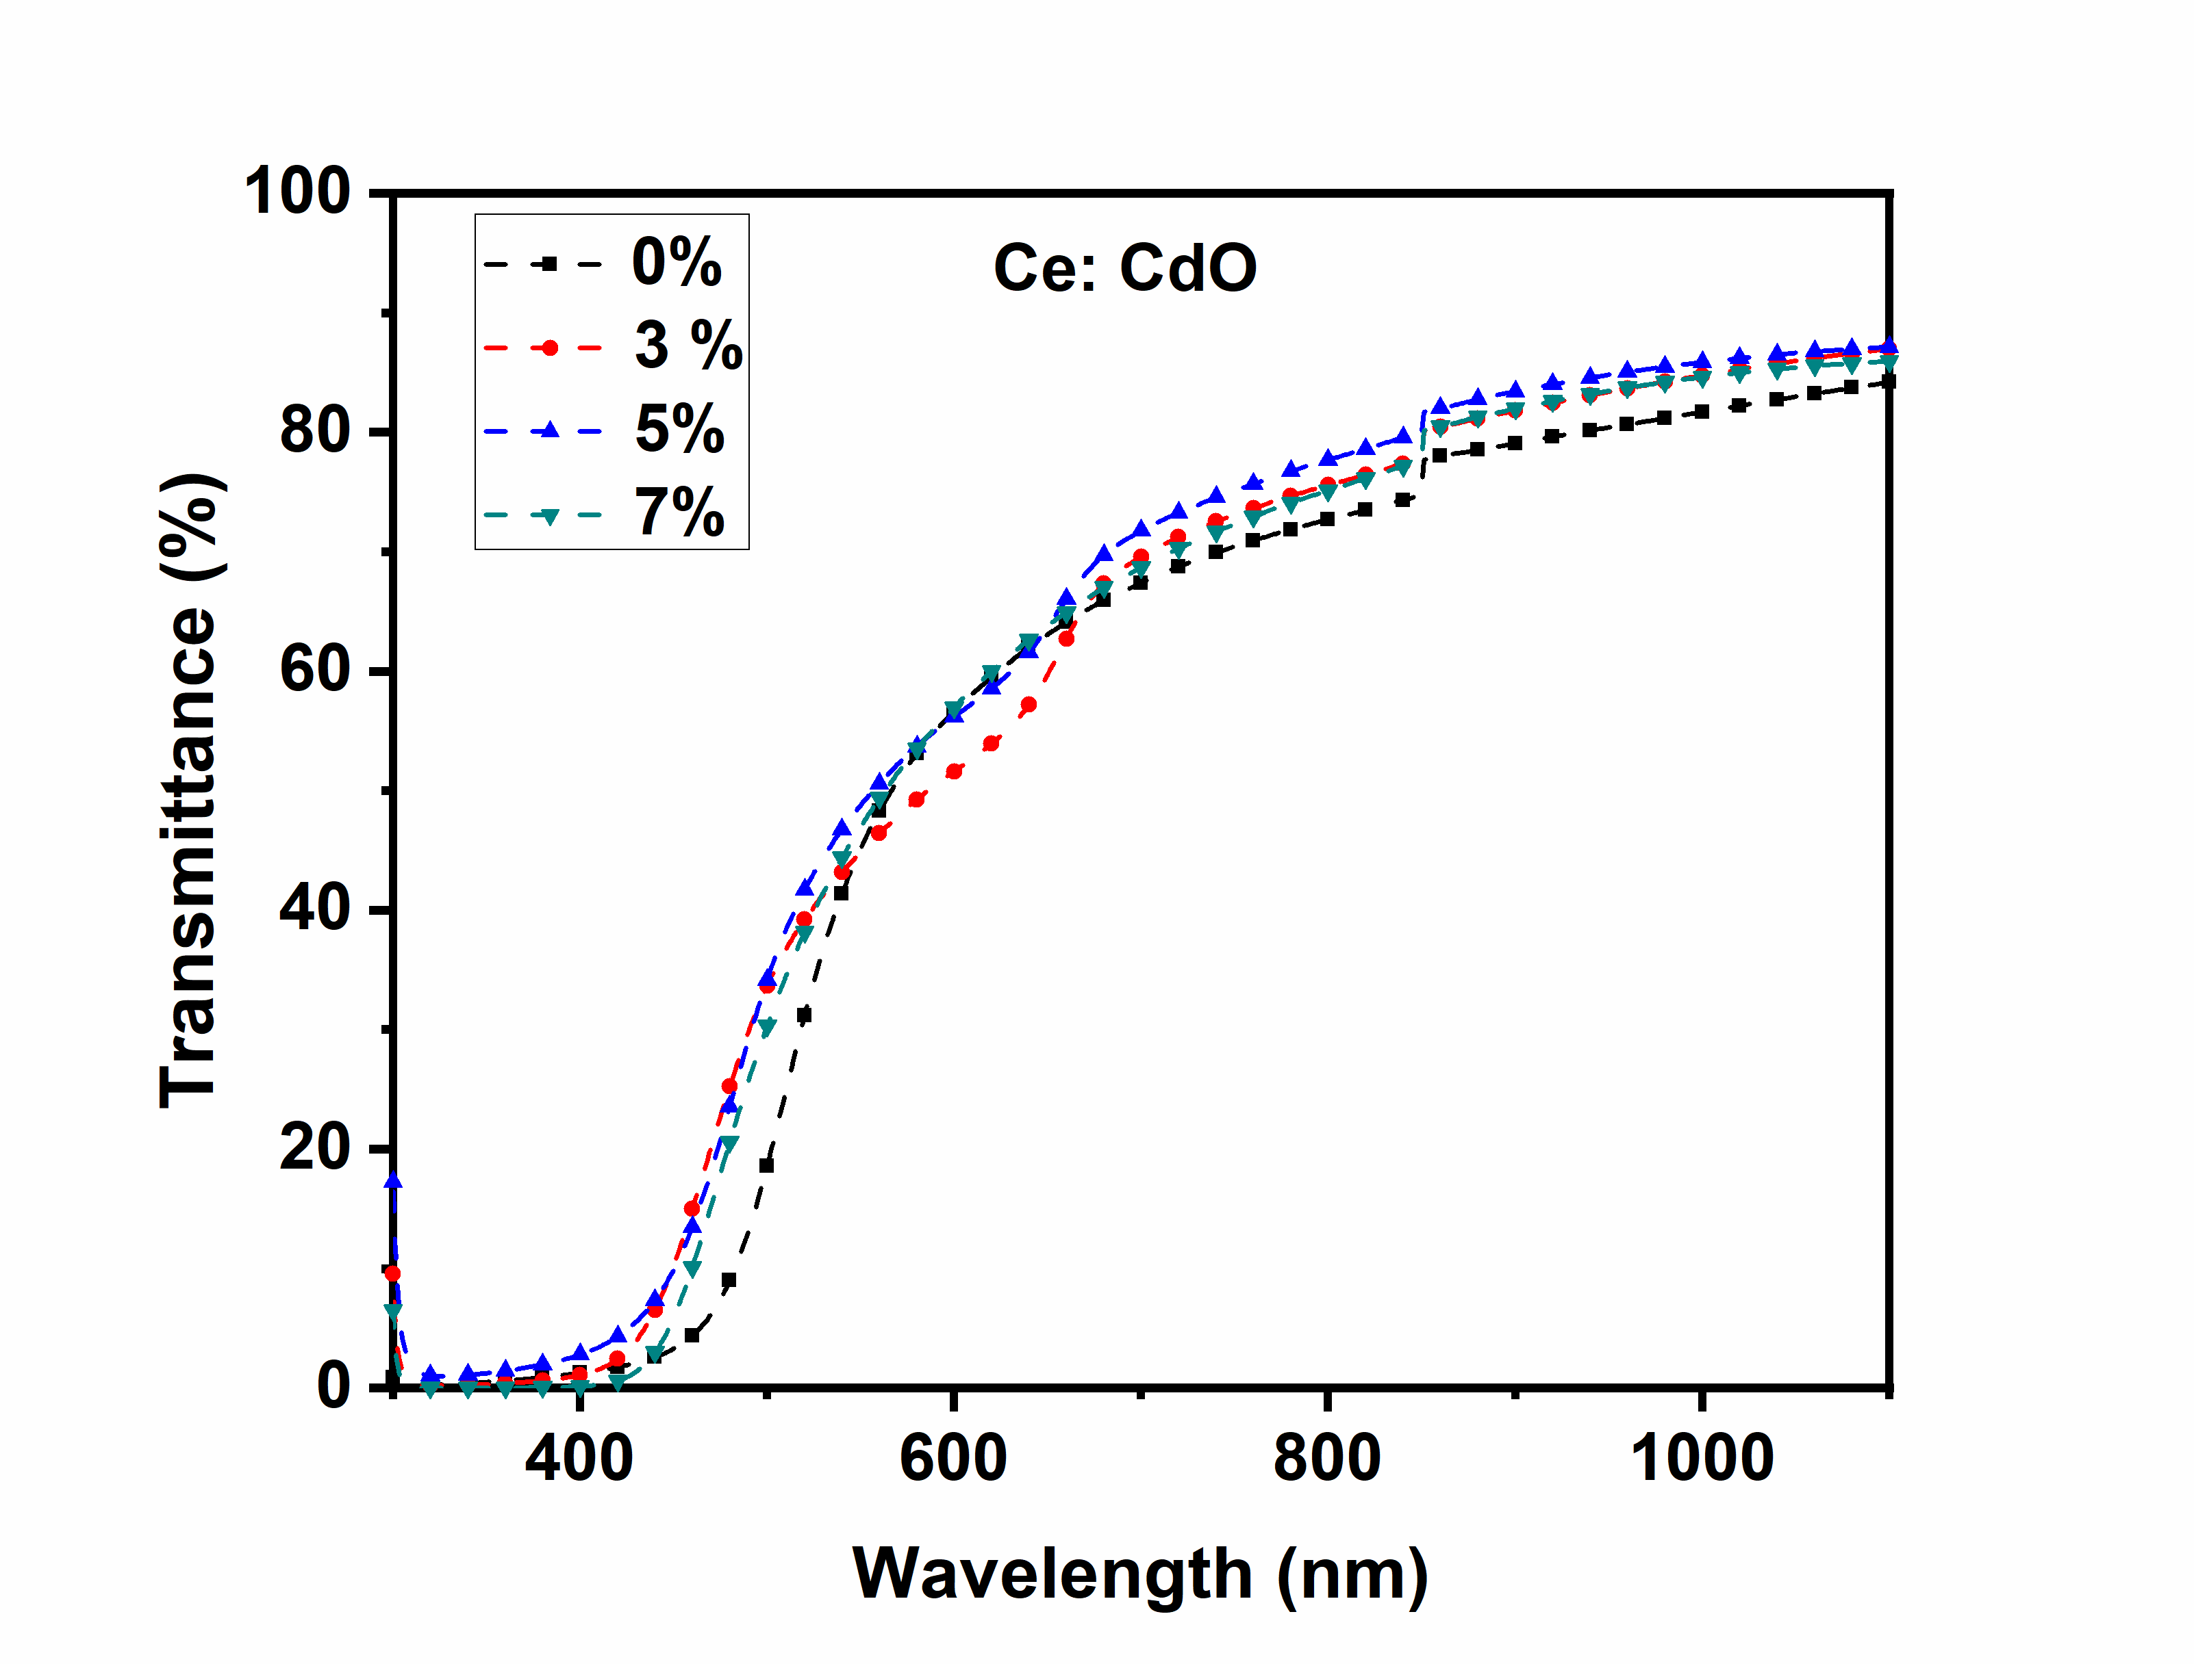
Figure 5 Optical transmittance of undoped and Ce doped CdO thin films

The optical transmittance spectra of undoped and Ce- doped CdO thin films deposited on glass substrates are shown in figure 5. The deposited Ce- doped CdO films exhibit high transmittance of about 80 % in the non absorption region and optical transmittance of the films at longer wavlenth region increases with increase in Ce concentration. A blue shift of absorption edge due to the Ce doping is observed. The blue shift of absorption region is known as band gap widening which can be explained by the Moss–Burstein effect [13]. The lifting of the Fermi level up to the conduction band might have caused the band gap broadening in degenerated semiconductors. This may cause a blue shift in absorption edge. The absorption coefficient (α) as a function of wavelength (λ) is evaluated using the following
$α\left(λ\right)=\frac{1}{t}\ln\left(\frac{1}{T}\right)$ (5)
where T is the transmittance and t is the thickness of the films. The relation between the α and the incident photon energy (hν) is given by the following equation

$\left(αhν\right)= {A(hν-E_{g})}^{m}$ (6)

where ‘A’ is energy independent constant, E_{g} is optical band gap and ‘m’ is an index, which depends on the type of optical transition.The value m is 1/2, 3/2, 2 and 3 when the transition is direct-allowed, direct-forbidden, indirect-allowed, and indirect-forbidden, respectively. From the theoretical and experimental results, CdO is known to be a direct-allowed semiconducting material and m is chosen as 2. The direct optical band gap has been estimated from (αhν)² verses hν plot (Tauc’s Plot) through extrapolating the linear portion to hν axis. The Tauc’s plot drawn is shown in figure 6. The energy band gap values for 3 to 5 wt. % doped CdO films are 2.47 and 2.50 eV, respectively. The observed increase in band gap because of Ce doping in CdO films reveal the blue shift.
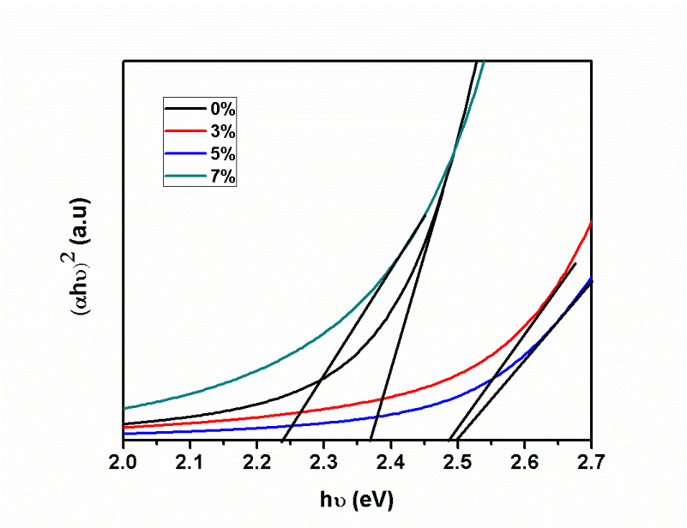
Figure 6 Energy bandgap of undoped and Ce doped CdO thin films
3.4 Photoluminescence studies

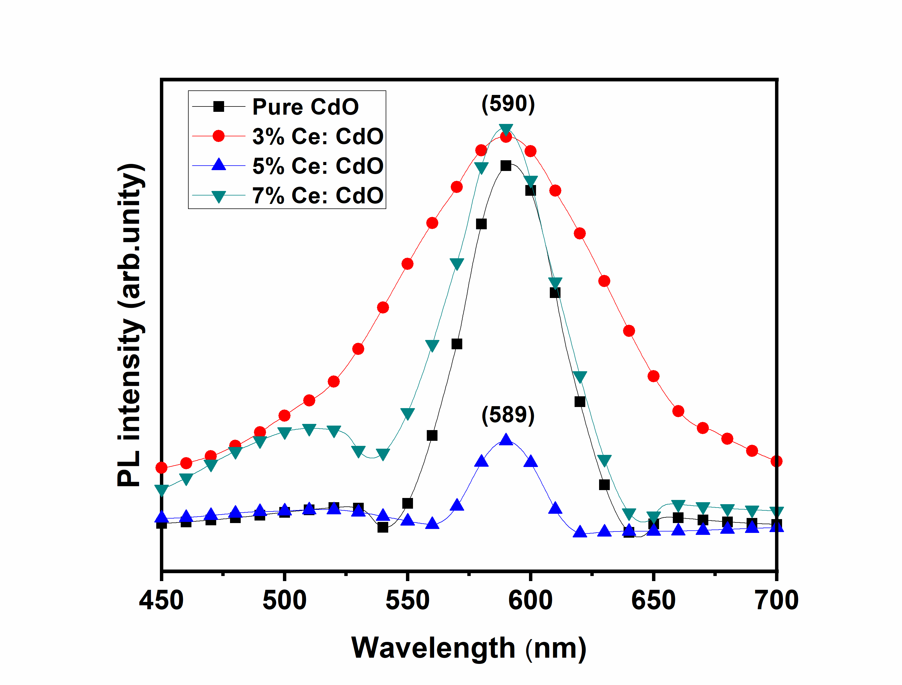
Figure 7 PL spectra of Ce doped CdO films
Figure 7 shows the PL spectra of Ce doped CdO thin films. A light wavelength 320 nm was used for exciting uniformly. The PL spectra of the undoped and Ce- doped CdO thin films exhibit various emission features. As the doping concentration changes the intensity and the position of PL emission peak varies as shown in figure 7. The near edge emission associated with CdO host is absent or not dominant in the system with this excitation. The high intense PL peak obtained at 590 nm (orange emission) for CdO film may be due to deep-level or trap-state emission, corresponding to the ionized oxygen vacancies in the CdO thin films. For higher doping concentration, the intensity of the peak is increased. The broad band emission observed (550 – 650 nm) in the photoluminescence spectra of CdO thin film indicates the defect-related luminescence peak. The radiative transitions between oxygen vacancies or Cd interstitials acting as shallow donors and Cd vacancies acting as deep acceptors becomes the dominant mechanism surpassing the host emissions. The absence of blueshift in PL is due to the emission process dominated by the excitable traps. The presence of such excitable traps or defects is an attractive feature of this low cost prepared thinfilms.

3.5 Electrical properties
Electric measurements have shown that the deposited films are highly conducting. Many parameters relate to the electrical properties such as carrier concentration (n), carrier mobility (μ), resistivity (ρ) of pristine CdO and Ce doped CdO films are estimated using Hall measurements shown in graphical representation in figures 8 and 9 respectively. The negative sign of Hall coefficient confirms the n- type conductivity of the films respectively. Ce³⁺ acts as neutral impurity to increase the neutral impurity scattering which limits the carrier concentration and also mobility resulting in a change in the surface morphology. A high carrier concentration of 1.54 ×10²¹ cm⁻³ is obtained for 5 % Ce- doped CdO thin films.

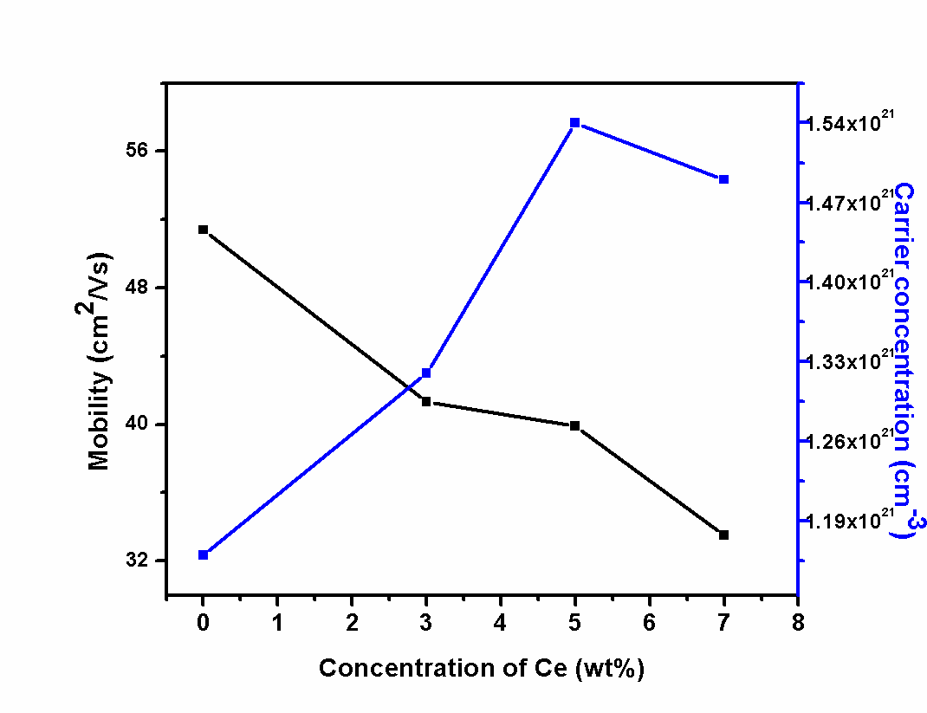
Figure 8 Mobility and carrier concentration of Ce doped CdO

A low resistivity (1.02 × 10⁻⁴ Ωcm) and high conductivity (9.84 ×10³ cm⁻¹) are observed for 5 wt. % Ce- doped CdO thin films (Figure 9). The increasing carrier concentration can be ascribed to the substitution of Ce³⁺ for Cd²⁺ in the CdO lattice, which results in additional electrons.

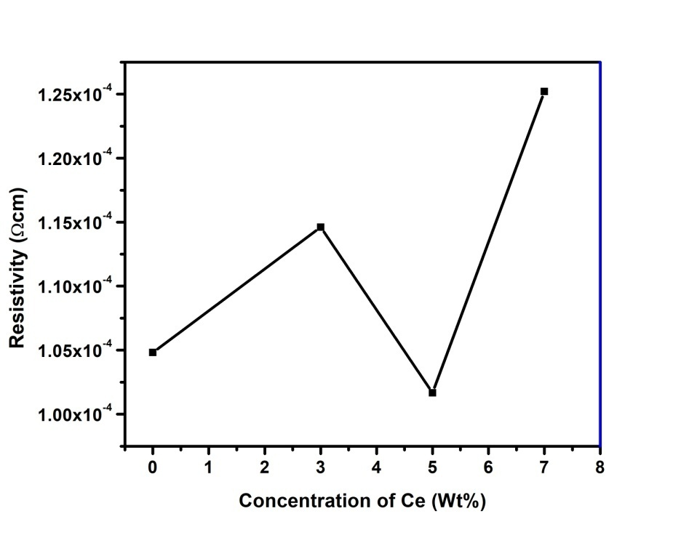
Figure 9 Resistivity of undoped and Ce doped CdO thin films

3.6 I-V characteristics under light illumination

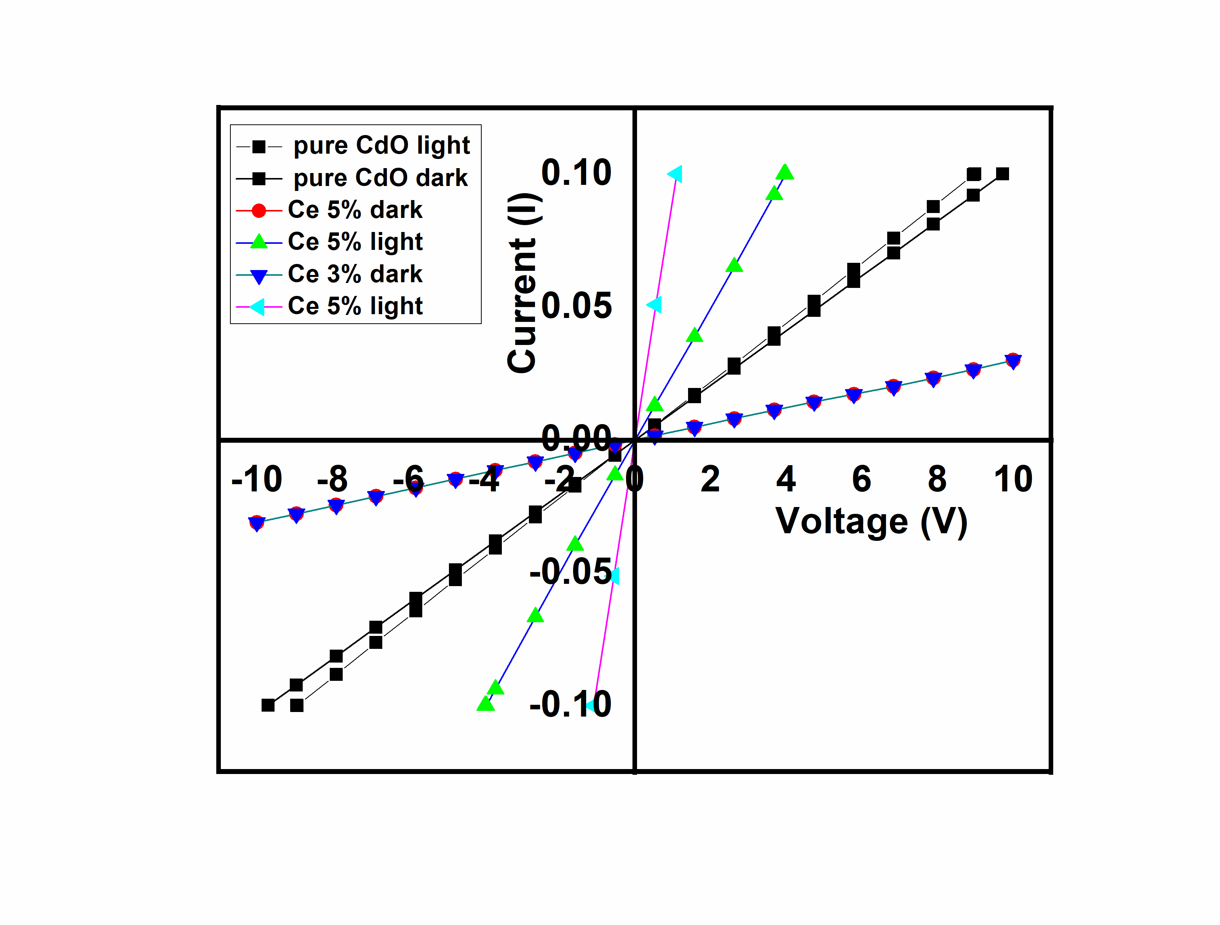
Figure 10 I-V characteristics under dark and light illumination of undoped and
Ce doped CdO thin films
Figure 10 shows the typical I-V characteristics under dark and light illumination of undoped and Ce doped CdO thin films. The halogen lamp was used for recording the I-V values during illumination. It is observed that the films show ohmic behaviour exhibiting the good conductive nature of the material. It is also seen that conductivity for the film at Ce 5% of doping level has increased to ~70% on illumination due to the additional photo generated charge carriers available in the film.
4. CONCLUSIONS
The effect of Ce-doping at various concentrations on some properties like the structural, morphological, optical and electrical properties of CdO thin films prepared using spray pyrolysis technique has been investigated. Structural studies reveal the polycrystalline nature with cubic structure. The crystallite size varies from 11 to 9 nm for various doping levels of Ce. SEM reveals that the films are uniform with spherical shaped grains. The presence of Ce atoms in doped films have been confirmed by EDAX studies. Ce- doped CdO films exhibit high transmittance of about 80 % in the longer wavelength region. Low resistivity (1.02 × 10⁻⁴ Ω cm) and high conductivity (9.84 ×10³ (Ω cm)⁻¹ are observed for 5 wt. % Ce- doped CdO thin films. 5% of Ce doping level shows an increased conductivity up to ~70% on illumination due to the additional photo generated charge carriers yield in the film. The studies revealed the suitability of spray pyrolysis method for producing Ce doped CdO thin films with superior TCO and photo generation properties.
5. REFERENCES

1. Agnes C Nkele, Assumpta C Nwanya, Nwankwo U Nwankwo, A B C Ekwealor, Rose U Osuji, R Bucher, Malik Maaza and Fabian I Ezema, 2019 Structural, optical and electrochemical properties of SILAR-deposited zirconium-doped cadmium oxide thin films, Materials Research Express, Volume 6, Number 9
2. Gan Siew Mei, P Susthitha Menon and Gurumurthy Hegde, 2020 ZnO for performance enhancement of surface plasmon resonance biosensor : a review, Mater. Res. Express 7 012003.
5
3. S. Vasheghani Fahrahani, T. D. Veal, P. D. C. King, J. Zúñiga-Pérez, V. Muñoz-Sanjoé, and C. F. McConville,2011 “Electron mobility in CdO films,” J. Appl. Phys. 109, 073712.
4. Rituparna Chatterjee, Gopes Chandra Das and Kalyan Kumar Chattopadhyay 2020 Luminescence properties of nano and bulk ZnWO4 : Eu3+ phosphors for solid state lighting applications, Mater. Res. Express 7 074002.
5. Vanasundaram N, Muneer Ahmad, A K Chaudhary and Praveen Kumar Sharma, 2020 Surface charge doping induced carrier type reversal in spin coated CdS/rGO layered nanohybrid films, Mater. Res. Express 7 025015.
6. Evan L. Runnerstrom, Kyle P. Kelley, Edward Sachet, Christopher T. Shelton, and
Jon-Paul Maria 2017 Epsilon-near-Zero Modes and Surface Plasmon Resonance in
Fluorine-Doped Cadmium Oxide Thin Films. ACS Photonics, 4, 1885-1892
7. Kyle P. Kelley, Edward Sachet, Christopher T. Shelton, and Jon-Paul Maria, 2017 High mobility yttrium doped cadmium oxide thin films, APL Materials 5, 076105.
8. Zeke Liu, Yaxu Zhong, Ibrahim Shafei, Soojin Jeong, Liguang Wang, Hoai T. Nguyen, Cheng-Jun Sun, Tao Li, Jun Chen, Lei Chen, Yaroslav Losovyj, Xinfeng Gao, Wanli Ma, Xingchen Ye. 2020Broadband Tunable Mid-infrared Plasmon Resonances in Cadmium Oxide Nanocrystals Induced by Size-Dependent Nonstoichiometry. Nano Letters , 20 (4) , 2821-2828..
9. Hui Chen, Lei Sun, Guo-Dong Li, Xiaoxin Zou. Well-Tuned Surface Oxygen Chemistry of Cation Off-Stoichiometric Spinel Oxides for Highly Selective and Sensitive Formaldehyde Detection. Chemistry of Materials 2018, 30 (6) , 2018-2027
10. Chao Ping Liu, Chun Yuen Ho, Roberto dos Reis, Yishu Foo, Peng Fei Guo, Juan Antonio Zapien, Wladek Walukiewicz, and Kin Man Yu . Room-Temperature-Synthesized High-Mobility Transparent Amorphous CdO–Ga2O3 Alloys with Widely Tunable Electronic Bands. ACS Applied Materials & Interfaces 2018, 10 (8) , 7239-7247.
11. M Ravikumar, R Chandramohan, K Deva Arun Kumar, S Valanarasu, A Kathalingam, V Ganesh, Mohd Shkir, S AlFaify, H Algarni, Effect of Pr3+ doping on key properties of CdO thin films deposited by spray pyrolysis using perfume atomizer, Journal of Physics and Chemistry of Solids, 118, 211-220(2018).
12. M Ravikumar, V Ganesh, Mohd Shkir, R Chandramohan, K Deva Arun Kumar, S Valanarasu, A Kathalingam, S Alfaify, Fabrication of Eu doped CdO [Al/Eu-nCdO/p-Si/Al] photodiodes by perfume atomizer based spray technique for opto-electronic applications, journal of Molecular Structure, 1160 , 311-18 (2018)
13. M Ravikumar, R Chandramohan, K Deva Arun Kumar, S Valanarasu, A Kathalingam, V Ganesh, Mohd Shkir, S AlFaify, Effect of Gd³⁺ doping on key structural, morphological, optical, and electrical properties of CdO thin films fabricated by spray pyrolysis using perfume atomizer, Journal of Sol-Gel Science and Technology, 85, 31-40(2018).
14. Dakhel, A.A. Impact of Silicon Doping on the Properties of Transparent Conducting CdO Thin Films. Silicon 11, 525–532 (2019).
15. Dakhel, A.A., Hamad, H. Electronic and Bandgap Tuning of Hydrogenated Ti-doped CdO Semiconductor. Journal of Elec Materi 48, 4293–4299 (2019).
16. M Ravikumar, R Chandramohan, K Deva Arun Kumar, S Valanarasu, V Ganesh, Mohd Shkir, S Alfaify, A Kathalingamm, Effect of Nd doping on structural and opto-electronic properties of CdO thin films fabricated by a perfume atomizer spray method, Bulletin of Materials Science, 42, 1, (2019)
17. S. J. Helen, Suganthi Devadason and T. Mahalingam, Improved physical properties of spray pyrolysed Al:CdO nanocrystalline thin films. J Mater Sci: Mater Electron 27 (5), 4426 (2016)
18. R David Prabu, S Valanarasu, V Ganesh, Mohd Shkir, S AlFaify, A Kathalingam, SR Srikumar, R Chandramohan An effect of temperature on structural, optical, photoluminescence and electrical properties of copper oxide thin films deposited by nebulizer spray pyrolysis technique, , Materials Science in Semiconductor Processing,74, 129-135, (2018).
19 . K. Ravichandran, G Muruganantham, K Saravanakumar, S Karnan, B Kannan, R Chandramohan, B Sakthivel, Doubly doped tin oxide films from cost effective spray technique using perfume atomiser, 25, Surface Engineering, Pages, 82-87(2009).
20. P. Velusamy, R. Ramesh Babu,K. Ramamurthi, M. S. Dahlemc and E. Elangovan, Highly transparent conducting cerium incorporated CdO thin films deposited by a spray pyrolytic technique, RSC Advances 5, 102741 (2015).
21. SJ Helen, Suganthi Devadason, M Haris, T Mahalingam, Journal of Electronic Materials, Transparent conducting Mo-doped CdO thin films by spray pyrolysis method for solar cell applications, 47, 2439-2446, (2018)
22. Mario Burbano, David O. Scanlon, and Graeme W. Watson, 2011 Sources of Conductivity and Doping Limits in CdO from Hybrid Density Functional Theory, Journal of the American Chemical Society 133 (38), 15065-15072.

23. S Rex Rosario, I Kulandaisamy, A M S Arulanantham, K Deva Arun kumar, S Valanarasu, Mohamed S Hamdy, K S Al-Namshah and Abdullah M Alhanash 2019 Analysis of Cu doping concentration on PbS thin films for the fabrication of solar cell using feasible nebulizer spray pyrolysis 6 5 111574.

