Mrs.Rajeswari.V, M.Sc (Nursing), Associate Professor, R.V.S College of Nursing, Kannampalayam, Coimbatore-641 402.
INTRODUCTION:

Various people have different perspectives on nursing. Nursing now refers to services that address the health needs of the entire community and has taken on a variety of forms. Nursing is a service that provides entire care for the ill in a hospital or at home, as well as works to promote health and prevent disease. In order to foster an environment that promotes patients' speedy recovery from illness, the nurse performs a crucial role.

NATURE OF NURSING:

Nursing is the process of addressing the societal health needs and advancing everyone's well-being. Nursing is a Noble profession since it helps those who are ill or injured and raises their standard of living.

N=NOBLE PROFESSION

U = UNIQUE

R= RESPONSE

S=SIMPLICITY

E = EFFICIENT

MODERN CARE:
The importance of public health in midwifery care is more obvious in community-based care, it has always been there. A qualified midwife acknowledges childbirth and offers emotional support to the mother and other family members. The short- and long-term health of women and their offspring is provided via midwifery care. She focuses on how pregnant women and their families should benefit from government policies.

MIDWIFERY & NURSING PRACTICE:
The independent administration of women's health care is the responsibility of trained nurse-midwives and certified midwives, with a focus on prenatal mothers; labour, the postpartum period, care of the newborn, and family planning and gynecologic requirements of women.

SUBJECT MATTER OF NURSE-MIDWIFERY PRACTICE:
• Women's primary care, health promotion, and family planning
• Assessment of the newborn and care of the well, term newborn during the first 28 days of life
• Health promotion, disease prevention, and individualized wellness education and counseling
• Increasing the rate of breastfeeding
• Supporting pregnant mothers' mental health
• Creating social networks
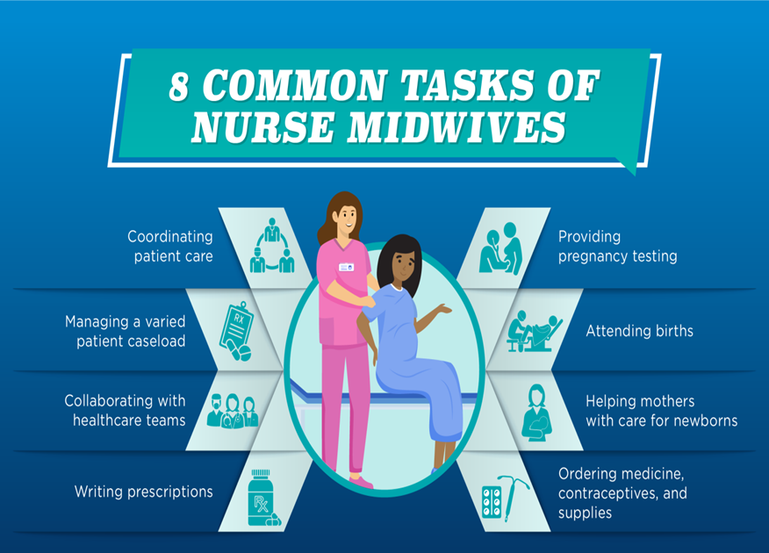

HOW MIDWIFERIES HELP PREGNANT MOTHERS
- Monitoring pregnancy and the developing fetus counseling
- The mother on good food and exercise.
- Enabling questions to be asked in a comfortable manner
- Taking care of women in labour Supporting women in 1:1 care in labour
MIDWIFERY NURSING'S OBJECTIVES INCLUDE:
- Stressing the naturalness of pregnancy as a typical stage of mature human development.
- Promote the best interests of the mother and child by educating and preparing all pregnant women.
- To be informed caregivers for the duration of the entire childbearing process, from conception to delivery.
- Create a nurturing environment that makes childbirth enjoyable and promotes the growth of wholesome relationships within the family as a whole as well as between the mother and her newborn.
MODELS AND APPROACHES FOR HEALTH PROMOTION IN MIDWIFERY CARE:

Medical Centered Approach:
- This strategy entails proactive medical involvement to prevent illness.
- The effectiveness of the medical approach is frequently measured by physical health, with little consideration given to the psychological, social, or financial components of the causes and consequences of disease.
- The routine urine analysis and blood pressure checks for clients with eclampsia are two examples of how this strategy is still employed in midwifery.
Approach to behavior change:
- The midwife encourages the expectant mothers to adopt a healthy lifestyle, such as eating the proper foods, drinking moderate amounts of alcohol, and quitting smoking.
- This is a key component of modern antenatal health promotion practices.
- The stages of pregnancy, childbirth, and parenthood offer a period that calls for significant psychological growth, during which expectant mothers learn a lot of new information.
Approach to education:
- An educator will explain to expectant moms the significance of food, medications, exercise, the dangers of smoking and drunkenness, etc.
- The utilization of this information during the prenatal, intrapartum, and postpartum periods is trusted.
- It is the duty of the educator to bring up issues. This is a two-way conversation; the midwife will explain a health condition and the expectant mother may ask any questions she may have.
- Using this strategy will facilitate decision-making.
Client-centered strategy:
- The expectant mother established the issues and the plan of action for their resolution.
- As opposed to a "top down" strategy, this is thought to be "bottom-up."
- The expectant mother is treated equally, and the information and abilities she contributes to the conversation are respected. Self-empowerment is a crucial subject.

MIDWIFERY NURSING TRENDS

Trends in economic issues:
- As costs have risen and as more women work outside the home, the expense of having and raising children continues to rise faster than family income.
- More women of reproductive age than ever before work outside the house. Because living expenses are high.
- Parents with low levels of education are more likely to struggle to keep up with the demands.
Technology-related trends:
- The development of technology had brought about change in all facets of our life.
- It has an impact on each of us personally, our families, our society, and even our approach to childbearing.
- Technology enables the diagnosis and treatment of severe diseases and abnormalities.
- Particular areas where technological advancements affect families with children include:
1) Fertility issues
2) Genetic advice
3) Diagnostic procedures performed before or during labour.

Trends and demographic issues:
- Population distribution shifts the most economic possibilities and conveniences are found in large cities.
- The number of hospitals that are staffed and prepared to treat pregnant women at high risk and the accessibility of maternity care in urban areas. These amenities are sometimes lacking in rural locations.
- Birth rate, maternal mortality, and morbidity rates are among the most important statistics.
- Focusing on expanding access to preventive care rather than on high-tech medical interventions will result in changes in mortality rates.
Trends in healthcare settings include:
- Health care delivery that prioritizes lowering the cost of healthcare by closely observing the financial situation of staff.
- In response to customer desire for a more natural delivery environment, hospitals have made changes.
- Community-based care is being emphasized more in nursing school curricula.
- After a straightforward delivery, the standard hospital stay for women and newborns is now two days or fewer.
Patient participation trends:
Pregnant patients are often in good health, thus their care is concentrated on promoting health and wellness. When visiting a health care professional, you have the chance to talk about things like
1. Nutrition Education
2. Stress reduction
3. Quitting smoking
4. Treatment for alcohol and drug abuse.
Current issues include:
1. Minimum hospital stay.
2. Lessening of amenities in remote areas
3. A lack of desire to offer breast milk
4. Prenatal, postnatal, and intranatal care
5. Legal issues related to care delivery
6. Moral concerns
7. Upcoming trends.

MATERNAL CARE CULTURAL VARIATION
• Reactions on an emotional level
• Clothes
• Exercise and rest
• Sexual activity
• Diet
• Cultural factors of lactation
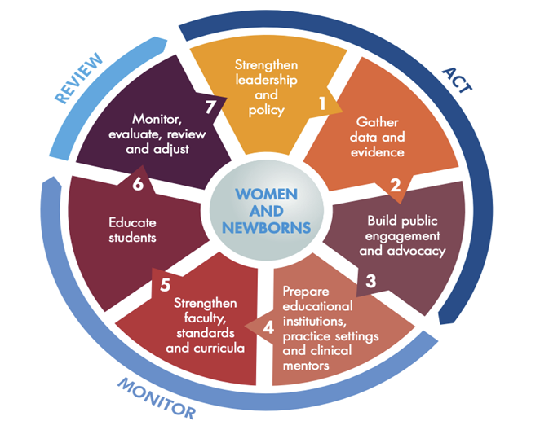
• Post-partum care.

CURRENT MATERNAL HEALTH POLICY:
- Community Focus
- Delivering services flexibility
- Continuity of Care
- Maternal Care
- Multidisciplinary collaboration.
Community focus:
- The National Service Framework for Children, Young People and Maternity Services (NSF) encourages a shift in the way maternity care services are organized and actively works to remove obstacles to maternity care.
- By offering free pregnancy tests at a family planning clinic at the same time as midwives in a children's center, for example, women may be able to access services earlier.
- Additionally, because midwives spend most of their time in the community, they may be better able to follow up with those who do not attend appointments.
Delivering services flexibility:
- Maternity care could be tailored to women and their families.
- Beyond merely organizational change, the NSF's concept of flexibility in service supply has implications for clinical treatment, particularly postnatal care.
- The maternity services take into account both their personal requirements and the needs of their infants.
- The inclusion of early childhood services, peer support programmes, and maternity support professionals in the overall care plan during the prolonged period.

Continuity of care:
- The "community- based continuity of care projects" that the midwifery service promotes is private inquiries into mother and child health (CEMACH).

- All pregnant women should receive support from a designated "midwife" during their pregnancy.

- At any time of the day or night, pregnant women can call a hospital's midwifery service on the labour ward.

Maternity care
- Maternity care has been provided with the goal of keeping women and their unborn children healthy.
- The results of medical and midwifery treatment for women and newborns have significantly improved.
- A growing awareness of the need to lower maternal mortality.
- The focus of midwifery care may need to change, especially during the prenatal and postnatal periods, as pregnant mothers must interact with concerns of poverty, housing, domestic abuse, and psychological well-being.
Multidisciplinary collaboration:
- Women's Aid to ensuring that support networks are in place for women who reveal domestic abuse.
- Working as a member of a specialty team, such as with women who have drug or alcohol issues.
- Managed care networks are community partnerships, public health networks, sure-start midwives, specialist midwives, and midwifery team leaders.
- They provide antenatal care with a distinction between the specialist services offered in the community and hospital setting.
- The woman's lead career refers directly, serves as a gateway, and maintains regular contact with the woman.
INDIA'S MATERNAL SCHEMES
- Janani Suraksha Yojana
- Janani- Shishu Surasha Karyakramanani.
- Implementation package for DAKSHATA
- Pradhan Mantri Surakshit Abhiyan yojana.

Janani- Shishu Surasha Karyakramanani.
On June 1st, 2011, the Indian government introduced the Janani Shishu Suraksha Karyakaram (JSSK). Pregnant mothers who deliver in government-run hospitals will benefit from the programme.
- Delivery is free and cashless.
- No Cost C-Section
- Free medicines and supplies
- Free evaluations
- Free meals and transportation while a patient at a medical facility
- Free transportation from institutions to homes after a stay of 48 hours

JANANI SURAKSHA YOJANA (JSY):
The National Rural Health Mission (NRHM) is implementing JSY, a safe motherhood strategy, with the goal of reducing maternal and neonatal mortality by encouraging institutional delivery among pregnant women from poor socioeconomic backgrounds.

The ASHA's or another link health worker connected to JSY's role would be to:
* Determine whether a pregnant woman is a programme beneficiary and have her report for antennal registration.
* Where necessary, assist expectant moms in obtaining the required certifications.
* Give pregnant women iron and folic acid tablets along with TT injections.
* Legal advice for deliveries in institutions.
* Set up the newborn's immunizations till they are 14 weeks old.
* Alert the expectant moms of the birth or death of a child or mother.
* Seven-day postpartum visits to monitor the mother's health following birth and makes it easier for her to get care.
* Encourage family planning and the start of breastfeeding as soon as the baby is delivered and continuing for three to six months.

IMPLEMENTATION PACKAGE FOR DAKSHATA.
The Dakshata Initiative was able to address this complex issue with the help of the District Administration.
The Initiative's main goals are:
*To increase the capacity of supply-side frontline workers,
*Track pregnant women regularly to ensure safe deliveries, and
*Effectively decentralize decision-making so that contextual needs at the village level can be taken into account when planning interventions at the block and district levels.

Pradhan Mantri Surakshit Abhiyan yojana.
The Pradhan Mantri Surakshit Matritva Abhiyan (PMSMA) was established to provide all pregnant women in India fixed-day assured, comprehensive, and high-quality antenatal treatment on the ninth day of every month.

Objectives:
*Pregnant women receive antenatal care on a regular basis, and under the PMSMA, doctors in the fields of obstetrics and gynaecology, radiology, and medicine offer particular antenatal services.
*Pregnant women in their second and third trimesters are given a minimum package of antenatal care services as part of the campaign at government health facilities such as primary health centers, community health centers, district hospitals, (PHCs/ CHCs, DHs/ urban health facilities, etc.) in both urban and rural areas.
*It is also anticipated that using the principles of a single window system, a minimum package of investigations and medications such as iron and folic acid will be provided.
CONCLUSION
Preventing unnecessary maternal deaths must remain a major priority for the entire world. However, merely making it through pregnancy and delivery cannot ever be considered a successful intervention for maternal health. To improve maternal health and well-being, it is essential to step up efforts to reduce injury and incapacity. Pregnant women should maintain their health and define their knowledge, attitudes and behaviors in relation to the promotion, preservation, and restoration of health. Promotion of health includes disease prevention, health protection, and health education.
*************

