SPACE BREEDING

^{*1}Murakonda Sai Dinesh, ²Dr. I. R. Delvadiya and
²Dr. A. V. Ginoya

^{*1}M.Sc. Student, Department of Genetics and Plant Breeding, School of Agriculture
Lovely Professional University, Jalandhar - Delhi G. T Road, Phagwara-144411, (Punjab), India
²Assistant Professor, Department of Genetics and Plant Breeding, School of Agriculture
Lovely Professional University, Jalandhar - Delhi G. T Road, Phagwara-144411, (Punjab), India

Corresponding author
^{*1}Murakonda Sai Dinesh
M.Sc. Student,
Department of Genetics and Plant Breeding,
School of Agriculture
Lovely Professional University, Jalandhar - Delhi G. T Road, Phagwara-144411, (Punjab), India
dineshmurakonda61@gmail.com
Mobile: +91 9490949195

SPACE BREEDING
Abstract
Space as a vast entity holds many unique conditions that holds different from ground conditions of earth and these conditions desired to use for crop improvement. One such use is ‘space breeding’. Aerospace provides a special environment with strong cosmic radiation, microgravity, weak geomagnetic field, and super-vacuum, etc., which might affect plant growth and development as well as induce genetic changes of crop seeds. More than 40 new mutant varieties of crops including rice, wheat, cotton, sesame, pepper, tomato, and alfalfa developed by space breeding have been officially released in China by far. Studies that have directly considered the impact of reduced gravity and microgravity on bioregenerative life-support systems have identified important bio-physical changes in the reduced gravity environments that impact the design of these systems.
Keywords: Space, breeding, crop, orbit, microgravity, cosmic radiation, induced mutation
Introduction
Space breeding as a tool involve utilization of plant growing habitat in orbiting space platforms like international space station (ISS) provides scientists with a chance to perform novel and breakthrough experiments in a pool of plant science disciplines. Microgravity is also a revolutionary trait involved in assessing physiological conditions of plants such as gravity and phototropic response given by plants. The studies of physiological responses to a prolonged microgravity environment have not been possible prior to the space flight era, and plants had not been exposed to a lower gravity throughout natural history. (Joshua P. et al., 2015)
In fact, experiments with plant seeds were part of the early Soviet and American space missions in the 1960s, and even on unmanned satellites in the late 1950s (Ferl and Paul 2010). In fact, First, the American space agency (NASA) and other international space agencies have cited human exploration of the Moon and Mars as important goals in the upcoming years (Nair et al. 2008). The International Space Station (ISS) is now complete, and on-orbit laboratories with centrifuges now make it possible to study plant biology at reduced gravity and to study the effects of reduced gravity on plant growth and development (Brinckmann, 2005; Astrium, 2012).
Space Breeding:
Speed breeding refers to the technique of sending seeds into seeds on a recoverable satellite or in other recoverable spacecraft. Returning to earth, mutant seeds will be selected and planted to evaluate the mutations for desirable traits or breed strains with high desirable traits. Main factors of space environment that affect the plant mutation are high energy ion radiation, ultra-vacuum, space magnetic field, microgravity. (Liu, L. X., et al.,2009)
Currently, space research has gained widespread attention and there have been considerable advances in in-depth space exploration. Beyond the ozone layer, space gradually loses gravity, magnetic field, air, and environmental pressure. As a result, it receives large quantities of cosmic radiation, the effects of which are still not well understood. Additionally, space is a hyper-vacuum environment that makes demanding condition space breeding research. The International Space Station (ISS) an artificial habitable satellite that was launched and established in 1998. It has been used as a research centre for astrobiology studies in a microgravity environment. Moreover, the higher sound frequency can be a deterrent to living cells. (Ferl, R., et al., 2007)
China- The Pioneer of Space Breeding
k- Jiang Xingcun, a scientist with the Chinese Academy of Sciences, discovered that spaceflight can increase mutation rates by hundreds of times that experienced on Earth. 12% of seeds sent to space in satellites manifested mutations of some kind in such experiments. Since then, China has sent more than 400 plant seed species to space. “Breeding seeds in space is expected to become a strong driving force behind Chinese agriculture in the 21st century since it can bring about high-yield and high-quality crops that are hard for ordinary breeding methods to obtain.”

Deputy Director of (ICSCAAS) &
Head of the Research Group of Wheat Mutation Breeding,
Centre for Crop Genetics and Breeding

- “We benefit from China’s strong space programme”
- “We can use recoverable satellites, high-altitude platforms but also manned spacecraft to send our seeds to space up to twice a year and use those space utilities for crop improvement.”
- “We actually see a higher frequency of useful mutations from space mutagenesis than from gamma rays,”.
- “In space, the radiation intensity is considerably lower, but the seeds are exposed to it over a much longer period of time. What we call the linear energy transmission of the particles, and the overall biological effect are higher in space and there is a much lower rate of damage to the seeds compared to those irradiated in labs.”
RICE:
It was recently reported that China harvested the first batch of rice that it is calling “space rice” or “rice from heaven”. The Chinese space organisation sent a batch of rice seeds for a lunar round-trip with the Chang’e-5 mission that put a lander on the surface of the Moon in November 2020. According to Chinese news reports, these lunar rice seeds successfully produced grain in laboratory after their return to Earth. (Wei, L. J., et al., 2006)

WHEAT:
The variety known as Luyuan 502 and are China’s second most widely grown type of wheat. The plants were bred from seeds that were flown into orbit 200 miles (340km) above the Earth’s surface. Luyuan 502, has an 11% higher yield than the standard wheat variety grown in China, a better tolerance to drought and stronger resilience against the most common wheat pests, according to the International Atomic Energy Agency. (bbc.com/future/article/20220708)

SWEET PEPPER:
Chinese scientists released the first space-bred crop a type of sweet pepper called Yujiao 1 – in 1990. Compared to conventional sweet pepper varieties grown in China, Yujiao 1 produces much bigger fruit and is more resistant to diseases. (Arain Saima Mir, et al, 2020)

Varieties Released of China

Crop | Varieties
Rice | Hangyu1, Huahang1, Eryouhang1, Teyouhang1, Yuehang1, Zhe101, Yuyoul, Teyou175 and Huaxiang7, etc.
Wheat | Taikong5, Taikong6, LongfumailS, Hangmai96, Longfumail7 and Luyuan301
Cotton | Zhongmiansuo42 and Zhongmiansuo52
Sesame | Zhongzhi11 and Zhongzhil3
Pepper | Yujiaol, Yujiao2, Yujiao3, Yujiao4 and Longjiao9
Tomato | Yufanl and Yufan2
Alfalfa | Longjingl
(Credit: Chinese Academy of Agricultural Sciences)

Effects of Radiation:
In one experiment, Arabidopsis plants were carried into space at the cotyledon stage, and these plants succeeded in growth and flowering. However, the androecium and gynoecium of these plants were degenerated and sterile. Although the gross morphology of the reproductive organs was not affected, their sterility was caused by unsuitable illumination. The space environment induces mutations in crop genomes. An estimated 30.2% genetic polymorphism was recorded from space-environment-induced mutations in rice, when compared to the ground control. However, the growth and fertility of all plants returned from the spaceships and the ground control plants were functionally normal (Luo et al., 2007). The radiation encountered in space leads to various types of DNA damage in cells: single nucleotide damage, single-stranded breaks, and double-stranded breaks. (Furukawa et al., 2020)

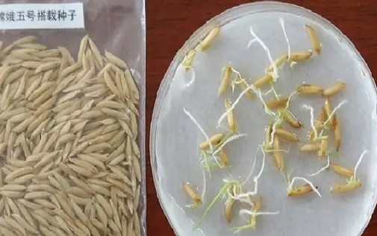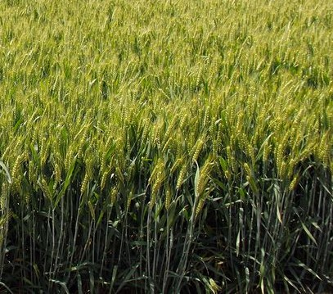
(Credit: Chinese Academy of Agricultural Sciences)
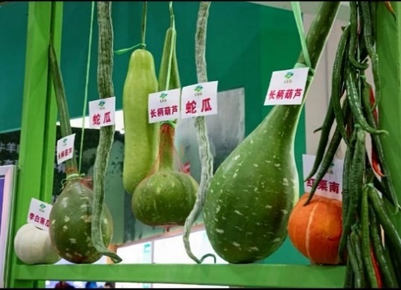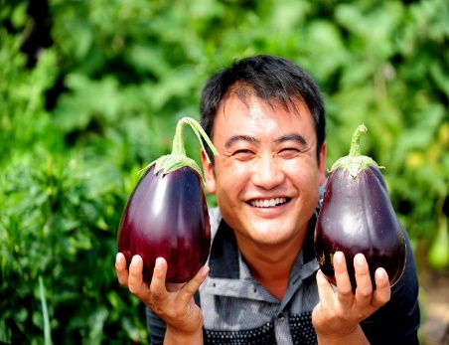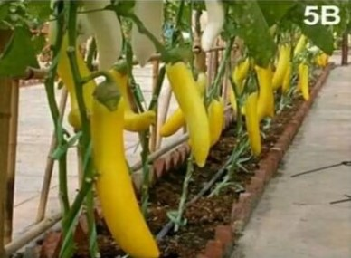
(Credit: China Daily)

Conclusion:
Space-induced mutation technique is an effectively new way not only to develop new crop variety, but also possible to obtain rare mutants that may make a great breakthrough in important economic characters of crop, such as yield and quality, which are difficult to get using the other breeding methods on ground. The research on applied basis of space-induced mutation technique needs to be strengthened. Because of the big investment and good technological support, this method is limited but is important to make ground simulation on space environment factors. It is important to make ground simulation on space environment factors to conduct research work for revealing the mechanism of space-induced mutation and applying it for crop breeding.

Reference
- Astrium. (2012) Space biology product catalog. Astrium, Friedrichshafen, Germany.
- Brinckmann E. (2005) ESA hardware for plant research on the International Space Station. Advances in Space Research, 36, 1162–1166.
- https://www.bbc.com/future/article/20220708-how-china-is-creating-new-foods-in-space#:~:text=But%20the%20vast%20fields%20of,340km)%20above%20the%20Earth%27s%20surface.
- Furukawa, S., Nagamatsu, A., Nenoi, M., Fujimori, A., Kakinuma, S., Katsube, T., and Takahashi, A. (2020). Space radiation biology for “Living in Space”. BioMed Research International.
- Ferl R.J., Paul A.L. (2010) Lunar plant biology – a review the Apollo era. Astrobiology, 10, 261–274.
- Ferl, R., Wheeler, R., Levine, H. G., and Paul, A. L. (2002). Plants in space. Current opinion in plant biology, 5(3), 258-263.
- Liu, L. X., Guo, H. J., Zhao, L. S., Wang, J., Gu, J. Y., and Zhao, S. R. (2009). Achievements and perspectives of crop space breeding in China. Induced plant mutations in the genomics era. Food and Agriculture Organization of the United Nations, Rome, 213-215.
- Luo, Y., Wang, X., Mei, M., Zhuang, C., Feng, Z., Zengquan, W., et al. (2007). Genomic polymorphism in consecutive generation rice plants from seeds on board a spaceship and their relationship with space HZE particles. Front. Biol. China, 2, 297–302.
- Mir, A. S., Maria, M., Muhammad, S., and Ali, S. M. (2020). Potential of mutation breeding to sustain food security. Genetic Variation.
- Nair, G. M., Murthi, K. S., and Prasad, M. Y. S. (2008). Strategic, technological, and ethical aspects of establishing colonies on Moon and Mars. Acta astronautica, 63(11-12), 1337-1342.
- Vanden brink, J. P., and Kiss, J. Z. (2016). Space, the final frontier: A critical review of recent experiments performed in microgravity. Plant Science, 243, 115-119.
- Wei, L. J., Xu, J. L., Wang, J. M., Qian, Y. A. N. G., Luo, R. T., Zhang, M. X., ... and Sun, Y. Q. (2006). A comparative study on mutagenic effects of space flight and irradiation of γ-rays on rice. Agricultural Sciences in China, 5(11), 812-819.

