BREEDING STRATEGIES FOR CLIMATE RESILIENT CROPS
Parthsinh Rahevar
Assistant Professor,
GUNI - Kantaben Kashiram Institute of Agriculture Sciences and Research, Ganpat University,
Ganpat Vidyanagar, Mehsana-Gozaria Highway - 384 012. INDIA
Corresponding Author: parthsinhrahevar@gmail.com
INTRODUCTION
The necessity of humans on plant resources is inevitable. Existing in close interaction with nature, man has learnt to utilize plants for food, fodder, medicine and other determinations. From the ancient time, the desirable selection and domestication of wild plants by humans has assisted in evolution of numerous valuable plant species. By way of a global wealth of about 80,000 edible plants, only a minor part containing 3,000 plant species have been used for food (Gyorgy, 2009). This comprises cereals, legumes, root and other food crops. The continuous dependency on a smaller number of plants carries a great risk of biotic virulence that leads to large scale crop failures. This dictates the broadening of the genetic base and discovering possibilities of newer plant species for diversification of agriculture. The green revolution during 60’s provided us a great relief on the food production front but continued mono-cropping systems in agriculture and cereal based diets (wheat – rice) led to undesirable effects on soil as well as human healthiness. The soils have convert sick in terms of micronutrients deficiency. The human beings have become prone to numerous chronic diseases as some of the minor crops which were essential components of diet in the historical time have been replaced by wheat and rice. These minor or the Underutilized plants, in general, constitute those plant species that occur as life support species in hard environmental circumstances and threatened surroundings, having genetic tolerance to endure under harsh conditions and own qualities of nutritional and/or industrial significance for a variety of purposes. Their cultivation is limited to remote areas in different agro-ecological regions, mainly by the poor farming societies who have limited contact to modern agro-inputs and well planned marketing structure.
Plant breeders must address all issues of food production to make it sustainable in the climate change. Plant breeding techniques have been continuously developing to come across the increasing food demand. The art of plant breeding has been created in various forms since the start of human civilization. Development of a cultivar through conventional plant breeding, may take around 10 years or even exceed this period based on the plant habit, reproductive cycle and complexity of traits involved. The rapid climate change requires the development of varieties in a shorter span to tackle with the unpredictable weather parameters. In order to achieve self-sufficiency in food production, there should be a transition in breeding work to develop crop varieties that can give sustainable yields under rapid climate change. Climate change will worsen the incidence of abiotic and biotic stresses in crop plants and minor pests and diseases can become economically important. Drought only is estimated to reduce crop productivity in half of the global arable land by 50% in the next five decades. Hence, development of climate resilient varieties safeguards food security in adverse climatic conditions.
BREEDING CHALLENGES IN A CLIMATE CHANGE SCENARIO
Agriculture and climate change are interrelated processes. Climate change can adversely affect agriculture in altered ways, through changes in normal temperatures (heat and cold stress), dispersal of rainfall (drought and floods) and increased occurrence of biotic stresses (pests and diseases). Production and quality of food is affected by climate change. In general, stabilizing yield is simple by creating an improved variety resistant to various biotic and abiotic stresses, rather than by improving management practices. In traditional breeding methods, plant breeders develop new cultivars by selecting directly or indirectly for yield and its components in specific environments as most varieties will not be able to have stable performance across the environments. Moreover, these methods require longer time for varietal development. Most common breeding methods used by breeders are pedigree and backcross. Pedigree is a proven breeding method, but it depends on growing all of the field's plant populations and takes a longer period to fix lines.
ROLE OF POTENTIAL OR UNDERUTILIZED CROPS IN FUTURE CLIMATE RESILIENCY
Now, worldwide, there has been a concern to diversify the agriculture and identified the possibilities of novel plant resources and promote utilization of underutilized nutritive food crops. Besides being the store house of nutrients, these crops are endowed with very vital gene pool for resistance to biotic and abiotic stresses which in the present day are of much importance as the genes can be transferred among species and genera using biotechnological tools.
Considering the need for diversification of agriculture and to meet various human needs, it is essentially required that the potential underutilized crops; predominantly the grain legumes and pseudocereals be given due consideration in terms of their adoption, varietal development, value addition and marketing so that these crops can be lucratively grown by the farmers on their marginal lands. Marginal requirements of nutrients/inputs and whenever improved in respect of their yield and marketing facilities; it will go a long way in improving the status of farming community in marginal areas and health standards in urban areas. On account of low water requirement in raising amaranth, the area under this crop in Banaskantha district of Gujarat has been increasing over that of potato and wheat during the lean years. Around 65000 to 1,00,000 q of grain amaranth from an area of about 4000 ha is being produced and marketed every year in Banaskantha District only. Buckwheat, one more pseudo cereal, is vital food in higher hills. For strengthening blood vessels; Rutin content in buckwheat is considered to be a very important agent. Rice bean is an important pulse crop among legumes of high hills where mungbean and black gram cannot be cultivated, and even in plains it can be successfully grown as it is immune to yellow mosaic virus which is quite serious in this crops. In addition to the food crops, the other useful crops also attracting attention now days which are for medicinal value and source of bio-fuels. To popularize Jatropha cultivation for extraction of bio-diesel; a country wide campaign has been launched by the Central and State Governments.
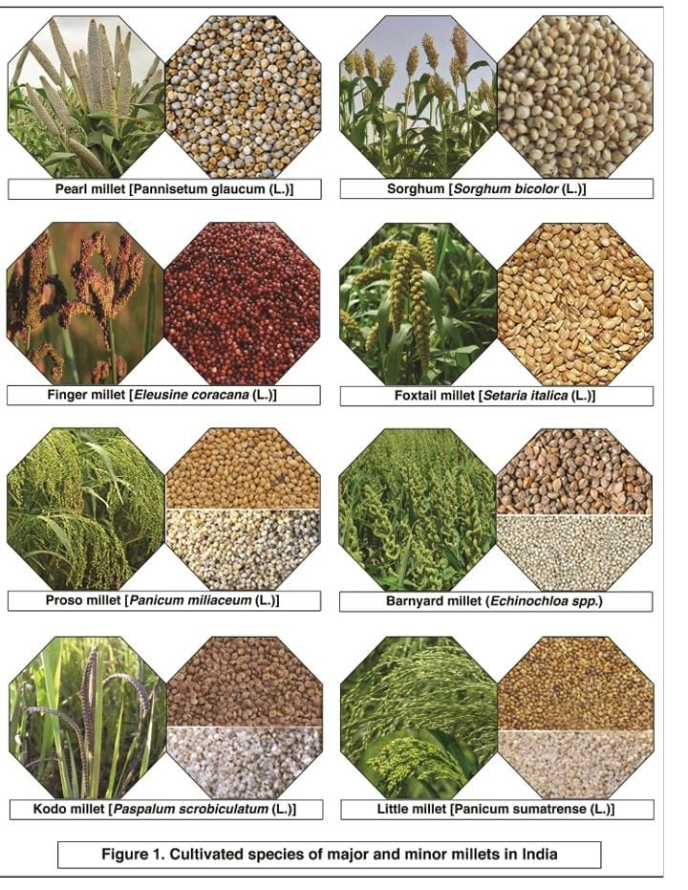
Table 1: Varieties released under All India Coordinated Research Network on Potential Crops
Crop | Varieties | Year of identification/ release | Economic product | Average yield (q/ha) | Characteristics | Recommended areas | Released by
GRAIN AMARANTH
1 | Annapurna | 1984 | Grain | 22.50 | High yield potential, high protein (15%) drought tolerant and wider adaptability | Mid and high Himalayan region of India | Shimla
2 | GA-1 | 1991 | Grain | 19.50 | High seed yield and drought resistant | Gujarat, Maharashtra | S.K. Nagar
3 | Suvarna | 1992 | Grain | 16.00 | Drought tolerant, high yield | Peninsular region (Karnataka, Orissa) Gujarat | Bangalore
4 | PRA-1 (PRA 8801) | 1997 | Grain | 14.50 | High grain yield | Uttaranchal hills | Ranichauri
5 | PRA-2 (PRA 9101) | 2001 | Grain | 14.50 | High grain yield | North- West Himalayan region except J&K | Ranichauri
6 | GA-2 | 2002 | Grain | 15.50 | High grain yield | Gujarat state | S.K. Nagar
7 | PRA-3 (PRA 9401) | 2003 | Grain | 16.50 | High grain yield | North-West Himalayan region except J&K | Ranichauri
8 | IC 35407  (Durga) | 2006 | Grain | 21.00 | High grain yield and Early maturing | North west hill zone comprising states of  Himachal Pradesh Uttaranchal and J &K | Shimla
9 | BGA-2  (Kapilasa) | 2006 | Grain | 13.26 | High grain yield and Early maturing | Karnataka, Orissa and Tamil Nadu | Bhubaneswar
10 | VL Chua 44 | 2005-06 | Grain | 13.20 | Early maturing (110- 120 days), escapes from Leaf webber and has non spiny bract for easy threshability | Mid and higher hills of  Uttaranchal | Almora
11 | SKNA 21 (GA-3) | 2008 | Grain | 12.58 | High grain  yield | States of  Gujarat and Jharkhand | S.K. Nagar
12 | RMA- 4 | 2008 (Id.) | Grain | 13.90 | High grain yield | States of Rajasthan, Jharkhand and Orissa | Mandor
13 | RMA-7 | 2010 (Id.) | Grain | 14.66 | High grain yield | Rajasthan, Gujarat, Orissa, Maharashtra, Haryana, Delhi states | Mandor
BUCKWHEAT
14 | Himpriya | 1991 | Grain | 12.00 | High grain yield, medium maturing F. tataricum | High altitude  Areas of  Himachal Pradesh and Uttrakhand | Shimla
15 | VL Ugal 7 | 1991 | Grain | 8.00 | Early maturing, moderate yield F. esculentum | Mid hills of Uttrakhand | Almora
16 | PRB 9001  (PRB 1) | 1998 | Grain | 12.00 | High yielding F. esculentum, medium maturity | Hill region of UP, HP and North Easten states | Ranichauri
17 | Himgiri (Shimla B-1) | 2006 | Grain | 11.12 | Early maturing (81-95 days) | Dry temperate region of Himachal Pradesh and J & K | Shimla
18 | Sangla B-1 | 2006 | Grain | 12.65 | Medium in maturity(104-108 days) and high yielding | Mid and high hills of Himachal Pradesh and Uttranchal | Sangla
WINGED BEAN
19 | AKWB-1 | 1991 | Green pods | 105.00 | Dual purpose (seed and vegetable), high pod yield | All winged bean growing areas | Akola
FABA BEAN
20 | VH 82-1 | 1999 | Grain | 14.55 | High seed yield, medium maturity | Northern plains | Hisar
RICE BEAN
21 | RBL-1 | 1986 | Grain | 16.00 | High yielding, medium maturing, light green seeded, resistant to diseases and stored grain pests | Punjab | Ludhiana
22 | PRR-1 | 1995 | Grain | 15.00 | High yielding | Uttaranchal hills | Ranichauri
23 | PRR-2 | 1997 | Grain | 12.00 | High seed yield, shining light yellow seed | Hill region of UP, HP and North Eastern states, particularly mid and high altitude areas | Ranichauri
24 | RBL-6 | 2000 | Grain | 13.33 | High yielding, medium in maturity, light green seeded, resistant to diseases and pests | Entire plain Zone | Ludhiana
25 | RBL 35 | 2003 | Grain | 11.65 | Early maturing | Plains | Ludhiana
26 | RBL 50 | 2003 | Grain | 10.90 | Dark green seeds | Plains | Ludhiana
27 | BRS 1  (Identified) | 2003 | Grain | 14.50 | Early maturing and high seed yield | Hills | Bhowali
KALINGADA
28 | Gujarat Karingada-1 | 2001 | Seed and vegetable | 10.00 | High protein (18%), oil (37.1%) and TSS (3.4%) | Arid/semi-arid areas of Gujarat | S.K. Nagar
GUAYULE
29 | Arizona-1 | 1986 | Rubber | 13.50 | Drought resistant, high rubber content (6%), medium vigour | Arid and semi-arid areas | Hisar
30 | HG-8 | 1991 | Rubber | 15.00 | High rubber content (7%), tolerant to root rot, vigorus growth | Arid and semi-arid areas | Hisar
TUMBA
31 | RMT 59  (Mansha Marudhara) | 2005 | Seed/oil | 2.38 | High fruit and seed yield | Rajasthan and Gujarat | Mandor
JOJOBA
32 | EC-33198 | 1986 | Oil | 5.00 | High seed yield, drought tolerant | Arid regions  And coastal areas | Jodhpur
KANKODA
33 | Indira Kankoda (RMF-37) | 2007 | Vegetabl e | 15-20 | High fruit yield | Chhatisgarh, Uttar Pradesh, Jharkhand, Orissa and  Maharashtra | Ambikapur
JATROPHA
34 | Chhatrapati (SDAUJ-1) | 2007 | Oil | 4.00  (3rd year) | High yield and oil percent | Gujarat and Rajasthan under rainfed conditions | S.K. Nagar
Source: All India Co-Ordinated Research Network On Potential Crops
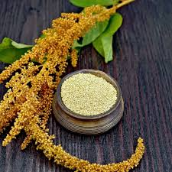 | 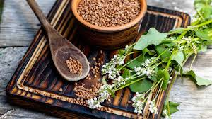
GRAIN AMARANTH | BUCKWHEAT
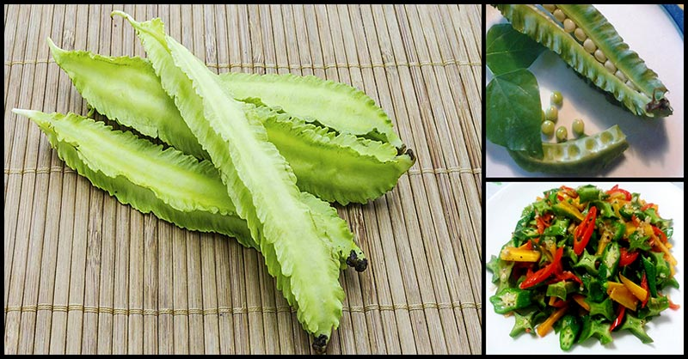 | 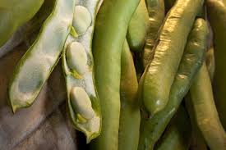
WINGED BEAN | FABA BEAN
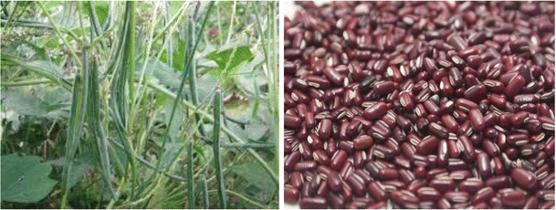 | 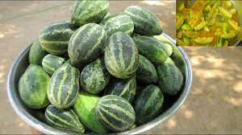
RICE BEAN | KALINGADA
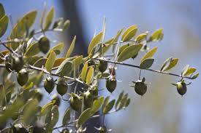 | 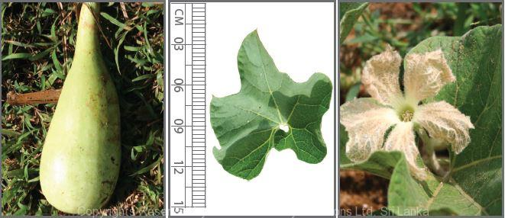
JOJOBA | TUMBA
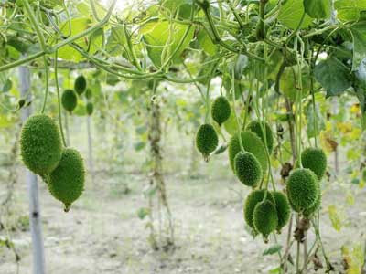 | 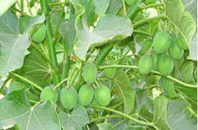
KANKODA | JATROPHA

BREEDING STRATEGIES
CONVENTIONAL APPROACHES
It is a common view that if a new character is added to a breeding program, either gains in other characters will suffer (for example yield potential), or the program will have to be extended by a factor which is reliant on the selection rate. The breeder hence has to consider whether breeding for resistance is economically sustainable. The subsequent step in a breeding program for resistance is the documentation of an appropriate source of resistance. The genotypic dissimilarity within the genotypes of the crop and often also within related species should be investigated. Sources for resistance may be found in taxonomic groups that are more or less distantly related to the crop, such as the cultivar itself, commercial cultivars, landraces, wild progenitors, related species and genera.
Introduction
Variety introduced to new area resistant to the concerned stresses may be released for cultivation if it performs well in the new environment and is agronomically desirable. Hence, it is the fastest and possibly, the most primitive method of developing a stress resistant or climate resilient variety. Occasionally, the introduced variety may not perform well in the new environment and it may be liable to the biotypes of the concerned pest predominant in the area or to a novel insect pests and/or diseases of the region.
Selection
Climate resilient variants may be found in an existing variety of a crop. In such case, selection for stress resistance is practiced to isolate climate resilient variety. Screening large number of germplasm for resistance at field level and further confirmation through artificial testing will help in selection of a resistant line which may be directly used as variety or utilized as donor for developing a hybrid.
Hybridization
When the desired stress resistance is present in an agronomically inferior variety of the crop or in a related wild species, hybridization is the only course of action for the breeder (Pedigree and Mass breeding Method).
Backcross Method of Breeding
The backcross is a form of recurrent hybridization by which one or two required characteristics are added on to a superior variety, wherein the hybrids and the progenies in the succeeding generations are recurrently back crossed to one of their parents. The objective of back crossing is to transfer one or two desired characteristics from an inferior variety to a superior variety, disturbing the genotype of the superior variety as little as possible in the process. Backcrossing is chiefly well suited for the transfer of one or two simply inherited and easily predictable characters to a variety that excels in most of its characters.
Mutation
Mutation has not been used to produce a successful climate resilient crop yet. The reason for this is difficulty in screening of suitable mutations, the failure of such mutagenesis to create positive changes to the genome and large number of progenies that must be handled.
ADVANCED APPROACHES
Wide hybridization
Plant breeding programs can benefit from genetic variability originating from interspecific or intergeneric crosses, commonly known as wide crosses, between different crop plants or between crop plants and their wild relative. Distant hybridization is also a favorable means for haploid plant development through chromosome elimination during embryogenesis. As example; Triticum aestivum (2n = 6 X = 42) x Pennisetum americanum (2n = 14). Enhanced success in recovering plants from wheat x pearl millet crosses seems viable and could be of practical interest to plant breeding programs. if pearl millet could be effectively hybridized as the female parent to wheat, introducing some of the wheat protein genes into pearl millet could be valuable to improve the quality of pearl millet, the main cereal in many parts of India and much of Africa with climate resiliency.
Allele Mining
Functionally integrated omics and computational biology tools for climate resilience include reconnaissance of novel climate resilient genes and the expression levels, that may induce the climate resilient response. These omics approaches are used to understand the functional role of stress responsive genes and the generation of stress tolerant transgenic lines. Furthermore, they also cover the way for guiding genetic and metabolic engineering studies. In potential crops, large numbers of expressed sequence tags (ESTs) have been generated from different cDNA libraries, collected from Abiotic stress treated tissues at different developmental stages, and are considered as a significant functional genomic approach to impute the responsive genes. The expressed sequence tag database (dbEST) provides information about the number and type of different tolerant species. Genomics based approaches were started in the potential crops such as sorghum.
Marker-assisted selection
Defined quantitative traits can be used to dissect by quantitative trait locus (QTL) mapping so that individual loci can be targeted in marker-assisted selection (MAS). Typically, QTL mapping studies are an essential for MAS which can be used to pyramid several different QTLs. Marker assisted backcrossing (MABC) combines ‘foreground’ selection of donor alleles linked to QTLs and ‘background’ selection of recurrent parent alleles in the BC₂ and later generations. QTLs must be expressed and beneficial in new genetic backgrounds for effective MAS programmes and need to be stable across different mapping populations and environments.
QTLs for Drought tolerance in pearl millet were identified using two mapping populations based on hybrid parents with known differential response to stress. One among the two parents of each of the two populations (PRLT 2/89-33 and 863B) was mainly derived from landrace material from Togo and Ghana that has enhanced tolerance to post-flowering drought stress but poor seedling thermotolerance. Molecular markers can be used to generate linkage map for each population. MABC is being used to introgressed these QTLs into inbred hybrid parental lines for the subsequent production of improved hybrids. Foxtail millet is considered as a C₄ crop model for studying the biology of other millets and biofuel grasses. Significant genomic resources were developed including simple sequence repeats (SSRs), intron length polymorphisms, eSSRs, miRNA-based markers, and transposable-elements based markers for foxtail millet as it serves as a rich reserve of genes, alleles, or QTL for genetic improvement of chief cereals and bioenergy grasses. Moreover, open access online databases such as foxtail millet marker database, foxtail millet miRNA database and foxtail millet transposable elements-based marker database have been constructed. Along with development of these markers, their efficacy in population genetics, association mapping, comparative genomics and genomics-assisted breeding have also been demonstrated. Study on millets is at initial stage compared to other crops. Being principally climate resilient crops, millets could serve as valuable source of novel genes, alleles and QTL for stress tolerance, which needs to be identified and characterized. The effective phylogenetic relationships between millets and other cereals could enable the introgression of novel alleles, genes or QTL identified in millets for better agronomic traits into other cereals toward ensuring food security under changing climate.
‘Omics’ technologies for climate resilient crops
The achievement of MAS for pyramiding QTLs could be improved by targeting the genes controlling the traits rather than linked marker loci, so that linkage drag is reduced. Observing efficient genes within a QTL is complex because the QTL confidence intervals can span several hundred genes. Integrated genomics studies are probable due to the availability of DNA sequences in databases, and complete physical maps for several plant species. Gene expression studies that were, until in recent times, limited to only a few genes at once can today be performed with oligonucleotide and cDNA microarrays on multiple genes together to produce expression profiles specific to the environments in which they are assayed. Expression profiling to understand responses to applied drought and salinity stresses have been used in many crops.
Transgenic
Gene functions can be allocated either through the classical forward genetics approach of starting with a phenotype and identifying the genes responsible, or reverse genetics that starts with a DNA sequence and identifies its biological role. Most probably, transgenic technologies allow the genetics to be confirmed by checking the action of single genes; over expression of which can lead to increased tolerance. The widely held of transgenes used for stress tolerance are transcription factors that upregulate or downregulate the expression of other genes. Along with constitutive promoters, these have been introduced under the regulation of an Arabidopsis dehydration-responsive promoter rd29A.
ACCELERATED BREEDING APPROACHES
Genetic improvement of crop plants is traditionally a slow process and it takes at least 12 years for release of new varieties as the breeding process includes; development of genetically fixed lines, evaluation and identification, hybridization and obtaining homozygous lines by selfing. Recent developments in crop breeding methodology have resulted in persistent increase in crop performance, but the major constraint is generation time of plants which is biologically fixed. In future, the major challenge for existing breeding is to speed up the generation time of breeding cycle in order to speed up the genetic gain in any breeding program.
- Shuttle Breeding
Noble Laureate Dr. Norman E. Borlaug was the person behind the idea of this method at CIMMYT (International Wheat and Maize Improvement Centre), Mexico. Shuttle breeding will permit an extra generation per year by raising the crop at different locations. Wheat breeding programme in Mexico exploited two different locations, which permitted use of the off season for breeding activities. The advantages of this approach are development of varieties/breeding lines adopted across great geographical and agro ecological areas, except perhaps poorest of the environment. However, over the years this method is used to a limited extent due to logistical problems, particularly during the exchange of seeds across international territories, issues related to intellectual property and security of national germplasm.
Dr. S. K. Gupta discussed about the shuttle breeding method which is underway with CAZRI to produce drought-tolerant breeding lines, with selection and evaluation of material done at CAZRI, followed by generation advancement at ICRISAT in the off season.

Rapid Generation Advance (RGA)
This is the most successful breeding technique in rice and in this method, extensive single plant selections are made and screening for desired characters is done in segregating generations and finally yield testing of identified homozygous lines in target environment. RGA breeding method is used to develop homozygous lines. RGA or SSD uses only one seed from each plant from F₂ to F₆ generations to forward each generation by inbreeding and produce 'true lines'. Essentially, RGA facilitates the development of true breeding lines to be achieved rapidly by controlling plant growth conditions there by enforcing early dehiscence and rapid seed set than under normal growing conditions. In this method, plants are grown in a controlled condition from F₂ to F₆ generations within a shorter time period than under routine growing conditions. It was learnt from theories of plant breeding that delaying selection after several cycles of inbreeding may have rewards.

Doubled Haploids (DH)
DH systems were used to hasten the breeding cycle in many of crops. DH plants are homozygous at each locus which significantly reduces line fixation time since completely homozygous lines are produced instantly. DH production includes both in vivo or in vitro methods. Haploid embryos are produced in vivo by pseudogamy, parthenogenesis, or wide crossing. Whereas in vitro techniques are androgenesis (anther and microspore culture) and gynogenesis (ovary, ovule and flower culture). Androgenesis is widely used among all the methods. Double haploid production at large scale depends on the embryogenesis rate and regeneration of plants, the amount of obtaining albinism among regenerates and the frequency of chromosome doubling required to obtain fertile DH plants. Colchicine is commonly used as chromosome doubling agent and may also affect the androgenetic process. To summarize, the DH technique has played a significant role in crop improvement. It has the potential to reduce the generation time of line development leading to production of complete homozygous plants. DH technique is best suited for variety development, fixation of heterosis, back cross breeding, mapping, gene identification, discovery of gene and genetically modified plant development. DH provides an opportunity to hasten up conventional breeding methods, and also provides more opportunity in that it can be employed at any time.

Genomic Selection (GS)
GS is a specialized method of MAS in which genotype data on marker alleles covering the entire genome constitutes the basis of selection i.e. Genomic Estimated Breeding Values (GEBVs) determined from the effects of all marker loci. For training population (TP) firstly, genotyping and phenotyping is done for the targeted trait. Then model training is carried out i.e., the data of the phenotype and marker genotypes are used to compute the parameters of the GS model. The breeding population without phenotyping is evaluated for the same set of markers on which basis, model parameters were estimated in the training population. The marker genotype data and associated effects calculated from the training population are used for estimating the GEBVs of the breeding population's individuals / lines.

Genome Editing
There are two categories of genome editing first one is Oligonucleotide Directed Mutagenesis (ODM) in which chemically synthesized 20-100 nucleotides are delivered into plant cells where they induce mutations in the target site. Site-directed nucleases (SDNs) are enzymes that can bind specifically to targeted short DNA sequences that range from 9 to 40 nucleotides and leads to introduction of Double-Strand Breaks (DSBs), acetylation, methylation, demethylation, and deamination to alter a biological activity (e.g., base editing, gene silencing, gene expression, etc.). For repairing of DSB, homologous recombination and non-homologous end joining are the two mechanisms in living cells. SDNs includes Zinc Finger Nucleases (ZFNs), meganucleases (or homing endonucleases, HE), Transcription Activator-Like Effector Nucleases (TALENs), and clustered regularly interspaced short palindromic repeats (CRISPR)-associated protein (CRISPR/Cas). Genome editing has been used recently in soybean for incorporating salt and drought tolerance by disrupting the DREB2band DREB2a genes.

Speed Breeding

Speed breeding is the technique which uses supplemental lighting in enclosed and controlled-environment growth chambers that shortens generation time and speeds up the breeding and research programmes. The single seed descent method for rapid advancement of the generation and harvesting the immature seed and proceeding to next generation without losing their viability helps to shorten the generation time. By using light-emitting diode (LED) and harvesting immature seeds, six generations per year can be obtained in crops like spring wheat, durum wheat, barley, chickpea and pea, and four generations for canola, instead of 2–3 under normal glass house conditions. With the help of speed breeding, climate resilient varieties can be developed in a short period of time.
Climate Resilient Variety Development - Major Achievements
These crop varieties with special traits have been developed by the Indian Council of Agricultural Research to address the twin challenge of climate change & Malnutrition. The trait specific details of all the crop varieties are given below:
Sr.  No. | Crop | Variety | Specific trait
 | Quinoa | Him Shakti | High protein content (15.64%) and oil (8.91%)
 | Buckwheat | Him Phaphra | High protein (13.1%) with methionine and iron (6.6 mg/100g) content
 | Winged bean | PBW 11-2 | High pod yield and protein content
 | Faba bean | HFB 2 | High seed yield and protein content (24.13%)
 | Soybean | KBVS 1 (Karune) | First variety of soybean having green pod suitable for consumption
 | Soybean | NRC 142 | First double null variety free from anti-nutritional factor Kunitz trypsin inhibitor (KTI) and lipoxygenase-2 (principal contributor to off-flavour)
 | Pigeonpea | IPH 15-3 | Early maturing (<150 day) and resistant to wilt and sterility and mosaic disease
 | Pigeonpea | IPH 09-5 | Early maturing (<150 day) and resistant to wilt and sterility and mosaic disease
 | Chickpea | Pusa Chickpea 4005 | A drought tolerant high yielding varieties of chickpea developed through marker assisted selection
 | Chickpea | IPCMB 19-3  (Samriddhi) | A Fusarium wilt resistant high protein (22.9%) varieties developed through marker assisted selection
 | Pearl millet | PB 1877 | Summer pearl millet variety rich in Iron (42 ppm) and zinc (32 ppm)
 | Pearl millet | HHB 67  Improved 2 | Pearl millet hybrid rich in Iron (42 ppm) and zinc (32 ppm) and resistance to downy mildew
 | Sorghum | Jaicar Raseela- CSV 49SS (SPV 2600) | Sweet sorghum suitable for 1G biofuel and silage making
 | Forage  sorghum | JaicarUrja-CSV 48 (SPV 2402) | High biomass variety suitable for 2G biofuel and silage making
 | Maize | Pusa HQPM-1 Improved (APQH-1) | High 7.02 μg/g of provitamin, lysine (4.59%) and tryptophan (0.85%); widely adapted  hybrid suitable for all zones
 | Maize | Pusa Biofortified Maize Hybrid-1 (APH-1) | Rich in provitamin-A  (6.6 μg/g), lysine (3.37%) and  tryptophan (0.72%); hybrid suitable for northern hill and north eastern plain zone
 | Maize | Pusa HM4 Male Sterile Baby Corn (Shishu) (ABSH4-1) | First male sterile baby corn hybrid of the country  Saves Rs. 8,000-10,000/- per ha as no manual detasseling is required
Source: Press Information Bureau, Government of India, Ministry of Agriculture & Farmers Welfare
Future Needs and Way Forward
- Developing multiple stress tolerant crops to combat yield losses in climate change scenario.
- To tackle the yield losses in C₃ crops and harness the benefits of increasing CO₂ concentration due to climate change, on-going research on converting C₃ to C₄ crops should be given more emphasis.
- To address the new races of pathogens and crop pests, more number of resistant genes should be identified for the major and minor pest and diseases.
- More extensive study on root systems should be conducted to develop crop varieties that can thrive well under water stress conditions.
- Climate change on the other hand increases the problematic soil area, and efforts should be made to develop crop varieties tolerant to grow under such soils.
- Speed Breeding protocol must be developed and optimised for all crops to accelerate the breeding programs.
- Genomic prediction tools must be utilised for effective and enhanced crop breeding program to tackle climate change.
- The untapped plant genetic resources must be exploited favourably to look for genes and new traits that confer better adaptability under changing climate.
- Genetic engineering and gene editing tools like CRISPR/Cas should be utilised to precisely induce gene mutations in key genes that have role in climate change adaptation, to improve their functionality.
- The phenomics technology should be used for precise phenotyping of large number of lines to enhance the breeding efficiency.
- The knowledge obtained for whole genome sequencing of major crops should be favourably integrated in breeding programs.
- The crop ideotypes should be relooked to include traits that help crops to produce better under variable climatic conditions.
- Extending breeding programs to minor crops to facilitate crop diversification.
- Crop simulation genetic modelling can help in prediction and selection of best breeding methodology based on gene frequency, breeding value and genotype environment interaction under different climatic conditions in order to develop climate resilient cultivar or genotype.

REFERENCES
Begna, T. (2021). Global role of plant breeding in tackling climate change. J. Agric. Sc. Food. Technol. 7(2): 223-229. DOI: 10.17352/2455-815X.000111
Gyorgy F. (2009). Cultivated plants, primarily as food sources. EOLSS Publications. 1: pp 1-12
Kole, C.; Muthamilarasan, M.; Henry, R.; Edwards, D.; Sharma, R.; Abberton, M.; Batley, J.; Bentley, A.; Blakeney, M.; Bryant, J.; Cai, H.; Cakir, M.; Cseke, L. J.; Cockram, J.; de Oliveira, A. C.; De Pace, C.; Dempewolf, H.; Ellison, S.; Gepts, P.; Greenland, A.; Hall, A. and Prasad, M. (2015). Application of genomics-assisted breeding for generation of climate resilient crops: progress and prospects. Front. Plant Sci. 6:563. doi: 10.3389/fpls.2015.00563
Raiger, H. L. and Bhandari, D. C. (2012). Underutilized Crops: Varieties released in India. All India Coordinated Research Network on Potential Crops, NBPGR, New Delhi. 253p
Ramasamy, G.; Shiv, A.; Basavaraj, P. and Mulpuri, S. (2020). Accelerated Crop Breeding Towards Development of Climate Resilient Varieties. ICAR-National Academy of Agricultural Research Management, Hyderabad, Telangana, India.
Singh, B.; Singh, G. and Srivastava, P. (2020). Smart Breeding for Climate Resilient Agriculture, Plant Breeding - Current and Future Views, Ibrokhim Y. Abdurakhmonov, IntechOpen, DOI: 10.5772/intechopen.94847.
Witcombe, J. R., Hollington, P. A., Howarth, C. J., Reader, S., and Steele, K. A. (2008). Breeding for abiotic stresses for sustainable agriculture. Philosophical transactions of the Royal Society of London. Series B, Biological sciences, 363(1492), 703–716. https://doi.org/10.1098/rstb.2007.2179

