**Zinc absorption in rice: uptake,** **translocation and transformation**

**S. K. Jadav2**

2Assistant Professor, Department of Genetics and Plant Breeding, College of Agriculture Waghai, Navsari Agricultural University, Navsari, Gujarat, INDIA

**V. G. Baldaniya1**

1Assistant professor, GUNI-Kantaben Kashiram of Agriculture Sciences and Research, Ganpat University, Ganpat Vidyanagar Mehsana-Gozaria Highway – 384 012. INDIA

*Corresponding author: vipulbaldaniya00@gmail.com*

**Introduction**

In cereal crops, rice is the greatest widely consumed staple food grain crop for over more than 50% of the world's human population, particularly in Asia and Africa. In all agricultural products (grain-crops), production of rice highest in world, after sugarcane and maize. Rice is the utmost vital food grain crop for human diet (nutrition) and caloric consumption, provided that more than 20% of the calories spent worldwide by people. Rice grains are composed of water (68%), carbohydrates (28%), protein (3%), and tiny fat but a very small number of micronutrients especially zinc and iron.

Plants and humans required different essential nutrients were important for the appropriate growth and development. Now a day, micronutrient deficiency and hidden hunger was major problems in the world wild especially zinc (Zn). India declared new Recommended Dietary Allowances (RDA) of zinc is 17 mg for men and 13.2 mg for women (nutraingredients-Asia 2021) but inappropriately, the food system of people across the world has an insufficient concentration of Zn for their adequate nutrition. In emerging nations of Asia, Africa, and Latin America more than two billion persons were affected by these two problems (Verma *et al.* 2021). About 17% population was affected by only zinc deficiency globally, out of this 30% human population was affected in Afghanistan, Bangladesh, Bhutan, India, Maldives, Nepal, Pakistan, and Sri Lanka (Kamaral *et al.* 2021).

Zinc was important for different cellular processes including metabolic and physiological processes, also required for regulation of different 300 enzymes and work as a co-factor. A key role of zinc in synthesis or regulation of protein, nucleic acid, carbohydrate, and lipid metabolism (Ishimaru *et al.* 2011). About 25% of humans in the world, predominantly in kids and females suffer from zinc deficit related health difficulties such as growth obstruction, loss of appetite, weakened immune function, losses of hair, diarrhea, eye and skin lesions, loss of weight, delayed healing of wounds, and mental lethargy (Swamy *et al.* 2016; Shukla *et al.* 2016 and Noulas *et al.* 2018). A first human case was reported in Egyptian teenagers with serious zinc deficiency in humans, characterized by dwarfism and delayed sexual maturation (Prasad 1991). According to Aiqing *et al.* 2021, due to zinc deficiency, nearly 433,000 kids die every year those age below 5 years, and nearly about 82% of pregnant women suffering in worldwide.

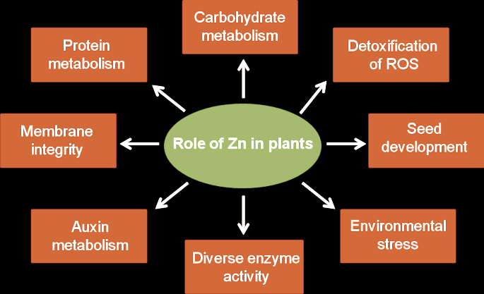More than 30% of the soils on Earth lack zinc and near about 80% of zinc decrease in rice grain due to the lack of zinc in cultivated soil (Impa *et al.* 2013). Compared legumes and cereals, particularly rice, were most probable to have a zinc scarcity in grain. This severe deficiency problem resulted from either the overconsumption of polished rice grain, which is naturally low zinc concentration, or from crop development on barren grounds. For this reason, required an increased zinc concentration in rice grain using different techniques like biofortification, fertilizer application in soil, and biotechnology approaches (Khush *et al.* 2012 and Mao *et al.* 2014).

Fig.1 Roles of zinc in plants (Verma *et al.* 2021)

**Soil concentrations of Zn and factor affecting absorption of zinc**

Soil pH is the most important factor that is for the availability of zinc from soil to root absorption. While increasing soil pH 5 to 7 considerably decreases zinc concentration (35 to 45-fold) in soil solution. Zn+2 predominates formation when soil pH is more than 7.7, while soil pH is between pH 7.7 and 9.1 formations of ZnOH+ and Zn(OH)2 are formed while soil pH is more than 9.1 (Marschner 1993 and Alloway, 2008). Low moisture levels in the soil, high CaCO3, high P concentration in soil, high clay, and low soil organic matter are affecting zinc solubility and acceptance by plant roots from the soil (Cakmak, 2008).



Fig. 2: Different physical and chemical soil properties those affected for Zn absorption by roots (Gupta *et al.* 2016).

**Zinc uptake**

The distribution of Zn in rice grain was impact by the genetic characteristic of the plant, environmental factors, and crop management application. Root produced non-protein amino acids such as phytosiderophore (PS) those are responsible for deficiency of zinc. Storage of zinc in rice grains it was depending on uptake and translocation Zn from soil by plants. This process involved different physiological processes at diverse levels in the rice plant. Even if a small part of zinc crosses the root parts of a plant and succeeds to arrive in xylem with the help of two different pathway (apoplastic or symplastic), but most probably zinc transportation across the roots to the xylem by symplastic pathway (Zaman *et al.* 2018).

Rice plant root, zinc ions are taken up from the rhizosphere regions in the form of either Zn+2 ions, Zn-DMS (Deoxymugineic acid) complexes, or Zn–phytosiderophore complex (Kawakami and Bhullar 2018). The uptake of zinc at root surface is determined by definite uptake transporter rice iron-regulated transporter1 (*OsIRT1*) (Ishimaru *et al.* 2007). Regularly, Zn–phytosiderophore complex and Zn+2 ions, uptake by secondary transporter Ca+2 channels and transporters (*OsZIP5, OsZIP8* and *OsZIP9*) are present on the plasma membrane, but principally it is facilitated by ZIPs protein groups (*ZIP1, ZIP3*, and *ZIP4*) (Palmgren *et al.* 2008 and Lee *et al.* 2010). Members of the ZIP family carry out Zn influx into the cytosol, whereas members of the HMA family carry out Zn efflux to the apoplast. Zn is sequestered into intracellular spaces like the vacuole and endoplasmic reticulum by the MTP (MtZIP2) family. These are yellow stripe-like (YSL) proteins and PCR (plant cadmium resistance) involved in uptake of Zn–phytosiderophore (Zn-PS) complexes in rice plants (Gupta *et al*. 2016).

A higher concentration of zinc accumulated in the root due to express of *OsIRT1* because this transporter also helps to take up Zn (Lee and An 2009). In the cytoplasm of a plant cell, there are abundant Zn+2 holding proteins, but a generally very low concentration of Zn+2 was found (Broadley *et al.* 2007). In xylem tissue, zinc may move like a Zn+2 or as a complex form *viz.,* organic acids, nicotinamide (Zn-NA), or histidine. However, in the vacuoles of plant zinc was collected as an organic acid complex (Leitenmaier and Küpper 2013). In rice, under zinc deficiency plant decreases secretion levels of PS and takes up Zn+2 higher as compared to Zn-DMA complex (Suzuki *et al.* 2008).

**Zinc** **translocation**

When nutrients are absorbed by root surface from soil, they must be carried radially via several root layers and finally transfer to root stele, where nutrient loading into the vasculature occurs. In the root of rice, there are present two casparian strips (outer exodermis and inner endodermis) made-up of suberin-containing coatings of cells that restricted flow of water and nutrients from root surface to inside xylem or phloem via apoplastic pathway (Sasaki *et al.* 2016 and Che *et al.* 2018). Aerenchyma tissue formation between the exodermis and endodermis, that are participated in exchange of gases at the time of water logging conditions (Coudert *et al.* 2010).

In rice different transporters help for translocation of Zn. *OsZIP1, OsZIP3* and *OsZIP4*, are involved in zinc translocation into vascular bundles and meristem also in phloem Zn loading while *OsZIP4* is expressed in phloem cell and *OsZIP3* is highly expressed in rice nodes and involved in zinc unloading from the xylem of vascular bundles and contributes to the superior supply of zinc to new tissues (Ishimaru *et al.* 2005 and Sasaki *et al.* 2015).

P‐type adenosine triphosphatase (*OsHMA2*) works as a chief Zn transporter from roots to shoots in rice plants and at the time of reproductive stage *OsHMA2* is highly articulated in nodes and participated in superior distribution of zinc to developing tissues (Takahashi *et al.* 2012 and Yamaji *et al.* 2013). Members of the ZIP family, HMA (P1B-type ATPase) family, and MTP (metal tolerance protein) family help to influx of Zn+2 into the leaf section of the plant and ultimately transfer into the phloem tissue. (Ishimaru *et al.* 2005). Moreover, YSL proteins help to transportation zinc in the phloem, and zinc is stored as a complex with protein in sink (rice grain) tissue from the phloem. Zinc mobility generally low in the phloem tissue but it was depending upon the characteristic of the plant and species.

In rice, stem nodes play an important role in translocation of zinc from root to shoot or reproductive parts (Yamaji and Ma 2014). Root taken up Zn then after, Zn is mainly entered onto the xylem, which is driven by transpiration and translocation to shoot and leaf area of plant. However, Zn distribution in young parts of plants because zinc requires for different physiological functions. Each node actively contributed to the transfer of Zn from the xylem to leaf to the upper nodes or organs and in this activity involved two zinc transporters (*OsZIP3* and *OsHMA2*).

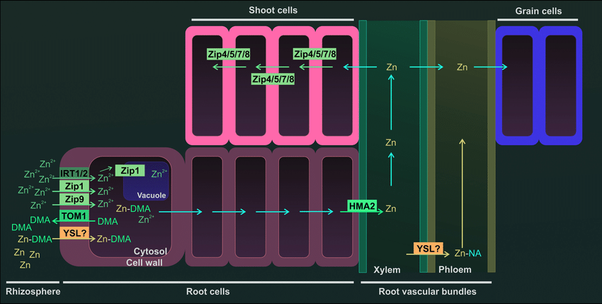

Fig. 3: Diagram of a Zn uptake from rhizosphere and transport to rice grain. Uptake from soil (rhizosphere) preferentially in Zn+2 form by different transporters (IRT1 (iron-regulated transporter 1), IRT2, Zip1 (Zn-regulated transporters), and Zip9). Also, Zn can be uptake in complex form (DMA) which is secreted in the rhizosphere by TOM1 (transporter of mugineic acid phytosiderophore 1). The complex Zn+-DMA can be uptake by a YLS transporter (yellow stripe-like protein). Zn+2 transfer cytoplasm to vacuole by transporter and after that root cells to root vascular bundles. Zinc transport root to shoot with the help of HMA2 (heavy metal ATPase2). In shoots, Zn is transported by ZIP family protein (Zip4, Zip5, Zip7, and Zip8). The Zinc transmission to rice grains is proposed to be horizontally from xylem to phloem after that zinc transfer in rice grain.

**Zinc transformation and store in grain**

Functionally, endosperm and embryo are symplastically collected from the rice plants (Krishnan and Dayanandan 2003 and Palmgren *et al.* 2008). Rice grain requires efflux and influx transporter for nutrient loading inside and outside of the grain side. Like micro-nutrients, zinc is also remobilized in the plants from leaf (source) to grain (sink) tissues.

Transporter *OsHMA9* is located on the plasma membrane and is expressed stronger in mature leaves than in young leaves and works as a Zn efflux transporter, while helpful in the export of Zn from mature leaves (Lee *et al.* 2007). *OsZIP4* is highly expressed in flag leaves and correlates with zinc stored in rice grains (Swamy *et al.* 2016). Accordingly, *OsZIP7* essential role in Zn xylem loading in roots and inter‐vascular transport in the basal node, therefore zinc translocation toward leaves and rice grains (Tan *et al.* 2019). Finally, one more rice gene (VIT), *OsVIT5*, and *OsNAS3* have extremely expressed in panicles parts of the rice plant and contribute to high Zn transportation, transformation, and accumulation in rice grain (Neeraja *et al.* 2018).

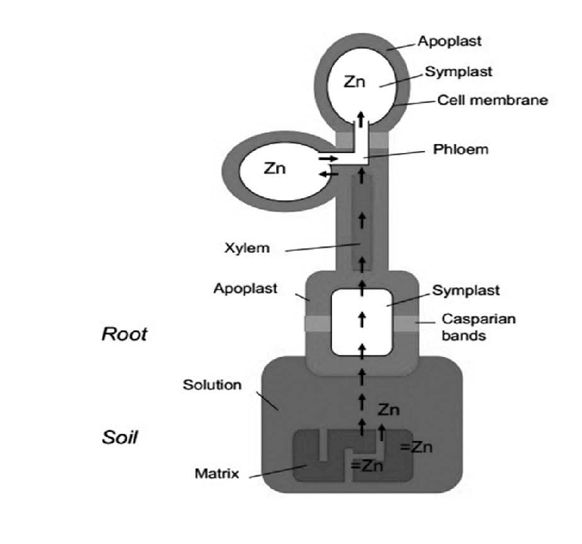Rice plant use has different strategies for Zn distribution in grains. In contrast to other plants, rice leaves are not a source of zinc for grains so, plants deliver Zn to grains at the time of post-flowering through xylem transport. Overall, different mechanisms use for translocation of zinc in rice grains when sufficient and deficient concentration of zinc are reported (Sperotto, 2013 and Wu *et al.* 2010). For instance, when Zn is not provided adequately because leaves are not actively participated in Zn trmobilizr into grsin but plants Zn stored in roots, stem, and sheath.

Fig. 4: Pathway of zinc store in rice grain. Zinc uptake from soil to root cell via symplastic pathway and allocation into xylem then after transfer in shoots with transpiration stream and allocation in leaves. Replacement of zinc via phloem from leaves to grains at the time of grain development stages (Schulin *et al.* 2015).

**Table 1: Role of different zinc transporters in rice for Zn uptake, translocation and storage**

|  |  |  |
| --- | --- | --- |
| **Transporter** | **Function** | **References** |
| OsZIP1, OsZIP5, OsZIP8 | Uptake of Zn in root, Zn transport into  endodermis | Gao *et al.* 2019, Liu *et al.* 2019 and Amini *et al.* 2021 |
| OsZIP3, OsZIP4 | Translocation of Zn in nodes and co-transporter of Zn+2-HCO3 | Ramesh *et al.* 2003 and Ishimaru *et al.* 2005 |
| OsZIP7 | Zinc xylem loading in root,  Zinc translocation in nodes | Tan *et al.* 2019 and Amini *et al.* 2021 |
| OsZIP9 | Zinc uptake and distribution | Tan *et al.* 2020 |
| OsHMA2 | Zinc translocation into the shoot,  Zinc transpot into the phloem from xylem, Zinc ransfer into the seed endosperm | Amini *et al.* 2021 |
| OsNAS1 | Zn enhancement in grain and increase Zn concentration in seed up to 45–74% | Johnson *et al.* 2011 and  Amini *et al.* 2021 |
| OsNAS2 |
| OsNAS3 |
| OsVIT1 | Zinc sequestration in vacuoles of  flag leaves | Amini *et al.* 2021 |
| OsVIT2 |
| OsVIT5 | Zinc accumulation in grain | Amini *et al.* 2021 |

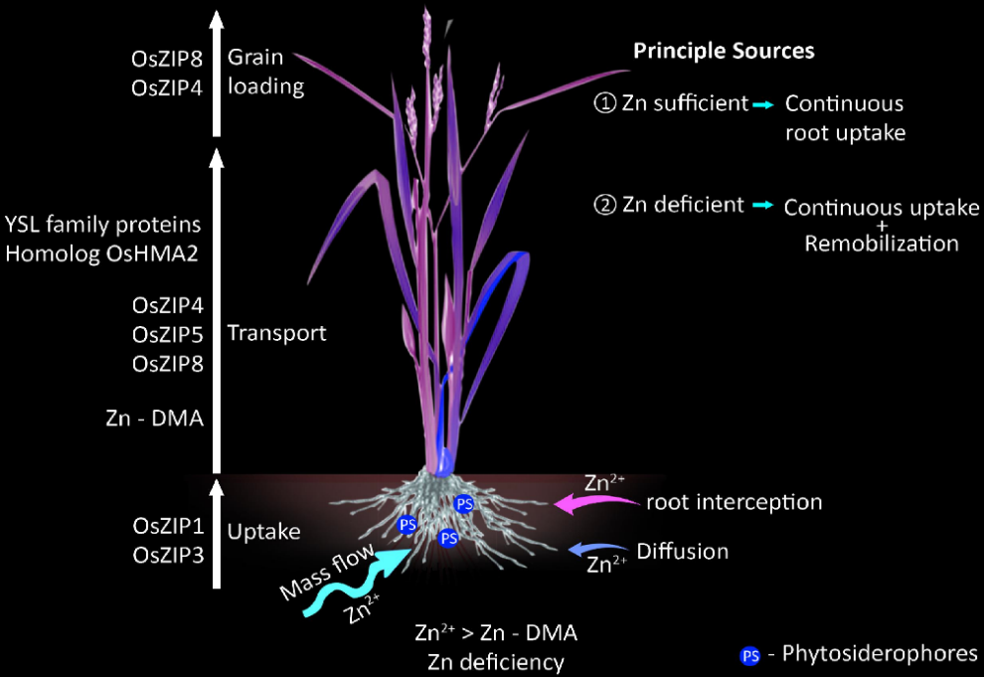

Fig. 5: Systemic diagram of zinc uptake and transport to loading into the rice grains with the help of transporters. Different Zn transporters are involved in long distance transportation and this flow inversely regulated by zinc availability in soil and stage of rice plants (Nakandalage *et al.* 2016).

**Reference**

A. A. Johnson, B. Kyriacou, D. L. Callahan, L. Carruthers, J. Stangoulis and E. Lombi (2011). Constitutive overexpression of the OsNAS gene family reveals single‐gene strategies for effective iron‐ and zinc‐biofortification of rice endosperm. PLOS One, 6(9).

A. K. Shukla, P. K. Tiwari, A. Pakhare and C. Prakash (2016) Zinc and iron in soil, plant, animal and human health. Indian J Fertil 12(11):133–149.

A. S. Prasad (1991). Discovery of human zinc deficiency and studies in an experimental human model. The American Journal of Clinical Nutrition 53 (2): 403–12.

A. Sasaki, N. Yamaji and J. F. Ma (2016). Transporters involved in mineral nutrient uptake in rice. J Exp Bot 67: 3645–3653.

A. Sasaki, N. Yamaji, N. Mitani-Ueno, M. Kashino and J. F. Ma (2015). A node-localized transporter OsZIP3 is responsible for the preferential distribution of Zn to developing tissues in rice. Plant J., 84(2): 374–384.

B. J. Alloway (2008). Zinc in soils and crop nutrition. Belgium: international zinc association Brussels.

B. Leitenmaier and H. Küpper (2013). Compartmentation and complexation of metals in hyperaccumulator plants. Front Plant Sci. 4: 374–380.

B. P. M. Swamy, M. A. Rahman, M. A. Inabangan-Asilo, A. Amparado, C. Manito, P. Chadha-Mohanty, R. Reinke and I, H. Slamet-Loedin (2016). Advances in breeding for high grain zinc in rice. Rice, 9, 49: 2-16.

C. Kamaral, S. M. Neate, N. Gunasinghe, P. J. Milham, D. J. Paterson, P. M. Kopittke, and S. Seneweera (2021). Genetic biofortification of wheat with zinc: Opportunities to fine-tune zinc uptake, transport and grain loading. Physiologia Plantarum, 1-18.

C. N. Neeraja, K. S. Kulkarni, P. M. Babu, S. D. Rao, K. Surekha and R. V. Babu (2018). Transporter genes identified in landraces associated with high zinc in polished rice through panicle transcriptome for biofortification. PLOS One, 13(2).

C. Noulas, M. Tziouvalekas and T. Karyotis (2018). Zinc in soils, water and food crops. J Trace Elem Med Biol 49: 252–260.

C. Y. Wu, L. L. Lu, X. E. Yang, Y. Feng, Y. Y. Wei and H. L. Hao (2010). Uptake, translocation, and remobilization of zinc absorbed at different growth stages by rice genotypes of different Zn densities. Journal of Agricultural and Food Chemistry, 58(11): 6767–6773.

G. S. Khush, S. Lee, J. I. Cho and J. S. Jeon (2012). Biofortification of crops for reducing malnutrition. Plant Biotechnol Rep. 6:195–202.

H. Mao, J. Wang, Z. Wang, Y. Zan, G. Lyons and C. Zou (2014). Using agronomic biofortification to boost zinc, selenium, and iodine concentrations of food crops grown on the loess plateau in China. J Soil Sci Plant Nutr. 14: 459–470.

H. Marschner (1993). Zinc uptake from soils. In: Robson AD (ed) zinc in soils and plants. Kluwer, Dordrecht, 59–77.

I. Cakmak, (2008). Enrichment of cereal grains with zinc: agronomic or genetic biofortification? Plant Soil 302:1–17.

J. Che, N. Yamaji and J. F. Ma (2018). Efficient and flexible uptake system for mineral elements in plants. New Phytol., 219: 513–517.

L. Tan, M. Qu, Y. Zhu, C. Peng and J. Wang (2020). Zinc transporter5 and zinc transporter9 function synergistically in zinc/cadmium uptake1. Plant Physiology, 183(3): 1235–1249.

L. Tan, Y. Zhu, T. Fan, C. Peng, J. Wang, L. Sun and C. Chen (2019). OsZIP7 functions in xylem loading in roots and inter-vascular transfer in nodes to deliver Zn/Cd to grain in rice. Biochem Biophys Res Commun., 512(1): 112–118.

M. G. Palmgren, S. Clemens, L. E. Williams, U. Krämer, S. Borg, J. K. Schjørring and D. Sanders (2008). Zinc biofortification of cereals: problems and solutions. Trends Plant Sci. 13: 464–473.

M. R. Broadley, P. J. White, J. P. Hammond, I. Zelko, and A. Lux, (2007). Zn in plants. New Phytol. 173: 677–702.

M. Suzuki, T. Tsukamoto, H. Inoue, S. Watanabe, S. Matsuhashi, M. Takahashi, H. Nakanishi, S. Mori and N. K. Nishizawa (2008). Deoxymugineic acid increases Zn translocation in Zn-deficient rice plants. Plant Mol Biol., 66(6): 609–617.

N. Gupta, H. Ram and B. Kumar (2016). Mechanism of Zinc absorption in plants: uptake, transport, translocation and accumulation. Rev Environ Sci Biotechnol.

N. Nakandalage, M. Nicolas, R. M. Norton, N. Hirotsu, P. Milham and S. Seneweera (2016). Improving rice zinc biofortification success rates through genetic and crop management approaches in a changing environment. Front Plant Sci. 7: 764.

N. Yamaji and J. F. Ma (2014). The node, a hub for mineral nutrient distribution in graminaceous plants. Trends Plant Sci 19: 556–563.

N. Yamaji, J. Xia, N. Mitani-Ueno, K. Yokosho and M. J. Feng (2013). Preferential delivery of zinc to developing tissues in rice is mediated by P-type heavy metal ATPase OsHMA2. Plant Physiol 162(2): 927–939.

News and Analysis on Supplements, Health and Nutrition – Asia Pacific. (2021). <https://www.nutraingredients-asia.com/>

P. K. Verma, S. Verma, D. Chakrabarty and N. Pandey (2021). Biotechnological approaches to enhance zinc uptake and utilization efficiency in cereal crops. Journal of Soil Science and Plant Nutrition,

P. K. Verma, S. Verma, D. Chakrabarty and N. Pandey (2021). Biotechnological approaches to enhance zinc uptake and utilization efficiency in cereal crops. Journal of Soil Science and Plant Nutrition,

Q. U. Zaman, Z. Aslam, M. Yaseen, M. Z. Ihsan, A. Khaliq S. Fahad, S. Bashir, P. M. A. Ramzani and M. Naeem (2018). Zinc biofortification in rice: leveraging agriculture to moderate hidden hunger in developing countries, Archives of Agronomy and Soil Science, 64 (2): 147-161.

R. A. Sperotto (2013). Zn/Fe remobilization from vegetative tissues to rice seeds: Should I stay or should I go? Ask Zn/Fe supply!. Frontiers in Plant Science, 4, 464.

R. Schulin, S. Tandya, C. Thonarb, R. Grütera, B. Costeroussea, I. Müllera, J. Helfensteina, T. Dürr-Austera, F. Aghilia, V. Dorostkarc and A. Khoshgoftarmaneshc (2015). Zinc biofortification of wheat through soil organic matter management. 42.

R. Takahashi, Y. Ishimaru, H. Shimo, Y. Ogo, T. Senoura, N. K. Nishizawa and H. Nakanishi (2012). The OsHMA2 transporter is involved in root-to-shoot translocation of Zn and Cd in rice. Plant Cell Environ 35(11): 1948–1957.

S. A. Ramesh, R. Shin, D. J. Eide and D. P. Schachtman (2003). Differential metal selectivity and gene expression of two zinc transporters from rice. Plant Physiology, 133(1): 126–134.

S. Amini, B. Arsova, and M. Hanikenne (2021). The molecular basis of zinc homeostasis in cereals. Plant Cell Environment, 45:1339–1361.

S. Gao, Y. Xiao, F. Xu, X. Gao, S. Cao, F. Zhang, G. Wang, D. Sanders and C. Chu (2019). Cytokinin-dependent regulatory module underlies the maintenance of zinc nutrition in rice. New Phytol., 224(1): 202–215.

S. Krishnan and P. Dayanandan (2003). Structural and histochemical studies on grain-filling in the caryopsis of rice (*Oryza sativa L.*). J. Biosci., 28: 455–469.

S. Lee and G. An (2009). Over-expression of OsIRT1 leads to increased iron and zinc accumulations in rice. Plant Cell Environ 32: 408–416.

S. Lee, H. J. Jeong, S. A. Kim, J. Lee, M. L. Guerinot and G. An (2010). OsZIP5 is a plasma membrane zinc transporter in rice. Plant Mol Biol. 73: 507–517.

S. Lee, Y. Y. Kim, Y. Lee and G. An (2007). Rice P1B-type heavy-metal ATPase, OsHMA9, is a metal efflux protein. Plant Physiol., 145: 831–842.

S. M. Impa, M. J. Morete, A. M. Ismail, R. Schulin and S. E. Johnson-Beebout (2013). Zn uptake, translocation and grain Zn loading in rice (*Oryza sativa L.*) genotypes selected for Zn deficiency tolerance and high grain Zn. J Exp Bot 64 (10):2739–2751.

X. S. Liu, S. J. Feng, B. Q. Zhang, M. Q. Wang, H. W. Cao, J. K. Rono, X. Chen and Z. M. Yang (2019). OsZIP1 functions as a metal efflux transporter limiting excess zinc, copper and cadmium accumulation in rice. BMC Plant Biol., 19(1): 283.

Y. Coudert, C. Perin, B. Courtois, N. G. Khong and P. Gantet (2010). Genetic control of root development in rice, the model cereal. Trends Plant Sci., 15: 219–226.

Y. Ishimaru, H. Masuda, M. Suzuki, K. Bashir, M. Takahashi and H. Nakanishi (2007). Overexpression of the OsZIP4 zinc transporter confers disarrangement of zinc distribution in rice plants. J Exp Bot. 58: 2909–2915.

Y. Ishimaru, K. Bashir and N. K. Nishizawa (2011). Zn uptake and translocation in rice plants. Rice, 4, 21–27.

Y. Ishimaru, M. Suzuki, T. Kobayashi, M. Takahashi, H. Nakanishi, S. Moria and N. K. Nishizawa (2005). OsZIP4, a novel zinc-regulated zinc transporter in rice. J Exp Bot 56(422): 3207–3214.

Y. Kawakami and N. K. Bhullar (2018). Molecular processes in iron and zinc homeostasis and their modulation for biofortification in rice. Journal of Integrative Plant Biology, 60 (12): 1181–1198.

Z. Aiqing, L. Zhang, P. Ning, Q. Chen, B. Wang, F. Zhang, X. Yang and Y. Zhang (2021). Zinc in cereal grains: Concentration, distribution, speciation, bioavailability, and barriers to transport from roots to grains in wheat. Critical Reviews in Food Science and Nutrition, 2-12.