ISOLATION AND CHARACTERIZATION OF MICROBES FROM DIABETES MELLITUS CELLULITIS WOUND SAMPLE AND ESTIITS ANTIMICROBIAL PROPERTIEs

*KRISHNAVENI.R'., AYISHA SHIFANA.A'., THAMEENA BEGAM.M'.,

ASEELA MAIMOONA.H'., KEERTHIKA.S'.

Assistant professor and Head, PG &Research Department of Microbiology,

IdhayaCollege for Women ,Kumbakonam.

Ayisha Shifana.A, Thameena Begam.M, Aseela Maimoona.H, Keerthika.S, Ug Students, PG &Research Department of Microbiology,

IdhayaCollege for Women, Kumbakonam.

*Corresponding author. krishnavenimicro@gmail.com

ABSTRACT:

Bacterial Cellulitis is a spreading skin infection and causes skin lesions, necrotizing fasciitis, septic Arthritis and Osteomyelitis. It Damage the skin causes an abscess, Folliculitis. In the present study carriedout isolation and characterization of microbes from Cellulitis wounds samples from Diabetes Mellitus patients and testing its antimicrobial activity against the herbal plants, medicinal
plants Biden spilosa, Aloe barbadensis ,Rauvolfia serpentina. In the present study Klebsiella pneumonia enters through a break in your skin. It can infect your skin or soft tissue usually this happens with wounds caused by injury or surgery. Klebsiella pneumonia liver abscesses commonly affect people with diabetes or who have been taking antibiotics for a long time. Testing of Klebsiella pneumonia against herbal plants the maximum Zone serpentine (22mm) and minimum in Aloe barbadensis. Staphylococcus aureus bacteria cause Staphylococcus infections. There are Many types of Staphylococcus infections and depending on the cause,doctors may are antibiotics surgery or other methods to treat them. Most Staphylococcus infections clear up quickly with treatment, but people with a weekend immune system are at higher risk and may take longer to recover, Staphylococcus sp.,shows 15mm observed in Bidenspilosa maximum (15mm) and minimum (3mm) in Aloe barbadensis. Streptococcus sp., Cellulitis, an acute spreading Inflammation of the skin and Subcutaneous tissues, usually results from infections of Burns, Wounds or Surgical incisions but may also follow mild trauma clinical findings include Local pain, Tenderness, Swelling and Erythema. Streptococcus sp., shows maximum zone of Inhibition (13mm) and minimum in Aloe barbadensis (1mm). In the present study it concludes Rauvolfia serpentinaand Biden spilosa, maximum zone of inhibition against Cellulitis wound infection in Klebsiella shows maximum zone of inhibition. And Rauvolfia serpentine (22mm) and Bidens pilosa (19mm) were observed.

INTRODUCTION
Diabetes Mellitus is Prolonged disease. If the Pancreas Cannot Produce Sufficient Insulin. This Condition is known as Diabetes Mellitus. The Person who affected by Diabetes Mellitus faced many critical problems by microvascular dysfunction.
There are Some critical problems due to Diabetes Mellitus. They are Neuropathy, Obesity, Hypertension and High Susceptibility to a different pathogenic disease. Therefore low level of blood sugar caused highly fatal condition like Cardiovascular disease, Foot damage, Hearing difficulties, Fungal and bacterial disease, Alzheimer disease, Memory loss and stress (KimH-2019).The incidence of diabetes is greater in developing countries compared with developed ones. (Animaw ndseyoumY.2017).
Bacterial Cellulitis and erysipelas which means burst, Spreading skin infection and other infection belongs with occurring suppurative foci like Skin lesions, necrotizing fasciitis Septic arthritis and Osteomyelitis. Normally innermost occurred skin infection is called Cellulitis and outermost layer infection is known as Erysipelas. Therefore the difference between these two diseases is not vivid properly and other two conditions distributed the medical properties. Group B and rarely ,Staphylococcus sp., can also cause these disease(BonnetblancJM,BedaneC.2003,Chartier C,Groshans E 1990;Eriksson B et al 1996) .Result of patient blood culture normally positive for Beta-hemolytic Streptococcus sp., in <5% of cases (Bonnet blanc JM et al.,2003).( Chartier et al.,1990.Eriksson B et al.,)Although Cellulitis is normally not a fatal disease it leads to specific morbidity ,especially in older persons ( Bison AL, Stevens DL. Streptococcal infection of skin and soft tissues, N Engel J Med 1996).
Streptococcus sp., are classified under their Hemolytic properties and origin blood typing The explanation of wound healing is group of completive process which deals with varieties of compounds such as soluble mediators, blood cells, extra cellular matrix and parenchymal cell (Ballers S., et al.,2012).The antibiotics, antiseptics and chemical properties are the several agent that cure the infection. Streptococcus sp., is a Beta-hemolytic Streptococci and it is originated group A highly medical vital Species. Siddha Medicine have the capacity to recur from infections are ulcers, wound healing, skin lesions, Scabies, leprosy and venereal disease (kirthikar KR and Basu BD 2001).A wound is disruption of living tissue’s Cellular, Structural and Functional regularity caused by Physical, Chemical, Electrical or Microbial threats to the tissue(Yuvan H et al.,2016) and (Schilling JA1985).
The Staphylococcus aureus is a main pathogenic organism of diabetes mellitus foot infection. Dang, C.N et, al.,(2007) . Community Pharmacist it can play an vital role in ulcers that can cause skin inflammation such as Cellulitis which include Cellulitis, epidermis, dermis and in more complicated cases Subcutaneous tissue (Merlin J.I.,et ,al.,2007). Any disruption in the process of wound healing or pathological scarring Pastar, I., et.al.,(2014). Wound of Diabetes Mellitus foot so often contain infection leads to several condition including high blood sugar, suppressed immunity, inadequate blood supply and neuropathy ( Aherrao N et al., 2012).Normally such infection poly-microbial where anaerobic bacteria co-exist with aerobic organism (LipskyBA.,1997).In these cases, Anaerobes often complicate the long-standing ulcers by producing necrotic materials and fouled(LipskyBA et al.,1990). From the Medical preserved species, normally only oxygen utilizing organisms are isolated because of technical difficulties and not exceeding resources. Modified candle jar technique, developed and Validated for culture of anaerobes(Maiti PK et al.,2024) can be a simple replacement for such cases for method to isolate anaerobes from the samples of Diabetes foot ulcers. Type l Diabetes Mellitus affects 5-10% of patients and mostly occurs in young ages which have auto Immune destruction of beta-cell. This is treated mainly by Insulin. Patients in this type are non-obese (Lipsky BA etal.,1997).. Patients in this case are fast and highly affected by family history of Diabetes Mellitus (Servant PR,2018).Krishnaveni et. al.,(2020)into different sp., by their ability to Heamolyse blood by serology and or by biochemical tests.
All Staphylococcus aureus., produce the enzyme catalase which is used in the laboratory for rapid identification Kumar et. al.,(2006).Staphylococcus aureus and Coagulase negative Staphylococcus seen the high constituent of the Human skin microflora and responsible for differ of infections ranging from surface to deep wound and Septicaemia (Coloradoan Adegoke,2008).Reports have show that Bacterial Isolated contain developed non- sensitive Antimicrobial Chemotherapy and their prevalence in both hospital and community Acquired Infections is of potential threat(kalponetal.,2005). The Infection rate for Staphylococcus aureus is high. In the presence of organic acids, the organism was also able to survive the acidic stress. Chithra,P., et. al.,(1998). Therefore, it is of course that the positive retrospective studies on multi-drug Resistance should put the capable antibiotics in the region into consideration. Antimicrobial non-sensitive Staphylococcus aureus is a high people health threat, compounded by the urgency of strains resistant to Vancomycin and Daptomycin , both of which are last Antimicrobials (Menichetti 2005.,Van et al., Sass et al.,2012). The importance of wound healing including in a process on Connective Tissue Repairment on non behavioural by four over lapping stages such as haemostasis, swelling proliferation and again modelling in which the repairmen process need the association of various cells growth factors and cytokines (Cianfarani et al.,2013,Diegelmann,R.F and Evans, M.C 2004). Another medically important CONS in Staphylococcus saprophyticus which cause urinary tract infection in sexually active women. William Irving et. al.,(2015).
Delay in collagen synthesis and impairment in epithelial formation coupled with reduced angiogenesis have been observed during the proliferative stage of the healing process(Tam ,J.A.C et al.,2011,Caskey,R.C et al., 2014).
    - TOXONOMY OF Bidens pilosa (L)
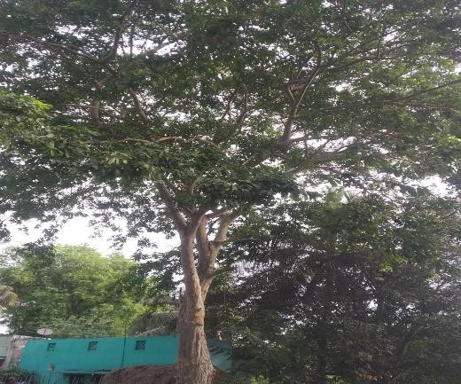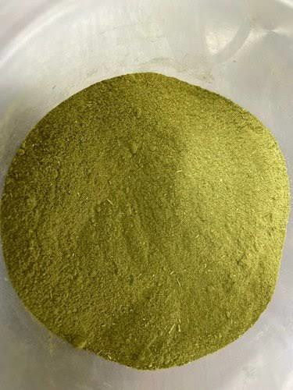

Bidens pilosa Bidenspilosa
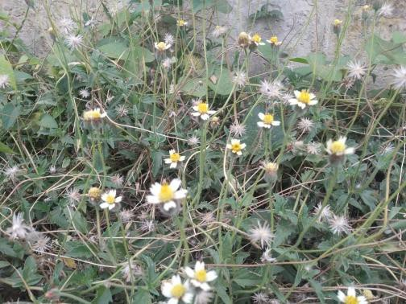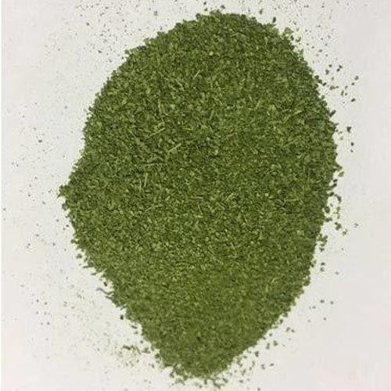

    - MEDICINAL PROPERTIES OF Bidenspilosa

Bidenspilosa, has been reported to be use full in the treatment of more than fourty disorder such as Inflammation, Immunological Disorders, Digestive Disorders Infectious Diseases, Cancers Metabolic Syndrome, Wounds and many other (P.V Tan et al.,). Bidensphilosais used to treat snake bites and wounds S.dharmananada, (2013). It is commonly used to treat inflammatory disorders. Its expression is induced by a wide variety of external stimuli indicating its involvement in Inflammatory Diseases, and it is used as an inflammatory Marker A. Xagorari, et al., (2001).
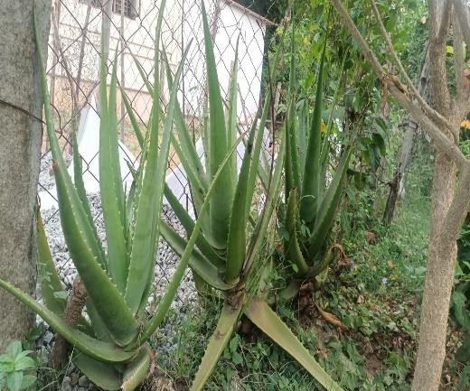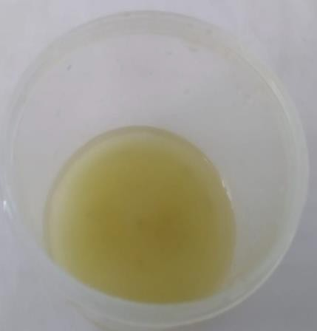

Aloe barbadensis Aloebarbadensis extract

    - MEDICINAL PROPERTIES OF Aleobarbadensis

It is originated from the Arabian Peninsula, but grows wild in tropical, semitropical and arid climates around the world. It is cultivated for commercial products, mainly as a topical treatment used over centuries. The species is attractive for decorative purposes and succeeds indoors as a potted plant. It is used in many consumer products, including beverages, skin lotion, cosmetics, ointments or in the form of gel for minor burns and sunburns. There is little clinical evidence for the effectiveness or safety of Aloe veraextract as a cosmetic or topical drug. Aloe verais a stemless or very short- stemmedplantgrowingto60- 100centimeters (24-39 inches) tall, spreading by offsets.

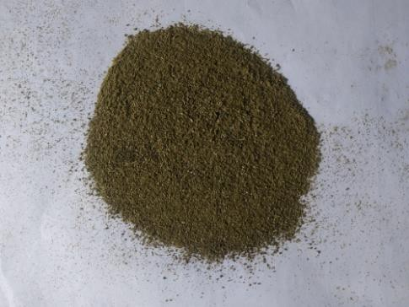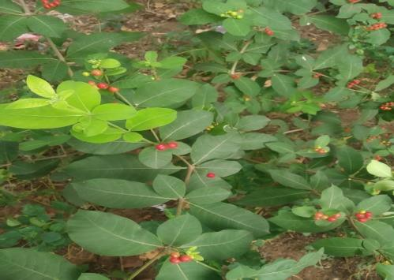

Rauvolfia serpentine Rauvolfia serpentina leaf powder

2.4 MEDICINAL PROPERTIES OF Rauvolfia serpentina

It is a perennial shrub. The roots of Rauwolfia are rarely branched. The rootlets are 0.5-1mm in diameter. Pieces of Rhizobes are recognized by a small central pith but it is closely resembling roots and sometimes they are attached to them small pieces of aerial stem. The external surface is grayish- yellow or light brown or brown in color. Outer surface consists of wrinkles or longitudinal ridges with occasional scars of rootlets. The drug composed of mostly small pieces which are 2-15 cm long and 3-22 mm in diameter. The shape of pieces is cylindrical, slightly tapering and tortuous.
Cellulitis Wound on Isolated Microbes from Cellulitis Diabetic Patients Diabetic Wound Sample

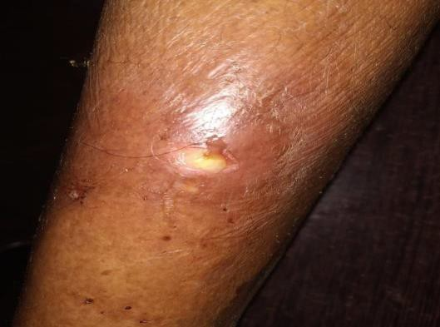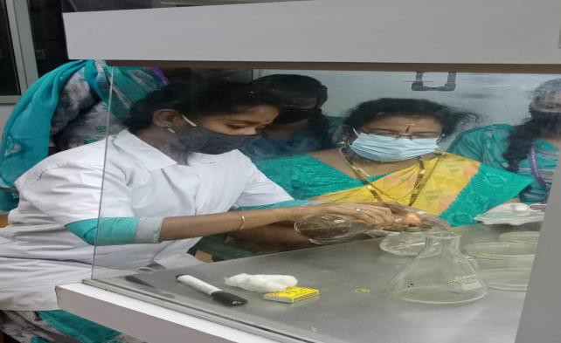

RESULT AND DISCUSSION

The present study carried out on isolation and Identification of Microbes from Cellulitis Wound Infection. Cellulitis is usually caused when bacteria enter a wound or area where there is no skin. The most common bacteria that cause Cellulitis include: group A β heamolytic Streptococcus,.

Klebsiella sp., acquired an increased acid tolerance during exponential growth upon exposure to sublethal acid stress a response designated as acid tolerance response Maximal Acid Resistance was seen when the organism was exposed to PH 5.0 (pre- acid skock) prior to challenge a PH 3.5. In the presence of organic acids, the organism was also able to survive the acidic stress.Chithra, P.,etal.,(1998).

Streptococcus sp., is a Gram-Positive pathogenic bacterium which causing a Wound and various Infection in various Cutaneous layer of the body. And many Terminalia sp., having the Antimicrobial activity against the pathogens Isolated from the Cellulitic Wound. Terminalia arjuna., extracts shows the potent Antimicrobial activity in the Disc Diffusion Assay against streptococcus sp., Mitchell henry et al.,(2016).,

Cellulitis due to S.pyogenesfollows a different pattern. It spreads rapidly and diffusely and is frequently associated with Lymphangitis and fever (silver berg and block.s ,2004). Recurrent Streptococcus cellulitis of the lower extremities Staphylococcus and Streptococcus species., are also the most common pathogens in Bacterial Infection among Drug- uses and Infection that implicate an unusual organism are often related to a specific Drug or drug-use behavior.

Supporting case measures include the elevation and Immobilization of the involved limb to reduce swelling and Application of sterile saline dressing to remove purulence from open lesions. Dermatophytic infections should be treated with topical Antifungal agents until cleared prompt use of Antifungal either Prophylactically or at the earliest sign of reference can reduce the risk of spreading

The results obtained from the present study shows that Staphylococcus aureus remains a prominent etiological agent in pyogenic infection. That the bacterium was Isolated from all the patients in the investigation, with makes the organism an issue for concern. Staphylococcus species was Isolated from Cellulitis wound correlated with the finding of the trend of Antibiotics Resistance to a large number of commonly prescribed Drugs as observed in the present study conforms to earlier findings.

In the present study Terminalia arjuna, Bidenspilosa, Aloe barbadensis, Rauvolfia serpentine can be done as there is the possibility that there might be a new Mutation of staphylococcus aureus originating from this region.

Bidenspilosa, has been reported to be useful in the Treatment of more than Fourty disorders such as Inflammation, Immunological Disorders, Digestive Disorders Infectious Diseases, Cancers Metabolic Syndrome, Wounds and many other (P.V Tan et al.,). Bidenspilosais used to treat Snake Bites and wounds Dharmananada.S, (2013). It is commonly used to treat Inflammatory Disorders. Its expression is induced by a wide variety of external stimuli indicating its involvement in Inflammatory Diseases, and it is used as an Inflammatory Marker. BidensPilosais an erect, perennial herb widely distributed across temperate and tropical regions. BidensPilosais either glabrous or hairy, with green opposite leaves that are serrate, lobbed or dissected. it has white or yellow flowers, and long narrow ribbed black achene’s (seeds). It grows to an average height of 60 cm and a maximum of 150 cm in favorable environments (Alcaraz and Jimenez, 1988).

It is originated from the Arabian Peninsula, but grows wild in tropical, semitropical and arid climates around the world. It is cultivated for commercial products, mainly as a topical Treatment used over centuries. The species is attractive for decorative purposes and succeeds indoors as a potted plant. It is used in many consumer products, including Beverages, Skin Lotion, Cosmetics, Ointments or in the form of gel for minor burns and sunburns. There is little clinical evidence for the effectiveness or safety of Aloe Vera extract as a cosmetic or topical drug. Aloe Vera is a stemless or very short- stemmed plant growing to 60- 100 centimeters (24-39 inches) tall, spreading by offsets.

The present work carried out Isolation and Characterization of microbes from Diabetic wound sample. Ten samples were collected from Diabetes cellulitic wound in S.Pudur, Thanjavur district, Tamilnadu. The bacterium like staphylococcus aureus. streptococcus sp., E.coli and Klebsiella sp., was isolated.

Antimicrobial activity of E.coli., against Terminalia arjuna, Bidenspilosa, Aloe barbadensis, Rauvolfiaserpentina. The maximum zone of inhibition observed on Rauvolfia serpentine(19mm). And minimum zone of inhibition observed in Aloe barbadensis.(4mm) and resistant in Arjuna trees. Testing of Klebsiella sp., against herbal plants the maximum zone Rauvolfiaserpentina.(20mm) and minimum in Aloe barbadensis(2mm).Testing of Stretococcus sp., shows more zone of inhibition (13mm) and minimum in Aloe barbadensis(1mm).Testing of Staphylococcus aureus., shows (15mm) observed in Bidenspilosashows maximum zone of inhibition and minimum zone of inhibition observed in Aloe barbadensis(3mm).

Previous studies suggested Aloe barbadensisor one or more of its constituents, promotes wound healing in various animal models however it mechanism of action remains unclear evaluated the effects of Aloe vera gel on full- thickness wound in diabetic rats. Their results indicated Aloe barbadensis
treatment may enhance the process of wound healing by affecting fibroplasia, collagen synthesis and wound contraction Eric Teplickieet al.,(2018).

In the present work the Cellulitis bacterium E.coli.shows the maximum zone of inhition (19mm) in Rauvolfia. Klebsiella sp.,shows the maximum zone (22mm) in Rauvolfia serpentine. Streptococcus sp., shows the maximum zone of inhibition in (14mm) in Bidens pilosa. And Staphylococcus aureus.,

Applying Terminalia arjuna powder reduces inflammation and reduces bleeding. This is because of its sita (cold) and kashaya (astringent) properties.

She present work carried out on Isolation and Characterization of microbes from cellulitis Diabetic wound. The Microbes like Staphylococcus aureus., Streptococcus sp.,Klebsiella sp., E.coli were isolated. The cellulities wound of Staphylococcus aureus., their skin Staphylococcus aureus causes serious infection of the skin, Soft tissue, Bone, Lung, Heart, Brain or Blood. Staphylococcus aureus is gram positive cocci that divide three- dimensionally to form clumps or clusters of cells. Kalpan et al., (2005). They are Nonmotile, Non sporulating and facultative anaerobes which grow well on most media. All Staphylococcus aureus.,produce the enzyme catalase which is used in the laboratory for rapid identification Kumar et al., (2006).

Staphylococcus aureus is the most virulent member of this genus and its defining characteristics is its ability to produce the enzyme Coagulase. All the other species, collectively named Coagulase- negative Staphylococcus aureus (CONS), are weaker pathogens. The best known and most prevalent CONS species is
Staphylococcus epidermis. Another medically important CONS in Staphylococcus saprophyticus which causes urinary tract infection in sexually active women. William lrving et al.,(2015).

The Streptococcus sp. is gram positive cocci that divide two dimensionally and form short or long chains. They are non motile and most strains grow under both aerobic and anaerobic conditions. Some species are strictly anaerobic (peptrstreptococcus) and other require Co2 for good growth unlike Staphylococcus sp,andStreptococcus sp.,are Catalase Negative. Krishnaveni et al.,(2020) into different sp., by their ability to Heamolyse blood by serology and/or by Biochemical tests. Most Streptococcus sp., do not tolerable. Whereas all enterococcus are bile tolerant and live in the human gut. Pfoh E wesselsgroup A Streptococcus pharingitis(2008).

Group A streptococci produce Impetigo, Cellulitis, Erysipelas, Wound infection and Gangrene and Cellulitis. It is an Inflammation of the skin or and underlying connective tissue in Diabetic patients Cellulitis may leads to Gangrene.

Table 1:Isolation of Microbes from Diabetic Wound

s. no | Isolated microbes | Colony forming units  CFU/ ml
 |  | Colonies | Units
1.  2.  3.  4. | E-coli  Staphylococcus aureus  Streptococcus sp.,  Klebsiella | 180  200  280  160 | 1.8X10³  2.0X10³  2.8X10³  1.6X10³

Table – 1 a): Biological Characteristics of E.Colion Cellulitic Diabetic Wound

S.No | Biological Test/ Staining | Positive/Negative
1 | Gram staining | (Rod shape) negative
2 | Culture characteristics on agar | White, moist glistening
 | slant | appearance
3 | Gelatin liquification | Negative
4 | Starch hydrolysis | Negative
5 | Liquid hydrolysis | Negative
6 | Lactose | AG
7 | Dextrose | AG
8 | Sucrose | A+
9 | H2s production | Negative
10 | No3 reduction | Positive
11 | Indole production | Positive
12 | MR reaction | Positive
13 | VP reaction | Negative
14 | Citrate utilization | Negative
15 | Urease activity | Negative
16 | Catalase activity | Positive

Acid +, gas +, reduction +
Fig – 1a): Biochemical Characters of Escherichia coli

E.coli on EMB AgarE .coli on Blood Agar

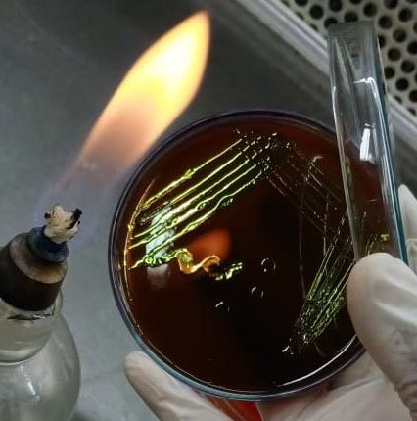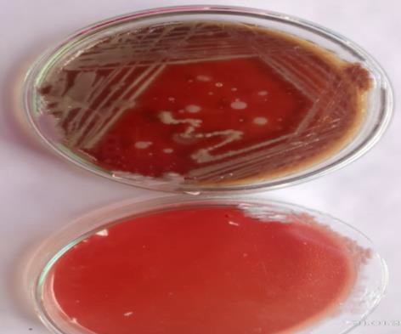

S.No | Biochemical Characters |  | Positive/ Negative
1 | Gram staining |  | Rod (Negative)
2 | Culture characteristics | on | Slimy, white somewhat
 | agar slant |  | translucent raised growth.
3 | Gelatin liquification |  | Negative
4 | Starch liquification |  | Negative
5 | Liquid liquification |  | Negative
6 | Lactose |  | AG
7 | Dextrose |  | AG
8 | Sucrose |  | AG
9 | H2s production |  | Negative
10 | No3 reduction |  | Positive
11 | Indole production |  | Negative
12 | MR reaction |  | Negative
13 | VP reaction |  | + acid gas, curd +
14 | Citrate use |  | Positive
15 | Urease activity |  | Positive
Table - 2: Biological Characteristics of Klebsiella sp., on Cellulitic Diabetic

Fig – 2: Biochemical characters of Klebsiella sp.

a) Klebsiellasp., on HectoneEntric agar b) Citrate Test – Positive

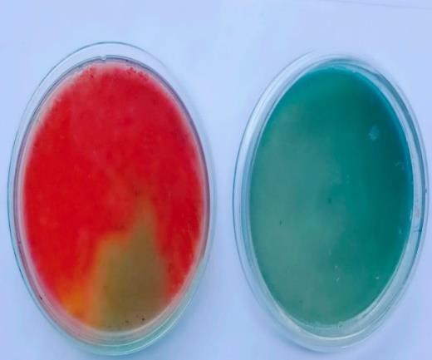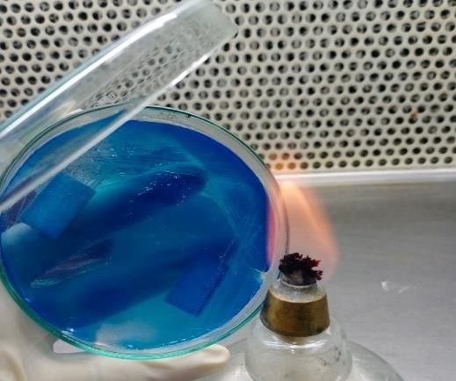

- Klebsiellasp., on Macconkey Agar

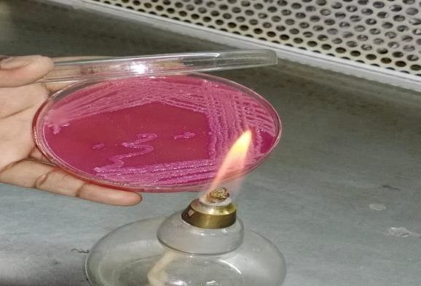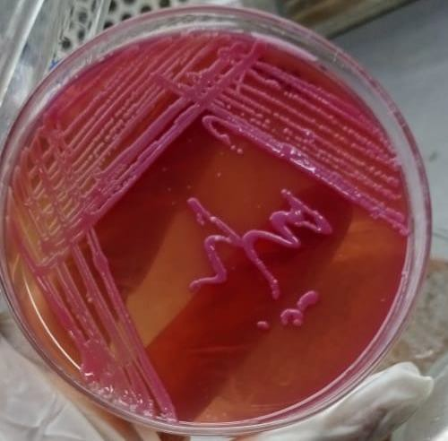

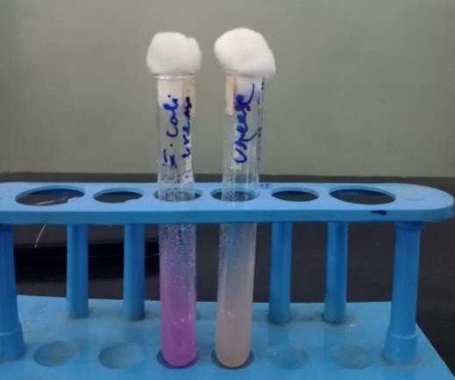
Urease Test - Positive Nitrate Reduction Tes

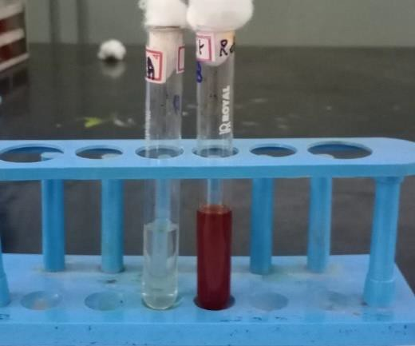
Table - 3: Biological Characteristics of Staphylococcus Sp., on Cellulitic Diabetic Wound

s.no | Biochemical test/staining | Positive/ Negative
1 | Gram staining | Positive coccus
2 | Culture characteristic on agar | Abundant, opaque golden
 | slant | growth
3 | Gelatin liquification | Positive
4 | Starch liquification | Negative
5 | Liquid liquification | Positive
6 | Lactose | Absence
7 | Dextrose | Absence
8 | Sucrose | Absence
9 | H2s production | Negative
10 | No3 reduction | Positive
11 | Indole production | Negative
12 | MR reaction | Positive
13 | VP reaction | +
14 | Citrate use | Negative
15 | Urease activity | Negative
16 | Catalase activity | Positive
17 | Oxidase activity | Negative

Acid reduction +
Fig – 3: Biochemical Characters of Staphylococcus aureus

S.aureuson Blood Agar Medium

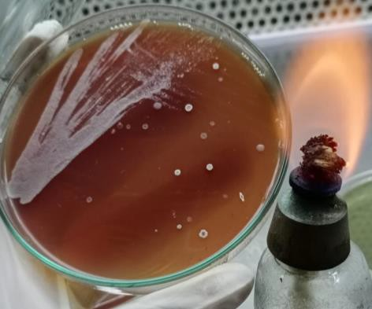

Nitrate Test - Positive MR Test - Positive

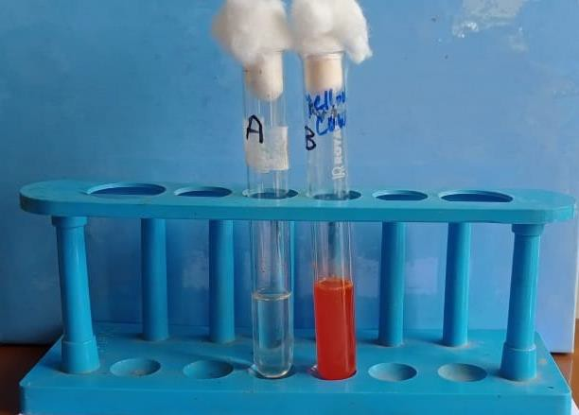
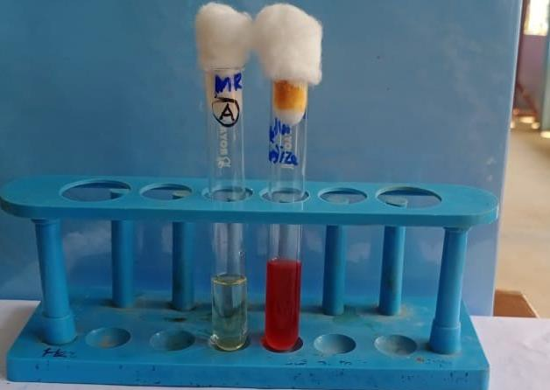

Table - 4: Biological Characters of Streptococcus Sp., on Cellulitic Diabetic Wound

S.NO | BIOLOGICAL TESTING  / STAINING | POSITIVE / NEGATIVE
1 | CAMP (Christie – Alkins | Negative
 | munch Peterson)
2 | Capsule formation | Capsulated
3 | Catalase | Negative
4 | Gram staining | Positive
5 | Hemolysis | Beta hemolysis
6 | Motility | Non -Motile
7 | OF(Oxidative fermentative) | Facultative anaerobes
8 | Shape | Cocci
9 | Spore | Non- sporing
10 | Urease | Negative
11 | VP (VogesProskauer) | Negative
12 | Fructose | Positive
13 | Galactose | Positive
14 | Glucose | Positive
15 | Lactose | Positive
16 | Gelatin liquification | Negative
17 | Starch hydrolysis | Negative

Fig – 4: Bio chemical characters of Streptococcus sp.,

Streptococcus sp., on Blood Agar Medium
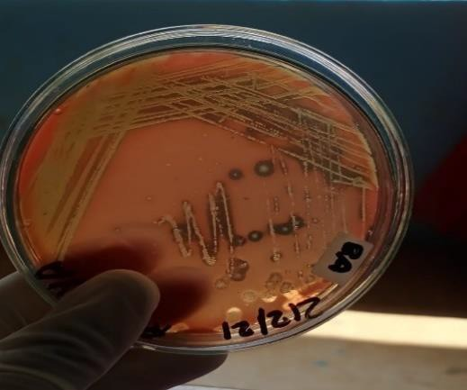

- Table - 5: Antibiotic Sensitivity:

S.NO | ANTIBIOTICS | E .coli | Klebsiella sp., | Streptococcus sp., | Staphylococcus aureus.,
1 | Ciproflaxin | 36mm | 27mm | 12mm | 35mm
2 | Tetracycline | 20mm | 20mm | 19mm | 12mm
3 | Erythromycin | 18mm | 21mm | 11mm | 25mm
4 | Penicillin | No  zone | No zone | 10mm | No zone
5 | Ampicillin | No  zone | No zone | 8mm | 9mm
- 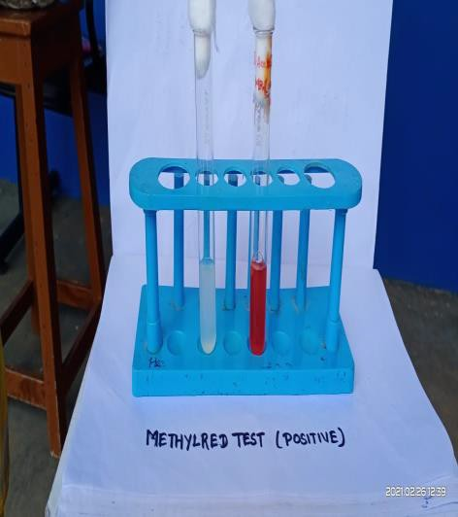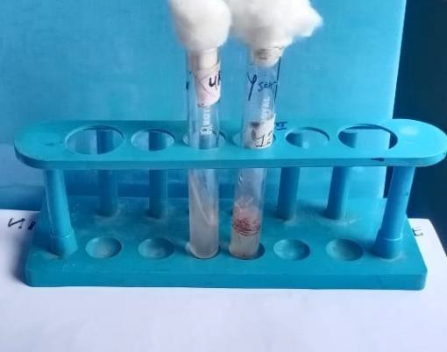Methyl Red Test - Positive c) Urease Test - Negative

Fig – 5: Antimicrobial Activity of Isolated Microbes

b) Disk Diffusion Method on) Disk Diffusion Method on
Streptoccocussp.,

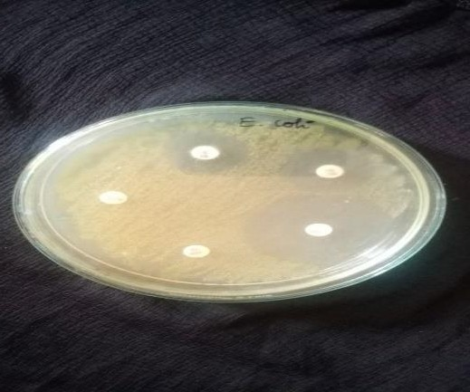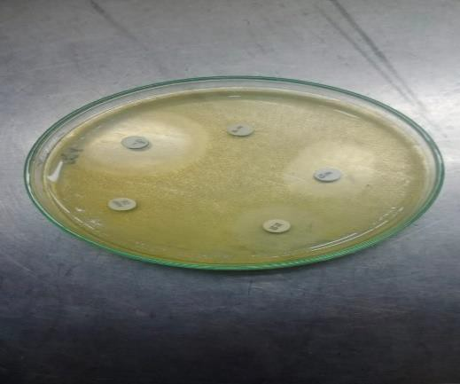

Klebsiellasp., Staphylococcus aureus.,

Table - 6: Antimicrobial Activity of Isolated Microbes

Tested Herbal Extract | E.coli., | Klepsiella sp., | Streptococcus sp., | Staphylococcus aureus.,
Terminalia arjuna | 6mm | 14mm | 12mm | 13mm
Rauvolfiaserpentina | 19mm | 22mm | 10mm | 12mm
Aleobarbadebnsis | 4mm | 2mm | 1mm | 3mm
Bidenspilosa | 14mm | 19mm | 13mm | 15mm

Fig -6: Anti microbial Activity of E.coli Against Herbal Plants
d) Rovolfia serpentine., aginstE.coli b) Bisenspilosaagainst E.coli

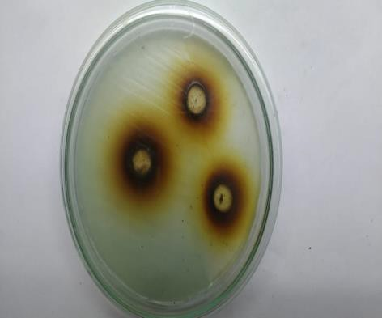
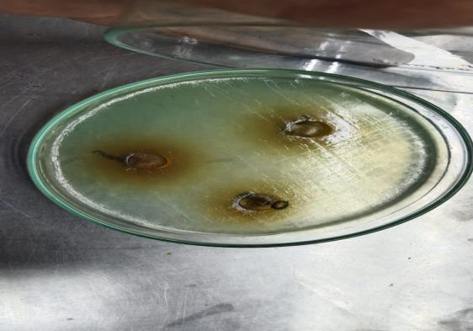

Fig -8: Anti microbial Activity of Streptococcus sp.,

Against Herbal Plants

c) Aloe barbadencisagainst d) Rovolfia serpentine
Streptococcus sp., Streptococcus sp.

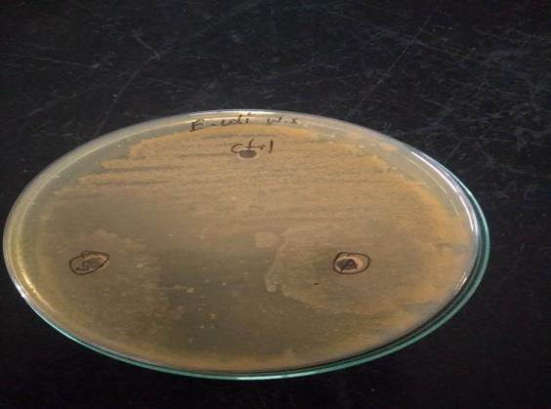
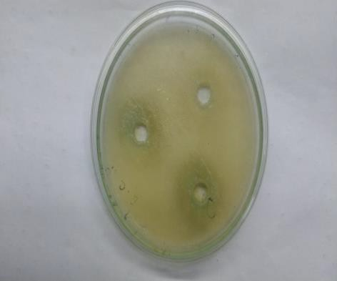

Fig -7: Anti microbial Activity of Staphylococcus aureus., Against Herbal Plants

a)Terminalia arjunaagainst
streptococcus sp., c) Aloe barbadencisagainst

Fig -7: Anti microbial Activity of Staphylococcus aureus., Against Herbal Plants

d) Rovolfiaserpentinaagainst

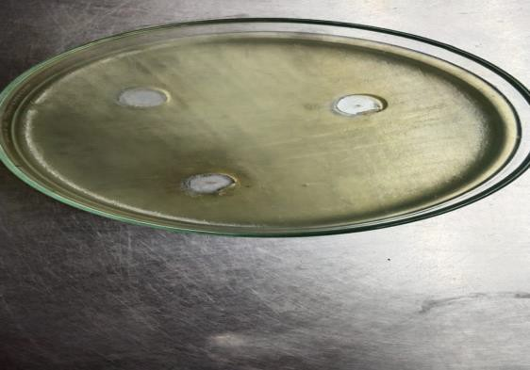

Total Number of Colonies was tabulated CFU/ml of isolated microbes. In the findings Staphylococcus aureus (2.8X10³) maximum no of colonies (280) and minimum Number of colonies (1.6x10³) observed in klebsiella sp., 160 colonies. Followed by E.coli (1.8x10³) colonies and streptococcus (2.0x10³) colonies noted.the biochemical characteristics of E.coli. It is gram negative rods in staining in cultural character. It is white moist glistening appearance. It shows positive on MR reaction, Catalyse active, Indole production and No3 reduction test. It is Negative on Gelatin Liquification, Starch Hydrolysis and Liquid Hydrolysis. It produces Acid and Gas in Lactose and Dextrose Test. It shows the Negative result in H2s production.(Fig-1a)the Biochemical Characters of Klebsiella sp.,., its Gram-Negative Rod in Staining in culture character. It is Slimy, white somewhat translucent raised growth. It shows Positive reaction on Urease Activity, Citrate Use, Catalase Activity test. It is Negative on Gelatin Liquification, Starch Hydrolysis, Liquid Hydrolysis, H2s Production, No3 Reduction, Indole Production, MR Reaction and Oxidase activity. (Fig-2).the biochemical characters of Staphylococcus aureousits Gram-Positive coccus in Staining in cultural character. It is abundant, opaque golden growth. It shows Positive reaction on Gelatin Liquification, Liquid Hydrolysis, No3 reduction and Catalase Test. It is Negative on Starch Hydrolysis, H2s production, Indole Production, Citrate Utilization Test, Urease Activity and Oxidase Activity. It makes absents in Lactose, Dextrose and SucroseStreptococcus aureous it is a Gram Negative, Non motile, Non spore forming cocci. It is catalase Positive and shows β hemolysis in Blood Agar Medium. Its Positive to Fructose, Galactose, Glucose, Lactose, test. It is Negative on Starch hydrolysis, Gelatin liquification, Urease and Catalase test. (Fig-4).

SUMMARY AND CONCLUSSION

Staphylococcus aureus and Staphylococcus sp., bacteria are commonly found on the skin that allows the bacteria to enter. Other causes may include human or animal bites or injuries that Cellulitis is an Infection of the deeper skin layers, occurring almost anywhere in the body, however the foot is the most vulnerable area for Diabetes. It is due to Streptococcus sp., and Staphylococcus sp, bacteria which exist symbiotically on the skin. However, if they enter the body through a cut, they can result in an Infection. Cellulitis ranges from mild to severe levels; mild cases mostly appear as redness in a localized area, while severe cases can lead to sepsis. Sepsis symptoms include Fever, Low blood pressure, Pale skin, Dizziness and a rapid Heartbeat, community pharmacists can play an integral role in educating ulcers that can lead to skin Infections such as Cellulitis, which involves such as Cellulitis which involves the Epidermis, Dermis and in more complicated cases Subcutaneous Tissue .MerlinoJ.I.,et al.,(2007).

Cellulitis is usually caused when bacteria enter a wound or area where there is no skin. The most common bacteria that cause cellulitis include: Group A β hemolytic Streptococcus sp., Streptococcus pneumonia, Staphylococcus happen in water.The present work carried out isolation and characterization of microbes from cellulitis wound sample and testing its antimicrobial activity against herbal plants Terminalia arjuna, Bidenspilosa, Aloe barbadensis, Rauvolfia serpentine.

E.coli is a type of bacteria that normally lives in intestines. It’s also found in the gut of some animals. Most types of E.coli are harmless and even helpkeep your digestive tract healthy. But some strains can cause diarrhea if you eat contaminated food or drink fouled water.While many of us associate E.coli with food poisoning, you can also get Pneumonia and Urinary Tract Infections from different types of the bacteria. In fact 75% to 95% of Urinary Tract Infections are caused by E.coli. E.coliisa normal resident of the bowel, which is how it makes it way to the Urinary Tract.In the present study the isolated E.coli treated against the maximum zone of inhibition (19mm) observed on Rauvolfiaserpentina. and minimum zone of inhibition observed(4mm) Aloe barbadensis.

Klebsiella pneumonia enters through a break in your skin. It can infect your skin or soft tissue usually this happens with wounds caused by injury or surgery. Klebsiella pneumonia liver abscesses commonly affect people with diabetes or who have been taking antibiotics for a long time. Testing of Klebsiella pneumonia against herbal plants the maximum zone serpentine (22mm) and minimum in Aloe barbadensis. (2mm).

Staphylococcus aureus bacteria cause Staphylococcus infections. There are many types of Staphylococcus infections and depending on the cause, doctors may are antibiotics surgery or other methods to treat them. Most Staphylococcus infections clear up quickly with treatment, but people with a weakened immune system are at higher risk and may take longer to recover, Staphylococcus sp., shows 15mm observed in Bidenspilosamaximum (15mm) and minimum (3mm) in Aloe barbadensis.Streptococcus sp., cellulitis, an Acute spreading Inflammation of the skin and subcutaneous tissues, usually results from infections of Burns, Wounds or
Surgical incisions but may also follow mild trauma clinical findings include Local pain, Tenderness, Swelling and Erythema. Streptococcus sp., shows maximum zone of inhibition (13mm) and minimum in Aloe barbadensis(1mm).In the present study it concludes Rauvolfia serpentine and Bidens pilosa, maximum zone of inhibition against cellulitis wound infection in Klebsiella shows maximum zone of inhibition. And Rauvolfia serpentina(22mm) and Bidens pilosa shows (19mm) were observed. So, Rauvolfia serpentine and Bidens pilosa

REFERENCES

- Aherrao.N ,ShahiS.K, Dwivedi A KumarAGuptaS,SinghS.K.Delection of Anaerobic Infection in Diabetic Foot Ulcer Using Pcr Technique and The Status of Metronidazole Therapy onTreatment Outcome, Wound2012;24:283-8.
- American Diabetes Association ,Diagnosis and classification of Diabetes Mellitus, Diabetes Care2013;36(suppl1):S67.

- Animaw W, Seyoum. Y. Increasing Prevalence of Diabetes Mellitus in A Developing Country and Its Related Factores. PloS One.2017;12(11):e0187670.
- BisnoAL,GerberMA,GwaltneyJM.Practice Guidelines for the Diagnosis and Management of Group A Streptococcal Pharyngitis. ClinicalInfectious Diseases.2002:35(2):113-25.
- Chithra, P., Sajithlai, G.B. and Chandrakasan, G.(1998) Influence of Aloe veraon the on the healing of dermal wounds in diabetic rats. J.Ethnopharmacol.,59(3): 195-201.
- Cianfarani,F.,Toietta,G.,Di- Rocco,G.,Cesareo,E.,Zambruno,G.andOdorisio,T.(2013) Diabetes impairs adipose tissue-derived stem cell function and efficiency in promoting wound healing.WoundRepair Regen.,21(4):545-553.
- Dang., C.N., Prasad., Y.D., Boulton. A.J., and Jude, E.B., (2007) Methicillin- Resistant Staphylococcus aureus in the diabetic foot Clinic: A Worsening Problem. Diabet, Med.,20(2):159-161.
- Kaplan SL, Hulten KG, Gonzalez BE, Hammerman WA, Lambert L, Versalvic J and

- Manson EOJ (2005)..ClininfectDis.,40:1785-1791.

- KimH-G.Cognitive dysfunctions in individuals with diabete smellitus.YeungnamUnivJMed.2019;36(3):183.

- Kirthikar K.R., Basu BD (2001) Indian Medicinal PlantsmInt Plants Oriental EnterprisesDehraDum.

- Komolade AO and Adegoke AA (2008). Incidence of bacterial septicaemia in I le-I fe,NigeriaMalasianJ Microbial.,4(2):51-61.

- Krishnaveni R. EuginAmala V, Uma Maheshwari B, Josepin J, Vasukipriya C, Abinamery A. Isolation and characterization and effects of antibiotics and disinfectant on various wound sample (2020).

- Kumar, M.S., Sripriya, R., Raghavan, H.V., And Sehgal, P. K., (2006) Wound healing potentialofcassiafistulaoninfected albinoratmodel,J.Surg.Res.,131(2): 283-289
- LipskyB.A,PecoraroR.E.WheatL.J.TheDiabeticFoot.SoftTissueandBoneInfe ction.InfectDisClinNorthAm1990;4:409-32.

- Maiti P.K. Haldar J. Mukherjee P. Dey R, Anaerobic Culture on Growth Efficient Bi-Layered Culture Plate in A Modified Candle Jar Using A Rapid and Slow Combustion System.IndianJMedMicrbial2013;31:173-6.

- Menichetti F(2005).Current and emerging serious gram-positive infections.

ClinMicrobial.infect,11(3):22-28.

- Pastar, I.,stojadivonic, O.,Yin,N.C.,Ramirez, H., Nusbaum, A.G.,Sawaya, A., Patel,S.B.,Khalid,L., Isseroff, R.R., and Tomic-Canic, M.(2014) Epithelialization in wound healing:A Comprehensivereview.Adv.Woundcare,3(7):1-10.

- Servant PR. Diet recommendations in diabetes and obesity. Nutra Hosp.

2018;35 (SpecNo4):109-15 Evolving antimicrobial chemotherapy for staphylococcus aureus infection,ourbacks tothewall.CritCareMed.,29(4:Suppl):92-96.

- William lrving, Tim Boswell, DlaverAlalAldeen (2105).,Medical Microbiology book.

- Yuvan, H. M A Q.Ye L. Piae G (2016) The Traditional Medicine and Modern Medicine from Natural Products Mol:21(5):559.

