**Zinc absorption in rice: uptake,** **translocation and transformation**

**S. K. Jadav2**

2Assistant Professor, Department of Genetics and Plant Breeding, College of Agriculture Waghai, Navsari Agricultural University, Navsari, Gujarat, INDIA

**V. G. Baldaniya1**

1Assistant professor, GUNI-Kantaben Kashiram of Agriculture Sciences and Research, Ganpat University, Ganpat Vidyanagar Mehsana-Gozaria Highway – 384 012. INDIA

*Corresponding author: vipulbaldaniya00@gmail.com*

**Introduction**

As a cereal grain, rice is the most widely consumed staple food for over half of the world's human population, especially in Asia and Africa. It is the agricultural commodity with the third-highest worldwide production, after sugarcane and maize. Rice is the most important food crop for human nutrition and caloric intake, providing more than one-fifth of the calories consumed worldwide by humans. Rice is composed of 68% water, 28% carbohydrates, 3% protein, and negligible fat but a low concentration of micronutrients especially zinc and iron.

Different essential nutrients were important for the proper growth and development of plants and humans. Now a day, micronutrient deficiency and hidden hunger was major problems in the world wild especially zinc (Zn). India declared new Recommended Dietary Allowances (RDA) of zinc is 17mg for men and 13.2mg for women (nutraingredients-Asia 2021) but inappropriately, the food system of people across the world has an insufficient concentration of Zn for their adequate nutrition. In developing countries of Asia, Africa, and Latin America more than two billion people were affected by these two problems (Verma *et al.* 2021). About 17% population was affected by only zinc deficiency globally, out of this 30% human population was affected in Afghanistan, Bangladesh, Bhutan, India, Maldives, Nepal, Pakistan, and Sri Lanka (Kamaral *et al.* 2021).

Zinc was important for different cellular processes including metabolic and physiological processes, which work as a co-factor for more than 300 enzymes. A major role of zinc in synthesis or regulation of protein, nucleic acid, carbohydrate, and lipid metabolism (Ishimaru *et al.* 2011). About 25% of humans in the world, particularly children and women suffer from zinc deficiency-related health problems such as growth retardation, loss of appetite, impaired immune function, hair loss, diarrhea, eye and skin lesions, weight loss, delayed healing of wounds, and mental lethargy (Swamy *et al.* 2016; Shukla *et al.* 2016 and Noulas *et al.* 2018). A first human case was reported in Egyptian teenagers with serious zinc deficiency in humans, characterized by dwarfism and delayed sexual maturation (Prasad 1991). According to Aiqing *et al.* 2021, due to zinc deficiency, nearly 433,000 children under the age of 5 die every year, and 82% of pregnant women suffering in worldwide.

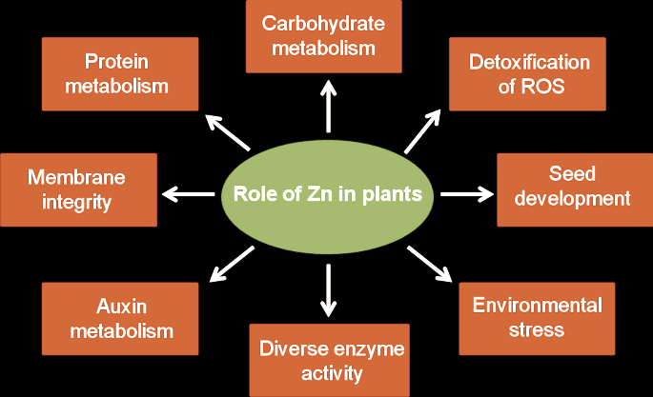More than 30% of the soils on Earth lack zinc and near about 80% of zinc decrease in rice grain due to the lack of zinc in cultivated soil (Impa *et al.* 2013). Compared legumes and cereals, particularly rice, were most probable to have a zinc scarcity in grain. This severe deficiency problem resulted from either the overconsumption of polished rice grain, which is naturally low zinc concentration, or from crop development on barren grounds. For this reason, required an increased zinc concentration in rice grain using different techniques like biofortification, fertilizer application in soil, and biotechnology approaches (Khush *et al.* 2012 and Mao *et al.* 2014).

Fig.1 Roles of zinc in plants (Verma *et al.* 2021)

**Soil concentrations of Zn and factor affecting absorption of zinc**

Soil pH is the most important factor that is for the availability of zinc from soil to root absorption. While increasing soil pH 5 to 7 considerably decreases zinc concentration (35 to 45-fold) in soil solution. Zn+2 predominates formation when soil pH is more than 7.7, while soil pH is between pH 7.7 and 9.1 formations of ZnOH+ and Zn(OH)2 are formed while soil pH is more than 9.1 (Marschner 1993 and Alloway, 2008). Low moisture levels in the soil, high CaCO3, high P concentration in soil, high clay, and low soil organic matter are affecting zinc solubility and uptake by plant roots from the soil solution (Cakmak, 2008).



Fig. 2: Major soil physical and chemical properties affecting Zn availability to roots (Gupta *et al.* 2016)

**Zinc uptake**

The concentration of zinc in rice grain was influenced by the genetic characteristic of the plant, environmental factors, and crop management application. Plants produce non-protein amino acids root exudates such as phytosiderophore (PS) in response to Zn deficiency. Storage of zinc in grains, rice plants have to uptake and translocation Zn from soil to grain. This process involved different physiological processes at different levels in the rice plant. Even if a small part of zinc crosses the root parts of a plant and succeeds to reach the xylem using an apoplastic or symplastic pathway, but regularly zinc uses the symplastic pathway for transportation across the roots to the xylem (Zaman *et al.* 2018).

Rice plant root, zinc ions are taken up from the rhizosphere regions in the form of either Zn+2 ions, Zn-DMS (Deoxymugineic acid) complexes, or Zn–phytosiderophore complex (Kawakami and Bhullar 2018). The uptake of zinc at root surface is determined by specific uptake transporter rice iron-regulated transporter1 (*OsIRT1*) (Ishimaru *et al.* 2007). Regularly, Zn–phytosiderophore complex and Zn+2 ions, uptake by secondary transporter Ca+2 channels and transporters (*OsZIP5, OsZIP8* and *OsZIP9*) are present on the plasma membrane, but predominantly it is mediated by ZIPs (*ZIP1, ZIP3*, and *ZIP4*) (Palmgren *et al.* 2008 and Lee *et al.* 2010). Members of ZIP family perform the function of Zn influx into the cytosol, while HMA family participates in Zn efflux to the apoplast. MTP (*MtZIP2*) family is involved in the sequestration of Zn into intracellular compartments such as vacuole and endoplasmic reticulum. These are yellow stripe-like (YSL) proteins and PCR (plant cadmium resistance) helping the uptake of Zn–phytosiderophore complexes in rice (Gupta *et al*. 2016).

A higher concentration of zinc accumulated in the root due to express of *OsIRT1* because this transporter also helps to take up Zn (Lee and An 2009). In the cytoplasm of a plant cell, there are abundant Zn+2 holding proteins, but a generally very low concentration of Zn+2 was found (Broadley *et al.* 2007). In xylem tissue, zinc may move like a Zn+2 or as a complex form *viz.,* organic acids, nicotinamide (Zn-NA), or histidine. However, in the vacuoles of plant zinc was collected as an organic acid complex (Leitenmaier and Küpper 2013). In rice, under zinc deficiency plant decreases secretion levels of PS and takes up Zn+2 higher as compared to Zn-DMA complex (Suzuki *et al.* 2008).

**Zinc** **translocation**

When nutrients are absorbed by root surface from soil, they must be carried radially via several root layers and finally transfer to root stele, where nutrient loading into the vasculature occurs. In the root of rice, there are present two Casparian strips (outer exodermis and inner endodermis) made-up of suberin-containing coatings of cells that restricted flow of water and nutrients from root surface to inside xylem or phloem via apoplastic pathway (Sasaki *et al.* 2016 and Che *et al.* 2018). Aerenchyma tissue formation between the exodermis and endodermis, that is participated in exchange of gases during water logging conditions (Coudert *et al.* 2010).

In rice different transporters help for translocation of Zn. *OsZIP1, OsZIP3* and *OsZIP4*, are involved in zinc translocation into vascular bundles and meristem also in phloem Zn loading while *OsZIP4* is expressed in phloem cell and *OsZIP3* is highly expressed in rice nodes and involved in zinc unloading from the xylem of vascular bundles and contributes to the superior supply of zinc to developing tissues (Ishimaru *et al.* 2005 and Sasaki *et al.* 2015).

P‐type adenosine triphosphatase (*OsHMA2*) works as a chief Zn transporter from roots to shoots in rice plants and at the time of reproductive stage *OsHMA2* is highly expressed in nodes and participated in superior distribution of zinc to developing tissues (Takahashi *et al.* 2012 and Yamaji *et al.* 2013). The Zn+2 influx is mediated to the leaf portion of the plant and finally to the phloem through members of the ZIP family, the HMA (P1B-type ATPase) family, and the MTP (metal tolerance protein) family (Ishimaru *et al.* 2005). Moreover, YSL proteins help to transport zinc in the phloem, and zinc is stored as a complex with protein in sink (rice grain) tissue from the phloem. The mobility of zinc in the phloem is generally low but it was depending upon the characteristic of the plant and species.

In rice, stem nodes play an important role in translocation of zinc from root to shoot or reproductive parts (Yamaji and Ma 2014). Root taken up Zn then after, Zn is mainly entered onto the xylem, which is driven by transpiration and translocation to shoot and leaf area of plant. However, Zn distribution in young parts of plants because zinc requires for different physiological functions. Each node actively contributed to the transfer of Zn from the xylem to leaf to the upper nodes or organs and in this activity involved two zinc transporters (*OsZIP3* and *OsHMA2*).

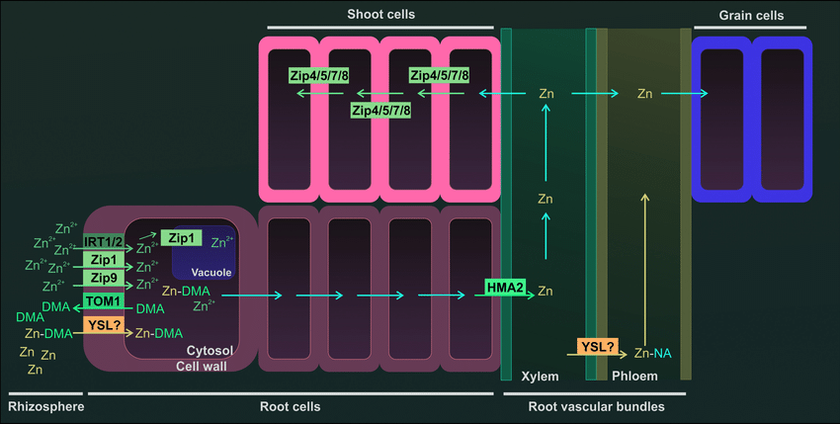

Fig. 3: Diagram of a zinc uptake and transport in rice. Zinc uptake from rhizosphere preferentially in Zn+2 form by IRT1 (iron-regulated transporter 1), IRT2, Zip1 (Zn-regulated transporters), and Zip9 transporters. Also, Zn can be uptake in complex form (DMA) which is secreted in the rhizosphere by TOM1 (transporter of mugineic acid phytosiderophore 1). The complex Zn+ DMA can be uptake by a transporter YLS (yellow stripe-like protein). Zn+2 transfer cytoplasm to vacuole by transporter and after that root cells to root vascular bundles. Zinc transport root to shoot with the help of HMA2 (heavy metal ATPase2). In shoots, Zn is transported by ZIP family protein (Zip4, Zip5, Zip7, and Zip8). The Zn transfer to grains is suggested to be horizontally from xylem to phloem after that zinc transfer in rice grain

**Zinc transformation and store in grain**

Functionally, endosperm and embryo are symplastically isolated from the rice mother plant (Krishnan and Dayanandan 2003 and Palmgren *et al.* 2008). Rice grain requires efflux and influx transporter for nutrient loading inside and outside of the grain side. Like micro-nutrients, zinc is also remobilized in the plants from leaf (source) to grain (sink) tissues.

Transporter *OsHMA9* is located on the plasma membrane and is expressed stronger in mature leaves than in young leaves and works as a Zn efflux transporter, while helpful in the export of Zn from mature leaves (Lee *et al.* 2007). *OsZIP4* is highly expressed in flag leaves and correlates with zinc stored in rice grains (Swamy *et al.* 2016). Accordingly, *OsZIP7* essential role in Zn xylem loading in roots and inter‐vascular transport in the basal node, therefore zinc translocation toward leaves and rice grains (Tan *et al.* 2019). Finally, one more rice gene (VIT), *OsVIT5*, and *OsNAS3* have extremely expressed in panicles parts of the rice plant and contribute to high Zn transportation, transformation, and accumulation in rice grain (Neeraja *et al.* 2018).

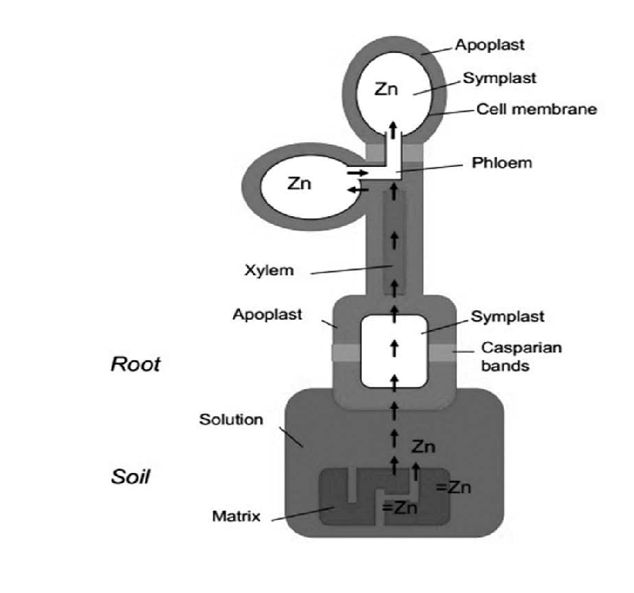Rice plant use has different strategies for Zn distribution in grains. In contrast to other plants, rice leaves are not a source of zinc for grains so, plants deliver Zn to grains at the time of post-flowering through xylem transport. Overall, different mechanisms use for translocation of zinc in rice grains when sufficient and deficient concentration of zinc are reported (Sperotto, 2013 and Wu *et al.* 2010). For instance, when Zn is not provided adequately, stored Zn in roots, stem, and sheath, but not leaves are reported to remobilize to rice grains.

Fig. 4: Pathway of zinc store in rice grain. Zinc uptake into root cell via symplastic pathway and transfer into xylem then after transfer into shoots with transpiration stream and allocation in leaf cells. Relocation of zinc via phloem from leaves into rice grains during grain development (Schulin *et al.* 2015).

**Table 1: Role of different zinc transporters in rice for Zn uptake, translocation and storage**

|  |  |  |
| --- | --- | --- |
| **Transporter** | **Function** | **References** |
| OsZIP1, OsZIP5, OsZIP8 | Uptake of Zn in root, Zn transport into  endodermis | Gao *et al.* 2019, Liu *et al.* 2019 and Amini *et al.* 2021 |
| OsZIP3, OsZIP4 | Translocation of Zn in nodes and co-transporter of Zn+2-HCO3 | Ramesh *et al.* 2003 and Ishimaru *et al.* 2005 |
| OsZIP7 | Zn xylem loading in root,  Zn translocation in nodes | Tan *et al.* 2019 and Amini *et al.* 2021 |
| OsZIP9 | Zn uptake and distribution | Tan *et al.* 2020 |
| OsHMA2 | Root to shoot Zn translocation, Transport of Zn in phloem from xylem, Translocation of Zn in seed endosperm | Amini *et al.* 2021 |
| OsNAS1 | Zn enhancement in grain and increase Zn concentration in seed up to 45–74% | Johnson *et al.* 2011 and  Amini *et al.* 2021 |
| OsNAS2 |
| OsNAS3 |
| OsVIT1 | Zn sequestration in vacuoles of  flag leaves | Amini *et al.* 2021 |
| OsVIT2 |
| OsVIT5 | Zn accumulation in grain | Amini *et al.* 2021 |

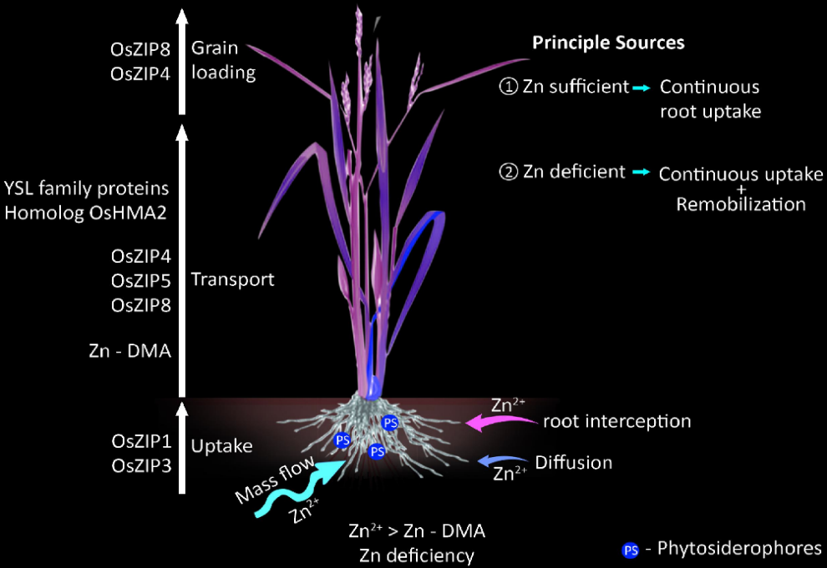

Fig. 5: Systemic diagram of Mass flow of Zn uptake and transport to loading into the rice grain using different transporters. Different Zn transporters are involved in long distance transport and this flow differently regulated by Zn availability in soil and status in plants (Nakandalage *et al.* 2016).

**Reference**

A. A. Johnson, B. Kyriacou, D. L. Callahan, L. Carruthers, J. Stangoulis and E. Lombi (2011). Constitutive overexpression of the OsNAS gene family reveals single‐gene strategies for effective iron‐ and zinc‐biofortification of rice endosperm. PLOS One, 6(9).

A. K. Shukla, P. K. Tiwari, A. Pakhare and C. Prakash (2016) Zinc and iron in soil, plant, animal and human health. Indian J Fertil 12(11):133–149.

A. S. Prasad (1991). Discovery of human zinc deficiency and studies in an experimental human model. The American Journal of Clinical Nutrition 53 (2): 403–12.

A. Sasaki, N. Yamaji and J. F. Ma (2016). Transporters involved in mineral nutrient uptake in rice. J Exp Bot 67: 3645–3653.

A. Sasaki, N. Yamaji, N. Mitani-Ueno, M. Kashino and J. F. Ma (2015). A node-localized transporter OsZIP3 is responsible for the preferential distribution of Zn to developing tissues in rice. Plant J., 84(2): 374–384.

B. J. Alloway (2008). Zinc in soils and crop nutrition. Belgium: international zinc association Brussels.

B. Leitenmaier and H. Küpper (2013). Compartmentation and complexation of metals in hyperaccumulator plants. Front Plant Sci. 4: 374–380.

B. P. M. Swamy, M. A. Rahman, M. A. Inabangan-Asilo, A. Amparado, C. Manito, P. Chadha-Mohanty, R. Reinke and I, H. Slamet-Loedin (2016). Advances in breeding for high grain zinc in rice. Rice, 9, 49: 2-16.

C. Kamaral, S. M. Neate, N. Gunasinghe, P. J. Milham, D. J. Paterson, P. M. Kopittke, and S. Seneweera (2021). Genetic biofortification of wheat with zinc: Opportunities to fine-tune zinc uptake, transport and grain loading. Physiologia Plantarum, 1-18.

C. N. Neeraja, K. S. Kulkarni, P. M. Babu, S. D. Rao, K. Surekha and R. V. Babu (2018). Transporter genes identified in landraces associated with high zinc in polished rice through panicle transcriptome for biofortification. PLOS One, 13(2).

C. Noulas, M. Tziouvalekas and T. Karyotis (2018). Zinc in soils, water and food crops. J Trace Elem Med Biol 49: 252–260.

C. Y. Wu, L. L. Lu, X. E. Yang, Y. Feng, Y. Y. Wei and H. L. Hao (2010). Uptake, translocation, and remobilization of zinc absorbed at different growth stages by rice genotypes of different Zn densities. Journal of Agricultural and Food Chemistry, 58(11): 6767–6773.

G. S. Khush, S. Lee, J. I. Cho and J. S. Jeon (2012). Biofortification of crops for reducing malnutrition. Plant Biotechnol Rep. 6:195–202.

H. Mao, J. Wang, Z. Wang, Y. Zan, G. Lyons and C. Zou (2014). Using agronomic biofortification to boost zinc, selenium, and iodine concentrations of food crops grown on the loess plateau in China. J Soil Sci Plant Nutr. 14: 459–470.

H. Marschner (1993). Zinc uptake from soils. In: Robson AD (ed) zinc in soils and plants. Kluwer, Dordrecht, 59–77.

I. Cakmak, (2008). Enrichment of cereal grains with zinc: agronomic or genetic biofortification? Plant Soil 302:1–17.

J. Che, N. Yamaji and J. F. Ma (2018). Efficient and flexible uptake system for mineral elements in plants. New Phytol., 219: 513–517.

L. Tan, M. Qu, Y. Zhu, C. Peng and J. Wang (2020). Zinc transporter5 and zinc transporter9 function synergistically in zinc/cadmium uptake1. Plant Physiology, 183(3): 1235–1249.

L. Tan, Y. Zhu, T. Fan, C. Peng, J. Wang, L. Sun and C. Chen (2019). OsZIP7 functions in xylem loading in roots and inter-vascular transfer in nodes to deliver Zn/Cd to grain in rice. Biochem Biophys Res Commun., 512(1): 112–118.

M. G. Palmgren, S. Clemens, L. E. Williams, U. Krämer, S. Borg, J. K. Schjørring and D. Sanders (2008). Zinc biofortification of cereals: problems and solutions. Trends Plant Sci. 13: 464–473.

M. R. Broadley, P. J. White, J. P. Hammond, I. Zelko, and A. Lux, (2007). Zn in plants. New Phytol. 173: 677–702.

M. Suzuki, T. Tsukamoto, H. Inoue, S. Watanabe, S. Matsuhashi, M. Takahashi, H. Nakanishi, S. Mori and N. K. Nishizawa (2008). Deoxymugineic acid increases Zn translocation in Zn-deficient rice plants. Plant Mol Biol., 66(6): 609–617.

N. Gupta, H. Ram and B. Kumar (2016). Mechanism of Zinc absorption in plants: uptake, transport, translocation and accumulation. Rev Environ Sci Biotechnol.

N. Nakandalage, M. Nicolas, R. M. Norton, N. Hirotsu, P. Milham and S. Seneweera (2016). Improving rice zinc biofortification success rates through genetic and crop management approaches in a changing environment. Front Plant Sci. 7: 764.

N. Yamaji and J. F. Ma (2014). The node, a hub for mineral nutrient distribution in graminaceous plants. Trends Plant Sci 19: 556–563.

N. Yamaji, J. Xia, N. Mitani-Ueno, K. Yokosho and M. J. Feng (2013). Preferential delivery of zinc to developing tissues in rice is mediated by P-type heavy metal ATPase OsHMA2. Plant Physiol 162(2): 927–939.

News and Analysis on Supplements, Health and Nutrition – Asia Pacific. (2021). <https://www.nutraingredients-asia.com/>

P. K. Verma, S. Verma, D. Chakrabarty and N. Pandey (2021). Biotechnological approaches to enhance zinc uptake and utilization efficiency in cereal crops. Journal of Soil Science and Plant Nutrition,

P. K. Verma, S. Verma, D. Chakrabarty and N. Pandey (2021). Biotechnological approaches to enhance zinc uptake and utilization efficiency in cereal crops. Journal of Soil Science and Plant Nutrition,

Q. U. Zaman, Z. Aslam, M. Yaseen, M. Z. Ihsan, A. Khaliq S. Fahad, S. Bashir, P. M. A. Ramzani and M. Naeem (2018). Zinc biofortification in rice: leveraging agriculture to moderate hidden hunger in developing countries, Archives of Agronomy and Soil Science, 64 (2): 147-161.

R. A. Sperotto (2013). Zn/Fe remobilization from vegetative tissues to rice seeds: Should I stay or should I go? Ask Zn/Fe supply!. Frontiers in Plant Science, 4, 464.

R. Schulin, S. Tandya, C. Thonarb, R. Grütera, B. Costeroussea, I. Müllera, J. Helfensteina, T. Dürr-Austera, F. Aghilia, V. Dorostkarc and A. Khoshgoftarmaneshc (2015). Zinc biofortification of wheat through soil organic matter management. 42.

R. Takahashi, Y. Ishimaru, H. Shimo, Y. Ogo, T. Senoura, N. K. Nishizawa and H. Nakanishi (2012). The OsHMA2 transporter is involved in root-to-shoot translocation of Zn and Cd in rice. Plant Cell Environ 35(11): 1948–1957.

S. A. Ramesh, R. Shin, D. J. Eide and D. P. Schachtman (2003). Differential metal selectivity and gene expression of two zinc transporters from rice. Plant Physiology, 133(1): 126–134.

S. Amini, B. Arsova, and M. Hanikenne (2021). The molecular basis of zinc homeostasis in cereals. Plant Cell Environment, 45:1339–1361.

S. Gao, Y. Xiao, F. Xu, X. Gao, S. Cao, F. Zhang, G. Wang, D. Sanders and C. Chu (2019). Cytokinin-dependent regulatory module underlies the maintenance of zinc nutrition in rice. New Phytol., 224(1): 202–215.

S. Krishnan and P. Dayanandan (2003). Structural and histochemical studies on grain-filling in the caryopsis of rice (*Oryza sativa L.*). J. Biosci., 28: 455–469.

S. Lee and G. An (2009). Over-expression of OsIRT1 leads to increased iron and zinc accumulations in rice. Plant Cell Environ 32: 408–416.

S. Lee, H. J. Jeong, S. A. Kim, J. Lee, M. L. Guerinot and G. An (2010). OsZIP5 is a plasma membrane zinc transporter in rice. Plant Mol Biol. 73: 507–517.

S. Lee, Y. Y. Kim, Y. Lee and G. An (2007). Rice P1B-type heavy-metal ATPase, OsHMA9, is a metal efflux protein. Plant Physiol., 145: 831–842.

S. M. Impa, M. J. Morete, A. M. Ismail, R. Schulin and S. E. Johnson-Beebout (2013). Zn uptake, translocation and grain Zn loading in rice (*Oryza sativa L.*) genotypes selected for Zn deficiency tolerance and high grain Zn. J Exp Bot 64 (10):2739–2751.

X. S. Liu, S. J. Feng, B. Q. Zhang, M. Q. Wang, H. W. Cao, J. K. Rono, X. Chen and Z. M. Yang (2019). OsZIP1 functions as a metal efflux transporter limiting excess zinc, copper and cadmium accumulation in rice. BMC Plant Biol., 19(1): 283.

Y. Coudert, C. Perin, B. Courtois, N. G. Khong and P. Gantet (2010). Genetic control of root development in rice, the model cereal. Trends Plant Sci., 15: 219–226.

Y. Ishimaru, H. Masuda, M. Suzuki, K. Bashir, M. Takahashi and H. Nakanishi (2007). Overexpression of the OsZIP4 zinc transporter confers disarrangement of zinc distribution in rice plants. J Exp Bot. 58: 2909–2915.

Y. Ishimaru, K. Bashir and N. K. Nishizawa (2011). Zn uptake and translocation in rice plants. Rice, 4, 21–27.

Y. Ishimaru, M. Suzuki, T. Kobayashi, M. Takahashi, H. Nakanishi, S. Moria and N. K. Nishizawa (2005). OsZIP4, a novel zinc-regulated zinc transporter in rice. J Exp Bot 56(422): 3207–3214.

Y. Kawakami and N. K. Bhullar (2018). Molecular processes in iron and zinc homeostasis and their modulation for biofortification in rice. Journal of Integrative Plant Biology, 60 (12): 1181–1198.

Z. Aiqing, L. Zhang, P. Ning, Q. Chen, B. Wang, F. Zhang, X. Yang and Y. Zhang (2021). Zinc in cereal grains: Concentration, distribution, speciation, bioavailability, and barriers to transport from roots to grains in wheat. Critical Reviews in Food Science and Nutrition, 2-12.