A NOVEL DRUG DELIVERY OF LIPOSOMES: A COMPREHENSIVE REVIEW
Miruthula.U.V, Muthukumar.S KMCH college of pharmacy
ABSTRACT
Liposomes are little spherical artificial vesicles, which is made up of naturally derived phospholipids or pure surfactants. Liposomes will aid with active targeting because it has flexibility in coupling with site-specific ligands. The components of liposomes are Phospholipids, Cholesterol and other additional excipients. Liposomes was like vesicular in structures consisting of hydrated bilayers. The hydrophilic part was mainly composed of phosphoric acid which is bound to a water-soluble molecule whereas the hydrophobic part which consists of two fatty acid chains. Liposomes are classified into different types like., Based on their structural components, based on method of liposome preparation, based on composition and applications etc. There are some advantages and disadvantages of liposomes formulation. Method of preparation is based on two techniques i.e., active loading technique and passive loading technique. The pharmacokinetics of liposomes focused on the total body fluids and tissue distribution and their metabolism. Liposomal based formulation is implemented in the clinical fields. Doxil is the anticancer liposome which was first approved in USA.

KEYWORDS: Liposomes, characteristics, method of preparation, stability, pharmacokinetics, clinical applications.

1.INTRODUCTION
Rational research in drug delivery began in 1950s with the advent of polyclonal antitumour antibodies developed for tumour targeting of cytotoxic drugs to experimental tumours. Liposomes were first described by Dr Alec D Bangham FRS (British haematologist) at the Babraham Institute, in Cambridge (early 1960s) and R. W. Horne, was the person who tested. According to legend, he was experimenting with new laboratory equipment, and he made a noted observation about phospholipids forming closed multiamellar vesicle spontaneously in aqueous solution which took two years to be proved. Liposomes are little spherical shaped artificial vesicles, which is made up of naturally- derived phospholipids with mixed liquid chain (like egg phosphatidyl-ethanolamine), or of pure surfactant components like dioleoyl phosphatidyl-ethanolamine. It consists of an internal aqueous compartment entrapped by one or multiple concentric lipidic bilayers.
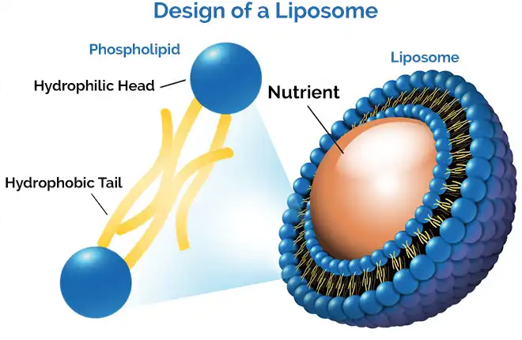
The phospholipid bilayer envelope was a cell-like boundary appropriate for affords liposomes a functional scaffold suitable for fundamental cellular functions such as motility and shape change not to mention the ability to mimic the biophysical properties of living cells. Liposomes nanoemulsions were widely used nanoparticles in nanomedicine mainly due to their biocompatibility, stability, ease to synthesize and high drug loading efficiency high bioavailability and their safe excipients used in these formulations. Depending upon the composition and the structure, liposomes can separate hydrophobic or hydrophilic molecules from the solution. When the structural layer of phospholipid is disrupted, they are able to realign themselves into smaller structures. These reassembled bilayer structures are known as liposomes while a monolayer is called micelle. A liposome can be formed at a variety of size. Liposomes can aid with active targeting as it had flexibility in coupling with site-specific. They were biocompatible, completely biodegradable, non-toxic, flexible and nonimmunogenic for systemic and no systemic administrations.

Fig.1 Structure of liposome

2.COMPOSITION OF LIPOSOME
The components of liposomes are:
1.Phospholipids 2. Cholesterol 3. Additional excipients
2.1. Phospholipids:
Phospholipid id the major structural components of biological membrane, where there are two types of phospholipids were existed – phosphodiglycerides and sphingolipids, together with their corresponding hydrolysis as a product. Glycerophospholipids contains a lipophobic head and a lipophilic tail. Liposome is made up of both natural and synthetic phospholipids.
The hydrophilic group in the lipids may be negatively, positively charged, or zwitterionic. The charge of the hydrophilic group provides stability through electrostatic repels. The hydrophobic group of lipids varies in the acyl chain length, saturation, and symmetry.
2.2. Cholesterol:
Cholesterol is a fat-like substance and an essential component of the body. Incorporation of sterols in liposomes bilayer can bring about major changes in the preparation of these membranes. Cholesterol does not form bilayer structure by itself but it can be incorporated into the phospholipid membrane in very high concentration. Cholesterol inserts into membrane with its hydroxy group which is oriented towards the aqueous surface and aliphatic chain aligned parallel to acyl chains in the centre of bilayer.
2.3. Additional excipient:
Polyethylene glycol [PEG] on the liposome surface offers extended circulation property, protects the captured drug from inactivation, enhances stability and improves intracellular intake.
2.4. General Ingredients
Generally, liposome composition includes natural and/or synthetic phospholipids (Phosphatidylethanolamine, Phosphatidylglycerol, Phosphatidylcholine, Phosphatidylserine, Phosphatidylinositol) Phosphatidylcholine and phosphatidylethanolamine constitute the two major structural components of most biological membranes. It improves the membrane bilayer stability, fluidity and reduces the permeability of water-soluble molecules through the membrane. An advantage of liposomes was the fact that the lipid membrane was made from physiological lipids which decreases the danger of acute and chronic toxicity.

3. MECHANISM OF LIPOSOME FORMATION
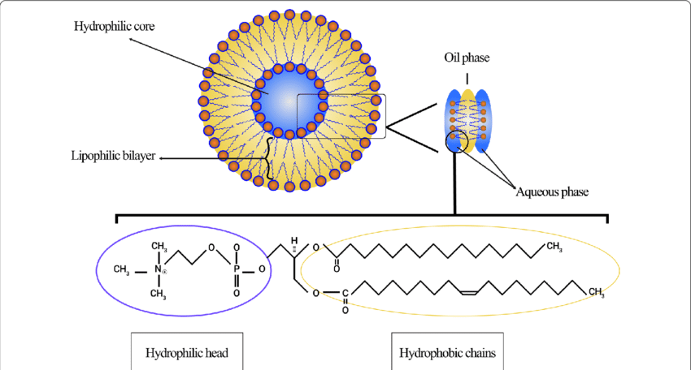
Liposomes were vesicular structures consisting of hydrated bilayers. Liposomes were formed by phospholipids (amphiphilic molecules having a hydrophilic head and hydrophobic tail). They form lamellar sheets when dispersed in aqueous medium by aligning themselves in such a way that the polar head group faces outwards the aqueous region while fattyacid group face each other forming a spherical, vesicle like structures called as liposomes.
Fig.2 Formation of liposome
Liposomes which were targeted to specific tissues were developed by stabilization of phosphatidylethanolamine into bilayer with antibody derivates of fatty acids like palmitic acid. Finally, liposomal content is released at this site. Specific sub-cellular targeting is still in novice and is in vitro research phase.

4.CLASSIFICATION OF LIPOSOMES
Liposomes are classified into different types:
1. structural components
- Multilamellar large vesicles
- Oligolamellar vesicles
- Unilamellar vesicles
- Medium sized unilamellar vesicles
- Large unilamellar
- Giant unilamellar vesicles
- Multivesicular vesicles

Fig.3 Size and lamellarity of liposomes
2. Method of liposome preparation
- By reverse phase evaporation vesicles (REV)
- Multilamellar vesicles made by reverse phase evaporation method (MLV / REV)
- Stable plurilamellar vesicles (SPLV)
- Frozen and thawed MLV (FATMLV)
- Vesicles prepared by extrusion method (VET)
- Vesicles prepared by fusion (FUV)
- Vesicles prepared by French press (FPV)
- Dehydration‐ rehydration vesicles (DRV)
- Bubblesomes (BSV)
3.Based on composition and applications
- Fusogenic liposomes
- pH sensitive liposomes
- Stealth liposomes

5. ADVANTAGES OF LIPOSOMES
- Liposome increased efficacy and therapeutic index of drug.
- Liposome provide controlled and sustained release.
- Suitable for delivery of hydrophobic, hydrophilic and amphipathic drugs and agents.
- Liposome increase stability via encapsulated drug.
6. DISADVANTAGES OF LIPOSOMES
- Sometimes, they are less stable.
- Short half-life.
- Difficult in large scale manufacture and sterilization.
- Very high production cost
- Low solubility and oxidation off bilayer phospholipid.
- Low therapeutic index and dose effectiveness.

7. METHODS OF LIPOSOME PREPARTION
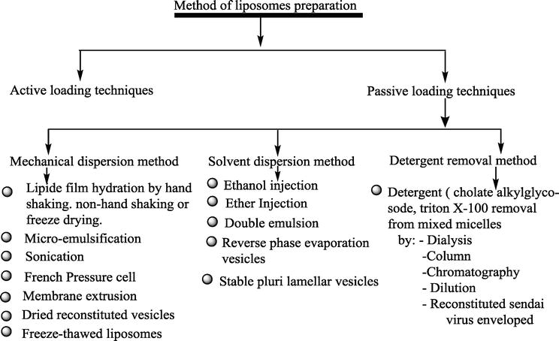

  - ACTIVE LOADING TECHNIQUE
- Prollposome:
Lipid and active substances(drug) were covered onto a solvent transporter to shape free-streaming granular material in supportive of liposomes which structure an isotonic liposomal suspension of hydration.
- Lyophilization:
The expulsion of water from items in a solidified state at incredibly decreases the weight i.e., called lyophilization.

  - PASSIVE LOADING TECHNIQUE
I.MECHANICAL DISPERSION METHOD:
- Lipid film hydration
First preparation of homogenous mixture of lipids takes place. By dissolving and mixing a lipid component in an organic solvents like ethanol, chloroform etc, the solvent was removed to yield a film of lipid. This lipid film was thoroughly dried by placing the vial or flask on a vacuum pump by removing the residual organic solvent. lipid

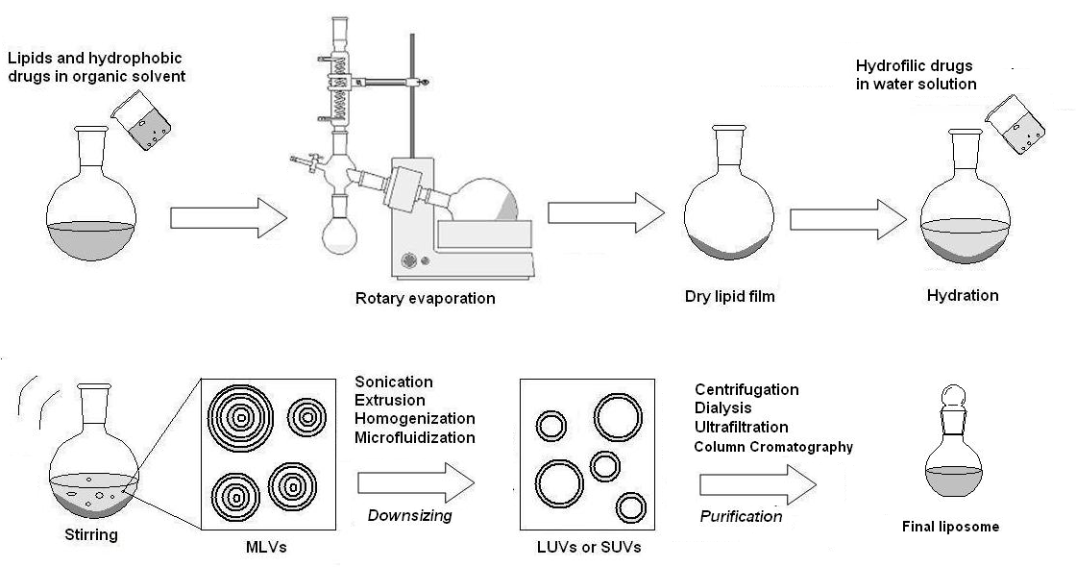
Fig.4 Lipid film hydration method

Advantages: Disadvantage:
- Simple process i. Difficulty in scaling up.
- Straightforward approach ii. Time consuming method.

- Sonication:
- Sonication was perhaps the most extensively used method for the preparation of SUV. The MLVs were sonicated either with a bath type sonicator or a probe sonicator under a passive atmosphere. The main disadvantage of the sonication method are very low internal volume and efficiency of encapsulation is also low and possible degradation of phospholipids and compounds to be encapsulated and the presence of MLV along with SUV lead to metal pollution.

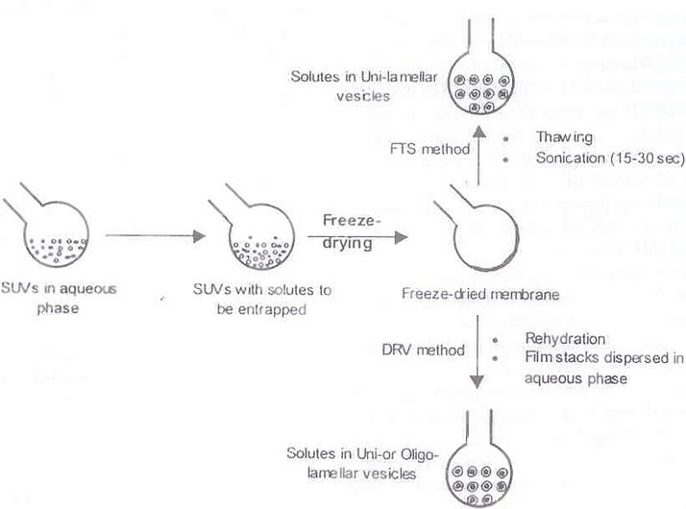
- Dried reconstituted
Fig.5 Dried reconstituted vesicle method vesicle

This method starts with freeze drying of a dispersion of empty SUVs and then rehydrating it with the aqueous fluid containing the material to be entrapped
However, this leads to dispersion of solid lipids in finely subdivided form. Liposomes obtained from this method are usually uni- or oligo- lamellar is 1.0 µm or less in diameter. Entrapment yield can vary, but 40% is fairly standard compared with 2-10% for MLVs prepared by hand-shaking method.

- Freeze-thawed liposomes:
SUVs are rapidly frozen and thawed slowly. The short-lived sonication disperses aggregated materials to LUV. The creation of unilamellar vesicles is as a result of the fusion of SUV throughout the processes of freezing and thawing.
II.SOLVENT DISPERSION METHOD:

- Ethanol injection:
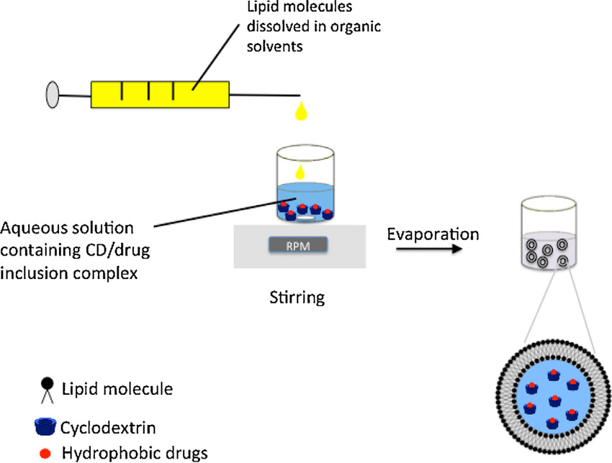
An ethanol solution of lipid is injection rapidly into an excess of saline or another aqueous medium, through a fine needle. The force of the injection was unusually sufficient to achieve complete mixing, so that the ethanol was diluted almost instanteously in water, and phospholipid molecules were dispersed evenly throughout the medium.

Fig. 6 Ethanol injection method

- Double emulsion
Double emulsion method is prepared firstly by dissolving the drug in the aqueous phase (W1), which is then emulsified in an organic solvent like ethanol, chloroform of a polymer is called primary emulsion (W/O). after the primary emulsion it is mixed in an emulsifier-containing aqueous solution (W2) to make a W1/O/W2 which is double emulsion.
8.CHARACTERISATION OF LIPOSOMES
The characteristics parameters of liposomes are based on different categories:
- Physical characterisation
- Chemical characterisation
- Biological characterisation
8.1. Physical characterisation:
a). Size
The particle size and distribution are critical parameters especially when liposomes are intended for therapeutic use by inhalation or parenteral route. The size of deformable liposomes in the size range of 300-350nm has been reported to maintain the drug in the skin layer for topical use and avoid its absorption into the systemic circulation.. So, other methods used d to evaluate the size and size distribution such as:
b). Surface charge
A technique has been developed that separates extruded vesicles on the basis of their surface charge by electrophoresis on a cellulose acetate plate in a sodium borate buffer pH 8.8. This sensitive assay should prove valuable for examining the charge heterogeneity in liposome preparation for following fusion between two populations of vesicles with different charge and for determining the presence of charge impurities e.g., fatty acids in liposome.
Liposome characterization is the surface charge of the liposome measured by the zeta potential. The zeta potential is the key factor that affects the cellular uptake and targeted drug delivery. The particles move in an electrical of known strength in the interference pattern of two laser beams and produce scattered light which depends on the speed of the particles.
c). Lamellarity
Liposome lamellarity is often accomplished by methods that are based on the visible or fluorescence signal change of lipids marker upon reagents addition. This approach is reviewed in more detail, since it is a relatively simple procedure that can be easily carried out in a standard lab. Several lipids can be used and results rely on the comparison of the total signal to the signal achieved from the reaction between the lipids marker and the specified reagents.

d). Phase behaviour of liposomes
An important feature of lipid membrane is the existence of a temperature dependent reversible phase transition, where the hydrocarbon chains of the phospholipid undergo a transformation from an ordered(gel) state to more disordered fluid (liquid crystalline) state.
e). Percent capture (Entrapment)
For longer term stability test and for developing new liposome formulation or method of preparation, a technique was needed for separating free from entrapped material. In general, two methods may be used i.e., mini column centrifugation and protamine aggregation.
f). In vitro studies related to drug release
Some millilitres aliquot of liposome suspension is placed in the dialysis bag, hermetically tied and dropped in the receptor compartment containing the dissolution medium. The entire system is kept at 37°C under continuous magnetic stirring and the receptor medium is closed to avoid evaporation of the dissolution medium.

8.2. Chemical characterisation
Phospholipid peroxidation is quantitatively determined using UV absorbance, iodometry (for hydroperoxidase) and GLC techniques. Phospholipid hydrolysis as well as cholesterol autooxidation can be determined using HPLC and TLC. pH of the liposomal dispersion can be determined using pH meter.

8.3. Biological characterisation
The importance of determining biological parameters was very helpful in determining the safety of formulation for therapeutic applications. Sterility, pyrogenicity and animal toxicity were determined during the biological characteristics of the liposomes
- STABILITY OF LIPOSOMES
Liposomes face a number of chemical and physical destabilisation processes. Liposomes can be degraded chemically through oxidation and hydrolysis. The aspects in stability of liposomes are of two types:
- Physical stability
- Chemical stability

  - Physical stability:
The leakage rate strongly depends on the bilayer composition and the physiochemical nature of the drug. Aggregation is the formation of larger units of liposome material, these units are still composed of individual liposomes.

  - Chemical stability:
The two acyl ester bonds are most liable to hydrolysis. The glycerophosphate and phosphocholine ester bonds are more stable. The polyunsaturated acyl chains of phospholipids are sensitive to oxidation via free radical reactions. Phospholipids are chemically unsaturated fatty acids, prone to oxidation and hydrolysis, which may alter the stability of the drug products. Cyclic peroxides, hydroperoxides, malondialdehyde, alkanes are the major degradation products.

  - Stability protocols:
The liposomal stability can be determined by storing it under some conditions. The conditions are:
- Visual or microscopic examination.
- Highest and lowest temperatures likely to be encountered (1 month)
- Room temperature (12-24 months)
- 2-3 freeze-thaw cycles. (20-25°C)
- 6-8 heat-cool cycle (5-45°C)

- CLINICAL APPLICATION OF LIPOSOMES
Liposomes can be formulated in liquid (suspension), solid (dry powder) or semi-solid (gel, cream) forms. In vivo, they can be administered topically or via parenteral route.
  - . Cancer treatment:
- liposomal daunorubicin and pegylated liposomal doxorubicin versions has greatly prolonged circulation.
- Doxil was designed as a polyethylene glycol coated doxorubicin (DOX) liposome intended for the treatment of Kaposi's sarcoma.
- Daunorubicin was the second anthracycline antineoplastic drug loaded in liposomes to treat acute myeloid leukaemia (AML) under the generic name DaunoXome.
- Pegylated liposomal doxorubicin has shown substantial efficacy in breast cancer treatment both as monotherapy and in combination with another chemotherapeutics.
- The thermo-sensitive liposomal formulation ThermoDox
  - . Liposomes in vaccinations:
- Liposome formulations could protect DNA/RNA and proteins payload from biodegradation.
- Two commercial vaccines based on virosome technology are currently on the market, Epaxal and Inflexal are hepatitis A vaccine.

  - . Ophthalmic treatment
- So many drugs are used for the treatment of eye disorders like dry eye syndrome, corneal ulcer etc.
- The pharmaceutical preparations may be suspension form or ointment for topical application as well as in solution forms but those preparations will have poor ocular bioavailability. To omit this barrier, liposomal formulation is used.

  - . Pain relievers management
- DepoDur is a formulation of morphine which is formulated in sustained release formula using DepoFoam Technology with extending the time of clinical effect.
- Exparel release Bupivacaine

CONCLUSION
In conclusion, liposomes have a diverse range of uses ever since it was first noted that it is able to self-assemble into vesicles. Crucial progress has been made in the long circulating liposome process which was not recognized immediately Liposomes with increased drug delivery to the desired disease locations, by the ability of long circulating residence time. Now they achieved the acceptance from clinical sector. Liposomes also promote the particular diseased cell to target within the disease site. The fact that all issues are associated with scaleup, stability and increasingly world wise lipid-based therapeutics in future.

REFERENCE
- http://www.jpsr.pharmainfo.in/Documents/Volumes/vol5issue09/jpsr05091304.pdf
- https://innovareacademics.in/journal/ijcpr/Issues/Vol3Issue2/292.pdf
- https://eijppr.com/n4DZcRj
- https://eijppr.com/LOdV6nk
- https://portal.issn.org/resource/ISSN/0976-2779
- https://doi.org/10.1166/jcsb.2012.1020
- https://doi.org/10.4172/2155-952X.1000276
- https://doi.org/10.1080/10717544.2016.1177136
- Controlled and novel drug delivery – N.K. Jain (pg.no., 321,322,324)
- Theory and practice in novel drug delivery system – S.P. Vyas (pg.no., 161,162,163)

