Sustainable development: social equality, economic progress, and environmental preservation
Saloni Sahal¹, Sarita Khaturia^{1*} and Harlal Singh¹
¹Department of Chemistry , School of Liberal Arts and Sciences, Mody University of Science and Technology, Lakshmangarh, Sikar 332311, Rajasthan, India.

Author/s email addresses: salonisahal03@gmail.com (Ms. Saloni Sahal, Research Scholar)
saritarajkhatri@gmail.com (Dr. Sarita Khaturia)
hlsingh9@gmail.com (Dr. Harlal Singh)

TABLE OF CONTENTS
- INTRODUCTION
- IMPORTANCE OF GREEN CHEMISTRY
- THE SUSTAINABLE DEVELOPMENT GOALS
- REFERENCES

1. INTRODUCTION
Environmental chemistry is the branch of chemistry that deals with investigating the movement, origins, reactions, outcomes, and fate of all chemical species found in water, soil, and air. The study of naturally occurring chemical and biological processes in the environment falls under this field of science. It is a research distinct from that of soil, water, air, and chemicals. In order to find the answers to all of the environmental concerns, this field uses a variety of mathematical, biological, engineering, genetic, toxicological, and hydrologic methodologies. Additionally, it incorporates aspects of analytical chemistry, organic, inorganic, and physical chemistry as well as elements from a number of other disciplines, including public health, epidemiology, biology, biochemistry, and toxicology. Environmental chemists learn how the unpolluted environment functions and discover ways to sustainably improve the environment without endangering it. Environmental chemists conduct studies on how chemicals produced by humans and naturally occurring substances affect the atmosphere, soils, surface water, groundwater, and ground air. Discovering which chemicals are produced naturally and how they affect the environment is the focus of this research. Additionally, it is reliant on human activity and the control of chemicals' harmful effects on the environment.
An interdisciplinary field known as environmental chemistry includes:
- Mathematics
- Geology
- Biology
- Ecology (the study of ecosystems)
- Toxicology (the study of adverse effects of chemicals on living organisms)
- Hydrology (the study of water)
The analysis of how chemicals affect the environment can take all of these into account.

2. IMPORTANCE OF GREEN CHEMISTRY
It is connected to environmental impact, pollutants, environmental management, and contamination reduction, environmental chemistry is valued on a societal level. Humans are one of the many creatures that are exposed to environmental chemicals, and they rely on many of these substances that are thought of as nutrients. Volcanoes, forest fires, and lake-level flooding are largely to blame for the contamination. Additionally, to some extent, organisms have a direct or indirect role in the dispersal of environmentally harmful compounds. The majority of substances that occur naturally are hazardous.
Analyzing how chemicals behave in a given setting as well as in the overall environment is vital to comprehend and study the effects of chemicals on the environment. The environment is divided into various sections to address the diversity of natural systems. These are regarded as the components of the actual surroundings that are enclosed by a line dividing them from the outside world. Surface water, soil, biota, and the atmosphere are a few examples of these natural systems.

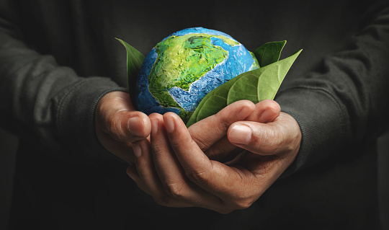
Figure-1 Green Chemistry

3. The Sustainable Development Goals (SDGs)
The SDGs, recognised as the world's objective sat times, are a set of 17 interconnected international objectives created to serve as a "roadmap to a better and more environmentally friendly future for all.
The UN General Assembly (UN-GA) were created the SDGs in 2015 with the intention of completing them by 2030.

Goal 1: No poverty
"Put an end to poverty in all its manifestations worldwide," states SDG 1. Global extreme poverty would end by 2030 if SDG 1 was accomplished. Thirteen indicators are used to track progress toward the goal's seven targets.
By 2030, there will be a major increase in extreme poverty if social policy is not significantly changed. 17.2 percent of rural residents live in poverty, compared to 5.3 percent of urban dwellers (in 2016). The majority are kids.
In spite of poverty having been consistently declining over the previous 20 years, according to a report released in September 2020, it increased by 7% in just a few months.
TARGETS
1. By 2030, end severe poverty worldwide, which is presently defined as a daily income of less than $1.25.
2. By 2030, reduce the number of persons by half of all ages who are considered to be living in poverty, as measured by national standards, in all of its forms.
3. Boost the toughness of the underprivileged by 2030 and those who are already vulnerable, as well as lessen their exposure to and susceptibility to natural catastrophes and other shocks and shocks related to the economy, society, and environment.
4. Establish solid international, regional, and national policy frameworks levels that support increased investment in efforts to eradicate poverty and are centred on development policies that is gender-sensitive and pro-poor.

Goal 2: Zero hunger (No hunger)
"Zero hunger" is the goal of SDG 2. Around 690 million people worldwide roughly 10% of the world's population are considered to be food insecure, according to the United Nations.
One in nine individuals worldwide, the vast majority of whom reside in poor nations, are undernourished. 52 million children worldwide suffer from serious or severe wasting due to undernutrition. It accounts for 3.1 million children's deaths under the age of five each year, or nearly half (45%) of all under-five deaths.

Targets
1. By 2030, eradicate cravings and assurance access all year long to safe, wholesome meals for everyone, particularly the underprivileged ,such as infants.
2. By 2030, eradicate all forms of malnutrition, including reaching the objectives for stunting and wasting in children under the age of five that have been set by international organisations. Additionally, the nutritional needs of older people, maternity and lactating women, and adolescent girls must be taken care of.
3. Increase the productivity of agriculture and the salaries of small-scale food producers, especially women, indigenous peoples, family farmers, pastoralists, and fishermen, by doubling them by 2030. This will be accomplished in part by ensuring that all producers have equal access to non-farm work opportunities, financial services, markets, expertise, and other productive resources.
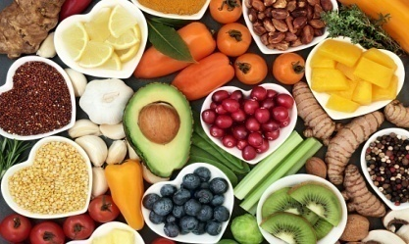
Figure-2 All people ought to have access to enough nutritious food

Resources
- Zero Hunger Challenge of the United Nations
- Nutrition Programmes for Children with Disabilities, UNICEF
- Background Note for the Global Partnership on Children with Disabilities: Inclusive Nutrition for Children and Mothers with Disabilities, 2012, UNICEF
- FAO Working in Support of Persons with Disabilities, 2006, FAO

Goal 3: Good health and well-being
SDG 3 comprises 28 indicators and 13 targets for tracking progress.
One of the four "ways to accomplishing" SDG 3 targets is the WHO Framework Convention on Tobacco Control. Increasing health spending and assisting the medical workforce in developing nations, as well as enhancing early warning systems for global health threats, are the other three "ways to attaining" SDG 3 aims.

Targets
1.By 2030, bring down the rate of maternal death worldwide to under 70 per 100 000 live births, on average.
2. By 2030, Eliminate hepatitis, water-borne infections, and other contagious diseases , as well as put an end to the AIDS, tuberculosis, malaria, and neglected tropical disease epidemics.
3. Through prevention and treatment, reduce premature mortality from noncommunicable diseases by one-third by 2030, and foster mental health and wellbeing.
4. By 2030, guarantee that all people have access to family planning services. Reproductive health should be covered in national policies and programmes, as well as through information and education.

Goal 4: Quality education
The purpose of SDG 4 is to "provide inclusive and equitable quality education and encourage opportunities for lifelong learning for everyone."
There has been significant improvement in both boys' and girls' access to education, particularly at the primary school level. Global involvement in tertiary education increased to 224 million in 2018, which is equivalent to a gross enrolment ratio of 38%.

Targets
1. Make sure all boys and girls have access to high-quality pre-primary education by the year 2030 so they are ready for primary school.
2. Ensure equal access to technical, vocational, and postsecondary education for men and women by the year 2030 i.e both affordable and of high quality.
3. By 2030, make sure that every child, men and women in their mature years are literate and numerate to a significant extent.
4. Build and upgrade learning environments that are gender, disability, and child-sensitive and provide a safe, tranquil, inclusive, and successful learning environment for all students.
Figure-3 Encourage everyone to pursue a lifetime education

Goal 5: Gender equality

SDG 5 states that all women and girls should be empowered.
In single or lower houses of national parliament, women made up 25% of the membership in 2020, up from 22% in 2015. Based on statistics from 133 nations and regions, women currently have better access to positions of decision-making at the local level, holding 36% of elected seats in local deliberative organizations. FGM/C, which involves cutting or mutilating the female genitalia, is damaging and still affects at least 200 million girls and women worldwide.

Targets
1. Discrimination against women and girls must end worldwide in all forms.
2. Put an end to trafficking, sexual exploitation, and both public and private forms of violence against women and girls.
3. Promote the empowerment of women by the application of supporting technology, especially information and communications technology.
4. Adopt and uphold reasonable rules and regulations that will advance gender equality and provide all women and girls the power they deserve at all levels.

Goal 6: Clean water and sanitation

To "make sure that everyone has access to sustainable water and sanitation management," according to SDG 6. Eleven indicators are used to assess the eight aims.
The six "outcome-oriented aims" are: providing access to sanitation and hygiene; eliminating open defecation; enhancing water quality; improving wastewater treatment; and safe reuse; increasing water-use efficiency and ensuring freshwater supplies; implementing IWRM; and protecting and restoring ecosystems that are related to water. Extending assistance for water and sanitation to developing nations and encouraging local participation in water and sanitation management are the two "ways of attaining" the targets.

Targets
1. Ensure that everyone has fair access to clean, inexpensive drinking water by the year 2030.
2. By 2020, conserve and restore water-related ecosystems, such as lakes, rivers, aquifers, marshes, mountains, and forested areas.
3. Encourage and support community participation in improving water and sewage management in the area.

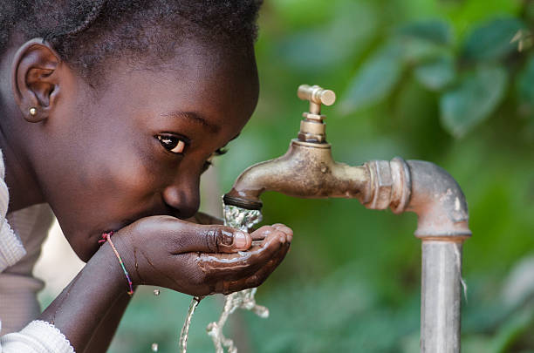
Figure-4 For everyone, a supply of clean, inexpensive water

Goal 7: Affordable and clean energy

To "ensure that everyone has access to reliable, cost-effective, sustainable, and contemporary energy".

Several nations, most notably India, Bangladesh, and Kenya, have made progress in increasing access to energy. From 1.2 billion in 2010 to about 840 million in 2017, fewer people were without access to power. (Sub-Saharan Africa remains the region with the largest access deficit). In 2016, 17.5 percent of the world's total energy consumption was from renewable sources. The usage of renewables increased the fastest with regard to electricity out of the three end users of renewable (heat, transport, and power).
Targets
1. Ensure that everyone has access to dependable, affordable, and sophisticated energy services by 2030.
2. By 2030, increase the share of renewable energy by a significant amount.
3. Doubling the rate of energy efficiency growth at the global level by 2030.

Goal 8: Decent work and economic growth
Encourage sustained, inclusive, and sustainable economic growth as well as decent work is the goal of SDG 8.
SDG 8 includes a total of (12) twelve targets that must be accomplished by 2030. Least developed nations have had economic growth at an average annual rate of 4.3% during the last five years. The real GDP per capita increased by 2% globally in 2018. Additionally, the rate for least developed nations fell short of the SDG 8 target of 7% growth in 2018 and 2019 at 4.5% and 4.8%, respectively. The percentage of young people worldwide who were not in job, education, or training in 2019 was 22%, which has hardly changed since 2005. In order to address youth employment, it is important to work with and for the young people who are looking for a good job. Such solutions ought to deal with both supply and demand, i.e., education, skill development etc. In contrast to men, who made up 75% of the labour force in 2018, women made up only 48% of it.

Targets
1. Maintain per capita economic growth in accordance with local conditions, with the least developed nations experiencing annual GDP growth of at least 7%.
2. By the year 2030, we should have full and productive employment, respectable employment for all women and men, including children and those with disabilities, and equitable pay for work of equal value.

3. By 2030, develop and put into action policies that support sustainable tourism, which supports local economies and products while also generating jobs.
4. Increase aid-for-trade support to developing countries, especially the least developed ones.

Goal 9: Industry, Innovation and Infrastructure
SDG 9 states that we must "encourage innovation, advance inclusive and sustainable industrialization, and build resilient infrastructure."
14 percent of all workers worldwide were involved in manufacturing in 2019. Since 2000, this percentage has hardly changed. Eastern and South-Eastern Asia had the highest manufacturing job share (18%) and sub-Saharan Africa had the lowest manufacturing employment share (6 percent). Since 2000, the intensity of global CO2 emissions has decreased by around 25%, demonstrating a widespread decoupling of CO2 emissions from GDP growth. Just 53% of people worldwide are reportedly internet users as of right now.

TARGETS
1. Promote small-scale industrial and other businesses' integration into value chains and marketplaces as well as their access to financial services, particularly in emerging nations.
2. Encourage innovation, raise governmental and commercial research and development spending, and greatly increase the number of R&D workers per million inhabitants by 2030. This includes improving scientific research, modernising industrial sectors' technological capabilities worldwide, but especially in developing nations.
3. Strive to give widespread and reasonably priced access to the Internet in least developed countries by 2020. This would require significantly expanding access to information and communications technologies.

Goal 10: Reduced inequality
Reduce income inequality within and across countries is the goal of SDG 10.
The income of the bottom 40% of the population increased in 73 nations between 2012 and 2017. Nevertheless, the bottom 40% of the population in all the nations with data received less than 25% of the total income or consumption. 12 Women are more likely than men to become the targets of prejudice. 3 out of 10 people with impairments report having personally encountered discrimination, with greater rates among disabled women. These women primarily cited religion, ethnicity, and sex as the bases for prejudice rather than the disability itself, highlighting the critical need for policies to address various and intersecting types of discrimination.

Targets

1. Eliminate discriminatory laws, rules, and practises in order to ensure equal opportunity and reduce outcome discrepancies and encouraging the adoption of suitable legislation, policies, and other measures.
2. Adopt strategies to gradually attain greater equality, focusing on budgetary, wage, and social protection programmes.
3. Facilitate the orderly, secure, regular, and responsible movement of people, including by putting in place well-thought-out migration regulations.
4. In keeping with World Trade Organization accords, apply the principle of special treatment and differential treatment for developing countries, especially for the least developed ones.
5. By 2030, lower the transaction costs for migrant remittances to less than 3% and remove remittance corridors with prices of more than 5%.

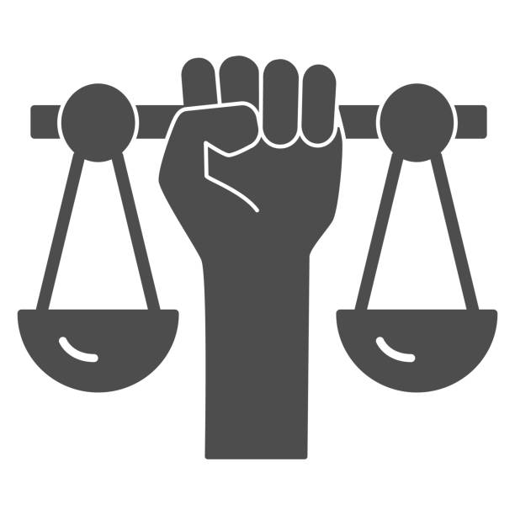

Figure-5 Minimise wealth disparities within and between nations

Goal 11: Sustainable cities and communities

Create inclusive, safe, resilient, and sustainable cities and human settlements is the goal of SDG 11.
In 2018, there were more than 1 billion slum residents, or 24% of the urban population. Eastern and South-Eastern Asia, sub-Saharan Africa, and Central and Southern Asia have the highest populations living in urban slums. In 2019, just 50 percent of people residing in metropolitan areas had easy access to public transportation, which is defined as being 500 metres or less from a low-capacity system (like a bus stop) and one kilometre or less from a high-capacity system (such as a railway). Most urban regions saw an overall increase in the amount of built-up area per inhabitant between 1990 and 2015.
TARGETS
1. By 2030, increase the capacity of all nations for human settlement design and management that is inclusive, integrated, and sustainable.
2. Step up efforts to protect and conserve the world's natural resources and cultural assets.
3. By 2030, lessen the negative environmental effects of cities on a per-capita basis, particularly in regard to municipal and other trash management, as well as air quality.
4. Help the least developed nations construct durable, sustainable buildings using local materials, particularly by providing financial and technical support.

Goal 12: Responsible consumption and production
"Ensure sustainable consumption and production trends," states SDG 12.
Changes like lowering usage and boosting the circularity of the plastic economy are anticipated to be needed to make plastic products more durable and hence reduce plastic trash. Other measures that could assist in achieving the objective include increasing domestic recycling and reducing dependency on the international plastic trash trade.

Targets
1. Put into action a 10-year plan for programmes promoting sustainable production and consumption, with industrialised nations taking the lead and all other nations following suit while taking into account the progress and potential of developing nations.
2. Manage natural resources sustainably and effectively by the year 2030.
3. Use trash reduction, recycling, and reuse techniques to significantly reduce waste creation by 2030.
4. In line with national aims and policies, promote sustainable public procurement practises.

Goal 13: Climate action
Immediately take steps to reduce climate change and its effects by limiting emissions and encouraging advancements in renewable energy sources, according to SDG 13.
The warmest decade in history was the one lasting from 2010 to 2019. Currently, every country in the globe is being impacted by climate change on a global scale. The effects of climate change extend beyond national economies to people's lives and livelihoods, particularly those who are already vulnerable. By 2018, the frequency of natural disasters like large wildfires, droughts, hurricanes, and floods had increased due to climate change. SDG 13 and SDG 7 on clean energy are interconnected and mutually supportive. Switching to renewable energy as a fuel source and improving end-use energy efficiency are the two main areas where governments need to concentrate in order to meet their pledges under the Paris Agreement.
Targets
1. Increase each nation's capacity for adapting to climate-related threats and natural disasters.
2. Include climate change mitigation measures in national planning, strategy, and policies.
3. Improve education, awareness-raising, and institutional and human capacity on early warning, impact reduction, and adaptation to climate change.

Goal 14: Life below water
SDG 14 states that "oceans, seas, and marine resources will be conserved and sustainably used for sustainable development."
The world's population relies on the oceans and fisheries to meet its economic, social, and environmental demands. The planet's life comes from the oceans, which also control the temperature on a worldwide scale. They include approximately a million recognized species, making them the biggest ecosystem in the world.

Goal 14 is primarily concerned with minimizing the effects of marine plastic pollution.

TARGETS
1. By 2025, avoid and drastically cut down all forms of marine pollution, especially that caused by land-based activities, such as marine debris and nutrient pollution.
2. Reduce and mitigate the effects of ocean acidification, notably through improved cross-cutting scientific collaboration.
3. By 2020, on the basis of the most recent scientific knowledge and in compliance with international and national legislation, conserve at least 10% of coastal and marine regions.
4. Make marine resources and markets accessible to small-scale artisanal fishers.
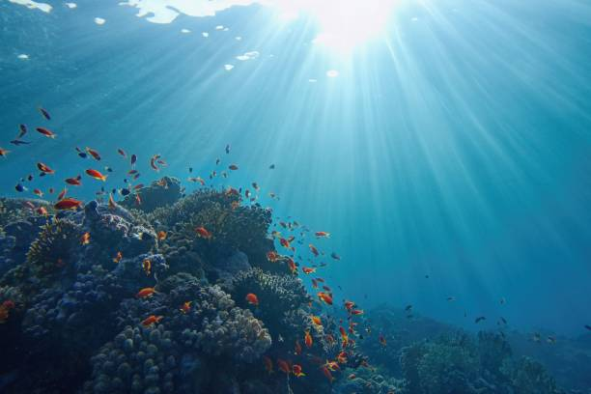
Figure-6

Goal 15: Life on land
Protecting, restoring, and promoting sustainable use of terrestrial ecosystems, managing forests sustainably, preventing desertification, and halting biodiversity loss are all part of SDG 15.
TARGETS
1. By 2030, make sure that mountain ecosystems are preserved, particularly their biodiversity, to increase their capacity to offer advantages that are crucial for sustainable development.
2. Combat both the supply and demand of illegal wildlife products. Take immediate action to stop poaching and trafficking of species of flora and fauna that are protected.
3. Raise and greatly raise the amount of money available from all sources to protect and sustainably use ecosystems and biodiversity.

Goal 16: Peace, justice and strong institutions
"Foster inclusive and peaceful communities for long-term growth, ensure that all people have access to justice, and create institutions that are efficient, responsible, and inclusive at all levels.," is the goal of SDG 16.
The elimination of child abuse, forced labor, sex trafficking, and violent crime are clear global objectives. The International Community calls for more powerful judicial systems that will enforce laws and work toward a more equitable and peaceful society because they cherish peace and justice. To access justice and critical services, all women must be able to turn to institutions that are fair and effective. In the absence of peace and stability in any nation, sustainable development is impossible to expect for. Around 1 in 5 nations would need to speed up development in order to attain universal birth registration by 2030, as more than a quarter of children under the age of 5 were not registered globally as of 2015.
TARGETS
1. Assure that everyone has equal access to justice and encourage the application of the law both domestically and internationally.
2. Ensure that decisions are made at all levels in a responsive, inclusive, participatory, and representational manner.
3. Increase and broaden poor nations' engagement in global governance institutions.
4. By 2030, everyone will have access to a legal identity, including birth registration.

Goal 17: Partnership for the goals
Strengthening the means of implementation and reviving the global collaboration for sustainable development are the goals of SDG 17. There are 24 indicators and 19 outcome targets for this goal. Each of the 16 earlier goals is thought to require greater international collaboration. Goal 17 is included to ensure that nations and organizations work together rather than against one another.
To fulfill the SDGs, investments ranging from $5 trillion to $7 trillion year were made, totaling US$147.2 billion in 2017. Although consistent, this is below the predetermined goal. Six nations achieved the global goal of maintaining government development aid at or above 0.7 percent of gross national GDP in 2016. Conflict-related or disaster-related humanitarian problems have continued to necessitate greater funding and assistance. To promote trade and prosperity, however, many nations also require official development support.
TARGETS
Finance
1. Developed nations should fully carry out their commitments to provide official development assistance, including their pledges to reach the goals of providing 0.7% of their GDP to developing nations and 0.15–0.20% of their GDP to the least developed nations. ODA donors are urged to think about aiming to give the least developed nations at least 0.20 percent of their total ODA/GNI.
2. Find additional funding for developing nations from a variety of sources.
3. Adopt and put in place least developed country investment promotion policies.
Technology
1. Encourage the creation, transfer, dissemination, and diffusion of ecologically sound technologies in developing nations under advantageous conditions, including preferential and concessional ones that are mutually agreed upon.

Trade
1. Significantly boost exports from developing nations, especially with an eye on doubling the share of exports from the least developed nations by 2020.

Systemic issues
Institutional and policy coherence
1. Promote macroeconomic stability globally, including through coherence and coordination of policies
2. Strengthen the consistency of policy for sustainable development
3. Respect the ability of each nation to set and carry out policies for the eradication of poverty and sustainable development.
Multi-party collaborations
1. Encourage and support successful public, public-private, and civil society partnerships, drawing on their resources and experience.
Data, observation, and responsibility
1.By 2030, expand on current efforts to create metrics for sustainable development progress that complement gross domestic product and aid in the development of statistical capacity in poor nations.
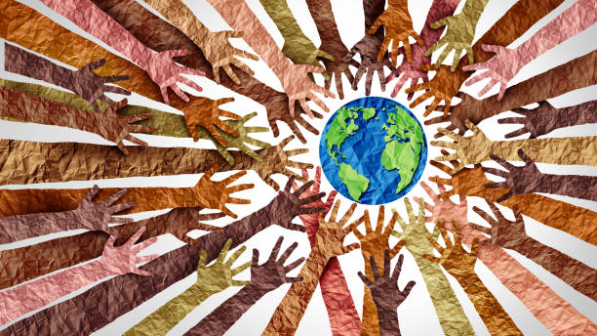
Figure-7 Collaboration for the common good

REFERENCES
  - ^ Jump up to:ª ^{b} "THE 17 GOALS | Sustainable Development". sdgs.un.org. Retrieved 10 August 2022.
  - ^ United Nations (2017) Resolution adopted by the General Assembly on 6 July 2017, Work of the Statistical Commission pertaining to the 2030 Agenda for Sustainable Development (A/RES/71/313 Archived 28 November 2020 at the Wayback Machine)
  - ^ United Nations (2015) Resolution adopted by the General Assembly on 25 September 2015, Transforming our world: the 2030 Agenda for Sustainable Development (A/RES/70/1 Archived 28 November 2020 at the Wayback Machine)
  - ^ Jump up to:ª ^{b} United Nations (2017) Resolution adopted by the General Assembly on 6 July 2017, Work of the Statistical Commission pertaining to the 2030 Agenda for Sustainable Development (A/RES/71/313 Archived 28 November 2020 at the Wayback Machine)
  - ^ Jump up to:ª ^{b} "SDG Indicators - Global indicator framework for the Sustainable Development Goals and targets of the 2030 Agenda for Sustainable Development". United Nations Statistics Division (UNSD). Retrieved 6 August 2020.
  - ^ Jump up to:ª ^{b} ^{c} "SDG Tracker". Our World in Data. Retrieved 6 August 2020.
  - ^ Jump up to:ª ^{b} ^{c} ^{d} ^{e} ^{f} ^{g} ^{h} ^{i} ^{j} ^{k} ^{l} ^{m} ^{n} º ^{p} ^{q} ^{r} ^{s} ^{t} ^{u} ^{v} ^{w} United Nations Economic and Social Council (2020) Progress towards the Sustainable Development Goals Report of the Secretary-General Archived 30 December 2020 at the Wayback Machine, High-level political forum on sustainable development, convened under the auspices of the Economic and Social Council (E/2020/57), 28 April 2020.
8. "Goal 1: No poverty". UNDP. Retrieved 30 December 2020.
- ^ United Nations (2017) Resolution adopted by the General Assembly on 6 July 2017, Work of the Statistical Commission pertaining to the 2030 Agenda for Sustainable Development (A/RES/71/313)
- ^ Ritchie, Roser, Mispy, Ortiz-Ospina (2018) "Measuring progress towards the Sustainable Development Goals." (SDG 1) SDG-Tracker.org, website
- ^ "Decline of Global Extreme Poverty Continues but Has Slowed". World Bank. Retrieved 26 August 2020.
- ^ "Poverty and conflict". GSDRC. Retrieved 17 June 2022.
- ^ "Goal 1 - End poverty in all it forms,everywhere". United Nations, Department of Economic and Social Affairs, Statistics Division. Retrieved 26 August 2020.
- ^ Jump up to:ª ^{b} United Nations Department of Economic and Social Affairs (20 July 2016). The Sustainable Development Goals Report 2016. The Sustainable Development Goals Report. UN. doi:10.18356/3405d09f-en. ISBN 978-92-1-058259-9.
- ^ BMGF (2020) Covid-19 A Global Perspective - 2020 Goalkeepers Report Archived 18 October 2020 at the Wayback Machine, Bill & Melinda Gates Foundation, Seattle, USA
- ^ "Goal 2: Zero hunger". UNDP. Archived from the original on 30 December 2020. Retrieved 13 April 2017.
- ^ Jump up to:ª ^{b} United Nations (2017) Resolution adopted by the General Assembly on 6 July 2017, Work of the Statistical Commission pertaining to the Agenda 2030 for Sustainable Development (A/RES/71/313)
- ^ Jump up to:ª ^{b} ^{c} "Progress for Every Child in the SDG Era" (PDF). UNICEF. Archived (PDF) from the original on 15 July 2020. Retrieved 2 April 2018.
- ^ "From Promise to Impact: Ending malnutrition by 2030" (PDF). UNICEF. Archived (PDF) from the original on 5 February 2017. Retrieved 2 April 2018
- "Goal 3: Good health and well-being". UNDP. Archived from the original on 30 December 2020. Retrieved 13 April 2017.
- ^ Ritchie, Roser, Mispy, Ortiz-Ospina (2018) "Measuring progress towards the Sustainable Development Goals." (SDG 3) SDG-Tracker.org, website
- ^ "Goal 4: Quality education". UNDP. Archived from the original on 11 September 2018. Retrieved 13 April 2017.
- ^ "Education : Number of out-of-school children of primary school age". data.uis.unesco.org. Archived from the original on 30 December 2020. Retrieved 10 March 2019.
- ^ UNESCO (2020). "Global Education Monitoring Report 2020". unesdoc.unesco.org. Archived from the original on 30 December 2020. Retrieved 19 September 2020.
- ^ "Goal 5: Gender equality". UNDP. Archived from the original on 27 February 2018. Retrieved 13 April 2017.
- ^ Sustainable development goals report 2016. New York: United Nations. 2016. ISBN 978-92-1-101340-5. OCLC 959869696. Archived from the original on 28 November 2020. Retrieved 27 August 2020.
- ^ "Female genital mutilation". www.unicef.org. Archived from the original on 30 December 2020. Retrieved 27 August 2020.
- ^ "Goal 6 Targets". United Nations Development Programme. Archived from the original on 19 February 2018. Retrieved 16 November 2017.
- ^ United Nations (2018). Sustainable Development Goal. 6, Synthesis report 2018 on water and sanitation. United Nations, New York. ISBN 9789211013702. OCLC 1107804829.
- ^ WHO and UNICEF (2017) Progress on Drinking Water, Sanitation and Hygiene: 2017 Update and SDG Baselines Archived 25 July 2019 at the Wayback Machine. Geneva: World Health Organization (WHO) and the United Nations Children's Fund (UNICEF), 2017
- ^ Abellán, Javier; Alonso, José Antonio (2022). "Promoting global access to water and sanitation: A supply and demand perspective". Water Resources and Economics. 38: 100194. doi:10.1016/j.wre.2022.100194. S2CID 246261266.
- ^ "Goal 7: Affordable and clean energy". UNDP. Archived from the original on 7 September 2018. Retrieved 28 September 2015.
- ^ Jump up to:ª ^{b} Ritchie, Roser, Mispy, Ortiz-Ospina (2018) "Measuring progress towards the Sustainable Development Goals." (SDG 7) SDG-Tracker.org, website
- ^ "Goal 7: Affordable and clean energy". UNDP. Archived from the original on 7 September 2018. Retrieved 28 September 2015.
- ^ Jump up to:ª ^{b} ^{c} ^{d} IEA, IRENA, UNSD, WB, WHO (2019), Tracking SDG 7: The Energy Progress Report 2019 Archived 30 December 2020 at the Wayback Machine, Washington DC (on Tracking SDG 7 website Archived 30 December 2020 at the Wayback Machine)
- ^ Jump up to:ª ^{b} "Goal 8: Decent work and economic growth". UNDP. Archived from the original on 25 February 2018. Retrieved 12 March 2018.
- "Goal 9: Industry, innovation, infrastructure". UNDP. Archived from the original on 1 March 2018. Retrieved 12 March 2018.
- ^ "2019 Affordability Report". Alliance for Affordable Internet. Archived from the original on 30 December 2020. Retrieved 25 September 2020.
- ^ "Press Release". www.itu.int. Archived from the original on 30 December 2020. Retrieved 25 September 2020.
- ^ "Goal 10: Reduced inequalities". UNDP. Archived from the original on 30 December 2020. Retrieved 12 March 2018.
- ^ United Nations (2017) Resolution adopted by the General Assembly on 6 July 2017, Work of the Statistical Commission pertaining to the 2030 Agenda for Sustainable Development (A/RES/71/313)
- ^ Jump up to:ª ^{b} United Nations (2020) Sustainable development goals report Archived 30 December 2020 at the Wayback Machine, New York
- ^ "Goal 11: Sustainable cities and communities". UNDP. Archived from the original on 11 September 2018. Retrieved 12 March 2018.
- ^ "Goal 11 | Department of Economic and Social Affairs".
- ^ "Goal 12: Responsible consumption, production". UNDP. Archived from the original on 13 August 2018. Retrieved 12 March 2018.
- ^ The State of Food and Agriculture 2019. Moving forward on food loss and waste reduction, In brief. Rome: FAO. 2019. p. 4.
- ^ United Nations (2017) Resolution adopted by the General Assembly on 6 July 2017, Work of the Statistical Commission pertaining to the 2030 Agenda for Sustainable Development (A/RES/71/313)
- ^ Jump up to:ª ^{b} Walker, Tony R. (August 2021). "(Micro)plastics and the UN Sustainable Development Goals". Current Opinion in Green and Sustainable Chemistry. 30: 100497. doi:10.1016/j.cogsc.2021.100497.
- ^ "Goal 13: Climate action". UNDP. Archived from the original on 13 August 2018. Retrieved 12 March 2018.
- ^ Magazine, Smithsonian; Wu, Katherine J. "The 2010s Were the Hottest Decade on Record. What Happens Next?". Smithsonian Magazine. Retrieved 8 February 2022.
- ^ "Climate Action Why it Matters" (PDF). United Nations. Retrieved 11 September 2020.
- ^ United Nations (2017) Resolution adopted by the General Assembly on 6 July 2017, Work of the Statistical Commission pertaining to the 2030 Agenda for Sustainable Development (A/RES/71/313)
- ^ "SDG Report 2020". UN Stats. Retrieved 11 September 2020.
- ^ IEA, IRENA, UNSD, WB, WHO (2019), Tracking SDG 7: The Energy Progress Report 2019, Washington DC (on Tracking SDG 7 website)
- "Goal 14: Life below water". UNDP. Archived from the original on 15 August 2018. Retrieved 12 March 2018.
- ^ United Nations (2017) Resolution adopted by the General Assembly on 6 July 2017, Work of the Statistical Commission pertaining to the 2030 Agenda for Sustainable Development (A/RES/71/313)
- ^ Jump up to:ª ^{b} "Goal 14: Conserve and sustainably use the oceans, seas and marine resources for sustainable development". United Nations, Department of Economic and Social Affairs, Statistics Division. Retrieved 7 September 2020.
- ^ "Oceans & Seas". Sustainable Development Knowledge Platform. Retrieved 5 September 2020.
- ^ "Illegal Fishing | Threats | WWF". World Wildlife Fund. Archived from the original on 30 December 2020. Retrieved 5 September 2020.
- ^ "Ocean acidification (Issues Brief)" (PDF). IUCN (International Union for Conservation of Nature). November 2017. Archived (PDF) from the original on 30 December 2020. Retrieved 3 November 2020.
- ^ "Goal 15: Life on land". UNDP. Archived from the original on 30 December 2020. Retrieved 12 March 2018.
- ^ "Goal 15: Life on land". UNDP. Retrieved 5 September 2020.
- ^ "15.1.1 Forest area| Sustainable Development Goals| Food and Agriculture Organization of the United Nations". www.fao.org. Archived from the original on 30 December 2020. Retrieved 5 September 2020.
- ^ "Desertification, land degradation and drought .:. Sustainable Development Knowledge Platform". sustainabledevelopment.un.org. Archived from the original on 30 December 2020. Retrieved 5 September 2020.
- ^ "Goal 16: Peace, justice and strong institutions". UNDP. Archived from the original on 30 December 2020. Retrieved 12 March 2018.
- ^ United Nations (2017) Resolution adopted by the General Assembly on 6 July 2017, Work of the Statistical Commission pertaining to the 2030 Agenda for Sustainable Development (A/RES/71/313)
- ^ "Goal 16". United Nations Department of Economics and Social Affairs. Retrieved 11 August 2021.
- ^ un [un.women.org un.women.org]. Retrieved 16 February 2022. {{cite web}}: Check |url= value (help); Missing or empty |title= (help)
- ^ undp https://www.ng.undp.org. Retrieved 16 February 2022. {{cite web}}: Missing or empty |title= (help)
- ^ "Progress for Every Child in the SDG Era" (PDF). UNICEF. Archived (PDF) from the original on 15 July 2020. Retrieved 2 April 2018.
- ^ "Goal 17: Partnerships for the goals". UNDP. Archived from the original on 30 December 2020. Retrieved 12 March 2018.
- ^ Pierce, Alan (26 November 2018). "SDG Indicators: why SDG 17 is the most important UN SDG". Sopact. Archived from the original on 30 December 2020. Retrieved 24 September 2020.
- "Goal 17: Partnerships for the goals". United Nations Development Programme (UNDP). Archived from the original on 31 August 2018. Retrieved 24 September 2020.
- https://www.un.org/development/desa/disabilities/envision2030.html

