NANOPARTICLES: APPLICATIONS IN MODERN TECHNOLOGY
Charu Sharma, Thapar Institute of Engineering and Technology, Patiala-147004
Sharmacharu654@gmail.com
Introduction
In science, particles play an important role in all most everything whether it is dissolving sugar in water or in nuclear reactors. The thing that matters the most is size of particles used in that reaction. On the basis of the size, physics get divided into two categories: - Classical and Quantum Physics where the former deals with macroscopic matter and latter describes the microscopic matter. When the particles size gets further diminished it shows unique properties and versatile applications which attracted the scientific community to analyze their nature. Nanoparticles are the gems of modern science. These particles have been found in nanometer scale which is defined as 1nm=10⁻⁹m=10A⁰. To study the structures of particles (1 and 100 nm) and materials there is another category of science i.e. nanoscience and the technology that utilizes its practical applications is called nanotechnology [1].
Nanoparticles exist in nature long time ago but there interaction with humans can be traced back to ancient times. These particles can be distinguished on the basis of their shape, size, surface properties and functionalities. Moreover, there are naturally occurring organic nanomaterials which includes oxides, carbonates and inorganic nanomaterials which formed as a result of volcanic eruptions, combustion etc [1].
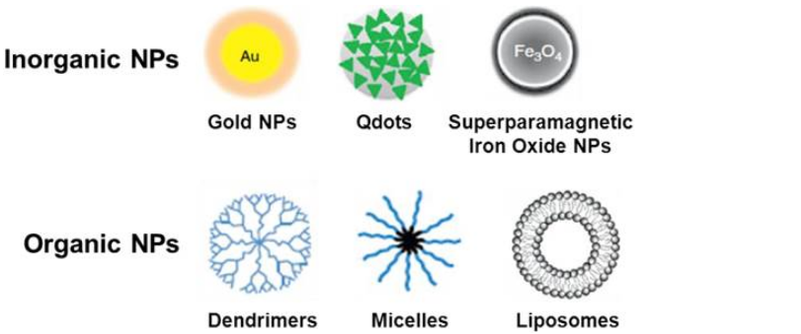
Figure 1: Showing different types of organic and inorganic nanoparticles [2].

When the size of the particles changes from bulk to nanometer range their characteristic behavior also alters it is because of the relative surface area and quantum size effect. These factors cause variations in their reactivity, strength and electrical as well as magnetic behaviours.
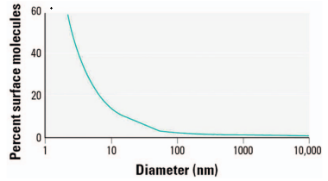
Figure 2: Increase in percent surface molecule as a function of molecule size[3].
A nanomaterial is in the nanometer dimension. It can also be defined as the material whose dimensions lies between a cluster of molecules and a bulk material but having properties different from the big sized material of same composition. These are the building blocks of nanotechnology.
Further, nanoparticles (NPs) are divided on the basis of their dimensionality that is 3-D, 2-D, 1-D andd 0-D.
3-D nanomaterials are those clusters of nanoparticles that do not have dimensions in nanometer range. But still they show properties at nanoscale. Nanosized grains are combined to form nanophase material called 3-D nanomaterials. Examples of 3-D nanomaterials are nanocomposites
2-D nanomaterials are those which on reducing the size of the bulk material from three dimensions to two dimensions, the movement of electrons got confined only in one direction and are capable of moving in the remaining two directions. If we see this in Cartesian coordinates we can say that reducing the size from x, y, z axis either to x-y plane, y-z plane or z-x plane so that the particle got restricted in any of the one direction. Practically example of a thin film layer, quantum well etc
Similarly 1-D nanomaterials are defined when the reduction of the bulk material goes to two dimensions i.e. electron is allowed to move in one direction and the other two dimensions are in nanometer range. In Cartesian coordinates the movement can be along x axis or y axis or z axis. Examples for 1-D nanoparticles are quantum rods, quantum wires etc.
For 0-D nanoparticles, reducing the size of bulk material from all the dimensions where the electron’s movement will be restricted from all the 3 directions. The structure got limited in all dimensions. Example: quantum dot and nanoparticles[4].
Table 1: Showing delocalization dimensions and confinements of different types of nanomaterials[5].
DIMENSIONALITY | DELOCALISATION DIMENSION | CONFINEMENT
BULK (3-D) | 3 | 0
WELL (2-D) | 2 | 1(X)
WIRE (1-D) | 1 | 2(X,Y)
DOT (0-D) | 0 | 3(X,Y,Z)
.
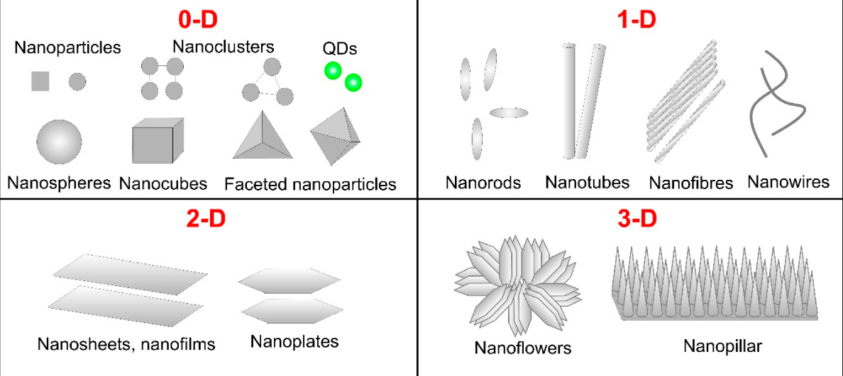Figure 3: Showing shapes and examples of different types of nanomaterials [6].
APPLICATIONS OF NANOPARTICLES
As these particles are tiny, it brings a diverse range of changes in their properties making them of utmost importance and giving us a variety of applications. From the past few decades NP’s were prime source of investigation and utilizing them in numerous fields such as biomedical, food agriculture, industries etc. Some of the applications are discussed below:
NP’s plays a vital role in almost every industry. It is used in industries such as: cosmetics, agriculture, food manufacturing, pharmaceuticals, textiles, bioengineering etc.
(a) AUTOMOBILE INDUSTRY: The major source of consumption of fuel is automobiles but if their weight is reduced then this problem can be solved. Polymers made by NP’s additives are used in automobile spare parts, luggage, helmets etc for making them stiff, durable & light weight. Nanoparticles are also responsible for making an efficient engine with the usage of Al₂O₃ nanoparticles. Moreover, carbon nanotubes sheets are being used for air vehicles. In addition, nanomaterials are also useful in providing effective scratch free coatings on vehicles. As vehicles are exposed to harsh weather conditions so there outermost layer should be made in such a way that it prevents the cracks and scratches for longer period. A considerable amount of nanoparticles should be added in the paint to have good results. So, researchers use nano-SiO₂ coating with 3 wt% which resulted in higher abrasion resistance and resolved the problem of glass cracks [7].
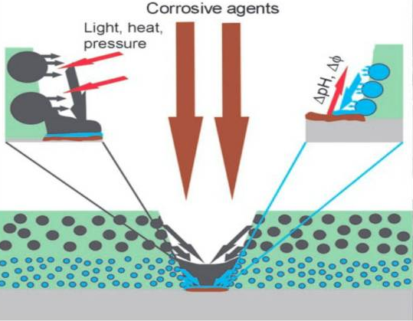 Figure 4: Nanomaterial self repairing mechanism for surface coating[7].
(b) WASTE WATER TREATMENT: Nanoparticles have gained much importance in treating waste water. They offer the possibility of efficient removal of germs and pollutant from water due to their unique property of high surface area (surface/volume ratio). Basically different types of nanoparticles and nanomaterials were used to treat waste water but carbon nanotubes and nanofibers show some positive impact. It has also been said that in future large amount of water purification can be done through this process. Earlier the purification with the ultrasonic irradiation before the Ag-NP’s at a low concentration, improvised antibacterial effect. Also, by using both the processes together one could get better results in treating waste water. Some results are shown below [8]:
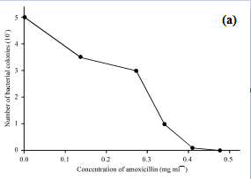
Figure 5 (a): Effect of different concentration of amoxicillin put into 5*106 CFU of bacterial colonies [8].
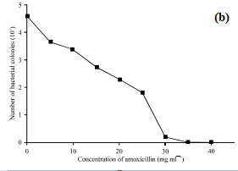
Figure 5 (b): Effect of different concentration of nanosilver put into 5*106 CFU of bacterial colonies [8].

(c) DRUG DELIVERY AND MEDICINES: Today with the rise in advancement in bio-technology, the process of medication has also changed a lot. Cures for many diseases like: cancer have been found but it lacks in the delivery of drug process. NP’s small size has solved this problem too. They target cells which are damage or even the nucleus of the cell by directly delivering medicine in the optimum dose which effects in increased therapeutic efficiency of the drugs. NP’s have been used for various clinical uses like: gene delivery to tumour, contrast agent in imaging. It also reduces the side effects that are observed in other ways of drug delivery. Particles that are most commonly used in biomedical applications are Iron oxide particles such as magnetite (Fe₃O₄ ) or its oxidized form maghemite (Fe₂O₃). Furthermore, AuNP’s are greatly affective for cancer treatment and diagnosis as it shows versatile properties and biological compatibilities [9].
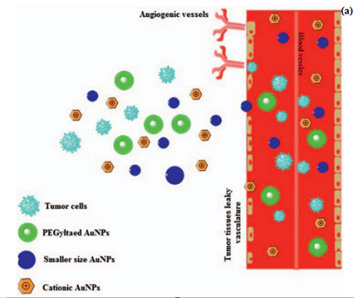
Figure 6: Schematic representation of passive targeting AuNP’s in targeted Cancer therapy [9].

(d) ENERGY HARVESTING: Energy that we get to do our daily chaos comes from the fossil fuels that are non renewable resources. Due to regular use of fossil fuels they are going extinct. So to find an alternative, scientists worked on some resources that are easily available and at cheap costs. They switched their research to nanoparticles. As these particles shows variety of differences in their properties as compared to the bulk material such as their catalytic properties, large surface area, magnetic and optical properties which enable them to be utilized in energy harvesting process. NP’s were able to produce energy from photoelectrochemical (PEC) and electrochemical water splitting and widely used in Photocatalytic applications. Moreover, nanogenerators are made which changes mechanical energy into electricity by using piezoelectric, which is an unusual approach to generate energy. Many other things like electrochemical Carbon dioxide reduction to fuels precursors, solar cells etc have offered more ways to produce energy. Also, energy reservation can be done through NP’s into various forms at nanoscale range. Such new approaches to achieve new ways of producing energy will be beneficial for the coming ages [10].
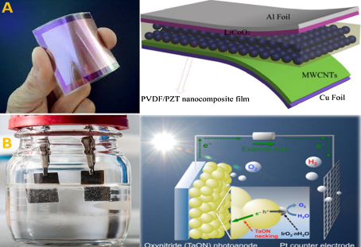
Figure 7: Energy generation approaches from (a) piezoelectric actuators, (b) water splitting [10].

(e) COSMETICS: It is a vast field in which various products are used for external use on the skin such as shaving creams, sunscreens, lotions, lip balms etc. The rapid growth of this industry has lead to increase in the innovation and improvisation in the same products. Products used in this field are either solid, liquid or semi solids. Taking inspiration from the growing advancement of nanotechnology in bioscience, this industry also evolved themselves into Organic and Inorganic nanoparticles. Sunscreens are for protecting us from the UV radiations which are divided into three parts UVA, UVB and UVC. Inorganic NP’s like TiO_{2,} ZnO are used as filters against the UVA and UVB as they reflect a small portion of the incident light particles, resulting in a transparent effect. Anti-aging creams use liposomes made of saturated and unsaturated phospholipids which when applied on the skin results in the formation of osmolytes leading to reduction in water loss and tightness of skin. Silver NP’s are used in the antibacterial and anti fungal agents [11].
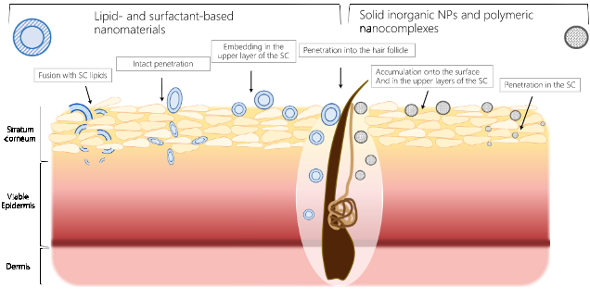
Figure 8: Potential routes for penetration of nanomaterials into skin [11].

CONCLUSION
This chapter puts spotlight on the nanoparticles which are the growing interests of scientists and researchers due to their variable properties at nanoscale range. These particles are of great importance not only in physics but also in other fields explained above. They are pushing the boundaries of technology and creating examples of their work on at a time. NM’s are paving a way to a better future with more advancement and solutions to almost everything. Nanoscience and nanotechnology are improving continuously by providing applications in wide range of areas such as medicines, cosmetics, automobiles etc. The future from now is as same as we imagine in a science fiction and is also in safe hands.

References
- Jorg Kreuter, Nanoparticles- A historical perspective, International journal of pharmaceutics, 331, 1-10 (2007).
- https://application.wiley-vch.de/books/sample/3527331972_c01.pdf.
- https://www.google.com/search?q=1d+2d+3+d+nanoparticles&client=firefox-b-ab&source=lnms&tbm=isch&sa=X&ved=0ahUKEwiJuZuMsuXbAhUbSX0KHSWFDSUQ_AUICigB&biw=1366&bih=611#imgrc=5c4UhclIwr_7vM:
- Jitendra N. Tiwari, Rajanish N. Tiwari and Kwang S. Kim, Progress in matrial science, 57, 724-834(2012).
- https://www.google.co.in/search?safe=strict&client=firefox-b-ab&dcr=0&biw=1366&bih=634&tbm=isch&sa=1&ei=n_jvWu_-IIqR8gWekJCIAQ&q=table+of+delocalisation+of+0d+1d+2d+3d+nanoparticles&oq=table+of+delocalisation+of+0d+1d+2d+3d+nanoparticles&gs_l=img.3...19218.21460.0.23694.9.9.0.0.0.0.296.1570.0j2j5.7.0....0...1c.1.64.img..2.0.0....0.qFaIxawJCC4#imgrc=UxjNvi3s-GZKLM:
- https://www.google.com/search?q=examples+of+0,1,2,3+D+nanoparticles&sxsrf=ALiCzsYZjo8LIJuetNT-MMuh0hPiWwry8w:1660800043852&source=lnms&tbm=isch&sa=X&ved=2ahUKEwjVlqCl0s_5AhV3RmwGHUXCAe8Q_AUoAXoECAEQAw&biw=1366&bih=625&dpr=1
- Muhammad Shafique and Xiaowei Luo, Nanotechnology in Transportation Vehicles: An overview of its applications, Environmental, Health and Safety Concerns, Journal of Materials, 12 (15), 2493 (2019)
- Dhermendra Tiwari, J. Behari and Prasenjit Sen, Application of nanoparticles in waster water treatment, World Applied Science Journal, 3(3), 417-433 (2008)
- M. R. Shah, M. Imran and S. Ullah, In Micro and Nano Technologies, Metal Nanoparticles for Drug Delivery and Diagnostic Applications (Elsevier, 2020). https://doi.org/10.1016/B978-0-12-816960-5.00022-7
- Ibrahim Khan, Khalid Saeed, Idrees Khan, Nanoparticles: properties, applications and toxicities, Arabian Journal of chemistry, 12, 908-931 (2019).
- Lucia Salvioni, Lucia Morelli, Miriam Colombo, The Emerging role of Nanotechnology in skincare, Advances in Colloid and Interface Science, 293, 102437 (2021).

