BIOLOGICAL SYNTHESIS OF NANOPARTICLES

Prachi Jha
MATS School of Sciences
MATS University
Raipur, C.G.
E mail id – Prachi.jha0@gmail.com

Ashish Saraf
MATS School of Sciences
MATS University
Raipur, C.G.
E mail id- ashish.saraf22@gmail.com

ABSTRACT
Nanotechnology is one of the most promising domains of science. Nanoparticles with extended application in various industries have received global attention. Recently, synthesis of nanoparticles using green technology has gained importance as it has been considered cost effective, eco- friendly and efficient. This method uses microorganism and plants working as nano-factories to mediate synthesis of nanoparticles with different size, shape and characteristics. This chapter includes green methods of nanoparticle synthesis, advantages of biological methods and characterization techniques of nanoparticles.

- INTRODUCTION

Nanotechnology as a field of research is growing day by day creating an impact in almost every aspect of human lives. It is considered as one of the most promising approach to many areas of science and technology such as biomedicine, electronics, agriculture, textiles, medicine, antimicrobials and cosmetics, etc. (Shah et al. 2022; Salvioni et al. 2022; Jha et al. 2021). The nanoparticles possess unique physical, chemical and optical properties as compared to their bulk materials. Though the Properties of nanoparticles are highly dependent on its size, the surface properties and morphology are also responsible for its characteristics. The novel idea of nanotechnology was given for the very first time in 1959 by Richard Feynman in his visionary talk “There’s Plenty of Room at the Bottom”. But the term Nanotechnology was coined in 1974 by Tokyo science university professor Norio Taniguchi. Since then Nanotechnology has set many milestones. Currently, the more commercially viable and environment friendly approach to synthesize the nanoparticles are being worked upon by the scientist all over the world which may eliminate the adverse effects of already existing physical and chemical methods.
Advantages of Green Technology

- METHODS OF NANOPARTICLE SYNTHESIS

Figure 1. Nanoparticles synthesis methods
s
Nanoparticle Synthesis

Chemical method
Biological method
Physical method

Pyrolysis, Sol-gel processes, Supercritical fluid synthesis, Chemical vapor deposition
Green Synthesis (Plants, Algae, Bacteria, Fungi, Yeasts & Actinomycetes)
Etching, Mechanical milling, Sputtering, Laser ablation, Lithography, Thermal Decomposition

Generally there are numerous approaches including chemical, physical, and biological methods for the synthesis of nanoparticles (Fig-1). Physical method involves mechanical milling, thermal decomposition, laser ablation etc. Chemical approach uses various organic chemicals to act as precursor and capping agents. Physical and chemical methods of nanoparticles synthesis are traditional methods with many attractive advantages such as high yield in less time, precise control over size and shape of nanoparticles, and extensive scalability. However, potential harm associated with these methods outweighs the advantages of these approaches. The excessive use of organic chemicals as capping agent and precursor leading to generation of toxic by-products, disposal of these by products, high pressure and high temperature working conditions are some of the disadvantages that raises grave concern during synthesis process. Therefore, there is an urgent need for environment friendly, non-toxic, and cost effective approach for nanoparticles synthesis. These disadvantages can be overcome by applying biological method or green technology which uses biological entities as nano-factories (Fig. 2). In this approach, the natural sources like plants, fungi, yeast, actinomycetes, and bacteria etc. are used to synthesize intracellular and extra cellular nanoparticles having natural reducing and stabilizing properties (Bahrulolum et al., 2021).

Fig 2 Advantages of biological method of Nanoparticle synthesis

Cost effective

Eco friendly

Advantage of Biological synthesis

No hazardous by-products
Single step process

Presence of natural reducing and capping agents

- BIOSYNTHESIS OF NANOPARTICLES

In the current scenario the green method of nanoparticle synthesis using plants, bacteria, fungi etc. has gained much attention because of their compatibility for application in biomedical and pharmaceutical industries (Geethalakshmi and Sarada, 2010). The synthesis of nanoparticles might be either intracellular or extracellular. Various factors including pH, temperature, concentration of precursor metal affects the process of synthesis. Thus, it becomes important to understand the interaction mechanism of biological systems and precursor metal in order to gain control of the process. The principle remains same for both microorganisms and plants where metal salts are reduced to metal ions by bioactive compounds found in plants or enzymes released by microbes.

- Synthesis of Nanoparticles by Microorganisms

Microorganisms like fungus, bacteria, yeast and algae are capable of synthesizing nanoparticles. The basic principle of formation of nanoparticle is the reduction of metal ions to nanoparticles (Sadowski et.al, 2008). Prokaryotes are commonly used for the synthesis of metals and metal oxide nanoparticles (Gobinath et al., 2021). Bacteria mediated synthesis has gained attention as bacterial cultures are easy to grow and their genetic code can be easily manipulated. The first bacteria mediated nanoparticles synthesis was reported in 1984 when a strain of Pseudomonas stutzeri AG259, which was isolated from silver mine was found to be capable of synthesizing silver nanoparticles (Venkataraman et al., 2011).
Fungal synthesis of nanoparticles has also been reported (Wang et al., 2021). Higher tolerance to toxicity, easy and economic culture methods and simple biomass handling characteristics has made fungus a very significant medium of nanoparticles synthesis. They also secrete large amount of enzymes which leads to extracellular synthesis of nanoparticles.
Algae have been shown to assimilate heavy metals from the environment. They reduce these metals to nanoparticles. Fucus vesiculosus, a brown alga, was researched for its potential to bioreduce and biosorb Au [III] ions (Mata et al., 2009). They are able to synthesize metallic nanoparticles from both live and dead dry biomass. (LewisOscar et al., 2016)

- Plant mediated synthesis of Nanoparticles

Plants contain wide range of bioactive compounds which includes alkaloids, ﬂavonoids, terpenoids, steroids, etc. which acts as reducing agent for the formation of nanoparticles. Plant extracts based synthesis has advantages over microbial synthesis of nanoparticles because it’s one-steps process, cost-effective and nonpathogenic (Fig. 3) (Roy and Bharadvaja, 2017a,b; Nagore et al., 2021; Mittal and Roy, 2021). It also eliminates the tedious process of maintenance of cell cultures and release of hazardous by-products.

Fig 3 Plant mediated synthesis of Nanoparticles

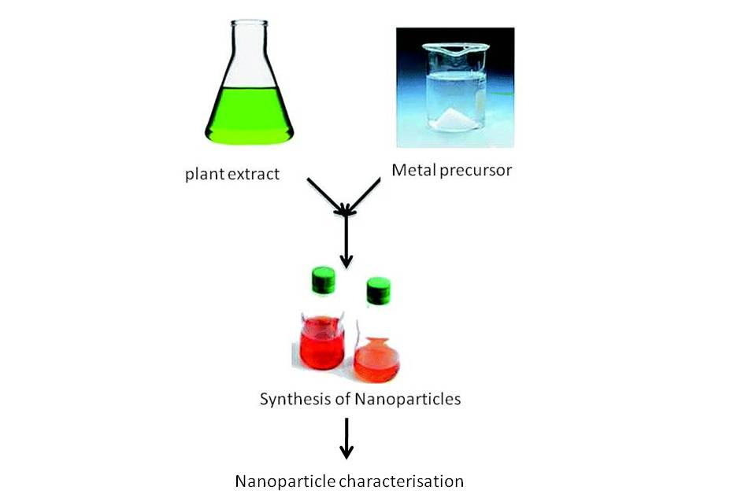

- CHARACTERIZATION OF NANOPARTICLES

- Scanning Electron Microscope (SEM)

SEM is used to determine the surface properties of any sample. When a high energy beam of electrons strikes the sample surface and interacts with atoms of sample, characteristic X-rays are generated that contain information about sample’s surface topography, composition etc (Begum et al., 2022).

B. Transmission Electron Microscope (TEM)
TEM studies the size and structure of nanoparticles. A sharp high-energy electron beam is passed through a thin layer of sample. Some of the electron beam interacts with the sample, remaining is diffracted. The intensity of diffraction depends on orientation of planes of atoms in a crystal. This produces a variation in the electron intensity that reveals information of the crystal structure.

C. Dynamic Light Scattering (DLS)
DLS technique is used to determine the size and size distribution of particles (Begum et al., 2022).When a sample is illuminated with laser, the fluctuation in the intensity of scattered light is measured which corresponds to the size of the sample particle. Hence, the exact size and size distribution can be measured by DLS.

D. UV-Vis Spectroscopy
Metal nanoparticles absorb and scatter optical light because of their surface plasmon resonance (SPR). This SPR peak is shown in absorption spectra which is dependent on size, shape and material composition of nanoparticles.

E. Fourier Transform Infrared Spectroscopy (FTIR)
FTIR provides information of the functional groups present on the surface of nanoparticles. The identification of functional groups leads to determination of the reducing agent and the capping agent responsible for synthesis and stability of nanoparticles (Eid, 2022).

- CONCLUSION

A large number of studies are reported for the synthesis of nanoparticles. The physical and chemical methods bring about many drawbacks including hazardous by-products, use of toxic chemicals, high energy consumption etc. Therefore it can be assumed that in future a clean, safe and green method of nanoparticles synthesis will be largely accepted. Greater understanding of mechanism involved with biological nano-factories will help to regulate the process more efficiently.

- BIBLIOGRAPHY

Bahrulolum, H., Nooraei, S., Javanshir, N., Tarrahimofrad, H., Sadat, V., Mirbagheri, Easton, A.J., & Ahmadian, G., “Green synthesis of metal nanoparticles using microorganisms and their application in the agrifood sector,” journal of Nanobiotechnology, volume 19, Article number: 86 (2021)

Begum, S.J.P.; Pratibha, S.; Rawat, J.M.; Venugopal, D.; Sahu, P.; Gowda, A.; Qureshi, K.A.; Jaremko, M. Recent Advances in Green Synthesis, Characterization, and Applications of Bioactive Metallic Nanoparticles. Pharmaceuticals 2022, 15, 455.
- Eid, M., “Characterization of Nanoparticles by FTIR and FTIR-Microscopy” Handbook of Consumer Nanoproducts,June 2022. DOI:10.1007/978-981-15-6453-6_89-1

- Geethalakshmi R, Sarada DVL, “Synthesis of plant-mediated silver nanoparticles using Trianthema decandra extract and evaluation oftheir antimicrobial activities,” International Journal of Engineering Science and Technology, 2(5), 2010, 970-975.

- Gobinath, R., Bandeppa, Manasa, V., Rajendiran, S., Kumar, K., Paul, R., & Basavaraj, K., “ Nanoparticle-Mediated Adsorption of Pollutants: A Way Forward to Mitigation of Environmental Pollution”, Microbial Rejuvenation of Polluted Environment,vol 2, 2021, pp 317–348.

- Jha, P., Saraf, A., Sohal, J. K., “Antimicrobial Activity of Biologically Synthesized Gold Nanoparticles from Wild Mushroom Cantharellus Species”, Journal of scientific Research, Vol 6(3), 2021, pp. 78-83.

- LewisOscar, F., Vismaya, S., Arunkumar, M., Thajuddin, N., Dhanasekaran, D., Nithya, C., “Algal Nanoparticle: Synthesis and Biotechnological Potential”, Algae – Organisms for Imminent Biotechnology, DOI: 10. 5772/62909Oscar

- Mata YN, Blazquez ML, Ballester A, Gonzalez F, Munoz JA. “Biosorption of cadmium, lead and copper with calcium alginate xerogels and immobilized Fucus vesiculosus,” Journal of Hazardous Materials. 2009;163(2–3):555–562.

- Mittal, S., Roy, A., “Fungus and plant-mediated synthesis of metallic nanoparticles and their application in degradation of dyes,” In: Photocatalytic Degradation of Dyes. Elsevier, 2021,pp. 287–308.

- Nagore, P., Ghotekar, S., Mane, K., Ghoti, A., Bilal, M., Roy, A.,” Structural properties and antimicrobial activities of polyalthia longifolia leaf extractmediated CuO nanoparticles,” BioNanoScience 11 (2), 2021,579–589.

- Roy, A., Bharadvaja, N., “Qualitative analysis of phytocompounds and synthesis of silver nanoparticles from Centella asiatica,” Innovat. Tech. Agric. 1 (2), 2017a ,88–95.

- Roy, A., Bharadvaja, N., “Silver nanoparticles synthesis from a pharmaceutically important medicinal plant Plumbago zeylanica,” MOJ Bioequiv Availab 3 (5), 2017b. ,00046.

- Sadowski Z, MaliszewskaIh, Grochowalska B, Polowczyk I, Koźlecki T, “Synthesis of silver nanoparticles using microorganisms,” Materials Science-Poland, 26(2), 2008, 419-424.

- Salvioni,L., Morelli, L., Ochoa, E., Labra, M., Fiandra, L., Palugan, L., Prosperi, D., Colombo,M., “The emerging role of nanotechnology in skincare,”Advances in Colloid and Interface Science, Volume 293, July 2021.

- Shah , M.A., Pirzada, B.M., Price, G., Shibiru, A.L., Qurash, A., “Applications of nanotechnology in smart textile industry: A critical review,” Journal of Advanced Research,Volume 38, May 2022, Pages 55-75

- Venkataraman D, Kalimuthu K, Sureshbabu RKP, Sangiliyandi G, Metal nanoparticles in Microbiology Rai M, Duran N, Vol.-XI, Springer, 2011, 17-35.

- Wang, D., Xue, B., Wang, L., Zhang, Y., Liu, L., Zhou, Y., “Fungus-mediated green synthesis of nano-silver using Aspergillus sydowii and its antifungal/antiproliferative activities.” Sci Rep 11, 2021, 10356

