ENDOMETRIOSIS
ABSTRACT: Endometriosis is a chronic gynaecological disorder that can lead to infertility and pelvic pain in adults and women of reproductive age. It is characterized by the presence of endometrial like-glands and stroma outside the uterine cavity. It is influenced by various risk factors like early menarche, late menopause and lifestyle. Numerous etiologic factors are linked to menstruation, genetics and hormones. With age, the diagnosis and severity of endometriosis rises up. Ultrasound, laproscopy, magnetic resonance imagings are the common diagnostic tools. Endometriosis has been classified into four stages by American Society of Reproductive Medicine based on the severity. Prevalence in women is around 2 to 50%. The endometriotic lesions are hormonally active and respond to the cyclic changes in estrogen and progesterone, while the appearance may vary from red, brown, black, white, yellow, pink, clear or red vesicle.
KEYWORDS: Deep Infiltrating Endometriosis, Apoptosis, Dysmenorrhea, Menstruation, Biomarkers, Laproscopy
- DEFINITION:
Endometriosis is a chronic inflammatory condition in which growth of the endometrium (tissue that lines the inside of the uterus) and lesions are seen outside the uterus. This condition is most commonly seen in pelvic areas, ovaries, the pouch of Douglas and uterosacral ligaments (ligaments that support the uterus) [1,2]. Endometriosis is a word derived from the Greek endo ‘'inside'', metra ''uterus'' and osis ‘' disease,'' [3]
- ETIOLOGY/ THEORIES OF FORMATION OF ENDOMETRIOSIS:
Several theories have been proposed regarding the development of endometriosis.
- Sampsons Theory/ Retrograde Menstruation - It is widely accepted theory worldwide. This theory states that retrograde menstruation causes the viable cells in the peritoneal fluid to implant, proliferate and infiltrate in the peritoneal cavity. The reflux of endometrial lining from the fallopian tubes to the peritoneum during menstruation is referred to as Retrograde menstruation and many women of reproductive age experience this phenomenon.[3]

- Mayer’s Theory/ Coelomic Metaplastic Theory – This theory assumes that the coelomic cells in the mesothelial lining of the visceral and abdominal peritoneum are capable of differentiating into muller type cells under the stimuli of cytokines and growth factors of the endometrial stroma. This theory also explains that normal undifferentiated peritoneal cells transform into endometrium like tissue. This hypothesis explains the development of endometriosis in prepubescent girls.[4]

- Halban’s Theory - According to this theory, the hematogenous or lymphatic dissemination of viable endometrial cells causes the endometrial lesions to develop. The endometrial tissue enters lymphatic and vascular systems and thereafter travels to foci like the brain, pleura or retroperitoneal regions.[3]

- Hormones – Oestrogen is the hormone responsible for endometrial proliferation and development of endometriosis. Endometriotic stromal cells aromatise circulating androgens to oestradiol and a decline in 17-hydroxysteroid enzyme activity results in very little conversion of oestradiol to less potent oestrone. Thus, it increases the bioavailability of oestrogen.[4]

On the other side, progesterone resistance in the endometrial tissue prevents progesterone from having an antagonistic effect with oestrogen, which contributes to the development of endometriosis. The progesterone resistance may result from either a functional defect of the progesterone receptors already present or from decreased expression of progesterone receptors in the endometriotic lesion. [3,4]

- Oxidative Stress - Oxidative stress is caused mainly due to imbalance between the reactive oxygen species (ROS) and the antioxidant ability of the body. The presence of water and electrolytes in the peritoneal fluid is the source of ROS in endometriosis patients. Numerous elements like the nucleic acids and proteins are susceptible to damage by ROS. If antioxidant capacity is decreased, ROS do not get eliminated from the cells. This accumulation can be the main contributing factor to endometriosis. [5]

- Inflammation – Women with endometriosis have elevated serum levels of pro-inflammatory cytokines like IL-1, IL-6, and IL-8. The regurgitation of endometrial cells into the peritoneum triggers an inflammatory response which results in activation of macrophages and proliferation of monocytes. This inflammatory response hinders clearance of the menstrual debris and promotes the implantation and growth of endometrial cells in the ectopic sites. [4,6]

- Genetics – Microsatellite instability (MSI), chromosomal instability (CIN), single nucleotide polymorphisms (SNP), gene mutations (GM), loss of heterozygosity (LOH), and mitochondrial DNA (mtDNA) mutations are some of genetic variables that affect the development of Endometriosis. [5]

Genetic variables that are inherited as well as acquired may predispose women for ectopic endometrial cell adherence to the peritoneal epithelium and survive immune clearance. Genetic predisposition raises the frequency of cellular damage. Significant gene mutations in the endometria of endometriosis-affected women have been discovered using laser capture microdissection and high throughput and high resolution comparative genomic hybridization (CGH) arrays. [4]

Numerous studies have linked genetic polymorphisms to the emergence of endometriosis as a contributing factor. Numerous loci are thought to be involved in the polygenic mode of inheritance of endometriosis and several chromosomal areas have been related to the corresponding endometriosis phenotype. [7]

- Stem Cells - The monthly regeneration of the endometrium following menstruation and the re-epithelialization of the endometrium post childbirth provides evidence that a stem cell reserve exists. The involvement of stem cells in the formation of endometriotic deposits could be as a result of abnormal translocation of normal endometrial basalis through retrograde menstruation.[4]

During menstruation, endometrium-derived stem cells located in the basalis layer can be lost and enter the peritoneal cavity through the fallopian tube, where they grow into endometriotic implants. It is also possible that dysfunctional endometrial stem cells have an increased capacity for implantation and ectopic tissue development or the normal stem cells find an irregular peritoneum to be a suitable implantation site.[8]

- Apoptosis Suppression - The survival of endometrial cells in the peritoneal cavity to generate ectopic deposits and to maintain the established lesions requires alteration of the endometrial cell destiny to favour antiapoptotic and proliferative phenotype.

Numerous pieces of evidence point to an increase in antiapoptotic genes in ectopic endometrial cells and downregulation of genes regulating the apoptosis pathway. The endometrium of patients with endometriosis expresses higher levels of antiapoptotic proteins in addition to having less scavenger activity. The transcriptional activation of genes that typically encourages inflammation and angiogenesis also play a role in the reduction of endometrial cells' ability to undergo apoptosis. [4]
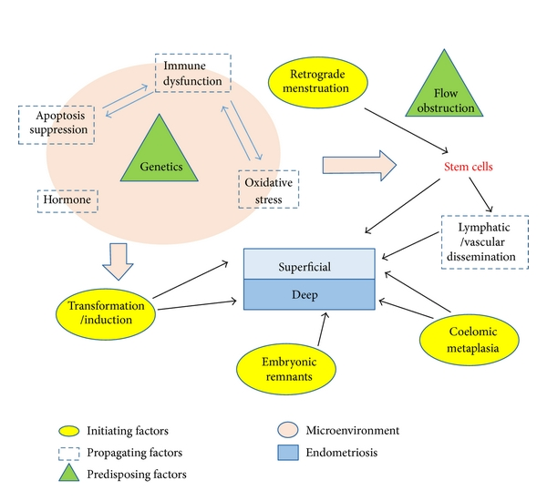Figure 1: Summary of interplay between the different factors involved in the pathogenesis of superficial versus deep endometriosis. [Adapted from Samer Sourial et al [4]]
- CLINICAL PRESENTATION:

Clinical presentation of endometriosis varies in women. The most common symptom in women with endometriosis is chronic pelvic pain which starts before menses and continues throughout the duration of menstrual flow. [9]
The second most typical symptom is infertility. Fertility rates are lower in women with moderate to severe endometriosis, especially when the ovaries and oviducts are affected. Infertility issues affect 30 to 50 percent of endometriosis patients, particularly those under 35. [9]

Table 1: Clinical Presentation of Endometriosis [1,10]

CLINICAL PRESENTATION
Intermenstrual bleeding
Dysmenorrhoea - painful periods
Dyspareunia - painful intercourse
Dyschezia - painful defecation
Dysuria - painful urination
Blood in stools
Diarrhoea or constipation
Infertility
Chronic fatigue
Pain in the sacral region of the spine and pelvic region

- STAGES OF ENDOMETRIOSIS:

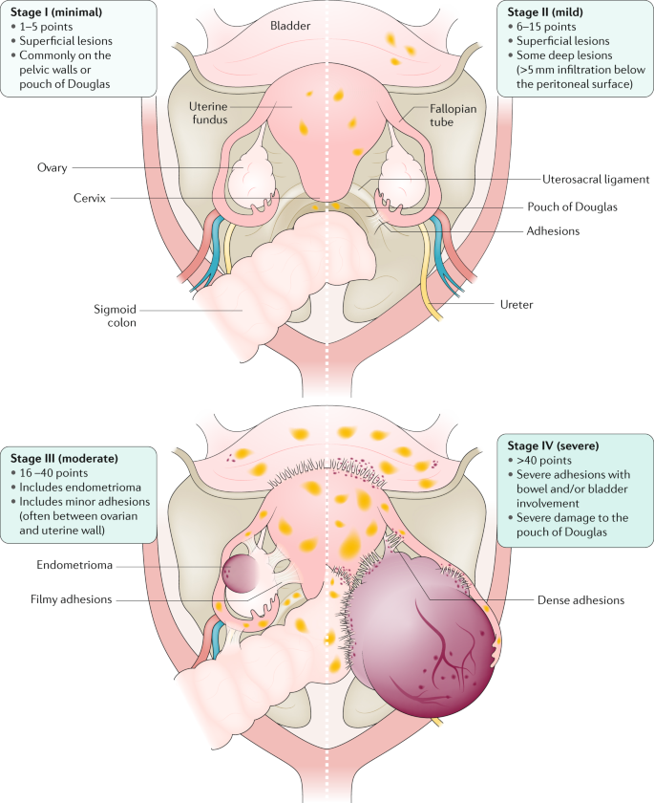Figure 2: Stages of Endometriosis [Adapted from Krina T. Zondervan et al [11]]
The updated American Fertility Society score which is now known as American Society of Reproductive Medicine (ASRM) endometriosis staging system is based on a points system that considers location, extent and depth of disease in relation to pelvic structures. [11]

Figure 3: Stages of Endometriosis according to American Society of Reproductive Medicine (ASRM) Criteria
The inadequacy of the ASRM criteria to foresee the probability of the conception following surgery, which is important for patients seeking to conceive, is one of its biggest drawbacks. This resulted in the development of more recent classification schemes, like the Endometriosis Fertility Index (EFI). The ASRM point system is combined with post-surgery fertility data in the EFI. After three years, patients are given a score between 0 and 10; those with scores between 0 and 3 had a 10% chance of conceiving, while those with scores between 9 and 10 had a 75% chance. [12]
- TYPES OF ENDOMETRIOSIS:

- Ovarian Endometriosis: It appears in the form of superficial lesions and as endometrial cysts in 2–10% of women of reproductive age. It is the most common one.[10]

Figure 4: Pictures depicting Ovarian Endometriosis [Adapted from I. Brosens et al [13]]

a: active and vascularised endometriotic lesion upon the ovarian surface and presence of vesicle on the parietal peritoneum.
b: endometriosis with fixed adhesions of ovary with pelvic sidewall.

- Peritoneal Endometriosis: It occur in various forms - white raids on the peritoneum (intra-peritoneal and sub-peritoneal), peritoneal defects, red, brown and black foci, colourless bright vesicles and focal dilated blood vessels and petechiae. Foci of endometriosis within the peritoneum are found in 15–50% of all women diagnosed with endometriosis.[10]
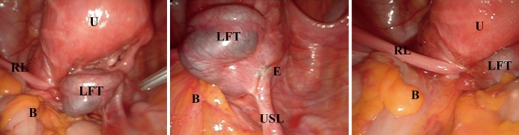
Figure 5: Pictures depicting Peritoneal Endometriosis [Adapted from Simone Ferrero et al [14]]
U – Uterus, E – Endometriosis, B – Bowel, USL – Left uterosacral ligament, RL – Right round ligament LFT – left Fallopian tube
- Deep Infiltrating Endometriosis (DIE) – It extends deep into the extra-peritoneal space of many pelvic organs. The pathophysiology of DIE is not clearly defined [10]. DIE includes endometriosis of the bladder, endometriosis of the ureter and rectovaginal endometriosis.[15]
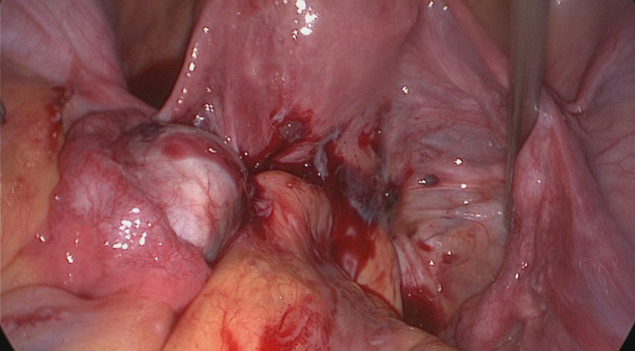
Figure 6: Picture depicting Deep Infiltrating Endometriosis [Adapted from Maurizio Nicola D’Alterio et al [15]]
- RISK FACTORS:

Table 2: List of factors that are associated with increased risk of Endometriosis [1,2,10]
FACTORS ASSOCIATED WITH INCREASED RISK
Early menarche - early first cycle before the age of 11
Late Menopause
Shorter than 27-day menstrual cycles
Genital defects - hymen overgrowth or narrowing of the cervical canal
Low BMI
Alcohol and Caffeine intake
Obesity
Age 25–29
Smoking

- DIAGNOSIS/EVALUATION:

- Physical Examination: The International Deep Endometriosis Analysis group, proposes some basic steps to be followed physical examination:
- Evaluate by palpating the uterus and adnexa for presence or absence endometriomas or pelvic mass.
- Evaluation of transvaginal sonographic soft markers such as specific tenderness and ovarian mobility.
- Examination of the Douglas pouch's condition.
- Examine the anterior and posterior compartments for DIE nodules. [16]

- Ultrasound (US): Transvaginal ultrasound is utilised to find ovarian endometriotic cysts and to more accurately look into the endometrium and uterine cavity. Pelvic masses are visualized by the use of transvaginal and transabdominal ultrasound. It is considered as a first-line imaging technique due its low cost and feasibility. [1,16]

- Magnetic resonance imaging: After ultrasound (US), it is regarded as a second-line method. Since it offers a more accurate picture of deep infiltrating endometriosis, MRI is currently regarded as the best imaging tool for mapping endometriosis. Imaging is essential for treatment planning despite the fact that final diagnosis is based on laparoscopy or surgery with histological verification of endometrial glands.[17]

- Laparoscopy: The only diagnostic procedure that can effectively rule out endometriosis is a laparoscopy. It is recognized as the standard investigation and is effective at detecting endometriosis [2]. Numerous studies have demonstrated that, in the majority of instances, the presence of endometriosis detected through laparoscopy may be verified histologically.[18]

- BIOMARKERS OF ENDOMETRIOSIS:

Table 3: List of endometriosis diagnostic biomarkers [1]
GROUP | BIOMARKERS
Inflammatory cytokines | IL-1 β, IL-6, IL-8, IL-17, IL-21, RANTES, TNF-α, IFN-gamma, MCP-1, MIF, CRP
Steroids and hormones | ERs, 17 βHSD, aromatase
Growth factors | IGF, Activin, TGF β1, HGF
Cell adhesion and extracellular matrix molecules | Integrins, Vimentin, E-cadherin, osteopontin, ICAM-1 (CD54), β-catenin, FAK
Genomics | HOXA10, 3p, 5q, 7p, 9p, 11q, 16q, 17p, 17q, 18q, 19p, 19q
Apoptosis and cell cycle control | Telomerase activity, Pak-1, cyclin D1, Survivin, Bcl-2, MCL-1, Bax, Bcl-xL, Bcl-xS
Stem cell markers | CD9, CD34, Oct-4

- COMPLICATIONS:

Figure 7: Picture depicting various complications of Endometriosis

- MANAGEMENT/TREATMENT:

Figure 8: Picture depicting numerous options of pharmacological treatment for endometriosis

- Non-steroidal anti-inflammatory drugs (NSAIDs): The most commonly employed first-line treatments for pain caused by endometriosis is NSAIDs. It functions by inhibiting the COX enzyme, which is required for the generation of inflammatory mediators. However, research has demonstrated that the ectopic endometrial tissues contain a greater amount of COX 2 receptors. There is considerable evidence regarding the effectiveness of NSAIDs in reducing endometriosis-related pain and its unfavourable gastrointestinal side effects [19]. NSAIDs are available over the counter and do not act by removing or decreasing deposits of ectopic endometrium [20].

- Progestins: Majority of the guidelines recommend progestins as first-line medical treatment for pain in endometriosis.

- Dienogest (DNG) is a 19-nortestosterone derivative and most commonly used dosage is 2mg per day.
- Medroxyprogesterone acetate, a 17OH-progesterone derivative. It is administered for intramuscularly or subcutaneously 150 mg every three months. It causes less bone loss than GnRH agonists.
- Levonorgestrel IntraUterine System (LNG –IUS) is a hormonal contraceptive method, releasing a 19-nortesterone derivative. It causes induction of endometrial glandular atrophy, the downregulates endometrial cell proliferation and intensifies apoptotic activities [21]. LNG- IUS is a T shaped device that contains 52 mg of Levonorgestrel, which releases 20 micrograms of hormone per day over a five-year period.[19]

- Combined oral contraceptive pills (COCPs): Progesterone by itself or in combination with oestrogen causes the endometriotic tissue to decidualize, which is believed to slow the disease's progress. The risk of venous thromboembolism is lower in combinations containing low doses of ethinyl estradiol (20 micrograms) than high doses (30 micrograms)[19]. It is widely indicated in patients with dysmenorrhea[21].

- Gonadotropin-releasing hormone (GnRH) analogs: This includes Gonadotropin-releasing hormone agonists and antagonists.

- Gonadotropin-releasing hormone agonists (GnRH agonists): GnRH agonists primarily cause the pituitary to release FSH and LH. Later, it results in pituitary GnRH receptor downregulation, which suppresses the hypothalamus pituitary ovarian axis and causes anovulation. As a result of the endometriotic implants being deprived of the essential oestrogen for their existence, this eventually causes hypoestrogenism, amenorrhea, and regression of the implants. Leuprolide acetate 3.75 mg monthly injection or 11.25 mg used three monthly, Goserelin and Nafarelin are the most commonly used preparation [19]. Patients with endometriosis who continue to experience symptoms after trying first-line therapy are the only ones who are indicated with GnRH agonists.
- Gonadotropin-releasing hormone agonists (GnRH antagonist): Cetrorelix, is the most widely prescribed GnRH antagonist which provides significant symptomatic relief and regression of the endometriotic implants. They have greater potential for treating endometriosis than GnRH agonists since they have better tolerance and less hypoestrogenemia

- Danazol: Danazol, a derivative of 17 alpha-ethinyl–testosterone, is an androgenic agent that inhibits LH surge, disrupts estrogen production from the ovary and ovarian steroidogenesis by direct inhibition of the ovarian enzymes. Due to its unfavourable side effects like weight gain, fluid retention, breast atrophy, acne, oily skin, hot flushes, hirsutism, its use is becoming less popular [9]. It is administered in divided doses of 400–800 mg per day for six months [19].

- Aromatase Inhibitors: Aromatase is the enzyme responsible for the conversion of androgens into estrogens.This induced estrogen synthesis leads to the growth of the endometrial implants, COX expression, prostaglandin secretion, which further induces aromatase activity. Aromatase inhibitors prevent the production of oestrogen in both the ovaries and the peripheral tissues. In postmenopausal women with endometriosis, when peripheral fat is the main source of oestrogen, this mechanism is especially beneficial.

Anastrazole, letrozole and exemestane are third generation aromatase inhibitors that can be administered orally with faster onset of action. When taken with progesterone, GnRH agonists, or combined oral contraceptives, they greatly lessen the discomfort associated with endometriosis, enhance quality of life, and have even been proven to reduce the size of the lesion. However, prolonged usage of these medications can result in ovarian follicular cysts and bone loss. Oral contraceptives and progestins can be added back in combination with GnRH agonists to lessen bone loss and prevent follicular growth.[19]

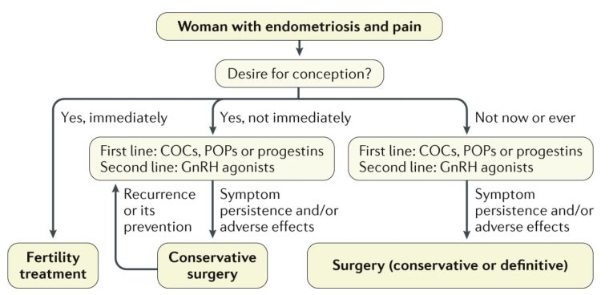
Figure 9: Algorithm for management of endometriosis-associated pain [Adapted from Krina T Zondervan et al [11]]

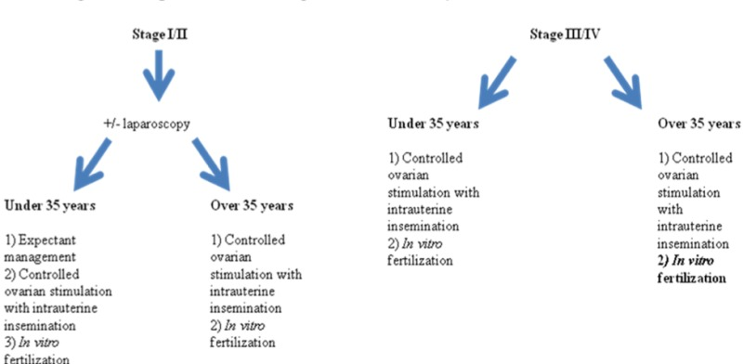
Figure 9: Algorithm for management of endometriosis-associated infertility [Adapted from Olivia J Carpinello et al [9]]

- SURGERY OPTIONS:
Surgeries might be categorised as conservative or definitive. Conservative therapy, sometimes known as fertility sparring, comprises the removal of endometriomas, resection of deep-infiltrating implants, and ablation or excision of peritoneal implants. While hysterectomy with or without oophorectomy is the only option for definitive surgical treatment, doing so would reduce future fertility. Laparoscopy is the gold standard in both diagnosing and managing endometriotic lesions and implants [22].
Most guidelines advise laparoscopic surgery over laparotomy for chronic endometriosis and infertility discomfort because it is less painful, requires less time in the hospital, heals more quickly, and produces better cosmetic results [21]. Endometrial implants should only be removed or ablated laparoscopically after thorough consideration of the anatomical tissues implicated. Reduced implant recurrence rates and enhanced pain relief have been demonstrated with combined surgical and medicinal care of endometriosis implants [22].

- NEW ADVANCES IN TREATMENT:
Endometriosis is a chronic medical disorder that necessitates extensive treatment. The efficacy of current treatment approaches in controlling symptoms varies, but they are constrained by long-term use, adverse effects of prolonged hypoestrogenism, and high rates of recurrence upon drug withdrawal. Due to these limitations, newer therapies are always being looked for. The following list of treatments have been tested in animal models with evidence in reduction lesions size and number and currently are under clinical trial testing for indication of endometriosis in humans.[19]

Figure 10: List of drugs that are currently under human trials to assess its indication in Endometriosis[19]

REFERENCES:
- Parasar P, Ozcan P, Terry KL. Endometriosis: epidemiology, diagnosis and clinical management. Current obstetrics and gynecology reports. 2017 Mar;6(1):34-41.
- Farquhar C. Endometriosis. BMJ. 2007 Feb 3;334(7587):249-53.
- Tsamantioti ES, Mahdy H. Continuing Education Activity.
- Sourial S, Tempest N, Hapangama DK. Theories on the pathogenesis of endometriosis. International journal of reproductive medicine. 2014 Oct;2014.
- Asghari S, Valizadeh A, Aghebati-Maleki L, Nouri M, Yousefi M. Endometriosis: Perspective, lights, and shadows of etiology. Biomedicine & Pharmacotherapy. 2018 Oct 1;106:163-74.
- Tao Y, Zhang Q, Huang W, Zhu H, Zhang D, Luo W. The Peritoneal Leptin, MCP‐1 and TNF‐α in the Pathogenesis of Endometriosis‐Associated Infertility. American Journal of Reproductive Immunology. 2011 Apr;65(4):403-6.
- Albertsen HM, Chettier R, Farrington P, Ward K. Genome-wide association study link novel loci to endometriosis. PloS one. 2013 Mar 5;8(3):e58257.
- Figueira PG, Abrão MS, Krikun G, Taylor H. Stem cells in endometrium and their role in the pathogenesis of endometriosis. Annals of the New York academy of sciences. 2011 Mar;1221(1):10-7.
- Carpinello OJ, Sundheimer LW, Alford CE, Taylor RN, DeCherney AH. Endometriosis.[Updated 2017 Oct. 22]. De Groot LJ, Chrousos G., Dungan K., Feingold KR, Grossman A., Hershman JM et al., eds. Endotext [Internet]. South Dartmouth (MA): MDText. com, Inc.; 2000. https://www. ncbi. nlm. nih. gov/books/NBK278996/(дата обращения—15.12. 2018). 2000.
- Smolarz B, Szyłło K, Romanowicz H. Endometriosis: epidemiology, classification, pathogenesis, treatment and genetics (review of literature). International Journal of Molecular Sciences. 2021 Sep 29;22(19):10554.
- Zondervan KT, Becker CM, Koga K, Missmer SA, Taylor RN, Vigano P. Endometriosis Nat Rev Dis Primers. 2018; 4: 9.
- Alimi Y, Iwanaga J, Loukas M, Tubbs RS. The clinical anatomy of endometriosis: a review. Cureus. 2018 Sep 25;10(9).
- Brosens I, Puttemans P, Gordts SY, Campo R, Gordts S, Benagiano G. Early stage management of ovarian endometrioma to prevent infertility. Facts, Views & Vision in ObGyn. 2013;5(4):309.
- Ferrero S, Vellone VG, Barra F. Pathophysiology of pain in patients with peritoneal endometriosis. Annals of Translational Medicine. 2019 Mar;7(Suppl 1).
- D’Alterio MN, D’Ancona G, Raslan M, Tinelli R, Daniilidis A, Angioni S. Management challenges of deep infiltrating endometriosis. International Journal of Fertility & Sterility. 2021 Apr;15(2):88.
- Rolla E. Endometriosis: advances and controversies in classification, pathogenesis, diagnosis, and treatment. F1000Research. 2019;8.
- Foti PV, Farina R, Palmucci S, Vizzini IA, Libertini N, Coronella M, Spadola S, Caltabiano R, Iraci M, Basile A, Milone P. Endometriosis: clinical features, MR imaging findings and pathologic correlation. Insights into imaging. 2018 Apr;9(2):149-72.
- Mettler L, Schollmeyer T, Lehmann-Willenbrock E, Schüppler U, Schmutzler A, Shukla D, Zavala A, Lewin A. Accuracy of laparoscopic diagnosis of endometriosis. JSLS: Journal of the Society of Laparoendoscopic Surgeons. 2003 Jan;7(1):15.
- Rafique S, Decherney AH. Medical management of endometriosis. Clinical obstetrics and gynecology. 2017 Sep;60(3):485.
- Brown J, Crawford TJ, Allen C, Hopewell S, Prentice A. Nonsteroidal anti‐inflammatory drugs for pain in women with endometriosis. Cochrane Database of Systematic Reviews. 2017(1).
- Kalaitzopoulos DR, Samartzis N, Kolovos GN, Mareti E, Samartzis EP, Eberhard M, Dinas K, Daniilidis A. Treatment of endometriosis: a review with comparison of 8 guidelines. BMC women's health. 2021 Dec;21(1):1-9.
- Zanelotti A, DeCherney AH. Surgery and endometriosis. Clinical obstetrics and gynecology. 2017 Sep;60(3):477.

