A NOVEL DRUG DELIVERY OF LIPOSOMES: A COMPREHENSIVE REVIEW
Miruthula.U.V, Muthukumar.S KMCH college of pharmacy
ABSTRACT
Liposomes are little spherical artificial vesicles, which is made up of naturally derived phospholipids or pure surfactants. The components of liposomes are Phospholipids, Cholesterol and other additional excipients. Liposomes was like vesicular in structures consisting of hydrated bilayers. Liposomes are classified into different types like., Based on their structural components, based on method of liposome preparation, based on composition and applications etc. The pharmacokinetics of liposomes focused on the total body fluids and tissue distribution and their metabolism. Liposomal based formulation is implemented in the clinical fields. Doxil was the anticancer liposome which was first approved liposome.

KEYWORDS: Liposomes, characteristics, method of preparation, stability, pharmacokinetics, clinical applications.

1.INTRODUCTION
Rational research in drug delivery began in 1950s with the advent of polyclonal antitumour antibodies developed for tumour targeting of cytotoxic drugs to experimental tumours.
According to legend, he was experimenting with new laboratory equipment, and he made an observation about the phospholipids forming closed multilamellar vesicles in aqueous solution which took two years to be proved. It consists of an internal aqueous compartment entrapped by one or multiple concentric lipidic bilayers.
When the structural layer of phospholipid is disrupted, they are able to realign themselves into smaller structures. These reassembled bilayer structures are known as liposomes while a monolayer is called micelle. A liposome can be formed at a variety of size. They were biocompatible, completely biodegradable, non-toxic, flexible and nonimmunogenic for systemic and no systemic administrations.
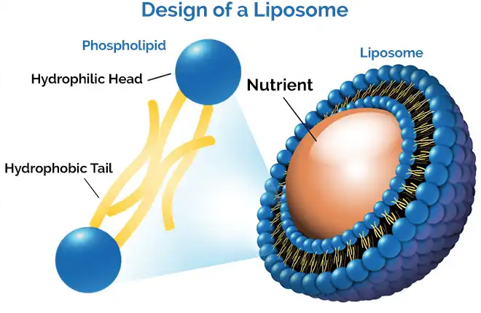

Fig.1 Structure of liposome

2.COMPONENTS OF LIPOSOME
The components of liposomes are:
1.Phospholipids 2. Cholesterol 3. Additional excipients

2.1. Phospholipids:
Phospholipid is the important structural components of biological membrane where there are two types were existed like phosphodiglycerides and sphingolipids which is a hydrolysis product.
2.2. Cholesterol:
Cholesterol is a fat-like substance and an essential component of the body.
Cholesterol inserts into membrane with its hydroxy groups which is oriented towards the aqueous surface and aliphatic chain aligned parallel to acyl chains in the centre of bilayer.
2.3. Additional excipient:
PEG i.e., Polyethylene glycol on the liposome surface offers extended circulation property, protects the captured drug from inactivation and enhance stability to improvise the intracellular intake.

3.CLASSIFICATION OF LIPOSOMES
Liposomes are classified into different types:
1. structural components
- Multilamellar large vesicles
- Oligolamellar vesicles
- Unilamellar vesicles
- Medium sized unilamellar vesicles
- Large unilamellar
- Giant unilamellar vesicles
- Multivesicular vesicles

Fig.3 Size and lamellarity of liposomes
2.Based on composition and applications
- Fusogenic liposomes
- pH sensitive liposomes
- Stealth liposomes

5. ADVANTAGES OF LIPOSOMES
- Liposome increases the efficacy and the therapeutic index of the drug.
- Liposome provides controlled release and sustained release.
- Suitable for delivery of hydrophobic, hydrophilic and amphipathic drugs and agents.
- Liposome increase stability via encapsulated drug.
6. DISADVANTAGES OF LIPOSOMES
- Sometimes, they are less stable.
- Short half-life.
- Difficult in large scale manufacture and sterilization.
- Very high production cost
- Low solubility and oxidation off bilayer phospholipid.
- Low therapeutic index and dose effectiveness.

7. METHODS OF LIPOSOME PREPARTION
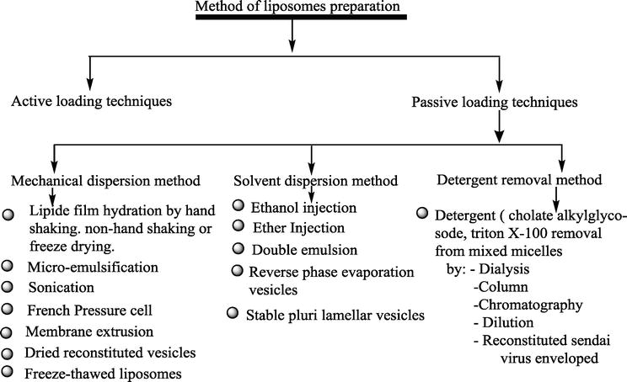

  - ACTIVE LOADING TECHNIQUE
- Prollposome:
Lipid and active drug were covered onto a solvent transporter tp shape free-streaming granular material in supportive of liposomes where it is in isotonic liposomal suspension for the hydration.
- Lyophilization:
The expulsion of water from items in a solidified state at incredibly decreases the weight which is called as lyophilization.

  - PASSIVE LOADING TECHNIQUE
I.MECHANICAL DISPERSION METHOD:
- lipid film hydration.
First preparation of homogenous takes place. By dissolving and mixing a lipid component in an organic solvents like ethanol, chloroform etc. This lipid film was thoroughly dried by placing the vial or flask on a vacuum pump by removing the residual organic solvent.

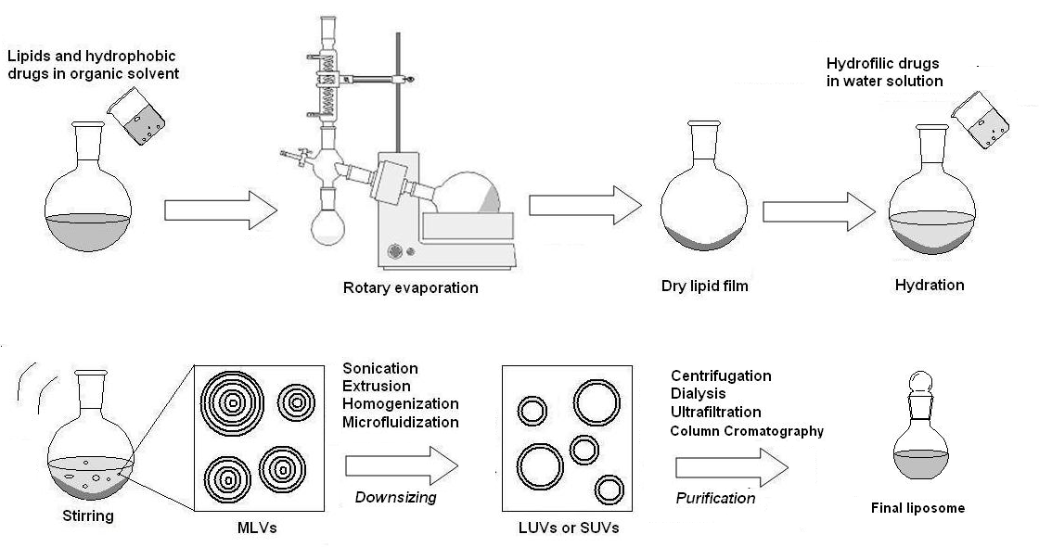
Fig.4 Lipid film hydration method

Advantages: Disadvantage:
- It is simple process i. Difficulty in scaling up.
- Straight-forward approach ii. Time consuming method.

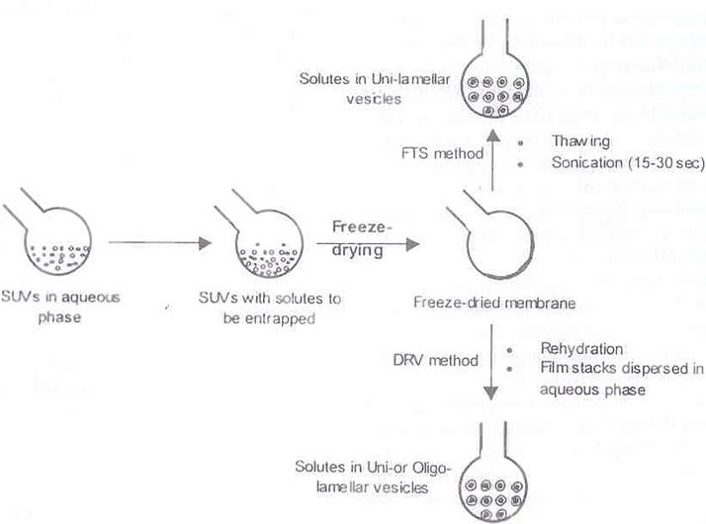
- Dried reconstituted
Fig.5 Dried reconstituted vesicle method vesicle
However, Liposomes obtained from this method are usually 1.0 µm or less in diameter. Entrapment yield can vary, but 40% is fairly standard compared with 2-10% for MLVs prepared by hand-shaking method.

II.SOLVENT DISPERSION METHOD:

- Ethanol injection:
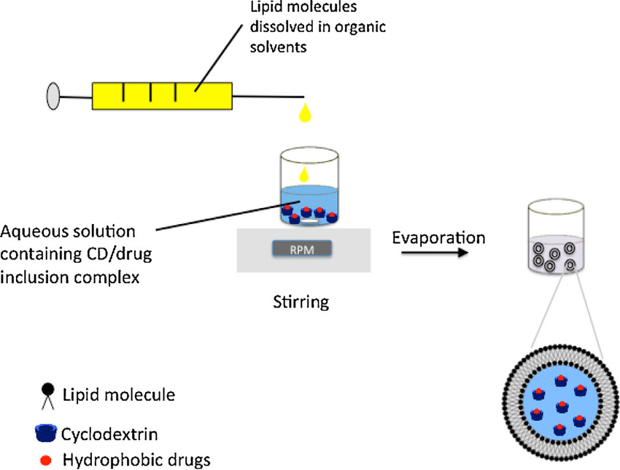
An ethanolic solution of the lipid was injected rapidly into an excess of saline or another medium of aqueous through some fine needle. The force of the injection was sufficient to them to achieve it completely by mixing, so that the ethanol was diluted with water and phospholipid molecules were dispersed evenly throughout the medium.

Fig. 6 Ethanol injection method
Chemical characterisation
Phospholipid peroxidation is quantitatively determined using UV absorbance, iodometry (for hydroperoxidase) and GLC techniques. Phospholipid hydrolysis as well as cholesterol autooxidation can be determined using HPLC and TLC. pH of the liposomal dispersion can be determined using pH meter.

Biological characterisation
The importance of determining biological parameters was very helpful in determining the safety of formulation for therapeutic applications. Sterility, pyrogenicity and animal toxicity were determined during the biological characteristics of the liposomes

- STABILITY OF LIPOSOMES
Liposomes faces many stability problems with physical as well as chemical destabilisation process. It degraded chemically through oxidation and hydrolysis.the two aspects are:
- Physical stability
- Chemical stability

  - Physical stability:
Aggregation is the formation of larger units of liposome material, these units are still composed of individual liposomes.

  - Chemical stability:
The glycerophosphate and phosphocholine ester bonds are more stable. The polyunsaturated acyl chains of phospholipids are sensitive to oxidation via free radical reactions Cyclic peroxides, hydroperoxides, malondialdehyde, alkanes are the major degradation products.

- CLINICAL APPLICATION OF LIPOSOMES
10.1 . Cancer treatment:
- liposomal daunorubicin and pegylated liposomal doxorubicin versions has greatly prolonged circulation.
- Pegylated liposomal doxorubicin has shown substantial efficacy in breast cancer treatment both as monotherapy and in combination with another chemotherapeutics.
- The thermo-sensitive liposomal formulation ThermoDox

  - . Ophthalmic treatment
- So many drugs are used for the treatment of eye disorders like dry eye syndrome, corneal ulcer etc.
- The pharmaceutical preparations may be suspension form or ointment for topical application as well as in solution forms but those preparations will have poor ocular bioavailability. To omit this barrier, liposomal formulation is used.

  - . Pain relievers management
- DepoDur is a formulation of morphine which is formulated in sustained release formula using DepoFoam Technology with extending the time of clinical effect.
- Exparel release Bupivacaine

CONCLUSION
In conclusion, liposomes have a diverse range of uses ever since it was first noted that it is able to self-assemble into vesicles. Crucial progress has been made in the long circulating liposome process which was not recognized immediately. Liposomes with increased drug delivery to the desired disease locations, by the ability of long circulating residence time. Now they achieved the acceptance from clinical sector. Liposomes also promote the particular diseased cell to target within the disease site. The fact that all issues are associated with scaleup, stability and increasingly world wise lipid-based therapeutics in future.

REFERENCE
- http://www.jpsr.pharmainfo.in/Documents/Volumes/vol5issue09/jpsr05091304.pdf
- https://innovareacademics.in/journal/ijcpr/Issues/Vol3Issue2/292.pdf
- https://eijppr.com/n4DZcRj
- https://eijppr.com/LOdV6nk
- https://portal.issn.org/resource/ISSN/0976-2779
- https://doi.org/10.1166/jcsb.2012.1020
- https://doi.org/10.4172/2155-952X.1000276
- https://doi.org/10.1080/10717544.2016.1177136
- Controlled and novel drug delivery – N.K. Jain (pg.no., 321,322,324)
- Theory and practice in novel drug delivery system – S.P. Vyas (pg.no., 161,162,163)

